Supplemental Information

Multivariate Calibration Approaches for Measurement of Elemental Concentration of Aerosols
L. Zheng,^{a, b} P. Kulkarni,ª† and D. D. Dionysiou^{b}

- Centers for Disease Control and Prevention, National Institute for Occupational Safety and Health, Cincinnati, OH 45226, USA.
- Environmental Engineering and Science Program, Department of Biomedical, Chemical, and Environmental Engineering, University of Cincinnati, OH, 45221, USA.
† Author to whom correspondence should be addressed to: Phone: (513) 841-4300; Fax: (513) 841-4545; Email: PSKulkarni@cdc.gov

S1. Plots of PLS regression coefficients for each element
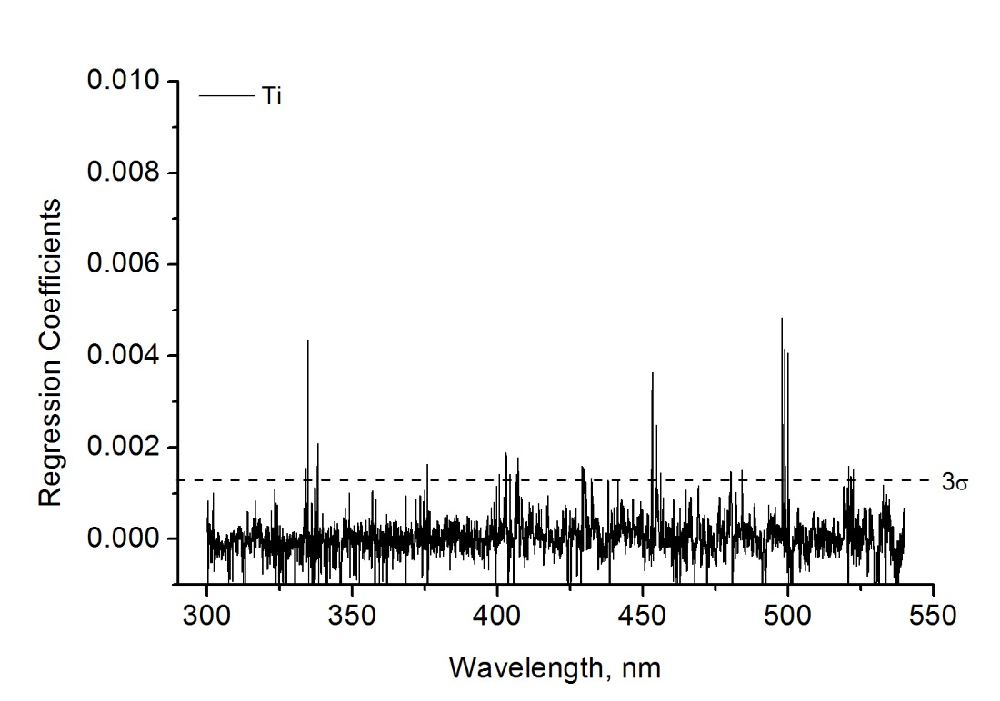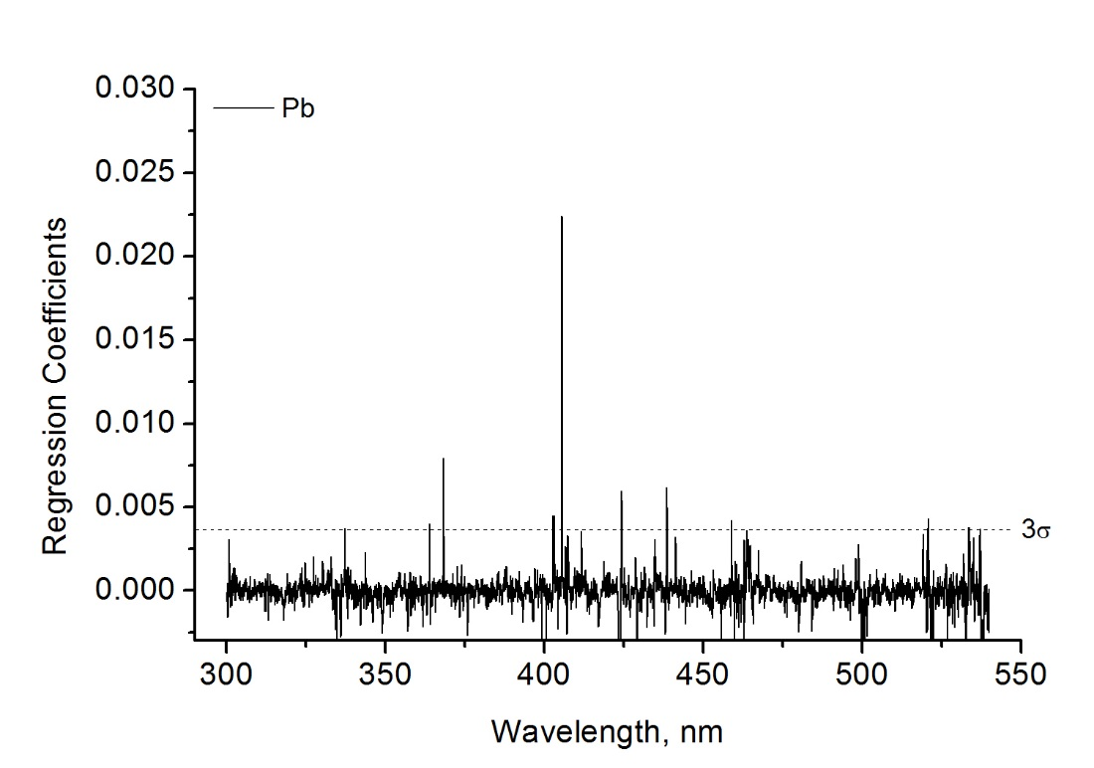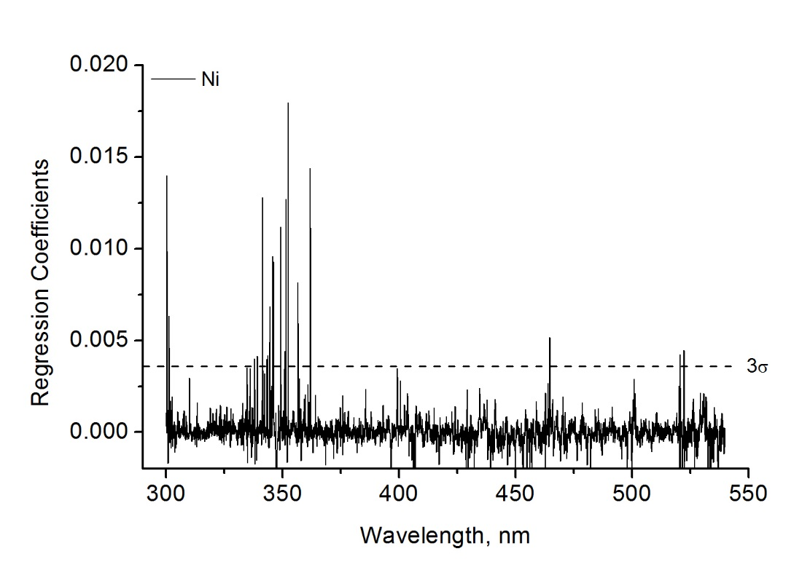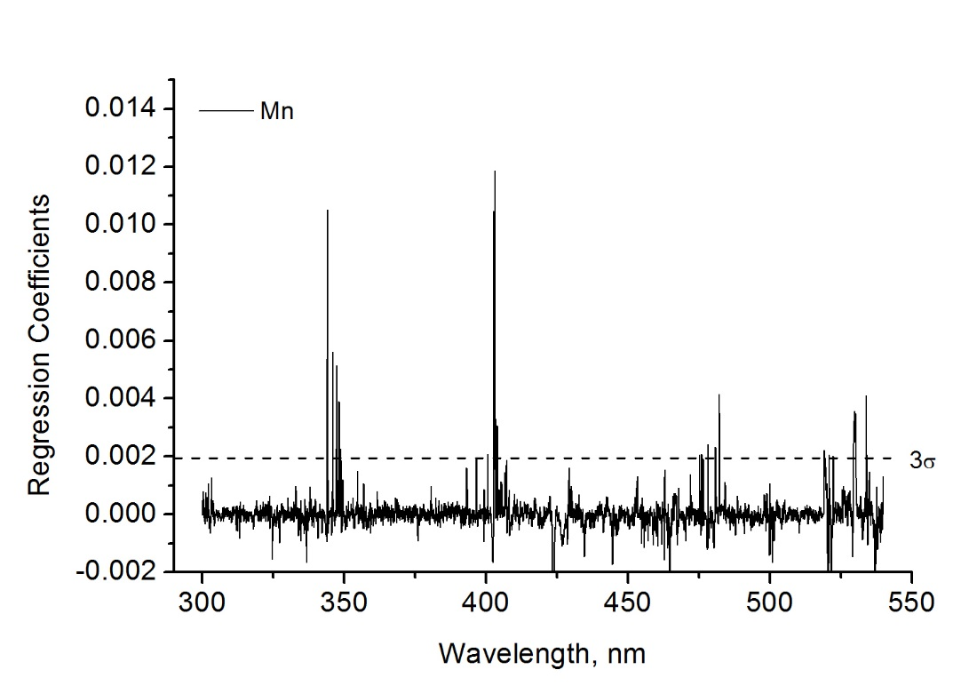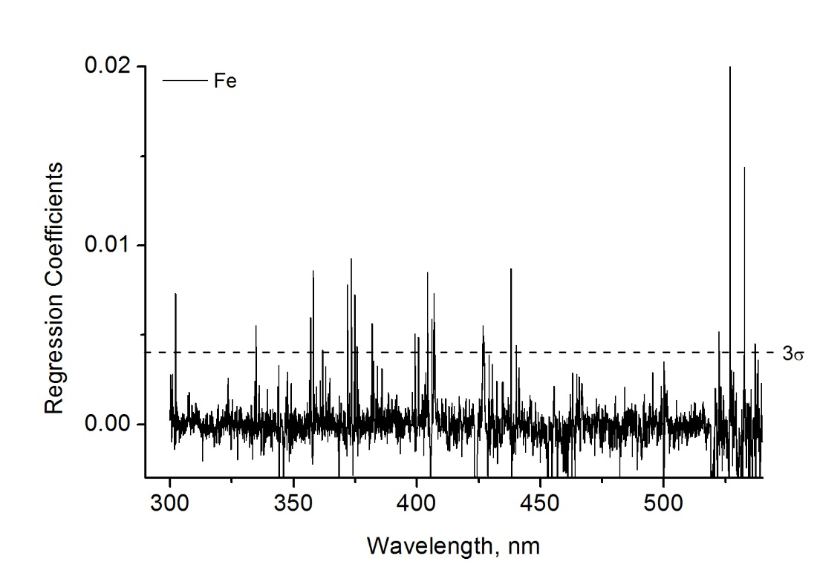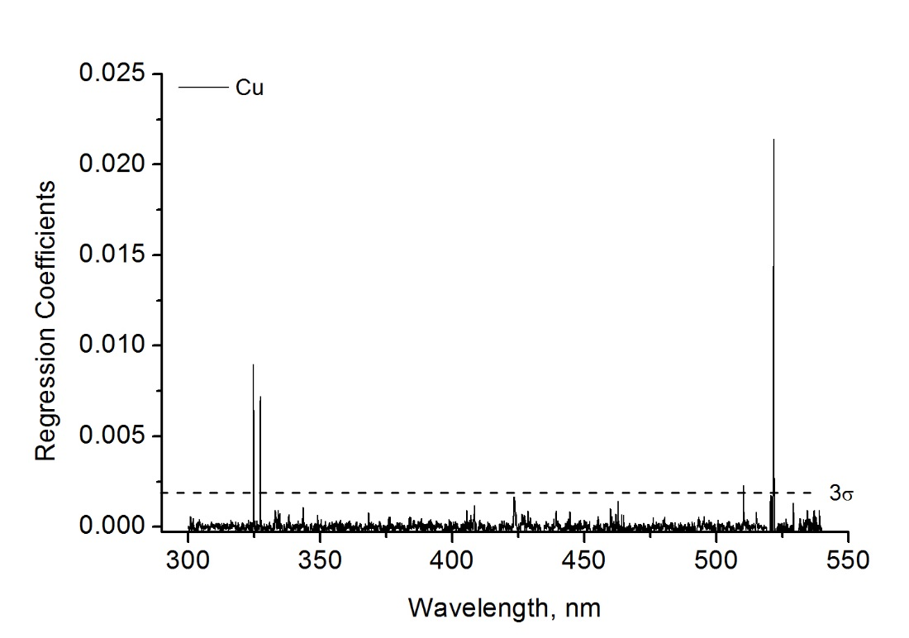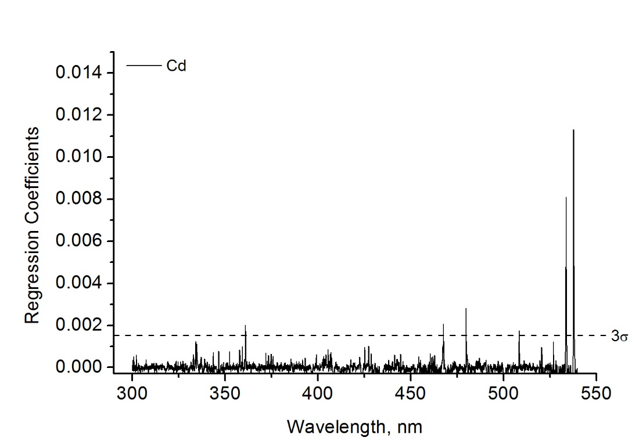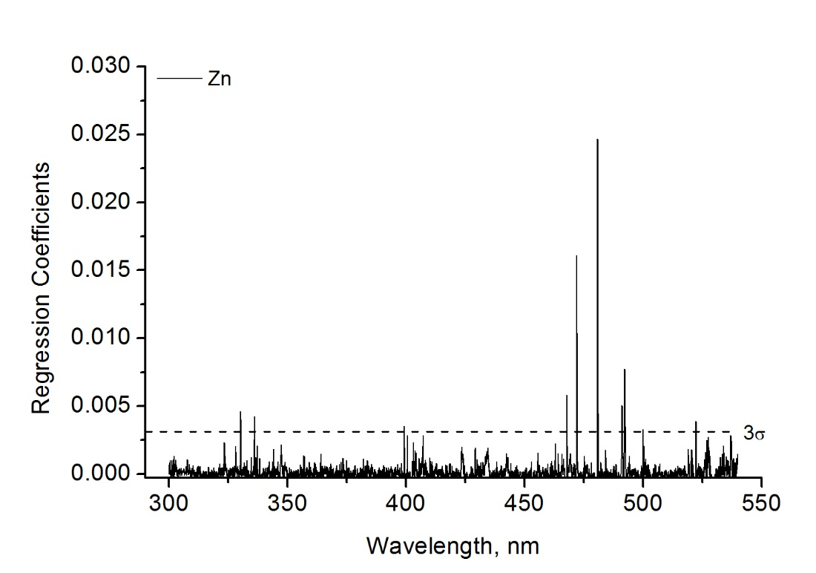

Fig. S1 PLS Regression coefficients for Mn, Fe, Ni, Cu, Zn, Cd, Pb, and Ti, by analysis of the full range spectra (300 – 540 nm)

S2. Univariate calibration curves

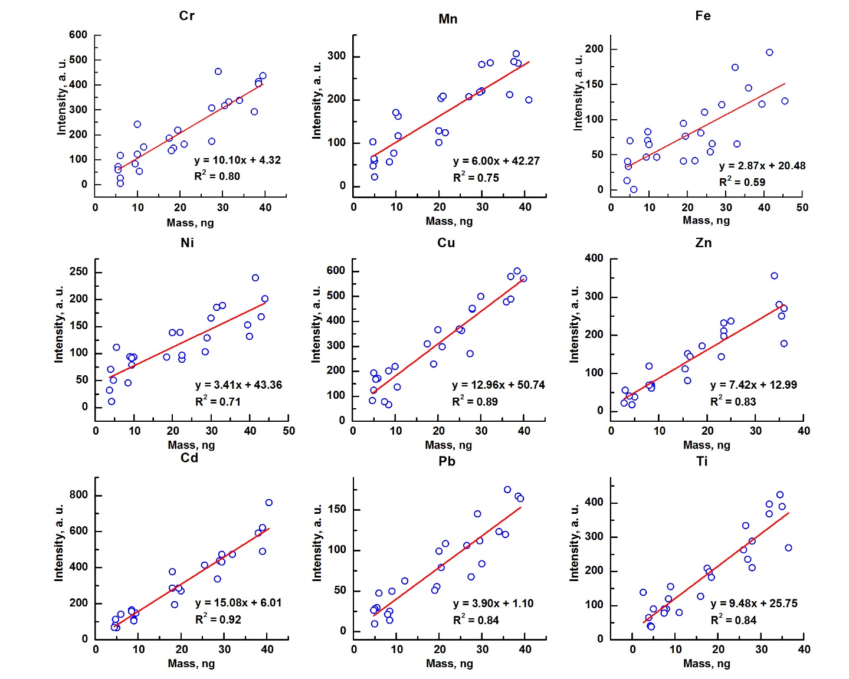
Fig. S2 Univariate calibration curves for all the nine elements constructed using the 25 multielement samples in the training set.

