Supplemental Figure 1. Comparison of manual and automatic segmentation. Left: Lumen density segmentation. Right: Epithelium density segmentation.

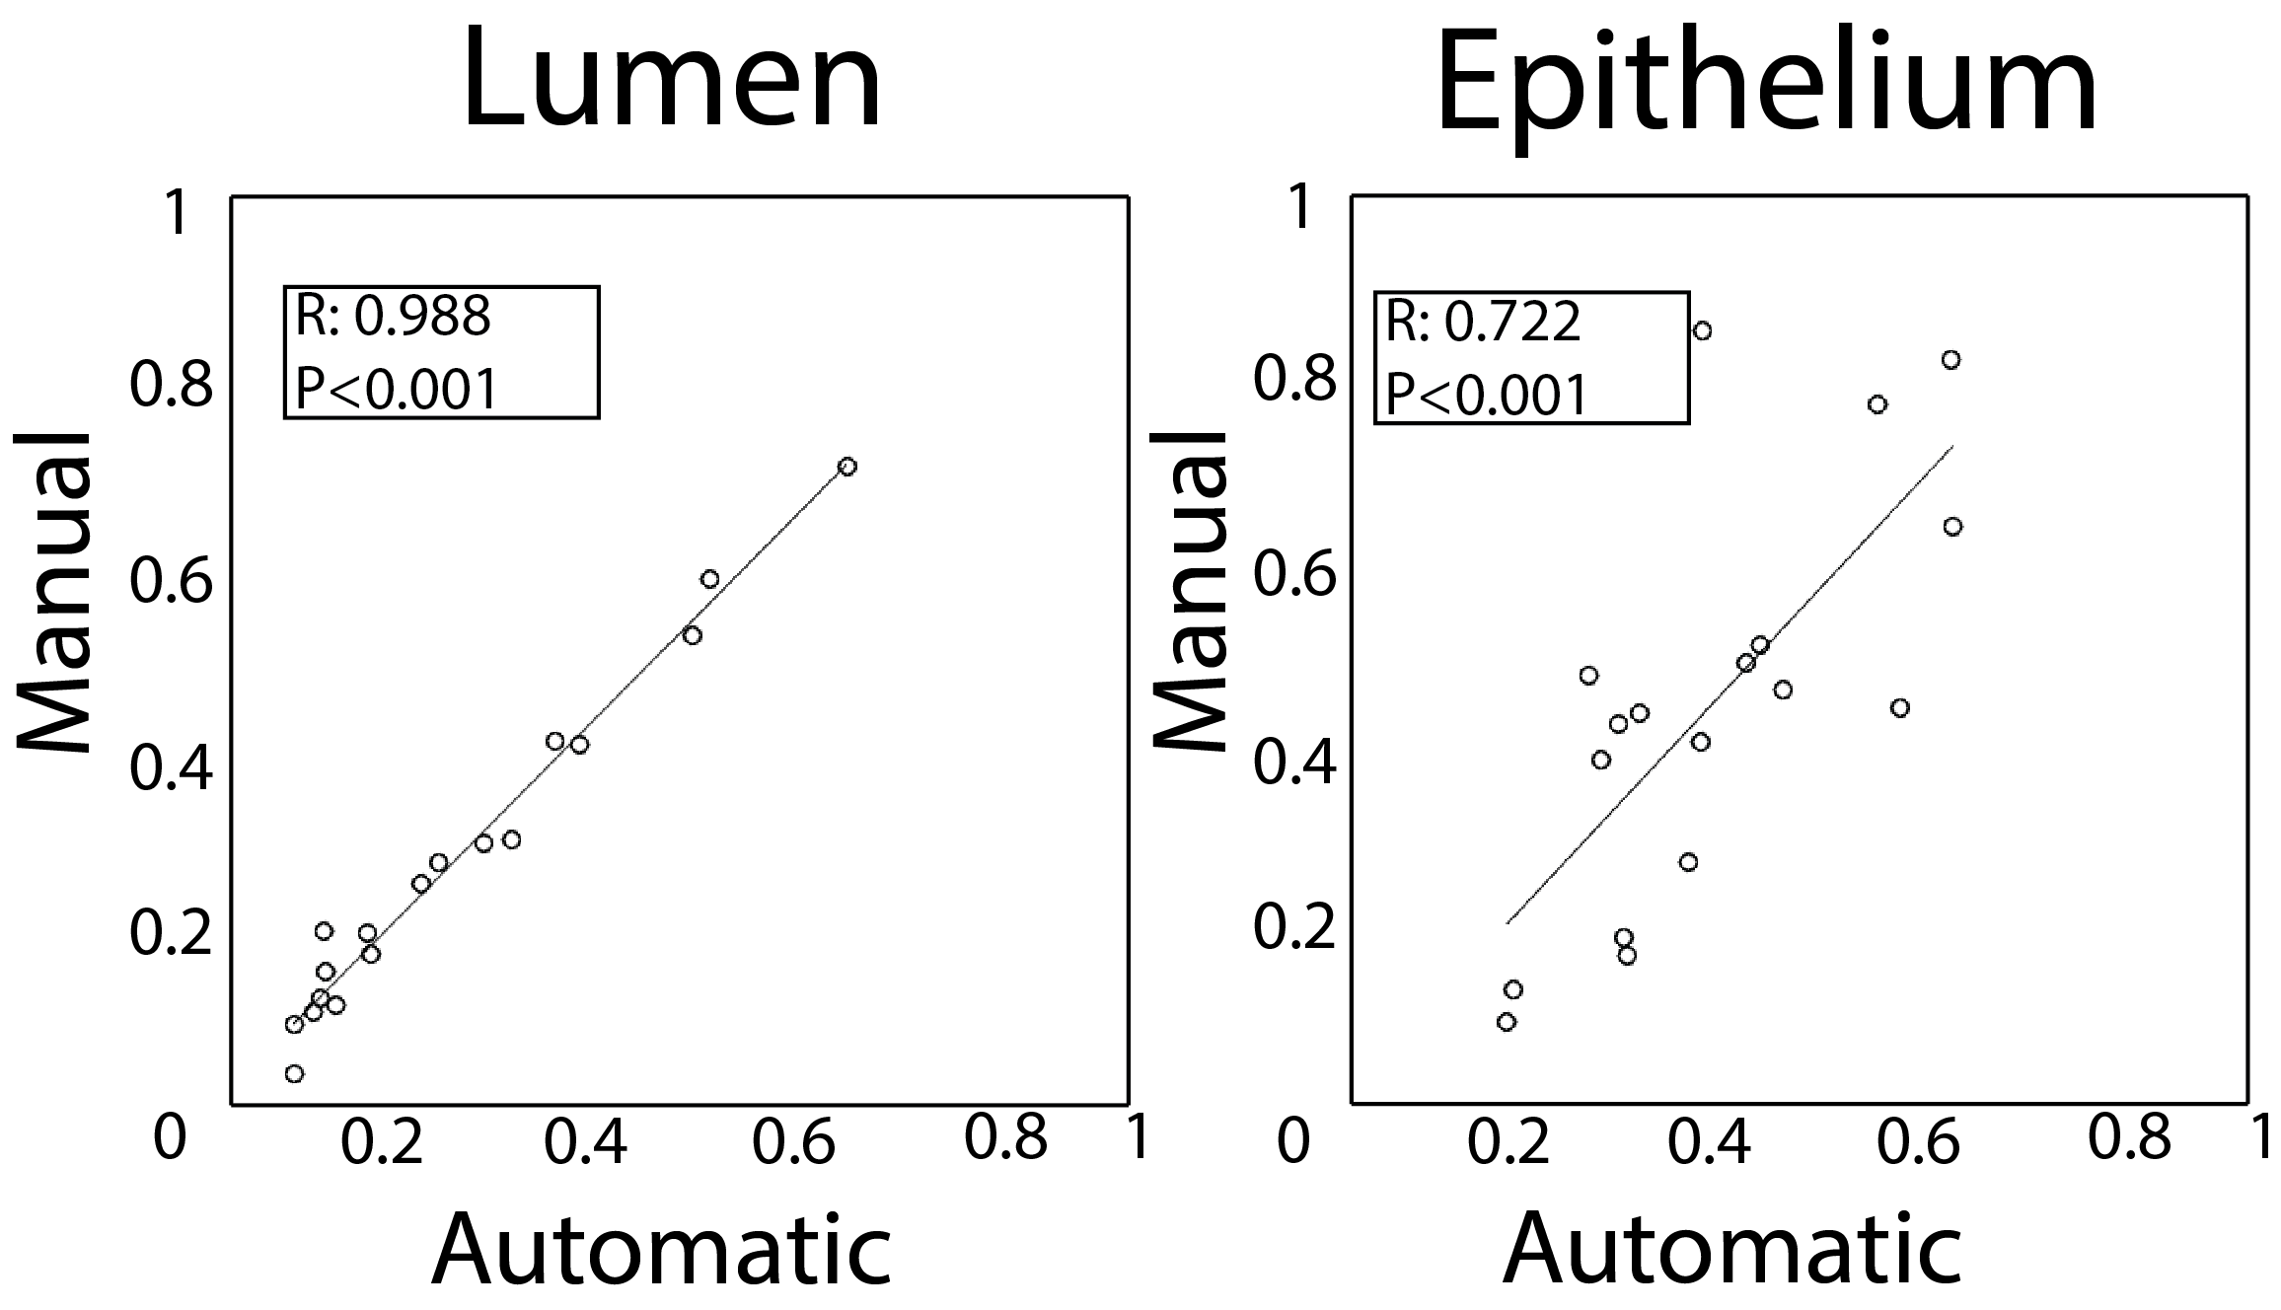

Supplemental Figure 2. Validation of histology co-registration. A known transform is applied to a whole mount slide. The original slide is aligned with the known transform using the control point warping technique. Bottom: Expert annotation with identical transforms applied. Accuracy measured as a dice coefficient between the known and control point warp of the expert annotation.

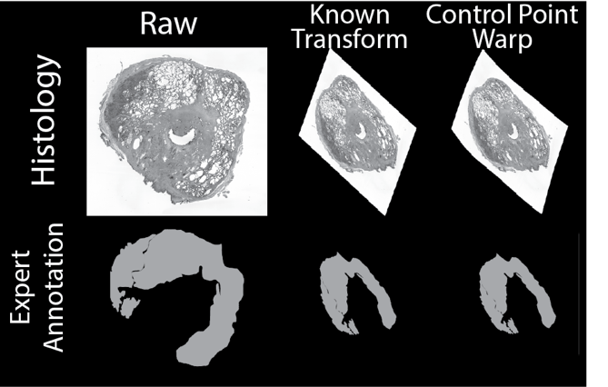

Supplemental Figure 3. Correlation Table for PiCT input features.

Supplemental Figure 4. The learning curve analysis of lesion numbers used to establish cohort size. A fitted curve applied to root mean square error calculated from predicted versus actual lumen and epithelium density, varying the number of lesions included in training. 320 total lesions (about 10 patients) resulted in reaching 99% of the plateau.

Supplemental Figure 5. Radio-pathomic maps generated with different numbers of patients. Top: Raw T2 image axially oriented and expert ‘Deep’ annotation of G4 Cribriform tumor shown in yellow. Middle: Radio-pathomic maps of epithelium density trained with 2,4,6, and 8 patients. Bottom: Full radio-pathomic model trained with 10 patients.

Supplemental Figure 6. Statistical comparison of the resulting predicted histological features compared to the actual histology. ** Indicates P<0.01, *** indicates P<0.001. Left: Lumen density in histology compared to the predicted values from model 1 and model 2. Right: Predicted epithelium density from model 1 and model 2 compared to raw histology data.

Supplementary Table 1. Summary of tumor burden across 210 whole mount slides.

 | Benign Atrophy | Grade 3 | Grade 4 Fused Gland | Grade 4 Cribriform Gland | Grade 5
Number of Lesions | 605 | 117 | 30 | 11 | 4

Supplementary Table 2. Summary of Imaging Parameters

 | TR | Acquisition Matrix | Field of View | Slice Thickness | Voxel Dimensions | Number of Slices
T2 | 3713 ms | 512x512 | 120 mm | 3 mm | 0.234 x 0.234 mm | 25
Diffusion | 4000 ms | 256x256 | 160 mm | 4 mm | 0.625 x 0.625 mm | 16
DCE | 3.47 ms | 256x256 | 120 mm | 3 mm | 0.468 x 0.468 mm | 25

Supplementary Table 3. Features ranked by predictive power for all four models presented in this study.

 | Model 1 |  | Model 2
 | Lumen | Epithelium | Lumen | Epithelium
1. | ADC 0-1000 | ADC 0-1000 | ADC 0-1000 | ADC 500-2000
2. | ADC 500-2000 | DWI B0 | Delta T1 | ADC 0-1000
3. | Delta T1 | Delta T1 | DWI B0 | ADC 1000-2000
4. | T2 | ADC 500-2000 | T2 | DWI B0
5. | ADC 1000-2000 | T2 | ADC 500-2000 | T2
6. | DWI B0 | ADC 1000-2000 | ADC 1000-2000 | Delta T1

