SUPPLEMENTARY FIGURE. Adjusted hazard ratios of selected potential post–COVID-19 symptoms and conditions among children and adolescents aged 0–17 years with and without COVID-19 and unadjusted incidence of symptoms and conditions among children and adolescents aged 0–17 years with COVID-19 — HealthVerity medical claims database, United States, March 1, 2020–January 31, 2022
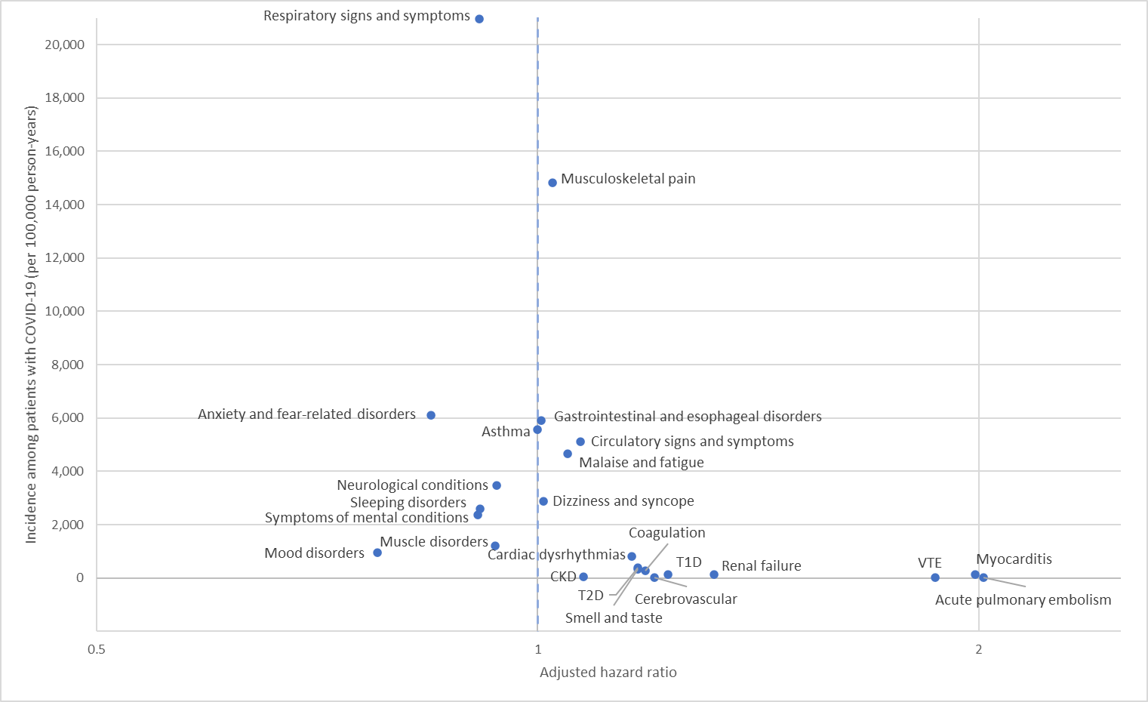
Abbreviations: T1D – type 1 diabetes, T2D – type 2 diabetes, VTE – venous thromboembolic event, CKD – chronic kidney disease

