Community Overdose Surveillance: Comparing Substances Collected from the Death Investigation Scene to Toxicology Results

Supplementary Information

Tracy-Lynn E. Lockwood, BS^{a*}, Philip Huynh, MPH^{b}, Alex Richard, BSª, Emily Sightes, MPH^{b}, Katie Bailey, MPA^{b}, Bradley Ray, PhD^{b}, Marya Lieberman, PhDª

ªUniversity of Notre Dame, Department of Chemistry and Biochemistry, 236 Cavanaugh Dr., Suite 251, South Bend, IN 46556 United States
^{b}Wayne State University, School of Social Work, Center for Behavioral Health and Justice, 5201 Cass Ave, Suite 226, Detroit, MI 48202 United States

Table of Contents
Online Supplement 1: NMS Labs - Current Version (May 2020) 2
Online Supplement 2: Sample Images 23

Online Supplement 1: NMS Labs - Current Version (May 2020)

8054B Postmortem, Expanded with NPS, Blood - Current Version
Analyte | Units | Analyte Mapping Code
Salicylates | mcg/mL | SALICYLATS
Cannabinoids | ng/mL | THCS
Barbiturates | mcg/mL | BARBS
Gabapentin | mcg/mL | GABAPENTIN
Ethanol | mg/dL | ETHQ1RPM
Blood Alcohol Concentration (BAC) | g/100 mL | BAC4
Methanol | mg/dL | METHQ1R
Isopropanol | mg/dL | ISOQ1R
Acetone | mg/dL | ACETQ1R
AMB-FUBINACA | ng/mL | SYC3-AMBF
4-cyano-CUMYL-BINACA | ng/mL | SYC3-4CYCB
ADMB-FUBICA | ng/mL | SYC3-5FADB
ADMB-FUBINACA | ng/mL | SYC3-ADMBF
5-fluoro-QU-PINAC | ng/mL | SYC2-5FNPB
MMB-FUBICA | ng/mL | SYC2-MMBF
5-fluoro-MMB-PINACA | ng/mL | SYC2-5FMMBP
4-fluoro-MDMB-BINACA | ng/mL | SYC3-4FMDMB
5-fluoro-MDMB-PICA | ng/mL | SYC3-5FMDMB
MMB-FUBINACA | ng/mL | SYC2-MBFUB
CUMYL-THPINACA | ng/mL | SYC2-CTHP
MDMB-FUBICA | ng/mL | SYC2-MDMBF
5-fluoro-MDMB-PINACA / 5-fluoro-EMB-PINACA | ng/mL | SYC2-5FEMB
AMB-CHMINACA | ng/mL | SYC3-AMBC
MDMB-FUBINACA / EMB-FUBINACA | ng/mL | SYC2-EMBF
NA-FUBIM | ng/mL | SYC2-NAFUB
5-fluoro-EDMB-PINACA | ng/mL | SYC2-5FEDP
ADMB-CHMINACA | ng/mL | SYC3-ADMBC
MMB-CHMICA | ng/mL | SYC2-CHMIC
5-fluoro-NA-PIC | ng/mL | SYC2-5FNAP
MDMB-CHMICA | ng/mL | SYC2-MDMBC
MMB-CHMINACA | ng/mL | SYC2-MMBC
NA-FUBIC | ng/mL | SYC2-FDB22
MDMB-CHMINAC | ng/mL | SYC2-MDBC
ADAMANTYL-FUBINACA | ng/mL | SYC2-AYFUB
MDMB-CHMCZCA | ng/mL | SYC2-CHMCZ
2-Furanylfentanyl | ng/mL | HALL-2FURF
3-Fluorophenmetrazine | ng/mL | HALI-3FLPHM
3-MeO-PCP | ng/mL | HALI-3MEOP
4-ANPP | ng/mL | HALL-4ANPP
4-MeO-PCP | ng/mL | HALI-4MEOP
6-Beta-Naltrexol - Free | ng/mL | NALM-BNALT
6-Monoacetylmorphine | ng/mL | TOX8-6MAM
7-Amino Clonazepam | ng/mL | TOX5-7ACL
7-Amino Flunitrazepam | ng/mL | TOXG-7FLU
9-Hydroxyrisperidone | ng/mL | TOXP-9RIS
10-Hydroxycarbazepine | mcg/mL | HYDROXYC10
25B-NBOMe | ng/mL | NBOME-B
25C-NBOMe | ng/mL | NBOME-C
25H-NBOMe | ng/mL | NBOME-H
25I-NBOMe | ng/mL | NBOME-I
Acetaminophen | mcg/mL | ACETAMINO
Acetyl Fentanyl | ng/mL | FEN1-AFENT
Acryl Fentanyl | ng/mL | HALL-ACRYF
Alfentanil | ng/mL | TOXN-ALFT
Alpha-Hydroxyalprazolam | ng/mL | TOX5-AHPZ
alpha-PVP | ng/mL | HAL5-PVP
Alprazolam | ng/mL | TOX5-ALPZ
Amitriptyline | ng/mL | AMIT-AMITR
Amlodipine | ng/mL | AMLODIPINE
Amoxapine | ng/mL | AMOXAPINE
Amphetamine | ng/mL | AMP1-AMPH
Aripiprazole | ng/mL | ARIPIPRAZO
Atomoxetine | ng/mL | ATOMOXETIN
Atropine | ng/mL | ATROPINE
Benzoylecgonine | ng/mL | TOX6-BZE
Benztropine | ng/mL | BENZTROPIN
Bromazepam | ng/mL | HALK-BROM
Brompheniramine | ng/mL | BROMPHENI
Bupivacaine | mcg/mL | BUPIVACAIN
Buprenorphine | ng/mL | TOX2-BUPR
Bupropion | ng/mL | TOXC-BUPR
Buspirone | ng/mL | BUSPIRONE
Butorphanol | ng/mL | TOX2-BUTO
Butylone | ng/mL | HALJ-BUTY
Butyrylfentanyl | ng/mL | HALL-BUYF
BZP | ng/mL | TOXR-BZP
Caffeine | mcg/mL | CAFFEINE
Carbamazepine | mcg/mL | TOXD-CARB
Carbamazepine-10,11-Epoxide | mcg/mL | TOXD-EPOX
Carfentanil | ng/mL | HALL-CARF
Carisoprodol | mcg/mL | TOXE-CARS
Chlordiazepoxide | ng/mL | TOX5-CDPX
Chlorpheniramine | ng/mL | CHLORPHENI
Chlorpromazine | ng/mL | CHLORPROMA
cis-3-Methylfentanyl | ng/mL | HALL-3CISM
Citalopram / Escitalopram | ng/mL | CITALESCT1
Clephedrone | ng/mL | HALI-CLEPH
Clobazam | ng/mL | TOX5-CLBZ
Clomipramine | ng/mL | CLOM-CLOM
Clonazepam | ng/mL | TOX5-CLNZ
Clonazolam | ng/mL | HALK-CLONZ
Clonidine | ng/mL | CLONIDINE
Clozapine | ng/mL | TOXF-CLOZ
Cocaethylene | ng/mL | TOX6-COCE
Cocaine | ng/mL | TOX6-COC
Codeine | ng/mL | TOX8-CODE
Cotinine | ng/mL | COTININE
Cyclobenzaprine | ng/mL | CYCLOBENZA
Cyclopropylfentanyl | ng/mL | HALL-CYCLF
Delorazepam | ng/mL | HALK-DELOR
Desalkylflurazepam | ng/mL | TOX5-DFLZ
Deschloroetizolam | ng/mL | HALK-DSCHET
Desipramine | ng/mL | IMIP-DESIP
Desmethylclomipramine | ng/mL | CLOM-DSMC
Desmethyldoxepin | ng/mL | DOXE-DOXDM
Desmethylloperamide | ng/mL | LOPM-DLOPER
Desmethylsertraline | ng/mL | TOXJ-DEST
Desmethyltrimipramine | ng/mL | TRIMI-DESMT
Dextro / Levo Methorphan | ng/mL | DEXL-METHO
Dextrorphan / Levorphanol | ng/mL | DEXL-LEVO
Diazepam | ng/mL | TOX5-DIAZ
Dibutylone | ng/mL | HALJ-DIBUTY
Diclazepam | ng/mL | HALK-DICLZ
Dicyclomine | ng/mL | DICYCLOMIN
Dihydrocodeine / Hydrocodol | ng/mL | TOX8-DIHY
Diltiazem | ng/mL | DILTIAZEM1
Diphenhydramine | ng/mL | DIPHENHYDR
Donepezil | ng/mL | DONEPEZIL
Doxepin | ng/mL | DOXE-DOXEP
Doxylamine | ng/mL | DOXYLAMINE
Duloxetine | ng/mL | DULOXETINE
EDDP | ng/mL | TOX7-EDDP
Ephedrine | ng/mL | AMP1-EP
Estazolam | ng/mL | TOX5-ESTZ
Eszopiclone / Zopiclone | ng/mL | ESZOZOPI
Ethylone | ng/mL | HALJ-ETHY
Etizolam | ng/mL | HALK-ETIZ
Etomidate | mcg/mL | ETOMIDATE
Fentanyl | ng/mL | FEN1-FENTA
Flecainide | mcg/mL | FLECAINIDE
Flubromazepam | ng/mL | HALK-FZEPAM
Flubromazolam | ng/mL | HALK-FZOLAM
Flunitrazepam | ng/mL | TOXG-FLTZ
Fluoxetine | ng/mL | FLUOX-FLUOX
Fluphenazine | ng/mL | FLUPHENAZI
Flurazepam | ng/mL | TOX5-FLUZ
Fluvoxamine | ng/mL | FLUVOXAMIN
Glimepiride | ng/mL | GLIMEPIRI
Glipizide | mcg/mL | TOX13-GLIP
Glyburide | mcg/mL | TOX13-GLYB
Guaifenesin | mcg/mL | GRP2-GUIF
Haloperidol | ng/mL | HALOPERIDO
Hydrocodone | ng/mL | TOX8-HYCD
Hydromorphone | ng/mL | TOX8-HYMP
Hydroxybupropion | ng/mL | TOXC-HYXB
Hydroxychloroquine | ng/mL | HYDROXYCHL
Hydroxyethylflurazepam | ng/mL | TOX5-HEFL
Hydroxytriazolam | ng/mL | TOX5-HTRZ
Hydroxyzine | ng/mL | HYDROXYZIN
Iloperidone | ng/mL | ILOPERIDON
Imipramine | ng/mL | IMIP-IMIP
Isobutyrylfentanyl | ng/mL | HALL-IBFT
Itraconazole | mcg/mL | ITRACONAZO
Ketamine | ng/mL | TOXH-KETM
Ketoconazole | mcg/mL | KETOCONAZO
Lacosamide | mcg/mL | LACOSAMIDE
Lamotrigine | mcg/mL | LAMOTRIGIN
Laudanosine | ng/mL | LAUDANOSIN
Levamisole | mcg/mL | LEVAMISOLE
Levetiracetam | mcg/mL | LEVETIRACE
Lidocaine | mcg/mL | LIDOCAINE
Loperamide | ng/mL | LOPM-LOPER
Lorazepam | ng/mL | TOX5-LORZ
Loxapine | ng/mL | LOXAPINE
LSD | ng/mL | LSD
Maprotiline | ng/mL | MAPROTILIN
mCPP | ng/mL | TRAZ-MCPP
MDA | ng/mL | AMP1-MDA
MDEA | ng/mL | AMP1-MDEA
MDMA | ng/mL | AMP1-MDMA
MDPV | ng/mL | TOXQ-MDPV
Meclonazepam | ng/mL | HALK-MECL
Memantine | ng/mL | MEMANTINE
Meperidine | mcg/mL | MEPE-MEPD
Mephedrone | ng/mL | TOXQ-MPHD
Meprobamate | mcg/mL | TOXE-MEPB
Mescaline | mcg/mL | MESCALINE
Mesoridazine | ng/mL | TRID-MESOR
meta-Methylmethoxyacetylfentanyl | ng/mL | HALL-MMMAF
Metaxalone | mcg/mL | METAXALONE
Methadone | ng/mL | TOX7-METD
Methamphetamine | ng/mL | AMP1-MAMP
Methaqualone | mcg/mL | METHAQ
Methcathinone | ng/mL | METHCATHIN
Methocarbamol | mcg/mL | GRP2-MCAR
Methoxetamine | ng/mL | HAL5-MOXT
Methoxphenidine | ng/mL | HALI-METHXP
Methoxyacetylfentanyl | ng/mL | HALL-MXYAF
Methylone | ng/mL | TOXQ-MTHY
Methylphenidate | ng/mL | METHYLPHEN
Metoclopramide | ng/mL | METOCLOPRA
Metoprolol | ng/mL | METOPROLOL
Mexiletine | mcg/mL | MEXILETINE
Midazolam | ng/mL | TOX5-MIDZ
Mirtazapine | ng/mL | MIRTAZAPIN
Mitragynine | ng/mL | MITRAGYNIN
Monoethylglycinexylidide (MEGX) | mcg/mL | MEGX
Morphine | ng/mL | TOX8-MORP
MPHP | ng/mL | MPHP
N-Ethyl Pentylone | ng/mL | HALJ-NETHPT
Nalbuphine | ng/mL | TOX2-NALB
Naloxone | ng/mL | NALOXONE
Naltrexone | ng/mL | NALM-NALT
Naproxen | mcg/mL | TOX1-NAPR
Nicotine | ng/mL | NICOTINE
Nifedipine | ng/mL | NIFEDIPINE
Norbuprenorphine - Free | ng/mL | TOX2-NORB
Norclozapine | ng/mL | TOXF-NCLZ
Nordiazepam | ng/mL | TOX5-NDIZ
Norfentanyl | ng/mL | FEN1-NORFE
Norflunitrazepam | ng/mL | TOXG-NFLZ
Norfluoxetine | ng/mL | FLUOX-NORFL
Norketamine | ng/mL | TOXH-NKET
Normeperidine | mcg/mL | MEPE-NMEP
Norpropoxyphene | mcg/mL | TOX9-NORP
Norpseudoephedrine | ng/mL | AMP1-NOR
Nortriptyline | ng/mL | AMIT-NORTR
O-Desmethyltramadol | ng/mL | TOXK-OTRA
O-Desmethylvenlafaxine | ng/mL | TOXL-ODMV
Olanzapine | ng/mL | OLANZAPINE
Orphenadrine | ng/mL | ORPHENADRI
ortho-Fluorofentanyl | ng/mL | HALL-OFLF
Oxazepam | ng/mL | TOX5-OXAZ
Oxycodone | ng/mL | TOX8-OXYC
Oxymorphone | ng/mL | TOX8-OXYM
para-Fluorobutyrylfentanyl | ng/mL | HALL-PFBF
para-Fluorofentanyl | ng/mL | HALL-PFF
para-Fluoroisobutyrylfentanyl | ng/mL | HALL-PIBUTY
para-Methylmethoxyacetylfentanyl | ng/mL | HALL-PMMAF
Paroxetine | ng/mL | PAROXETINE
Pentedrone | ng/mL | HAL5-PENT
Pentylone | ng/mL | HALJ-PENTY
Perphenazine | ng/mL | PERPHENAZI
Phenazepam | ng/mL | HALK-PHEN
Phencyclidine | ng/mL | PCP
Phentermine | ng/mL | AMP1-PHET
Pheniramine | ng/mL | PHENIRAMIN
Phenylpropanolamine | ng/mL | AMP1-PHEN
Phenytoin | mcg/mL | PHENYTOIN
PMA | ng/mL | PMA
Primidone | mcg/mL | PRIMIDONE
Prochlorperazine | ng/mL | PROCHLORPE
Promazine | ng/mL | PROMAZINE
Promethazine | ng/mL | PROMETHAZI
Propoxyphene | mcg/mL | TOX9-PRPX
Pseudoephedrine | ng/mL | AMP1-PS
Psilocin | ng/mL | PSILOCIN
Pyrazolam | ng/mL | HALK-PYRZ
Quetiapine | ng/mL | QUETIAPINE
Quinidine | ng/mL | QUINIDINE
Quinine | ng/mL | QUININE
Risperidone | ng/mL | TOXP-RISP
Sertraline | ng/mL | TOXJ-SERT
Sildenafil | ng/mL | SILDENAFIL
Strychnine | ng/mL | STRYCHNINE
Sufentanil | ng/mL | TOXN-SUFT
Tadalafil | ng/mL | TADALAFIL
Tapentadol | ng/mL | TAPENTAD
Temazepam | ng/mL | TOX5-TEMZ
TFMPP | ng/mL | TOXR-TFMP
Tetrahydrozoline | ng/mL | TETRAHYZOL
THF-F | ng/mL | HALL-THFF
Theophylline | mcg/mL | THEOPHYLLI
Thioridazine | ng/mL | TRID-THIO
Tiletamine | mcg/mL | TILETAMINE
Topiramate | ng/mL | TOPIRAMATE
Tramadol | ng/mL | TOXK-TRAM
trans-3-Methylfentanyl | ng/mL | HALL-T3MF
Trazodone | mcg/mL | TRAZ-TRAZOD
Triazolam | ng/mL | TOX5-TRIZ
Trifluoperazine | ng/mL | TRIFLUOPER
Trihexyphenidyl | ng/mL | TRIHEXYPHE
Trimipramine | ng/mL | TRIMI-TRIMI
Triprolidine | ng/mL | TRIPROLIDI
U-47700 | ng/mL | HALL-U47700
U-49900 | ng/mL | HALL-U49900
U-51754 | ng/mL | HALL-U51754
Valeryl Fentanyl | ng/mL | HALL-VALF
Vardenafil | ng/mL | VARDENAFIL
Venlafaxine | ng/mL | TOXL-VLAF
Verapamil | ng/mL | VERAPAMIL
Voriconazole | mcg/mL | VORICONAZ
Warfarin | mcg/mL | WARFARIN
Xylazine | mcg/mL | XYLAZINE
Yohimbine | ng/mL | YOHIMBINE
Zaleplon | ng/mL | ZALEPLON
Ziprasidone | ng/mL | ZIPRASIDON
Zolazepam | mcg/mL | ZOLAZEPAM
Zolpidem | ng/mL | ZOLPIDEM
Zonisamide | mcg/mL | ZONISAMIDE
Scope Statement |  | SCOPESTMT
8054B Postmortem, Expanded with NPS, Blood - Effective 06/01/2020
Analyte | Units | Analyte Mapping Code
Salicylates | mcg/mL | SALICYLATS
Cannabinoids | ng/mL | THCS
Barbiturates | mcg/mL | BARBS
Gabapentin | mcg/mL | GABAPENTIN
Ethanol | mg/dL | ETHQ1RPM
Blood Alcohol Concentration (BAC) | g/100 mL | BAC4
Methanol | mg/dL | METHQ1R
Isopropanol | mg/dL | ISOQ1R
Acetone | mg/dL | ACETQ1R
AMB-FUBINACA | ng/mL | SYC3-AMBF
4-cyano-CUMYL-BINACA | ng/mL | SYC3-4CYCB
ADMB-FUBICA | ng/mL | SYC3-5FADB
ADMB-FUBINACA | ng/mL | SYC3-ADMBF
5-fluoro-QU-PINAC | ng/mL | SYC2-5FNPB
MMB-FUBICA | ng/mL | SYC2-MMBF
5-fluoro-MMB-PINACA | ng/mL | SYC2-5FMMBP
4-fluoro-MDMB-BINACA | ng/mL | SYC3-4FMDMB
5-fluoro-MDMB-PICA | ng/mL | SYC3-5FMDMB
MMB-FUBINACA | ng/mL | SYC2-MBFUB
CUMYL-THPINACA | ng/mL | SYC2-CTHP
MDMB-FUBICA | ng/mL | SYC2-MDMBF
5-fluoro-MDMB-PINACA / 5-fluoro-EMB-PINACA | ng/mL | SYC2-5FEMB
AMB-CHMINACA | ng/mL | SYC3-AMBC
MDMB-FUBINACA / EMB-FUBINACA | ng/mL | SYC2-EMBF
NA-FUBIM | ng/mL | SYC2-NAFUB
5-fluoro-EDMB-PINACA | ng/mL | SYC2-5FEDP
ADMB-CHMINACA | ng/mL | SYC3-ADMBC
MMB-CHMICA | ng/mL | SYC2-CHMIC
5-fluoro-NA-PIC | ng/mL | SYC2-5FNAP
MDMB-CHMICA | ng/mL | SYC2-MDMBC
MMB-CHMINACA | ng/mL | SYC2-MMBC
NA-FUBIC | ng/mL | SYC2-FDB22
MDMB-CHMINAC | ng/mL | SYC2-MDBC
ADAMANTYL-FUBINACA | ng/mL | SYC2-AYFUB
MDMB-CHMCZCA | ng/mL | SYC2-CHMCZ
2-Furanylfentanyl | ng/mL | HALL-2FURF
3-Fluorophenmetrazine | ng/mL | HALI-3FLPHM
3-MeO-PCP | ng/mL | HALI-3MEOP
4-ANPP | ng/mL | HALL-4ANPP
4-MeO-PCP | ng/mL | HALI-4MEOP
6-Beta-Naltrexol - Free | ng/mL | NALM-BNALT
6-Monoacetylmorphine | ng/mL | TOX8-6MAM
7-Amino Clonazepam | ng/mL | TOX5-7ACL
7-Amino Flunitrazepam | ng/mL | TOXG-7FLU
9-Hydroxyrisperidone | ng/mL | TOXP-9RIS
10-Hydroxycarbazepine | mcg/mL | HYDROXYC10
25B-NBOMe | ng/mL | NBOME-B
25C-NBOMe | ng/mL | NBOME-C
25H-NBOMe | ng/mL | NBOME-H
25I-NBOMe | ng/mL | NBOME-I
Acetaminophen | mcg/mL | ACETAMINO
Acetyl Fentanyl | ng/mL | FEN1-AFENT
Acryl Fentanyl | ng/mL | HALL-ACRYF
Alfentanil | ng/mL | TOXN-ALFT
Alpha-Hydroxyalprazolam | ng/mL | TOX5-AHPZ
alpha-PVP | ng/mL | HAL5-PVP
Alprazolam | ng/mL | TOX5-ALPZ
Amitriptyline | ng/mL | AMIT-AMITR
Amlodipine | ng/mL | AMLODIPINE
Amoxapine | ng/mL | AMOXAPINE
Amphetamine | ng/mL | AMP1-AMPH
Aripiprazole | ng/mL | ARIPIPRAZO
Atomoxetine | ng/mL | ATOMOXETIN
Atropine | ng/mL | ATROPINE
Benzoylecgonine | ng/mL | TOX6-BZE
Benztropine | ng/mL | BENZTROPIN
Bromazepam | ng/mL | HALK-BROM
Brompheniramine | ng/mL | BROMPHENI
Bupivacaine | mcg/mL | BUPIVACAIN
Buprenorphine | ng/mL | TOX2-BUPR
Bupropion | ng/mL | TOXC-BUPR
Buspirone | ng/mL | BUSPIRONE
Butorphanol | ng/mL | TOX2-BUTO
Butylone | ng/mL | HALJ-BUTY
Butyrylfentanyl | ng/mL | HALL-BUYF
BZP | ng/mL | TOXR-BZP
Caffeine | mcg/mL | CAFFEINE
Carbamazepine | mcg/mL | TOXD-CARB
Carbamazepine-10,11-Epoxide | mcg/mL | TOXD-EPOX
Carfentanil | ng/mL | HALL-CARF
Carisoprodol | mcg/mL | TOXE-CARS
Chlordiazepoxide | ng/mL | TOX5-CDPX
Chlorpheniramine | ng/mL | CHLORPHENI
Chlorpromazine | ng/mL | CHLORPROMA
cis-3-Methylfentanyl | ng/mL | HALL-3CISM
Citalopram / Escitalopram | ng/mL | CITALESCT1
Clephedrone | ng/mL | HALI-CLEPH
Clobazam | ng/mL | TOX5-CLBZ
Clomipramine | ng/mL | CLOM-CLOM
Clonazepam | ng/mL | TOX5-CLNZ
Clonazolam | ng/mL | HALK-CLONZ
Clonidine | ng/mL | CLONIDINE
Clozapine | ng/mL | TOXF-CLOZ
Cocaethylene | ng/mL | TOX6-COCE
Cocaine | ng/mL | TOX6-COC
Codeine | ng/mL | TOX8-CODE
Cotinine | ng/mL | COTININE
Cyclobenzaprine | ng/mL | CYCLOBENZA
Cyclopropylfentanyl | ng/mL | HALL-CYCLF
Delorazepam | ng/mL | HALK-DELOR
Desalkylflurazepam | ng/mL | TOX5-DFLZ
Deschloroetizolam | ng/mL | HALK-DSCHET
Desipramine | ng/mL | IMIP-DESIP
Desmethylclomipramine | ng/mL | CLOM-DSMC
Desmethyldoxepin | ng/mL | DOXE-DOXDM
Desmethylloperamide | ng/mL | LOPM-DLOPER
Desmethylsertraline | ng/mL | TOXJ-DEST
Desmethyltrimipramine | ng/mL | TRIMI-DESMT
Dextro / Levo Methorphan | ng/mL | DEXL-METHO
Dextrorphan / Levorphanol | ng/mL | DEXL-LEVO
Diazepam | ng/mL | TOX5-DIAZ
Dibutylone | ng/mL | HALJ-DIBUTY
Diclazepam | ng/mL | HALK-DICLZ
Dicyclomine | ng/mL | DICYCLOMIN
Dihydrocodeine / Hydrocodol | ng/mL | TOX8-DIHY
Diltiazem | ng/mL | DILTIAZEM1
Diphenhydramine | ng/mL | DIPHENHYDR
Donepezil | ng/mL | DONEPEZIL
Doxepin | ng/mL | DOXE-DOXEP
Doxylamine | ng/mL | DOXYLAMINE
Duloxetine | ng/mL | DULOXETINE
EDDP | ng/mL | TOX7-EDDP
Ephedrine | ng/mL | AMP1-EP
Estazolam | ng/mL | TOX5-ESTZ
Eszopiclone / Zopiclone | ng/mL | ESZOZOPI
Ethylone | ng/mL | HALJ-ETHY
Etizolam | ng/mL | HALK-ETIZ
Etomidate | mcg/mL | ETOMIDATE
Fentanyl | ng/mL | FEN1-FENTA
Flecainide | mcg/mL | FLECAINIDE
Flubromazepam | ng/mL | HALK-FZEPAM
Flubromazolam | ng/mL | HALK-FZOLAM
Flunitrazepam | ng/mL | TOXG-FLTZ
Fluoxetine | ng/mL | FLUOX-FLUOX
Fluphenazine | ng/mL | FLUPHENAZI
Flurazepam | ng/mL | TOX5-FLUZ
Fluvoxamine | ng/mL | FLUVOXAMIN
Glimepiride | ng/mL | GLIMEPIRI
Glipizide | mcg/mL | TOX13-GLIP
Glyburide | mcg/mL | TOX13-GLYB
Guaifenesin | mcg/mL | GRP2-GUIF
Haloperidol | ng/mL | HALOPERIDO
Hydrocodone | ng/mL | TOX8-HYCD
Hydromorphone | ng/mL | TOX8-HYMP
Hydroxybupropion | ng/mL | TOXC-HYXB
Hydroxychloroquine | ng/mL | HYDROXYCHL
Hydroxyethylflurazepam | ng/mL | TOX5-HEFL
Hydroxytriazolam | ng/mL | TOX5-HTRZ
Hydroxyzine | ng/mL | HYDROXYZIN
Iloperidone | ng/mL | ILOPERIDON
Imipramine | ng/mL | IMIP-IMIP
Isobutyrylfentanyl | ng/mL | HALL-IBFT
Itraconazole | mcg/mL | ITRACONAZO
Ketamine | ng/mL | TOXH-KETM
Ketoconazole | mcg/mL | KETOCONAZO
Lacosamide | mcg/mL | LACOSAMIDE
Lamotrigine | mcg/mL | LAMOTRIGIN
Laudanosine | ng/mL | LAUDANOSIN
Levamisole | mcg/mL | LEVAMISOLE
Levetiracetam | mcg/mL | LEVETIRACE
Lidocaine | mcg/mL | LIDOCAINE
Loperamide | ng/mL | LOPM-LOPER
Lorazepam | ng/mL | TOX5-LORZ
Loxapine | ng/mL | LOXAPINE
LSD | ng/mL | LSD
Maprotiline | ng/mL | MAPROTILIN
mCPP | ng/mL | TRAZ-MCPP
MDA | ng/mL | AMP1-MDA
MDEA | ng/mL | AMP1-MDEA
MDMA | ng/mL | AMP1-MDMA
MDPV | ng/mL | TOXQ-MDPV
Meclonazepam | ng/mL | HALK-MECL
Memantine | ng/mL | MEMANTINE
Meperidine | mcg/mL | MEPE-MEPD
Mephedrone | ng/mL | TOXQ-MPHD
Meprobamate | mcg/mL | TOXE-MEPB
Mescaline | mcg/mL | MESCALINE
Mesoridazine | ng/mL | TRID-MESOR
meta-Methylmethoxyacetylfentanyl | ng/mL | HALL-MMMAF
Metaxalone | mcg/mL | METAXALONE
Methadone | ng/mL | TOX7-METD
Methamphetamine | ng/mL | AMP1-MAMP
Methaqualone | mcg/mL | METHAQ
Methcathinone | ng/mL | METHCATHIN
Methocarbamol | mcg/mL | GRP2-MCAR
Methoxetamine | ng/mL | HAL5-MOXT
Methoxphenidine | ng/mL | HALI-METHXP
Methoxyacetylfentanyl | ng/mL | HALL-MXYAF
Methylone | ng/mL | TOXQ-MTHY
Methylphenidate | ng/mL | METHYLPHEN
Metoclopramide | ng/mL | METOCLOPRA
Metoprolol | ng/mL | METOPROLOL
Mexiletine | mcg/mL | MEXILETINE
Midazolam | ng/mL | TOX5-MIDZ
Mirtazapine | ng/mL | MIRTAZAPIN
Mitragynine | ng/mL | MITRAGYNIN
Monoethylglycinexylidide (MEGX) | mcg/mL | MEGX
Morphine | ng/mL | TOX8-MORP
MPHP | ng/mL | MPHP
N-Ethyl Pentylone | ng/mL | HALJ-NETHPT
Nalbuphine | ng/mL | TOX2-NALB
Naloxone | ng/mL | NALOXONE
Naltrexone | ng/mL | NALM-NALT
Naproxen | mcg/mL | TOX1-NAPR
Nicotine | ng/mL | NICOTINE
Nifedipine | ng/mL | NIFEDIPINE
Norbuprenorphine - Free | ng/mL | TOX2-NORB
Norclozapine | ng/mL | TOXF-NCLZ
Nordiazepam | ng/mL | TOX5-NDIZ
Norfentanyl | ng/mL | FEN1-NORFE
Norflunitrazepam | ng/mL | TOXG-NFLZ
Norfluoxetine | ng/mL | FLUOX-NORFL
Norketamine | ng/mL | TOXH-NKET
Normeperidine | mcg/mL | MEPE-NMEP
Norpropoxyphene | mcg/mL | TOX9-NORP
Norpseudoephedrine | ng/mL | AMP1-NOR
Nortriptyline | ng/mL | AMIT-NORTR
O-Desmethyltramadol | ng/mL | TOXK-OTRA
O-Desmethylvenlafaxine | ng/mL | TOXL-ODMV
Olanzapine | ng/mL | OLANZAPINE
Orphenadrine | ng/mL | ORPHENADRI
ortho-Fluorofentanyl | ng/mL | HALL-OFLF
Oxazepam | ng/mL | TOX5-OXAZ
Oxycodone | ng/mL | TOX8-OXYC
Oxymorphone | ng/mL | TOX8-OXYM
para-Fluorobutyrylfentanyl | ng/mL | HALL-PFBF
para-Fluorofentanyl | ng/mL | HALL-PFF
para-Fluoroisobutyrylfentanyl | ng/mL | HALL-PIBUTY
para-Methylmethoxyacetylfentanyl | ng/mL | HALL-PMMAF
Paroxetine | ng/mL | PAROXETINE
Pentedrone | ng/mL | HAL5-PENT
Pentylone | ng/mL | HALJ-PENTY
Perphenazine | ng/mL | PERPHENAZI
Phenazepam | ng/mL | HALK-PHEN
Phencyclidine | ng/mL | PCP
Phentermine | ng/mL | AMP1-PHET
Pheniramine | ng/mL | PHENIRAMIN
Phenylpropanolamine | ng/mL | AMP1-PHEN
Phenytoin | mcg/mL | PHENYTOIN
PMA | ng/mL | PMA
Primidone | mcg/mL | PRIMIDONE
Prochlorperazine | ng/mL | PROCHLORPE
Promazine | ng/mL | PROMAZINE
Promethazine | ng/mL | PROMETHAZI
Propoxyphene | mcg/mL | TOX9-PRPX
Pseudoephedrine | ng/mL | AMP1-PS
Psilocin | ng/mL | PSILOCIN
Pyrazolam | ng/mL | HALK-PYRZ
Quetiapine | ng/mL | QUETIAPINE
Quinidine | ng/mL | QUINIDINE
Quinine | ng/mL | QUININE
Risperidone | ng/mL | TOXP-RISP
Sertraline | ng/mL | TOXJ-SERT
Sildenafil | ng/mL | SILDENAFIL
Strychnine | ng/mL | STRYCHNINE
Sufentanil | ng/mL | TOXN-SUFT
Tadalafil | ng/mL | TADALAFIL
Tapentadol | ng/mL | TAPENTAD
Temazepam | ng/mL | TOX5-TEMZ
TFMPP | ng/mL | TOXR-TFMP
Tetrahydrozoline | ng/mL | TETRAHYZOL
THF-F | ng/mL | HALL-THFF
Theophylline | mcg/mL | THEOPHYLLI
Thioridazine | ng/mL | TRID-THIO
Tiletamine | mcg/mL | TILETAMINE
Topiramate | ng/mL | TOPIRAMATE
Tramadol | ng/mL | TOXK-TRAM
trans-3-Methylfentanyl | ng/mL | HALL-T3MF
Trazodone | mcg/mL | TRAZ-TRAZOD
Triazolam | ng/mL | TOX5-TRIZ
Trifluoperazine | ng/mL | TRIFLUOPER
Trihexyphenidyl | ng/mL | TRIHEXYPHE
Trimipramine | ng/mL | TRIMI-TRIMI
Triprolidine | ng/mL | TRIPROLIDI
U-47700 | ng/mL | HALL-U47700
U-49900 | ng/mL | HALL-U49900
U-51754 | ng/mL | HALL-U51754
Valeryl Fentanyl | ng/mL | HALL-VALF
Vardenafil | ng/mL | VARDENAFIL
Venlafaxine | ng/mL | TOXL-VLAF
Verapamil | ng/mL | VERAPAMIL
Voriconazole | mcg/mL | VORICONAZ
Warfarin | mcg/mL | WARFARIN
Xylazine | mcg/mL | XYLAZINE
Yohimbine | ng/mL | YOHIMBINE
Zaleplon | ng/mL | ZALEPLON
Ziprasidone | ng/mL | ZIPRASIDON
Zolazepam | mcg/mL | ZOLAZEPAM
Zolpidem | ng/mL | ZOLPIDEM
Zonisamide | mcg/mL | ZONISAMIDE
Scope Statement |  | SCOPESTMT
52168B Amitriptyline and Metabolite Confirmation, Blood- Current Version
Analyte | Units | Analyte Mapping Code
Amitriptyline | ng/mL | AMITRIP
Nortriptyline | ng/mL | NORTRIPTYL
52483B Amphetamines Confirmation, Blood- Current Version
Analyte | Units | Analyte Mapping Code
Ephedrine | ng/mL | EPHEDRINE
Pseudoephedrine | ng/mL | PSEUDOEPHE
Phenylpropanolamine | ng/mL | PHENYLPROP
Norpseudoephedrine | ng/mL | NORPSEUDO
Amphetamine | ng/mL | AMPHETAMIN
Phentermine | ng/mL | PHENTERMIN
Methamphetamine | ng/mL | METHAMPHET
MDA | ng/mL | MDA
MDMA | ng/mL | MDMA
MDEA | ng/mL | MDEA
52416B Aripiprazole Confirmation, Blood- Current Version
Analyte | Units | Analyte Mapping Code
Aripiprazole | ng/mL | ARIPIPRAZO
52007B Atomoxetine Confirmation, Blood- Current Version
Analyte | Units | Analyte Mapping Code
Atomoxetine | ng/mL | ATOMOXETIN
50011B Barbiturates Confirmation, Blood- Current Version
Analyte | Units | Analyte Mapping Code
Butabarbital | mcg/mL | BUTABARBIT
Butalbital | mcg/mL | BUTALBITAL
Amobarbital | mcg/mL | AMOBARB
Pentobarbital | mcg/mL | PENTOBARB
Secobarbital | mcg/mL | SECOBARB
Phenobarbital | mcg/mL | PHENOBARB
50012B Benzodiazepines Confirmation, Blood- Current Version
Analyte | Units | Analyte Mapping Code
Diazepam | ng/mL | DIAZEPAM
Nordiazepam | ng/mL | NORDIAZEPA
Oxazepam | ng/mL | OXAZEPAM
Temazepam | ng/mL | TEMAZEPAM
Clobazam | ng/mL | CLOBAZAM
Chlordiazepoxide | ng/mL | CHLORDIAZE
Lorazepam | ng/mL | LORAZEPAM
Clonazepam | ng/mL | CLONAZEPAM
7-Amino Clonazepam | ng/mL | AMINOCLO7
Alprazolam | ng/mL | ALPRAZOLAM
Alpha-Hydroxyalprazolam | ng/mL | ALPHAHYDR
Midazolam | ng/mL | MIDAZOLAM
Triazolam | ng/mL | TRIAZOLAM
Hydroxytriazolam | ng/mL | HYDROXYTRI
Hydroxyethylflurazepam | ng/mL | HYDROXYETH
Desalkylflurazepam | ng/mL | DESALKYLFL
Flurazepam | ng/mL | FLURAZEPAM
Estazolam | ng/mL | ESTAZOLAM
52245B Brompheniramine Confirmation, Blood- Current Version
Analyte | Units | Analyte Mapping Code
Brompheniramine | ng/mL | BROMPHENIR
52011B Bupivacaine Confirmation, Blood- Current Version
Analyte | Units | Analyte Mapping Code
Bupivacaine | mcg/mL | BUPIVACAIN
52012B Bupropion and Metabolite Confirmation, Blood- Current Version
Analyte | Units | Analyte Mapping Code
Bupropion | ng/mL | BUPROPION
Hydroxybupropion | ng/mL | HYDROXYBUP
52017B Carisoprodol and Metabolite Confirmation, Blood- Current Version
Analyte | Units | Analyte Mapping Code
Carisoprodol | mcg/mL | CARISOPROD
Meprobamate | mcg/mL | MEPROBAMAT
52440B Chlorpheniramine Confirmation, Blood- Current Version
Analyte | Units | Analyte Mapping Code
Chlorpheniramine | ng/mL | CHLORPHENI
52482B Citalopram Confirmation, Blood- Current Version
Analyte | Units | Analyte Mapping Code
Citalopram / Escitalopram | ng/mL | CITALESCIT
52023B Clozapine and Metabolite Confirmation, Blood- Current Version
Analyte | Units | Analyte Mapping Code
Clozapine | ng/mL | CLOZAPINE
Norclozapine | ng/mL | NORCLOZAPI
50014B Cocaine and Metabolites Confirmation, Blood- Current Version
Analyte | Units | Analyte Mapping Code
Cocaine | ng/mL | COCAINE
Cocaethylene | ng/mL | COCAETHYLE
Benzoylecgonine | ng/mL | BENZOYLECG
52445B Cyclobenzaprine Confirmation, Blood- Current Version
Analyte | Units | Analyte Mapping Code
Cyclobenzaprine | ng/mL | CYCLOBENZA
52487B Designer Benzodiazepines Confirmation, Blood- Current Version
Analyte | Units | Analyte Mapping Code
Bromazepam | ng/mL | BROMAZEPAM
Clonazolam | ng/mL | CLONAZOLAM
Pyrazolam | ng/mL | PYRAZOLAM
Meclonazepam | ng/mL | MECLOAZEPM
Flubromazepam | ng/mL | FLUBROMAZE
Etizolam | ng/mL | ETIZOLAM
Deschloroetizolam | ng/mL | DESCHETIZO
Flubromazolam | ng/mL | FLUBROMAZ
Delorazepam | ng/mL | DELORAZEP
Phenazepam | ng/mL | PHENAZEPAM
Diclazepam | ng/mL | DICLAZEPAM
52447B Diltiazem Confirmation, Blood- Current Version
Analyte | Units | Analyte Mapping Code
Diltiazem | ng/mL | DILTIAZEM
52034B Donepezil Confirmation, Blood- Current Version
Analyte | Units | Analyte Mapping Code
Donepezil | ng/mL | DONEPEZIL
52036B Duloxetine Confirmation, Blood- Current Version
Analyte | Units | Analyte Mapping Code
Duloxetine | ng/mL | DULOXETINE
52287B Fluoxetine and Metabolite Confirmation, Blood- Current Version
Analyte | Units | Analyte Mapping Code
Fluoxetine | ng/mL | FLUOXETINE
Norfluoxetine | ng/mL | NORFLUOXET
52320B Hallucinogens and Stimulants Confirmation 2 (Qualitative), Blood- Current Version
Analyte | Units | Analyte Mapping Code
3-Fluorophenmetrazine | ng/mL | 3FLPHMET
3-MeO-PCP | ng/mL | 3MEOPCP
4-MeO-PCP | ng/mL | 4MEOPCP
Clephedrone | ng/mL | CLEPHEDRON
Methoxphenidine | ng/mL | METHOXPHEN
52405B Hypoglycemics Confirmation, Blood- Current Version
Analyte | Units | Analyte Mapping Code
Glipizide | ng/mL | GLIPIZIDE
Glyburide | ng/mL | GLYBURIDE
52418B Iloperidone Confirmation, Blood- Current Version
Analyte | Units | Analyte Mapping Code
Iloperidone | ng/mL | ILOPERIDON
52276B Imipramine and Metabolite Confirmation, Blood- Current Version
Analyte | Units | Analyte Mapping Code
Imipramine | ng/mL | IMIPRAMINE
Desipramine | ng/mL | DESIPRAMIN
52270B Maprotiline Confirmation, Blood- Current Version
Analyte | Units | Analyte Mapping Code
Maprotiline | ng/mL | MAPROTILIN
52422B Metaxalone Confirmation, Blood- Current Version
Analyte | Units | Analyte Mapping Code
Metaxalone | mcg/mL | METAXALONE
50015B Methadone and Metabolite Confirmation, Blood- Current Version
Analyte | Units | Analyte Mapping Code
Methadone | ng/mL | METHADONE
EDDP | ng/mL | EDDP
52430B Methcathinone Confirmation (Qualitative), Blood- Current Version
Analyte | Units | Analyte Mapping Code
Methcathinone | ng/mL | METHCATHIN
52076B Methocarbamol and Guaifenesin Confirmation, Blood- Current Version
Analyte | Units | Analyte Mapping Code
Guaifenesin | mcg/mL | GUAIFENESI
Methocarbamol | mcg/mL | METHOCARBA
52497B Naltrexone and Metabolite - Free (Unconjugated) Confirmation, Blood- Current Version
Analyte | Units | Analyte Mapping Code
Naltrexone - Free | ng/mL | NALTREXONF
6-Beta-Naltrexol - Free | ng/mL | BETANALTRF
52406B Naproxen Confirmation, Blood- Current Version
Analyte | Units | Analyte Mapping Code
Naproxen | mcg/mL | NAPROXEN
52387B NBOMe Confirmation (Qualitative), Blood- Current Version
Analyte | Units | Analyte Mapping Code
25I-NBOMe | ng/mL | NBOME-I
25C-NBOMe | ng/mL | NBOME-C
25H-NBOMe | ng/mL | NBOME-H
25B-NBOMe | ng/mL | NBOME-B
50016B Opiates - Free (Unconjugated) Confirmation, Blood- Current Version
Analyte | Units | Analyte Mapping Code
Dihydrocodeine / Hydrocodol - Free | ng/mL | DIHYDROCOF
Codeine - Free | ng/mL | CODEINEF
Morphine - Free | ng/mL | MORPHINEF
Hydrocodone - Free | ng/mL | HYDROCODF
6-Monoacetylmorphine - Free | ng/mL | MAMF
Hydromorphone - Free | ng/mL | HYDROMORF
Oxycodone - Free | ng/mL | OXYCODONEF
Oxymorphone - Free | ng/mL | OXYMORPHF
50017B Phencyclidine Confirmation, Blood- Current Version
Analyte | Units | Analyte Mapping Code
Phencyclidine | ng/mL | PCP
52291B Pheniramine Confirmation, Blood- Current Version
Analyte | Units | Analyte Mapping Code
Pheniramine | ng/mL | PHENIRAMIN
52446B Promazine Confirmation, Blood- Current Version
Analyte | Units | Analyte Mapping Code
Promazine | ng/mL | PROMAZINE
52456B Promethazine Confirmation, Blood- Current Version
Analyte | Units | Analyte Mapping Code
Promethazine | ng/mL | PROMETHAZI
52431B Psilocin Confirmation (Qualitative), Blood- Current Version
Analyte | Units | Analyte Mapping Code
Psilocin | ng/mL | PSILOCIN
52436B Risperidone and Metabolite Confirmation, Blood- Current Version
Analyte | Units | Analyte Mapping Code
Risperidone | ng/mL | RISPERIDON
9-Hydroxyrisperidone | ng/mL | HYDROXYRI9
Risperidone and 9-Hydroxyrisperidone - Total | ng/mL | RISPERI9HY
52328B Substituted Cathinone Panel, Blood- Current Version
Analyte | Units | Analyte Mapping Code
Ethylone | ng/mL | ETHYLONE
Butylone | ng/mL | BUTYLONE
Pentylone | ng/mL | PENTYLONE
N-Ethyl Pentylone | ng/mL | NETHPENT
Dibutylone | ng/mL | DIBUTYLO
5971B Synthetic Cannabinoids Confirmation 2019 (Qualitative), Blood- Current Version
Analyte | Units | Analyte Mapping Code
AMB-FUBINACA | ng/mL | SYC3-AMBF
ADMB-FUBINACA | ng/mL | SYC3-ADMBF
ADMB-FUBICA | ng/mL | SYC3-5FADB
4-cyano-CUMYL-BINACA | ng/mL | SYC3-4CYCB
AMB-CHMINACA | ng/mL | SYC3-AMBC
4-fluoro-MDMB-BINACA | ng/mL | SYC3-4FMDMB
5-fluoro-MDMB-PICA | ng/mL | SYC3-5FMDMB
ADMB-CHMINACA | ng/mL | SYC3-ADMBC
5970B Synthetic Cannabinoids Confirmation 2019 (Qualitative), Blood- Current Version
Analyte | Units | Analyte Mapping Code
5-fluoro-MMB-PINACA | ng/mL | SYC2-5FMMBP
CUMYL-THPINACA | ng/mL | SYC2-CTHP
MDMB-FUBICA | ng/mL | SYC2-MDMBF
MMB-FUBINACA | ng/mL | SYC2-MBFUB
5-fluoro-MDMB-PINACA / 5-fluoro-EMB-PINACA | ng/mL | SYC2-5FEMB
MMB-FUBICA | ng/mL | SYC2-MMBF
MDMB-FUBINACA / EMB-FUBINACA | ng/mL | SYC2-EMBF
5-fluoro-EDMB-PINACA | ng/mL | SYC2-5FEDP
NA-FUBIM | ng/mL | SYC2-NAFUB
5-fluoro-QU-PINAC | ng/mL | SYC2-5FNPB
MMB-CHMICA | ng/mL | SYC2-CHMIC
NA-FUBIC | ng/mL | SYC2-FDB22
MDMB-CHMICA | ng/mL | SYC2-MDMBC
5-fluoro-NA-PIC | ng/mL | SYC2-5FNAP
MMB-CHMINACA | ng/mL | SYC2-MMBC
MDMB-CHMINAC | ng/mL | SYC2-MDBC
ADAMANTYL-FUBINACA | ng/mL | SYC2-AYFUB
MDMB-CHMCZCA | ng/mL | SYC2-CHMCZ
52425B Tadalafil Confirmation, Blood- Current Version
Analyte | Units | Analyte Mapping Code
Tadalafil | ng/mL | TADALAFIL
52426B Tapentadol - Free Confirmation, Blood- Current Version
Analyte | Units | Analyte Mapping Code
Tapentadol - Free | ng/mL | TAPENTADF
52427B Tetrahydrozoline Confirmation, Blood- Current Version
Analyte | Units | Analyte Mapping Code
Tetrahydrozoline | ng/mL | TETRAHYZOL
52415B Trihexyphenidyl Confirmation, Blood- Current Version
Analyte | Units | Analyte Mapping Code
Trihexyphenidyl | ng/mL | TRIHEXYPHE
52280B Trimipramine and Metabolite Confirmation, Blood- Current Version
Analyte | Units | Analyte Mapping Code
Trimipramine | ng/mL | TRIMIPRAMI
Desmethyltrimipramine | ng/mL | DEMETHYLTR
52297B Triprolidine Confirmation, Blood- Current Version
Analyte | Units | Analyte Mapping Code
Triprolidine | ng/mL | TRIPROLIDI

Online Supplement 2: Sample Images

Sample ID | Sample Image | Targeted Substances Found in Tox Report
30 | 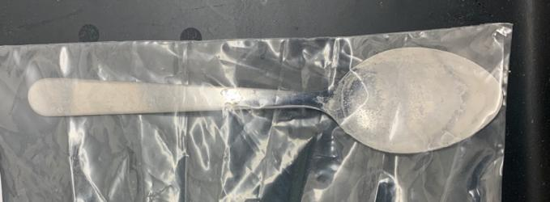 | Fentanyl
36 | 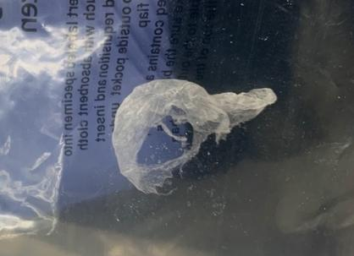 | Heroin  Fentanyl
37 | 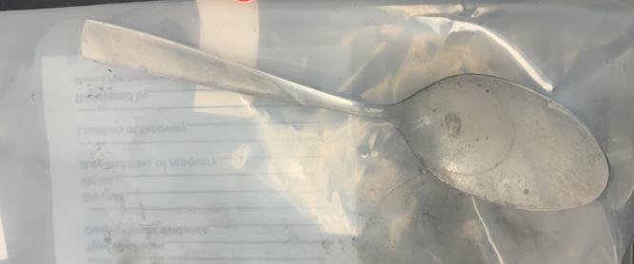 | Heroin  Fentanyl
39 | 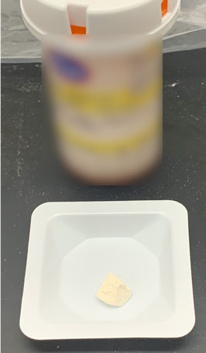 | Fentanyl
40 | 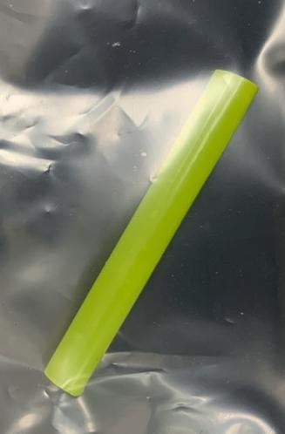 | Fentanyl
41 | 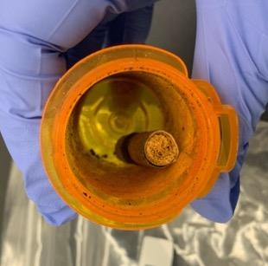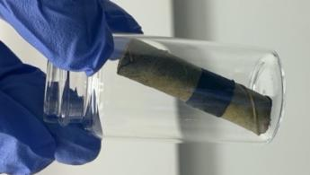 | Fentanyl
42B | 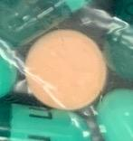 | Cocaine
44 | 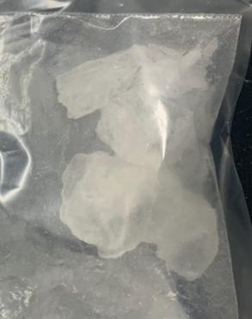 | Methamphetamine
45 | 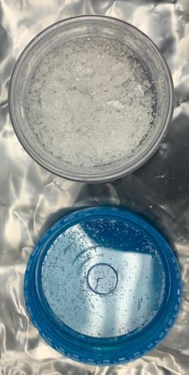 | Methamphetamine
46 | 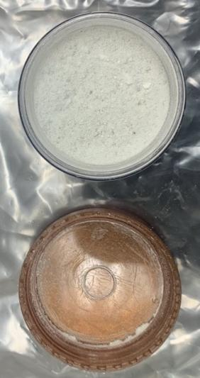 | Heroin  Fentanyl
47C (small white pieces) | 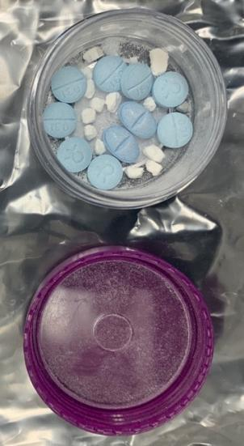 | Fentanyl
48 | 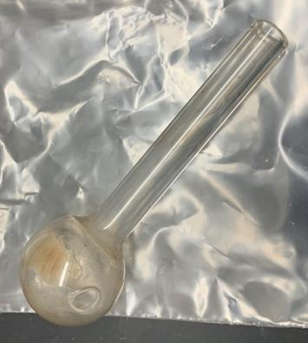 | Methamphetamine
49 | 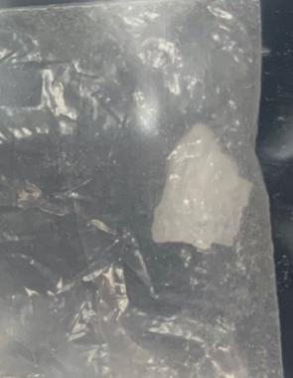 | Methamphetamine
54 | 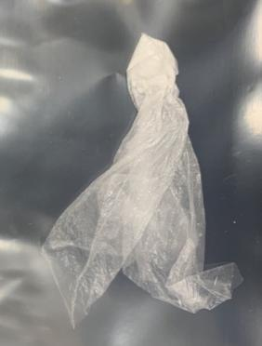 | Cocaine
55 | 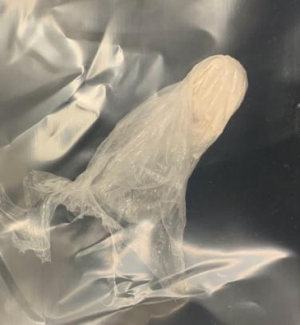 | Fentanyl
57 | 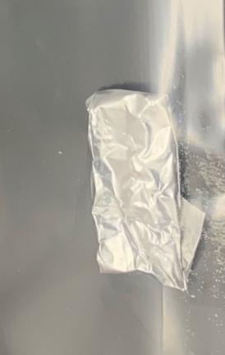 | Heroin
59 | 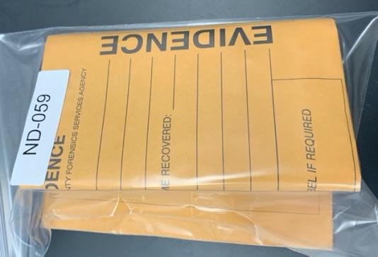 | Heroin  Fentanyl
60 | 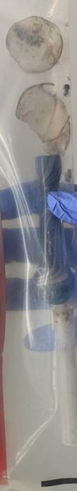 | Cocaine
61 | 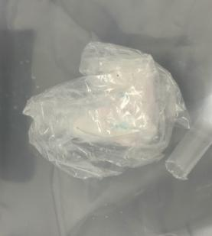 | Cocaine
64 | 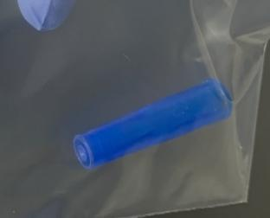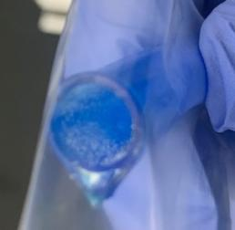 | Heroin  Fentanyl
68 | 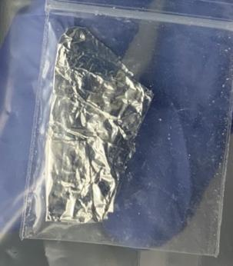 | Fentanyl
69A/B | 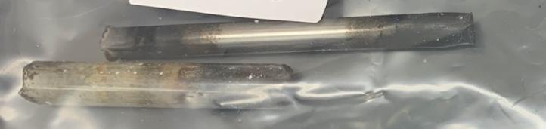 | Cocaine
70 | 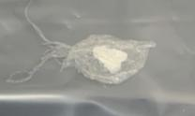 | Cocaine
71 | 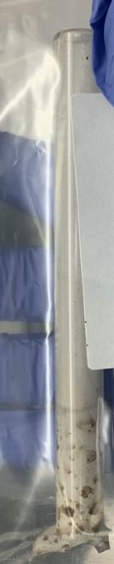 | Methamphetamine
72 | 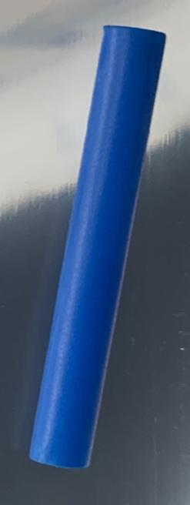 | Fentanyl
75 | 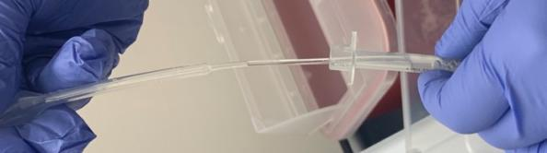 | Heroin  Fentanyl
77 | 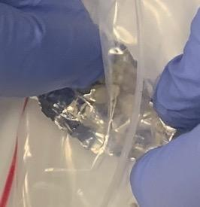 | Heroin  Fentanyl
79 | 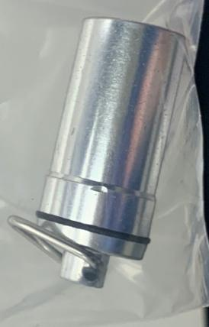 | Cocaine  Methamphetamine
80A | 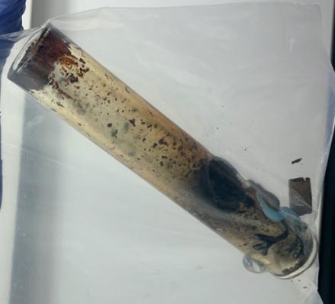 | Cocaine
89 | 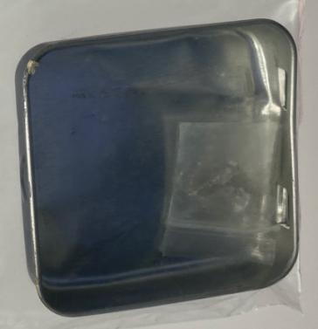 | Fentanyl
92 | 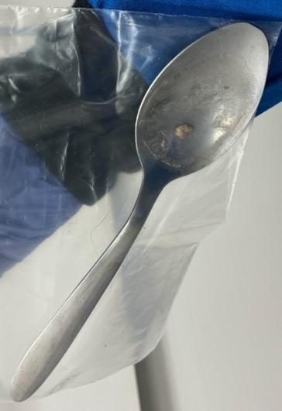 | Heroin  Fentanyl
93 | 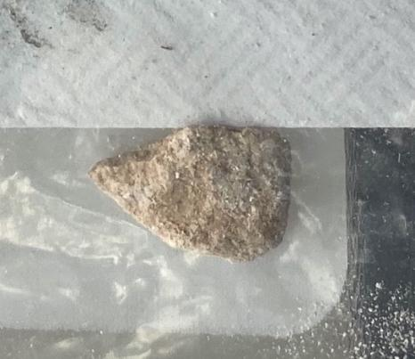 | Heroin  Fentanyl
94 | 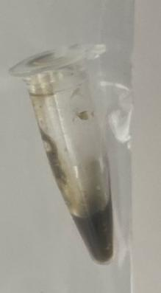 | Heroin  Fentanyl
95 | 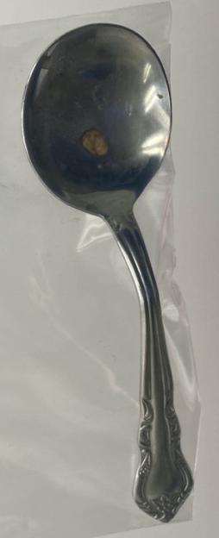 | Fentanyl
96 | 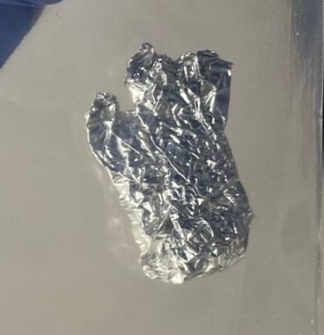 | Fentanyl
98 | 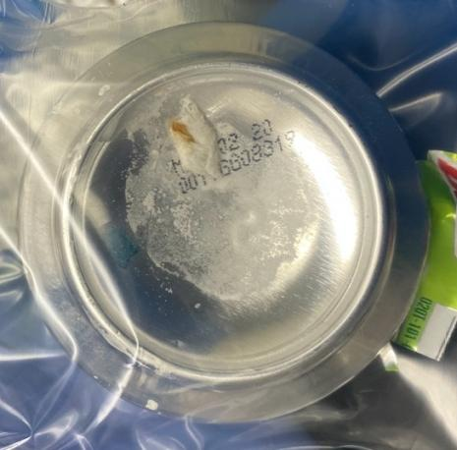 | Fentanyl
101 | 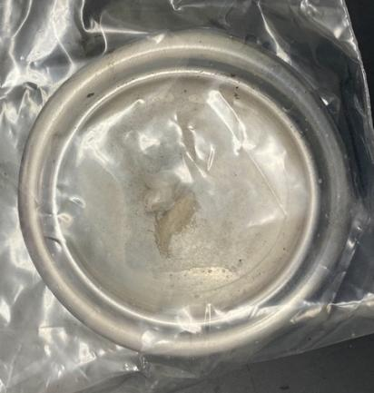 | Heroin  Fentanyl
104B | 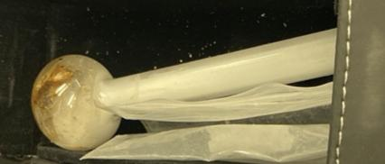 | Methamphetamine
104C | 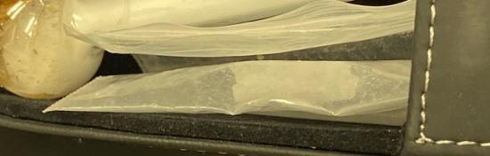 | Methamphetamine
105 | 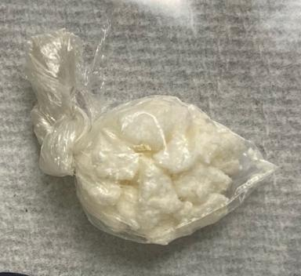 | Cocaine
107A | 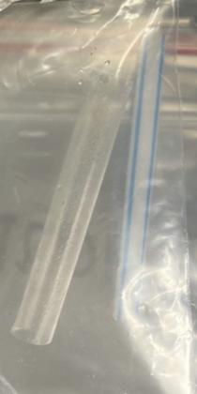 | Fentanyl
107B | 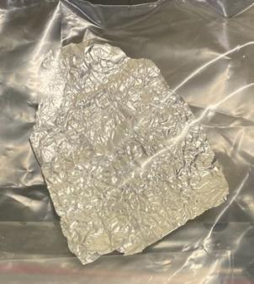 | Fentanyl
110 | Plastic container containing Brown Residue | Heroin  Fentanyl
112 | 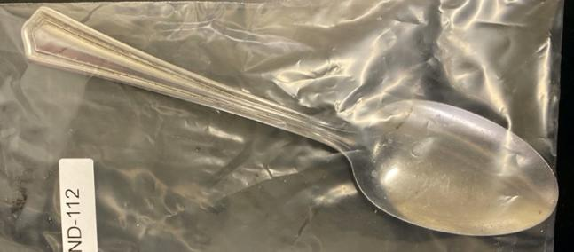 | Fentanyl
115 | 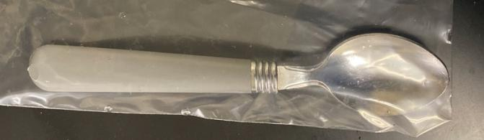 | Fentanyl
116 | Syringe | Methamphetamine
118 | 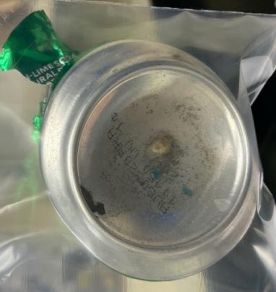 | Heroin  Fentanyl
119 | 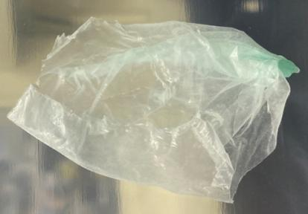 | Cocaine
122 | 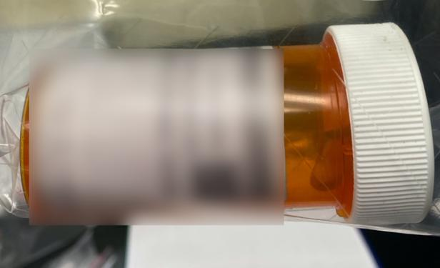Glass pipe fragments inside. | Cocaine
123 | 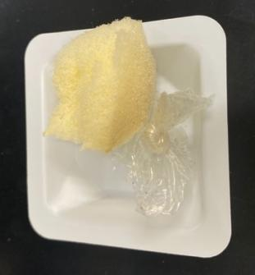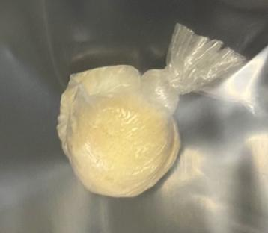 | Cocaine
124 | 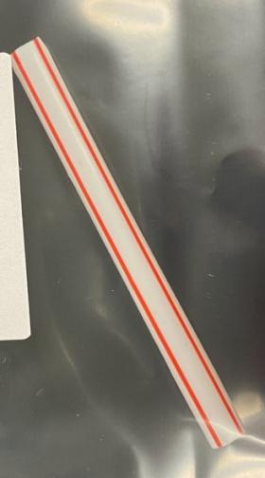 | Heroin  Fentanyl
127 | 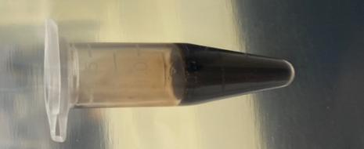 | Fentanyl

