Supporting Information
Bacteriophage-loaded poly(lactic-co-glycolic acid) microparticles mitigates Staphylococcus aureus infection and co-cultures of Staphylococcus aureus and Pseudomonas aeruginosa

Pranav P. Kalelkar, Dina A. Moustafa, Milan Riddick, Joanna B. Goldberg, Nael A. McCarty and Andrés J. García*

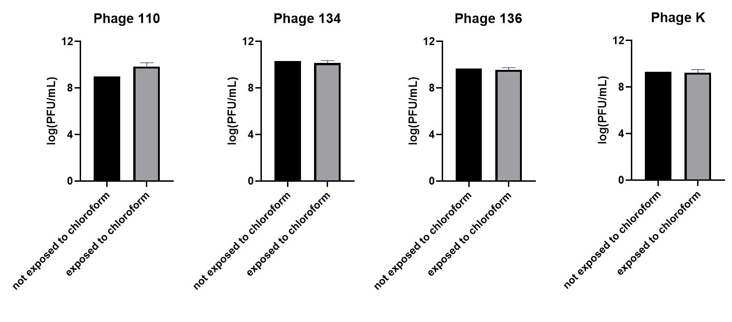
Figure S-1. Stability of phage when exposed to chloroform. 1:1 (by volume) of aqueous solution of phage was added to chloroform. The aqueous layer of this biphasic mixture was collected, serially diluted and plated on an agar overlay containing the JE-2 bacteria on a TSA plate followed by overnight incubation at 37 °C. As a control, aqueous solution of phage that was not exposed to chloroform was serially diluted and plated on an agar overlay of JE-2. N=1-3

A
B
C
Figure S-2. Dynamic light scattering profiles for A, phage K, B, unloaded MPs, and C, phage K-MPs. 3 traces shown in different colors.
Figure S-3. Release of phage from MPs. Phage-K MPs were suspended in PBS and the release of phage into the supernatant (blue) and the amount of phage remaining on MPs (red) was quantified at each time point. N=3.

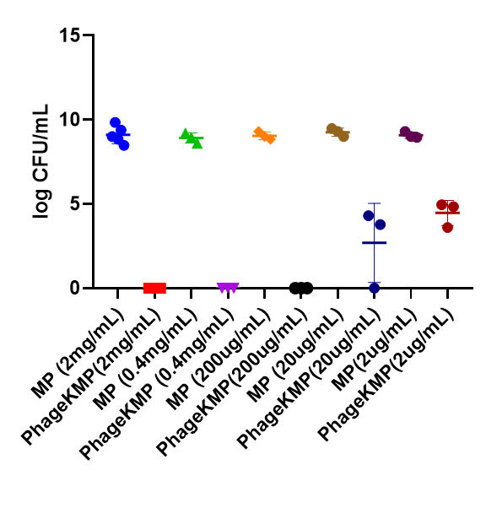
Figure S-4. Susceptibility of UAMS-1 against different doses of phage K-MPs. 100 µL of UAMS-1 (1×10⁷ CFU/mL) in LB treated with different concentrations of phage K-MPs or the equivalent dose of unloaded MPs for 15 hours. Samples were serially diluted, plated on TSA plates, and incubated at 37 °C. Bacterial colonies were counted after overnight incubation of the plates N=3.

Figure S-5. Optical density of A, UAMS-1 B, PAO1 GFP and C, PA103. Optical density measured at 590 nm. Bacterial stock suspensions were prepared at different optical density. These stock suspensions were serially diluted, and the aliquots were plated on a TSA plate. The TSA plates were incubated at 37 °C for 16-20 hours and the colonies were enumerated to calculate CFU/mL at each optical density of the bacterial suspension. N = 3, mean ± SD.

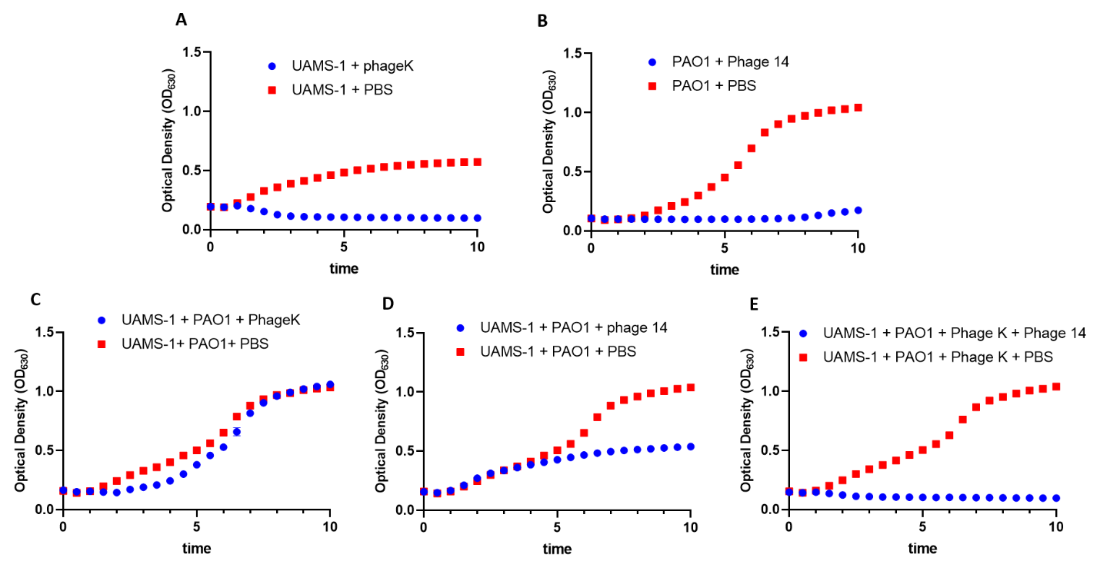
Figure S-6. Growth of monoculture or co-culture of S. aureus and P. aeruginosa in presence of one or multiple phage. Optical density measured at 630 nm over a period of 10 hours, N = 3. A, UAMS-1 (S. aureus) in presence of phage K (blue) or PBS (red). B, PAO1-GFP (P. aeruginosa) in presence of phage 14 (blue) or PBS (red). C-E, Co-culture of UAMS-1 and PAO1-GFP in presence of phage K (blue) or PBS (red); phage 14 (blue) or PBS (red); or mixture of phage K and phage 14 (blue) or PBS (red), respectively.

Figure S-7. Co-infection of S. aureus (UAMS-1) and P. aeruginosa (PA103) is susceptible when exposed to a mixture of phage K (active against UAMS-1) and phage 22 and phage E2005C (active against PA103). Optical density measured at 630 nm over a period of 12 hours, N = 3, Mean +/- S.D.

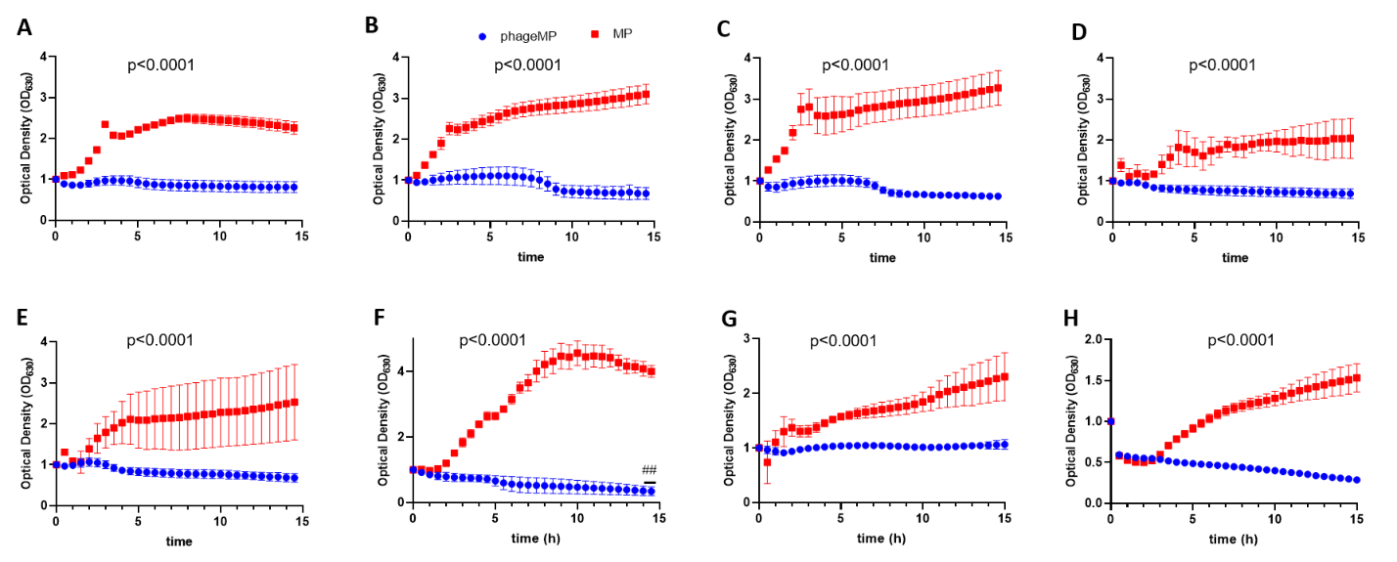
Figure S-8. Phage K-MP efficacy against different strains of S. aureus. A, Xen29. B, SA 46106A. C, SA 46106B. D. SA 19685. E, mixture of four strains of S. aureus (SA Xen29 + SA 46106A + SA 46106B + SA 19685). F, UAMS-1 a clinical isolate of S. aureus, G Methicillin-resistant S. aureus. H, mixture of MRSA and UAMS-1. Optical density of 100 µL of bacterial suspension prepared by suspending a few colonies of the bacteria in LB was measured at 630 nm in presence of 100 µL of phage-MP or unloaded MPs (2 mg/mL) over a period of 15 hours. Two-way ANOVA with Sidak’s test for multiple comparison. Two-way ANOVA with Dunnett’s multiple comparisons test relative to time 0; ##p<0.005, N = 3 Mean +/- S.D.

Figure S-9. Efficacy of phage K-MPs to mitigate acute S. aureus lung infection. Input dose of JE-2 = 1 × 10⁸ CFU/mouse; input phage dose = 1 × 10⁸ PFU/mouse. ns via unpaired two-tailed t test, N = 4-5 Mean +/- S.D.

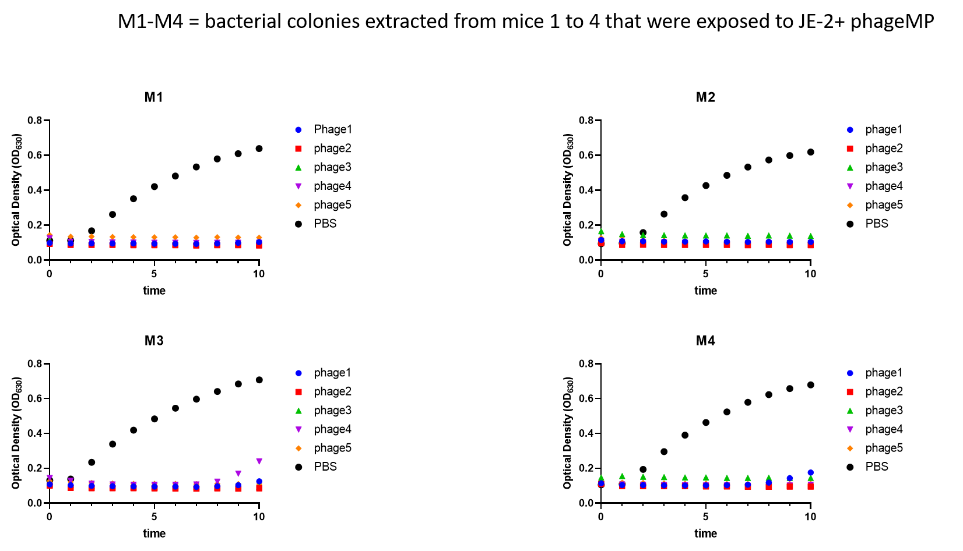
Figure S-10. Evaluation of sensitivity of JE-2 colonies recovered from four different mice treated with phage-MPs to individual phage components. Bacteria collected from the lungs of mice exposed to JE-2 and phage-MPs were added to LB media. 100 µL aliquots of the bacterial suspension were added to different wells of a 96 well plate. 50 µL of individual phage component or PBS was added to the wells and the optical density of the suspension was measured at 630 nm for 10 hours.

Table S-1. Demographics of CF sputum supernatant samples obtained from the CF Biospecimen Repository, Emory University
CFBR ID | Program | Sex | CFTR Mutation 1 | CFTR Mutation 2
CFBR-289 | ADULT | Male | delF508 | delF508
CFBR-529 | ADULT | Male | delF508 | 296+1G>A
CFBR-638 | ADULT | Male | delF508 | delF508
CFBR-258 | ADULT | Female | delF508 | L467P
CFBR-NL116 |  | Male
CFBR-NL187 |  | Female
CFBR ID: Cystic Fibrosis Biospecimen Repository subject ID number. CFTR: Cystic fibrosis transmembrane conductance regulator.

Table S-2. Phage and host bacteria used for the phage amplification and purification
Phage | Host bacteria
Phage K | SA 19685
Phage 14 | PsAer-9
Phage 22 | PsAer-10
Phage E2005C | EAMS2005-C

Table S-3 Effect of microparticle size on phage K loading
Microparticle size (µm) | Phage K loading
3.53 ± 0.53 | 1×10⁵ PFU/mg
6.25 ± 0.38 | 8.8 ×10⁵ PFU/mg
8.12 ± 0.27 | 8 ×10⁵ PFU/mg

