Online-only supplemental material.
Table S1. Percent of patients with diabetic ketoacidosis by age at hospital admission among patients with diabetes hospitalized with COVID-19 in the United States, March–November, 2020.

 |  | T1DM |  |  |  | T2DM
Age (yrs) | DKA | % (95% CI) | Total |  | DKA | % | Total
0–17 | 53 | 74.6 (63.1–83.5) | 71 |  | 14 | 24.6 (14.9–37.6) | 57
18–39 | 383 | 54.9 (51.2–58.6) | 697 |  | 482 | 9.7 (8.9–10.5) | 4,994
40–49 | 96 | 33.1 (27.9–38.7) | 290 |  | 596 | 6.1 (5.6–6.6) | 9,832
50–64 | 120 | 27.6 (23.6–32.0) | 435 |  | 1301 | 3.8 (3.6–4.0) | 33,918
65–74 | 22 | 11.0 (7.3–16.2) | 200 |  | 682 | 2.3 (2.1–2.5) | 29,973
≥75 | 16 | 10.3 (6.4–16.1) | 156 |  | 430 | 1.3 (1.2–1.5) | 32,069
Total | 690 | 37.3 (35.1–39.5) | 1,849 |  | 3505 | 3.2 (3.1–3.3) | 110,843

Abbreviations: CI = confidence interval; DKA = diabetic ketoacidosis; T1DM = type 1 diabetes mellitus; T2DM = type 2 diabetes mellitus

Table S2. Adjusted absolute risk and odds ratios for intensive care unit/mechanical ventilation among 269,674 patients hospitalized with COVID-19 in the United States, March–November, 2020.

 | Risk Ref (95% CI) | Risk T1DM (95% CI) | OR (95% CI) | p-value
ICU/MV
T1DM (Ref. no DM)
Model Set 0 | 0.44 (0.41–0.46) | 0.60 (0.57–0.63) | 1.96 (1.77–2.17) | <0.001
Model Set 1* | 0.44 (0.41–0.46) | 0.65 (0.62–0.68) | 2.48 (2.23–2.76) | <0.001
Model Set 2 | 0.44 (0.41–0.46) | 0.65 (0.63–0.68) | 2.58 (2.32–2.87) | <0.001
Model Set 2+CKD | 0.44 (0.42–0.46) | 0.64 (0.61–0.66) | 2.40 (2.16–2.67) | <0.001
Model Set 3a | 0.44 (0.42–0.46) | 0.64 (0.61–0.67) | 2.42 (2.17–2.70) | <0.001
T1DM (Ref. no T2DM)
Model Set 0 | 0.55 (0.53–0.57) | 0.60 (0.57–0.63) | 1.25 (1.13, 1.38) | <0.001
Model Set 1 | 0.55 (0.52–0.57) | 0.64 (0.61–0.67) | 1.47 (1.32–1.64) | <0.001
Model Set 2 | 0.55 (0.53–0.57) | 0.65 (0.63–0.68) | 1.58 (1.43–1.76) | <0.001
Model Set 2 + CKD | 0.55 (0.53–0.57) | 0.64 (0.62–0.67) | 1.52 (1.37–1.69) | <0.001
Model Set 2 + DKA | 0.55 (0.53–0.57) | 0.56 (0.53–0.59) | 1.05 (0.95–1.16) | 0.369
Model Set 3b | 0.55 (0.53–0.57) | 0.57 (0.54–0.60) | 1.09 (0.98–1.21) | 0.098
Death
T1DM (Ref. no DM)
Model Set 0 | 0.12 (0.12–0.13) | 0.10 (0.08–0.11) | 0.76 (0.66–0.89) | <0.001
Model Set 1* | 0.12 (0.12–0.13) | 0.17 (0.15–0.19) | 1.54 (1.31–1.81) | <0.001
Model Set 2 | 0.12 (0.12–0.12) | 0.17 (0.15–0.19) | 1.51 (1.29–1.77) | <0.001
Model Set 2+CKD | 0.12 (0.12–0.13) | 0.15 (0.13–0.17) | 1.31 (1.12–1.54) | <0.001
Model Set 3a | 0.12 (0.12–0.12) | 0.15 (0.13–0.17) | 1.32 (1.12–1.55) | 0.001
T1DM (Ref. no T2DM)
Model Set 0 | 0.19 (0.18–0.19) | 0.10 (0.08–0.11) | 0.47 (0.40–0.54) | <0.001
Model Set 1 | 0.18 (0.18–0.19) | 0.18 (0.16–0.21) | 1.00 (0.86–1.17) | 0.975
Model Set 2 | 0.18 (0.18–0.19) | 0.18 (0.16–0.20) | 0.98 (0.84–1.14) | 0.763
Model Set 2+CKD | 0.18 (0.18–0.19) | 0.17 (0.15–0.19) | 0.92 (0.78–1.07) | 0.259
Model Set 2+DKA | 0.18 (0.18–0.19) | 0.16 (0.14–0.18) | 0.81 (0.69–0.95) | 0.009
Model Set 3b | 0.18 (0.18–0.19) | 0.16 (0.14–0.18) | 0.80 (0.68–0.94) | 0.007

Abbreviations: CI = confidence interval; CKD = chronic kidney disease; COVID-19 = coronavirus disease 2019; DKA = diabetic ketoacidosis; DM = diabetes; ICU/MV= intensive care unit/mechanical ventilation; OR = odds ratio; Ref = reference; T1DM = type 1 diabetes mellitus; T2DM = type 2 diabetes mellitus. Each estimate represents results from a separate model, clustered on hospital ID and controlling for age, sex, race/ethnicity (Model Set 1); and additionally for payer type, Census region, urbanicity of hospitals, and admission month (Model Set 2); underlying medical conditions (hypertension, disorders of lipid metabolism, obesity, CKD, coronary atherosclerosis and other heart disease, COPD, neoplasms) (Model Set 3a); and DKA (Model Set 3b).
Table S3. Adjusted absolute risk differences and risk ratios for intensive care unit/mechanical ventilation among 269,674 patients hospitalized with COVID-19 in the United States, March–November, 2020 using the full modified Klompas algorithm.
 | RD | p-value | RR | p-value
ICU/MV
T1DM (Ref. no DM)
Model Set 1 | 0.23 (0.21,0.26) | <0.001 | 1.53 (1.46,1.60) | <0.001
T1DM (Ref. no T2DM)
Model Set 1 | 0.11 (0.09,0.14) | <0.001 | 1.20 (1.16,1.25) | <0.001
Model Set 2 + DKA | 0.02 (-0.00,0.05) | 0.069 | 1.04 (1.00,1.09) | 0.064
Death
T1DM (Ref. no DM)
Model Set 1 | 0.05 (0.03,0.07) | <0.001 | 1.42 (1.25,1.61) | <0.001
T1DM (Ref. no T2DM)
Model Set 1 | 0.00 (-0.02,0.03) | 0.914 | 1.01 (0.89,1.15) | 0.914
Model Set 2+DKA | -0.03 (-0.05,-0.01) | 0.005 | 1.23 (1.04,1.45) | 0.013
Abbreviations: CI = confidence interval; COVID-19 = coronavirus disease 2019; DKA = diabetic ketoacidosis; DM = diabetes; ICU/MV= intensive care unit/mechanical ventilation; RD = risk difference; Ref = reference; RR = risk ratio; T1DM = type 1 diabetes mellitus; T2DM = type 2 diabetes mellitus. Each estimate represents results from a separate model, clustered on hospital ID and controlling for age, sex, race/ethnicity (Model Set 1); and additionally for payer type, Census region, urbanicity of hospitals, admission month, and DKA (Model Set 2+DKA).
Figure S1. Adjusted absolute risk differences for intensive care unit/mechanical ventilation and mortality among 269,674 patients hospitalized with COVID-19 in the United States, discharged March–November 2020.
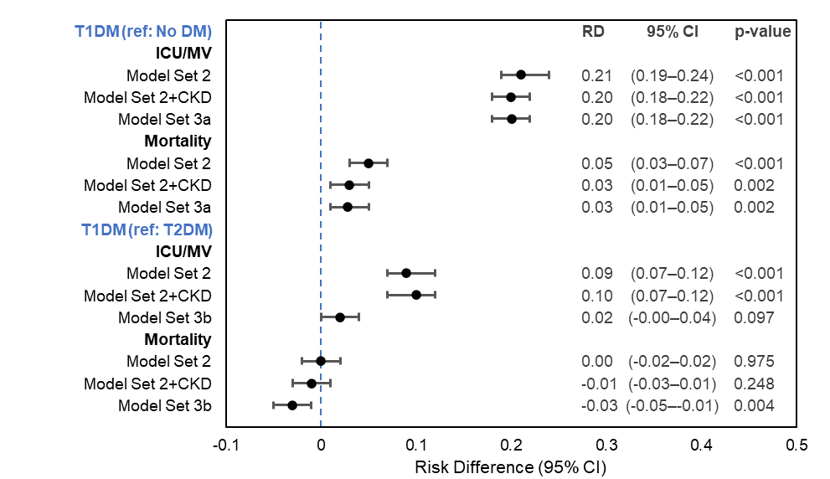
Abbreviations: CKD = chronic kidney disease; COVID-19 = coronavirus disease 2019; DKA = diabetic ketoacidosis; DM = diabetes mellitus; ICU/MV= intensive care unit/mechanical ventilation; RD = risk difference; Ref = reference; T1DM = type 1 diabetes mellitus; T2DM = type 2 diabetes mellitus. Each estimate represents results from a separate model, clustered on hospital ID and controlling for age, sex, race/ethnicity, payer type, Census region, urbanicity of hospitals, and admission month (Model Set 2); underlying medical conditions (hypertension, disorders of lipid metabolism, obesity, CKD, coronary atherosclerosis and other heart disease, COPD, neoplasms) (Model Set 3a); and DKA (Model Set 3b).
Figure S2. Adjusted absolute risk ratios for intensive care unit/mechanical ventilation and mortality among 269,674 patients hospitalized with COVID-19 in the United States, discharged March–November 2020.
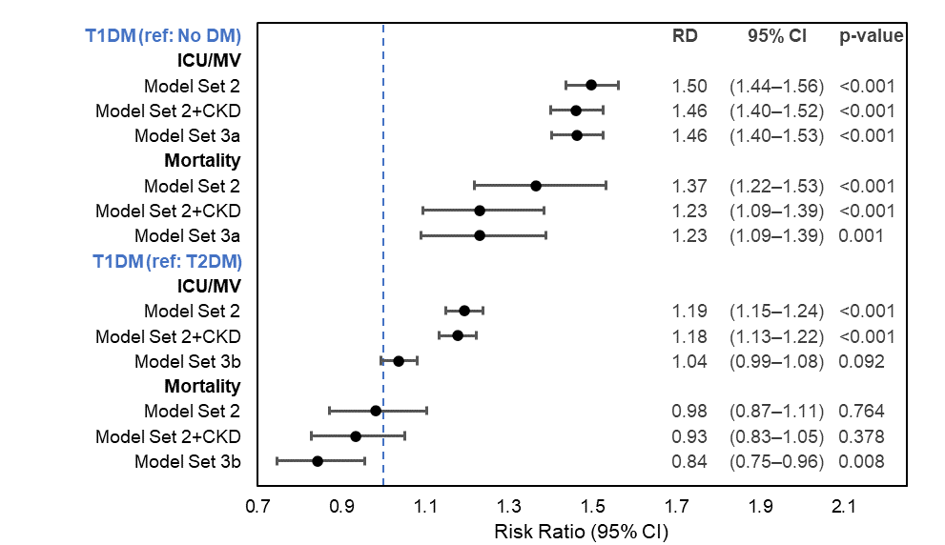
Abbreviations: COVID-19 = coronavirus disease 2019; DM = diabetes mellitus; ICU/MV= intensive care unit/mechanical ventilation; Ref = reference; RR = risk ratio; T1DM = type 1 diabetes mellitus; T2DM = type 2 diabetes mellitus. Each estimate represents results from a separate model, clustered on hospital ID and controlling for age, sex, race/ethnicity, payer type, Census region, urbanicity of hospitals, and admission month (Model Set 2); underlying medical conditions (hypertension, disorders of lipid metabolism, obesity, CKD, coronary atherosclerosis and other heart disease, COPD, neoplasms) (Model Set 3a); and DKA (Model Set 3b).

