Supplementary Material

Title: Epigenetic Aging Biomarkers and Occupational Exposure to Benzene, Trichloroethylene and Formaldehyde

Authors: Lars van der Laan, Andres Cardenas, Roel Vermeulen, Raj P. Fadadu, Alan E. Hubbard, Rachael V. Phillips, Luoping Zhang, Charles Breeze, Wei Hu, Cuiju Wen, Yongshun Huang, Xiaojiang Tang, Martyn T. Smith, Nathaniel Rothman, Qing Lan

Table S1. Participant characteristics for the formaldehyde study.
Subject Demographics | Controls  (n=39) | Formaldehyde Exposed  (n=31)
Age, mean (SD) | 29.6 (7.4) | 31.7 (6.0)
Body mass index, mean (SD) | 21.8 (3.2) | 21.7 (2.67)
Sex, n (%)  Female  Male | 32 (82%)  7 (18%) | 26 (84%)  5 (16%)
Current smoker  Yes  No | 16 (41%)  23 (59%) | 13 (42%)  18 (58%)
Recently infected  Yes  No | 13(34%)  26 (66%) | 13 (42%)  18 (58%)
Alcohol consumption  Yes  No | 15 (39%)  24 (61%) | 6 (20%)  25 (80%)
Formaldehyde exposure (ppm)  mean (SD)  range (min, max) | 0.02 (0.00749)  (0.00849, 0.0262) | 1.25 (0.62)  (0.318, 2.611)

Table S2. Pearson test of correlation for each TCE exposure group and Fischer transform test of difference in correlation for DNAmTL and measured qPCR leukocyte telomere length among TCE exposure groups.
Pearson test of correlation |  |  | Fischer transform test
Control | Lower | Higher | Control vs Lower | Control vs Higher | Lower vs Higher
r=0.47  p=0.0026 | r=0.51  p=0.0087 | r=-0.0051  p=0.98 | p=0.599 | p=0.044 | p=0.02

Table S3. Spearman correlation matrix between age acceleration measures (adjusted residuals) for all pair-wise combination of clocks.
 | Pan tissue | Hannum | Skin-Blood | GrimAge | Pheno  Age | DNAmTL | IEAA | EEAA
Pan tissue |  | 0.46 | 0.61 | 0.11 | 0.33 | -0.25 | 0.94 | 0.38
Hannum | 0.46 |  | 0.51 | 0.31 | 0.51 | -0.42 | 0.48 | 0.95
Skin-Blood | 0.61 | 0.51 |  | 0.18 | 0.34 | -0.26 | 0.52 | 0.42
Grim Age | 0.11 | 0.31 | 0.18 |  | 0.43 | -0.13 | 0.19 | 0.29
Pheno Age | 0.33 | 0.51 | 0.36 | 0.43 |  | -0.45 | 0.38 | 0.53
DNAmTL | -0.25 | -0.42 | -0.26 | -0.13 | -0.45 |  | -0.30 | -0.51
IEAA | 0.94 | 0.48 | 0.52 | 0.19 | 0.38 | -0.30 |  | 0.41
EEAA | 0.38 | 0.95 | 0.42 | 0.28 | 0.53 | -0.51 | 0.41

Table S4A. Medians and *adjusted differences in medians for epigenetic aging biomarkers among workers exposed to benzene and controls estimated with quantile regression. Bold values represent p<0.05.
 | Median Epigenetic Age |  | Difference Exposed vs. Controls
Epigenetic Aging Biomarker | Exposed | Controls | Difference  (95% CI)
Horvath Pan tissue  Clock | 38.42 | 37.07 | 1.34  (-0.02, 2.83)
Hannum Clock | 55.42 | 55.77 | -0.34  (-2.05, 2.25)
Skin-Blood Clock | 43.11 | 41.38 | 1.74  (0.58, 2.99)
Grim Age  Clock | 45.65 | 46.48 | -0.82  (-1.37, -0.18)
PhenoAge  Clock | 31.10 | 30.52 | 0.53  (-2.51, 1.87)
DNAm Telomere Length  (DNAmTL) | 7.08 | 7.19 | -0.10  (-0.18, -0.03)
Intrinsic Epigenetic Age Acceleration (IEAA) | -0.11 | 0.59 | -0.70  (-2.17, 1.31)
Extrinsic Epigenetic Age Acceleration (EEAA) | -0.41 | -0.20 | -0.21  (-3.02, 2.68)

*Quantile regression models adjusted for age, alcohol intake, sex, BMI, and smoking history in the model as sensitivity analyses.
Table S4B. Medians and *adjusted differences in medians for epigenetic aging biomarkers among workers with higher benzene exposed (≥10 ppm), lower benzene exposed (<10 ppm) and controls. Bold values represent p<0.05.
 | Median Epigenetic Age |  |  | EAA (Difference)  (95% CI)  P-value: Test of Cond. Ind.
Epigenetic Aging Biomarker | Controls  (n=48;  <0.035 ppm) | <10 ppm  (n=41;  1.35 ppm) | ≥10 ppm  (n=9; 27.3 ppm) | <10 ppm vs. Control | ≥10 ppm vs. Control
Horvath Pan tissue Clock | 37.22 | 38.15 | 38.83 | 0.93  (-1.68, 2.79)  p=0.61 | 1.61  (-0.14, 3.55)  p=0.16
Hannum Clock | 54.71 | 54.60 | 59.20 | -0.11  (-3.48, 1.26)  p=0.37 | 4.49  (-1.41, 6.41)  p=0.13
Skin-Blood Clock | 41.42 | 42.86 | 43.50 | 1.43  (0.71, 2.81)  p=0034 | 2.07  (0.05, 4.62)  p=0.019
Grim Age  Clock | 46.47 | 45.60 | 45.71 | -0.86  (-1.43, -0.23)  p=0.07 | -0.75  (-1.27, 1.66)  p=0.82
PhenoAge  Clock | 30.48 | 30.49 | 32.94 | 0.01  ( -2.92, 1.97)  p=0.85 | 2.46 (-3.49, 7.35)  p=0.13
DNAm Telomere Length (DNAmTL) | 7.186 | 7.104 | 6.911 | 0.08  (-0.18, 0.00)  p=0.06 | -0.27  (-0.33, -0.01)  p=0.004
Intrinsic Epigenetic Age Acceleration (IEAA) | 0.43 | -0.56 | 0.78 | -0.99  (-2.62, 0.62)  p=0.39 | 0.35  (-1.24, 2.15)  p=0.96
Extrinsic Epigenetic Age Acceleration (EEAA) | -0.20 | -2.18 | 6.48 | 1.98  (-4.50, 1.50)  p=0.59 | 6.68  (-2.70, 8.53)  p=0.19
*Quantile regression models adjusted for age, alcohol intake, sex, BMI, and smoking history in the model as sensitivity analyses.
Table S5. Medians and *adjusted differences in medians for epigenetic aging biomarkers among workers exposed to trichloroethylene (TCE) and controls along with permutation exact p-values.
 | Median Epigenetic Age |  | Difference Exposed vs. Controls
Epigenetic Aging Biomarker | Exposed | Controls | Median Difference  (95% CI) | Exact p-value
Horvath Pan tissue  Clock | 32.39 | 32.74 | 0.35  (-1.26,1.43) | 0.80
Hannum  Clock | 34.35 | 33.58 | 0.77  (-1.53,1.23) | 0.42
Skin-Blood  Clock | 25.95 | 26.10 | 0.15  (-0.46,1.53) | 0.28
Grim Age  Clock | 35.12 | 35.84 | 0.71  (-0.89,1.25) | 0.47
PhenoAge  Clock | 23.84 | 23.63 | -0.21  (-1.53, 2.66) | 0.81
DNAm Telomere Length Adjusted (DNAmTLAdj) | 7.44 | 7.43 | -0.01  (-0.12, 0.05) | 0.74
Intrinsic Epigenetic Age Acceleration (IEAA) | -0.23 | 0.50 | 0.73  (-0.18, 2.38) | 0.26
Extrinsic Epigenetic Age Acceleration (EEAA) | 0.07 | -0.68 | -0.74  (-1.91, 0.87) | 0.36
*Quantile regression models adjusted for age, alcohol intake, sex, BMI, and smoking history in the model as sensitivity analyses.
Table S6. Medians and *adjusted differences in medians for epigenetic aging biomarkers among workers with ≥10 ppm TCE (mean 37.4 ppm), <10 ppm TCE (mean 4.38 ppm) and controls. Bold values represent p<0.05.
 | Median Epigenetic Age |  |  | EAA (Differences)  (95 %CI)  P-value: Test of Cond. Ind.
Epigenetic Aging  Biomarker | Controls  (n=71) | <10 ppm  (n=27) | ≥10 ppm  (n=37) | < 10 ppm vs.  Controls | ≥10 ppm vs.  Controls
Horvath Pan tissue  Clock | 32.49 | 33.40 | 32.56 | 0.91  (-0.91, 2.87)  p=0.51 | 0.07  (-2.44, 1.14)  p=0.91
Hannum  Clock | 34.53 | 36.33 | 33.20 | 1.79  (-1.09, 3.32)  p=0.07 | -1.33  (-3.33, 0.41)  p=0.19
Skin-Blood  Clock | 25.88 | 28.01 | 25.82 | 2.13  (0.37, 4.84)  p=0.035 | -0.06  (-1.27, 1.42)  p=0.88
Grim Age  Clock | 35.07 | 35.68 | 35.97 | 0.61  (-1.35,1.48)  p=0.93 | 0.90  (-0.87, 1.39)  p=0.33
PhenoAge  Clock | 23.92 | 23.07 | 24.79 | -0.84  (-3.03, 2.11)  p=0.64 | 0.87  (-1.64, 2.90)  p=0.33
DNAm TL (DNAmTL) | 7.46 | 7.46 | 7.36 | 0.001  (-0.04, 0.09)  p=0.89 | -0.098  (-0.14, 0.05)  p=0.08
Intrinsic Epigenetic Age Acceleration (IEAA) | -0.21 | 0.43 | 0.62 | 0.64  (0.03, 2.37)  p=0.39 | 0.83  (-1.56, 2.41)  p=0.33
Extrinsic Epigenetic Age Acceleration (EEAA) | 0.24 | 0.68 | -0.81 | 0.44  (-1.74, 3.17)  p=0.53 | -1.05  (-2.67, 0.11)  p=0.24

Table S7. Medians and *adjusted differences in medians for epigenetic aging biomarkers among workers exposed to formaldehyde and controls along with permutation exact p-values.
 | Median Epigenetic Age |  | Difference Exposed vs. Controls
Epigenetic Aging Biomarker | Controls | Exposed | Difference  (95% CI) | Exact p-value
Horvath Pan tissue  Clock | 34.12 | 34.82 | 0.70  ( -1.52, 2.59) | 0.66
Hannum Clock | 50.84 | 52.52 | 1.68  (0.42, 3.44) | 0.20
Skin-Blood Clock | 37.02 | 37.63 | 0.61  (-0.93, 2.38) | 0.29
Grim Age  Clock | 34.90 | 35.09 | 0.19  (-3.07, 2.34) | 0.59
PhenoAge  Clock | 26.71 | 25.75 | -0.96  (-3.80, 1.53) | 1.00
DNAm Telomere Length Adjusted (DNAmTLAdj) | 6.92 | 6.93 | 0.02  (-0.09, 0.14) | 0.68
Intrinsic Epigenetic Age Acceleration (IEAA) | -0.85 | 0.09 | 0.94  (-1.82, 2.69) | 0.74
Extrinsic Epigenetic Age Acceleration (EEAA) | -0.37 | 2.35 | 2.30  (-0.87, 4.23) | 0.38

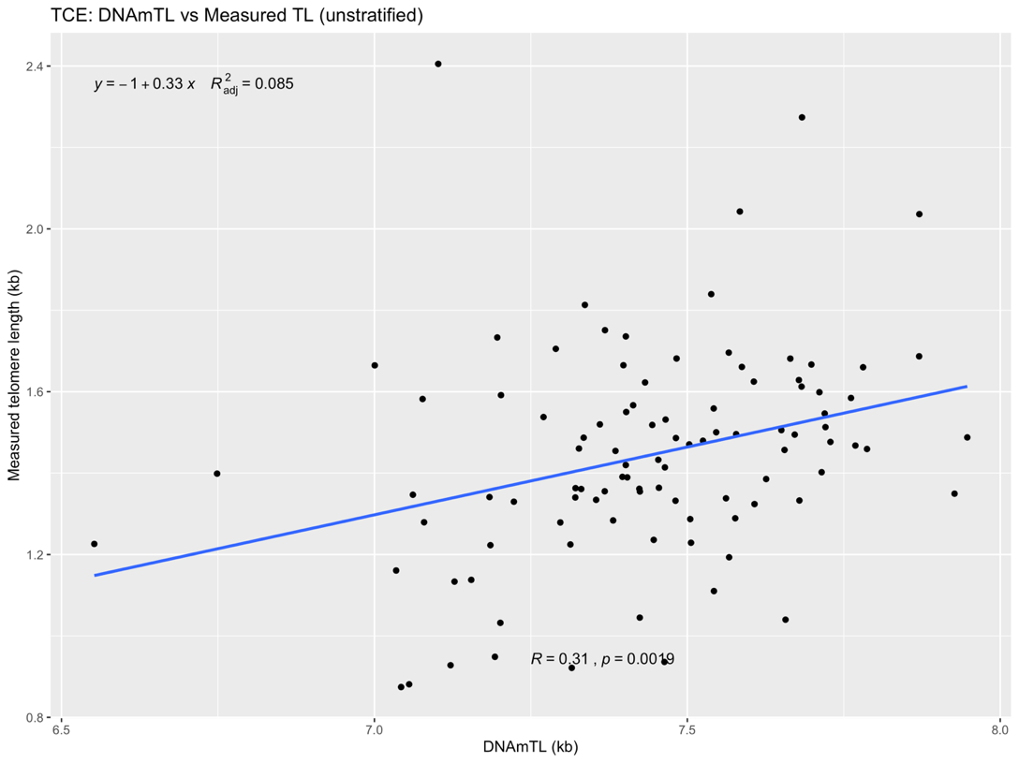
Figure S1. Correlations and linear regression lines (A) between measured telomere length via qPCR and DNAm estimated of telomere length and (B) by TCE exposure group (stratified and unstratified).

