Supplementary Table 1. Logistic regression of CDSMP initiators vs non-initiators

|  |  |  |
| --- | --- | --- |
| **Category** | **Unadjusted OR**  **(95% CI)** | **Adjusted OR**  **(95% CI)** |
| Age (years) | **1.03 (1.01-1.06)** | **1.04 (1.00-1.07)** |
| Disease duration (years) | 1.02 (0.99-1.05) | 0.98 (0.94-1.01) |
| Marital status |  |  |
| Not single | 0.95 (0.5-1.81) | 1.03 (0.53-1.99) |
| Single | Ref | Ref |
| Education Level, n (%) |  |  |
| High school or less | Ref | Ref |
| Some college or more | 1.26 (0.73-2.17) | 1.14 (0.61-2.15) |
| Current work status |  |  |
| Working full-time or part-time | Ref | Ref |
| Unemployed/Disableda | **2.46 (1.35-4.50)** | **2.05 (1.00-4.23)** |
| Number of children in household | **0.78 (0.62-0.98)** | 0.84 (0.62-1.14) |
| Severity of disease activity |  |  |
| Mild activity (SLAQ=0-10) | Ref | Ref |
| Moderate/severe activity (SLAQ≥11) | 0.96 (0.48-1.93) | 0.50 (0.23-1.10) |
| Severity of organ damage |  |  |
| No damage (BILD=0) | Ref | Ref |
| Mild damage (BILD=1-2) | 1.56 (0.74-3.29) | 1.71 (0.75-3.90) |
| Severe damage (BILD>=3) | **2.93 (1.34-6.40)** | 2.26 (0.97-5.27) |
| Insurance type |  |  |
| None | Ref | Ref |
| Private/Public | 1.48 (0.65-3.35) | 1.43 (0.55-3.73) |
| Emergency department visits* |  |  |
| 0 visits | Ref | Ref |
| ≥1 visit | 0.88 (0.52-1.50) | 0.84 (0.42-1.66) |
| Hospital admissions* |  |  |
| 0 hospitalizations | Ref | Ref |
| ≥1 hospitalizations | 1.15 (0.59-2.23) | 1.15 (0.57-2.35) |
| PROMIS Depression | 1.01 (0.98-1.05) | 1.00 (0.96-1.05) |

aIncludes unemployed, retired, homemaker and student

*In previous year

Abbreviations: OR=odds ratio, CI=confidence interval.

Bolded values indicate statistical significance (95% CI not crossing 1)

Supplementary Table 2. Logistic regression of CDSMP completers vs non-completers

|  |  |  |
| --- | --- | --- |
| **Category** | **Unadjusted OR**  **(95% CI)** | **Adjusted OR**  **(95% CI)** |
| Age (years) | **1.04 (1.01-1.07)** | **1.05 (1.01-1.10)** |
| Disease duration (years) | 1.01 (0.98-1.05) | 0.97 (0.92-1.02) |
| Marital status |  |  |
| Not single | 0.97 (0.45-2.12) | 0.90 (0.38-2.12) |
| Single | Ref | Ref |
| Education Level, n (%) |  |  |
| High school or less | Ref | Ref |
| Some college or more | 1.14 (0.55-2.39) | 1.15 (0.50-2.69) |
| Current work status* |  |  |
| Working full-time or part-time | Ref | Ref |
| Unemployed/Disableda | 1.88 (0.85-4.18) | 1.36 (0.47-3.91) |
| Number of children in household | 0.87 (0.65-1.17) | 0.97 (0.65-1.43) |
| Severity of disease activity |  |  |
| Mild activity (SLAQ=0-10) | Ref | Ref |
| Moderate/severe activity (SLAQ≥11) | 0.48 (0.18-1.24) | 0.47 (0.16-1.39) |
| Severity of organ damage |  |  |
| No damage (BILD=0) | Ref | Ref |
| Mild damage (BILD=1-2) | 1.62 (0.61-4.28) | 1.25 (0.41-3.81) |
| Severe damage (BILD>=3) | 1.97 (0.77-5.07) | 1.40 (0.43-4.50) |
| Insurance type |  |  |
| None | Ref | Ref |
| Private/Public | 1.25 (0.37-4.22) | 1.16 (0.31-4.39) |
| Emergency department visits* |  |  |
| 0 visits | Ref | Ref |
| ≥1 visit | 1.11 (0.54-2.28) | 1.32 (0.51-3.44) |
| Hospital admissions* |  |  |
| 0 hospitalizations | Ref | Ref |
| ≥1 hospitalizations | 0.81 (0.37-1.76) | 0.84 (0.31-2.24) |
| Workshop compositionb |  |  |
| Only study participants | 1.15 (0.56-2.37) | 1.24 (0.52-2.91) |
| Study participants and community clients | Ref | Ref |
| Number in workshop |  |  |
| <10 participants | Ref | Ref |
| ≥10 participants | 1.22 (0.59-2.54) | 1.41 (0.60-3.31) |
| PROMIS Depression | 0.99 (0.95-1.04) | 1.01 (0.95-1.08) |

aIncludes unemployed, retired, homemaker and student

bAmong those who attended at least one meeting

*In previous year

Abbreviations: OR=odds ratio, CI=confidence interval.

Bolded values indicate statistical significance (95% CI not crossing 1)

Supplementary figure 1: adjusted odds of intiation

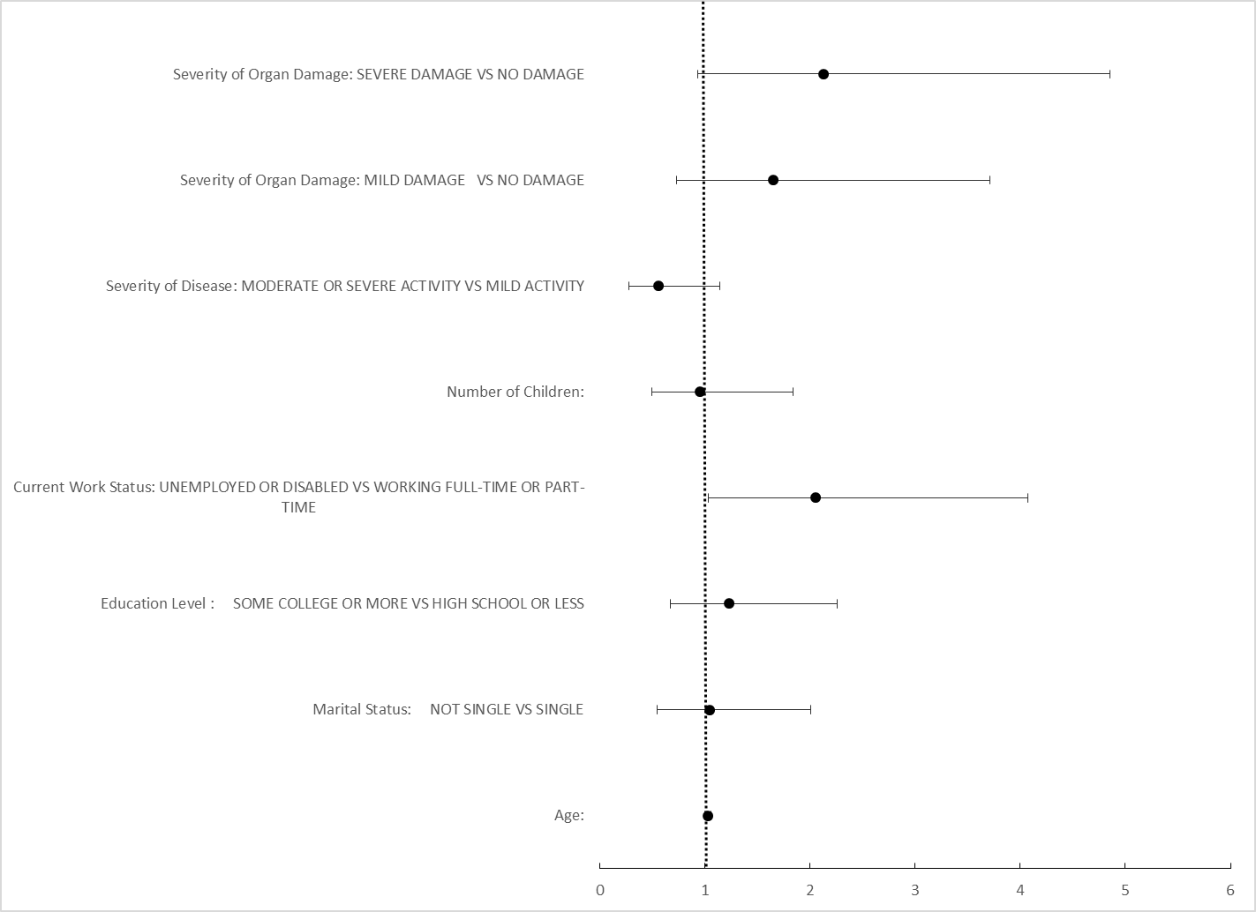

Supplementary figure 2: adjusted odds of completion

