Title: Building Laboratory Testing and Reporting Capacity: An Approach to Electronic Communications in Puerto Rico Following the Zika Epidemic
Authors: Juneka H Rembert, BS; Carlos S Zometa, PhD, MSPH; Patrick W O’Carroll, MD, MPH; Anabelle L Licier, MPH; Carol McPhillips-Tangum, MPH; Piper M Hale, BA

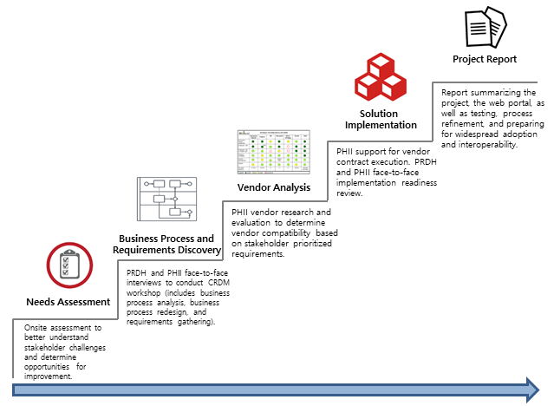
Figure 1. Approach.
Abbreviations: CRDM, Collaborative Requirements Development Methodology; PHII, Public Health Informatics Institute; PRDH, Puerto Rico Department of Health.

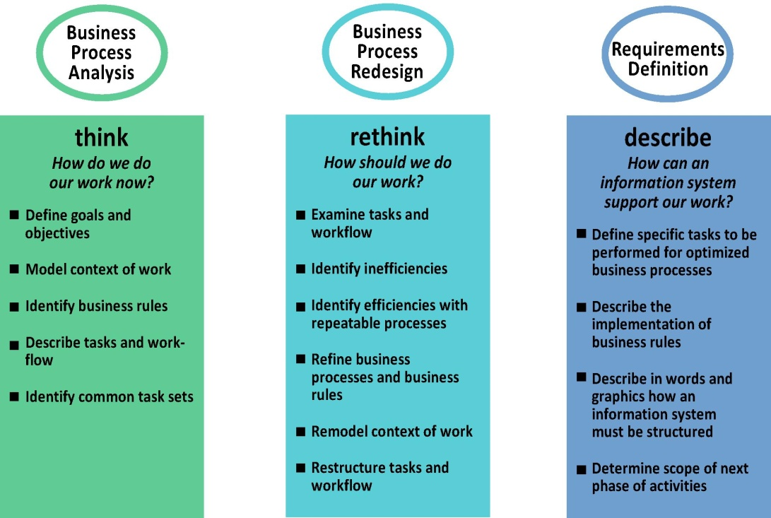
FIGURE 2. Collaborative Requirements Development Methodology

Table 1. Business Processes of Arbovirus Laboratory Test Ordering
Objectives | Business rules | Triggers | Task set | Inputs | Outputs | Measurable outcomes
- To request an arbovirus laboratory test.  - To receive a laboratory test order(s).  - To confirm patient cases of arbovirus diseases. | - Puerto Rico Department of Health policies and procedure(s)  - HIPAA regulation(s)  - Health Information Exchange policies  - HITECH regulation  - Laboratory and Clinical Guideline(s) | - Patient has symptoms associated with any Arbovirus disease  - Patient needs Arbovirus laboratory test  - Clinic walk-in/patient request  - Physician refers patient | - Patient visits health provider  - Examine patient  - ACIF test required?  - Partially fill out ACIF document  - Take sample(s)  - Attach ACIF to sample(s)  - Submit laboratory test  - Receive ACIF document and sample(s) | - Patient identifiable information (eg, first name, last name, birth date, etc.)  - Patient address  - Patient medical condition/ symptom(s)  - Provider/ clinical laboratory contact information  - Sample(s) collection date | - Conducted laboratory test  - ACIF document and patient sample(s). | - Number of arbovirus laboratory test order submission(s)  - Number of Arbovirus test ordered in a specific time frame  - Number of type(s) of test ordered  - Number of type(s) of test ordered by provider(s)
Abbreviations: ACIF, arbovirus case investigation form; HIPPA, Health Insurance Portability and Accountability Act, HITECH, The Health Information Technology for Economic and Clinical Act.

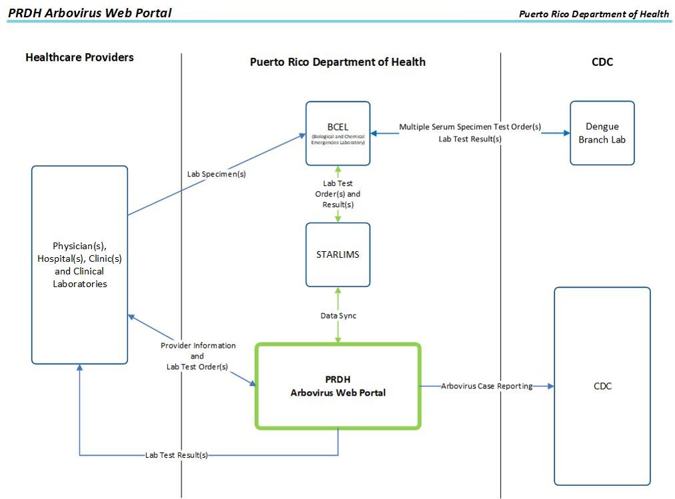

Figure 3. Context Diagram
Abbreviations: CDC, Centers for Disease Control and Prevention; PRDH, Puerto Rico Department of Health.

