SUPPLEMENTAL INFORMATION

Determinants of phthalate exposure among a U.S.-based group of Latino workers.

Janice A. Allotey, MPH;¹ Meleah Boyle, MPH;² Amir Sapkota, PhD;² Linyan Zhu, PhD; ² Roger D. Peng, PhD;³ Mary A. Garza, PhD, MPH;⁴ and Lesliam Quirós-Alcalá, PhD, MSc^{1,2,*}

Affiliations:
- Johns Hopkins University, Bloomberg School of Public Health, Department of Environmental Health & Engineering, Baltimore, MD, USA
- Maryland Institute of Applied Environmental Health, School of Public Health, University of Maryland, College Park, MD, USA
- Johns Hopkins University, Bloomberg School of Public Health, Department of Biostatistics, Baltimore, MD, USA
- California State University, Fresno, College of Health and Human Services, Department of Public Health, Fresno, CA, USA

* Corresponding Author

Table of Contents:

Table S1. Summary statistics for urinary phthalate metabolite concentrations by worker category for study participants (n=94)…………………………………………………………………….. 2

Table S2. Spearman correlations between continuous variables and phthalate metabolite concentrations………………………………………………………………...…………………. 3

Figure S1. Boxplots for diet-related factors associated with phthalate metabolite concentrations at p<0.10 in bivariate analyses (n=94).…………………..………………………….………..… 4

Figure S2. Boxplots of statistically significant associations (at p<0.10) between MEP concentrations and chemicals use or workplace behavior……………………………………….10

Figure S3. Boxplots for factors related to consumer products used outside the workplace associated with phthalate metabolite concentrations at p<0.10 in bivariate analyses (n=94)….. 15

Table S3. Comparison of median concentrations (µg/L) with phthalate concentrations from studies in other countries…………………………………………………...…………………....20

Table S4. Results from multiple testing using the Benjamini-Hochberg procedure…………….21
Supplemental Table S1. Summary statistics for urinary phthalate metabolite concentrations by worker category for study participants (n=94).

Abbreviations: U, uncorrected metabolite concentrations, (µg/L); SG, Specific-gravity corrected metabolite concentrations, (µg/L); LOD, limit of detection; DF%, detection frequency percentage; P_{25,50,75}, 25th, 50th, and 75th percentiles, respectively.

Phthalate Metabolite |  | Summary Statistics of Phthalate Metabolite Concentrations (µg/L)
 | LOD  (µg/L) | Workers in  Facilities Management (n=48) |  |  | Workers in  Residential Facilities (n=27) |  |  | Workers in  Dining Services (n=19)
 |  | DF% | P₅₀ (P₂₅, P₇₅) | DF% |  | P₅₀ (P₂₅, P₇₅) | DF% |  | P₅₀ (P₂₅, P₇₅)
MEP | 0.24 | 100 | U: 12.3 (5.28, 38.5)  SG: 13.1 (6.41, 37.8) | 100 |  | U: 10.9 (6.07, 78.7)  SG: 24.9 (10.6, 100.3) | 100 |  | U: 26.8 (5.26, 86.5)  SG: 35.9 (6.28, 102.1)
MBzP | 0.06 | 95.8 | U: 1.78 (0.86, 4.28)  SG:1.77 (1.24, 2.96) | 85.2 |  | U: 1.16 (0.27, 1.66)  SG: 1.26 (0.55, 3.22) | 94.7 |  | U: 0.86 (0.38, 1.91)  SG:0.88 (0.64, 1.61)
MBP | 0.25 | 97.9 | U: 5.81 (2.58, 12.6)  SG: 7.22 (3.24, 12.7) | 77.8 |  | U: 2.42 (0.42, 4.95)  SG: 2.95 (2.07, 9.09) | 79.0 |  | U: 1.62 (0.39, 2.97)  SG: 1.42 (0.75, 2.29)
MiBP | 0.54 | 85.4 | U: 3.34 (1.53, 6.93)  SG: 3.40 (1.60, 10.0) | 55.6 |  | U: 0.75 (0.38, 2.80)  SG: 1.52 (0.74, 4.56) | 57.9 |  | U: 0.78 (0.38, 2.18)  SG: 1.14 (0.72, 2.25)
MCPP | 0.19 | 52.1 | U: 0.29 (<LOD, 0.76)  SG: 0.33 (<LOD, 0.69) | 33.3 |  | U: <LOD (<LOD, 0.32)  SG: <LOD (<LOD, 1.01) | 31.6 |  | U: <LOD (<LOD, 0.39)  SG: <LOD (<LOD, 0.39)
MEHHP | 0.20 | 97.9 | U: 3.78 (2.16, 6.50)  SG: 3.69 (2.41, 6.65) | 100 |  | U: 2.60 (0.87, 4.27)  SG: 2.98 (2.05, 6.89) | 100 |  | U: 2.98 (1.43, 5.67)  SG: 2.74 (2.03, 4.22)
MECPP | 0.16 | 97.9 | U: 3.75 (1.98, 6.63)  SG: 3.89 (2.26, 6.56) | 96.3 |  | U: 1.59 (0.58, 4.28)  SG: 3.02 (1.53, 7.00) | 94.7 |  | U: 2.35 (0.77, 4.82)  SG: 2.87 (1.29, 4.32)
MEOHP | 0.09 | 95.8 | U: 1.85 (1.03, 3.74)  SG: 1.87 (1.26, 3.81) | 88.9 |  | U: 1.29 (0.30, 2.21)  SG: 1.25 (0.75, 3.57) | 89.5 |  | U: 1.23 (0.51, 2.61)  SG: 1.44 (0.64, 2.32)
MEHP | 0.29 | 4.2 | U: <LOD (<LOD, <LOD)  SG: <LOD (<LOD, <LOD) | 0 |  | U: <LOD (<LOD, <LOD)  SG: <LOD (<LOD, <LOD) | 0 |  | U: <LOD (<LOD, <LOD)  SG: <LOD (<LOD, <LOD)
∑DEHP | -- | -- | U: 0.03 (0.02, 0.06)  SG: 0.03 (0.02, 0.06) | -- |  | U: 0.02 (0.01, 0.04)  SG: 0.03 (0.02, 0.05) | -- |  | U: 0.02 (0.01, 0.04)  SG: 0.02 (0.02, 0.03)

Supplemental Table S2. Spearman correlations between continuous variables and phthalate metabolite concentrations (n=94).

Phthalate metabolite | Age |  | Total Annual Household Income |  | Time in the U.S. |  | BMI
 | 𝜌 | p-value | 𝜌 | p-value | 𝜌 | p-value | 𝜌 | p-value
MEP | -0.05 | 0.64 | 0.02 | 0.84 | -0.10 | 0.32 | 0.10 | 0.35
MBzP | 0.07 | 0.53 | -0.01 | 0.95 | 0.06 | 0.55 | 0.23 | 0.02*
MBP | 0.23 | 0.02* | 0.04 | 0.71 | 0.12 | 0.26 | 0.14 | 0.19
MiBP | 0.21 | 0.04* | -0.01 | 0.96 | 0.05 | 0.63 | 0.07 | 0.50
DEHP | 0.05 | 0.61 | -0.12 | 0.26 | 0.03 | 0.77 | 0.04 | 0.71
BMI: Body mass index; (*) indicates p-value<0.05

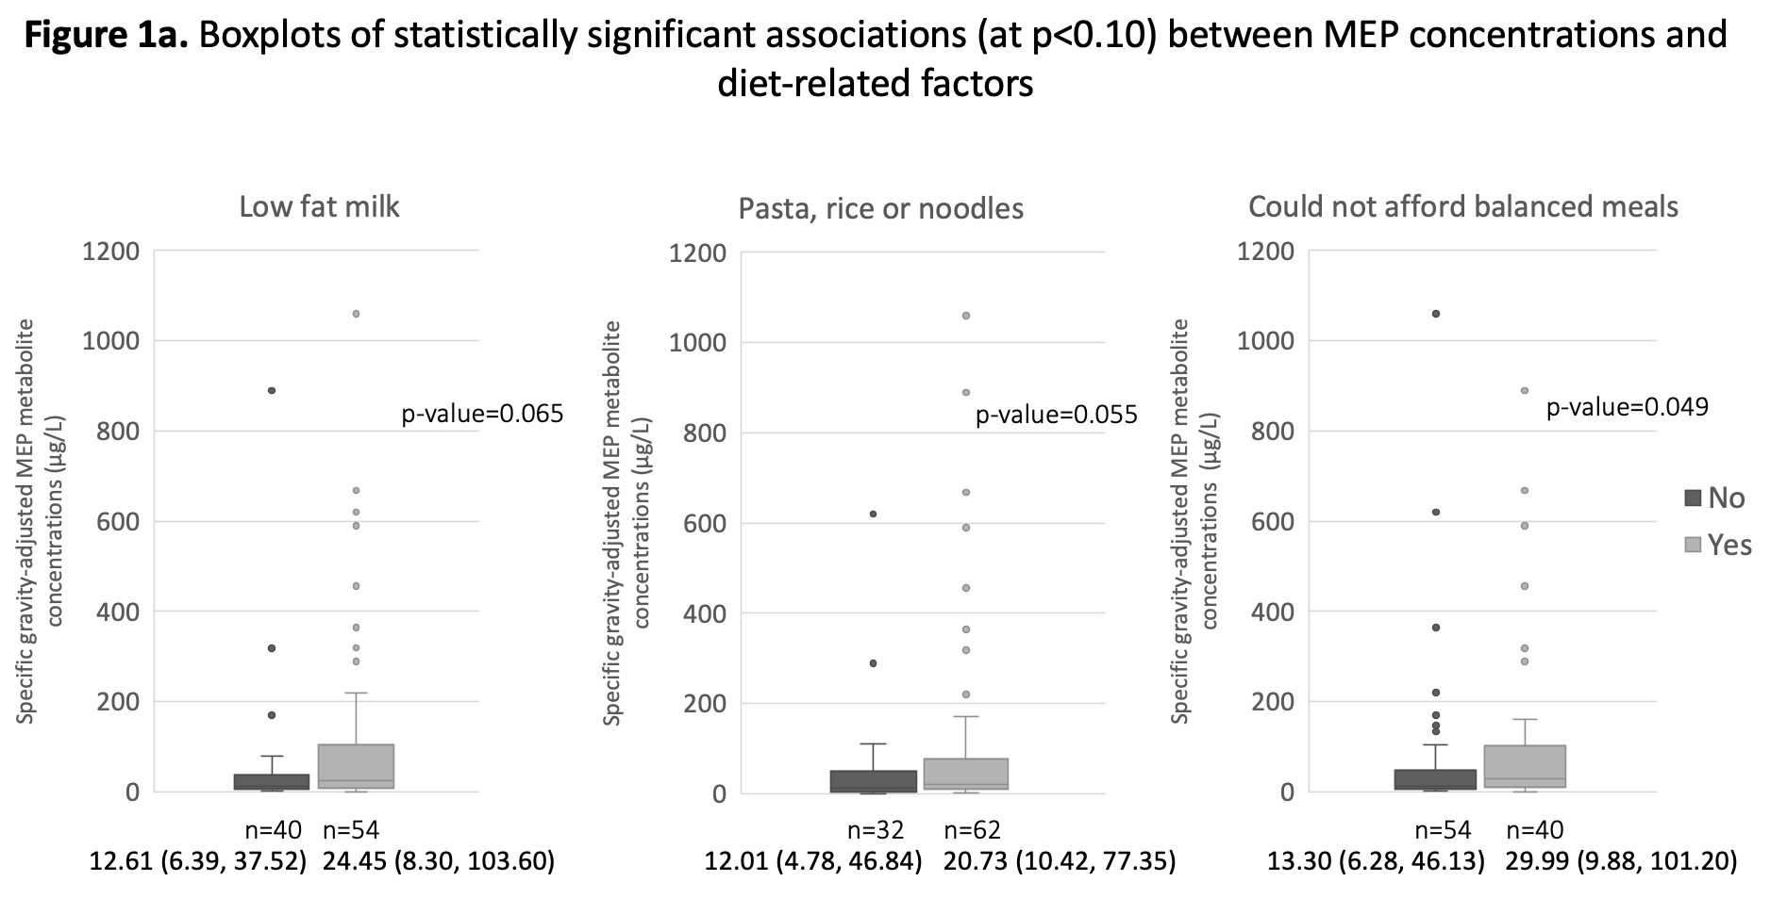

Values reported under the sample size for each response reflects p50,(p25, p75) concentrations.

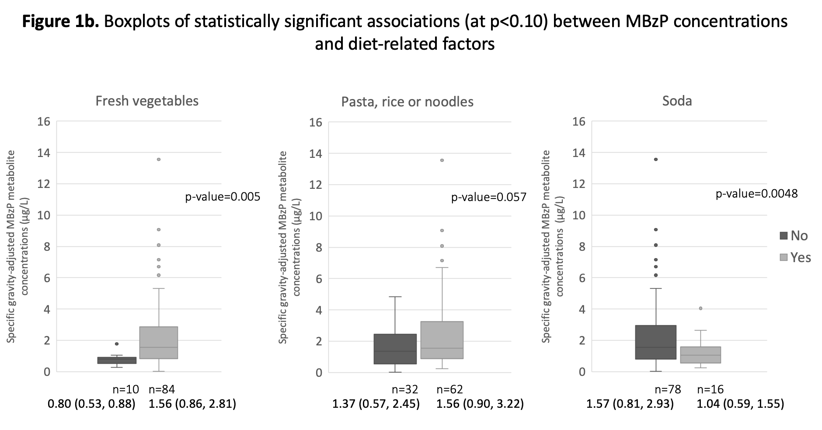

Values reported under the sample size for each response reflects p50,(p25, p75) concentrations.

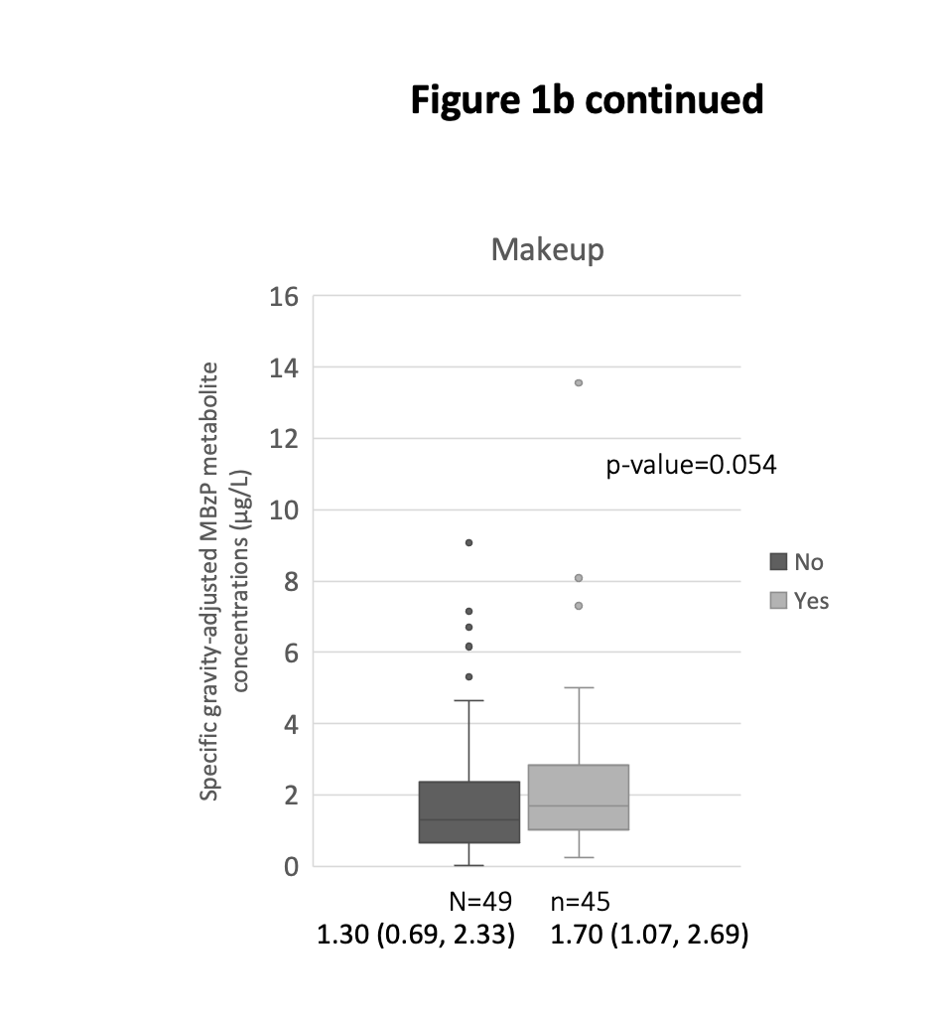

Values reported under the sample size for each response reflects p50,(p25, p75) concentrations.

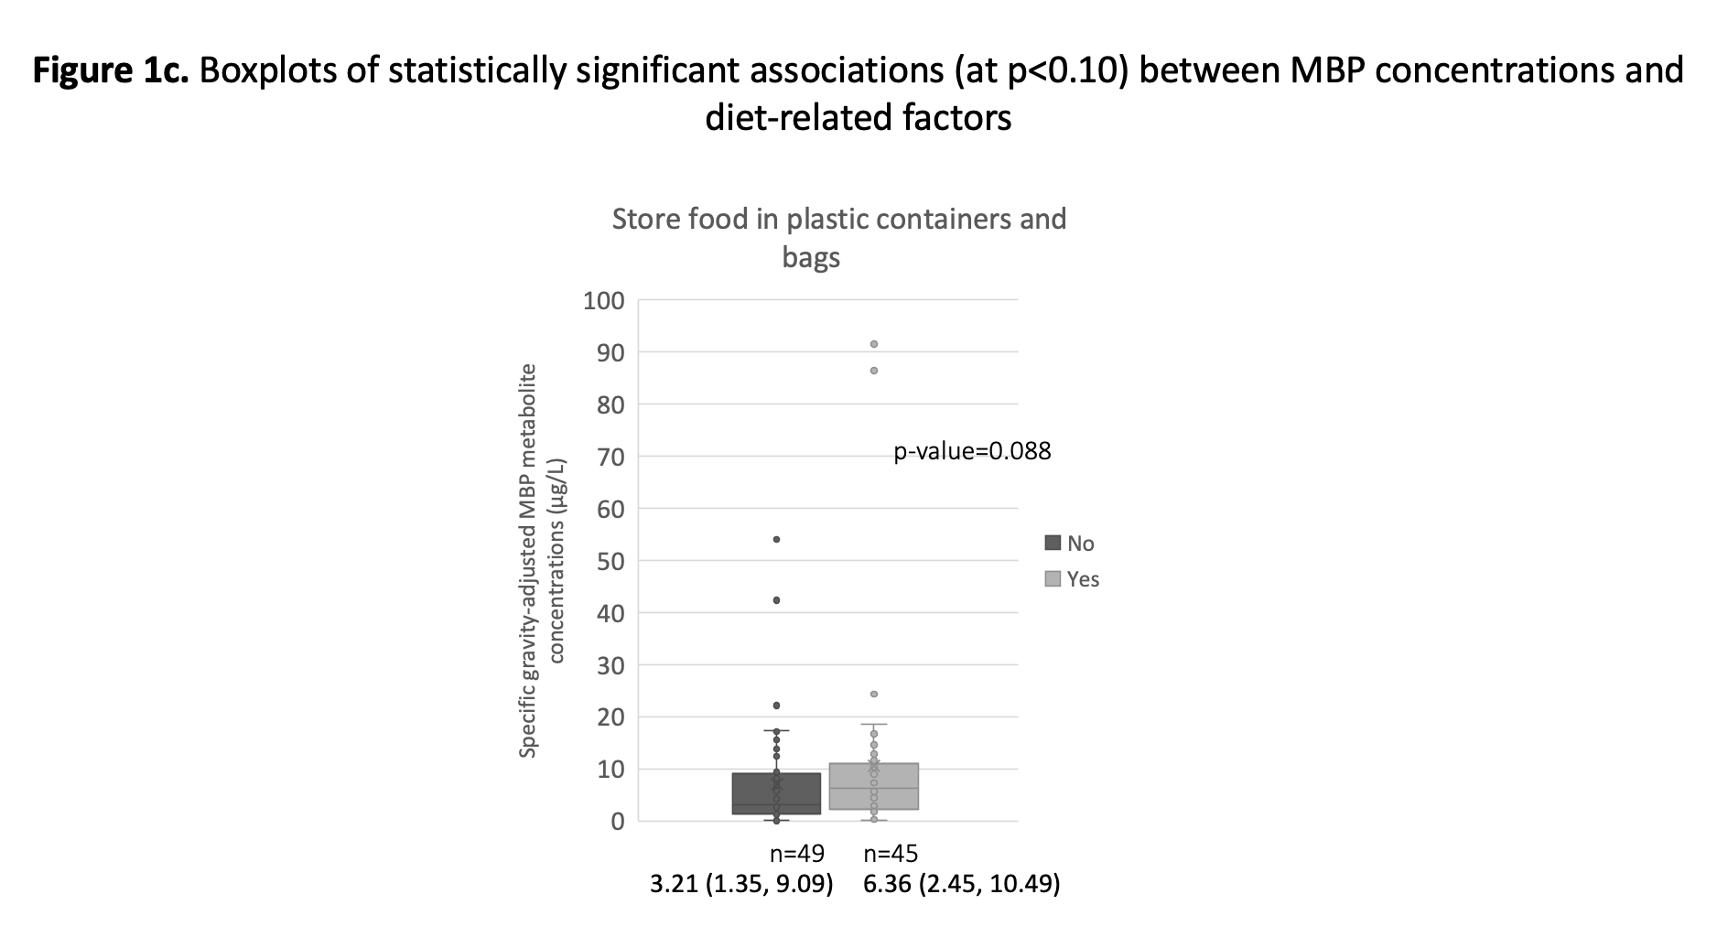

Values reported under the sample size for each response reflects p50,(p25, p75) concentrations.

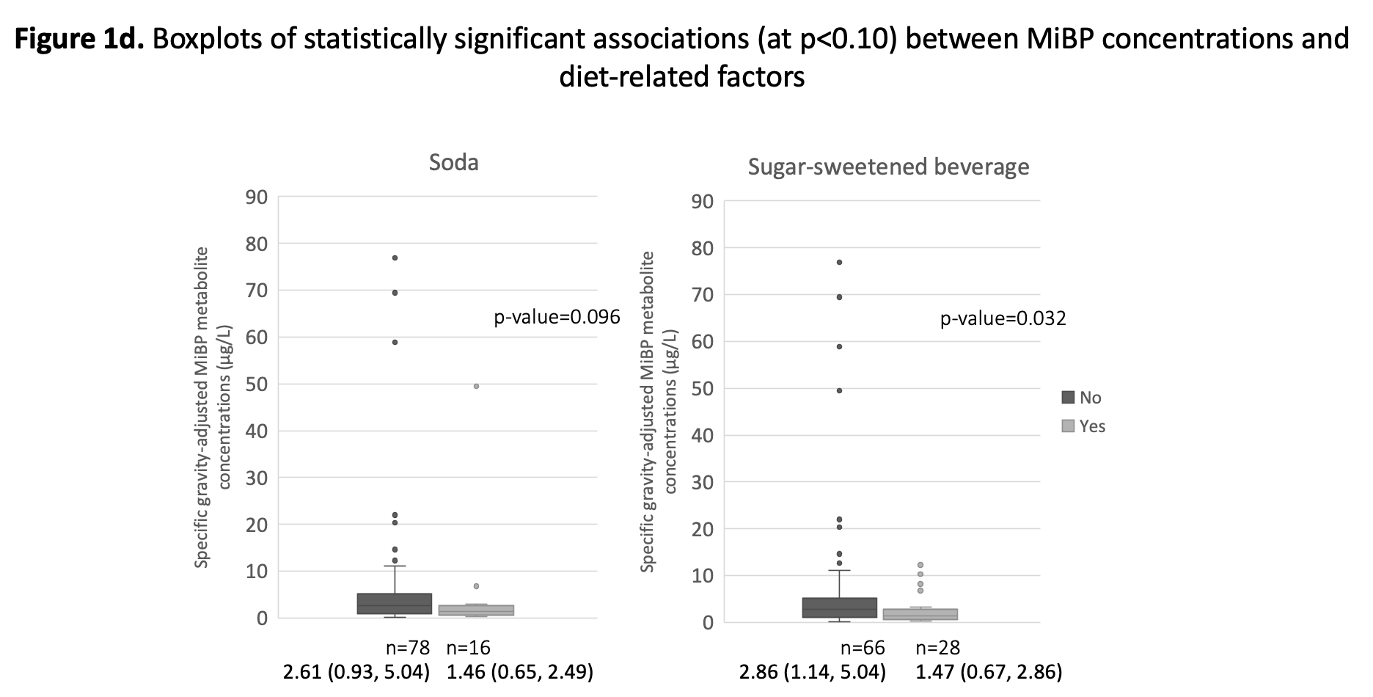

Values reported under the sample size for each response reflects p50,(p25, p75) concentrations.

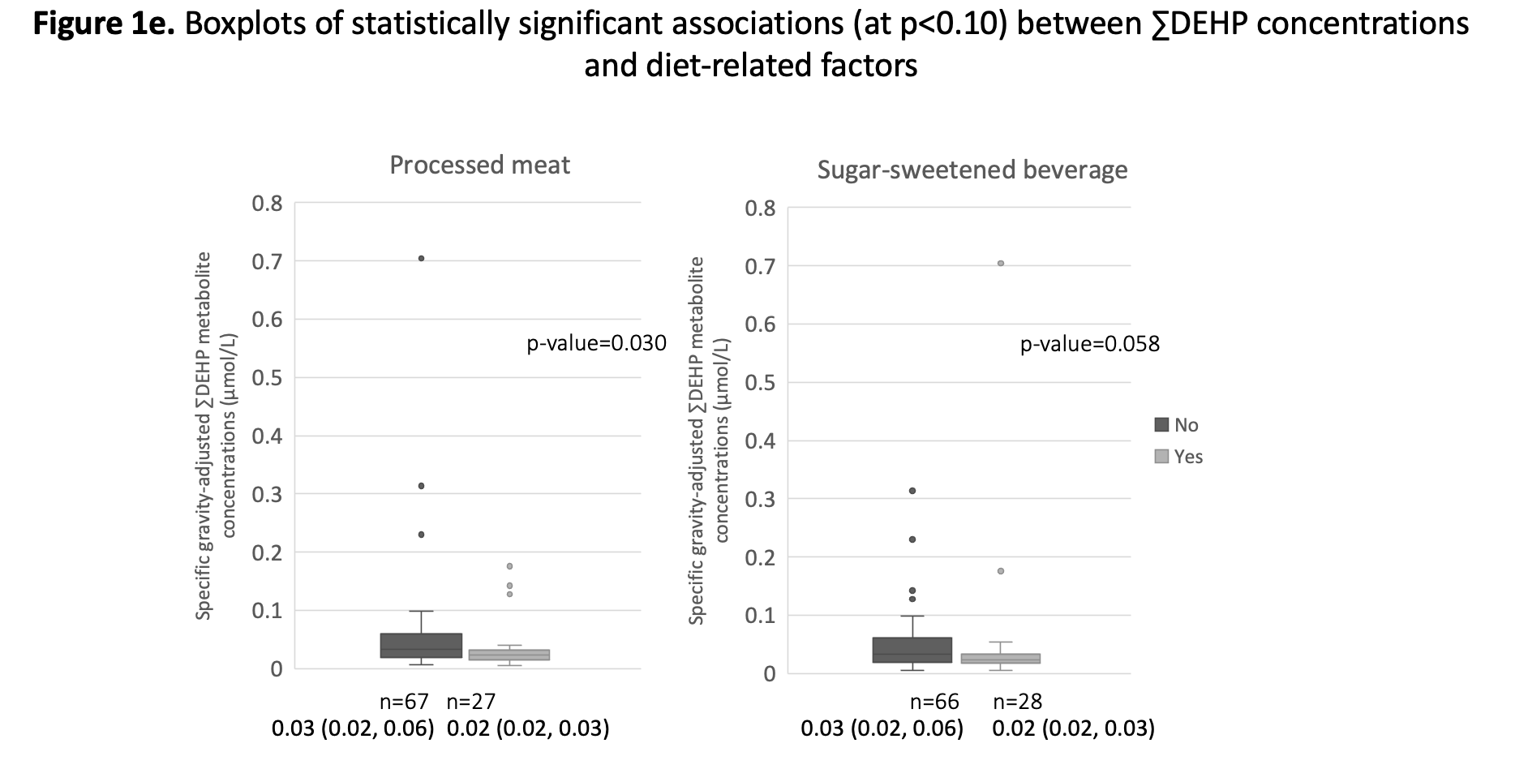

Values reported under the sample size for each response reflects p50,(p25, p75) concentrations.

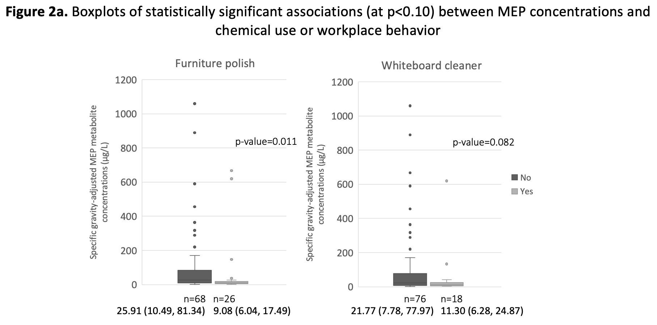

Values reported under the sample size for each response reflects p50,(p25, p75) concentrations.

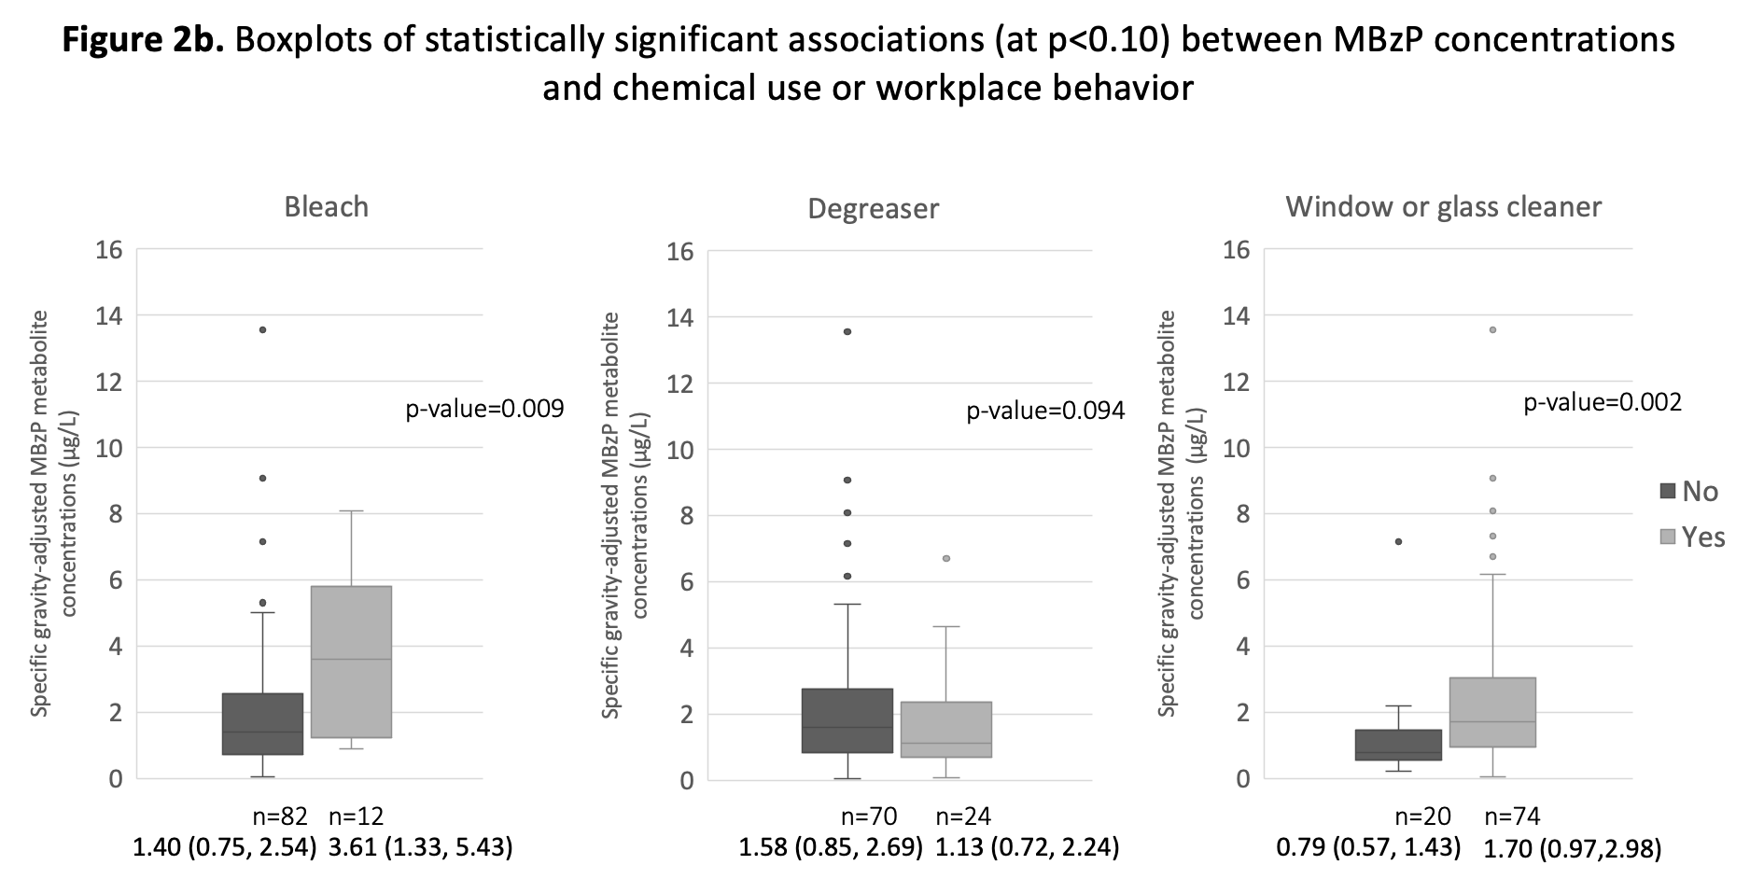

Values reported under the sample size for each response reflects p50,(p25, p75) concentrations.

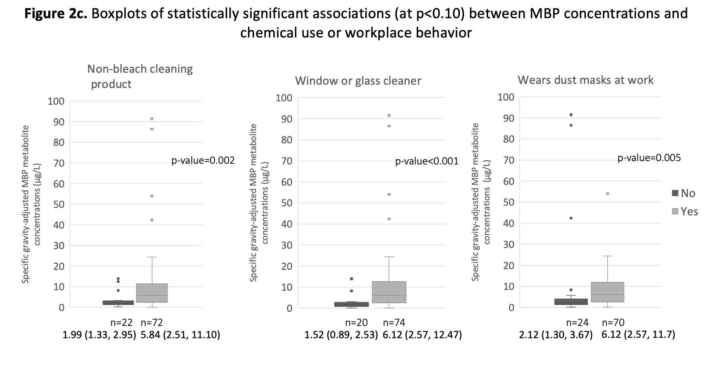

Values reported under the sample size for each response reflects p50,(p25, p75) concentrations.

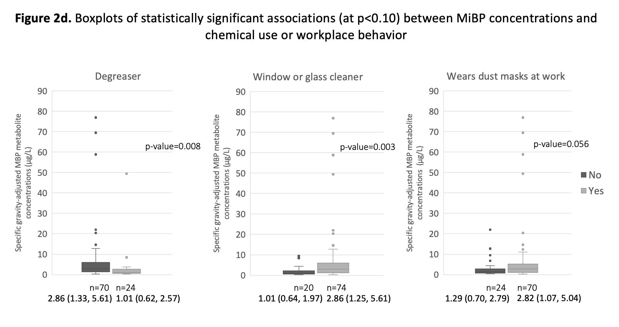

Values reported under the sample size for each response reflects p50,(p25, p75) concentrations.

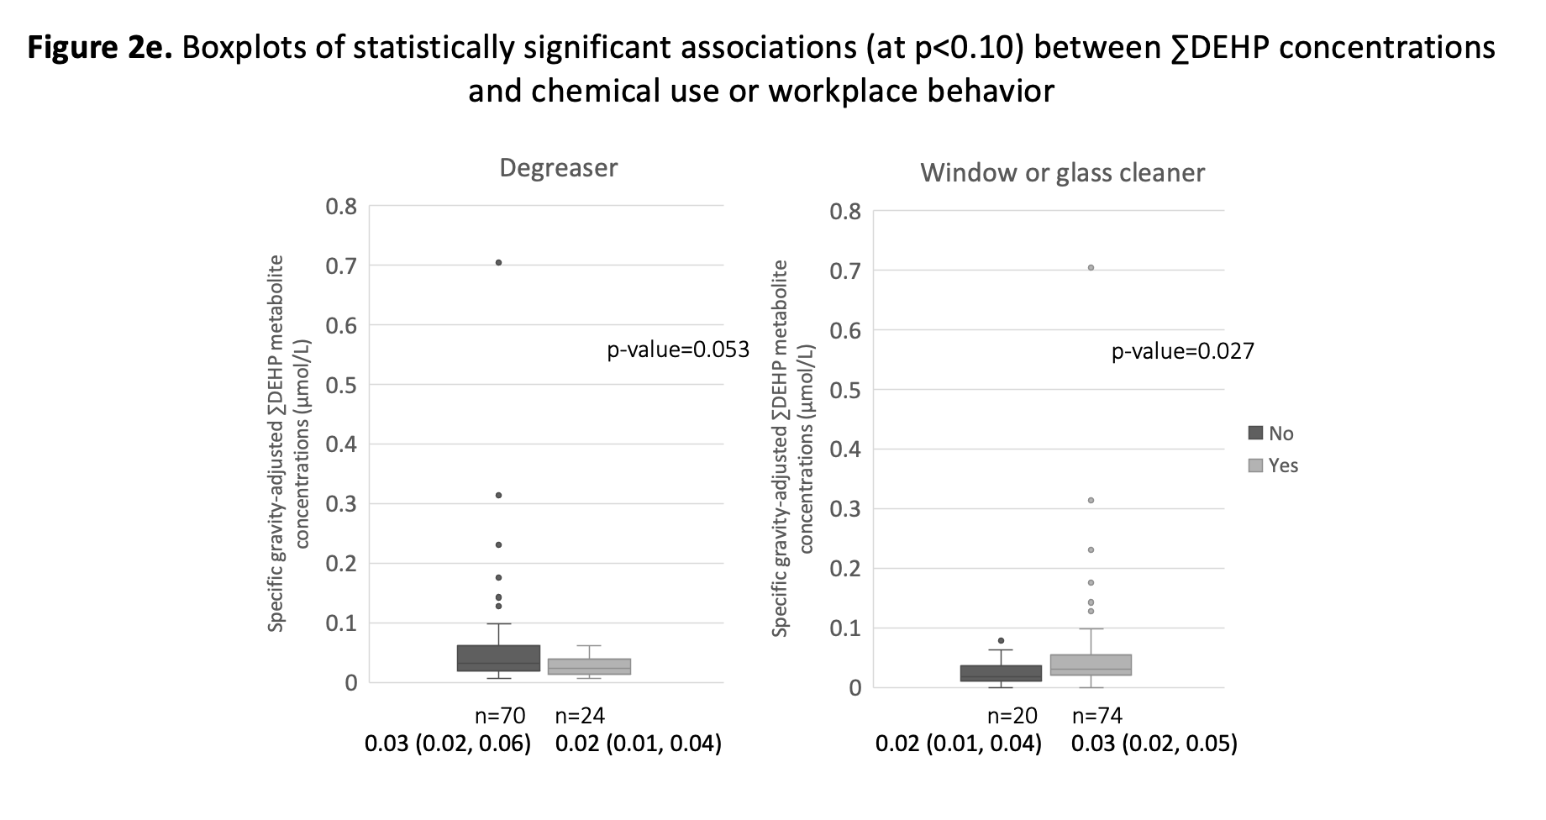

Values reported under the sample size for each response reflects p50,(p25, p75) concentrations.

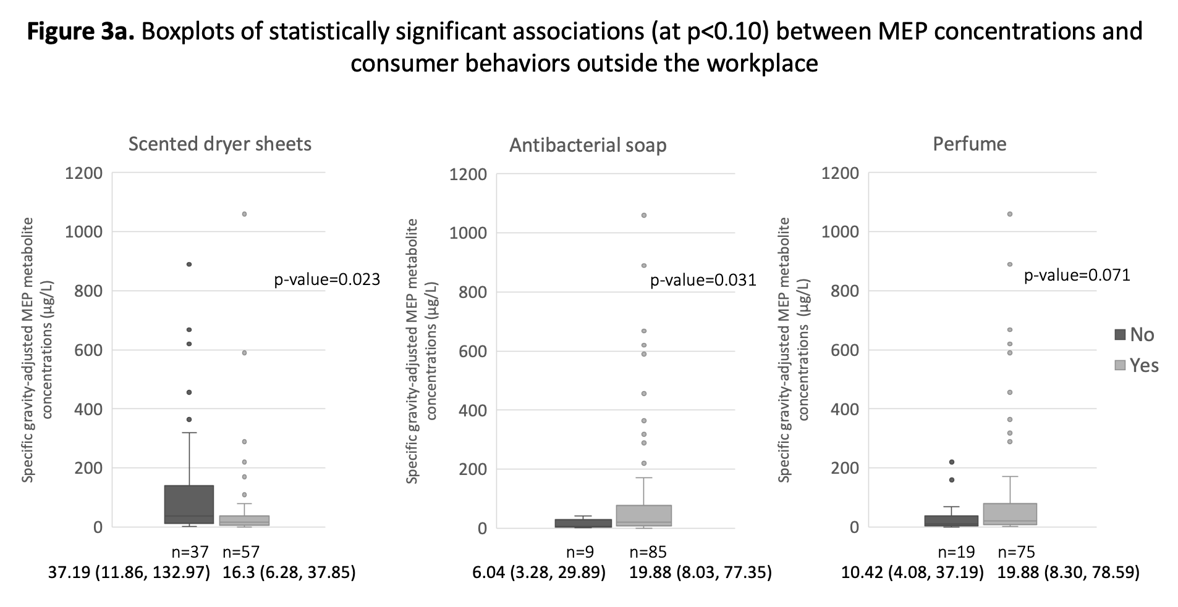

Values reported under the sample size for each response reflects p50,(p25, p75) concentrations.

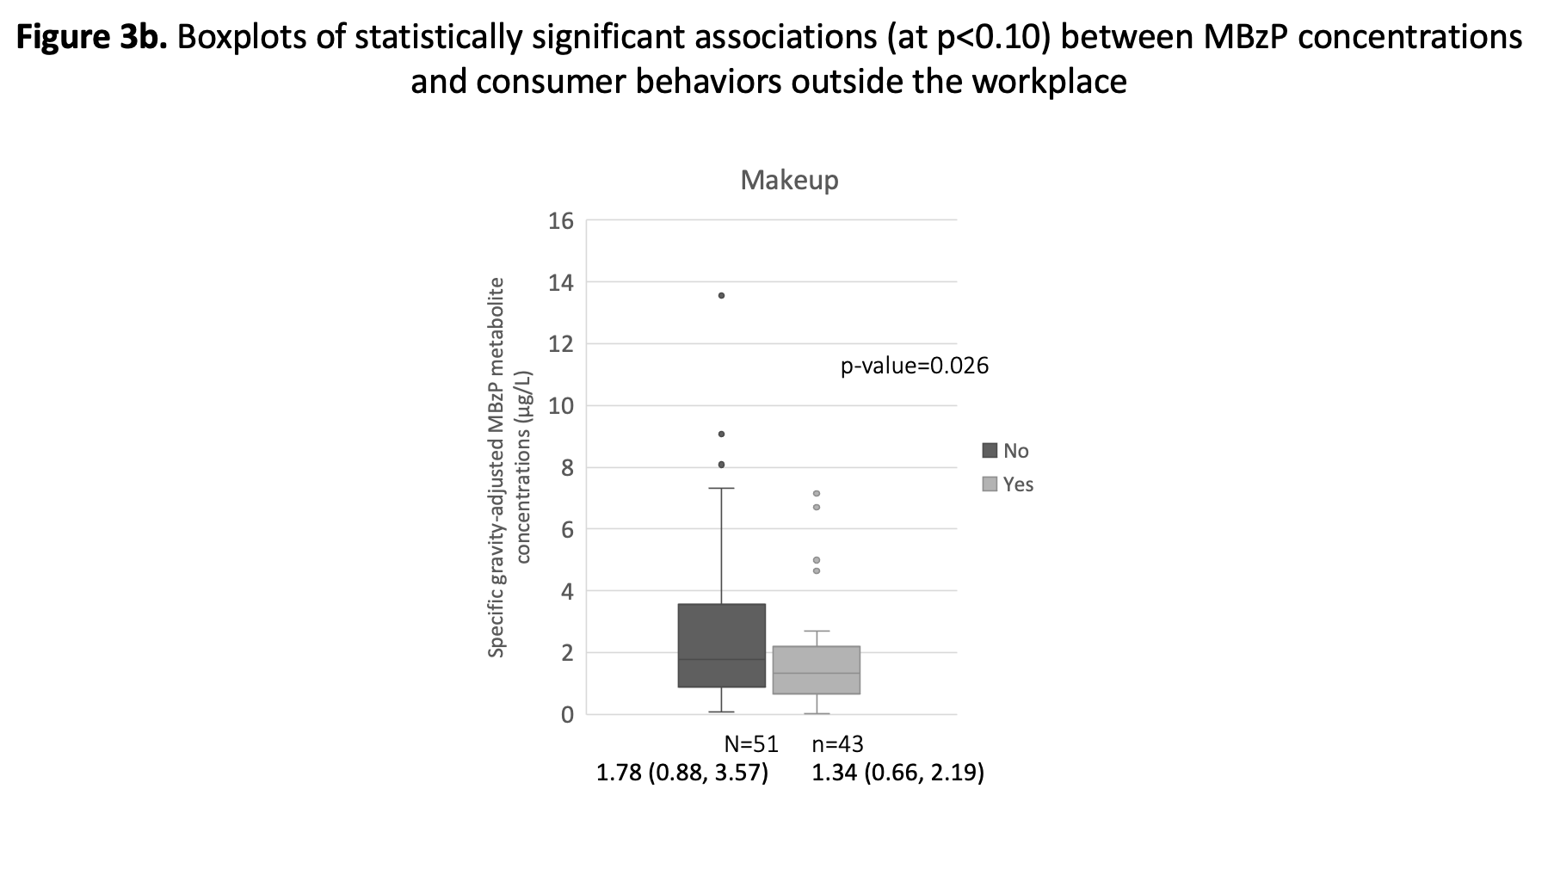
Values reported under the sample size for each response reflects p50,(p25, p75) concentrations.

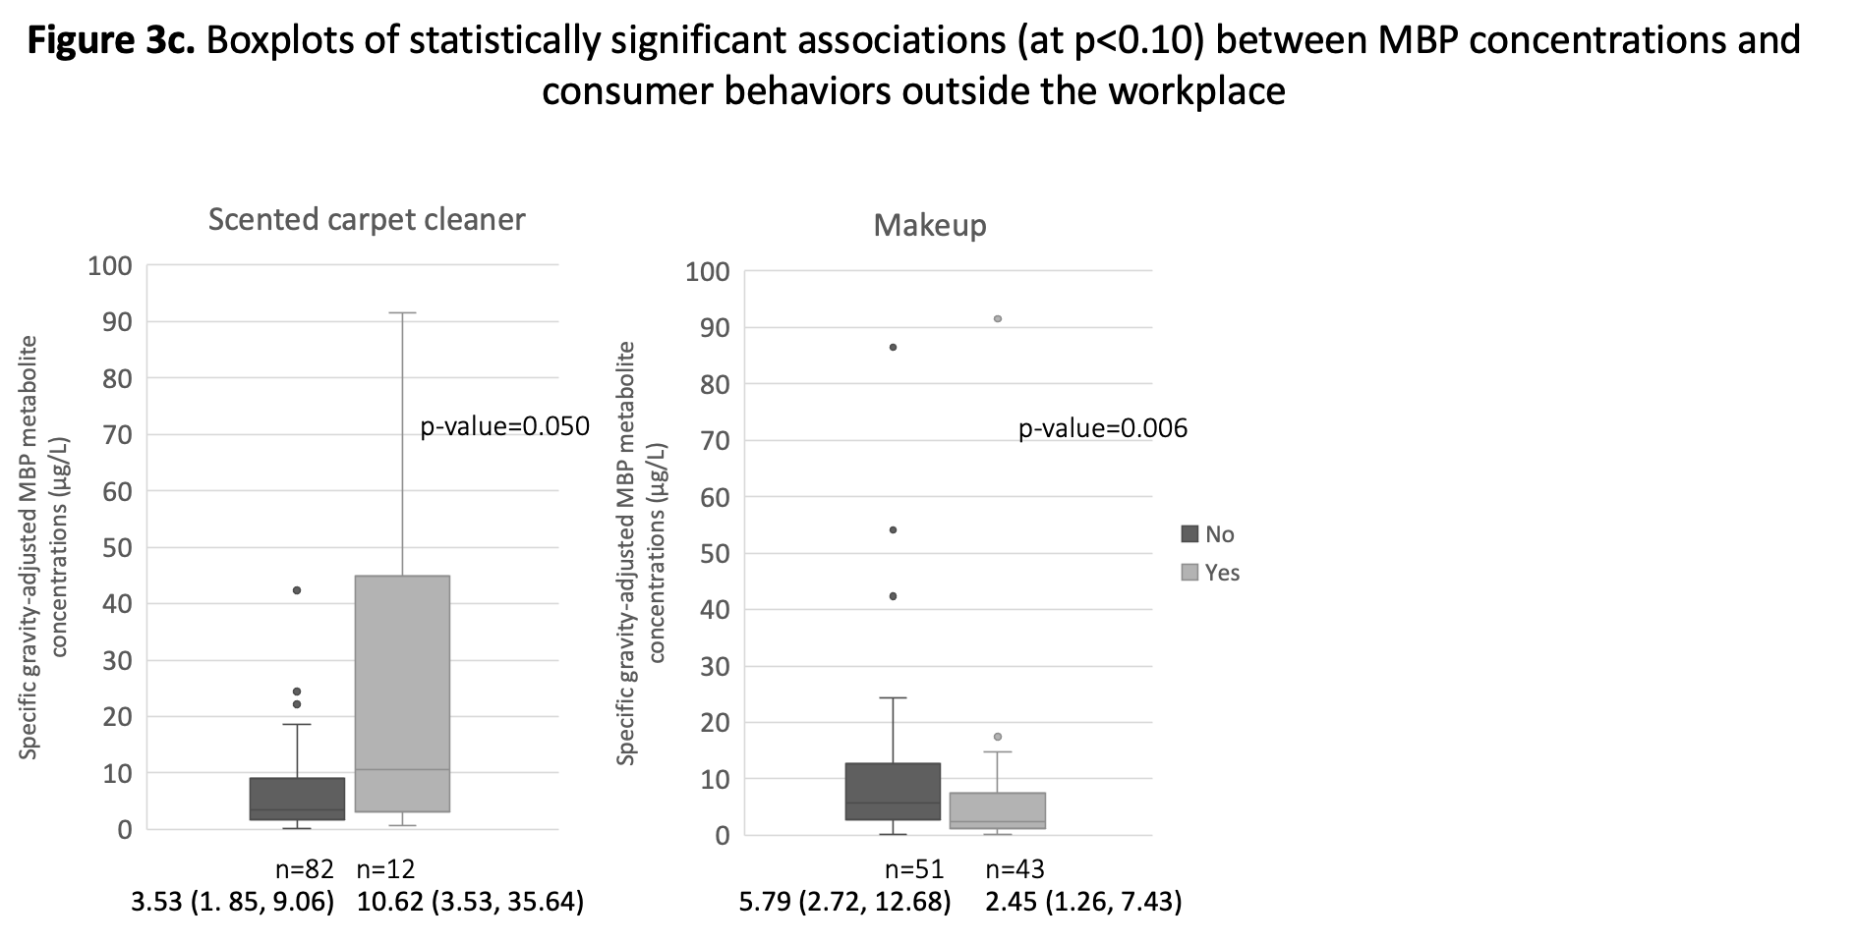

Values reported under the sample size for each response reflects p50,(p25, p75) concentrations.
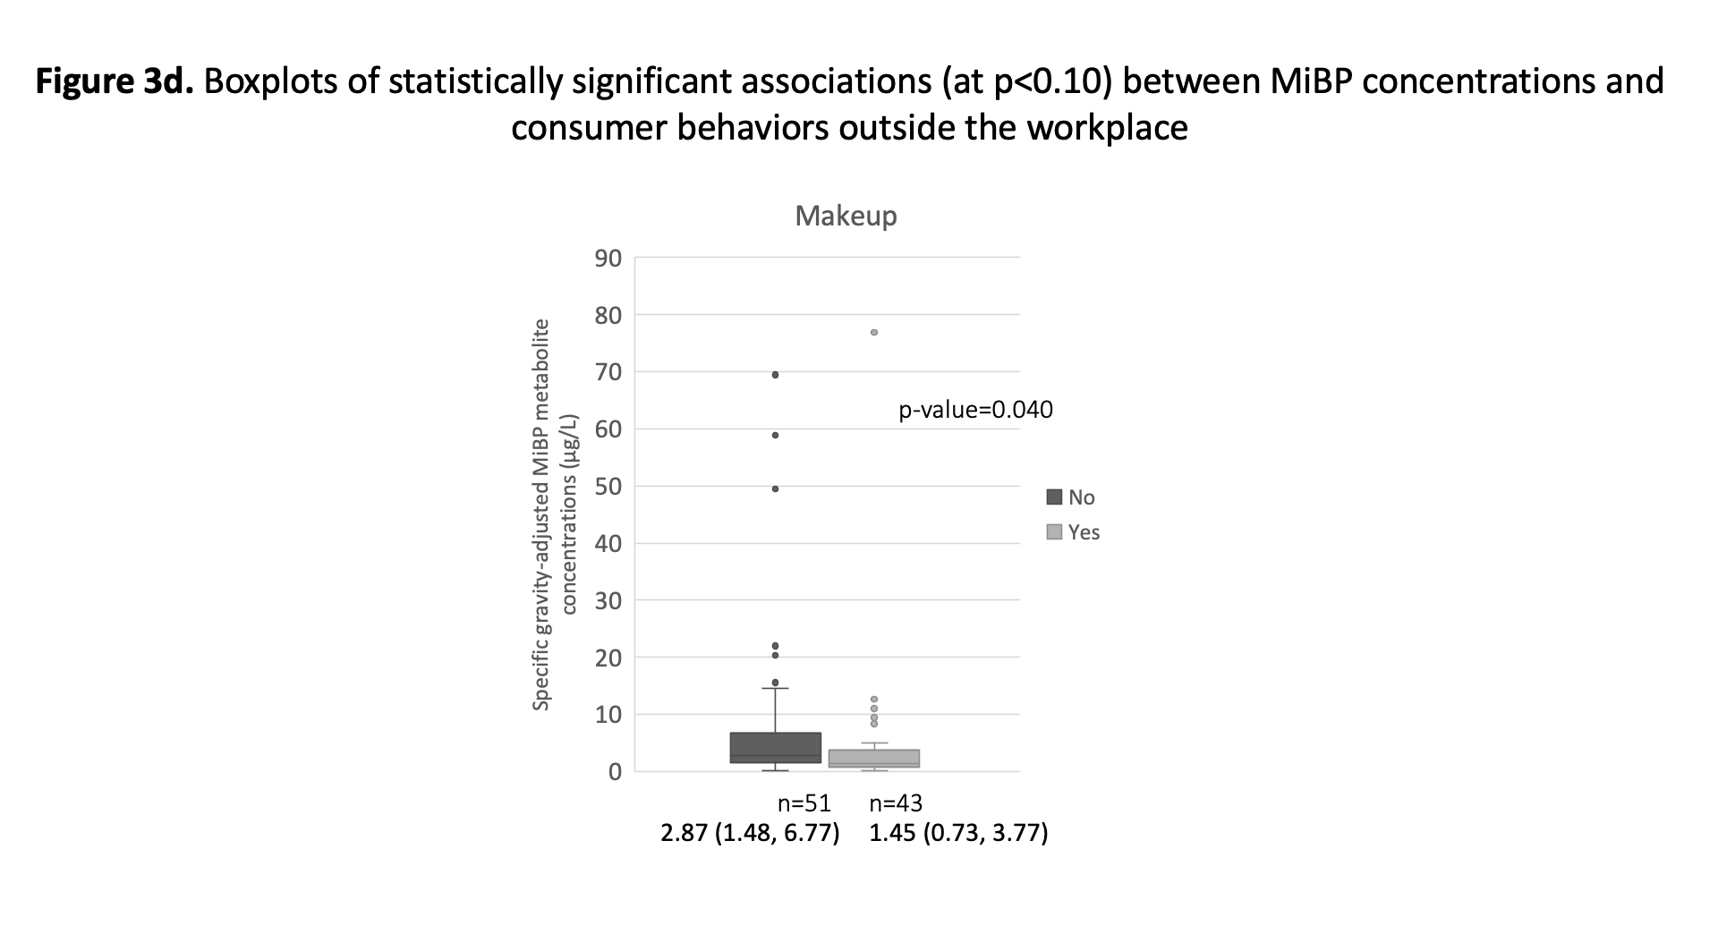

Values reported under the sample size for each response reflects p50,(p25, p75) concentrations.

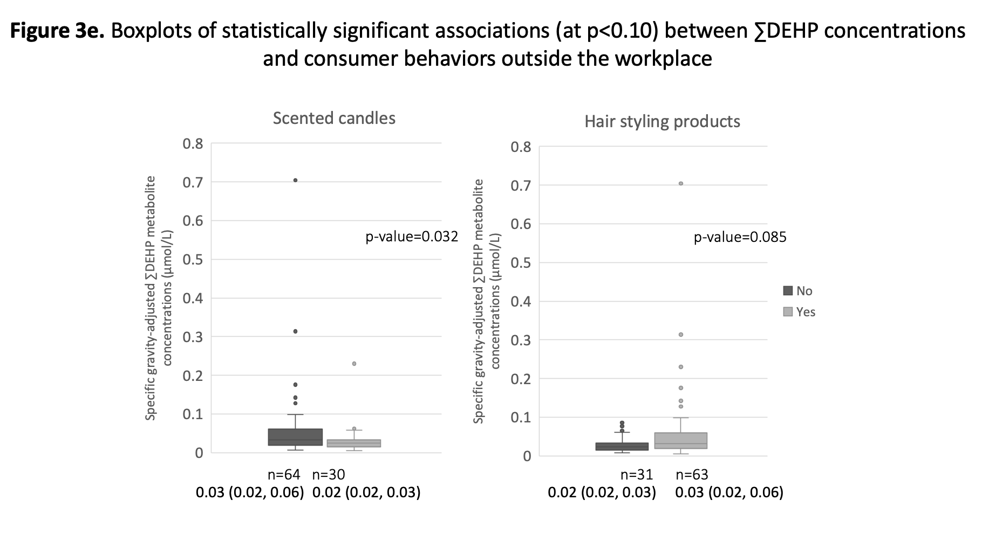

Values reported under the sample size for each response reflects p50,(p25, p75) concentrations.

Supplemental Table S3. Results from multiple testing using the Benjamini-Hochberg procedure.

Phthalate Metabolite | Predictor considered | MLR  p-value | Benjamini-Hochberg significance | Benjamini-Hochberg p-value
MEP | scented dryer sheets | 0.025 | Significant | 0.145
 | furniture polish | 0.029 | Significant | 0.145
 | low fat milk consumption | 0.078 | Significant | 0.220
 | pasta/rice/noodles | 0.1 | Significant | 0.220
 | perfume | 0.11 | Significant | 0.220
 | antibacterial soap | 0.153 | Not significant | 0.255
 | food insecurity | 0.199 | Not significant | 0.284
 | whiteboard cleaner | 0.327 | Not significant | 0.409
 | dining services worker | 0.612 | Not significant | 0.680
 | residential facilities worker | 0.717 | Not significant | 0.717
MBzP | pasta/rice/noodles | 0.005 | Significant | 0.040
 | bleach | 0.008 | Significant | 0.040
 | fresh vegetable consumption | 0.135 | Not significant | 0.270
 | makeup | 0.102 | Not significant | 0.270
 | residential facilities worker | 0.109 | Not significant | 0.270
 | foods stored in plastic | 0.166 | Not significant | 0.277
 | degreaser use at work | 0.248 | Not significant | 0.354
 | soda consumption | 0.374 | Not significant | 0.374
 | dining services worker | 0.335 | Not significant | 0.374
 | glass cleaner | 0.339 | Not significant | 0.374
MBP | scented carpet cleaner | 0.116 | Not significant | 0.348
 | residential facilities worker | 0.07 | Not significant | 0.348
 | dining services worker | 0.094 | Not significant | 0.348
 | foods stored in plastic | 0.16 | Not significant | 0.360
 | makeup | 0.247 | Not significant | 0.432
 | glass cleaner use at work | 0.288 | Not significant | 0.432
 | cleaner (not bleach) | 0.358 | Not significant | 0.460
 | renovations in the last 6 months | 0.557 | Not significant | 0.627
 | use of dust mask at work | 0.723 | Not significant | 0.723
MiBP | residential facilities worker | 0.077 | Not significant | 0.308
 | degreaser use at work | 0.075 | Not significant | 0.308
 | sugar sweetened beverages | 0.354 | Not significant | 0.520
 | makeup | 0.39 | Not significant | 0.520
 | dining services worker | 0.283 | Not significant | 0.520
 | glass cleaner use at work | 0.256 | Not significant | 0.520
 | soda consumption | 0.593 | Not significant | 0.678
 | use of dust mask at work | 0.716 | Not significant | 0.716
DEHP | processed meat consumption | 0.098 | Significant | 0.196
 | use of hairstyling products | 0.084 | Significant | 0.196
 | scented candles | 0.085 | Significant | 0.196
 | degreaser use at work | 0.033 | Significant | 0.196
 | glass cleaner use at work | 0.176 | Not significant | 0.282
 | sugar sweetened beverages | 0.728 | Not significant | 0.832
 | residential facilities worker | 0.703 | Not significant | 0.832
 | dining services worker | 0.936 | Not significant | 0.936
Abbreviations: MLR, Multivariable linear regression model.

Supplemental Table S4. Comparison of median concentrations (µg/L) with phthalate concentrations from studies in other countries.
 | Present study  (Sampling period: 2017-2018) |  |  |  |  |  | Canadian Health Measures Survey (Sampling period: 2009-2011; Country: Canada)  (Haines et al., 2017) |  | German Environmental Specimen Bank (Sampling period: 2014-2015; Country: Germany)  (Koch et al., 2017) |  | EDEN and PALAGIE Cohorts (Sampling period: 2002-2006; Country: France)  (Philippat et al., 2012)
 | Adults aged 19-65 years  (n=94) |  | Males 19-65 years  (n=9) |  | Females 19-65 years  (n=85) |  | Canadians aged 3-79 years  (n=2,498-2,561; varies based on metabolite) |  | Male and female German university students aged 20-29 years (n=60) |  | Pregnant women in France  (n=287)
Phthalate metabolite | DF% | Phthalate metabolite concentration, µg/L  P₅₀ (P_{25,75}) | DF% | Phthalate metabolite concentration, µg/L  P₅₀ (P_{25,75}) | DF% | Phthalate metabolite concentration, µg/L  P₅₀ (P_{25,75}) | DF% | Phthalate metabolite concentration, µg/L  P₅₀ (P_{25,75}) | DF% | Phthalate metabolite concentration, µg/L  P₅₀ | DF% | Phthalate metabolite concentration, µg/L  P₅₀
MBP | 88 | U: 3.17 (1.27, 9.54)  SG: 4.35 (1.86, 9.41) | 100 | U: 7.22 (3.13, 22.2)  SG: 6.36 (4.70, 17.2) | 87 | U: 2.97 (1.20, 9.01)  SG: 3.68 (1.85, 9.09) | 100 | U: 20 (11, 36) | -- | U: 8.0 | 100 | U: 48.1
MBzP | 93 | U: 1.33 (0.53, 3.01)  SG: 1.51 (0.78, 2.66) | 100 | U: 1.77 (1.38, 3.30)  SG: 2.33 (0.88, 3.22) | 91 | U: 1.29 (0.53, 2.81)  SG: 1.49 (0.76, 2.65) | 100 | U: 7.1 (3.4, 16) | -- | U: 1.2 | 100 | U: 17.7
MCPP | 43 | U: <LOD (<LOD, 0.48)  SG: <LOD (<LOD, 0.61) | 67 | U: 0.44 (<LOD, 0.59)  SG: 0.38 (<LOD, 0.60) | 40 | U: <LOD (<LOD , 0.45)  SG: <LOD (<LOD, 0.66) | 99.9 | U: 2.0 (1.0, 3.8) | -- | U: 0.3 | 98 | U: 2.2
MECPP | 97 | U: 3.06 (1.09, 5.77)  SG: 3.24 (1.88, 5.71) | 100 | U: 3.03 (2.11, 3.46)  SG: 2.87 (2.67, 3.02) | 97 | U: 3.12 (1.06, 6.11)  SG: 3.47 (1.88, 6.49) | -- | -- | -- | U: 3.8 | 100 | U: 43.8
MEHHP | 99 | U: 2.98 (1.43, 5.67)  SG: 3.44 (2.24, 6.39) | 100 | U: 2.68 (1.87, 3.27)  SG: 2.37 (1.94, 2.74) | 99 | U: 3.15 (1.40, 6.21)  SG: 3.61 (2.27, 6.44) | 99.9 | U: 23 (11, 47) | -- | U: 4.2 | 100 | U: 32.3
MEHP | 2 | U: <LOD (<LOD, <LOD)  SG: <LOD (<LOD, <LOD) | 0 | U: <LOD (<LOD, <LOD)  SG: <LOD (<LOD, <LOD) | 2 | U: <LOD (<LOD, <LOD)  SG: <LOD (<LOD, <LOD) | 99.4 | U: 1.9 (0.97, 3.4) | -- | U: 1.1 | 92 | U: 7.1
MEOHP | 93 | U: 1.49 (0.60, 3.21)  SG: 1.58 (0.88, 3.57) | 100 | U: 1.41 (0.88, 1.57)  SG: 1.35 (0.94, 1.44) | 92 | U: 1.52 (0.57, 3.45)  SG: 1.73 (0.88, 3.74) | 100 | U: 7.4 (4.1, 14) | -- | U: 3.2 | 99.7 | U: 25.0
MEP | 100 | U: 12.8 (5.85, 59.9)  SG: 18.3 (7.31, 61.2) | 100 | U: 12.6 (8.70, 35.0)  SG: 16.9 (7.31, 35.9) | 100 | U: 13.0 (5.31, 66.3)  SG: 19.2 (7.42, 67.9) | 100 | U: 42 (18, 100) | -- | U:13.5 | 100 | U: 110.22
MiBP | 71 | U: 1.73 (<LOD, 4.79)  SG: 2.30 (<LOD, 4.77) | 89 | U: 2.30 (2.00, 5.62)  SG: 2.23 (1.68, 3.34) | 69 | U: 1.56 (<LOD, 4.62)  SG: 2.32 (<LOD, 4.77) | -- | -- | -- | U: 9.8 | 100 | U: 45.9

Supplemental Table S4. Comparison of median concentrations (µg/L) with phthalate concentrations from studies in other countries. (continued).
 | Present study  (Sampling period: 2017-2018) |  |  |  |  |  | (Sampling period: 2012-2014; Country: Korea)  (Choi, 2017) |  |  | (Sampling period: 2011; Country: Israel)  (Berman et al., 2013) |  |  | Generation R (Sampling period: 2004-2005)  Country: Netherlands  (Philips et al., 2018)
 | Adults aged 19-65 years  (n=94) |  | Males 19-65 years  (n=9) |  | Females 19-65 years  (n=85) |  | Male and female adults aged ≥19 years  (n=6,252-6,406; varied based on metabolite) |  |  | Adults aged 20-74 years  (n=248) |  |  | Pregnant women in Rotterdam  (n=877)
Phthalate metabolite | DF% | Phthalate metabolite concentration, µg/L  P₅₀ (P_{25,75}) | DF% | Phthalate metabolite concentration, µg/L  P₅₀ (P_{25,75}) | DF% | Phthalate metabolite concentration, µg/L  P₅₀ (P_{25,75}) |  | DF% | Phthalate metabolite concentration, µg/L  P₅₀ (P_{25,75}) |  | DF% | Phthalate metabolite concentration, µg/L  P₅₀ | DF% | Phthalate metabolite concentration, µg/L  P₅₀ (P_{25,75})
MBP | 88 | U: 3.17 (1.27, 9.54)  SG: 4.35 (1.86, 9.41) | 100 | U: 7.22 (3.13, 22.2)  SG: 6.36 (4.70, 17.2) | 87 | U: 2.97 (1.20, 9.01)  SG: 3.68 (1.85, 9.09) |  | 99.7 | U: 24.9 (13.1, 44.2) |  | 99 | U: 27.9 | 99.0 | U: 15.31 (6.73, 30.26)
MBzP | 93 | U: 1.33 (0.53, 3.01)  SG: 1.51 (0.78, 2.66) | 100 | U: 1.77 (1.38, 3.30)  SG: 2.33 (0.88, 3.22) | 91 | U: 1.29 (0.53, 2.81)  SG: 1.49 (0.76, 2.65) |  | 97.7 | U: 2.80 (1.32, 5.84) |  | 92 | U: 4.3 | 91.3 | U: 6.19 (2.85, 11.92)
MCPP | 43 | U: <LOD (<LOD, 0.48)  SG: <LOD (<LOD, 0.61) | 67 | U: 0.44 (<LOD, 0.59)  SG: 0.38 (<LOD, 0.60) | 40 | U: <LOD (<LOD , 0.45)  SG: <LOD (<LOD, 0.66) |  | -- | -- |  | -- | -- | 100 | U: 1.41 (0.75, 2.70)
MECPP | 97 | U: 3.06 (1.09, 5.77)  SG: 3.24 (1.88, 5.71) | 100 | U: 3.03 (2.11, 3.46)  SG: 2.87 (2.67, 3.02) | 97 | U: 3.12 (1.06, 6.11)  SG: 3.47 (1.88, 6.49) |  | 100 | U: 20.9 (12.2, 34.4) |  | 100 | U: 34.2 | 99.9 | U: 15.86 (8.00, 31.88)
MEHHP | 99 | U: 2.98 (1.43, 5.67)  SG: 3.44 (2.24, 6.39) | 100 | U: 2.68 (1.87, 3.27)  SG: 2.37 (1.94, 2.74) | 99 | U: 3.15 (1.40, 6.21)  SG: 3.61 (2.27, 6.44) |  | 99.8 | U: 18.7 (10.3, 31.7) |  | 100 | U: 30.4 | 99.8 | U: 11.40 (5.67, 23.22)
MEHP | 2 | U: <LOD (<LOD, <LOD)  SG: <LOD (<LOD, <LOD) | 0 | U: <LOD (<LOD, <LOD)  SG: <LOD (<LOD, <LOD) | 2 | U: <LOD (<LOD, <LOD)  SG: <LOD (<LOD, <LOD) |  | -- | -- |  | 100 | U: 11.2 | 76.4 | U: 0.33 (0.16, 0.63)
MEOHP | 93 | U: 1.49 (0.60, 3.21)  SG: 1.58 (0.88, 3.57) | 100 | U: 1.41 (0.88, 1.57)  SG: 1.35 (0.94, 1.44) | 92 | U: 1.52 (0.57, 3.45)  SG: 1.73 (0.88, 3.74) |  | 99.8 | U: 13.0 (7.27, 22.1) |  | 100 | U: 17.1 | 100 | U: 7.63 (3.43, 15.54)
MEP | 100 | U: 12.8 (5.85, 59.9)  SG: 18.3 (7.31, 61.2) | 100 | U: 12.6 (8.70, 35.0)  SG: 16.9 (7.31, 35.9) | 100 | U: 13.0 (5.31, 66.3)  SG: 19.2 (7.42, 67.9) |  | -- | -- |  | -- | -- | 99.9 | U: 130.99 (39.68, 438.52)
MiBP | 71 | U: 1.73 (<LOD, 4.79)  SG: 2.30 (<LOD, 4.77) | 89 | U: 2.30 (2.00, 5.62)  SG: 2.23 (1.68, 3.34) | 69 | U: 1.56 (<LOD, 4.62)  SG: 2.32 (<LOD, 4.77) |  | -- | -- |  | 100 | U: 37.6 | 99.8 | U: 20.28 (9.14, 42.51)
Abbreviations: U, uncorrected metabolite concentrations, (µg/L); SG, Specific-gravity corrected metabolite concentrations, (µg/L); LOD, limit of detection; DF%, detection frequency percentage; P_{25,50,75}, 25th, 50th, and 75th percentiles, respectively; --, values not reported.

