Supplementary Information

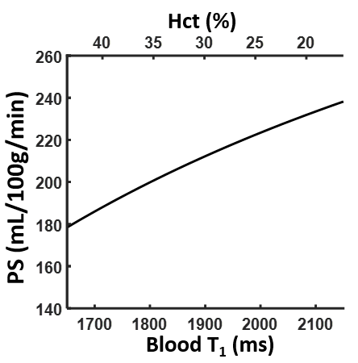

**Figure S1. Effect of blood T1 and hematocrit on PS quantification, at a WEPCAST signal of 2.7% of M0 and CBF of 106mL/100g/min (average value of the entire cohort).**