**Illustrating the Point: Choosing the right ART for the message**

Posted on September 8, 2015 by **Amy Filko, Pietra Check, Michael Flynn, Nura Sadeghpour**

[[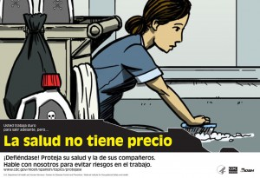](https://blogs.cdc.gov/niosh-science-blog/files/2015/09/porteja4.jpg)](https://blogs.cdc.gov/niosh-science-blog/files/2015/09/porteja4.jpg)If you wanted to deliver a series of public health messages to people gathered at a busy Consulate (think Saturday at the DMV), or at another trusted community organization, how would you do it?

We investigated the answer to that question specifically for a Spanish-speaking immigrant worker population, and specifically for conveying information designed to prevent work-related injury, illness, and death. The result of this process is a multi-faceted project that includes 1) a partnership with the Mexican Consulates and the [Ventanillas de Salud](http://ventanillas.org/index.php/es/) and 2) the creation of [illustrated educational materials](http://go.usa.gov/362PH) for workers including four brochures, two posters, and five videos: [***Protéjase***](http://go.usa.gov/362E4)***.***

The [first blog of this series](http://blogs.cdc.gov/niosh-science-blog/2015/09/01/protejase1/) described the content and utility of the [***Protéjase***](http://go.usa.gov/362E4) materials. In future blogs we will describe other key elements of this project, including the qualitative process we used to test our imagery with the community and the role and rationale of the NIOSH partnership with the U.S. Mexican Consulates, whose infrastructure has expanded to improve the health and well-being of their population, reaching the largest Spanish-speaking immigrant population in the country. This blog is about a small but vital part of this project—**choosing the right kind of art for the educational materials**.

The educational materials we created follow both fictional and real characters as they navigate a series of workplace risks. Our key message is: “Return home from work safely and with dignity.” We wanted our audience to know that help is available, so we developed the following call to action: “If you are worried, go to one of the many organizations that can help immigrants get information and services related to staying safe and healthy at work.”

**Should we invest in good visuals?**

To create these materials we asked ourselves a series of questions along the way. We started with a basic question-- should we invest in good visuals? We didn’t need scholarly articles to make a compelling case that good visuals attract attention in a world filled with competing messages, Madison Avenue figured that out for us a long time ago. But good imagery does more than attract attention, in visual learners (about 65% of the population, according to [Michigan State University](https://tech.msu.edu/teaching/course-guidelines/learning-styles/)) it also helps the audience understand, retain, connect with and act upon the key messages. In addition, anecdotal evidence from the NIOSH/Mexican Consulates partnership shows that many of the immigrants in our intended audience have low literacy levels, even in their native language. This assumption is supported by the 2009 Pew Hispanic Center finding that more than one-third of foreign-born Latinos in the U.S. had less than a 9th grade education. Strong imagery would help us communicate a clear message to audience members with low reading levels.

**What medium makes sense?**

Having decided that it was worth investing in good visuals, we needed to determine whether to enlist a photographer and find subjects, or enlist an illustrator. There is evidence to support that both [fotonovelas](http://en.wikipedia.org/wiki/Fotonovela) (documents that tell a story through photographs) and illustrated novels are popular with our target audience. Here is why we chose the latter:

**Emotional impact on viewer**— An art teacher once suggested that co-author Amy Filko leave a little bit of each drawing unfinished because people like to fill in the holes with their own mind. Illustration allows for that. We needed characters specific enough for people to identify with as workers, but general enough for them to fill in the blanks with their own stories.

**Adaptability**— During the development of a document, especially one focused on safety and health, it may go through many rounds of review and revision to ensure that the final product is accurate. Once a photograph is taken, it may be difficult to continuously edit or reshoot in order to align the document with safety practice due to time, coordination, and significant costs. An illustration is much more adaptable to change. We needed to be able to control the environment of our subjects and to edit out elements that didn’t pass muster with our experts. Here is one example from this project:

[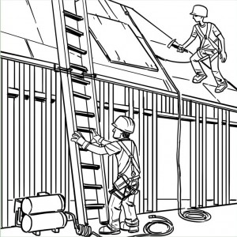](https://blogs.cdc.gov/niosh-science-blog/files/2015/09/const-p2_trimmed.jpg)

Our illustrator’s rough draft. (Click  for larger images).

[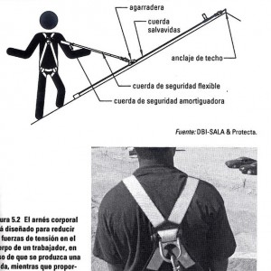](https://blogs.cdc.gov/niosh-science-blog/files/2015/09/NAHB-Photo-Harness-back.jpg)

Guidance for edits from NIOSH experts.

[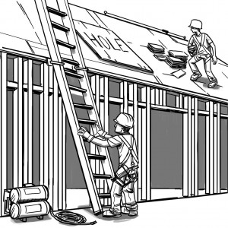](https://blogs.cdc.gov/niosh-science-blog/files/2015/09/const-p2_redraw.jpg)

Final illustration

**Problems with staging real life risk**—At the very least, it would not be ethical to ask a worker to reenact a workplace risk with a level of emotional impact we get here:[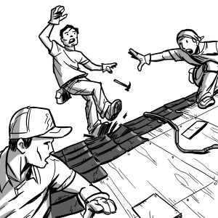](https://blogs.cdc.gov/niosh-science-blog/files/2015/09/vignette-1.jpg)

**How do we find the right artist?**

After deciding to illustrate the materials we needed to find the right artist. We found several whose styles met our messaging needs but we were confronted with other questions. Which artist would also resonate with Spanish-speaking immigrant workers? How would we know that we had overcome our personal tastes or our professional habits? How would we balance technical accuracy with clear visuals? Can the artist, for example, draw a safety harness that looks general enough to be universal but specific enough that every construction worker will recognize it as a harness?

Our answers to these questions are the topic of the upcoming blog *Illustrating the point: Choosing the right ARTIST for the message* which will be posted on September 17thth.

Please join this ongoing conversation by commenting. How would you ensure important messages hit home?

***Amy Filko, BA, is a Visual Information Specialist in the NIOSH World Trade Center Heath Program.***

***Pietra Check, MPH, is Deputy Director of the NIOSH Office of Agriculture Safety and Health and Coordinator of the Agriculture, Forestry & Fishing Program.***

***Michael Flynn, MA, is a Social Scientist in the NIOSH Education and Information Division and Assistant Coordinator of the  Priority Populations and Health Disparities Program.***

***Nura Sadeghpour, MPH, is a Health Communication Specialist in the NIOSH Office of the Director.***

*This is the second in a series of blogs describing the development and purpose of the* [*Protéjase*](http://go.usa.gov/362E4) *educational materials. These materials were created as part of NIOSH’s mission to conduct research and determine effective ways of delivering occupational safety and health information.   Organizations that serve Spanish-speaking immigrant workers can use these materials to encourage workers to think about their health and safety on the job and to seek assistance if they have a related question or concern. NIOSH released the* [*Protéjase*](http://go.usa.gov/362E4) *materials during Labor Rights Week in August 2015 and they can be found at found at* [*http://go.usa.gov/362PH*](http://go.usa.gov/362PH) *(English) and* [*http://go.usa.gov/362E4*](http://go.usa.gov/362E4) *(Spanish).*