***Illustrating the Point: Choosing the right ARTIST for the message***

***Posted on September 18, 2015 by Nura Sadeghpour, Pietra Check, Amy Filko, and Michael Flynn***

[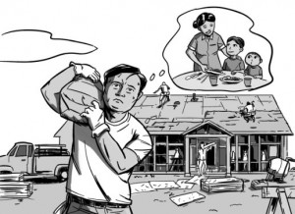](https://blogs.cdc.gov/niosh-science-blog/files/2015/09/protejase-3a.jpg)

Draft illustration by: Chi-Yun Lau

***As an artist, please provide one detailed and emotive illustration that captures this message:***

*“You have come to this country looking for a better future. You also want to show that you are hardworking. You have overcome great obstacles to give your family a better life.”*

It may be surprising that from these few words and simple directions given to six different illustrators, the drawings for a set of occupational safety and health (OSH) training and educational materials specifically tailored for Spanish-speaking immigrant workers were born. We call them: [***Protéjase***](http://go.usa.gov/362E4) ([Protect yourself](http://go.usa.gov/362PH)). Even more telling is that these four brochures, two posters, and five videos are a result of a partnership between NIOSH and the Mexican Ministry of Foreign Affairs, the topic of a forthcoming blog.

Following the decision to use illustrations as the [art of choice](http://blogs.cdc.gov/niosh-science-blog/2015/09/08/protejase2/) for a [set of OSH materials](http://blogs.cdc.gov/niosh-science-blog/2015/09/01/protejase1/) that help workers navigate workplace risks, how does a scientific institute go about choosing an *illustrator* whose work will resonate with Latino immigrant workers? Are we able to forego our personal tastes or professional habits for a style more relevant to those who will end up using the information provided? How do we find an artist who can balance technical accuracy with clear visuals and tell the immigrant story?

The [*Protéjase*](http://go.usa.gov/362E4) [materials](http://go.usa.gov/362PH) were not created by merely translating English text that describe ways to mitigate hazards, into Spanish, or by finding already existing and seemingly relevant illustrations to represent what the Spanish-speaking workforce face, or even by what we understood might be meaningful to the audience. They were created through community outreach and engagement. Participant input served as the basis for creating and pretesting visuals and written content, and cognitive testing, all imperative to producing materials that effectively communicated messages to intended audiences.

***The Search for an Artist***

[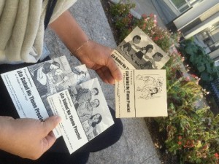](https://blogs.cdc.gov/niosh-science-blog/files/2015/09/protejase-3b.jpg)

Photo from NIOSH

NIOSH started the search for an illustrator by gathering referrals from internal and external colleagues and conducting an online talent search. Six artists were identified, each with a portfolio that showed the ability to draw emotion, recognizable objects, and create in both black-and-white and color. Each artist was asked to create three black & white drawings: one emotive drawing capturing the initial message of a hope for a better future, and two technical drawings that showed workplace hazards at construction and hotel worksites.

Once we had the illustrations from each artist, we tested them with Spanish-speaking immigrants at one Consulate office and one mobile Consulate, using a standardized interview guide:

* Cards were made for each illustration to simulate the experience of a finished brochure. Main messages and taglines were included to test them together.
* Respondents were asked to choose one sample out of the six, and then asked a series of questions about why they chose it and whether the *occupational safety and health message* was clearly communicated.
* The interviewer read the text out loud if there was any indication at all that the respondent might feel uncomfortable reading.
* If the occupational safety and health message was not clear from the card respondents were initially attracted to, we asked for suggestions as to how we could modify it to make the OSH message stronger.

***Examples of  feedback:***

***“I work in construction…I would show something that is more careful, not so dangerous like the situation this man here is in. The man is carrying something heavy, maybe he should be carrying something lighter.”***

***“When you come to this country you want to be like this drawing [points to family together], but you are like this drawing [points to man working away from family]. That is what you want, but this is reality.”***

[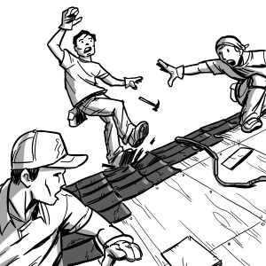](https://blogs.cdc.gov/niosh-science-blog/files/2015/09/vignette-1.jpg)

Draft illustration by: Chi-Yun Lau

Once we received a significant amount of feedback with no new trends, we did a formal data analysis and saw strong themes and similarities emerge. Since all of the illustrations had been shown with the same text, we concluded that differences in perceptions, interpretations, and appreciation of the 6 samples were due to the illustrations only, guiding us towards the appropriate choice.

***What We Found***

[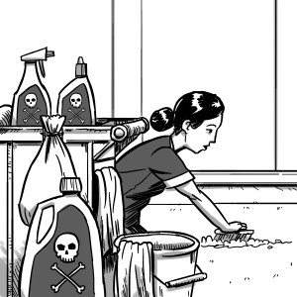](https://blogs.cdc.gov/niosh-science-blog/files/2015/09/protejase-3c.jpg)

Draft illustration by: Chi-Yun Lau

We quickly saw that our results did not match our original assumptions of who would test the most favorably - a case for testing art and artists with the community of interest. Our testing also confirmed that illustrations aren’t just pretty – they tell a story. The illustrations were able to clarify and enhance the meaning behind the text. They connected the reader to the OSH message and they provided a motivation for a call to action that the reader picked up on, for example: *“When we are carrying heavy things, we have to be safe. There is a limit to what we can do.”*

Our experience also confirmed the value of pre-testing. Our testing and analysis of participant feedback showed us that the illustrations not only make the products more attractive to potential viewers, meaning more people are likely to pick them up, but also add to the meaning and understanding of the materials, making them more impactful. The value of this type of cognitive testing, especially with low-literacy audiences, ensures that the materials communicate the intended message; in this case: Return home from work safely and with dignity.

In what ways has your organization chosen the “look” of educational materials to ensure the images convey the right tone, feeling and content?

***Nura Sadeghpour, MPH, is a Health Communication Specialist in the NIOSH Office of the Director.***

***Pietra Check, MPH, is Deputy Director of the NIOSH Office of Agriculture Safety and Health and Coordinator of the Agriculture, Forestry & Fishing Program.***

***Amy Filko, BA, is a Visual Information Specialist in the NIOSH World Trade Center Heath Program.***

***Michael Flynn, MA, is a Social Scientist in the NIOSH Education and Information Division and Assistant Coordinator of the Priority Populations and Health Disparities Program.***

**Meet the Artists**

[](https://blogs.cdc.gov/niosh-science-blog/files/2015/09/Lau.jpg)

**Chi-Yun Lau** (photo left) is the designer and illustrator of the *Protéjase* materials and lives in Boston. His work for NIOSH captured aspects of the immigrant story that inspire action; his illustrations show a rare quality of drawing the viewer in and his unique style seamlessly blends the overlap of family, work, and safety and health to provide a visual storyboard that resonates with personal experience.

**Results Video, Inc.** digital film and video production team located in El Paso, Texas worked with NIOSH to interview real workers about their experience on the job, as well as vetting actor portrayals, all within a comfortable, inviting and collaborative environment.

*This is the third in a series of blogs describing the development and purpose of the* [*Protéjase*](http://go.usa.gov/362E4) *educational materials. These materials were created as part of NIOSH’s mission to conduct research and determine effective ways of delivering occupational safety and health information.  Organizations that serve Spanish-speaking immigrant workers can use these materials to encourage workers to think about their health and safety on the job and to seek assistance if they have a related question or concern. NIOSH released the* [*Protéjase*](http://go.usa.gov/362E4) *materials during Labor Rights Week in August 2015 and they can be found at found at* [*http://go.usa.gov/362PH*](http://go.usa.gov/362PH) *(English) and* [*http://go.usa.gov/362E4*](http://go.usa.gov/362E4) *(Spanish). To view a CDC Digital Press Kit on the topic, please see:* <http://www.cdc.gov/media/dpk/2015/dpk-niosh.html>.