**Ionic liquid stationary phase coating study for semi-packed microfabricated columns**

Azam Gholizadeh, Mustahsin Chowdhury, Masoud Agah*

VT MEMS Lab, Bradley Department of Electrical and Computer Engineering, Virginia Tech, Blacksburg, VA, 24061, United States

Email:agah@vt.edu

**List of Figures:**

Figure S1: Schematic of chemical fast salinization deactivation method. ………...……S4

Figure S2: Golay plots of the capillary columns with 15 m length coated with BP20 and IL1 as stationary phase…………………………………..………………………………S4

Figure S3: Figure S4: Kinetic models fitting for IL1 coated at 200 °C. A) using B/x+Cx+Dx2, B) A+B/x+Cx, C) A+B/x+Cx+Dx2 equations……………………………S5

Figure S4. Chromatograms showing the separation of the saturated alkanes using IL1 with thermal treatment at (A) 200 °C, (B) 220 °C, and (C) 240 °C. Condition: injection volume 0.1 μL, split ratio 100:1, carrier gas pressure 45 psi, initial oven temperature 30 °C held for 0.5 min; ramp rate 50 °C/min to 200 °C held for 2.5 min. …...…………….S5

Figure S5. Chromatograms showing the separation of the saturated alkanes using IL1 with thermal treatment at (A) 200 °C, (B) 220 °C, and (C) 240 °C. Condition: injection volume 0.5 μL, split ratio 200:1, carrier gas pressure 30 psi, initial oven temperature 30 °C held for 0.5 min; ramp rate 20 °C/min to 200 °C held for 2.5 min. ………………....S6

Figure S6. Chromatograms showing the separation of the 20 components mixture using (A) Capillary column with 15 m length and 0.25 mm thickness coated with IL1 with thermal treatment at 240 °C and (B) commercial Restek capillary column with 15 m length and 0.25 mm thickened coated with BP20 as the stationary phase. Condition: injection volume 0.1 μL, split ratio 100:1, inlet carrier gas pressure 45 psi, initial oven temperature 30 °C held for 0.5 min; ramp rate 40 °C/min to 200 °C………………...….S7

Figure S7. Chromatograms showing the separation of the 20 components mixture using (A) Capillary column with 15 m length and 0.25 mm thickness coated with IL1 with thermal treatment at 240 °C and (B) commercial Restek capillary column with 15 m length and 0.25 mm thickened coated with BP20 as the stationary phase. Condition: injection volume 0.1 μL, split ratio 100:1, inlet carrier gas pressure 10 psi, initial oven temperature 30 °C held for 0.5 min; ramp rate 40 °C/min to 200 °C………………...….S8

Figure S8: Chromatograms showing the naphthalene peak for A) IL1 column, B) IL2 column, C) IL3 column after first, second and 100th experimental runs. Condition: injection volume: 0.3 μL, split ratio: 200:1, carrier gas pressure: 30 psi, oven temperature: 100 °C. ………………………………..…………………………………………………S9

Figure S9: Chromatograms showing the naphthalene peak for A) IL1 column, B) IL2 column, C) IL3 column after first, second and 20th experimental runs without cleaning step and D) IL1 column, E) IL2 column, F) IL3 column after first, second and 20th experimental runs wit cleaning step. Condition: injection volume: 0.3 μL, split ratio: 200:1, carrier gas pressure: 30 psi, oven temperature: 100 °C. cleaning step is involved 4 times washing with heptane and run for 1 min at 100 °C with carrier gas pressure of 30 psi. …………………...…………………………………………………………..……..S10

**List of Tables:**

Table S1. Resolution and symmetry of Capillary columns at carrier gas pressure of 45 psi (symmetry was reported based on UPS tailing at 5% height of the peak)………..….S7

..

Table S2. Resolution and symmetry of Capillary columns at carrier gas pressure of 10 psi (symmetry was reported based on UPS tailing at 5% height of the peak)………...…S8

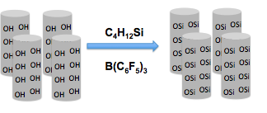

Figure S1. Schematic of chemical fast salinization deactivation method.

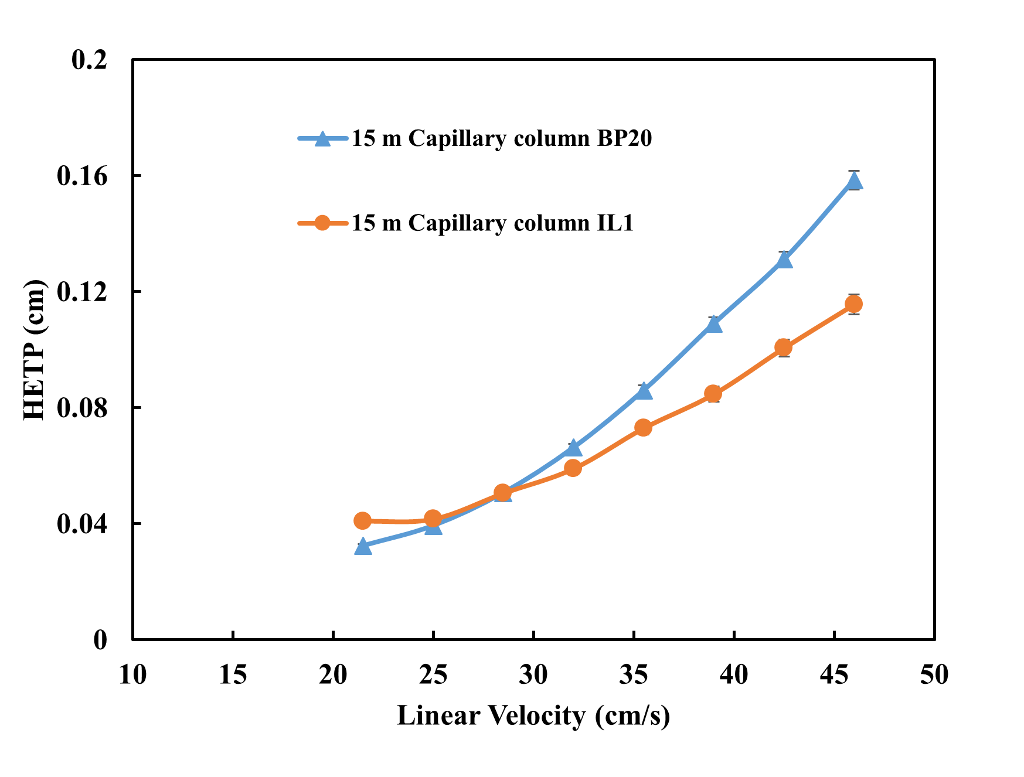

Figure S2. Golay plots of the capillary columns with 15 m length coated with BP20 and IL1 as stationary phase.

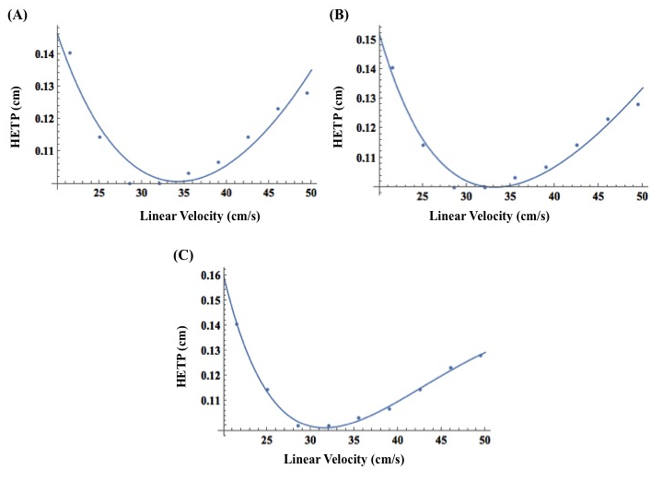

Figure S3. Kinetic models fitting for IL1 coated at 200 °C. A) using B/x+Cx+Dx2, B) A+B/x+Cx, C) A+B/x+Cx+Dx2 equations.

D:\PhD 2 mac start date 7.4.19\Fall 2018\postdoc applicaiton\project\papers\paper1\figures images\figure C7-BPY-5.tif

Figure S4. Chromatograms showing the separation of the saturated alkanes using IL1with thermal treatment at (A) 200 °C, (B) 220 °C, and (C) 240 °C. Condition: injection volume 0.1 μL, split ratio 100:1, carrier gas pressure 45 psi, initial oven temperature 30 °C held for 0.5 min; ramp rate 50 °C/min to 200 °C held for 2.5 min.

D:\PhD 2 mac start date 7.4.19\Fall 2018\postdoc applicaiton\project\papers\paper1\figures images\figure c7-bpy-3.tif

Figure S5. Chromatograms showing the separation of the saturated alkanes using IL1 with thermal treatment at (A) 200 °C, (B) 220 °C, and (C) 240 °C. Condition: injection volume 0.5 μL, split ratio 200:1, carrier gas pressure 30 psi, initial oven temperature 30 °C held for 0.5 min; ramp rate 20 °C/min to 200 °C held for 2.5 min.

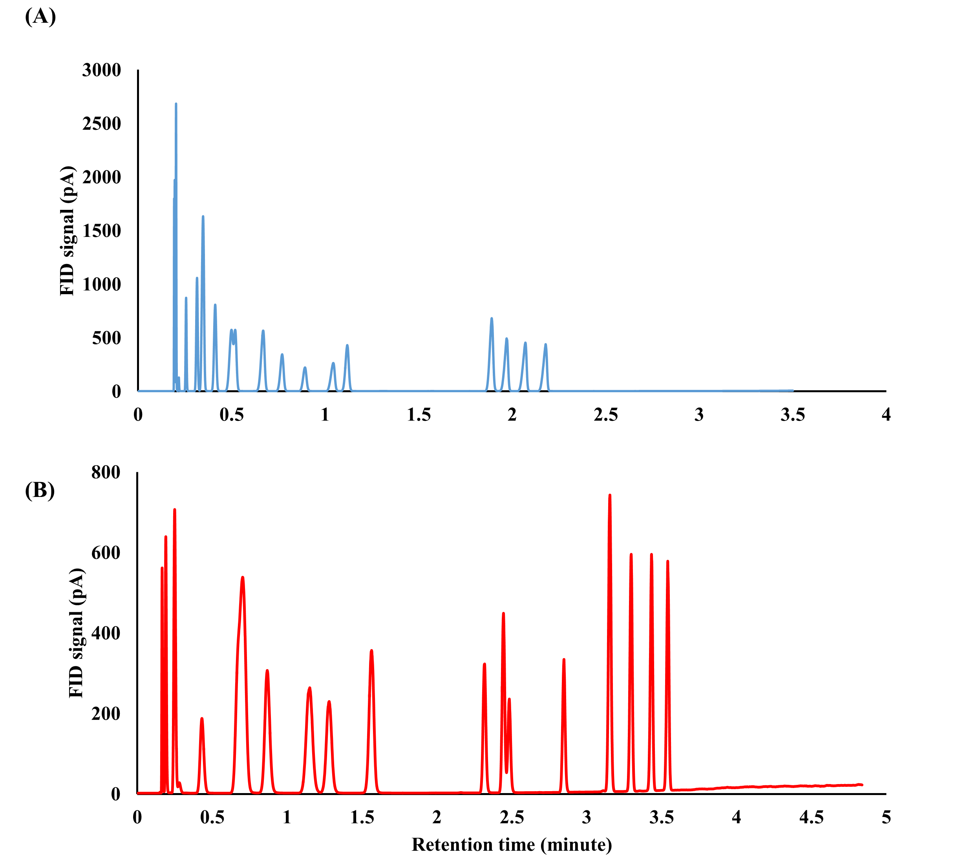

Figure S6. Chromatograms showing the separation of the 20 components mixture using (A) Capillary column with 15 m length and 0.25 mm thickness coated with IL1 with thermal treatment at 240 °C and (B) commercial Restek capillary column with 15 m length and 0.25 mm thickened coated with BP20 as the stationary phase. Condition: injection volume 0.1 μL, split ratio 100:1, inlet carrier gas pressure 45 psi, initial oven temperature 30 °C held for 0.5 min; ramp rate 40 °C/min to 200 °C.

Table S1. Resolution and symmetry of Capillary columns at carrier gas pressure of 45 psi (symmetry was reported based on UPS tailing at 5% height of the peak).

|  |  |  |  |  |
| --- | --- | --- | --- | --- |
| Component | Resolution Capillary IL1 | Tailing Capillary IL1 | Resolution Capillary  BP20 | Tailing Capillary BP20 |
| 2-nitrotoluene | 2.27 | 0.79 | 4.48 | 0.96 |
| 3-nitrotoluene | 2.74 | 0.73 | 4.50 | 0.96 |
| 4-nitrotoluene | 2.91 | 0.75 | 3.66 | 1.00 |

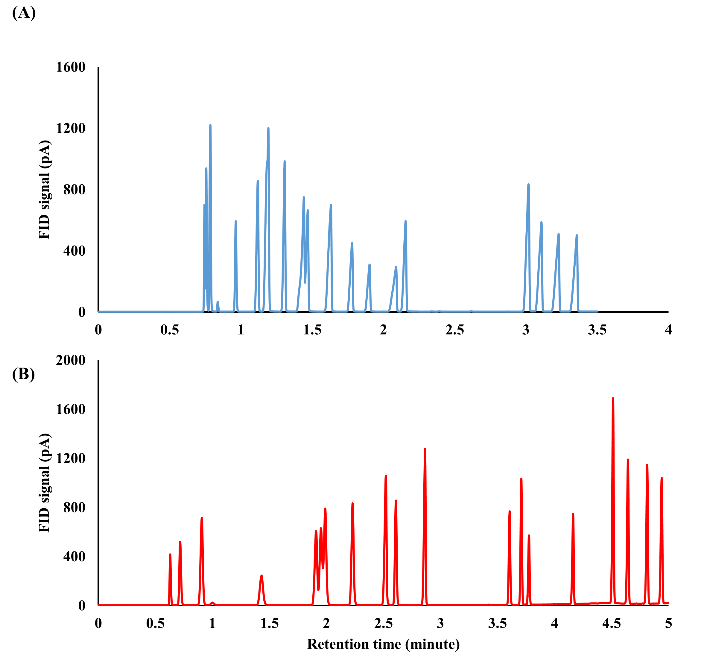

Figure S7. Chromatograms showing the separation of the 20 components mixture using (A) Capillary column with 15 m length and 0.25 mm thickness coated with IL1 with thermal treatment at 240 °C and (B) commercial Restek capillary column with 15 m length and 0.25 mm thickened coated with BP20 as the stationary phase. Condition: injection volume 0.1 μL, split ratio 100:1, inlet carrier gas pressure 10 psi, initial oven temperature 30 °C held for 0.5 min; ramp rate 40 °C/min to 200 °C.

Table S2. Resolution and symmetry of Capillary columns at carrier gas pressure of 10 psi (symmetry was reported based on UPS tailing at 5% height of the peak).

|  |  |  |  |  |
| --- | --- | --- | --- | --- |
| Component | Resolution Capillary IL1 | Tailing Capillary IL1 | Resolution Capillary  BP20 | Tailing Capillary BP20 |
| 2-nitrotoluene | 2.24 | 0.66 | 5.30 | 0.85 |
| 3-nitrotoluene | 2.76 | 0.61 | 6.70 | 0.84 |
| 4-nitrotoluene | 2.83 | 0.61 | 4.89 | 0.82 |

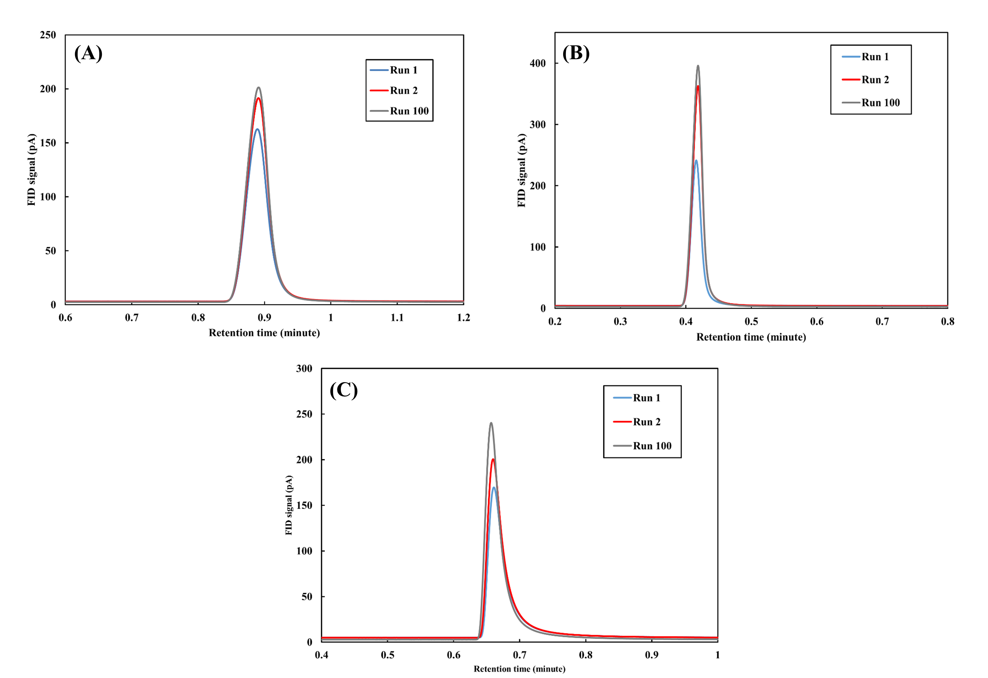

Figure S8. Chromatograms showing the naphthalene peak for A) IL1 column, B) IL2 column, C) IL3 column after first, second and 100th experimental runs. Condition: injection volume: 0.3 μL, split ratio: 200:1, carrier gas pressure: 30 psi, oven temperature: 100 °C.

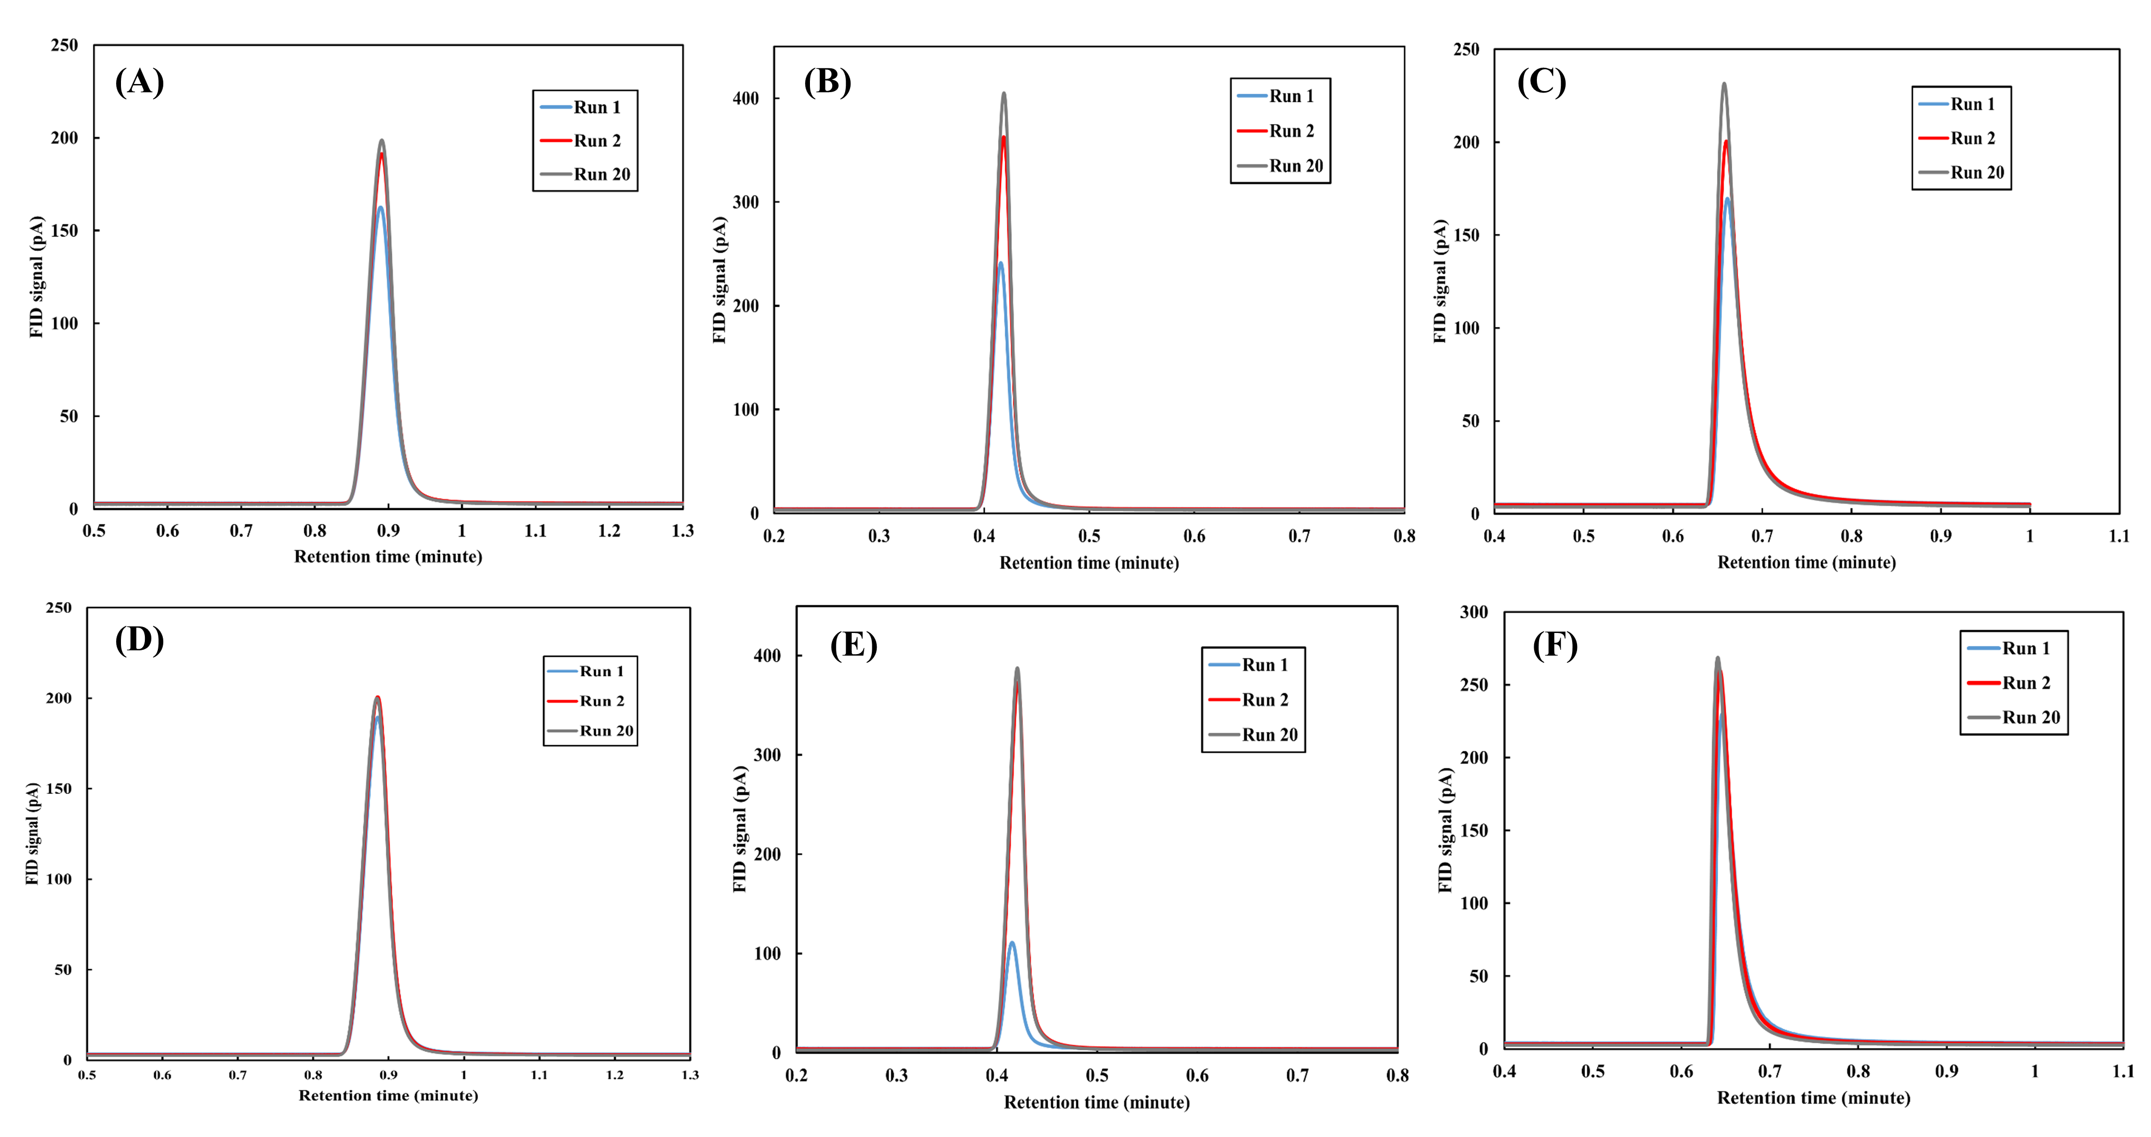

Figure S9. Chromatograms showing the naphthalene peak for A) IL1 column, B) IL2 column, C) IL3 column after first, second and 20th experimental runs without cleaning step and D) IL1 column, E) IL2 column, F) IL3 column after first, second and 20th experimental runs wit cleaning step. Condition: injection volume: 0.3 μL, split ratio: 200:1, carrier gas pressure: 30 psi, oven temperature: 100 °C. cleaning step is involved 4 times washing with heptane and run for 1 min at 100 °C with carrier gas pressure of 30 psi.