Supplementary information
Subject recruitment
Clinical and virological data of 10 norovirus outbreaks in long-term care facilities in Oregon (2009-2013) have been published previously. [1] Briefly, 43 LTCFs were enrolled from November 2009 to January 2013. Individual study subjects were recruited by study staff, both before the norovirus season began (baseline 1 and baseline 2) and when norovirus outbreaks occurred based on clinical and epidemiologic characteristics [2]. Only outbreaks that were reported to the local health departments within 3 days of the onset date of the first case and were still ongoing were selected for inclusion in the study.
Potential study subjects were screened for eligibility and asked for informed consent. Those enrolled were classified as case or control based on clinical symptoms (Fig S1). A case was defined as a resident or staff member with ≥3 episodes of diarrhea or vomiting in 24 h. Controls were assigned to one of two groups. An “exposed control” was a staff member or resident who remained asymptomatic despite regular contact or having shared living space with a case for at least 3 days during illness. Asymptomatic staff members and residents without such exposure to a case were recruited as “non-exposed controls.”
Saliva samples were collected on the day of symptom onset (day 0) or exposure (day 0) from cases and exposed controls, respectively, and also on days 1–5, 8, 14, 21, 56, 70, and 84 Acute and convalescent sera were collected from cases and exposed controls on days 0 and 21 and stored at -20°C. Stool specimens were collected from cases and exposed controls on days 0 and 21 and kept at 4°C. If a specimen could not be obtained on a given day, a sample was collected as close as possible to the scheduled day. For non-exposed controls, one saliva sample, one serum sample and one stool sample were collected within 7 days after the first case identified in the outbreak. Asymptomatic shedders were defined as participants without clinical samples but having a norovirus positive stool sample. Participants who provided both acute and convalescent stool samples were classified as: 1) prolonged shedders if both acute and convalescent stool sample tested positive for norovirus or 2) short shedders, if only the acute stool sample tested norovirus positive.
Ten norovirus outbreaks that were reported by 7 LTCFs were included in this study (Figure S1, Table S1). In total, 62 cases, 34 exposed controls, and 18 non-exposed controls were enrolled. Outbreak genotypes were GII.4 [Den Haag (n = 3), New Orleans (n = 4), Sydney (n = 2)], and GI.1 (n = 1) (Table S1). Viral loads in cases associated with GII.4 Sydney outbreaks were significantly higher (median: 2.33 x 10¹³ copies/g stool) than those in outbreaks caused by other genotypes. Symptomatic and asymptomatic individuals shed similar amounts of virus (1.22 x 10¹² vs 1.3 x 10¹² copies/g stool, respectively). Forty-seven percent of cases shed virus for ≥21 days. Fifty-five (95%) of 58 symptomatic participants in GII.4 outbreaks were secretors. Three of 7 non-secretors were infected by either GII.4 Den Haag or GII.4 New Orleans (Table S1)

Saliva and serum collection
Saliva was collected by rubbing the gums with an Oracol sampler sponge (Malvern Medical Developments, Worcester, UK) for 1 minute and immediately frozen. Saliva was separated from sponge by low-speed centrifugation and stored at -80°C. Only samples that had at least 200 μL were included in the study.

Norovirus-specific IgA and IgG in serum
Norovirus-specific IgA and IgG titers were determined using norovirus genotype–specific VLPs representing the outbreak genotype [1] as previously described [3]. Briefly, 96-well plates were coated with 1µg/mL norovirus VLPs. After blocking, 2-fold serial dilutions of serum samples were tested in duplicate. Bound IgA and IgG were detected using goat anti-human IgA or IgG HRP conjugate followed by color development with TMB substrate. Sigmoidal dose response were fit to determine the EC₅₀. Samples that did not show at least 50% of VLP binding at the lowest serum dilution tested were assigned a titer of 0.5 times the lowest tested dilution for statistical analysis.

Blockade antibody assay
Blockade antibody assays were performed as described previously [3]. VLPs were selected based on the genotype of the outbreaks [1] . EIA plates were coated with porcine gastric mucin (PGM) type III (Sigma) for 4 hours at room temperature and blocked overnight at 4°C with 5% dry milk in PBS-0.05% Tween-20. Two-fold serial dilutions of each serum sample were pre-incubated with 1μg/mL VLP for 1 h at 37°C and then the mixture was added to PGM-coated plates. Bound VLPs were detected using rabbit anti-norovirus hyperimmune serum and goat anti-rabbit-HRP followed by color development with TMB substrate. Percent control binding is defined as the binding in the presence of serum pretreatment compared to the binding in the absence of serum. Sigmoidal dose response were fit to the mean percent control binding to determine the IC₅₀. Samples that did not block at least 50% of VLP binding to pig gastric mucin type III (PGM; Sigma Aldrich, St. Louis) at the lowest serum dilution tested were assigned a titer of 0.5 times the lowest tested dilution for statistical analysis.

REFERENCES
1. Costantini VP, Cooper EM, Hardaker HL, et al. Epidemiologic, Virologic, and Host Genetic Factors of Norovirus Outbreaks in Long-term Care Facilities. Clin Infect Dis 2016; 62:1-10.
2. Hall AJ, Vinje J, Lopman B, et al. Update norovirus outbreak management and disease prevention guidelines. MMWR Recomm Rep 2011; 60:1-18.
3. Lindesmith LC, Brewer-Jensen PD, Mallory ML, et al. Antigenic Characterization of a Novel Recombinant GII.P16-GII.4 Sydney Norovirus Strain With Minor Sequence Variation Leading to Antibody Escape. J Infect Dis 2018; 217:1145-52.

Table S1: Summary of 10 norovirus outbreaks [1]ª
Outbreak^{b} |  |  |  | Groupe^{be} |  | N° participants^{b} |  |  | Saliva samples  N° tested |  | Stool samples^{b}  N° positive/collected (%) |  |  |  |  | Viral load^{bg}  (copies g⁻¹ stool) |  |  |  |  |  | Secretor status^{b} |  |  |  | Paired Serum samples  N° participant seroconverted/participant collected (%)
Genotype^{c} |  | N°^{d} |  |  |  |  |  |  |  |  | Acute |  | Convalescent |  |  | Acute |  | Convalescent |  | p-value^{h} |  | Secretor |  | Non-secretor |  | IgA |  | IgG |  | Blockade- Ab
I.1_  Norwalk |  | 1 |  | Cases |  | 5 |  | 34 |  |  | 4^{f}/5 (80) |  | 2/5 (40) |  |  | 1.21 x 10⁹ |  | 1.69 x 10⁷ |  | 0.0281 |  | 4 |  | 0 |  | 2/2 (100) |  | 2/2 (100) |  | 2/2 (100)
 |  |  |  | Exposed controls |  | 2 |  | 13 |  |  | 0/2 (0) |  | 0/2 (0) |  |  | - |  | - |  |  |  | 2 |  | 0 |  | 0/1 (0) |  | 0/1 (0) |  | 0/1 (0)
 |  |  |  | Non-exposed controls |  | 2 |  | 2 |  |  | 0/1 (0) |  | - |  |  | - |  | - |  |  |  | - |  | - |  | - |  | - |  | -
II.4_  Den Haag |  | 3 |  | Cases |  | 13 |  | 105 |  |  | 5/10 (50) |  | 3/8 (37) |  |  | 6.73 x 10⁹ |  | 7.61 x 10⁷ |  | 0.009 |  | 14 |  | 1 |  | 8/10 (80) |  | 8/10 (80) |  | 10/10 (100)
 |  |  |  | Exposed controls |  | 12 |  | 78 |  |  | 1/10 (10) |  | 0/9 (0) |  |  | 1.13 x 10⁷ |  | - |  |  |  | 11 |  | 1 |  | 1/8 (12) |  | 1/8 (12) |  | 1/8 (12)
 |  |  |  | Non-exposed controls |  | 2 |  | 2 |  |  | 0/2 (0) |  | - |  |  | - |  | - |  |  |  | - |  |  |  | - |  | - |  | -
II.4_  New Orleans |  | 4 |  | Cases |  | 40 |  | 260 |  |  | 31^{d}/36 (86) |  | 13/32 (41) |  |  | 7.81 x 10¹⁰ |  | 6.78 x 10⁸ |  | 0.029 |  | 37^{j} |  | 2 |  | 29/38 (76) |  | 28/38 (73) |  | 32/38 (84)
 |  |  |  | Exposed controls |  | 13 |  | 94 |  |  | 1/10 (10) |  | 1/12 (8) |  |  | 2.61 x 10⁷ |  | 2.18 x 10⁷ |  |  |  | 12 |  | 1 |  | 3/10 (30) |  | 3/10 (30) |  | 4/10 (40)
 |  |  |  | Non-exposed controls |  | 14 |  | 14 |  |  | 1/13 (7) |  | - |  |  | 3.36 x 10¹¹ |  | - |  |  |  | - |  | - |  | - |  | - |  | -
II.4_  Sydney |  | 2 |  | Cases |  | 4 |  | 42 |  |  | 2/4 (50) |  | 2/4 (50) |  |  | 2.33 x 10¹³ |  | 3.47 x 10⁹ |  | - |  | 4 |  | 0 |  | 4/4 (100) |  | 4/4 (100) |  | 3/4 (75)
 |  |  |  | Exposed controls |  | 7 |  | 52 |  |  | 1/7 (14) |  | 0/7 (0) |  |  | 3.90 x 10¹² |  | - |  |  |  | 5 |  | 2 |  | 1/4 (25) |  | 0/4 (0) |  | 0/4 (0)
 |  |  |  | Non-exposed controls |  | 0 |  | - |  |  | - |  | - |  |  | - |  | - |  |  |  | - |  | - |  | - |  | - |  | -
Totals |  | 10 |  | Cases |  | 62 |  | 441 |  |  | 42/55 |  | 20/49 |  |  | 1.22 x 10¹² |  | 8.14 x 10⁰⁸ |  | 0.4611^{i} |  | 59 |  | 3 |  | 43/54 (80) |  | 42/54 (78) |  | 47/54 (87)
 |  |  |  | Exposed controls |  | 34 |  | 237 |  |  | 3/29 |  | 1/30 |  |  | 1.30 x 10¹² |  | 2.18 x 10⁰⁷ |  |  |  | 30 |  | 4 |  | 5/23 (22) |  | 4/23 (18) |  | 5/23 (22)
 |  |  |  | Non-exposed controls |  | 18 |  | 18 |  |  | 1/16 |  | - |  |  | 3.36 x 10¹¹ |  | - |  |  |  | - |  | - |  | - |  | - |  | -
 |  |  |  |  |  | 114 |  | 696 |  |  | 46/100 (46) |  | 21/79 (27) |  |  |  |  |  |  |  |  | 89 |  | 7
ª Table includes only those cases and exposed controls from whom acute stool or acute and convalescent sera were available to establish norovirus etiology.
^{b} Data in this column and sub-columns have been previously published and are summarized here.
^{c} Outbreak genotype was established based on sequence of P2 region from positive stool samples from cases.
^{d} Number of outbreaks per genotype
^{e} Classification based on clinical symptoms. Control group includes asymptomatic (positive shedding, no clinical AGE symptoms) and non-infected (no-shedding, non-symptoms) individuals.
^{f} At least one sample has a genotype different from that of the outbreak strain.
^{g} Mean.
^{h} P-value compares acute virus shedding from cases of each GI.1 or GII.4 variant vs acute virus shedding from cases of GII.4 Sydney outbreaks, except where indicated.
^{i} P-value compares acute virus shedding from cases vs acute virus shedding from exposed controls.
^{j} One case shedding GII.4 Den Haag was included in the GII.4 Den Haag group for HBGAs study

Table S2: Number and percentage of subjects enrolled during baseline I season (2009-2010)
 | Baseline season 2009-2010
 | Long-term care facility (LTCF)
 | All  (n=10) |  |  | I |  |  | II |  |  | III |  |  | IV |  |  | V |  |  | VI |  |  | VII |  |  | VIII |  |  | IX |  |  | X
 |  | (%) |  | N° | (%) |  | N° | (%) |  | N° | (%) |  | N° | (%) |  | N° | (%) |  | N° | (%) |  | N° | (%) |  | N° | (%) |  | N° | (%) |  | N° | (%)
Enrolled | 190 |  |  | 17 |  |  | 12 |  |  | 29 |  |  | 18 |  |  | 20 |  |  | 17 |  |  | 7 |  |  | 13 |  |  | 36 |  |  | 21
Sex
Male | 35 | 18.4 |  | 4 | 23.5 |  | 1 | 8.3 |  | 6 | 20.7 |  | 3 | 16.7 |  | 0 | 0.0 |  | 5 | 29.4 |  | 1 | 14.3 |  | 4 | 30.8 |  | 10 | 27.8 |  | 1 | 4.8
Female | 155 | 81.6 |  | 13 | 76.5 |  | 11 | 91.7 |  | 23 | 79.3 |  | 15 | 83.3 |  | 20 | 100.0 |  | 12 | 70.6 |  | 6 | 85.7 |  | 9 | 69.2 |  | 26 | 72.2 |  | 20 | 95.2
Race
Black | 1 | 0.5 |  | 0 | 0.0 |  | 0 | 0.0 |  | 0 | 0.0 |  | 0 | 0.0 |  | 0 | 0.0 |  | 1 | 5.9 |  | 0 | 0.0 |  | 0 | 0.0 |  | 0 | 0.0 |  | 0 | 0.0
White | 177 | 93.2 |  | 16 | 94.1 |  | 10 | 83.3 |  | 28 | 96.6 |  | 17 | 94.4 |  | 19 | 95.0 |  | 14 | 82.4 |  | 7 | 100.0 |  | 12 | 92.3 |  | 36 | 100.0 |  | 18 | 85.7
Asian | 6 | 3.2 |  | 1 | 5.9 |  | 1 | 8.3 |  | 0 | 0.0 |  | 0 | 0.0 |  | 0 | 0.0 |  | 2 | 11.8 |  | 0 | 0.0 |  | 0 | 0.0 |  | 0 | 0.0 |  | 2 | 9.5
Hispanic | 0 | 0.0 |  | 0 | 0.0 |  | 0 | 0.0 |  | 0 | 0.0 |  | 0 | 0.0 |  | 0 | 0.0 |  | 0 | 0.0 |  | 0 | 0.0 |  | 0 | 0.0 |  | 0 | 0.0 |  | 0 | 0.0
Native american | 2 | 1.1 |  | 0 | 0.0 |  | 1 | 8.3 |  | 1 | 3.4 |  | 0 | 0.0 |  | 0 | 0.0 |  | 0 | 0.0 |  | 0 | 0.0 |  | 0 | 0.0 |  | 0 | 0.0 |  | 0 | 0.0
Unknown | 4 | 2.1 |  | 0 | 0.0 |  | 0 | 0.0 |  | 0 | 0.0 |  | 1 | 5.6 |  | 1 | 5.0 |  | 0 | 0.0 |  | 0 | 0.0 |  | 1 | 7.7 |  | 0 | 0.0 |  | 1 | 4.8
Age
21-49 | 67 | 35.3 |  | 6 | 35.3 |  | 4 | 33.3 |  | 1 | 3.4 |  | 11 | 61.1 |  | 7 | 35.0 |  | 8 | 47.1 |  | 4 | 57.1 |  | 9 | 69.2 |  | 8 | 22.2 |  | 9 | 42.9
50-69 | 49 | 25.8 |  | 8 | 47.1 |  | 2 | 16.7 |  | 6 | 20.7 |  | 4 | 22.2 |  | 7 | 35.0 |  | 5 | 29.4 |  | 2 | 28.6 |  | 0 | 0.0 |  | 8 | 22.2 |  | 7 | 33.3
70-89 | 55 | 28.9 |  | 2 | 11.8 |  | 5 | 41.7 |  | 18 | 62.1 |  | 2 | 11.1 |  | 5 | 25.0 |  | 2 | 11.8 |  | 1 | 14.3 |  | 2 | 15.4 |  | 14 | 38.9 |  | 4 | 19.0
≥90 | 19 | 10.0 |  | 1 | 5.9 |  | 1 | 8.3 |  | 4 | 13.8 |  | 1 | 5.6 |  | 1 | 5.0 |  | 2 | 11.8 |  | 0 | 0.0 |  | 2 | 15.4 |  | 6 | 16.7 |  | 1 | 4.8
Mean  [min, max] | 59  [21-99] |  |  | 52  [22-90] |  |  | 67  [18-92] |  |  | 78  [48-94] |  |  | 48  [22-94] |  |  | 61  [25-92] |  |  | 53  [23-94] |  |  | 57  [24-97] |  |  | 51  [21-93] |  |  | 70  [21-99] |  |  | 53  [21-95]
Group class
Resident | 78 | 41.1 |  | 5 | 29.4 |  | 6 | 50.0 |  | 23 | 79.3 |  | 3 | 16.7 |  | 6 | 30.0 |  | 3 | 17.6 |  | 1 | 14.3 |  | 4 | 30.8 |  | 21 | 58.3 |  | 6 | 28.6
Direct health care | 67 | 35.3 |  | 6 | 35.3 |  | 6 | 50.0 |  | 2 | 6.9 |  | 12 | 66.7 |  | 11 | 55.0 |  | 7 | 41.2 |  | 3 | 42.9 |  | 3 | 23.1 |  | 9 | 25.0 |  | 8 | 38.1
Non-health care | 45 | 23.7 |  | 6 | 35.3 |  | 0 | 0.0 |  | 4 | 13.8 |  | 3 | 16.7 |  | 3 | 15.0 |  | 7 | 41.2 |  | 3 | 42.9 |  | 6 | 46.2 |  | 6 | 16.7 |  | 7 | 33.3

Table S3: Number and percentage of subjects enrolled during baseline II season (2010-2011)
 | Baseline 2010-2011
 | Long-term care facility
 | All  (n=14) |  |  | I |  |  | III |  |  | IV |  |  | V |  |  | VII |  |  | VIII |  |  | IX |  |  | XI |  |  | XII |  |  | XIII |  |  | XIV |  |  | XV |  |  | XVI |  |  | XVII
 |  | (%) |  | N° | (%) |  | N° | (%) |  | N° | (%) |  | N° | (%) |  | N° | (%) |  | N° | (%) |  | N° | (%) |  | N° | (%) |  | N° | (%) |  | N° | (%) |  | N° | (%) |  | N° | (%) |  | N° | (%) |  | N° | (%)
Enrolled | 180 |  |  | 10 |  |  | 14 |  |  | 10 |  |  | 15 |  |  | 13 |  |  | 11 |  |  | 10 |  |  | 16 |  |  | 14 |  |  | 11 |  |  | 11 |  |  | 19 |  |  | 10 |  |  | 16
Sex
Male | 37 | 20.6 |  | 4 | 40.0 |  | 4 | 28.6 |  | 2 | 20.0 |  | 5 | 33.3 |  | 2 | 15.4 |  | 0 | 0.0 |  | 2 | 20.0 |  | 4 | 25.0 |  | 4 | 28.6 |  | 2 | 18.2 |  | 2 | 18.2 |  | 1 | 5.3 |  | 2 | 20.0 |  | 3 | 18.8
Female | 143 | 79.4 |  | 6 | 60.0 |  | 10 | 71.4 |  | 8 | 80.0 |  | 10 | 66.7 |  | 11 | 84.6 |  | 11 | 100.0 |  | 8 | 80.0 |  | 12 | 75.0 |  | 10 | 71.4 |  | 9 | 81.8 |  | 9 | 81.8 |  | 18 | 94.7 |  | 8 | 80.0 |  | 13 | 81.3
Race
Black | 6 | 3.3 |  | 0 | 0.0 |  | 0 | 0.0 |  | 0 | 0.0 |  | 0 | 0.0 |  | 0 | 0.0 |  | 0 | 0.0 |  | 0 | 0.0 |  | 2 | 12.5 |  | 1 | 7.1 |  | 0 | 0.0 |  | 0 | 0.0 |  | 2 | 10.5 |  | 1 | 10.0 |  | 0 | 0.0
White | 163 | 90.6 |  | 10 | 100.0 |  | 14 | 100.0 |  | 10 | 100.0 |  | 15 | 100.0 |  | 13 | 100.0 |  | 11 | 100.0 |  | 10 | 100.0 |  | 9 | 56.3 |  | 13 | 92.9 |  | 11 | 100.0 |  | 12 | 109.1 |  | 12 | 63.2 |  | 9 | 90.0 |  | 14 | 87.5
Asian | 9 | 5.0 |  | 0 | 0.0 |  | 0 | 0.0 |  | 0 | 0.0 |  | 0 | 0.0 |  | 0 | 0.0 |  | 0 | 0.0 |  | 0 | 0.0 |  | 4 | 25.0 |  | 0 | 0.0 |  | 0 | 0.0 |  | 0 | 0.0 |  | 3 | 15.8 |  | 0 | 0.0 |  | 2 | 12.5
Hispanic | 0 | 0.0 |  | 0 | 0.0 |  | 0 | 0.0 |  | 0 | 0.0 |  | 0 | 0.0 |  | 0 | 0.0 |  | 0 | 0.0 |  | 0 | 0.0 |  | 0 | 0.0 |  | 0 | 0.0 |  | 0 | 0.0 |  | 0 | 0.0 |  | 0 | 0.0 |  | 0 | 0.0 |  | 0 | 0.0
Native american | 1 | 0.6 |  | 0 | 0.0 |  | 0 | 0.0 |  | 0 | 0.0 |  | 0 | 0.0 |  | 0 | 0.0 |  | 0 | 0.0 |  | 0 | 0.0 |  | 0 | 0.0 |  | 0 | 0.0 |  | 0 | 0.0 |  | 0 | 0.0 |  | 1 | 5.3 |  | 0 | 0.0 |  | 0 | 0.0
Unknown | 2 | 1.1 |  | 0 | 0.0 |  | 0 | 0.0 |  | 0 | 0.0 |  | 0 | 0.0 |  | 0 | 0.0 |  | 0 | 0.0 |  | 0 | 0.0 |  | 1 | 6.3 |  | 0 | 0.0 |  | 0 | 0.0 |  | 0 | 0.0 |  | 1 | 5.3 |  | 0 | 0.0 |  | 0 | 0.0
Age
21-49 | 100 | 55.6 |  | 4 | 40.0 |  | 6 | 42.9 |  | 6 | 60.0 |  | 0 | 0.0 |  | 9 | 69.2 |  | 4 | 36.4 |  | 1 | 10.0 |  | 13 | 81.3 |  | 6 | 42.9 |  | 9 | 81.8 |  | 7 | 63.6 |  | 14 | 73.7 |  | 7 | 70.0 |  | 14 | 87.5
50-69 | 43 | 23.9 |  | 3 | 30.0 |  | 2 | 14.3 |  | 4 | 40.0 |  | 3 | 20.0 |  | 4 | 30.8 |  | 2 | 18.2 |  | 4 | 40.0 |  | 3 | 18.8 |  | 4 | 28.6 |  | 1 | 9.1 |  | 3 | 27.3 |  | 5 | 26.3 |  | 3 | 30.0 |  | 2 | 12.5
70-89 | 28 | 15.6 |  | 3 | 30.0 |  | 4 | 28.6 |  | 0 | 0.0 |  | 9 | 60.0 |  | 0 | 0.0 |  | 5 | 45.5 |  | 3 | 30.0 |  | 0 | 0.0 |  | 2 | 14.3 |  | 1 | 9.1 |  | 1 | 9.1 |  | 0 | 0.0 |  | 0 | 0.0 |  | 0 | 0.0
≥90 | 9 | 5.0 |  | 0 | 0.0 |  | 2 | 14.3 |  | 0 | 0.0 |  | 3 | 20.0 |  | 0 | 0.0 |  | 0 | 0.0 |  | 2 | 20.0 |  | 0 | 0.0 |  | 2 | 14.3 |  | 0 | 0.0 |  | 0 | 0.0 |  | 0 | 0.0 |  | 0 | 0.0 |  | 0 | 0.0
Mean  [min, max] | 49  [21-101] |  |  | 57  [26-81] |  |  | 57  [21-101] |  |  | 41  [23-64] |  |  | 80  [55-93] |  |  | 34  [21-56] |  |  | 59  [24-84] |  |  | 69  [23-92] |  |  | 36  [22-65] |  |  | 58  [20-93] |  |  | 45  [21-82] |  |  | 46  [21-85] |  |  | 42  [22-61] |  |  | 42  [23-67] |  |  | 36  [21-59]
Group class
Resident | 43 | 23.9 |  | 6 | 60.0 |  | 6 | 42.9 |  | 0 | 0.0 |  | 12 | 80.0 |  | 0 | 0.0 |  | 5 | 45.5 |  | 5 | 50.0 |  | 0 | 0.0 |  | 4 | 28.6 |  | 1 | 9.1 |  | 2 | 18.2 |  | 1 | 5.3 |  | 1 | 10.0 |  | 0 | 0.0
Direct health care | 108 | 60.0 |  | 3 | 30.0 |  | 6 | 42.9 |  | 8 | 80.0 |  | 2 | 13.3 |  | 8 | 61.5 |  | 5 | 45.5 |  | 3 | 30.0 |  | 16 | 100.0 |  | 10 | 71.4 |  | 10 | 90.9 |  | 7 | 63.6 |  | 13 | 68.4 |  | 6 | 60.0 |  | 11 | 68.8
Non-health care | 29 | 16.1 |  | 1 | 10.0 |  | 2 | 14.3 |  | 2 | 20.0 |  | 1 | 6.7 |  | 5 | 38.5 |  | 1 | 9.1 |  | 2 | 20.0 |  | 0 | 0.0 |  | 0 | 0.0 |  | 0 | 0.0 |  | 2 | 18.2 |  | 5 | 26.3 |  | 3 | 30.0 |  | 5 | 31.3

Table S4: Norovirus-specific salivary IgA levels in cases vs controls
Day |  | Norovirus-specific salivary IgA levels (ng/100 µg total IgA) ª |  |  |  | p-value^{b}
Day |  | Cases |  | Exposed controls
0 |  | 16.44 (7.64, 54.91) |  | 31.32 (5.81, 175.8) |  | 0.7302
1 |  | 28.46 (11.81, 46.23) |  | 41.39 (8.47, 95.21) |  | 0.5119
2 |  | 27.72 (11.9, 53.54) |  | 21.34 (14.47, 65.29) |  | 0.9030
3 |  | 26.76 (.63, 102.0) |  | 35.06 (12.3, 63.38) |  | 0.8419
4 |  | 36.10 (19.91, 74.52) |  | 32.84 (15.1, 85.35) |  | 0.9685
5 |  | 35.53 (20.2, 103.3) |  | 37.82 (22.27, 90.25) |  | 0.8579
8 |  | 296.3 (105.1, 608.7) |  | 31.56 (18.18, 65.76) |  | <0.0001^{c}
14 |  | 460.2 (212.6, 922.7) |  | 43.85 (19.49, 106.3) |  | <0.0001 ^{c}
21 |  | 444.9 (97.8, 1023.0) |  | 38.39 (18.95, 138.4) |  | <0.0001 ^{c}
56 |  | 158.3 (92.22, 347.1) |  | 35.19 (18.39, 101.7) |  | <0.0001 ^{c}
70 |  | 107.6 (47.47, 323.8) |  | 29.78 (12.4, 63.28) |  | 0.0013 ^{c}
84 |  | 142.9 (28.39, 226.7) |  | 42.08 (17.42, 96.94) |  | 0.0266 ^{c}
ª Median antibody level (25%, 75% quartiles)
^{c} Indicates statistical significance as calculated by the Mann Whitney test
^{b} Comparison of median antibody level between specimens collected from cases and exposed controls at the indicated day.

Table S5: Norovirus genotype-specific IgA in cases
 |  |  |  | Norovirus-specific salivary IgA levels (ng/100 µg total IgA) ª |  |  |  |  |  |  |  |  |  | p-value^{b}
 |  |  |  | All |  | GII.4 Den Haag |  | GII.4 New Orleans |  | GII.4 Sydney |  | GI.1 Norwalk |  | p-value^{b}
Day 0-4 |  | n |  | 149 |  | 38 |  | 85 |  | 14 |  | 12
 |  | IgA |  | 29.03 (13.0, 54.33) |  | 43.11 (23.88,106.2) |  | 29.03 (11.51, 53.89) |  | 14.43 (9.08,19.66) |  | 20.98 (18.61,42.62) |  | 0.003^{c}
Day 5 |  | n |  | 49 |  | 11 |  | 30 |  | 4 |  | 4
 |  | IgA |  | 35.53 (20.46,101.6) |  | 45.76 (24.05,99.9) |  | 34.21 (19.75, 113.1) |  | 10.3 (4.99,58.58) |  | 57.46 (35.73,109.6) |  | 0.1882
Day 8 |  | n |  | 49 |  | 10 |  | 31 |  | 4 |  | 4
 |  | IgA |  | 286.4 (104.3, 529.4) |  | 350.9 (92.38,711.6) |  | 269.0 (87.47,534.2) |  | 254.7 (120.6, 388.8) |  | 349.4 (114.1,585.6) |  | 0.9926
Day 14 |  | n |  | 48 |  | 12 |  | 30 |  | 4 |  | 3
 |  | IgA |  | 460.2 (212.1, 912.1) |  | 486.7 (351.1, 1489.0) |  | 478.1 (205.2, 922.7) |  | 278.2 (122.8,500.6) |  | 306.7 (272.1, 1533.0) |  | 0.6386
Day 21 |  | n |  | 48 |  | 11 |  | 31 |  | 4 |  | 3
 |  | IgA |  | 444.9 (189.1,994.0) |  | 493.7 (290.3,1751.0) |  | 497.7 (202.2,1003.0) |  | 195.2 (127.5,362.9) |  | 412.1 (70.56,1523.0) |  | 0.4059
ª Median antibody level (25%, 75% quartiles)
^{b} Comparison of median antibody level among all groups at the indicated day.
^{c} Indicates statistical significance according Kruskal-Wallis test, followed by Two-stage linear step-up procedure of Benjamini, Krieger and Yekutieli

Table S6: Norovirus-specific salivary IgA levels
Norovirus specific salivary IgA levels (GMT, ng/100 µg total IgA) ª
Day |  | Long shedding^{b} |  | Short shedding^{c} |  | p-value^{d} |  | Asymptomatic  shedding |  | Exposed control  (no shedding) |  | p-value^{e} |  | Cases |  | p-value^{f}
1 |  | 16.08 (6.49, 39.85) |  | 19.81 (11.47, 3.23) |  | 0.6620 |  | n/a |  | 31.26 (12.97, 75.33) |  | - |  | 16.09(2.82, 91.67) |  | -
2 |  | 23.64 (12.32, 45.35 |  | 30.39 (10.82, 85.37) |  | 0.6806 |  | 23.99(11.06, 52.02) |  | 20.84(10.54, 41.23) |  | 0.9234 |  | 23.93 (16.25, 35.24) |  | 0.9189
3 |  | 31.12 (15.04, 64.40) |  | 35.0 (11.84, 103.5) |  | 0.917 |  | 31.91 (3.20, 318.00) |  | 26.83 (14.87, 48.41) |  | 1 |  | 22.20 (12.14, 42.14) |  | 0.9251
4 |  | 22.0 (8.54, 56.69) |  | 46.55 (18.88, 114.8) |  | 0.2847 |  | 37.76 (4.99, 285.70) |  | 26.83 (14.87, 48.41) |  | 0.8807 |  | 29.61 (18.76, 46.75) |  | 0.2632
5 |  | 44.23 (22.26, 87.89) |  | 61.63 (36.69, 103.5) |  | 0.4956 |  | 58.53 (11.39, 300.70) |  | 37.21 (23.79, 58.17) |  | 0.6812 |  | 43.49 (31.81, 59.47) |  | 0.6058
8 |  | 335.7 (172.00, 655.30) |  | 237.9 (117.3, 482.5) |  | 0.5502 |  | 52.97 (1.77, 203.70,) |  | 27.8 (15.75, 49.05) |  | 0.3990 |  | 225.80 (150.1, 339.50) |  | 0.0591
14 |  | 589.3(303.4, 1144.00) |  | 753.8 (462.8, 1228.0) |  | 0.6832 |  | 138.90 (15.67, 251.38) |  | 43.0 (24.21, 76.39) |  | 0.3905 |  | 425.80 (300.40, 603.40) |  | 0.3235
21 |  | 489.6 (300.9, 796.7) |  | 766.6 (494.0, 1190.0) |  | 0.1371 |  | 184.90 (82.38, 635.40) |  | 42.35 (26.41, 67.91) |  | 0.0948 |  | 387.80 (267.10, 562.90) |  | 0.3427
56 |  | 132.8 (86.61, 203.7) |  | 285.9 (196.6, 415.9) |  | 0.0079 |  | 59.92 (22.55, 148.20) |  | 35.65 (23.29, 54.58) |  | 0.4249 |  | 170.70 (123.70, 235.40) |  | 0.1193
70 |  | 98.71 (32.43, 3004.00) |  | 261.7 (108.0, 634.1) |  | 0.0823 |  | 39.02 ^{g} |  | 30.01 (17.74, 50.77) |  | - |  | 117.70 (65.12, 212.80) |  | -
84 |  | 75.94 (21.77, 264.90) |  | 92.31 (26.6, 320.3) |  | 0.7789 |  | 31.91 ^{g} |  | 21.43 (13.82, 72.04) |  | - |  | 94.40 (54.68, 163.00) |  | -
ª Geometric mean (95% CI)
^{b} If both acute and convalescent stool sample tested positive for norovirus
^{c} If only the acute stool sample tested positive for norovirus
^{d} Comparison of median antibody level between specimens collected from cases with prolonged and short shedding at the indicated day.
^{e} Comparison of median antibody level between specimens collected from exposed controls and asymptomatic shedders.
^{f} Comparison of median antibody level between specimens collected from cases and asymptomatic shedders.
^{g} Only 1 participant provided a sample

Table S7: Humoral response (IgA and IgG) in cases and controls with and without virus sheddingª

Immunological marker^{b} |  | Shedding in acute stool
Immunological marker^{b} |  | Positive |  |  |  |  |  |  |  | Negative
Immunological marker^{b} |  | N° |  | GMT (95% CI) |  |  |  | GMFR  (95% CI) |  | N° |  | GMT (95% CI) |  |  |  | GMFR  (95% CI)
 |  |  |  | Acute |  | Convalescent |  |  |  |  |  | Acute |  | Convalescent |  | GMFR  (95% CI)
Cases^{c}
IgG |  | 38 |  | 1,040 |  | 10,944 |  | 10.5 |  | 10 |  | 1,489.0 |  | 5,905.0 |  | 3.2
 |  |  |  | (710.4–1,522.0) |  | (6,633–18,059) |  | (6.6–16.8) |  | 10 |  | (602.9–3,677.0) |  | (1560.0–22,356.0) |  | (0.9–11.3)
IgA |  | 38 |  | 957.7 |  | 8,595.0 |  | 9.0 |  | 10 |  | 698.5 |  | 3,072.0 |  | 4.1
 |  |  |  | (700.8–1,309.0) |  | (5,691.0–12,979.0) |  | (6.0–13.5) |  | 10 |  | (289.8–1,684.0) |  | (1,239.0–7,616.0) |  | (0.8–20.3)
Exposed controls^{d}
IgG |  | 2 |  | 2,008.0 |  | 14,123.0 |  | 7.26 |  | 18 |  | 944.6 |  | 1,195.0 |  | 1.3
 |  |  |  | (223.0–18,077.0) |  | (452.1–44,122.0) |  | (1.4–37.8) |  | 18 |  | (574.0–1,554.0) |  | (477.7–2,988.0) |  | (0.7–2.3)
IgA |  | 2 |  | 1,399.0 |  | 6,033.0 |  | 4.3 |  | 18 |  | 596.0 |  | 634.7 |  | 1.1
 |  |  |  | (796.1–2,457.0) |  | (4,095.0–8,888.0) |  | (3.6–5.1) |  | 18 |  | (338.3–1,050.0) |  | (328.0–1,227.0) |  | (0.6–1.8)
ª Table includes only those cases and exposed controls from which paired serum samples and acute stool were available.
^{b} Norovirus-specific antibodies were determined against the outbreak specific genotype.
^{c} Classification based on symptoms. Case group includes participant with positive or negative acute stool
^{d}. Classification based on symptoms. Control group includes asymptomatic (positive shedding, non-symptoms) and non-infected (no-shedding, non-symptoms) with acute stool.
GMT: Geometric mean titer; GMFR: Geometric mean fold rise; CI: confidence interval.

Figure S1: Study design
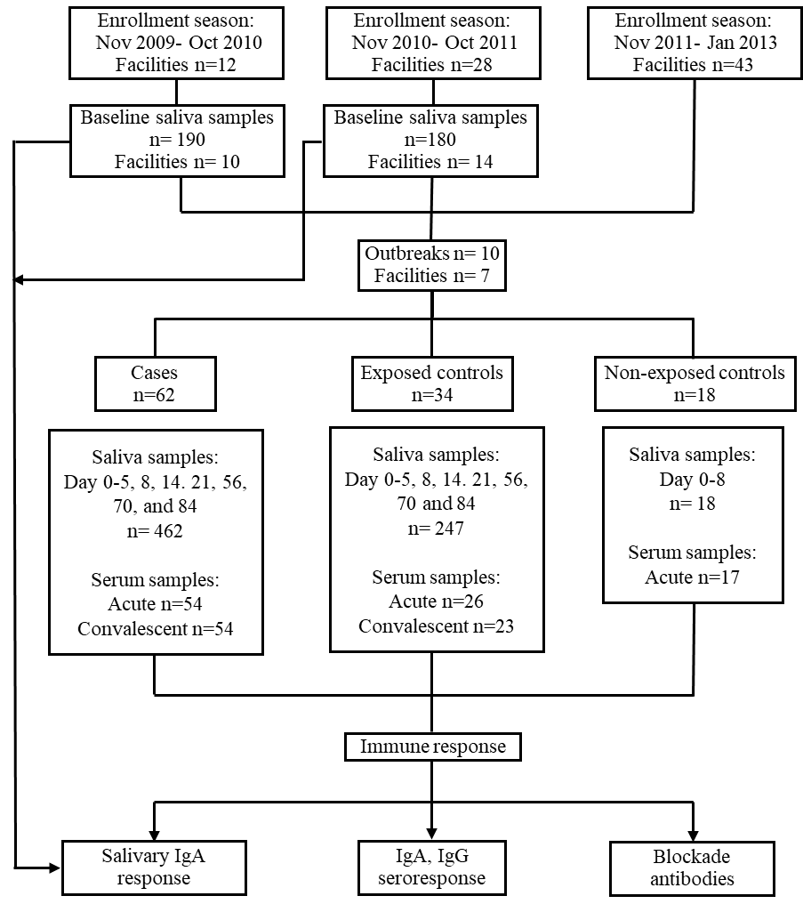
Study participants (n = 180–190) in LTCFs (n = 10–14) were enrolled between November 2009 and February 2010 (baseline I) and November 2010 and February 2011 (baseline II). Between 2009 and 2013, the 43 enrolled LTCFs reported 10 norovirus outbreaks that qualified under the inclusion criteria of the study. In total, 62 cases, 34 exposed controls, and 18 non-exposed controls were enrolled.

Figure S2: Salivary IgA levels in different group (residents, healthcare workers and non-health care) at each LTCFs during baseline I and II
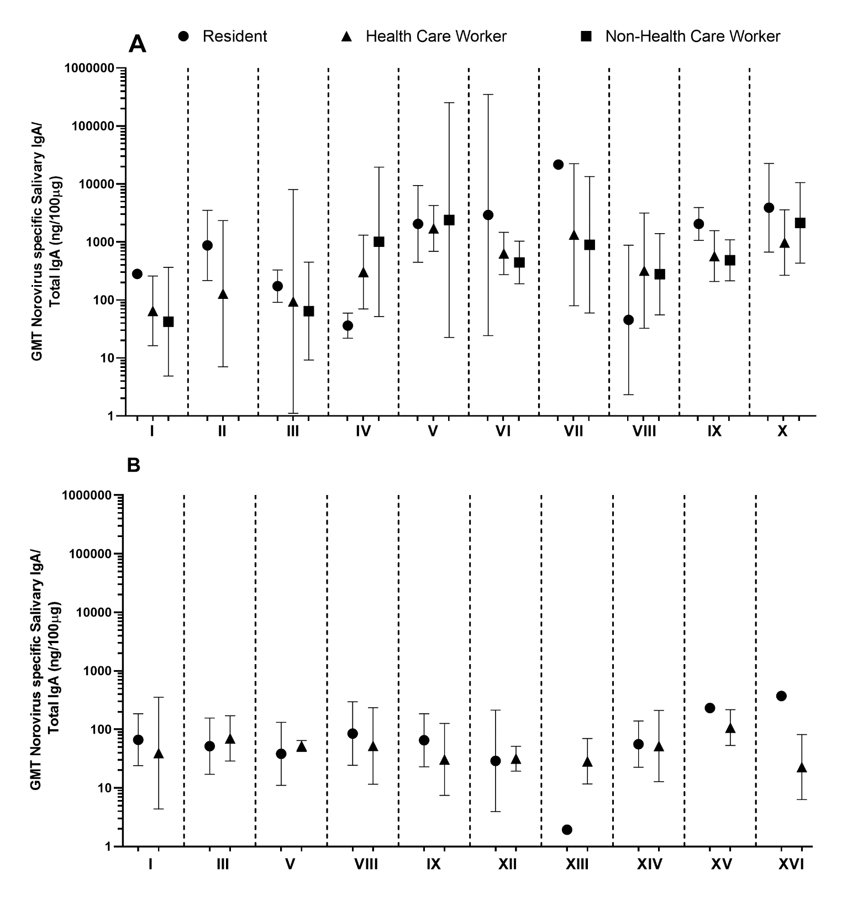
Norovirus-specific salivary IgA level was determined for residents, health care workers and non-health care workers for each institution. Geometric mean titers (GMTs) and 95% confidence intervals (Cis) were calculated for each study group.

Figure S3: Norovirus strain–specific salivary IgA antibodies.
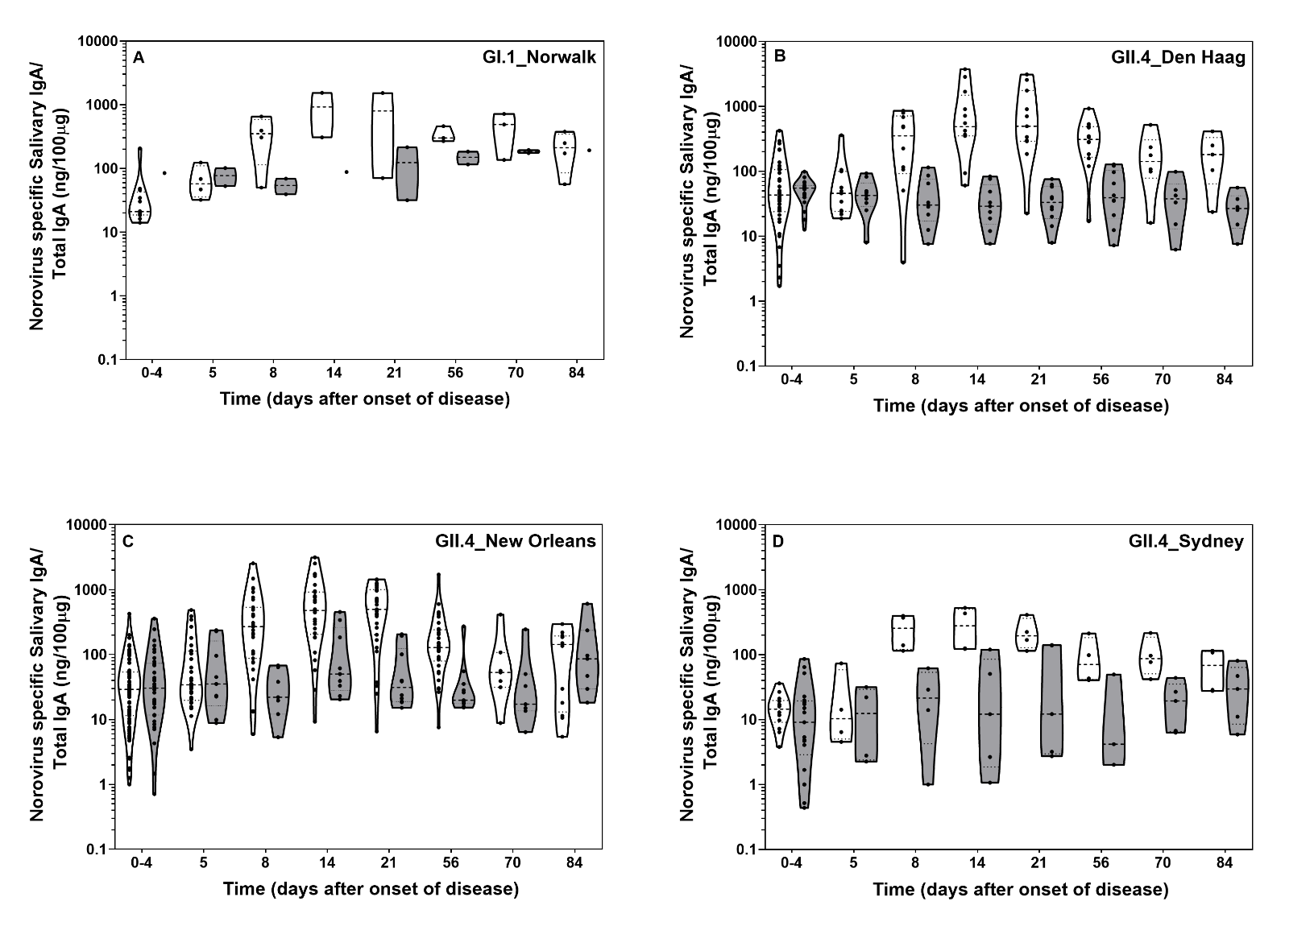

Norovirus strain–specific salivary IgA antibody. Violin plots represent the 25%–75% percentile of reactivity for each norovirus genotype in samples collected from cases (white) and exposed controls (gray) during outbreaks. Outbreak genotypes are listed in the upper right corner of each graph.

Figure S4: Comparison of distribution of norovirus-specific salivary IgA levels between cases and controls during outbreaks
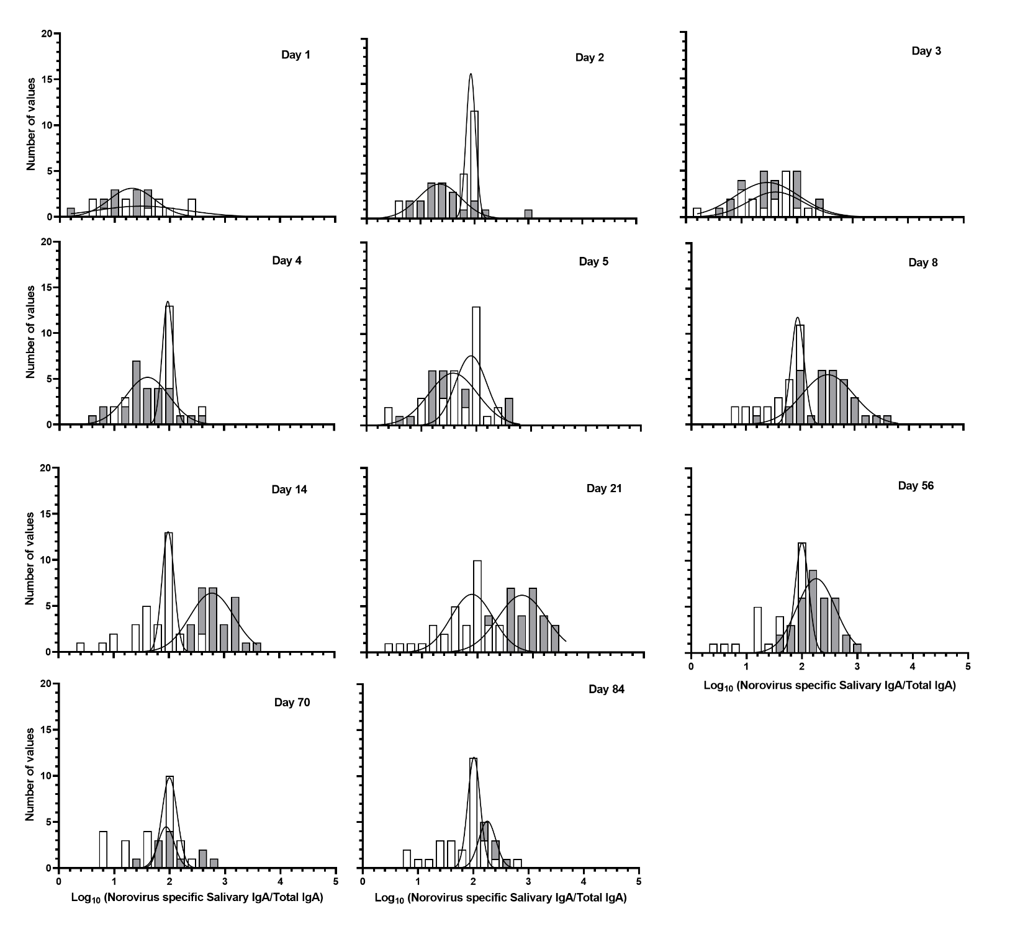
Frequency distribution of norovirus-specific salivary IgA in cases (gray columns) and controls (white columns) during norovirus outbreaks and fitted normal distribution (lines). Days are listed in the upper right corner of each graph.

