Supplemental Material

Evaluation of total and inhalable samplers for the collection
of carbon nanotube and carbon nanofiber aerosols

Matthew M. Dahm, Douglas E. Evans, Stephen Bertke, Sergey A. Grinshpun

Table of Contents
Table S1. Side-by-side sampler cross-configuration comparisons of gravimetric mass between grounded and ungrounded samplers at flow rates of 2 Lpm ………………………………………………...….…....2
Table S2. Side-by-side sampler cross-configuration comparisons of gravimetric mass between grounded and ungrounded samplers at flow rates of 5 Lpm………………………………………………….……..3
Figure S1. The venture dustiness testing device used in this study……………………………………….4
Figure S2. The sampler configuration arrangement for configuration two……………………………….4

Table S1. Side-by-side sampler cross-configuration comparisons of gravimetric mass between grounded and ungrounded samplers at flow rates of 2 Lpm.
Material | Statistical Analysis | 25-mm OFC | 25-mm OFC Metal | Button Sampler‡ | Button Sampler‡
 |  | Config. 1 | Config. 3 | Config. 1 | Config. 3
 |  | Ungrounded | Grounded* | Ungrounded | Grounded*
ARD | Mean (mg/m3) | 5.79 | 9.78 | 8.29 | 10.23
 | SD | 2.12 | 1.84 | 1.66 | 0.65
 | Percent Error (95% CI) † | -34.7% (-56.2, -13.1) |  | -18.9% (-26.9, -10.8)
MW1 | Mean (mg/m3) | 2.87 | 6.67 | 5.21 | 6.82
 | SD | 1.35 | 1.35 | 1.73 | 1.89
 | Percent Error (95% CI) † | -55.6% (-66.7, -44.5) |  | -16.5% (-36.3, 3.4)
MW2 | Mean (mg/m3) | 0.95 | 0.92 | 0.81 | 0.58
 | SD | 0.51 | 0.60 | 0.94 | 0.47
 | Percent Error (95% CI) † | 34.1% (-12.1, 80.2) |  | 99.2% (17.7, 180.7)
CNF1 | Mean (mg/m3) | 1.37 | 4.64 | 1.68 | 2.64
 | SD | 0.82 | 1.62 | 0.45 | 0.65
 | Percent Error (95% CI) † | -70.4% (-78.9, -61.8) |  | -30.1% (-47.1, -13.1)
† Percent error was calculated as the average of error from the 15 paired samples and does not reflect the errors of the means.
‡ The Button Sampler flow rate was set at the prescribed 4 Lpm to sample the inhalable aerosol fraction.
* Used as the reference sampler to calculate the averaged percent error.
Ungrounded and Grounded refer to the samplers being either electrically grounded or ungrounded to the VDT.
OFC= Open-Faced Cassette; ARD= Coarse Arizona Road Dust; MW1= Multi-Walled Carbon Nanotube 1; MW2= Multi-Walled Carbon Nanotube 2; CNF1= Carbon Nanofiber 1; SD= Standard Deviation; 95% CI= 95% Confidence Interval.
Bolded Percent Errors represent those found to contain the null (0) within their confidence interval.

Table S2. Side-by-side sampler cross-configuration comparisons of gravimetric mass between grounded and ungrounded samplers at flow rates of 5 Lpm.
Material | Statistical Analysis | 25-mm OFC | 25-mm OFC Metal | Button Sampler‡ | Button Sampler‡
 |  | Config. 1 | Config. 3 | Config. 1 | Config. 3
 |  | Ungrounded | Grounded* | Ungrounded | Grounded*
ARD | Mean (mg/m3) | 3.98 | 7.99 | 5.75 | 7.33
 | SD | 1.19 | 0.91 | 1.90 | 1.24
 | Percent Error (95% CI) † | -49.6% (-57.6, -41.5) |  | -15.9% (-41.1, 9.4)
MW1 | Mean (mg/m3) | 2.93 | 6.18 | 3.37 | 5.62
 | SD | 1.23 | 1.69 | 0.74 | 1.49
 | Percent Error (95% CI) † | -45.5% (-63.6, -27.3) |  | -37.4% (-46.0, -28.9)
MW2 | Mean (mg/m3) | 0.55 | 0.62 | 0.52 | 0.70
 | SD | 0.35 | 0.25 | 0.32 | 0.42
 | Percent Error (95% CI) † | 3.0% (-35.3, 41.3) |  | 5.9% (-41.1, 52.9)
CNF1 | Mean (mg/m3) | 1.50 | 3.67 | 1.42 | 2.00
 | SD | 0.60 | 0.77 | 0.46 | 0.46
 | Percent Error (95% CI) † | -56.6% (-67.3, -45.9) |  | -27.2% (-40.5, -13.8)
† Percent error was calculated as the average of error from the 15 paired samples and does not reflect the errors of the means.
‡ The Button Sampler flow rate was set at the prescribed 4 Lpm to sample the inhalable aerosol fraction.
* Used as the reference sampler to calculate the averaged percent error.
Ungrounded and Grounded refer to the samplers being either electrically grounded or ungrounded to the VDT.
OFC= Open-Faced Cassette; ARD= Coarse Arizona Road Dust; MW1= Multi-Walled Carbon Nanotube 1; MW2= Multi-Walled Carbon Nanotube 2; CNF1= Carbon Nanofiber 1; SD= Standard Deviation; 95% CI= 95% Confidence Interval.
Bolded Percent Errors represent those found to contain the null (0) within their confidence interval.

Figure S1. The Venturi Dustiness Tester used in this study.

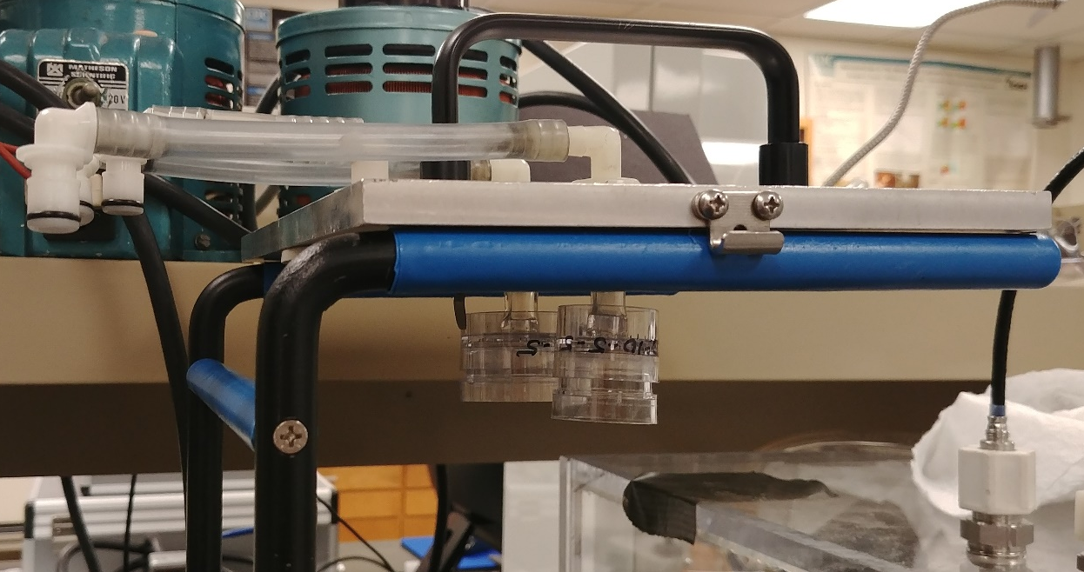

Figure S2. The sampler configuration arrangement for configuration two (25-mm styrene OFC vs. 37-mm styrene OFC.

