Title: Assessment of worker chemical exposures in California vape shops
Supplementary materials

Supplementary Figure 1. Co-located area samplers on central customer service surface
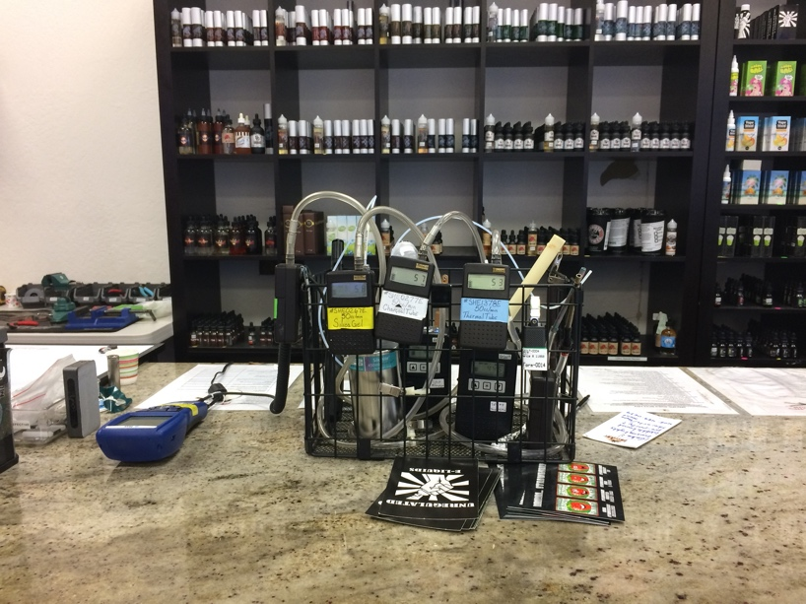

Supplementary Figure 2. Participant wearing an evacuated canister, silica gel tubes, and a formaldehyde badge
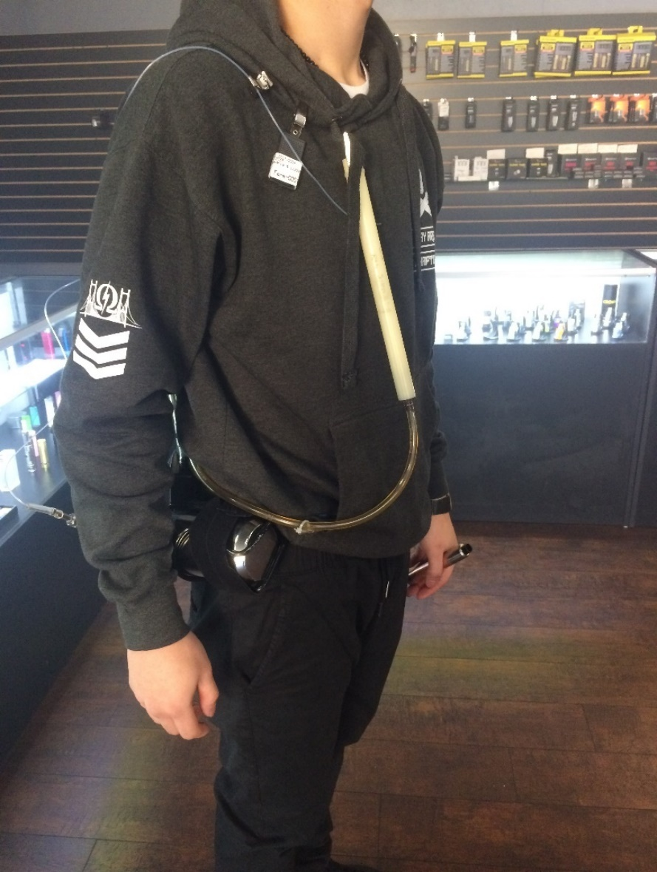

Supplementary Figure 3. Participant performing a custom e-liquid mixing work task
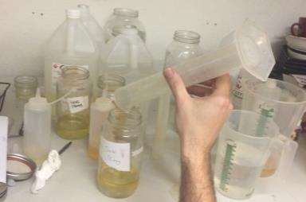

Supplementary Figure 4. Participant dispensing a custom mixed e-liquid
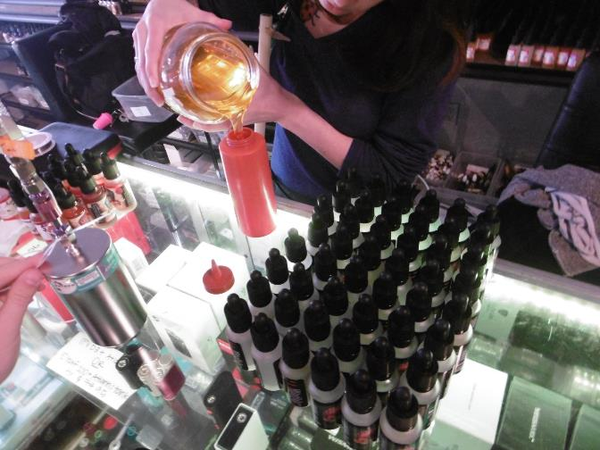

Supplementary Table 1. Full-shift personal sampling results of formaldehyde collected with passive sampling badges
Participant ID | Sample Duration (hours) | Concentration (ppb)
1A | 8.3 | 9.8
2A | 8.2 | 6.4
1B | 8.4 | 13
1C | 7.5 | 32
2C | 7.4 | 34
1D | 11.0 | 9.6
2D | 5.4 | 9.8
3D | 1.5 | 21
1E | 6.6 | 5.9
2E | 5.4 | (3.8)
3E | 6.8 | (3.2)
4E | 4.8 | (4.6)
1F | 4.4 | 14
2F | 3.0 | (6.5)
3F | 4.8 | 11
4F | 4.5 | 11
( ): below Minimum Quantifiable Concentration (MQC) and may be less accurate

Supplementary Table 2. All-day area sampling results of formaldehyde collected with passive sampling badges (n=7)
Shop | Sample Duration (hours) | Concentration (ppb)
A | 7.9 | 7.2
B | 8.6 | 11
C1 | 7.3 | 31
C2 | 7.6 | 30
D | 11.1 | 9.5
E | 13.3 | ND
F | 12.2 | 9.4
( ): below Minimum Quantifiable Concentration (MQC) and may be less accurate
ND: Not Detected (Value is below the Minimum Detectable Concentration (MDC).)

Supplementary Table 3. Full-shift personal sampling results for VOCs collected with evacuated canisters
Participant | Sample Duration (hours) | Acetaldehyde (ppb) | Acetone (ppb) | Acetonitrile (ppb) | Ethanol (ppb) | Isopropyl alcohol (ppb) | d-Limonene (ppb) | Methylene chloride (ppb)
1A | 8 | ND | ND | ND | 110 | 180 | ND | ND
2A | 8 | ND | (31) | ND | 130 | 40 | ND | ND
1B | 7.9 | ND | (50) | ND | 1800 | 960 | (3.5) | ND
1C | 7.4 | 17.2 | (23) | ND | 370 | 520 | (4.4) | ND
2C | 7.3 | 19 | (33) | ND | 390 | 490 | ND | ND
1D | 11 | ND | 51 | 4.6 | 470 | 40 | (3.1) | ND
2D | 5.4 | ND | 32 | ND | 1700 | 24 | ND | ND
1E | 6.7 | ND | 19 | 7.5 | 200 | 150 | ND | ND
2E | 5.4 | ND | 29 | ND | 74 | 49 | ND | ND
3E | 6.8 | ND | 26 | (2.2) | 97 | 110 | ND | ND
1F | 4.5 | (67.0) | 99 | (3.5) | 490 | 1700 | ND | (2.9)
2F | 3.1 | ND | 67 | (0.6) | 130 | 310 | ND | ND
3F | 4.8 | ND | 62 | (2.2) | 150 | 290 | ND | (2.8)
4F | 4.5 | ND | 99 | ND | 190 | 370 | ND | (4.8)
( ): below Minimum Quantifiable Concentration (MQC) and may be less accurate
ND: Not Detected (Value is below the Minimum Detectable Concentration (MDC).)
MDC for acetaldehyde ranges from 0.4 ppb –11.2 ppb
MDC for acetone is 28.8 ppb
MDC in ppb for acetonitrile ranges from 2 ppb – 15.9 ppb
MDC in ppb for d-Limonene ranges from 1 ppb – 5 ppb
MDC in ppb for methylene chloride ranges from 0.4 ppb – 1.5 ppb
*Benzene, chloroform, methyl methacrylate, alpha-pinene, and styrene were not detected in any of the personal samples. N-Hexane was detected below the MQC at (4.8) ppb in Employee 2E’s full-shift personal sample.

Supplementary Table 4: Full-day area sample results for VOCs in units of parts per billion collected with evacuated canisters
Shop | Sample Duration (hours) | Acetaldehyde  (ppb) | Acetone  (ppb) | Acetonitrile  (ppb) | Ethanol  (ppb) | Isopropyl alcohol  (ppb) | d-Limonene  (ppb) | Toluene  (ppb)
A | 8 | ND | ND | ND | (88) | 5400 | ND | ND
B | 8 | ND | ND | 82 | 1900 | 2200 | (7.4) | ND
C1 | 7.2 | 18 | (25) | ND | 380 | 3900 | (3.3) | ND
C2 | 7.5 | 24 | ND | (47) | 450 | 560 | ND | ND
D | 10.4 | ND | 45 | 49 | 510 | 89 | ND | (1.3)
E | 13 | ND | ND | 37 | 84 | 1200 | ND | ND
F | 12.1 | ND | ND | (20) | 220 | 4100 | ND | (1.4)
*Benzene, chloroform, ethyl benzene, methyl methacrylate, n-hexane, alpha-pinene, styrene and o-xylene were not detected in any of the area samples.
**Methylene chloride and m,p-xylene was detected in Shop F below the MQC

Supplementary Table 5: Full-shift personal sampling results of butter flavoring VOCs collected with silica gel tubes in six vape shops

Participant ID | Sample Duration (hours) | Diacetyl (ppb) | 2,3-Pentanedione (ppb) | Acetyl butyryl (ppb) | Acetoin (ppb)
1A | 8.2 | ND | ND | ND | ND
2A | 7.6 | ND | ND | ND | ND
1B | 7.8 | (0.47) | 31 | ND | 10
1C | 7.7 | (0.71) | (0.75) | ND | (1.2)
2C | 7.3 | (0.68) | (1.0) | ND | ND
1D | 11 | ND | (0.36) | ND | ND
2D | 5.4 | ND | ND | ND | ND
3D | 1.5 | ND | ND | ND | ND
1E | 6 | ND | ND | ND | ND
2E | 5.4 | ND | ND | ND | ND
3E | 6.1 | ND | ND | ND | ND
4E | 3.3 | ND | ND | ND | ND
1F | 4.5 | (0.50) | ND | ND | ND
2F | 3 | ND | ND | ND | ND
3F | 3 | ND | ND | ND | ND
4F | 3 | ND | ND | ND | ND

( ): below Minimum Quantifiable Concentration (MQC) and may be less accurate
ND: Not Detected (Value is below the Minimum Detectable Concentration (MDC).)
MDC for diacetyl ranges from 0.12 ppb – 0.4 ppb
MDC for 2,3-pentanedione ranges from 0.12 ppb – 0.6 ppb
MDC for acetyl butyryl ranges from 0.17 ppb – 0.5 ppb
MDC for acetoin ranges from 0.45 ppb – 3.3 ppb

Supplementary Table 6: Full-day area sampling results of butter flavoring VOCs collected with silica gel tubes at six vape shops during open business hours
Shop Area Samples | Sample duration (hours) | Diacetyl (ppb) | 2,3-Pentanedione (ppb) | Acetyl butyryl (ppb) | Acetoin (ppb)
A | 7.9 | ND | ND | ND | ND
B | 7.7 | (0.5) | 28 | ND | 9.5
C1 | 7.7 | 0.85 | (0.75) | ND | (1.1)
C2 | 7.3 | (0.67) | (0.84) | ND | (1.2)
D | 11 | ND | ND | ND | ND
E | 12.2 | ND | ND | ND | ND
F | 11.6 | ND | ND | ND | ND
( ): below Minimum Quantifiable Concentration (MQC) and may be less accurate
ND: Not Detected (Value is below the Minimum Detectable Concentration (MDC).)
MDC for diacetyl ranges from 0.12 ppb – 0.4 ppb
MDC for 2,3-pentanedione ranges from 0.12 ppb – 0.3 ppb
MDC for acetyl butyryl ranges from 0.18 ppb – 0.3 ppb
MDC for acetoin ranges from 0.46 ppb – 1.8 ppb

Supplementary Table 7: Possible flavor chemicals detected using thermal desorption (TD) tubes during full-day area sampling in six vape shops

Possible flavor chemicals^{A} | # of shops where flavor chemicals were detected  (out of 6) |  | Possible flavor chemicals^{A} | # of shops where flavor chemicals were detected  (out of 6)
1-Hydroxyacetone | 4 |  | Glycerin triacetate | 5
2-Methyl butanal | 1 |  | Heptanal | 5
2-Methyl-1-butyl acetate | 1 |  | Hexanal | 6
2,3-Pentanedione | 1 |  | Hexenol | 3
2-Hexenal | 2 |  | Hexyl acetate | 5
Acetaldehyde | 6 |  | Isoamyl acetate | 6
Acetic acid | 6 |  | Isoamyl alcohol | 1
Acetoin | 2 |  | Isoamyl butyrate | 2
Allyl caproate | 1 |  | Isobutyl acetate | 6
Allyl hexanoate | 1 |  | Isopropyl acetate | 1
Amyl acetate | 5 |  | Isopropyl formate | 2
Amyl isovalerate | 2 |  | Isopropyl myristate | 6
Anethole | 1 |  | Isovaleraldehyde | 1
Benzaldehyde | 5 |  | Lallyl hexanoate | 1
Benzophenone | 4 |  | d-Limonene | 6
Benzothiazole | 1 |  | Menthol | 5
Benzyl acetate | 5 |  | Menthone | 6
Benzyl alcohol | 5 |  | Methoxybenzaldehyde | 1
Butanol | 2 |  | Methyl acetate | 3
Butyl acetate | 3 |  | Methyl amyl ketone | 1
Carvone | 3 |  | Methyl cinnamate | 5
Cinnamaldehyde | 1 |  | Methyl furan | 2
Decalacetone | 2 |  | Methyl salicylate | 4
Decanal | 6 |  | Methyl pyrazine | 3
Decanoic acid | 1 |  | Methylnapthalene | 2
Diacetyl | 3 |  | Nonanol | 5
Dimethyl styrene | 2 |  | Nonanoic acid | 2
Dodecanal | 1 |  | Pentadecanoic acid | 1
Dodecanoic acid | 1 |  | Pentanal | 4
Ethyl acetate | 6 |  | alpha-Pinene | 3
Ethyl butyrate | 6 |  | Piperonal | 1
Ethyl caproate | 1 |  | Propanoic acid | 2
Ethyl citrate | 2 |  | Propanol | 2
Ethyl hexanol | 2 |  | Styrene | 3
Ethyl methyl butyrate | 6 |  | Terpineol | 1
Ethyl propanoate | 2 |  | Tetradecane | 5
Ethyl salicylate | 1 |  | Tetradecanoic acid | 1
Ethyl vanillin | 2 |  | Tridecanal | 1
Formic acid | 2 |  | Tridecanoic acid | 1
Furanmethanol | 1 |  | Undecanoic acid | 1
Furfural | 5 |  | Vanillin | 6
^{A}Chemicals listed as flavoring agents or flavor ingredients by PubChem (https://pubchem.ncbi.nlm.nih.gov/) and/or the Flavor and Extract Manufacturers Association (https://www.femaflavor.org, as identified from TD tube analysis

Supplementary Table 8: Metals detected in surface wipe samples collected in six vape shops (micrograms/100 square centimeters) (n=18) arranged by area type^{A,B,C}
Shop | Sampled Surface | Arsenic | Cadmium | Chromium | Cobalt | Lead | Manganese | Nickel
A | Build Area | ND | ND | ND | ND | ND | ND | ND
C | Build Area | ND | (0.061) | 1.4 | ND | 0.85 | (0.38) | 2.3
D | Build Area | ND | ND | 0.14 | ND | 1.1 | ND | (0.43)
E | Coffee Table where building occurred | (0.5) | ND | 0.13 | ND | ND | ND | (0.24)
E | Build Area | ND | (0.042) | 0.2 | ND | ND | ND | (0.35)
A | Register Surface | ND | ND | 0.082 | ND | ND | ND | 0.26
B | Counter (near register) | ND | ND | ND | ND | ND | ND | (0.091)
C | Counter (near register) | ND | ND | ND | ND | ND | (0.25) | (0.11)
F | Counter (near register) | ND | ND | (0.055) | ND | ND | ND | (0.13)
B | Counter (middle) | ND | (0.020) | ND | ND | ND | 0.75 | (0.14)
B | Counter (left) | ND | ND | ND | ND | ND | (0.53) | ND
F | Counter | ND | ND | (0.055) | ND | ND | ND | (0.13)
A | Sampling Bar | ND | ND | ND | (0.071) | ND | ND | (0.044)
D | Sampling Bar | ND | ND | (0.11) | ND | (0.32) | ND | ND
E | Sampling Bar (employee side) | ND | ND | (0.12) | ND | ND | ND | (0.34)
E | Sampling Bar (customer side) | ND | ND | (0.06) | ND | ND | ND | ND
C | Display Case | ND | ND | ND | ND | ND | ND | ND
F | Display Case | ND | ND | ND | ND | ND | ND | ND
( ): below Minimum Quantifiable Concentration (MQC) and may be less accurate

ND: Not Detected (Value is below the Minimum Detectable Concentration (MDC).)
^{A}Antimony, beryllium, indium, lanthanum, molybdenum, selenium, tellurium, titanium, and vanadium were not detected
^{B}Aluminum, barium, calcium, copper, iron, lithium, magnesium, phosphorus, potassium, silver, strontium, tin, yttrium, zinc, and zirconium were detected at low levels on shop surfaces.
^{C}MDCs in ug/100 cm² : arsenic 0.4, cadmium is 0.02, chromium is 0.02, cobalt is 0.03, copper is 0.07, lead is 0.3, manganese is 0.2, nickel is 0.08, silver is 0.02

