Supplementary Table 1. Characteristics associated with growth among infants attending 6 week and month 9 immunizations in Kenya
 | WAZ |  |  | LAZ |  |  | HCAZ
 | Coeff | (95% CI) | P | Coeff | (95% CI) | P |  | Coeff | (95% CI) | P
Week 6 Immunization Visit
Infant characteristics
HEU (ref: HUU) | -0.32 | (-0.50, -0.13) | 0.001 | -0.68 | (-1.08, -0.27) | 0.001 |  | -0.22 | (-0.49, 0.05) | 0.114
Male (ref: female) | -0.01 | (-0.14, 0.12) | 0.879 | -0.13 | (-0.34, 0.08) | 0.227 |  | -0.07 | (-0.20, 0.06) | 0.299
Low birthweight (<2.5 kg) | -1.84 | (-2.23, -1.44) | <0.001 | -1.45 | (-1.94, -0.96) | <0.001 |  | -1.27 | (-1.72, -0.82) | <0.001
Currently breastfeeding (ref: no) | 0.72 | (-0.15, 1.59) | 0.106 | 0.25 | (-1.33, 1.83) | 0.755 |  | 0.47 | (-0.78, 1.73) | 0.459
Prior hospitalizations (ref: no) | -0.60 | (-1.04, -0.16) | 0.008 | -0.33 | (-0.79, 0.13) | 0.158 |  | -0.56 | (-1.09, -0.04) | 0.036
Maternal characteristics
Age (years) | 0.00 | (-0.01, 0.01) | 0.747 | 0.01 | (-0.01, 0.03) | 0.196 |  | 0.01 | (0.00, 0.03) | 0.079
Height (cm) | 0.01 | (0.00, 0.02) | 0.079 | 0.03 | (0.01, 0.05) | 0.009 |  | 0.02 | (0.00, 0.03) | 0.019
Body mass index (continuous) | 0.04 | (0.02, 0.06) | <0.001 | 0.01 | (-0.04, 0.06) | 0.813 |  | 0.00 | (-0.04, 0.03) | 0.832
Primary education and below (ref: above primary) | -0.09 | (-0.22, 0.04) | 0.185 | -0.13 | (-0.38, 0.11) | 0.283 |  | 0.02 | (-0.14, 0.18) | 0.771
Crowding (ref: <3 per room) | -0.11 | (-0.25, 0.03) | 0.137 | -0.13 | (-0.40, 0.13) | 0.325 |  | -0.19 | (-0.39, 0.01) | 0.067
ART before pregnancy | -0.22 | (-0.55, 0.10) | 0.180 | -0.16 | (-0.60, 0.28) | 0.478 |  | 0.03 | (-0.35, 0.42) | 0.866
ART or ARV prophylaxis during pregnancy | -0.06 | (-0.47, 0.35) | 0.766 | 0.45 | (-0.18, 1.09) | 0.160 |  | 0.24 | (-0.34, 0.82) | 0.416
Month 9 Immunization visit
Infant characteristics
HEU (ref: HUU) | -0.17 | (-0.37, 0.04) | 0.104 | -0.53 | (-0.90, -0.17) | 0.005 |  | -0.51 | (-0.94, -0.09) | 0.018
Male (ref: female) | -0.23 | (-0.42, -0.04) | 0.019 | -0.42 | (-0.66, -0.19) | 0.001 |  | -0.23 | (-0.45, -0.01) | 0.042
Low birthweight (<2.5 kg) | -0.94 | (-1.37, -0.51) | <0.001 | -1.02 | (-1.67, -0.36) | 0.003 |  | -0.62 | (-1.07, -0.18) | 0.007
Currently breastfeeding (ref: no) | 0.01 | (-0.34, 0.36) | 0.949 | 0.32 | (-0.17, 0.81) | 0.201 |  | 0.39 | (-0.09, 0.87) | 0.110
Prior hospitalizations (ref: no) | -0.31 | (-0.60, -0.03) | 0.030 | 0.03 | (-0.27, 0.32) | 0.856 |  | 0.00 | (-0.33, 0.33) | 0.993
Maternal characteristics
Age (years) | -0.01 | (-0.03, 0.01) | 0.271 | 0.00 | (-0.01, 0.02) | 0.598 |  | 0.00 | (-0.02, 0.02) | 0.894
Height (cm) | 0.02 | (0.01, 0.03) | 0.003 | 0.02 | (0.01, 0.04) | 0.008 |  | 0.02 | (0.00, 0.04) | 0.067
Body mass index (continuous) | 0.04 | (0.02, 0.06) | 0.001 | 0.04 | (0.01, 0.07) | 0.003 |  | 0.04 | (0.02, 0.07) | <0.001
Primary education and below (ref: above primary) | -0.21 | (-0.37, -0.05) | 0.012 | -0.19 | (-0.42, 0.04) | 0.098 |  | -0.32 | (-0.52, -0.12) | 0.002
Crowding (ref: <3 per room) | -0.30 | (-0.47, -0.13) | 0.001 | -0.22 | (-0.47, 0.04) | 0.098 |  | -0.21 | (-0.44, 0.03) | 0.084
ART before pregnancy | -0.43 | (-0.78, -0.09) | 0.014 | -0.54 | (-1.04, -0.53) | 0.030 |  | -0.29 | (-0.72, 0.14) | 0.182
ART or ARV prophylaxis during pregnancy | -0.20 | (-0.65, 0.24) | 0.364 | 0.37 | (-0.17, 0.92) | 0.176 |  | -0.15 | (-0.80, 0.50) | 0.650
Abbreviations: HEU, HIV-exposed uninfected; HUU, HIV-unexposed uninfected

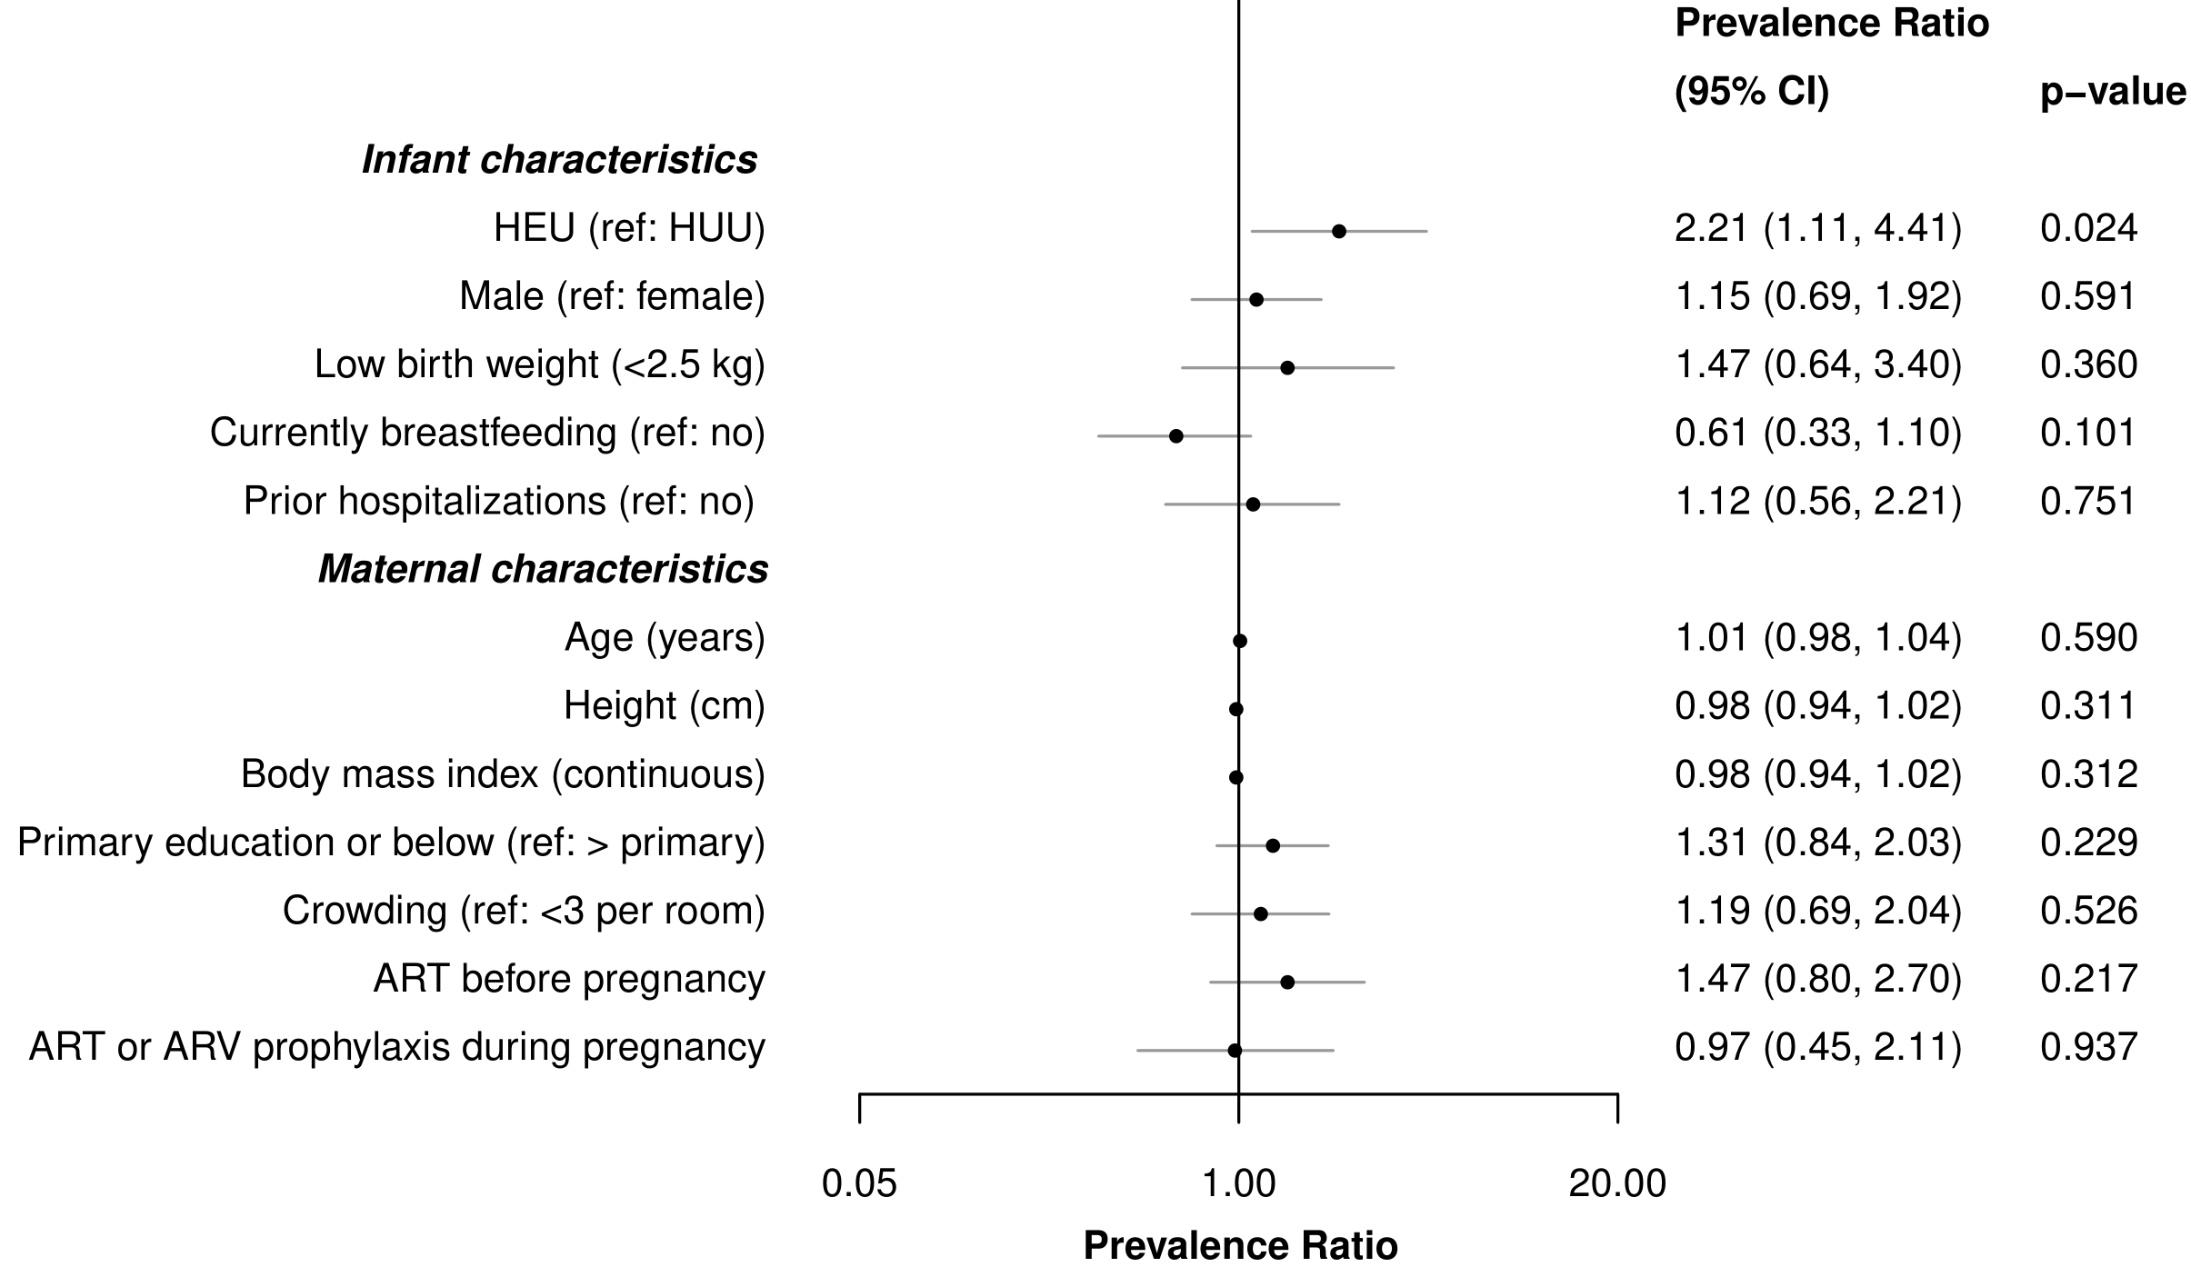
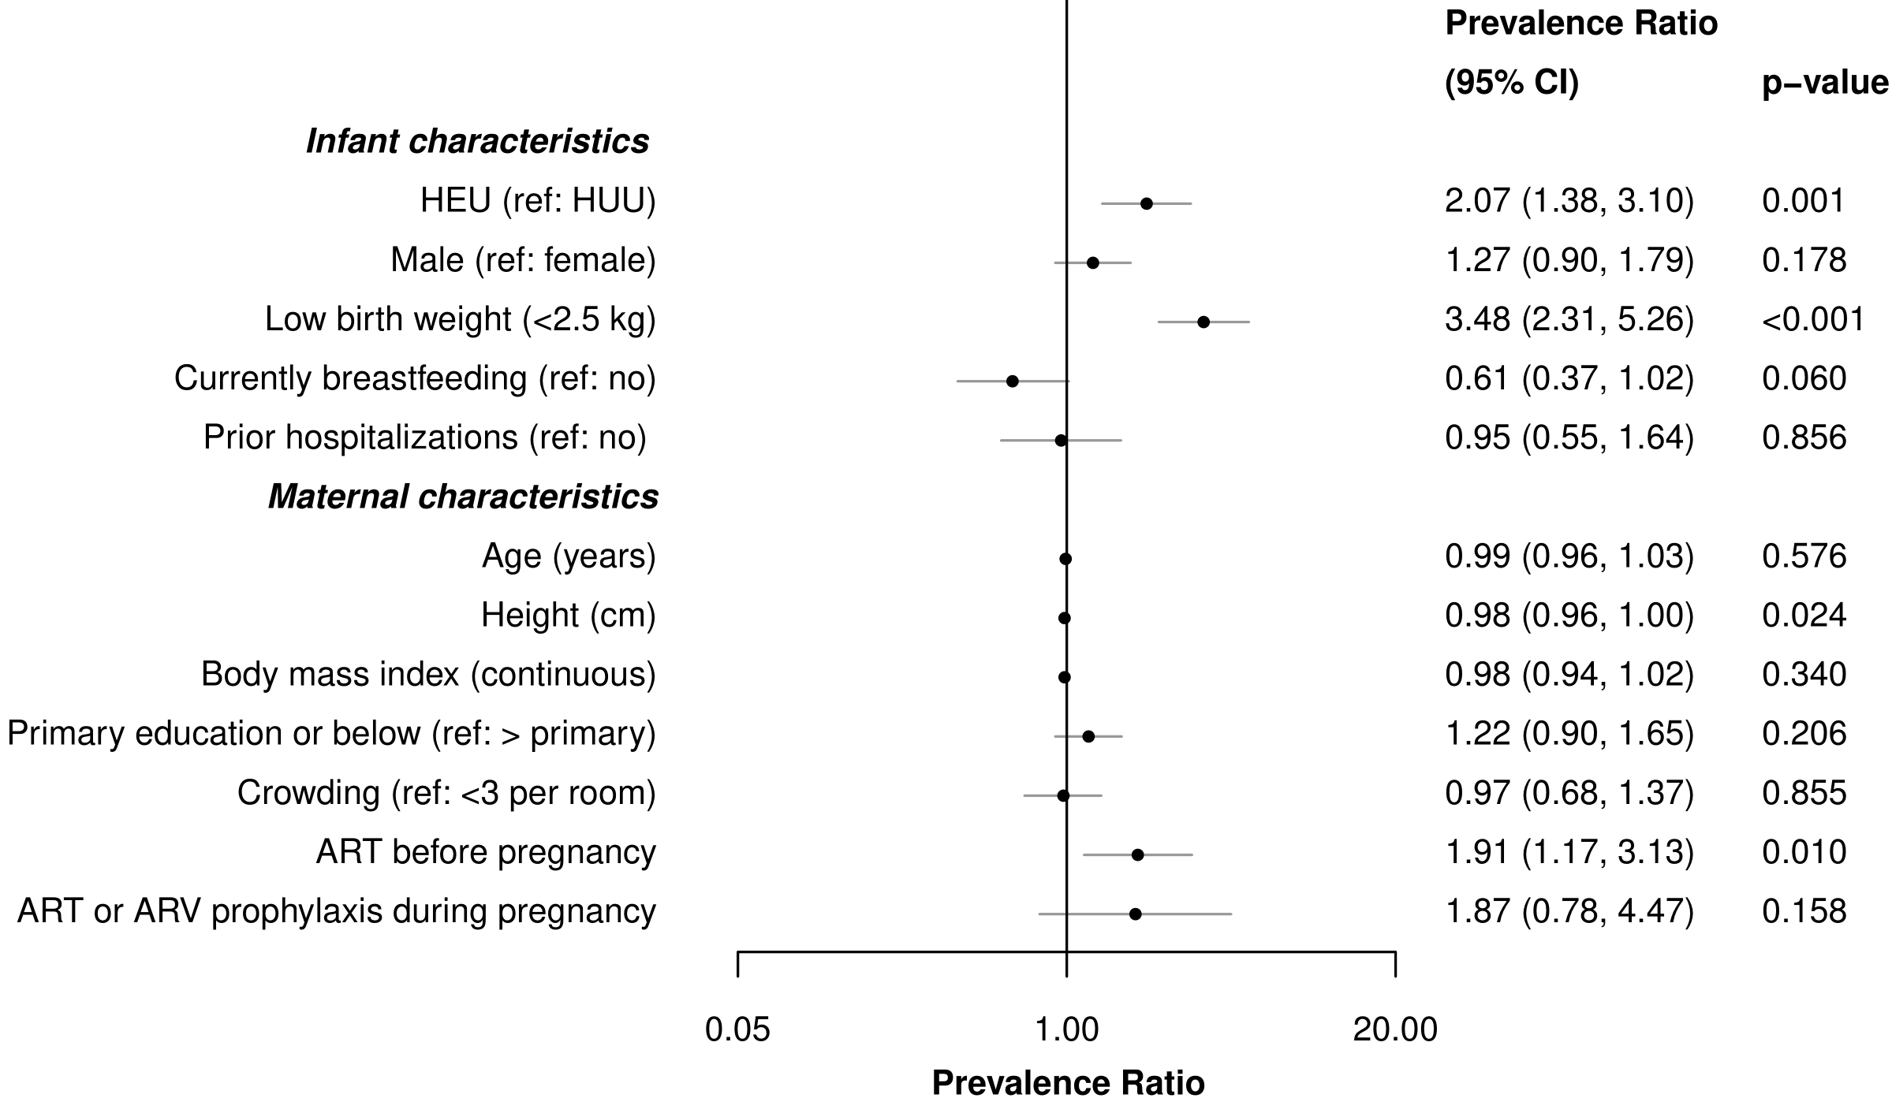
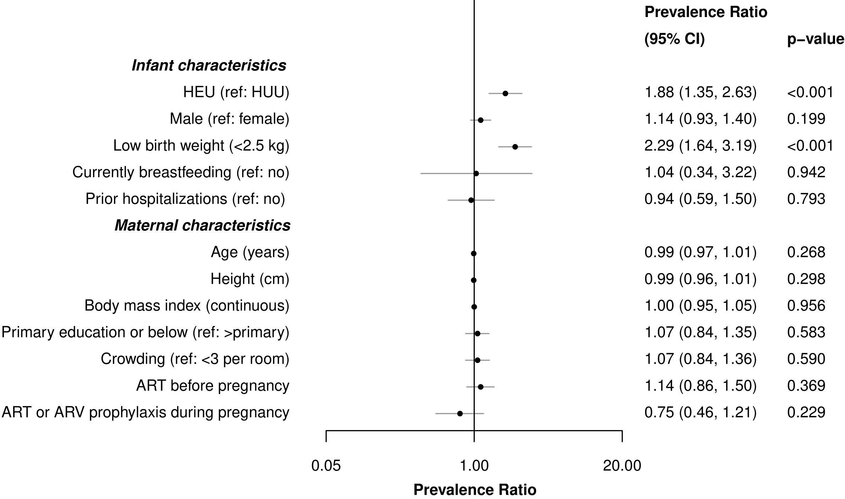
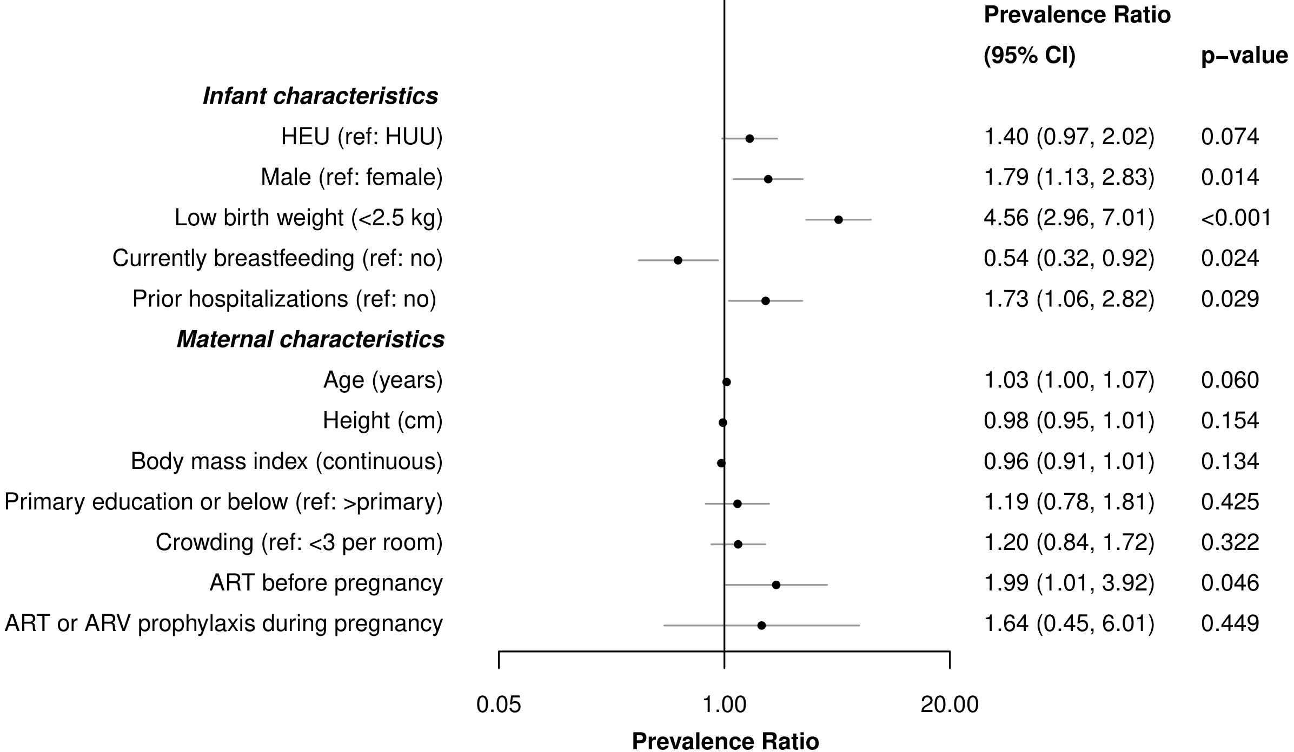
Figure 1. Correlates of underweight, stunting, and microcephaly in infants at week 6 and month 9 immunizations in Kenya
B. Month 9
A. Week 6
Microcephaly
Microcephaly
Stunting
Stunting
Underweight
Underweight
Legend
• Point estimate
− 95% confidence interval
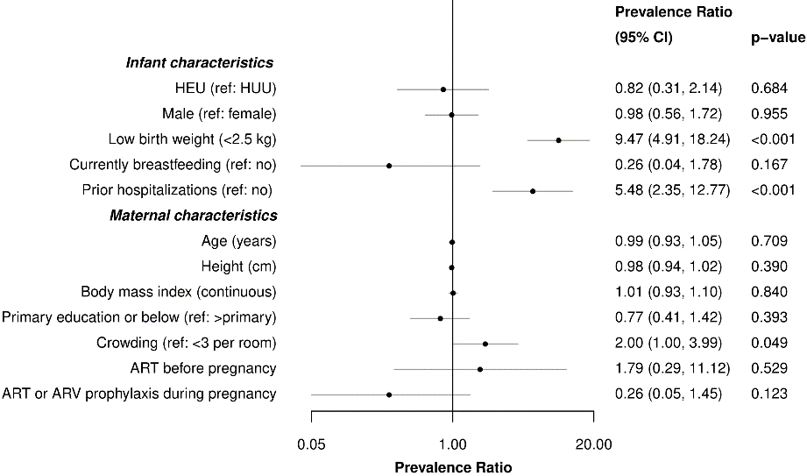
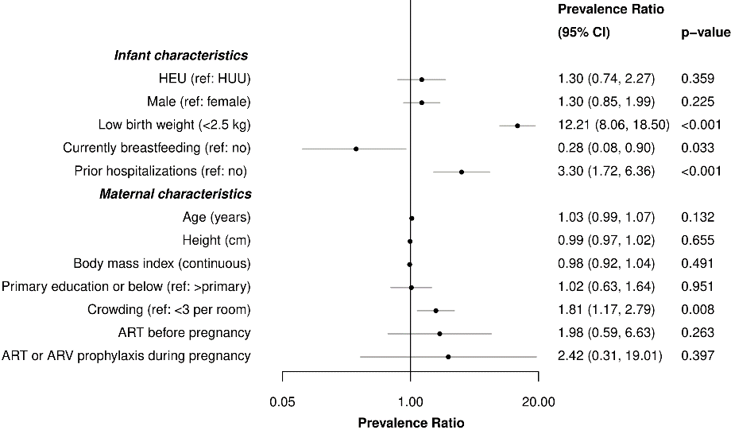
Supplementary Table 2. Multivariable analysis of growth among infants at week 6 and month 9 immunizations using only Survey A data
 | Underweight |  |  | Stunting |  |  | Microcephaly
 | aPR | (95% CI) | P | aPR | (95% CI) | P | aPR | (95% CI) | P
Week 6 Immunization Visit
HEU infant (ref: HUU) | 0.64 | (0.25, 1.65) | 0.356 | 1.78 | (1.20, 2.64) | 0.004 | 1.20 | (0.34, 4.17) | 0.774
Prior hospitalization infant (ref: no) | 3.46 | (1.72, 6.95) | 0.001 | - | - | - | 4.54 | (1.72, 12.04) | 0.003
Currently breastfeeding (ref: no) | 0.12 | (0.04, 0.39) | <0.001 | - | - | - | - | - | -
Maternal age (years) | - | - | - | 0.97 | (0.95, 0.99) | 0.008 | - | - | -
Crowding (ref: <3 per room) | 1.87 | (1.14, 3.07) | 0.014 | - | - | - | - | - | -
Month 9 Immunization Visit
HEU infant (ref: HUU) | 1.45 | (0.76, 2.75) | 0.258 | 1.59 | (0.86, 2.93) | 0.137 | 2.35 | (1.33, 4.15) | 0.004
Male infant (ref: female) | 2.03 | (1.15, 3.57) | 0.015 | - | - | - | - | - | -
Prior hospitalization infant (ref: no) | 1.88 | (1.08, 3.28) | 0.026 | - | - | - | - | - | -
Maternal height (cm) | - | - | - | - | - | - | 0.96 | (0.92, 1.00) | 0.053

 | WAZ |  |  | LAZ |  |  | HCAZ
 | aCoeff | (95% CI) | P | aCoeff | (95% CI) | P | aCoeff | (95% CI) | P
Week 6 Immunization Visit
HEU infant (ref: HUU) | -0.28 | (-0.49, -0.06) | 0.011 | -0.64 | (-1.09, -0.19) | 0.006 | -0.48 | (-0.86, -0.10) | 0.013
Prior hospitalization infant (ref: no) | -0.54 | (-0.92, -0.15) | 0.006 | - | - | - | -0.52 | (-0.98, -0.07) | 0.023
Maternal age (years) | - | - | - | 0.02 | (0.00, 0.04) | 0.029 | 0.01 | (0.00, 0.03) | 0.035
Maternal height (cm) | - | - | - | 0.04 | (0.01, 0.06) | 0.021 | 0.02 | (0.00, 0.03) | 0.031
Maternal BMI | 0.04 | (0.03, 0.06) | <0.001 | - | - | - | - | - | -
Crowding (ref: <3 per room) | - | - | - | - | - | - | -0.20 | (-0.40, 0.01) | 0.057
Month 9 Immunization Visit
HEU infant (ref: HUU) | -0.20 | (-0.55, 0.16) | 0.281 | -0.42 | (-0.88, 0.04) | 0.071 | -0.52 | (-0.97, -0.07) | 0.025
Male | -0.23 | (-0.44, -0.01) | 0.036 | -0.50 | (-0.75, -0.25) | <0.001 | - | - | -
Prior hospitalization infant (ref: no) | - | - | - | - | - | - | - | - | -
Maternal height (cm)** | - | - | - | 0.02 | (0.00, 0.03) | 0.033 | - | - | -
Maternal BMI | 0.03 | (0.01, 0.05) | 0.014 | - | - | - | 0.03 | (0.01, 0.06) | 0.011
Maternal primary education and below (ref: above primary) | - | - | - | - | - | - | -0.29 | (-0.51, -0.06) | 0.014
Crowding (ref: <3 per room) | -0.23 | (-0.42, -0.05) | 0.014 | -0.24 | (-0.52, 0.03) | 0.082 | - | - | -
*Maternal BMI and height were not included in the same multivariate model – only BMI was included for WAZ and HCAZ and only maternal height was included for LAZ; Abbreviations: BMI: body mass index, HEU: HIV-exposed uninfected, HUU: HIV-unexposed uninfected
Supplementary Table 3. Multivariable analysis of growth in infants at week 6 and month 9 immunizations including low birthweight as a confounder

 | Underweight |  |  | Stunting |  |  | Microcephaly
 | aPR | (95% CI) | P | aPR | (95% CI) | P | aPR | (95% CI) | P
Week 6 Immunization Visit
HEU infant (ref: HUU) | 1.08 | (0.63, 1.84) | 0.787 | 1.92 | (1.32, 2.79) | 0.001 | 0.64 | (0.22, 1.92) | 0.426
Low birthweight (ref: ≥2.5 kg) | 11.33 | (7.21, 17.83) | <0.001 | 2.17 | (1.56, 3.01) | <0.001 | 7.91 | (4.08, 15.35) | <0.001
Prior hospitalization infant (ref: no) | 2.21 | (1.29, 3.78) | 0.004 | - | - | - | 3.98 | (1.89, 8.39) | <0.001
Currently breastfeeding (ref: no) | 0.16 | (0.05, 0.59) | 0.006 | - | - | - | - | - | -
Crowding (ref: <3 per room) | 1.44 | (0.95, 2.20) | 0.088 | - | - | - | 1.73 | (0.85, 3.55) | 0.131
Month 9 Immunization Visit
HEU infant (ref: HUU) | 1.11 | (0.70, 1.75) | 0.662 | 1.89 | (1.23, 2.88) | 0.004 | 2.21 | (1.11, 4.41) | 0.024
Male infant (ref: female) | 1.99 | (1.23, 3.24) | 0.006 | - | - | - | - | - | -
Low birthweight (ref: ≥2.5 kg) | 4.36 | (2.73, 6.96) | <0.001 | 3.51 | (2.34, 5.26) | <0.001 | - | - | -
Prior hospitalization infant (ref: no) | 1.60 | (0.99, 2.59) | 0.055 | - | - | - | - | - | -
Currently breastfeeding (ref: no) | 0.78 | (0.41, 1.47) | 0.440 | - | - | - | - | - | -
Maternal height (cm) | - | - | - | 0.98 | (0.96, 1.00) | 0.041 | - | - | -

 | WAZ |  |  | LAZ |  |  | HCAZ
 | aCoeff | (95% CI) | P | aCoeff | (95% CI) | P | aCoeff | (95% CI) | P
Week 6 Immunization Visit
HEU infant (ref: HUU) | -0.28 | (-0.49, -0.08) | 0.006 | -0.67 | (-1.11, -0.23) | 0.003 | -0.22 | (-0.50, 0.05) | 0.107
Low birthweight (ref: ≥2.5 kg) | -1.74 | (-2.13, -1.35) | <0.001 | -1.38 | (-1.86, -0.90) | <0.001 | -1.20 | (-1.64, -0.76) | <0.001
Prior hospitalization infant (ref: no) | -0.53 | (-0.88, -0.17) | 0.004 | - | - | - | -0.53 | (-1.02, -0.03) | 0.036
Maternal height (cm) | - | - | - | 0.03 | (0.01, 0.06) | 0.010 | 0.02 | (0.00, 0.03) | 0.044
Maternal BMI | 0.03 | (0.02, 0.05) | <0.001 | - | - |  | - | - | -
Month 9 Immunization Visit
HEU infant (ref: HUU) | -0.05 | (-0.26, 0.16) | 0.661 | -0.46 | (-0.80, -0.11) | 0.009 | -0.38 | (-0.84 0.06) | 0.092
Male infant (ref: female)* | - | - | - | -0.35 | (-0.61, -0.10) | 0.007 | -0.19 | (-0.44, 0.05) | 0.122
Low birthweight (ref: ≥2.5 kg) | -0.89 | (-1.31, -0.46) | <0.001 | -1.00 | (-1.66, -0.35) | 0.003 | -0.61 | (-1.01, -0.21) | 0.003
Prior hospitalization infant (ref: no) | -0.29 | (-0.60, 0.02) | 0.071 | - | - | - | - | - | -
Maternal height (cm)** | - | - | - | 0.02 | (0.01, 0.04) | 0.008 | - | - | -
Maternal BMI | 0.03 | (0.00, 0.05) | 0.018 | - | - | - | 0.03 | (0.01, 0.05) | 0.005
Maternal primary education and below (ref: above primary) | -0.09 | (-0.27, 0.08) | 0.303 | - | - | - | -0.15 | (-0.38, 0.07) | 0.179
Crowding (ref: <3 per room) | -0.25 | (-0.44, -0.05) | 0.012 | - | - | - | - | - | -
*Male sex and low birthweight were collinear at 9-month WAZ; Infant sex was dropped from the model; **Maternal BMI and height were not included in the same multivariate model – only BMI was included for WAZ and HCAZ and only maternal height was included for LAZ; Abbreviations: BMI: body mass index, HEU: HIV-exposed uninfected, HUU: HIV-unexposed uninfected

Supplementary Table 4. Sensitivity analysis of only HEU infants with mothers on ART during pregnancy and HUU infants
 | Underweight |  |  | Stunting |  |  | Microcephaly
 | aPR | (95% CI) | P | aPR | (95% CI) | P | aPR | (95% CI) | P
Week 6 Immunization Visit
HEU infant (ref: HUU) | 1.25 | (0.65, 2.41) | 0.493 | 1.80 | (1.29, 2.51) | 0.001 | 0.73 | (0.21, 2.49) | 0.613
Prior hospitalization infant (ref: no) | 3.43 | (1.73, 6.78) | <0.001 | - | - | - | 5.47 | (2.35, 12.75) | <0.001
Currently breastfeeding (ref: no) | 0.21 | (0.07, 0.67) | 0.009 | - | - | - | - | - | -
Crowding (ref: <3 per room) | 1.77 | (1.12, 2.80) | 0.015 | - | - | - | 1.95 | (0.96, 3.93) | 0.063
Month 9 Immunization Visit
HEU infant (ref: HUU) | 1.50 | (0.94, 2.37) | 0.088 | 2.70 | (1.86, 3.93) | <0.001 | 2.73 | (1.48, 5.03) | 0.001
Male infant (ref: female) | 1.97 | (1.20, 3.23) | 0.007 | - | - | - | - | - | -
Prior hospitalization infant (ref: no) | 1.68 | (1.00, 2.84) | 0.052 | - | - | - | - | - | -
Currently breastfeeding (ref: no) | 0.71 | (0.37, 1.35) | 0.296 | - | - | - | - | - | -
Maternal height (cm) | - | - | - | 0.98 | (0.95, 1.00) | 0.021 | - | - | -

 | WAZ |  |  | LAZ |  |  | HCAZ
 | aCoeff | (95% CI) | P | aCoeff | (95% CI) | P | aCoeff | (95% CI) | P
Week 6 Immunization Visit
HEU infant (ref: HUU) | -0.40 | (-0.61, -0.18) | <0.001 | -0.63 | (-1.05, -0.21) | 0.004 | -0.23 | (-0.54, 0.08) | 0.148
Prior hospitalization infant (ref: no) | -0.69 | (-1.13, -0.26) | 0.002 | - | - | - | -0.64 | (-1.18, -0.10) | 0.020
Maternal height (cm) |  |  |  | 0.29 | (0.00, 0.05) | 0.022 | 0.01 | (0.00, 0.03) | 0.037
Maternal BMI | 0.04 | (0.02, 0.06) | <0.001 | - | - | - | - | - | -
Month 9 Immunization Visit
HEU infant (ref: HUU) | -0.23 | (-0.47, 0.00) | 0.054 | -0.71 | (-1.14, -0.29) | 0.001 | -0.71 | (-1.15, -0.26) | 0.002
Male infant (ref: female) | -0.27 | (-0.47, -0.07) | 0.008 | -0.48 | (-0.72, -0.24) | <0.001 | -0.24 | (-0.47, -0.02) | 0.036
Prior hospitalization infant (ref: no) | -0.30 | (-0.61, 0.00) | 0.053 | - | - | - | - | - | -
Maternal height (cm)* | - | - | - | 0.02 | (0.00, 0.04) | 0.012 | - | - | -
Maternal BMI | 0.03 | (0.01, 0.05) | 0.006 | - | - | - | 0.04 | (0.02, 0.06) | 0.001
Maternal primary education and below (ref: above primary) | -0.04 | (-0.21, 0.12) | 0.619 | - | - | - | -0.20 | (-0.42, 0.02) | 0.072
Crowding (ref: <3 per room) | -0.23 | (-0.40, -0.06) | 0.009 | - | - | - | - | - | -
*Maternal BMI and height were not included in the same multivariate model – only BMI was included for WAZ and HCAZ and only maternal height was included for LAZ; Abbreviations: BMI: body mass index, HEU: HIV-exposed uninfected, HUU: HIV-unexposed uninfected

