Supplemental Table 1. Pre- and Post-vaccination serum samples used in this study.
Seasons | Pairs (N) | Age range (years) | Median age (years) | Birth years
2010-2011 | 50 | 19-49 | 32 | 1961-1991
2011-2012 | 54 | 21-49 | 34 | 1962-1990
2013-2014 | 42 | 18-49 | 34 | 1964-1995
2014-2015 | 61 | 18-49 | 30 | 1965-1996
2015-2016 | 60 | 19-46 | 33 | 1969-1996
2016-2017 | 33 | 18-47 | 34 | 1969-1998
Total | 300 | 18-49 | 33 | 1961-1998

Supplemental Table 2. Amino Acid Sequence Differences in HA1 Regions of the 1977-2015 A(H1N1) Viruses Used in This Study.
90
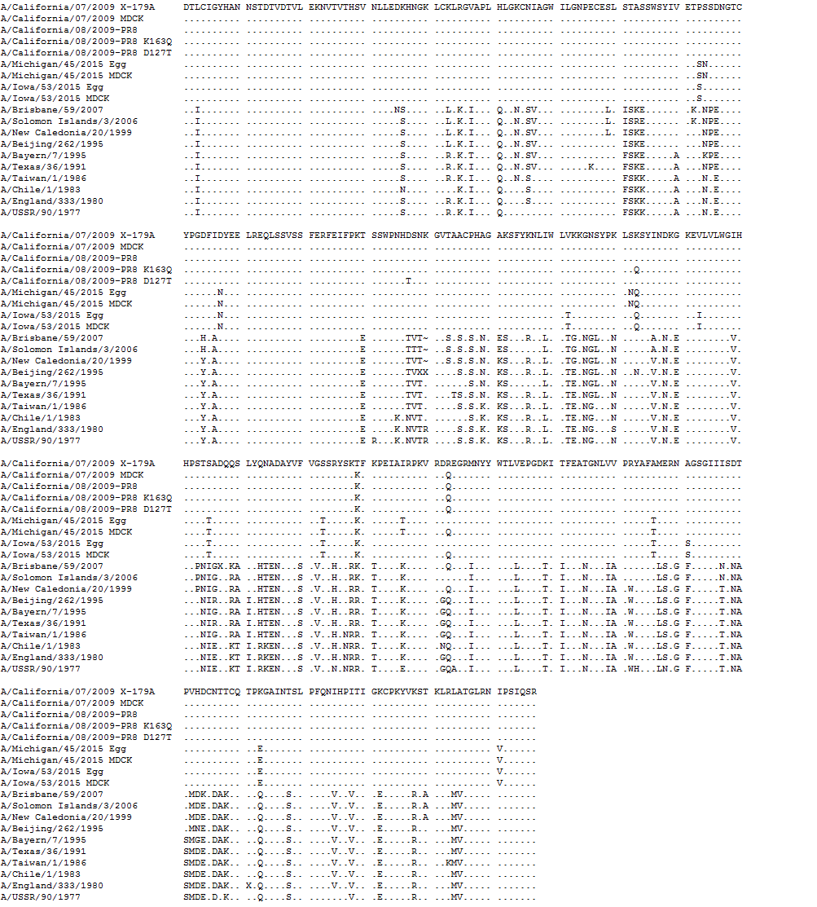
1

130
127
125
180
163
91

0
270
223
181

327
271

Mature H1 HA numbering is used. HA 125, 127, 163 and 223 sites are highlighted in frame. X-179A is used as the reference for comparison. “~” indicates a deletion at HA 130 site. “.” denotes the identical amino acids as X-179A. HA sequences are accessed from the Global Initiative on Sharing All Influenza Data platform: A/California/07/2009 X-179A (EPI180554), A/California/07/2009 MDCK (EPI516528), A/Michigan/45/2015 Egg (EPI685579), A/Michigan/45/2015 MDCK (EPI662594), A/Iowa/53/2015 Egg (EPI860087), A/Iowa/53/2015 MDCK (EPI676441), A/Brisbane/59/2007 (EPI162331), A/Solomon Islands/03/2006 (EPI155197), A/New Caledonia/20/99 (EPI511013), A/Beijing/262/1995 (EPI159384), A/Bayern/7/1995 (EPI1069243), A/Texas/36/1991 (EPI159432), A/Taiwan/1/1986 (EPI317570), A/Chile/1/1983 (EPI162331), A/England/333/1980 (EPI131321), and A/USSR/90/1977 (EPI390455). The three RG viruses: A/California/08/2009-PR8, A/California/08/2009-PR8 K163Q, and A/California/08/2009-PR8 D127T were sequenced in house.

