SUPPLEMENTARY MATERIAL

Detailed methods for population estimates used in incidence rate calculations
For the 50 U.S. States, D.C., and Puerto Rico, we calculated tuberculosis (TB) incidence rates using population estimates from the American Community Survey (ACS) and Puerto Rico Community Survey (PRCS) public use microsample (PUMS) 1-year files for 2007–2017 (Supplemental Table 1) (1). For the remaining U.S.-Affiliated Islands, we used modeled population estimates compiled by the U.S. Census Bureau, as neither the ACS nor the PRCS collects population estimates in these areas (1–3).
The National Tuberculosis Surveillance System (NTSS) began collecting data on parental country of birth among children aged <15 years in 2010 (Supplemental Table 1). Therefore, we could not calculate incidence rates by parental nativity prior to 2010 or among adolescents aged 15–17 years. Instead, we calculated TB incidence rates in children during 2010–2017 stratified by country of birth for non-U.S.–born children and parental country of birth for U.S.–born children using U.S. Census Bureau population estimates.
Only parental nativity, not parental country of birth, is available in ACS. For incidence rate calculations by parental country of birth, we used the Integrated Public Use Microdata Series (IPUMS), which is a collection of individual- and household-level U.S. population data from several sources, including the ACS and PRCS (4). We used IPUMS data compiled from ACS 1-year datasets to calculate rates by country of birth for non-U.S.–born children and parental country of birth for U.S.–born children.

Supplemental Table 1. Availability of variables in the National Tuberculosis Surveillance System (NTSS) and in U.S. population estimate sources by year, age group, and geographic area

Variable/Parameter | NTSS Data (2007–2017)  N= 9,276  (n=8,030 U.S. States and DC; n=1,246 U.S.-Affiliated Islands¹) |  |  |  | Data Sources for Population Estimates
 | 2007–2009  n=3,204² |  | 2010–2017  n=6,072³ |  | ACS/PRCS (PUMS) | IPUMS⁴ | Other Census Bureau
 | All Ages |  | Aged <15  N=4,650⁵ | Aged 15–17  N=1,422⁶ | 50 States, DC, PR | 50 States, DC, PR | Other U.S.-Affiliated Islands
Demographic characteristics | x |  | x | x | x | x | x
Nativity of child | x |  | x | x | x | x
Country of birth for child | x |  | x | x | x | x
Nativity of parents |  |  | x |  | x | x
Country of birth for parents |  |  | x |  |  | x
Child lived outside U.S. for >2 months |  |  | x
Child identified through contact tracing |  |  | x | x
Other revised NTSS/RVCT variables |  |  | x | x
Shaded box with ‘x’ indicates variable or parameter is available
Abbreviations: ACS=American Community Survey; DC= District of Columbia; IPUMS=Integrated Public Use Microsample; NTSS=National TB Surveillance System; PR=Puerto Rico; PRCS=Puerto Rico Community Survey; PUMS=Public Use Microsample RVCT=Revised of Verified Case of Tuberculosis; TB=Tuberculosis;

- U.S.-Affiliated Islands reporting to NTSS include U.S. Territories: American Samoa, Guam, Commonwealth of the Northern Mariana Islands, Puerto Rico, and the U.S. Virgin Islands; and freely-associated states: Federated States of Micronesia, Republic of the Marshall Islands, and Republic of Palau
- n=349 U.S.-Affiliated Islands, n=2,855 U.S. States/DC
- n=897 U.S.-Affiliated Islands, n=5,175 U.S. States/DC
- Integrated Public Use Microdata series (IPUMS) is a publicly-available repository of historical individual- and household-level U.S. Census Bureau data, including American Community Survey. IPUMS uses uniform codes across years and surveys and constructed variables to identify interrelationships between household members. Available: IPUMS-USA, University of Minnesota, www.ipums.org.
- n=754 U.S.-Affiliated Islands, n=3,896 U.S. States/DC
- n=143 U.S.-Affiliated Islands, n=1,279 U.S. States/DC

Supplemental Figure 1. TB incidence rates by age and nativity for children and adolescents aged <18 years reported in U.S. States and District of Columbia, 2007–2017
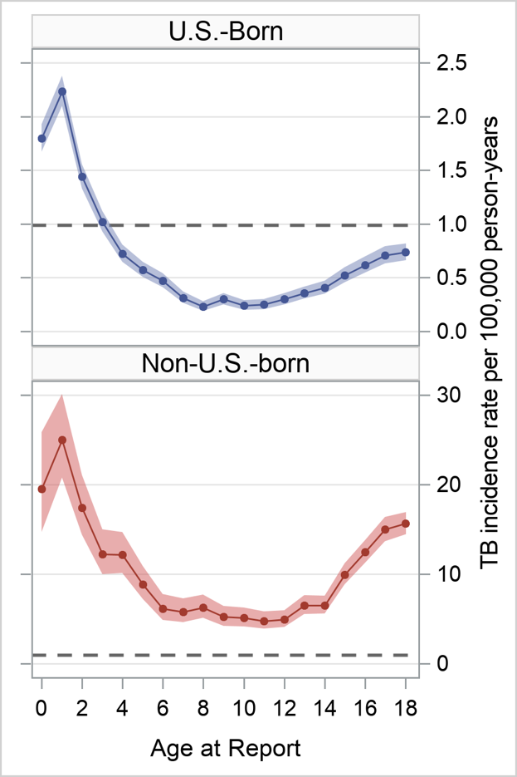
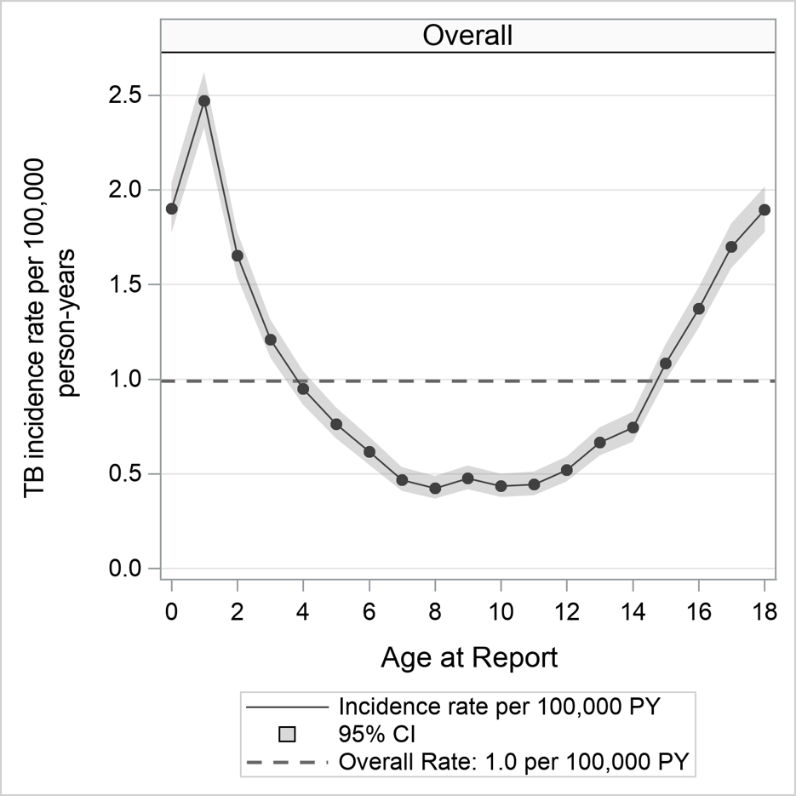
A
B
C

Supplemental Figure 2. Counts of tuberculosis (TB) and TB incidence rates among children and adolescents aged <18 years in U.S. States, District of Columbia, and U.S.-Affiliated Islands reporting to the National Tuberculosis Surveillance System (NTSS), 2007–2017
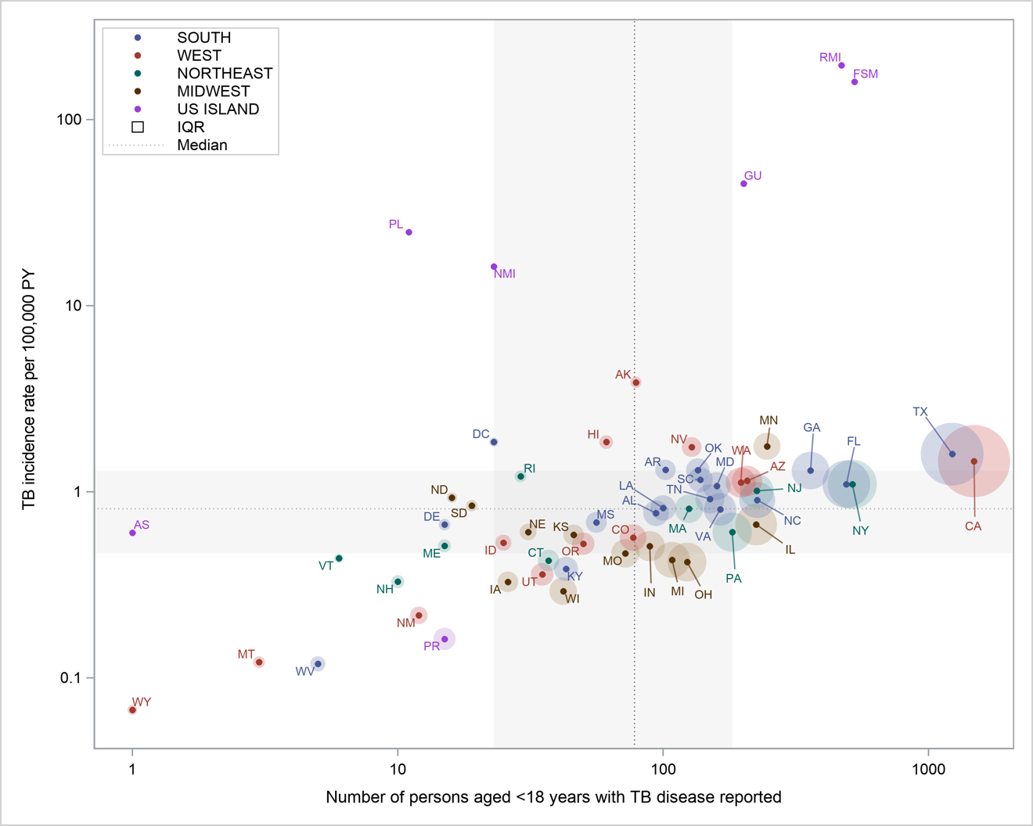
Each point represents one jurisdiction reporting to NTSS. Markers are colored according to U.S. Census Bureau region, sized proportional to the population aged <18 years, and labeled according to the abbreviations in the table below. Grey dotted lines and shaded regions represent the median and interquartile ranges (IQR) of count of TB disease cases reported for all jurisdictions (x-axis, 78 [23, 182]) and TB incidence rate for all jurisdictions (y-axis, 0.8 [0.5, 1.3] per 100,000 PY). Both axes are shown on the logarithmic scale.

Code | Reporting Area | Code | Reporting Area | Code | Reporting Area | Code | Reporting Area
AK | Alaska | IA | Iowa | NC | North Carolina | RI | Rhode Island
AL | Alabama | ID | Idaho | ND | North Dakota | RMI | Republic of the Marshall Islands
AR | Arkansas | IL | Illinois | NE | Nebraska | SC | South Carolina
AS | American Samoa | IN | Indiana | NH | New Hampshire | SD | South Dakota
AZ | Arizona | KS | Kansas | NJ | New Jersey | TN | Tennessee
CA | California | KY | Kentucky | NM | New Mexico | TX | Texas
CO | Colorado | LA | Louisiana | CNMI | Commonwealth of the Northern Mariana Islands | UT | Utah
CT | Connecticut | MA | Massachusetts | NV | Nevada | VA | Virginia
DC | District of Columbia | MD | Maryland | NY | New York | VT | Vermont
DE | Delaware | ME | Maine | OH | Ohio | WA | Washington
FL | Florida | MI | Michigan | OK | Oklahoma | WI | Wisconsin
FSM | Federated States of Micronesia | MN | Minnesota | OR | Oregon | WV | West Virginia
GA | Georgia | MO | Missouri | PA | Pennsylvania | WY | Wyoming
GU | Guam | MS | Mississippi | PL | Palau
HI | Hawaii | MT | Montana | PR | Puerto Rico

SUPPLEMENTARY APPENDIX REFERENCES
1. U.S. Census Bureau. American Community Survey - Public Use Microdata Sample (PUMS) Documentation [Internet]. 2018. Available from: https://www.census.gov/programs-surveys/acs/technical-documentation/pums.html
2. U.S. Census Bureau. Press Kit: 2010 Census Island Areas [Internet]. Available from: https://www.census.gov/newsroom/releases/archives/2010_census/press-kits/island-areas.html
3. U.S. Census Bureau. International Database [Internet]. Available from: https://www.census.gov/programs-surveys/international-programs/about/idb.html
4. Steven Ruggles, Katie Genadek, Ronald Goeken, Josiah Grover and MS. Integrated Public Use Microdata Series (IPUMS): Version 7.0 [dataset] [Internet]. Minneapolis: University of Minnesota, 2017. 2017. Available from: https://doi.org/10.18128/D010.V7.0

U.S.-Affiliated Islands reporting to NTSS include U.S. Territories: American Samoa, Guam, Commonwealth of the Northern Mariana Islands, Puerto Rico, and the U.S. Virgin Islands; and freely-associated states: Federated States of Micronesia, Republic of the Marshall Islands, and Republic of Palau

