Supplement
Pregnancy exposure to phthalates and DNA methylation in male placenta — An epigenome-wide association study
Paulina Jedynak, Jörg Tost, Antonia M. Calafat, Ekaterina Bourova-Flin, Lucile Broséus, Florence Busato, Anne Forhan, Barbara Heude, Milan Jakobi, Joel Schwartz, Rémy Slama, Daniel Vaiman, Johanna Lepeule, Claire Philippat
List of Supplementary Tables and Figures
Supplementary Tables 2
Supplementary Table 1: Adjusted GAMP associated with pregnancy exposure to phthalates. 2
Supplementary Table 2: DMRs and CpGs associated with pregnancy concentrations of phthalate metabolites. 3
Supplementary Table 3: Non-exhaustive list of the function of the genes associated with phthalate exposure. 4
Supplementary Table 4: Intraclass correlation coefficients (ICC) reported in previous studies assessing the variability of phthalate metabolites in spot urine samples of pregnant women. 5
Supplementary Figures 6
Supplementary Figure 1: Study flow chart. 6
Supplementary Figure 2: Boxplot of the distributions of placental cell type estimates obtained for the EDEN cohort. 7
Supplementary Figure 3: Spearman’s correlation coefficients (rho) between standardized urinary phthalate metabolite concentrations. 8
Supplementary Figure 4: Q-Q plots with genomic inflation factor (λ) and BIF for the association between phthalate biomarker concentrations and DNA methylation sites in the EWAS. 9
References 10

Supplementary Tables

Supplementary Table 1: Adjusted GAMP associated with pregnancy exposure to phthalates (n = 202, 379,904 CpGs).
Phthalate biomarker | Molecular weight | CDFᵃ  p-value | Densityᵇ  p-value
Monoethyl phthalate (MEP) | Low | 0.42 | 0.22
Mono-n-butyl phthalate (MnBP) | Low | 0.09 | 0.12
Mono-iso-butyl phthalate (MiBP) | Low | 1.00 | 1.00
Monobenzyl phthalate (MBzP) | High | 0.95 | 0.81
Mono(3-carboxypropyl) phthalate (MCPP) | High | 0.64 | 0.49
Mono(2-ethylhexyl) phthalate (MEHP) | High | 0.11 | 0.64
Mono(2-ethyl-5-hydroxyhexyl) phthalate (MEHHP) | High | 0.30 | 0.81
Mono(2-ethyl-5-oxohexyl) phthalate (MEOHP) | High | 0.40 | 0.97
Mono(2-ethyl-5-carboxypentyl) phthalate (MECPP) | High | 0.51 | 0.94
Molar sum of DEHP metabolites (ΣDEHP)^{c} | High | 0.36 | 0.85
Monocarboxy-iso-octyl phthalate (MCOP) | High | 0.86 | 0.43
Monocarboxy-iso-nonyl phthalate (MCNP) | High | 0.56 | 0.31
GAMP models were adjusted for recruitment center, maternal active smoking in the three months preceding pregnancy and during pregnancy, maternal age, parity, maternal education level, maternal pre-pregnancy BMI, season of conception, batch, plate, chip, and estimated placental cell-type proportions.
ª Tests the association of the CDF of the observed methylation distributions for each individual with each exposure variable.
^{b} Tests whether the densities of the observed methylation distributions for each individual are associated with an exposure variable.
^{c} ΣDEHP was calculated by summing molar concentrations of MEHP, MEHHP, MEOHP, and MECPP.
Abbreviations: BMI = body mass index. CDF = cumulative distribution function. GAMP = global analysis of methylation profiles.

Supplementary Table 2: DMRs and CpGs associated with pregnancy concentrations of phthalate metabolites (25 DMRs, 131 CpGs, Šidák-corrected p-value < 0.05, n = 202, 379,904 CpGs).
PLEASE REFER TO THE EXTERNAL SUPPLEMENTARY TABLE 2
EWAS regression models on which the DMR analysis was based were adjusted for recruitment center, maternal active smoking in the three months preceding pregnancy and during pregnancy, maternal age, parity, maternal education level, maternal pre-pregnancy BMI, season of conception, batch, plate, chip, and estimated placental cell-type proportions.
Abbreviations: BMI = body mass index. DMR = differentially methylated region.

Supplementary Table 3: Non-exhaustive list of the function of the genes associated with phthalate exposure.
PLEASE REFER TO THE EXTERNAL SUPPLEMENTARY TABLE 3
Information on genes encompassed by the DMRs identified as associated with the phthalate exposure were retrieved from the GeneCards Human Gene Database (Stelzer et al. 2016).

Supplementary Table 4: Intraclass correlation coefficients (ICC) reported in previous studies assessing the variability of phthalate metabolites in spot urine samples of pregnant womenª, restricted to compounds assessed in the present study.
 | Adibi et al. (2008) | Braun et al. (2012) | Cantowine et al. (2014) | Ferguson et al. (2014) | Shin et al. (2019) | Bastiaensen et al. (2020)^{b}
N of subjects | 32 | 137 | 139 | 482 | 98 | 994
Phthalate metabolite
MEP | 0.21 | 0.50 | 0.44 | 0.47 | 0.58 | 0.46-0.67
MnBP | 0.55 | 0.45 | 0.42 | 0.57 | 0.36 | 0.17-0.44
MiBP | 0.48 | 0.38 | 0.34 | 0.52 | 0.38 | 0.49-0.75
MBzP | 0.65 | 0.25 | 0.41 | 0.61 | 0.60 | 0.55-0.79
MCPP | 0.41 | - | 0.20 | 0.36 | 0.08 | -
MCOP | - | - | 0.28 | - | 0.24 | -
MCNP | - | - | 0.05 | - | 0.00 | -
MEHP | 0.25 | 0.08 | 0.36 | 0.30 | 0.36 | 0.39-0.55
MEHHP | 0.23 | - | 0.24 | 0.21 | 0.31 | -
MEOHP | 0.22 | - | 0.25 | 0.19 | 0.32 | -
MECPP | 0.21 | - | 0.19 | 0.31 | 0.37 | -
ICC interpretation after | poor <.40 | moderate .40-.59 | good .60-.74 | excellent >.75
(Rosner 2011):
ª Only studies that collected ≥ three voids per subject during pregnancy and reported an ICC are included. ICCs were calculated considering creatinine- standardized (Adibi et al. 2008; Bastiaensen et al. 2020; Cantonwine et al. 2014; Ferguson et al. 2014), specific gravity-standardized (Bastiaensen et al. 2020; Braun et al. 2012; Shin et al. 2019) or non-standardized (Bastiaensen et al. 2020) concentrations.
^{b} ICC value depended on the method applied to standardize concentrations (none, creatinine-, specific gravity-standardized).
Abbreviations: ICC = intraclass correlation coefficient. MBzP = monobenzyl phthalate. MCNP = monocarboxy-iso-nonyl phthalate. MCOP = monocarboxy-iso-octyl phthalate. MCPP = mono(3-carboxypropyl) phthalate. MECPP = mono(2-ethyl-5-carboxypentyl) phthalate. MEHHP = mono(2-ethyl-5-hydroxyhexyl) phthalate. MEHP = mono(2-ethylhexyl) phthalate. MEOHP = mono(2-ethyl-5-oxohexyl) phthalate. MEP = monoethyl phthalate. MiBP = mono-iso-butyl phthalate. MnBP = mono-n-butyl phthalate.

Supplementary Figures
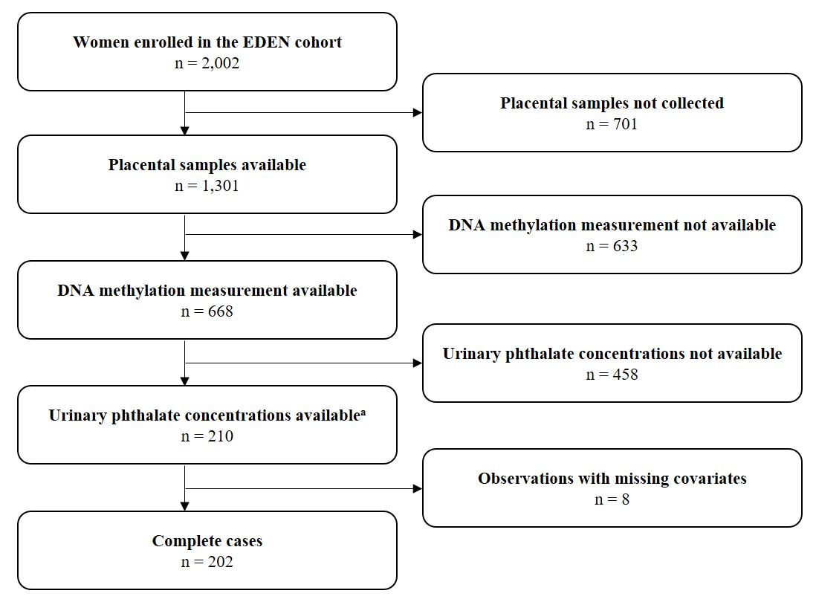

Supplementary Figure 1: Study flow chart.
ª Phthalate concentrations were assessed in the framework of a previous study restricted to boys with at least one maternal urine sample available for phthalate measurements and complete data on prenatal (three ultrasound measurements and biometry at birth) and postnatal growth (Philippat et al. 2014).
Abbreviations: EDEN = Etude des Déterminants pré et postnatals du développement et de la santé de l’Enfant.
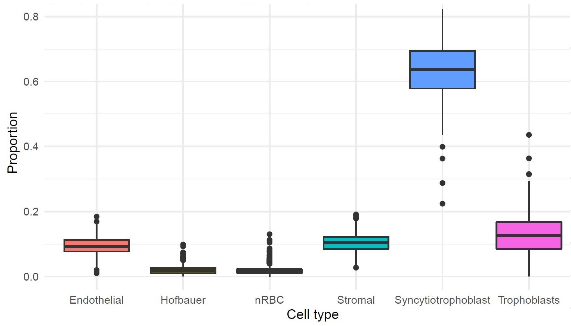

Supplementary Figure 2: Boxplot of the distributions of placental cell type estimates obtained for the EDEN cohort (n = 668).
Abbreviations: EDEN = Etude des Déterminants pré et postnatals du développement et de la santé de l’Enfant. nRBC = nucleated red blood cells.

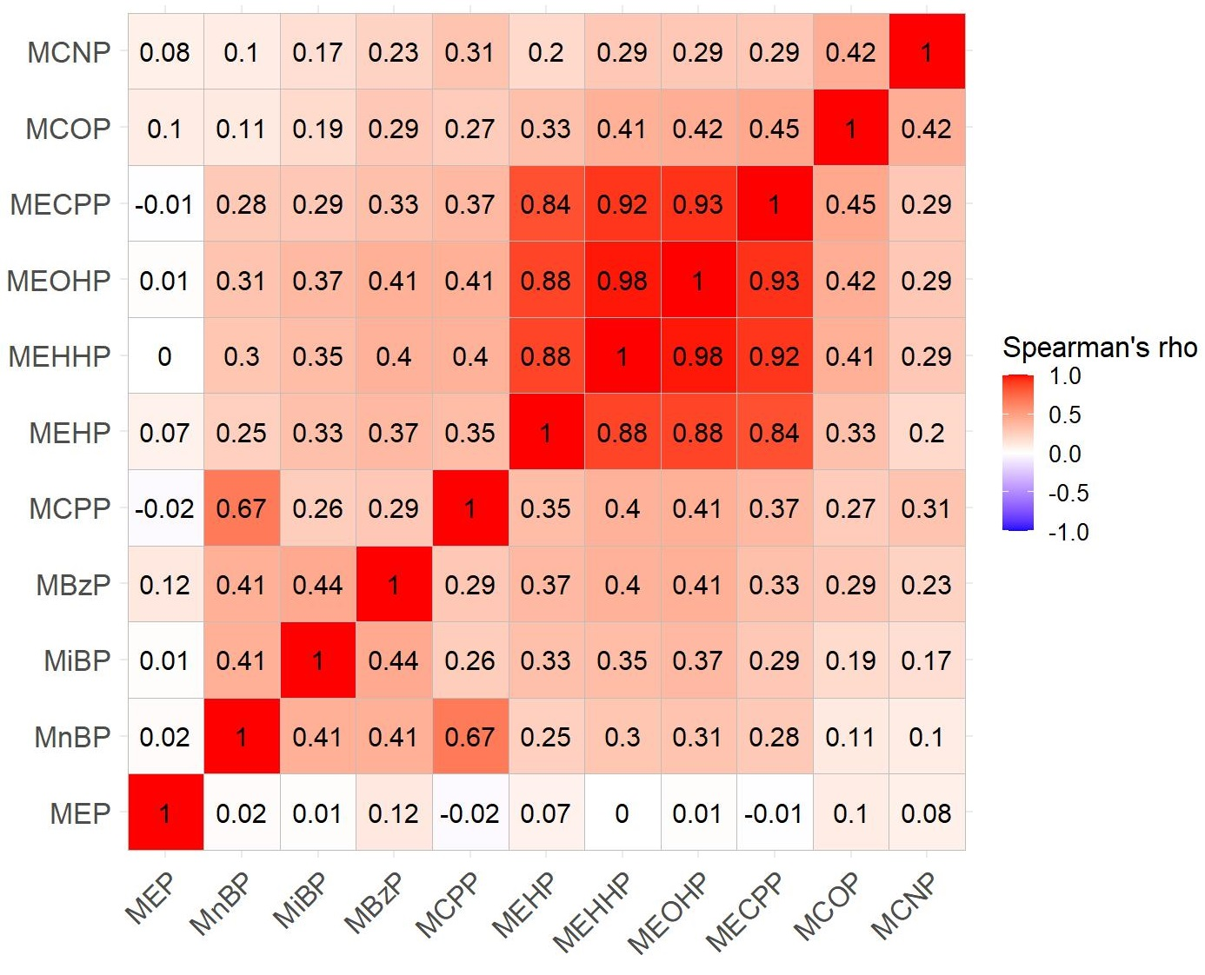

Supplementary Figure 3: Spearman’s correlation coefficients (rho) between standardized urinary phthalate metabolite concentrations (n = 202).
Abbreviations: MBzP = monobenzyl phthalate. MCNP = monocarboxy-iso-nonyl phthalate. MCOP = monocarboxy-iso-octyl phthalate. MCPP = mono(3-carboxypropyl) phthalate. MECPP = mono(2-ethyl-5-carboxypentyl) phthalate. MEHHP = mono(2-ethyl-5-hydroxyhexyl) phthalate. MEHP = mono(2-ethylhexyl) phthalate. MEOHP = mono(2-ethyl-5-oxohexyl) phthalate. MEP = monoethyl phthalate. MiBP = mono-iso-butyl phthalate. MnBP = mono-n-butyl phthalate.

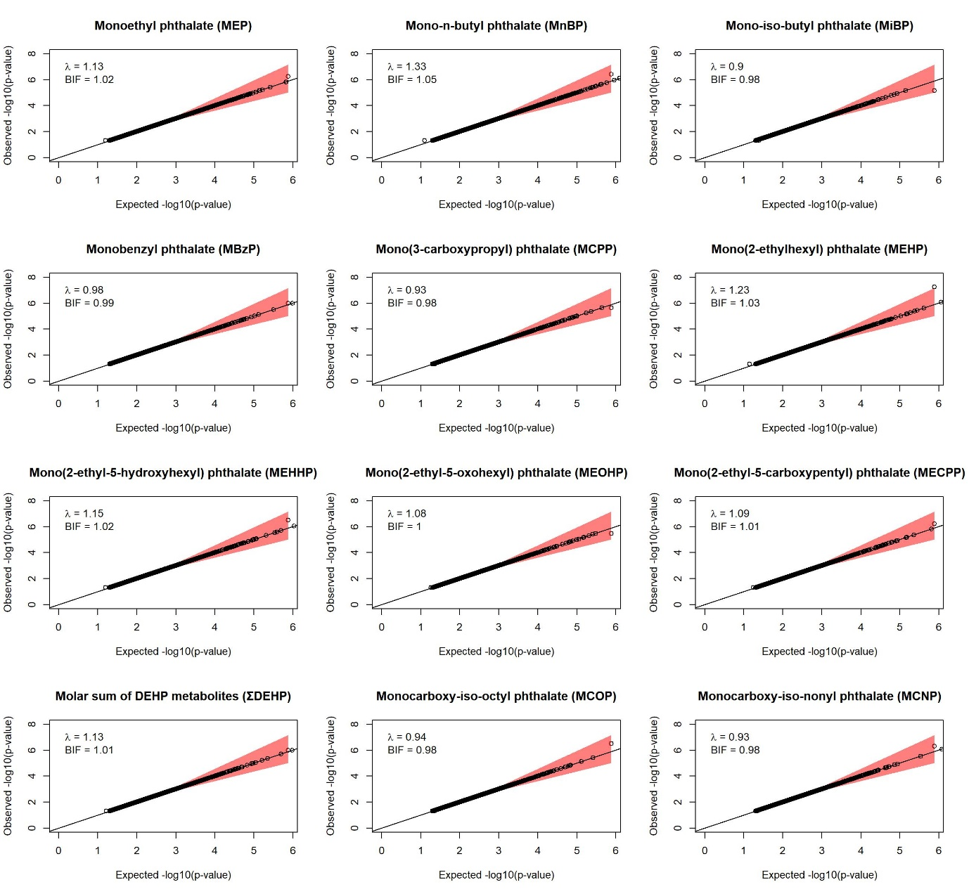

Supplementary Figure 4: Q-Q plots with genomic inflation factor (λ) and BIF for the association between phthalate biomarker concentrations and DNA methylation sites in the EWAS (n = 202, 379,904 CpGs). Red area marks the confidence interval of the fit. Regression models were adjusted for recruitment center, maternal active smoking in the three months preceding pregnancy and during pregnancy, maternal age, parity, maternal education level, maternal pre-pregnancy BMI, season of conception, batch, plate, chip, and estimated placental cell-type proportions. ΣDEHP was calculated by summing molar concentrations of MEHP, MEHHP, MEOHP, and MECPP.
Abbreviations: BIF = Bayesian inflation factor. BMI = body mass index. Q = quantile.

References
Adibi JJ, Whyatt RM, Williams PL, Calafat AM, Camann D, Herrick R, et al. 2008. Characterization of phthalate exposure among pregnant women assessed by repeat air and urine samples. Environ Health Perspect 116:467–473; doi:10.1289/ehp.10749. PMID: 18414628.
Bastiaensen M, Malarvannan G, Gys C, Ait Bamai Y, Araki A, Covaci A. 2020. Between- and within-individual variability of urinary phthalate and alternative plasticizer metabolites in spot, morning void and 24-h pooled urine samples. Environ Res 191:110248; doi:10.1016/j.envres.2020.110248. PMID: 32980307.
Braun JM, Smith KW, Williams PL, Calafat AM, Berry K, Ehrlich S, et al. 2012. Variability of urinary phthalate metabolite and bisphenol A concentrations before and during pregnancy. Environ Health Perspect 120:739–745; doi:10.1289/ehp.1104139. PMID: 22262702.
Cantonwine DE, Cordero JF, Rivera-González LO, Anzalota Del Toro LV, Ferguson KK, Mukherjee B, et al. 2014. Urinary phthalate metabolite concentrations among pregnant women in Northern Puerto Rico: Distribution, temporal variability, and predictors. Environ Int 62:1–11; doi:10.1016/j.envint.2013.09.014. PMID: 24161445.
Ferguson KK, McElrath TF, Ko Y-A, Mukherjee B, Meeker JD. 2014. Variability in urinary phthalate metabolite levels across pregnancy and sensitive windows of exposure for the risk of preterm birth. Environ Int 70:118–124; doi:10.1016/j.envint.2014.05.016. PMID: 24934852.
Philippat C, Botton J, Calafat AM, Ye X, Charles M-A, Slama R. 2014. Prenatal exposure to phenols and growth in boys. Epidemiology 25:625–635; doi:10.1097/EDE.0000000000000132. PMID: 25061923.
Rosner B. 2011. Fundamentals of Biostatistics. Brooks/Cole, Cengage Learning:Boston.
Shin H-M, Bennett DH, Barkoski J, Ye X, Calafat AM, Tancredi D, et al. 2019. Variability of urinary concentrations of phthalate metabolites during pregnancy in first morning voids and pooled samples. Environ Int 122:222–230; doi:10.1016/j.envint.2018.11.012. PMID: 30477814.
Stelzer G, Rosen N, Plaschkes I, Zimmerman S, Twik M, Fishilevich S, et al. 2016. The GeneCards Suite: from gene data mining to disease genome sequence analyses. Curr Protoc Bioinformatics 54:1.30.1-1.30.33; doi:10.1002/cpbi.5. PMID: 27322403.

