Supplemental Materials

Statistical analysis
We described the serum ferritin distributions (geometric means, 50th (median), 5th, and 95th percentiles) for each 2-y survey cycle, race/ethnic group (Mexican American, non-Hispanic White, non-Hispanic Black), and family poverty-to-income ratio (<130% vs >130%). Additionally, we examined the ferritin distribution by sex (male vs. female) and age group (12–35 months, 36–59 months) among children, and by age group (15–19 y, 20–34 y, 35–49 y), and education (less than high school, high school diploma, and more than high school) among non-pregnant women.
For the basic characteristics, serum ferritin distribution analysis and prevalence estimates, we used SUDAAN (version 11·0·1; Research Triangle Institute, Research Triangle Park, NC) with sample exam weights (used 2-year exam weights to calculated the overall weight across years 2003–2010 and 2015–2018) and design variables to account for the complex sample design. Both crude and adjusted geometric means were calculated for serum ferritin and multiple linear regression models were used for the calculation of adjusted mean SF. A Bonferroni adjustment³⁰ was used to correct the p values for the significance test for the multiple comparisons across each socio-demographic characteristic in serum ferritin. For the RCS analysis, R software 4·0·2 (R Foundation for Statistical Computing and Graphics, Vienna, Austria) was used to examine the biologic relationships within the sampled individuals with respect to these iron status indicators. Bootstrap resampling technique was used to generate the 95% confidence intervals (95%CI) around each plateau or minima point estimate derived from the differential solution of each RCS fit. For each model, 5000 replications were generated, and the 95% CIs estimates were corrected for bias using bias corrected acceleration (BCa).³⁰

Results
For the geometric mean serum ferritin concentrations, the 5th percentiles were 9·6 µg/L and 6·0 µg/L for children and women, respectively. In children, geometric mean serum ferritin concentrations were higher in girls than in boys and were higher among older children (36-59 months) than younger children (12-35 months) even after adjusting for socio-demographic variables. Non-Hispanic black children had higher serum ferritin concentrations than either Non-Hispanic white or Mexican American. Geometric mean serum ferritin concentrations did not differ by family income in children (Table 1). Serum ferritin concentrations differed by age group in non-pregnant women. Women aged 20–49 years had higher serum ferritin concentrations than adolescents 15–19 years (Table 1). Non-Hispanic white women had higher serum ferritin concentrations than non-Hispanic black or Mexican American. After adjusting for socio-demographic variables used in this study, mean serum ferritin concentrations did not differ by education or family income (Table 1).
We did not exclude children with abnormal CRP values because measurements were not uniformly determined among all ages or survey years. However, for children who had CRP measured (1940 of 2569) only 44 children’s CRP were >5mg/L and a sub-analysis excluding these 44 children did not change the restricted cubic splines thresholds.
Serum creatinine, as a biomarker for potential kidney disease, was only measured for participants aged 12 years and above in the NHNAES. In the non-pregnant women sample included in our analysis, about 17% (n=1302) of the women’ creatinine measurements were missing and about 4% (n=285) of women’ creatinine values were abnormal (<0.5 mg/dL or >1.0 mg/dL). However, in a sub-analysis (n=5911) after additionally excluding the women with missing or abnormal creatinine, the SF thresholds generated from RCS remain unchanged (results upon request), thus we presented the results in Table 2 without exclusion of potential kidney disease to achieve the maximum sample size and precision.

Supplemental Table 1. Serum ferritin (SF, µg/L) concentrations thresholds (95% confidence interval in parentheses) identified by the restricted cubic spline (RCS) regression with 5 knots in a healthy sample of U.S. children aged 12–59 months and non-pregnant women aged 15–49 years participating in the National Health and Nutrition Examination Survey 2003–2010 and 2015–2018, stratified by survey years
Children | 2003–2006  (n=853) |  | 2007–2010  (n=924) | 2015–2018  (n=792) | 3-way test for equality of  effect sizes (ES)  (Ho:ES₀₃₋₆=ES₀₇₋₁₀=ES₁₅₋₁₈)  p value
Hemoglobin (Hb)
SF corresponding to Hb plateau point | 20·1 (18·1, 29·8) ª | 18·5 (17·5, 20·7) ª |  | 23·4 (19·4, 30·0) ª | 0·3015§
*SF corresponding to Hb threshold values | -- | -- |  | --
RCS Model Adjusted R², % | 1·9 | 4·9 |  | 2·1
Soluble transferrin receptor (sTfR)
SF corresponding sTfR minima point | 20·4 (19·1, 22·5) ª | 19·2 (18·3, 20·3) ^{a, b} |  | 20·8 (19·8, 22·5) ª | 0·1499§
SF corresponding sTfR threshold values | 10·9 | 9·4 |  | 10·2
RCS Model Adjusted R², % | 15·6 | 23·8 |  | 22·4
Non-pregnant women | 2003–2006  (n=2630) | 2007–2010  (n=2862) |  | 2015–2018  (n=2006) | 3-way test for equality of  effect sizes (ES)  (Ho:ES₀₃₋₆=ES₀₇₋₁₀=ES₁₅₋₁₈)  p value
Hemoglobin (Hb)
SF corresponding to Hb plateau point | 28·5 (26·1, 30·0) ª | 25·3(24·0, 27·1) ª |  | 22·0 (20·9, 23·5) ^{b} | < 0·0001§
SF corresponding to Hb threshold values | 7·00 | 8·4 |  | 9·4
RCS Model Adjusted R2, % | 26·2 | 29·9 |  | 43·9
Soluble transferrin receptor (sTfR)
SF corresponding to sTfR minima point | 26·2(25·0, 27·7) ª | 24·3 (23·3, 25·5) ^{b} |  | 21·5 (20·4, 22·7) ^{c} | < 0·0001§
SF corresponding to sTfR threshold values | 8·2 | 8·0 |  | 8·9
RCS Model Adjusted R2, % | 35·5 | 39·2 |  | 45·5
Unweighted n and analyses.
The following exclusions apply to define health sample: children with infection and non-pregnant women with infection, inflammation and liver disease.
Hb threshold values are <11·0 g/dL for children and <12·0 g/dL for non-pregnant women.²⁸ sTfR threshold value are >5·33 mg/L for children and >6·00 mg/L for non-pregnant women.²⁹
All plateau and minima estimate and their 95% confidence interval (CI), were obtained from 5000 bootstrap replicates. All CIs have been corrected for bias using the bias corrected acceleration (BCa) approach.³⁰
Estimates with different superscript (a, b, or c) indicate pairwise values that are statistically different. p values estimated from test of paired-differences(superscripts) and 3-way differences§ in effect sizes via random effects meta-analyses with 1 and 2 degrees of freedom respectively.^{19,20}
In children, for SF corresponding to Hb threshold values, because the predicted values do not have Hb below 11·0 g/dL, gradient search¹⁷ was not feasible, so all the values show as -- (undefined).

Supplemental Table 2. Comparison of prevalence of iron deficiency (ID) and iron deficiency anemia (IDA) (%, 95% confidence interval in parentheses) defined by low serum ferritin (SF) using current WHO SF thresholds and the thresholds identified from the restricted cubic spline (RCS) regression from this analysis in U.S. children 12-59 months and non-pregnant women aged 15–49 years participating in the National Health and Nutrition Examination Survey (NHANES) 2003–2010 and 2015–2018
NHANES | n |  | % ID | % IDA |  | % ID | % IDA
 |  | Serum ferritin <12 µg/L |  |  |  | Serum ferritin <20 µg/L
Children | 3389 | 9·7 (8·4, 11·1) |  | 1·2 (0·8, 1·6) |  | 32·4 (30·2, 34·6) | 1·6 (1·1, 2·1)
 |  |  | Serum ferritin <15 µg/L |  |  | Serum ferritin <25 µg/L
Non-pregnant women | 9711 |  | 16·6 (15·7, 17·6) | 6·2 (5·5, 6·9) |  | 31·3 (30·1, 32·5) | 7·1 (6·3, 7·8)
Unweighted n, all other analyses are weighted. Full NHANES sample with Hb and SF data were used for this analysis with no exclusions. Ferritin was not adjusted for inflammation because inflammatory biomarkers are not consistently available across all years or age groups.
Anemia defined as low hemoglobin (Hb) below population specific threshold values which are Hb<11·0 g/dL for children and <12·0 g/dL for non-pregnant women.²⁸
Iron deficiency defined as low SF based on WHO threshold values which are SF<12 µg/L for children and <15 µg/L for non-pregnant women.¹⁸ RCS identified thresholds from this analysis are SF<20 µg/L for children and <25 µg/L for non-pregnant women.
IDA defined as both ID and anemia.

Supplemental Figure 1. Plot of Serum ferritin (SF, µg/L) concentrations with hemoglobin (Hb, g/dL) in U.S. children aged 12–59 months (n=3389, Panel A) and non-pregnant women aged 15–49 years (n=9771, Panel B) participating in the National Health and Nutrition Examination Survey 2003–2010 and 2015–2018

A
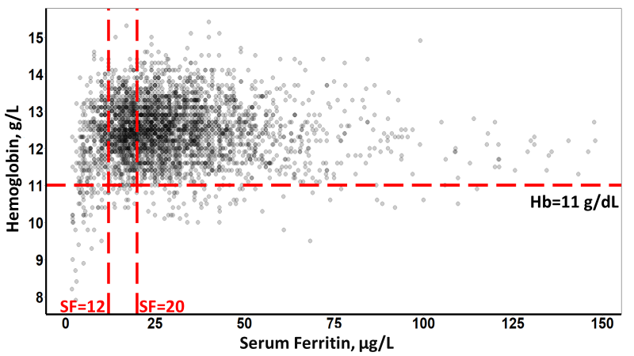

B