Supplemental Figure 1. Percentage of season’s influenza positives identified during each week of the pregnancy and the entire pregnancy period, by conception week, using data from the 2013 season in South Africa.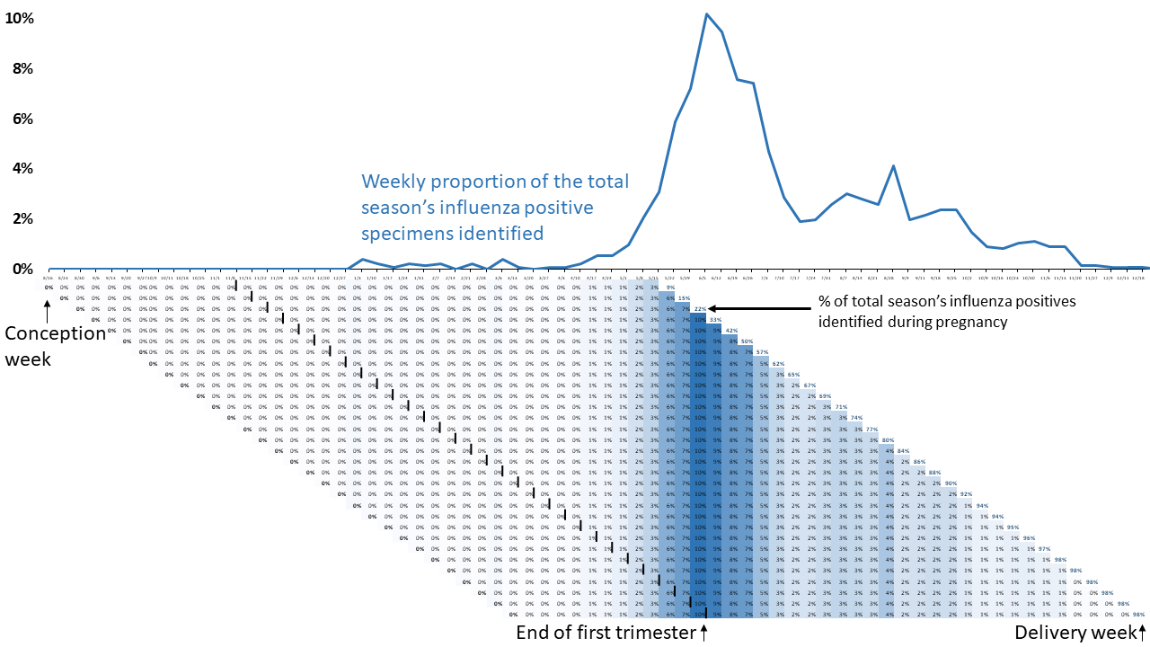

Supplemental Figure 2. Percentage of season’s influenza vaccinations administered during each week of the pregnancy and the entire pregnancy period, by conception week, using data from the 2013 season in South Africa.
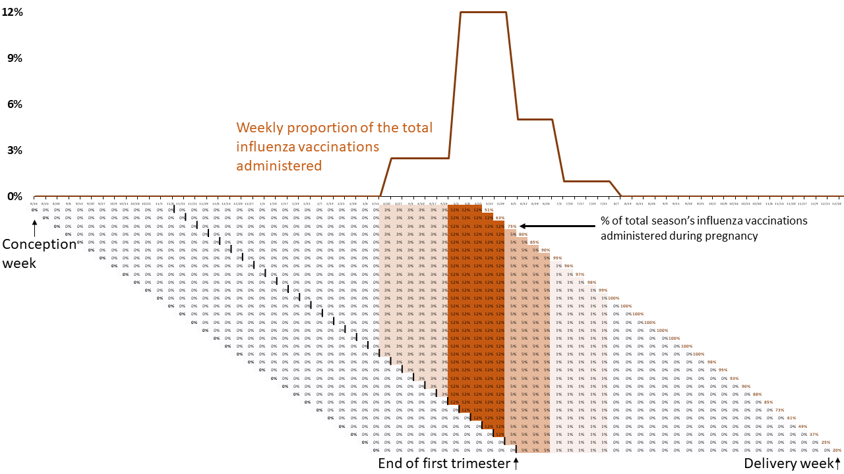
Supplemental Figure 3. Estimated averted burden of antenatal influenza vaccination in South Africa for pregnant women and infants varied by the coverage of HIV+ and HIV- pregnant women.
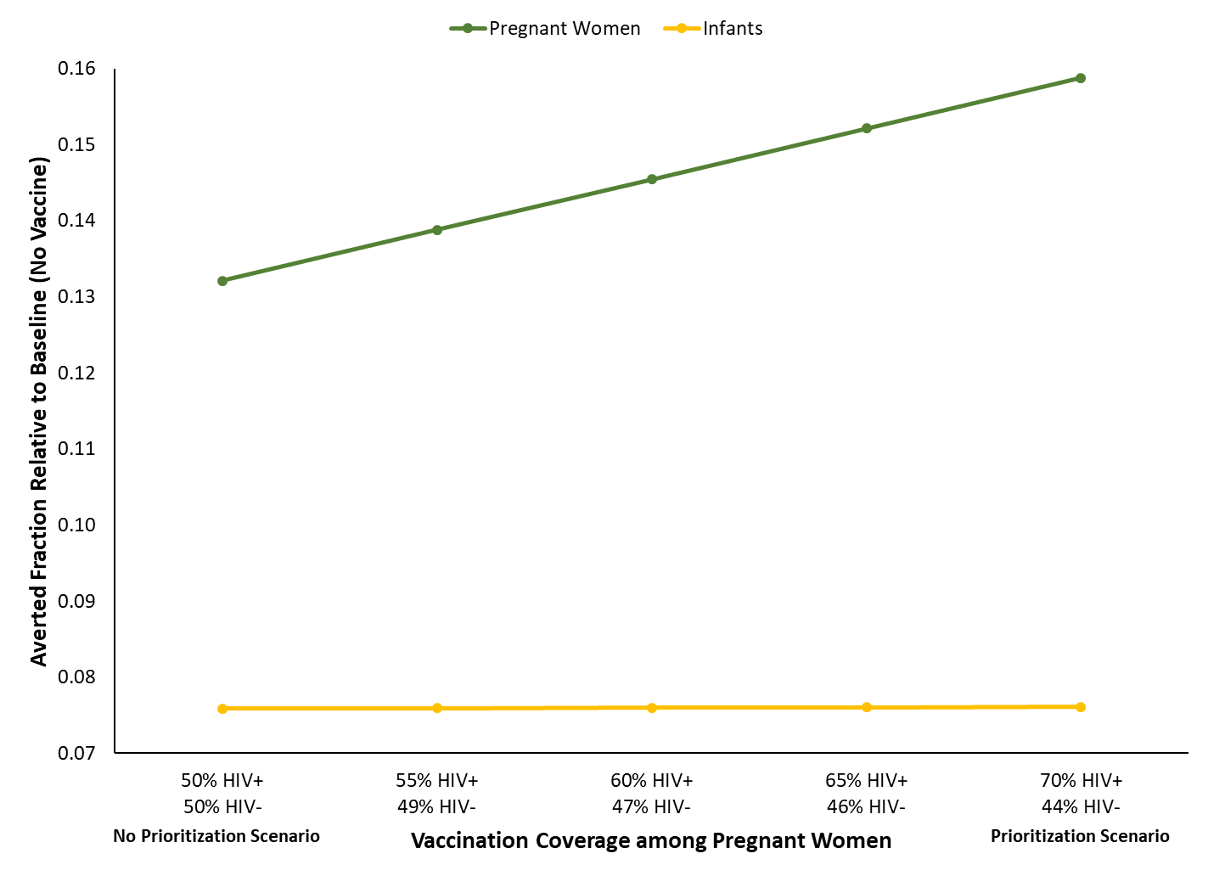

Supplemental Figure 4. Distribution of influenza vaccine and the influenza season for pregnant women, based on conception and delivery weeks, South Africa, 2012 season.
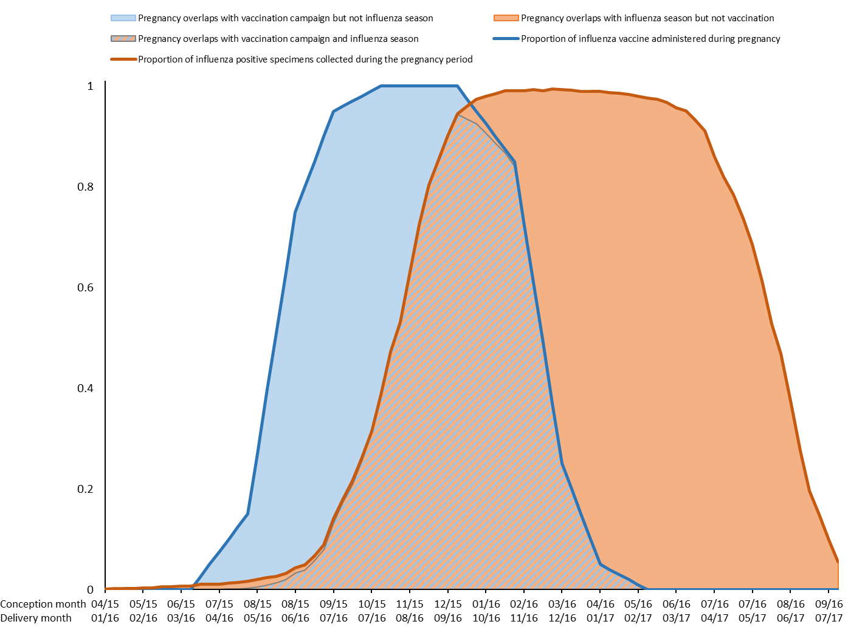

Supplemental Figure 5. Distribution of influenza vaccine and the influenza season for infants, by conception and delivery date, South Africa, 2012 season.

