Supplemental Text
A. Capture-recapture estimation of population size using log-linear models
The parameters of interest using capture-recapture models depend on whether a population is assumed to be closed, open, or both [1]. The population is said to be closed if there is no change in a population size within a given time period. We plausibly assume the nHSV mortality cases from three reporting sources remained in Florida (given that reporting of nHSV cases required the infants to be ≤ 60 days of age at time of diagnosis) and minimizing time they might transfer to other jurisdictions during 2011-2017. Therefore, we assume our population is closed and so the population size which is the true number of nHSV mortality cases is constant across the three reporting sources.
We estimate the size $N$ of the population using log-linear models. The models can incorporate three types of variability of capture probabilities, which include a between-source effect (subscript$t$), a within-source effect (subscript$h$) and a behavioral effect (subscript$b$). The between-source effect causes the variability of capture probabilities between reporting sources. The within-source effect causes the variability of the capture probabilities among cases within a reporting source. The behavioral effect implies the first reporting activity changes the probability of reporting subsequent cases and so the capture probabilities change before and after the first report.
We would expect less of both within-source and behavioral effects because reporting of each case would be independent and not affect one another. However, we may expect some of the between-source effect because three sources report different numbers of nHSV mortality cases.
Those three types of heterogeneity lead to eight models for the closed population model:
$M_{0}$ (no source of variation), $M_{t}, M_{h}, M_{b}, M_{th}, M_{tb}, M_{hb}, M_{thb}$
where a subscript represents each type of heterogeneity. We performed our analysis in the following steps.
$$Descriptive statistics→Model fitting→Model selection→Population size N estimation$$
Descriptive statistics help to identify the factors related to the variability of capture probabilities. We fit and compare several models based on standard criteria such as deviance, Akaike information criterion (AIC) and Bayesian information criterion (BIC). Once a model is selected, the population size $N$ and its confidence intervals are estimated. All analyses were performed using an “Rcapture” package [1] in R Statistical Software .

A.1. Descriptive analysis and exploring heterogeneity of capture probabilities
Supp. Table A.1 shows observable reporting patterns and frequencies. Only four cases were reported from all three sources. Supp. Figure A.1 suggests a possible heterogeneity in the capture probabilities that is explored by the graphs of $\log\left(\frac{f_{i}}{\left(\begin{matrix}t \\ i\end{matrix}\right)}\right)$ and $\log{u_{i}}$ versus $i$, where $i$ indicates a reporting source [1]. If there is no heterogeneity in the capture probabilities the number of cases follows a $Binomial(t,p)$ distribution with $t$ total number of reporting sources and the number of reporting sources follows a $Geometric\left(p\right)$ distribution, where the $p$ is the common capture probability from any source under no heterogeneity model $M_{0}$. Therefore,
$$\log\left(\frac{f_{i}}{\left(\begin{matrix}t \\ i\end{matrix}\right)}\right) ≅\log\left(\frac{N×\operatorname{Pr}\left(i cases\right)}{\left(\begin{matrix}t \\ i\end{matrix}\right)}\right)$$
$$=\log\left(N{\left(1-p\right)}^{t-i}p^{i}\right)=\log\left(N{\left(1-p\right)}^{t}\right)+i×\log\left(\frac{p}{1-p}\right) \left(1\right)$$
and
$$\log{u_{i}}≅\log\left(N×\operatorname{Pr}\left(first case from i^{th} source\right)\right)$$
$$=\log\left(N{\left(1-p\right)}^{i-1}p\right)=\log\left(\frac{Np}{1-p}\right)+i×\log\left(1-p\right), \left(2\right)$$
where $N$ is the population size we want to estimate. As shown in the equations (1) and (2), both graphs are linear under no heterogeneity model$M_{0}$. If there is heterogeneity by the between-source effect the $f_{i}$ graph would be concave downward [2]. If heterogeneity occurs by the within-source effect both graphs would be convex and not linear [3]. As shown in the Supp. Figure A.1, the $f_{i}$ graph (top) appears rather concave than linear suggesting that the between-source effect ($M_{t}$) may exist across the reporting lists. The $u_{i}$ graph (bottom) is almost linear and so the within-source effect ($M_{h}$) may be less expected.

Supplemental Table 1. Observable reporting patterns and frequencies
Provider  $$ω_{1}$$ | ELR  $$ω_{2}$$ | Vital Statistics  $$ω_{3}$$ | Reporting pattern  $$ω=(ω_{1}ω_{2}ω_{3})$$ | Frequency  $$n_{ω}$$
1 | 1 | 1 | 111 | 4
1 | 1 | 0 | 110 | 2
1 | 0 | 1 | 101 | 3
1 | 0 | 0 | 100 | 0
0 | 1 | 1 | 011 | 11
0 | 1 | 0 | 010 | 1
0 | 0 | 1 | 001 | 13
*ELR stands for electronic lab reporting; 1 = captured and 0 = not captured

Supplemental Figure 2. Exploratory heterogeneity graph
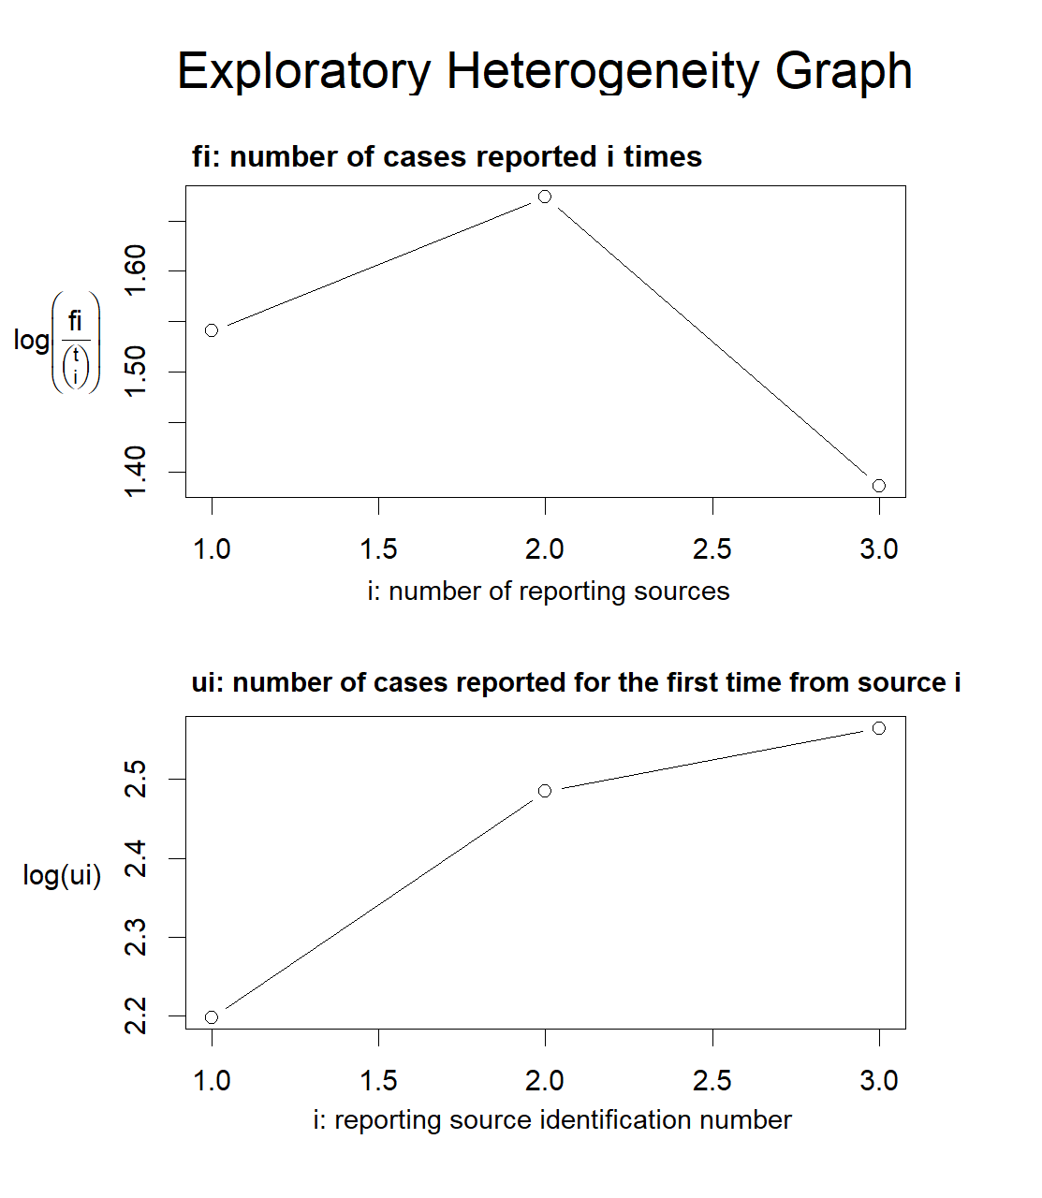

A.2. Model fitting, selection and population size estimation
The general form of population size estimator is $\hat{N}=n+μ_{0}$, where $n$ indicates the total number of cases reported at least once and $μ_{0}$ the number of cases missed from all reporting sources. The population size estimator is obtained by maximizing a $Poisson$ likelihood. A variance is derived by Sandland and Cormack which is given by $Var_{M}\left(\hat{N}\right)=Var_{P}\left(\hat{N}\right)-N,$ where the subscripts $M$ and $P$ refer to $multinomial$ and $Poisson$ distributions [4].
In no heterogeneity model$M_{0}$, the capture probability $p$ is constant to all cases. With $t$ total number of reporting sources, a reporting pattern of one case can be expressed in a vector$ω=\left(ω_{1}, ω_{2}, …, ω_{t}\right)$, where $ω_{i}=1$ if the case is reported from the $i^{th}$ reporting source, $i=1, …, t$, and $0$ if not. Let $n_{ω}$ be the frequency of the reporting pattern $ω$ and so the total number of cases reported at least once is$n=\sum{n_{ω}}$. There are $2^{t}-1$ observable reporting patterns (see Supp. Table A.1). The probability of a case having a reporting pattern $ω$ is
$$\operatorname{Pr}\left(ω\right)={\left(1-p\right)}^{t-X_{1}}p^{X_{1}},$$
where $X_{1}=\sum{ω_{i}}$ is the number of times the case is reported. Hence, the expected frequency $μ_{ω}$ of cases in the population having reporting pattern $ω$ is
$$μ_{ω}=N×\operatorname{Pr}\left(ω\right)=N×{\left(1-p\right)}^{t-X_{1}}p^{X_{1}}.$$
To re-express the equation in a loglinear form,
$$\log\left(μ_{ω}\right)=\log\left(N×\operatorname{Pr}\left(ω\right)\right)=\log\left(N{\left(1-p\right)}^{t}\right)+X_{1}log\left(\frac{p}{1-p}\right)=γ+X_{1}β,$$
where $γ=\log\left(N{\left(1-p\right)}^{t}\right)$ and $β=\log\left(\frac{p}{1-p}\right)$. From this model, the expected frequency of cases that are never reported $μ_{0}$ is estimated as $μ_{0}=N×\operatorname{Pr}\left(ω_{0}\right)=e^{r}=N{\left(1-p\right)}^{t}$. The “Rcapture” package specializes in modeling heterogeneity. It uses three types of models, Chao, Poisson2, and Darroch, to model heterogeneity, especially for $M_{h}$ and $M_{th}$. More details can be found [1,5,6]. Considering precision, parsimoniousness, sand model fit statistics (deviance, AIC, and BIC), $M_{t}$ is plausibly selected.

Supplemental. Table 2. Log linear model fitting results and measures of variation for three source (provider, ELR, and death record) estimation of nHSV infections in Florida, 2011-2017.
Model Name† | abundance | 95% CIs | stderr | deviance | df | AIC* | BIC*
$M_{0}$ | 39 | (32.8-45.2) | 3.2 | 32.421 | 5 | 55.959 | 59.012
$M_{t}$ | 35.8 | (32.3-39.3) | 1.8 | 4.048 | 3 | 31.586 | 37.691
$M_{h,Chao}$ | 39 | (32.8-45.2) | 3.2 | 32.421 | 5 | 55.959 | 59.012
$M_{h, Poisson2}$ | 37.3 | (30.6-44.0) | 3.4 | 32.107 | 4 | 57.645 | 62.224
$M_{h, Darroch}$ | 36.7 | (29.6-43.8) | 3.6 | 32.107 | 4 | 57.645 | 62.224
$M_{h, Gamma3.5}$ | 36.2 | (28.9-43.4) | 3.7 | 32.107 | 4 | 57.645 | 62.224
$M_{th}$ | 35.8 | (32.1-39.5) | 1.9 | 4.044 | 2 | 33.582 | 41.214
$M_{th,Chao}$ | 35.9 | (31.4-40.3) | 2.3 | 4.044 | 2 | 33.582 | 41.214
$M_{th, Poisson2}$ | 35.9 | (30.4-41.4) | 2.8 | 4.044 | 2 | 33.582 | 41.214
$M_{th, Darroch}$ | 35.9 | (29.1-42.8) | 3.5 | 4.044 | 2 | 33.582 | 41.214
$M_{b}$ | -48.4 | (-195.9-99.1) | 75.2 | 4.127 | 4 | 29.664 | 34.243
$M_{bh}$ | -135 | (-1677.6-1407.6) | 787.1 | 4.045 | 3 | 31.583 | 37.688
†Subscript $t$ for the between-source, $h$ for the within-source, and $b$ for the behavioral effects. *AIC = Akaike Information Criterion and BIC = Bayesian Information Criterion.

References:
1. Baillargeon S, Rivest L-P. The Rcapture Package: Loglinear Models for Capture-Recapture in R . J Stat Softw 2007; 19.
2. Rivest L-P. Why a time effect often has a limited impact on capture-recapture estimates in closed populations. Can J Stat 2008; 36:75–84.
3. Lindsay BG. Exponetial Family Mixture Models (With Least-Squares Estimators). Ann Stat 1986; 14:124–137.
4. Sandland RL, Cormack RM. Statistical inference for Poisson and multinomial models for capture-recapture experiments. Biometrika 1984; 71:27–33.
5. Rivest L-P, Lévesque T. Improved Log-Linear Model Estimators of Abundance in Capture-Recapture Experiments. Can J Stat 2001; 29:555–572.
6. Rivest LP, Baillargeon S. Applications and extensions of Chao’s moment estimator for the size of a closed population. Biometrics 2007; 63:999–1006.

