Leonard, et al, Supplemental Material

Supplementary Table 1. Proportion of individuals seropositive to malaria antigens by malaria species and antigen in northern Ethiopia, 2015.
Plasmodium species | Antigen | % seropositive (95% CI), under 5 years old (n= 1,032) | % seropositive (95% CI), 5-14 years old (n= 419) | % seropositive (95% CI), 15- 24 years old (n= 267) | % seropositive (95% CI), ≥ 25 years old (n= 561) | % seropositive (95% CI), all ages (n= 2,279)
P. falciparum | PfCSP | 3.4 (2.3- 4.5) | 8.1 (5.5- 10.7) | 12.0 (8.1- 15.9) | 18.2 (15.0- 21.4) | 8.9 (7.7- 10.1)
 | PfEtramp5Ag1 | 6.5 (5.0- 8.0) | 11.0 (8.0- 14.0) | 15.0 (10.7- 19.3) | 21.4 (18.0- 24.8) | 12.0 (10.7-13.3)
 | PfGLURP-R0 | 2.5 (1.6- 3.5) | 5.5 (3.3- 7.7) | 15.7 (11.4- 20.1) | 20.5 (17.2- 23.8) | 9.0 (7.9- 10.2)
 | PfLSA-1 | 0.58 (0.12- 1.1) | 1.4 (0.3- 3.1) | 5.2 (2.6- 7.9) | 5.7 (3.8- 7.6) | 2.5 (1.9- 3.2)
 | PfSEA-1 | 10.3 (8.4- 12.1) | 22.2 (18.2- 26.2) | 23.2 (18.2- 28.3) | 30.8 (27.0- 34.7) | 19.4 (17.4- 20.7)
 | PfAMA-1 | 10.0 (8.0- 11.6) | 22.0 (18.0- 25.9) | 46.4 (40.5- 52.4) | 61.7 (57.7- 65.7) | 29.1 (27.2- 31.0)
 | PfMSP-1 | 16.4 (14.1- 18.6) | 33.7 (29.1- 38.2) | 47.6 (41.6- 53.6) | 61.7 (57.7- 65.7) | 34.4 (32.4- 36.4)
P. vivax | PvAMA-1 | 4.2 (3.0- 5.4) | 15.3 (11.8- 19.1) | 25.5 (20.2- 30.7) | 39.4 (35.4- 43.4) | 17.4 (15.8- 18.9)
 | chPvMSP-1 | 17.0 (14.7- 19.3) | 37.7 (33.1- 42.4) | 49.8 (43.8- 55.8) | 62.4 (58.4- 66.4) | 35.8 (33.8- 37.8)
 | PvMSP-1 | 10.5 (8.6- 12.3) | 24.8 (20.7- 29.0) | 38.6 (32.7- 44.4) | 49.6 (45.4- 53.7) | 26.0 (24.2- 27.8)

Supplementary Figure 1. IgG antibody levels against 10 Plasmodium antigens by age.
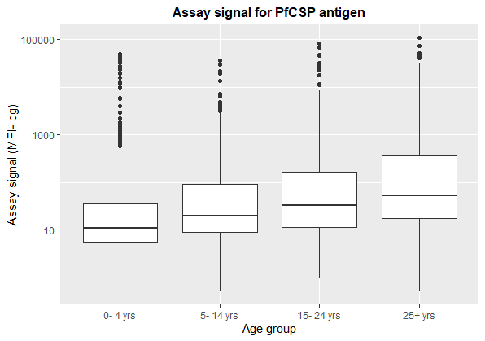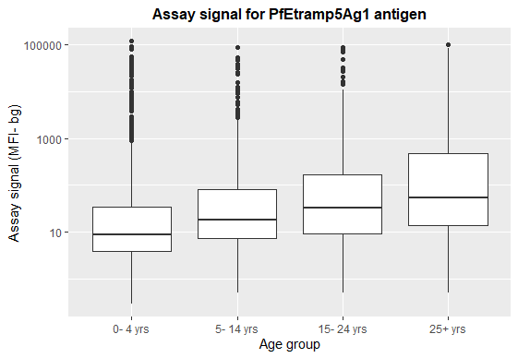
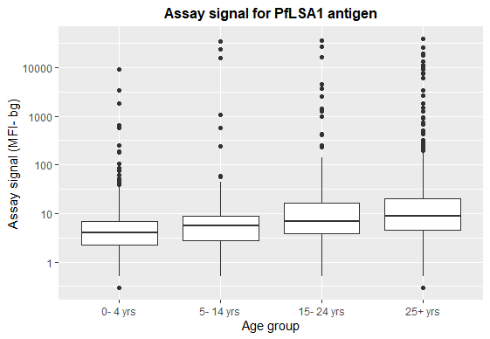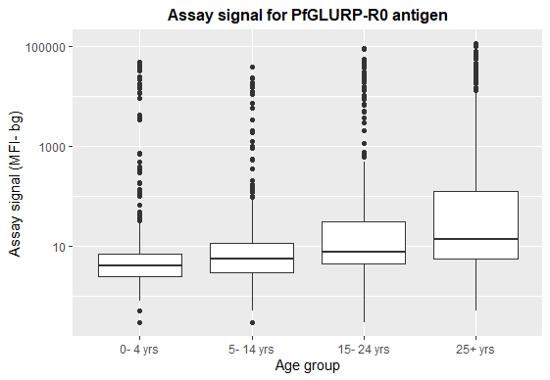
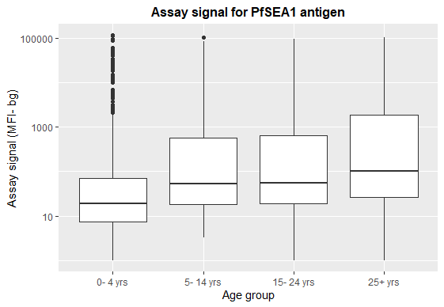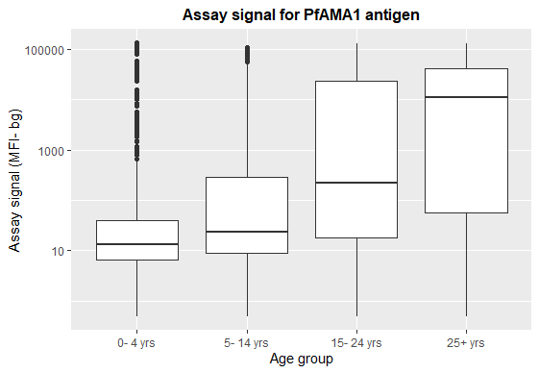
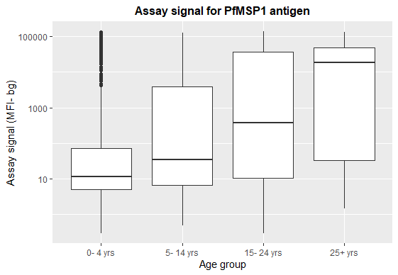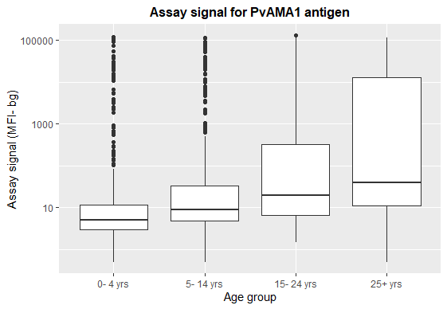
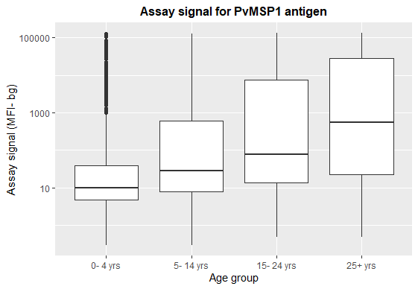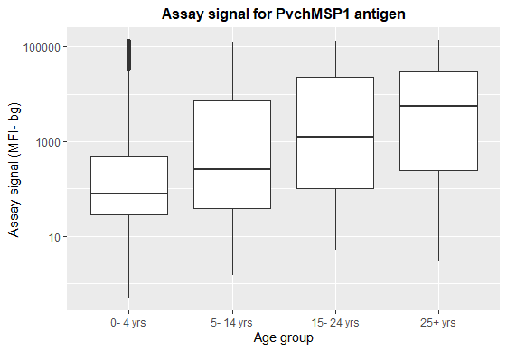
Supplementary Figure 2. Prevalence of different tests for P. falciparum infection or exposure, including RDT (A), bead-HRP2 antigen detection (B), microscopy (C), long-term antibody (D), and short-term antibody positivity (E). The clusters were assessed independently by region and indicate a statistically significant geospatial cluster of prevalence, where p < 0.05. Only enumeration areas with at least 10 observations are shown.
Supplementary Figure 3. Prevalence of different tests for P. vivax infection, including RDT (A), bead-pLDH/pALdolase antigen detection (B), microscopy (C), and long-term antibody (D). The clusters were assessed independently by region and indicate a statistically significant geospatial cluster of prevalence, where p < 0.05. Only enumeration areas with at least 10 observations are shown.

Supplementary Figure 4. Kernel-smoothed prevalence surfaces for the different diagnostic tests for P. falciparum infection, including rapid diagnostic test (A), bead HRP2 antigen detection (B), and microscopy (C). The areas encircled indicate areas of significantly higher prevalence (asymptotic p-values < 0.05).

Supplementary Figure 5. Kernel-smoothed prevalence surfaces for the different diagnostic tests for P. vivax infection, including rapid diagnostic test (A), bead pLDH/pALdolase antigen detection (B), and microscopy (C). The areas encircled indicate areas of significantly higher prevalence (asymptotic p-values < 0.05).

