Supplemental Appendix
Contents
Supplemental Figure 1 2
Supplemental Table 1 3
Supplemental Table 2 4
Supplemental Table 3 6
Supplemental Table 4: 7

Supplemental Figure 1: Flow diagram of KPNW members with medically attended acute gastroenteritis with index encounters July 1, 2014 – June 30, 2016—Metropolitan Portland, Oregon, United States. *Excludes episodes for persons who have a diagnostic code for a chronic condition associated with diarrhea, unless these persons also presented with vomiting.

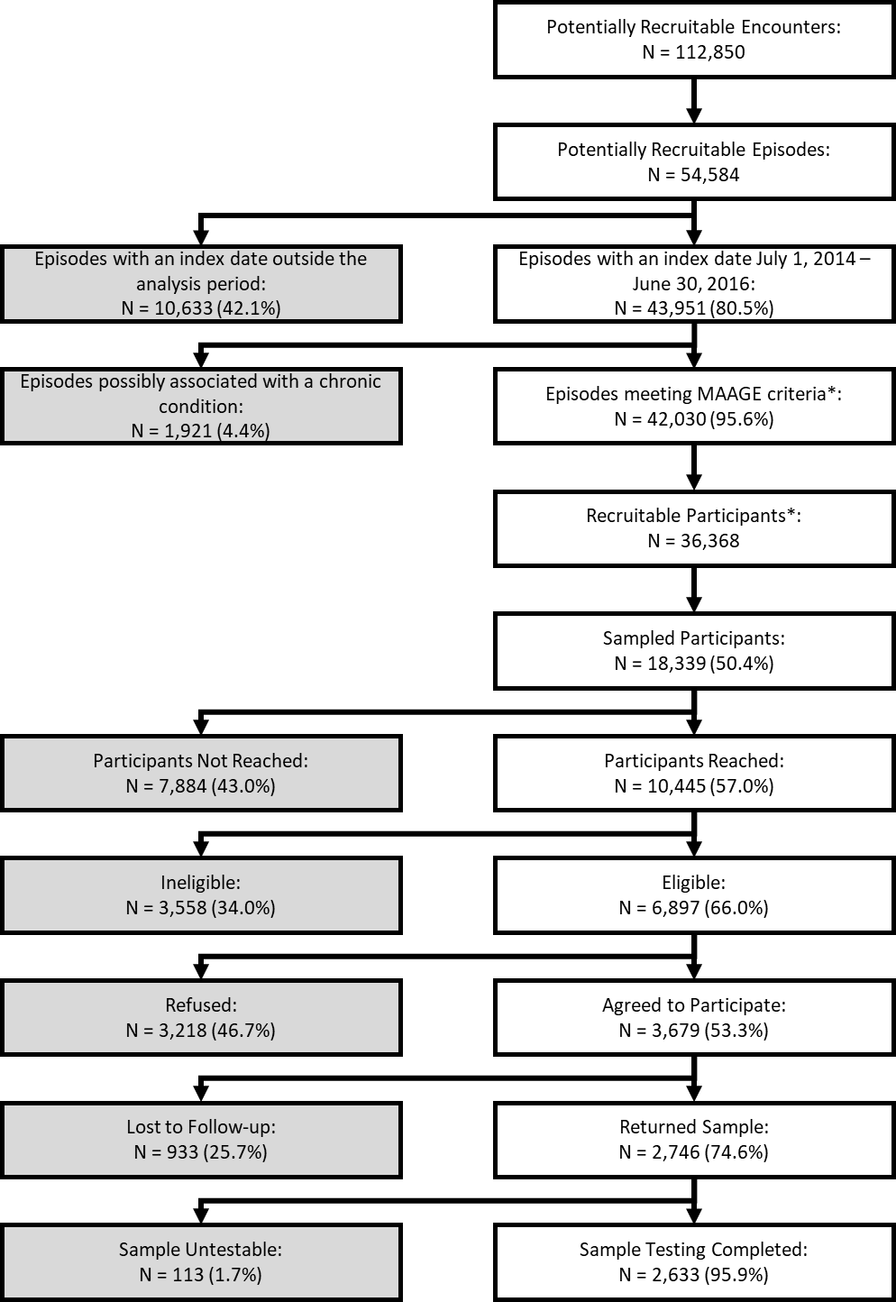

Supplemental Table 1: International Classification of Disease – Clinical Modification (ICD – CM), version 9 and 10, codes used to define Medically Attended Gastroenteritis Encounters
Diagnosis | ICD-9 | ICD-10
Cause unspecified
Presumed infectious | 009.0-009.3 | A09
Presumed noninfectious | 558.9 | K52.9
Symptom: Diarrhea NOS | 787.91
Cause specified
Viral | 008.61-008.8 | A08.0-A08.5
Rotavirus | 008.61 | A08.0
Adenovirus | 008.62 | A08.2
Norwalk | 008.63 | A08.1
Other viral enteritis | 008.64-008.69 | A08.3, A08.5
Other not elsewhere classified | 008.8 | A08.4
Bacterial | 001.0-005.9, 008.0-008.5 | A00.0-A05.9
Cholera | 001.0-00.9 | A00.0-A00.9
Typhoid/Paratyphoid | 002.0-002.9 | A01.0-A01.4
Salmonella | 003.0-003.9 | A02.0-A02.9
Shigella | 004.0-004.9 | A03.0-A03.9
Other bacterial food poisoning | 005.0-005.9 | A05.0-A05.9
E. coli | 008.0 | A04.0-A04.4
Other/unspecified bacteria | 008.1-008.5 | A04.5-A04.9
Parasitic | 006.0-006.2, 006.9-007.9 | A06.0-A07.9
Amoeba | 006.0-006.2, 006.9 | A06.0-A06.2
Other protozoal | 007.0-007.9 | A07.0-A07.9

Supplemental Table 2: Prevalence of viruses in medically attended acute gastroenteritis by age group and healthcare setting, Kaiser Permanente Northwest, July 2014–June 2016
Healthcare setting and Age Group | Total MAAGE Episodes | No. Tested | Norovirus | Rotavirus* | Sapovirus | Astrovirus
Remote
< 6 months | 7 | 2 | 0 (0%) | 0 (0%) | 0 (0%) | 0 (0%)
6 – 11 months | 8 | 2 | 1 (50%) | 0 (0%) | 1 (50%) | 0 (0%)
12 – 17 months | 14 | 2 | 0 (0%) | 0 (0%) | 1 (50%) | 0 (0%)
18 – 23 months | 11 | 2 | 2 (100%) | 0 (0%) | 0 (0%) | 0 (0%)
24 – 59 months | 45 | 10 | 4 (40%) | 0 (0%) | 2 (20%) | 0 (0%)
5 – 17 years | 112 | 2 | 0 (0%) | 0 (0%) | 0 (0%) | 0 (0%)
18 – 44 years | 783 | 17 | 2 (12%) | 0 (0%) | 1 (6%) | 0 (0%)
45 – 64 years | 929 | 24 | 2 (8%) | 0 (0%) | 2 (8%) | 1 (4%)
65 – 74 years | 521 | 17 | 1 (6%) | 0 (0%) | 4 (24%) | 1 (6%)
75 – 84 years | 333 | 15 | 1 (7%) | 0 (0%) | 0 (0%) | 1 (7%)
≥ 85 years | 186 | 5 | 0 (0%) | 0 (0%) | 0 (0%) | 0 (0%)
Outpatient
< 6 months | 363 | 47 | 7 (15%) | 1 (2%) | 3 (6%) | 0 (0%)
6 – 11 months | 727 | 135 | 39 (29%) | 0 (0%) | 15 (11%) | 7 (5%)
12 – 17 months | 726 | 132 | 34 (26%) | 0 (0%) | 16 (12%) | 9 (7%)
18 – 23 months | 528 | 101 | 32 (32%) | 2 (2%) | 10 (10%) | 9 (9%)
24 – 59 months | 1577 | 259 | 44 (17%) | 8 (3%) | 27 (10%) | 22 (8%)
5 – 17 years | 3640 | 194 | 48 (25%) | 6 (3%) | 15 (8%) | 15 (8%)
18 – 44 years | 10463 | 331 | 47 (14%) | 3 (1%) | 22 (7%) | 9 (3%)
45 – 64 years | 8752 | 427 | 32 (7%) | 3 (1%) | 11 (3%) | 12 (3%)
65 – 74 years | 4673 | 297 | 23 (8%) | 6 (2%) | 14 (5%) | 4 (1%)
75 – 84 years | 2544 | 317 | 20 (6%) | 1 (0%) | 13 (4%) | 5 (2%)
≥ 85 years | 1075 | 71 | 5 (7%) | 1 (1%) | 6 (8%) | 0 (0%)
Emergency Department
< 6 months | 27 | 4 | 0 (0%) | 0 (0%) | 0 (0%) | 0 (0%)
6 – 11 months | 69 | 8 | 1 (13%) | 0 (0%) | 2 (25%) | 0 (0%)
12 – 17 months | 56 | 8 | 3 (38%) | 0 (0%) | 0 (0%) | 0 (0%)
18 – 23 months | 35 | 6 | 1 (17%) | 1 (17%) | 0 (0%) | 0 (0%)
24 – 59 months | 97 | 13 | 3 (23%) | 1 (8%) | 1 (8%) | 1 (8%)
5 – 17 years | 244 | 13 | 5 (38%) | 2 (15%) | 2 (15%) | 0 (0%)
18 – 44 years | 1254 | 40 | 13 (33%) | 0 (0%) | 3 (8%) | 1 (3%)
45 – 64 years | 753 | 33 | 5 (15%) | 1 (3%) | 1 (3%) | 0 (0%)
65 – 74 years | 297 | 19 | 1 (5%) | 0 (0%) | 1 (5%) | 0 (0%)
75 – 84 years | 227 | 39 | 6 (15%) | 0 (0%) | 2 (5%) | 0 (0%)
≥ 85 years | 110 | 8 | 1 (13%) | 0 (0%) | 1 (13%) | 0 (0%)
Inpatient
< 6 months | 7 | 1 | 0 (0%) | 0 (0%) | 0 (0%) | 0 (0%)
6 – 11 months | 8 | 4 | 2 (50%) | 0 (0%) | 0 (0%) | 1 (25%)
12 – 17 months | 6 | 1 | 1 (100%) | 0 (0%) | 0 (0%) | 0 (0%)
18 – 23 months | 1 | 0 | NC | NC | NC | NC
24 – 59 months | 11 | 1 | 1 (100%) | 0 (0%) | 0 (0%) | 0 (0%)
5 – 17 years | 40 | 1 | 0 (0%) | 0 (0%) | 0 (0%) | 0 (0%)
18 – 44 years | 95 | 1 | NC | 0 (0%) | NC | NC
45 – 64 years | 235 | 11 | 0 (0%) | 0 (0%) | 0 (0%) | 0 (0%)
65 – 74 years | 198 | 2 | 0 (0%) | 0 (0%) | 0 (0%) | 0 (0%)
75 – 84 years | 152 | 6 | 2 (33%) | 0 (0%) | 0 (0%) | 0 (0%)
≥ 85 years | 118 | 5 | 0 (0%) | 0 (0%) | 0 (0%) | 0 (0%)
All Healthcare settings
< 6 months | 404 | 54 | 7 (13%) | 1 (2%) | 3 (6%) | 0 (0%)
6 – 11 months | 812 | 149 | 43 (29%) | 0 (0%) | 18 (12%) | 8 (5%)
12 – 17 months | 802 | 143 | 38 (27%) | 0 (0%) | 17 (12%) | 9 (6%)
18 – 23 months | 575 | 109 | 35 (32%) | 3 (3%) | 10 (9%) | 9 (8%)
24 – 59 months | 1730 | 283 | 52 (18%) | 9 (3%) | 30 (11%) | 23 (8%)
5 – 17 years | 4033 | 210 | 53 (25%) | 8 (4%) | 17 (8%) | 15 (7%)
18 – 44 years | 12603 | 389 | 62 (16%) | 3 (1%) | 26 (7%) | 10 (3%)
45 – 64 years | 10667 | 495 | 39 (8%) | 4 (1%) | 14 (3%) | 13 (3%)
65 – 74 years | 5668 | 335 | 25 (7%) | 6 (2%) | 19 (6%) | 5 (1%)
75 – 84 years | 3250 | 377 | 29 (8%) | 1 (0%) | 15 (4%) | 6 (2%)
≥ 85 years | 1486 | 89 | 6 (7%) | 1 (1%) | 7 (8%) | 0 (0%)
*RT-PCR and EIA positive.

Supplemental Table 3: Norovirus genotypes detected among patients with medically attended acute gastroenteritis, by age group, Kaiser Permanente Northwest, July 2014–June 2016 (N = 389)
 | Children <5 years old | Children 5 – 17 years old | Persons 18 – 74 years old | Persons ≥75 years old
Genotype | N (%) | N (%) | N (%) | N (%)
GI | 3 (1.7%) | 0 (0%) | 3 (2.4%) | 1 (2.9%)
GII.2* | 11 (6.3%) | 9 (17%) | 9 (7.1%) | 0 (0%)
GII.3** | 19 (10.9%) | 2 (3.8%) | 3 (2.4%) | 0 (0%)
GII.4 New Orleans | 0 (0%) | 0 (0%) | 1 (0.8%) | 0 (0%)
GII.4 Sydney*** | 60 (34.3%) | 4 (7.5%) | 20 (15.9%) | 14 (40%)
GII.4 Untypeable | 11 (6.3%) | 1 (1.9%) | 8 (6.3%) | 5 (14.3%)
GII.6B | 9 (5.1%) | 7 (13.2%) | 8 (6.3%) | 3 (8.6%)
GII.7 | 2 (1.1%) | 3 (5.7%) | 4 (3.2%) | 1 (2.9%)
GII.17 Kawasaki | 0 (0%) | 1 (1.9%) | 3 (2.4%) | 0 (0%)
Other GII | 1 (0.6%) | 1 (1.9%) | 0 (0%) | 1 (2.9%)
No Norovirus Genotype Data | 59 (33.7%) | 25 (47.2%) | 67 (53.2%) | 10 (28.6%)
Co-infection, no Norovirus genotype available | 6 (3.4%) | (0%) | 6 (4.8%) | 0 (0%)
High Ct Value | 36 (20.6%) | 12 (22.6%) | 49 (38.9%) | 6 (17.1%)
Genotyping unsuccessful | 15 (8.6%) | 11 (20.8%) | 8 (6.3%) | 4 (11.4%)
Genotyping not performed | 2 (1.1%) | 2 (3.8%) | 4 (3.2%) | 0 (0%)
TOTALS | 175 | 53 | 126 | 35
*Includes one GI/GII.2 co-infection. **Includes one GII.3B. ***Includes one GII.4 Sydney – astrovirus co-infection.

Supplemental Table 4: Incidence (95% CI) per 1000 person-years of medically attended acute gastroenteritis by virus, age group, and healthcare setting, Kaiser Permanente Northwest, July 2014–June 2016
 | Norovirus | Rotavirus* | Sapovirus | Astrovirus
Remote
< 5 years | 0.7 (0.3–1.1) | NA | 0.4 (0.1–0.8) | NA
5 – 17 years | NA | NA | NA | NA
18 – 64 years | 0.3 (0.1–0.5) | NA | 0.2 (0.0–0.4) | 0.1 (0.0–0.2)
≥ 65 years | 0.3 (0.0–0.8) | NA | 0.6 (0.1–1.3) | 0.3 (0.0–0.7)
All Ages | 0.2 (0.1–0.4) | NA | 0.2 (0.1–0.4) | 0.1 (0.0–0.2)
Outpatient
< 5 years | 18.1 (15.8–20.5) | 1.3 (0.6–2.2) | 8.2 (6.5–10.2) | 5.5 (4.1–7.0)
5 – 17 years | 5.8 (4.4–7.3) | 0.7 (0.2–1.3) | 1.8 (1.0–2.7) | 1.8 (1.0–2.7)
18 – 64 years | 3.3 (2.6–4.0) | 0.2 (0.1–0.5) | 1.4 (0.9–1.9) | 0.8 (0.5–1.2)
≥ 65 years | 3.5 (2.6–4.5) | 0.7 (0.3–1.2) | 2.4 (1.6–3.3) | 0.6 (0.2–1.1)
All Ages | 4.4 (3.9–4.9) | 0.4 (0.3–0.6) | 2 (1.6–2.3) | 1.1 (0.9–1.4)
Emergency Department
< 5 years | 1.2 (0.4–1.8) | 0.3 (0.0–0.8) | 0.5 (0.0–1.0) | 0.1 (0.0–0.6)
5 – 17 years | 0.6 (0.2–1.1) | 0.2 (0.0–0.6) | 0.2 (0.0–0.6) | NA
18 – 64 years | 0.8 (0.5–1.1) | 0 (0.0–0.1) | 0.2 (0.0–0.3) | 0 (0.0–0.2)
≥ 65 years | 0.4 (0.1–0.7) | NA | 0.2 (0.0–0.5) | NA
All Ages | 0.7 (0.5–0.9) | 0.1 (0.0–0.1) | 0.2 (0.1–0.3) | 0 (0.0–0.1)
Inpatient
< 5 years | 0.4 (0.1–0.6) | NA | NA | 0 (0.0–0.0)
5 – 17 years | NA | NA | NA | NA
18 – 64 years | NA | NA | NA | NA
≥ 65 years | 0.3 (0.0–0.7) | NA | NA | NA
All Ages | 0.1 (0.0–0.1) | NA | NA | 0 (0.0–0.0)
All Healthcare Settings
< 5 years | 20.4 (17.9–23.0) | 1.6 (0.8–2.5) | 9.2 (7.2–11.4) | 5.7 (4.3–7.4)
5 – 17 years | 6.6 (5.1–8.1) | 1 (0.4–1.8) | 2.1 (1.2–3.1) | 1.9 (1.0–2.8)
18 – 64 years | 4.3 (3.5–5.2) | 0.3 (0.1–0.5) | 1.7 (1.2–2.3) | 0.9 (0.6–1.3)
≥ 65 years | 4.5 (3.3–5.7) | 0.7 (0.3–1.3) | 3.3 (2.3–4.4) | 0.8 (0.4–1.3)
All Ages | 5.5 (4.8–6.1) | 0.5 (0.3–0.7) | 2.4 (2.0–2.8) | 1.3 (1.0–1.6
*RT-PCR and EIA positive.

