Figure S1: Adjusted process outcomes before and after ED intervention implementation
Patient-level multivariable logistic regression models were adjusted for patient characteristics and calendar time with hospital level fixed effects. The dashed line represents the intervention period.

- COWS Measured
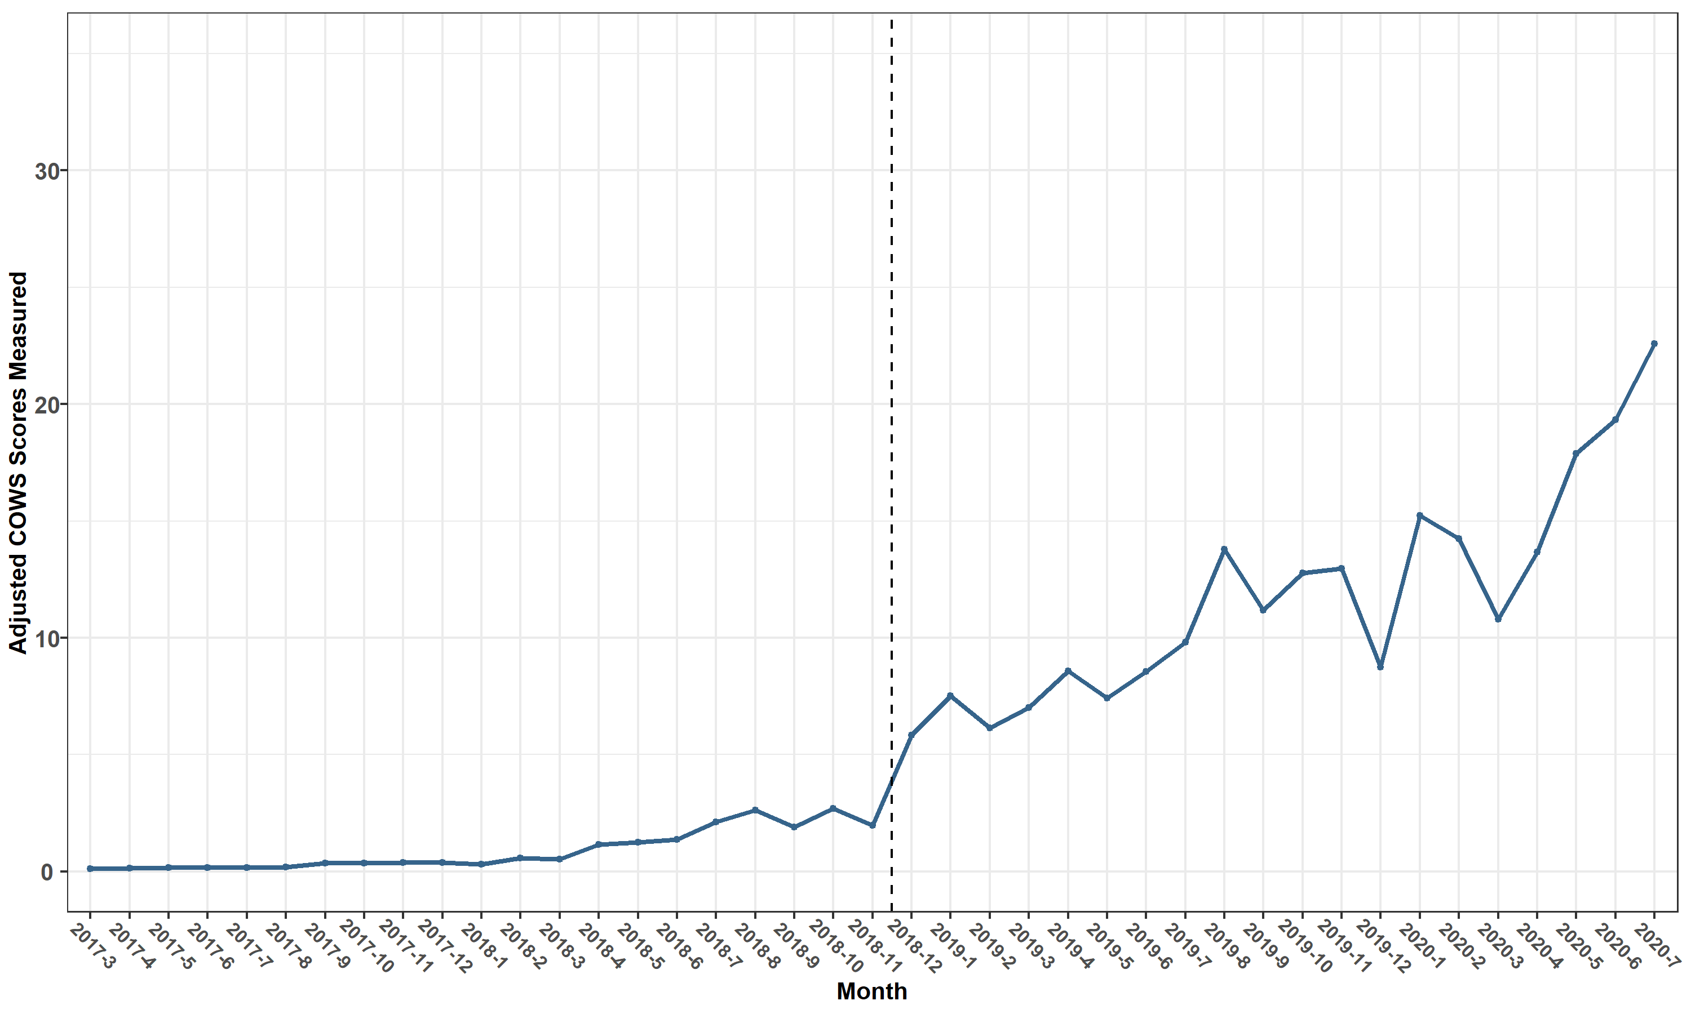

- Buprenorphine Induction Order Set
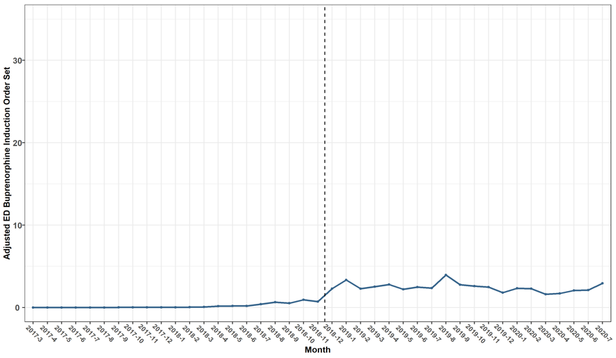

- ED OUD Discharge Smartset*
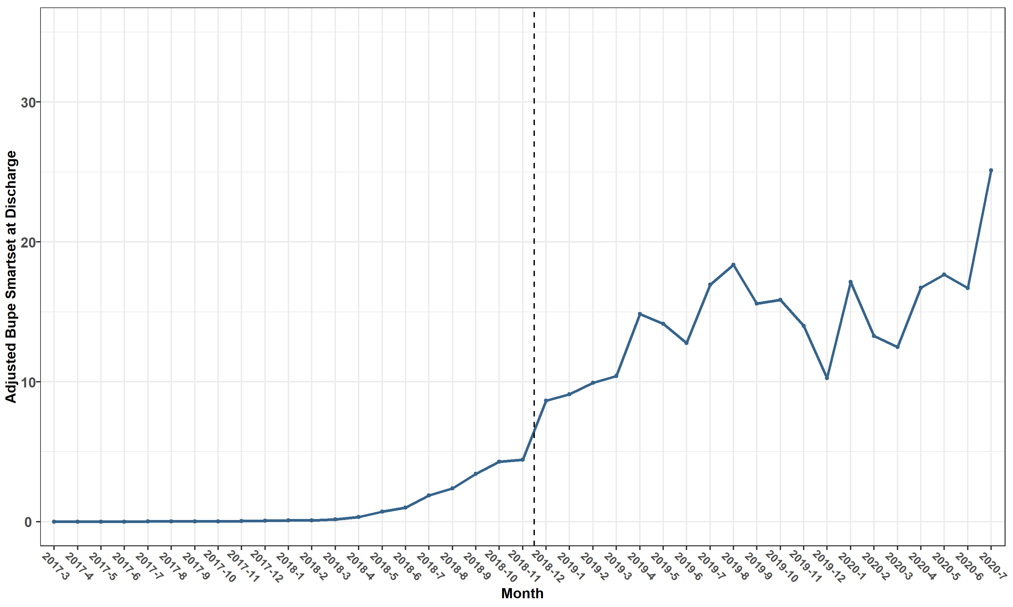
*Data shown includes two of hospitals where smartset available

Table S1: Patient-level models for process and treatment outcomes following the intervention implementation Patient-level multivariable logistic regression models for outcomes of interest are shown. Models were adjusted for patient characteristics and calendar time (month) with fixed effects at the hospital level.

- Total Buprenorphine Administration
 | Coefficient | aOR | 2.50% | 97.50%
Constant | -6.74*** (-8.46, -5.02) | 0.001 | 0.0002 | 0.01
Age | -0.01** (-0.03, -0.002) | 0.99 | 0.97 | 1
Male Gender | -0.18 (-0.48, 0.11) | 0.83 | 0.62 | 1.12
Race/Ethnicity
Hispanic | ref | 1
Non-Hispanic Black | -0.46 (-1.07, 0.16) | 0.63 | 0.35 | 1.18
Non-Hispanic White | -0.19 (-0.78, 0.39) | 0.82 | 0.46 | 1.51
Other/Unknown | -0.27 (-1.08, 0.54) | 0.76 | 0.34 | 1.72
Insurance Status
Commercial | ref | 1
Medicaid | -0.10 (-0.48, 0.28) | 0.9 | 0.62 | 1.33
Medicare | -0.51 (-1.16, 0.14) | 0.6 | 0.31 | 1.14
Other/Uninsured | 0.001 (-0.61, 0.61) | 1 | 0.54 | 1.83
Presentation
Overdose | ref | 1
Withdrawal | 2.60*** (2.11, 3.09) | 13.44 | 8.37 | 22.51
Other | 1.76*** (1.28, 2.24) | 5.82 | 3.68 | 9.61
HOSPITAL1 | -1.22*** (-1.65, -0.79) | 0.3 | 0.19 | 0.45
HOSPITAL2 | 0.18 (-0.16, 0.52) | 1.2 | 0.86 | 1.69
Month | 0.17*** (0.07, 0.26) | 1.18 | 1.08 | 1.31
Intervention1 | 4.82*** (3.12, 6.53) | 124.5 | 25.7 | 806
Month:Intervention1 | -0.16*** (-0.25, -0.06) | 0.85 | 0.77 | 0.93

- ED Buprenorphine Administration
 | Coefficient | aOR | 2.50% | 97.50%
Constant | -7.61*** (-9.62, -5.60) | 0.0005 | 0.0001 | 0.003
Age | -0.02*** (-0.03, -0.01) | 0.98 | 0.97 | 0.99
Male Gender | -0.21 (-0.54, 0.13) | 0.81 | 0.58 | 1.14
Race/Ethnicity
Hispanic | Ref | 1
Non-Hispanic Black | -0.34 (-1.03, 0.35) | 0.71 | 0.36 | 1.46
Non-Hispanic White | -0.003 (-0.66, 0.66) | 1 | 0.53 | 1.99
Other/Unknown | -0.09 (-1.00, 0.82) | 0.91 | 0.36 | 2.27
Insurance Status
Commercial | Ref | 1
Medicaid | 0.16 (-0.29, 0.61) | 1.17 | 0.76 | 1.86
Medicare | -0.16 (-0.93, 0.60) | 0.85 | 0.39 | 1.8
Other/Uninsured | 0.04 (-0.69, 0.77) | 1.04 | 0.49 | 2.14
Presentation
Overdose | Ref | 1
Withdrawal | 3.37*** (2.58, 4.16) | 29.1 | 14.19 | 70.31
Other | 2.44*** (1.66, 3.22) | 11.47 | 5.63 | 27.6
HOSPITAL1 | -1.09*** (-1.57, -0.60) | 0.34 | 0.21 | 0.54
HOSPITAL2 | -0.04 (-0.43, 0.34) | 0.96 | 0.66 | 1.42
Month | 0.16*** (0.06, 0.26) | 1.18 | 1.07 | 1.32
Intervention1 | 4.68*** (2.77, 6.58) | 107.5 | 18.6 | 890.3
Month:Intervention1 | -0.16*** (-0.27, -0.05) | 0.85 | 0.76 | 0.94

- Naloxone at Discharge

 | Coefficient | aOR | 2.50% | 97.50%
Constant | -1.42*** (-2.10, -0.74) | 0.24 | 0.12 | 0.47
Age | -0.01*** (-0.02, -0.003) | 0.99 | 0.98 | 1
Male Gender | 0.38*** (0.16, 0.60) | 1.46 | 1.18 | 1.82
Race/Ethnicity
Hispanic | Ref | 1
Non-Hispanic Black | 0.15 (-0.33, 0.63) | 1.16 | 0.73 | 1.89
Non-Hispanic White | 0.33 (-0.13, 0.79) | 1.39 | 0.88 | 2.23
Other/Unknown | -0.11 (-0.77, 0.55) | 0.9 | 0.46 | 1.73
Insurance Status
Commercial | Ref | 1
Medicaid | -0.09 (-0.36, 0.19) | 0.92 | 0.7 | 1.21
Medicare | 0.06 (-0.35, 0.47) | 1.06 | 0.7 | 1.6
Other/Uninsured | 0.39* (-0.01, 0.79) | 1.48 | 0.99 | 2.2
Presentation
Overdose | Ref | 1
Withdrawal | -1.33*** (-1.60, -1.05) | 0.27 | 0.2 | 0.35
Other | -1.80*** (-2.05, -1.56) | 0.17 | 0.13 | 0.21
HOSPITAL1 | -1.20*** (-1.52, -0.89) | 0.3 | 0.22 | 0.41
HOSPITAL2 | 0.55*** (0.30, 0.80) | 1.73 | 1.35 | 2.23
Month | 0.04*** (0.02, 0.07) | 1.05 | 1.02 | 1.07
Intervention1 | 0.09 (-0.73, 0.90) | 1.09 | 0.48 | 2.45
Month:Intervention1 | 0.01 (-0.03, 0.04) | 1.01 | 0.97 | 1.04

Figure S2: Unadjusted interrupted time series analysis of total buprenorphine administration before and after ED intervention implementation

