Appendix A

The following members of the NSBPR Coordinating Committee are non-author contributors.
Richard Adams, Texas Scottish Rite Hospital for Children, Dallas
Pat Beierwaltes, Children’s Hospital of Michigan, Detroit
Timothy Brei, Riley Hospital for Children, Indianapolis
Robin Bowman, Ann and Robert H. Lurie Children’s Hospital of Chicago, Chicago
James Chinarian, Children’s Hospital of Michigan, Detroit
Mark Dias, Hershey Medical Center, Hershey
Nienke Dosa, Upstate Golisano Children’s Hospital, Syracuse
Carlos Estrada, Boston Children’s Hospital, Boston
Kurt Freeman, Oregon Health and Science University, Portland
David Joseph, Children’s Hospital of Alabama, Birmingham
Pamela Murphy, District Medical Group Children’s Rehabilitative Services, Phoenix
Jacob Neufeld, Children’s Hospital and Research Center at Oakland, Oakland, University of California at San Francisco Benioff Children’s Hospital, San Francisco, and St. Luke’s Boise Medical Center, Boise
Joseph O’Neil, Riley Hospital for Children, Indianapolis
Michael Partington, Gillette Children’s Specialty Healthcare, St. Paul
Elaine Pico, Children’s Hospital and Research Center at Oakland, Oakland and University of California at San Francisco Benioff Children’s Hospital, San Francisco
Karen Ratliff-Schaub, Nationwide Children’s Hospital, Columbus
Stacy Tanaka, Monroe Carell Jr. Children’s Hospital at Vanderbilt, Vanderbilt
Jeffrey Thomson, Connecticut Children’s Medical Center, Hartford and Shriners Hospitals for Children Springfield, Springfield
David Vandersteen, Gillette Specialty Clinics, St. Paul
William Walker, Seattle Children’s Hospital, Seattle
Pamela Wilson, Children’s Hospital Colorado, Denver
Hadley Wood, Cleveland Clinic, Cleveland

Appendix B

Information on each treatment modality

There are multiple treatment modalities that were analyzed in our study which are further detailed below:

Timed defecation:
Timed defecation, sometimes referred to as a habit training program, can provide some versatility in management. The bowel is trained to empty at the same time every day. It involves no special equipment, but does require the stool to be soft and formed. Achieving this consistency prior to beginning the program is recommended. Rewards or incentives can also be used to help young children achieve success.

Oral medications only:
Listed below are general categories of medications and all are generally available without prescriptions:
- Bulk forming laxatives: Psyllium (Metamucil), Calcium Polycarbophil (Fibercon), Benefiber
- Saline laxatives: Milk of Magnesia, Magnesium Citrate
- Stimulant laxatives: Senna (Ex Lax and Senokot), Bisacodyl (Dulcolax)
- Osmotic laxatives: Lactulose, MiraLAX

Rectal stimulation to provoke defecation:
Digital stimulation requires inserting a non-latex lubricated gloved finger into the rectum and massaging the wall of the rectum. Stool needs to be soft and formed for the stimulation to be effective. Suppositories are helpful in attempting to evacuate stool and train the bowel. Generally two types are available: Glycerin Suppositories (made of glycerin that melt and lubricate the rectum) and Dulcolax Suppositories (that contain a stimulant medication to promote emptying of the bowel). Mini-enemas are similar to suppositories but contain a small amount of liquid, and when inserted into the rectum result in emptying after 5 to 10 minutes. Enemeez and Pedia-Lax are common examples of mini-enemas.

Standard rectal enemas:
Standard rectal enemas are commonly known as small volume enemas (30-120ml). The most common standard enema is the fleets enema. Warm water enemas are included in this category and may have soap added to the volume.

Manual disimpaction:
A non-latex glove is used to pull stool out of the rectal vault. Consistency of stool is generally hard and constipation is a concern.

Retrograde large volume enemas:
Large volume enemas are those requiring higher volumes of irrigating fluid generally calculated by body weight (20ml per kg). The common large volume retrograde enemas are:

- Cone enema: Irrigation solution given using a cone irrigation set up similar to irrigation equipment for evacuation of a colostomy. This is usually done on the toilet using the cone as a plug to retain water and bowel movement occurs in 30 to 45 minutes.
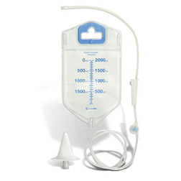
Visi-Flow® Irrigator with Stoma Cone (Courtesy of ConvaTec Inc.)

- Peristeen® transanal irrigation system: This device is designed with a catheter that inflates inside the rectum and stays in place until the irrigation is completed and the device is deflated.
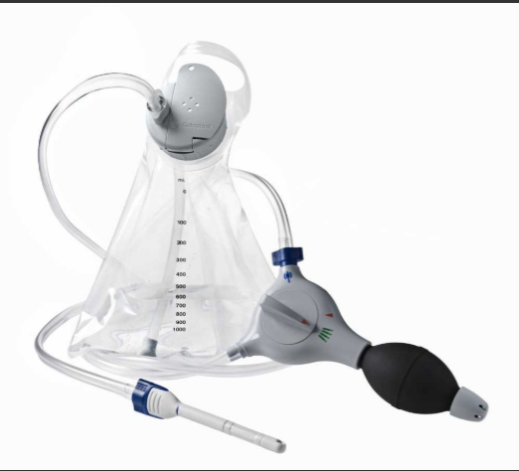

- Balloon enema: Irrigation is given through a latex-free Foley catheter inserted in the rectum and inflated to prevent backflow of the fluid. Once volume is delivered the balloon is deflated.
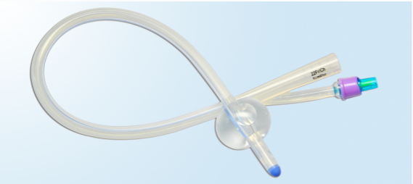

- Antegrade enemas (MACE and cecostomy): An antegrade enema is one that is instilled through a channel or port located on the abdomen or in the belly button that connects to the large colon. The fluid is flushed through the large bowel and out through the rectum. This type of enema requires a prior percutaneous or surgical procedure to create the channel or port.

