DOMAOAL NAMPHIA EID POC

Supplemental Digital Content 1. Validation of the Xpert HIV-1 Qual Assay for sensitivity and repeatability at the Namibia Institute of Pathology (NIP) using 32-member DTS validation panel prior to data collection for NAMPHIA.
Cycle Threshold Value
(Fluorescence Units)
Validation Panel HIV-1 Viral Load (copies/mL)* | Number of Samples | Number Samples with Detected Result (% detected) | Mean | Range | Standard Deviation
301267 | 8 | 8 (100%) | 29.9 | 29.2 – 30.5 | 0.4
18941 | 8 | 8 (100%) | 34.7 | 34.3 – 35.1 | 0.3
7311 | 8 | 8 (100%) | 35.8 | 35.4 – 36.4 | 0.3
0 | 8 | 0 | NA | 0.0 – 0.0 | NA
*Viral load of DTS used for validation determined by Roche CAP/CTM instrument at CDC Atlanta

Supplemental Digital Content 2. Map of NAMPHIA Laboratory Locations
The map of Namibia shows the location of the 18 satellite laboratories used in NAMPHIA. The 12 stationary satellite laboratory locations are shown in red. The mobile satellite laboratory locations are shown in blue. Participant specimens were collected in the field and transported to the closest satellite laboratory location for processing and Xpert EID Testing. There were a maximum of five satellite labs operational at one time. NIP in Windhoek served as the central laboratory and a satellite laboratory for the survey and is shown in green. NIP is also the location were EID testing is performed in the national HIV testing program using the Roche CAP/CTM platform.
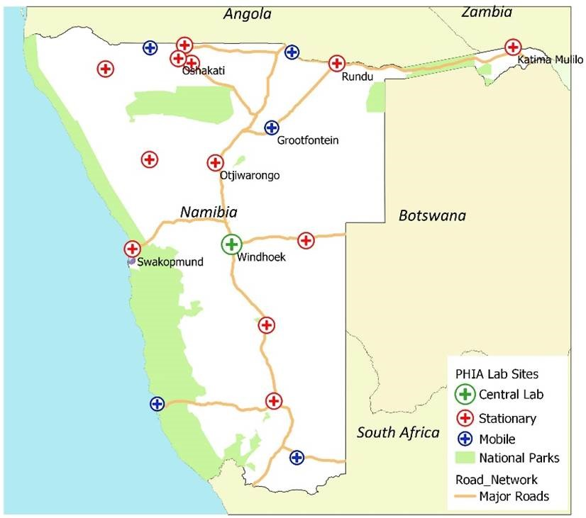

Supplemental Digital Content 3. Training results on Xpert HIV-1 Qual Assay using a blinded 3-member DTS competency panel for satellite laboratory staff trained for NAMPHIA.
Characteristics | Competency Sample 1  (VL = 301267 cp/mL) | Competency Sample 2  (VL = 7311 cp/mL) | Competency Sample 3  (VL = 0 cp/mL)
Number of Trainees | 14 | 14 | 14
Number Detected | 14 | 14 | 0
Number Not Detected | 0 | 0 | 14
Ct Fluorescence Units, Mean | 29.8 | 35.5 | 0
Ct Fluorescence Units, Range | 28.6 – 30.6 | 34.7 – 36.7 | 0.0 – 0.0
Number Trainees Passed Competency | 14 | 14 | 14
*Viral load of DTS used for validation were determined by Roche CAP/CTM at CDC Atlanta

