Supplementary Figure 1: Incidence rate of Shigella sonnei and non-sonnei speciesª infections among children, by site— Foodborne Diseases Active Surveillance Network, 2009–2018
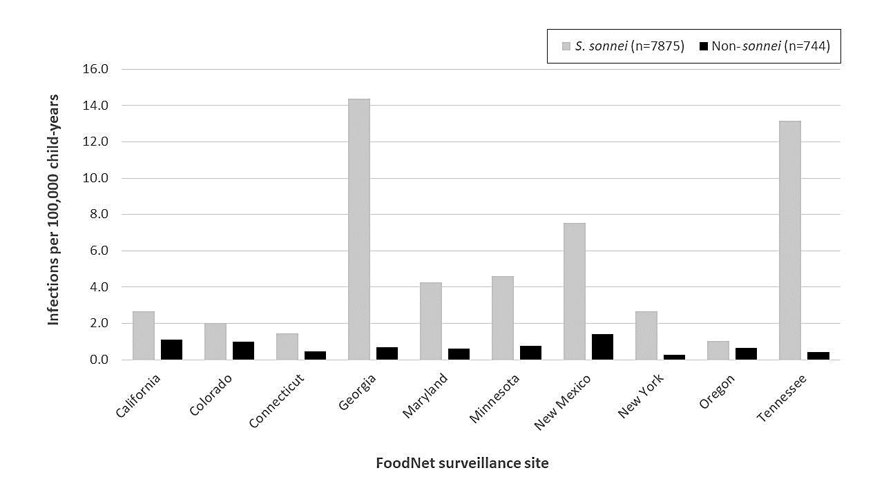
ª Includes S. flexneri, S. boydii, and S. dysenteriae

Supplementary Table 1. Odds ratios for developing a non-sonnei speciesª infection^{b} among children, by race/ethnicity— Foodborne Diseases Active Surveillance Network, 2009–2018
Characteristic | Unadjusted | Adjusted^{c}
 | Odds ratio (95% CI) | Odds ratio (95% CI)
Race/ethnicity
Hispanic, any race | 5.46 (4.28–6.96) | 3.28 (2.53–4.25)
American Indian/Alaska Native, non-Hispanic | 0.73 (0.26–2.00) | 0.32 (0.11–0.89)
Asian/Pacific Islander, non-Hispanic | 13.52 (9.43–19.37) | 8.42 (5.73–12.37)
Black, non-Hispanic | 1.52 (1.16–1.99) | 1.58 (1.19–2.09)
White, non-Hispanic | 1.00 (ref) | 1.00 (ref)

Abbreviations: ref, reference group for odds ratio.
ª Includes S. flexneri, S. boydii, and S. dysenteriae
^{b} Odds ratio for non-sonnei species infection compared with S. sonnei infection, as a binary outcome
^{c} Results of multivariable model including race/ethnicity, sex, age group, and FoodNet site

