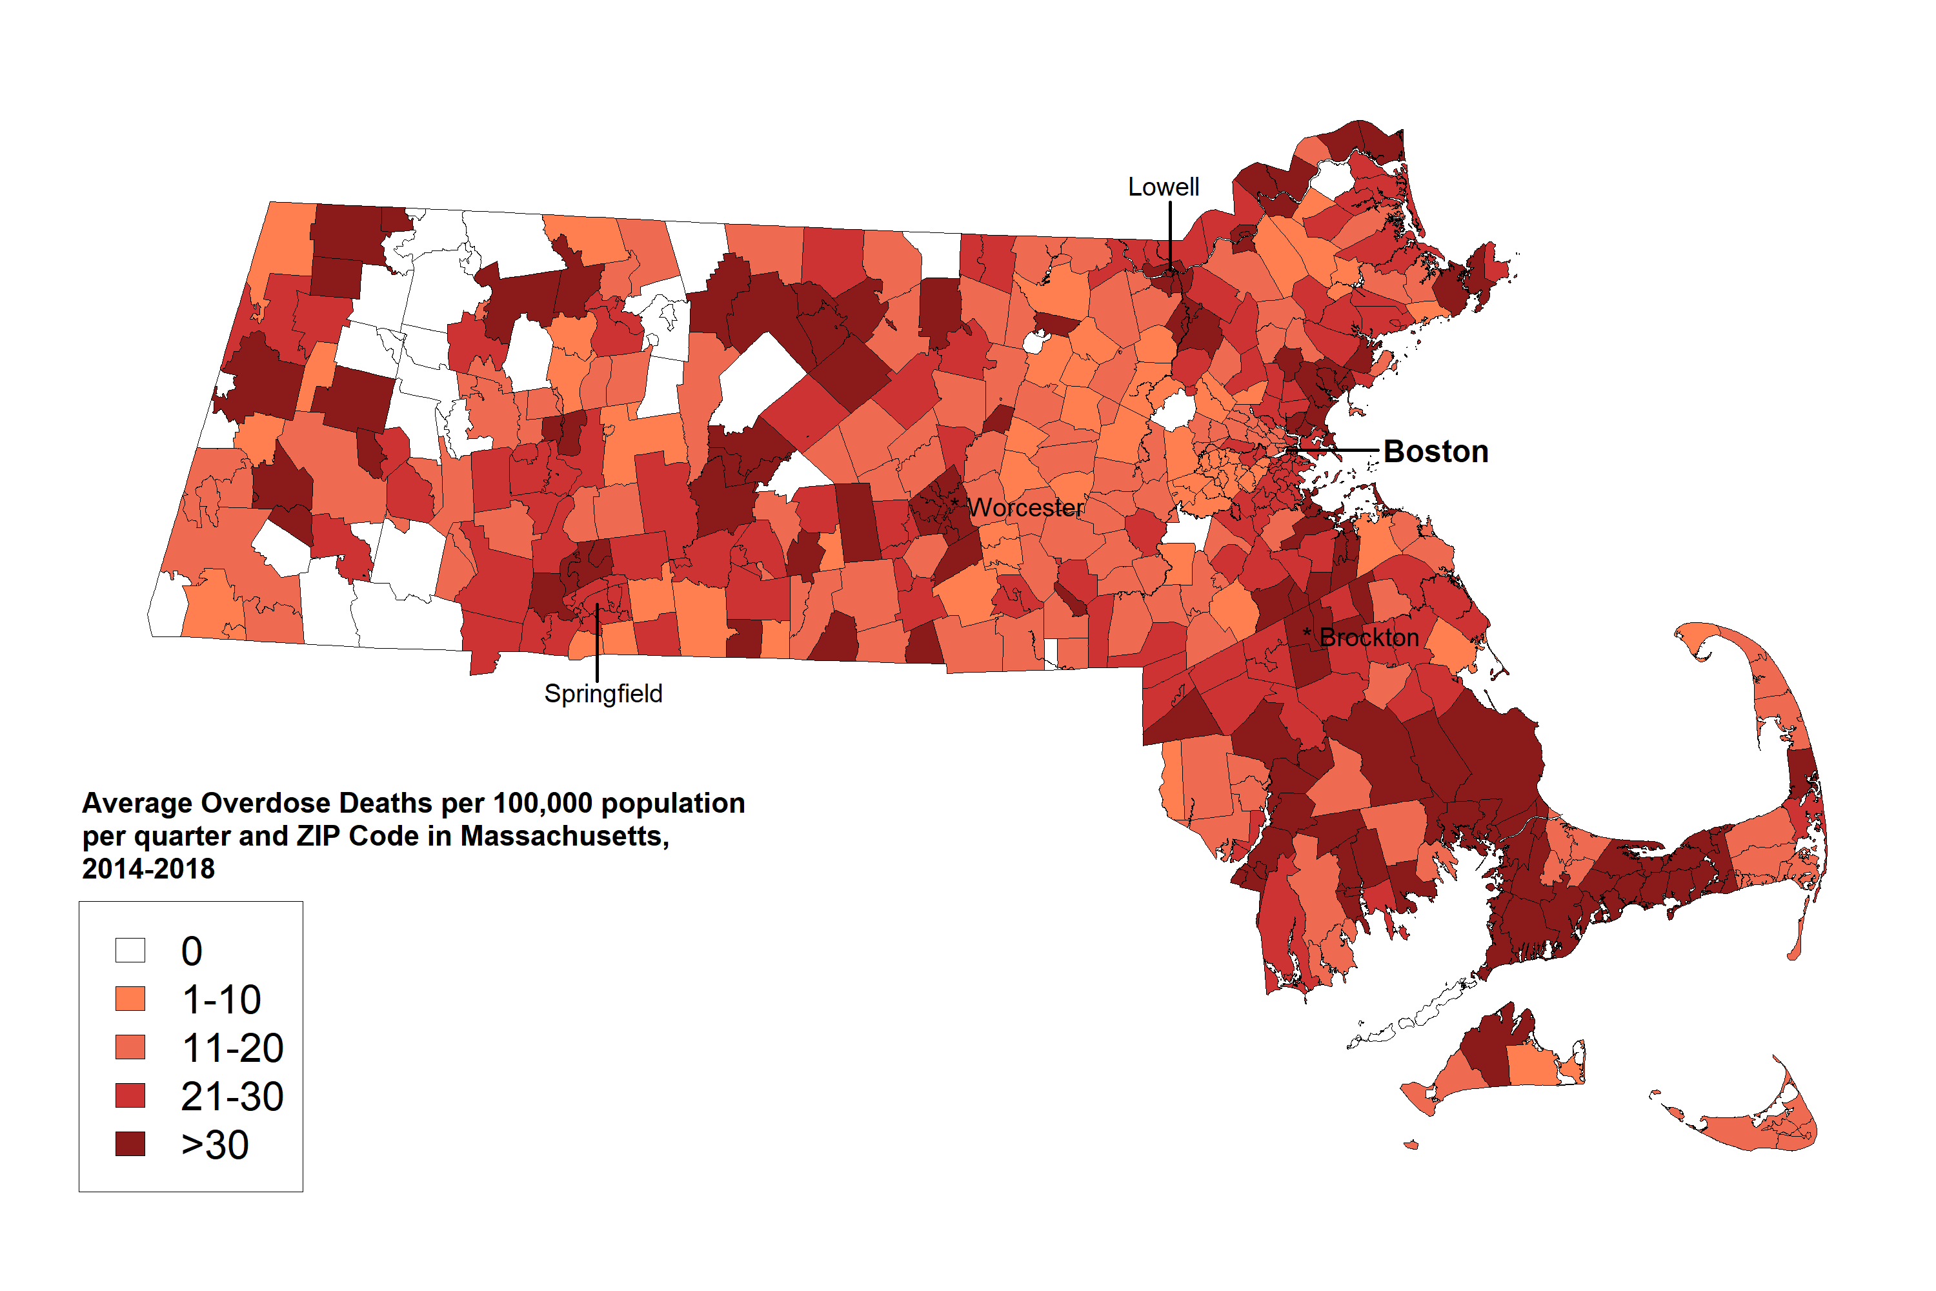
Supplemental Figure: Average number of overdose deaths per 100,000 population per quarter and ZIP Code in Massachusetts, 2014-2018.

Supplemental Table 1: Initial list of co-variates from the American Community Survey describing sociodemographic characteristics of residents in Massachusetts ZIP Codes between 2014 and 2018.
Variables list
Age | Age 25-44
 | Age 45-54
 | Age 55-64
 | Age <25
 | Age >64
Gender | Gender_female
Race and Ethnicity | Non-white population
 | Hispanic population
Annual income level | Income 1-9999
 | Income 10,000-14,999
 | Income_15,000-24,999
 | Income_25,000-34,999
 | Income_35,000-49,999
 | Income_50,000-64,999
 | Income_65,000-74,999
 | Income_greater or equal than 75,000
Poverty status | Poverty_above 150% poverty guideline
 | Poverty_below 150% poverty guideline
Other covariates | Isolation score
 | percentage of population with public insurance
 | Pharmacy density
 | Buprenorphine admission
 | Methadone admission

Supplemental Table 2. Adjusted relationships between ZIP Code characteristics, whether standing order naloxone was dispensed, and quantity of standing order naloxone dispensing events from a sample (59%) of retail pharmacies in Massachusetts, 2014-2018. This sensitivity analysis included individually prescribed naloxone quantities.
Variables | Zero-inflated model, OR (95% CI) | Negative binomial model, IRR (95% CI)
 | Dichotomous odds ratio (OR) outcome of whether any standing order naloxone was dispensed | Incidence rate ratio (IRR) outcome of the quantity of standing order naloxone in zip codes that dispense standing order naloxone
Year
2014 | Ref | Ref
2015 | 4.57 (2.44, 8.56)** | 2.21 (1.59, 3.08)*
2016 | 8.38 (4.50, 15.62)** | 3.82 (2.74, 5.31)**
2017 | 11.59 (6.12, 21.95)** | 4.72 (3.38, 6.60)**
2018 | 15.48 (8.01, 29.91)** | 4.96 (3.53, 6.96)**
Age
Less than 25 years old (5) | 1.05 (0.94, 1.18) | 0.96 (0.89, 1.04)
More than 65 years old (5) | 1.05 (0.91, 1.20) | 1.09 (0.99, 1.20)
Gender
Female (1) | 0.94 (0.90, 0.99)** | 0.98 (0.95, 1.00)
Race
Nonwhite population (5) | 1.04 (0.98, 1.10) | 0.99 (0.96, 1.03)
Ethnicity
Hispanic population (5) | 0.90 (0.85, 0.95)** | 0.98 (0.95, 1.02)
Rurality
Isolation score (1) | 0.83 (0.74, 0.92)** | 1.04 (0.96, 1.13)
Income
Annual income greater than 75,000 (5) | 0.90 (0.83, 0.97)** | 0.91 (0.87, 0.96)**
Buprenorphine admission (100) | 1.69 (0.93, 3.08) | 1.24 (1.05, 1.48)**
Methadone admission (100) | 0.89 (0.56, 1.43) | 1.12 (0.96, 1.30)
Overdose death (100) | 0.96 (0.90, 1.02) | 1.13 (1.08, 1.17)**
OEND naloxone distribution (100) | 1.21 (1.04, 1.40)* | 1.01 (0.97, 1.05)
Individual prescription naloxone dispensing events | 1.04 (1.01, 1.08)* | 1.01 (1.00, 1.01)*
The zero-inflated model has a dichotomous outcome of whether or not any standing order naloxone was dispensed, while the negative binomial model has an outcome of the quantity of standing order naloxone in ZIP Codes that do dispense standing order naloxone.
The numbers in parentheses indicate the unit of analysis for the regression. For example, for every 5 percentage point increase in proportion of people younger than 25, the odds ratio is 1.05 (0.94, 1.18) in the adjusted, zero-inflated model.
*=p<0.05
**=p<0.01

