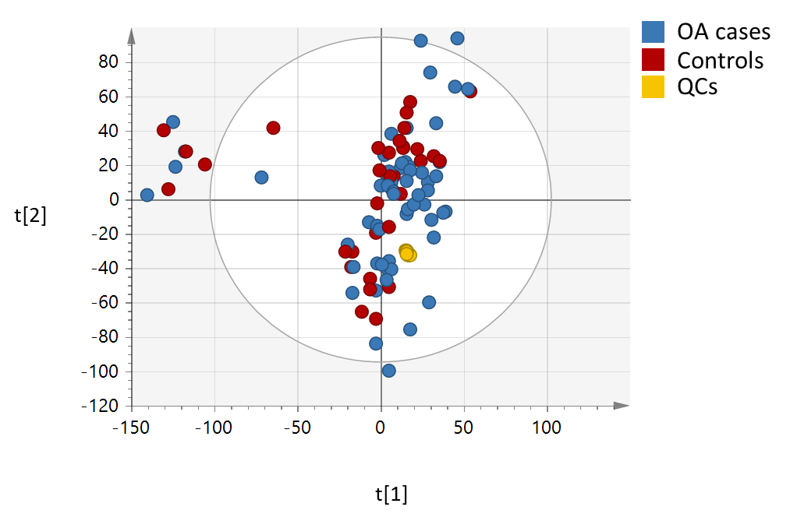
Figure S1. Principal Component Analysis (PCA) plot showing the spread of the study samples and the high reproducibility of the QC pools. t[1] and t[2] denote the first and second components respectively.

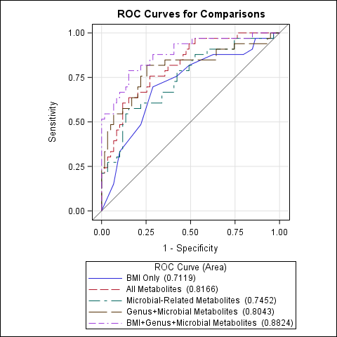

Figure S2. ROC (Receiver operating characteristic) curves for logistic regression models (Table 4). The model using BMI, microbiome genus (or lowest available taxon), and microbial metabolites has a statistically higher AUC than the model with only BMI as the predictor (p=0.013).

