Supplementary Material - Toolkit Description

Item | Description | Photo
Screwdriver | A tool for turning screws. Always use a screwdriver tip that properly fits the slot of the screw. | 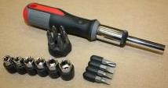
Allen wrench | A tool for turning screws that have a hexagonal socket in the head (point to image on slide). Always use the correct size needed for the job, as using an Allen wrench on a socket that is too large may result in rounding the socket (which means that the Allen wrench in the future would not be able to grab a hold of the socket). | 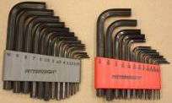
Open-end box-end wrench combination tool or Crescent wrench | A tool for turning nuts and bolts or keeping them from turning while tightening them. Be sure to use the proper size wrench, and only use adjustable wrenches when you do not have the proper size. An adjustable wrench may cause bolts or nuts to round off if not used correctly. | 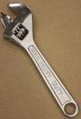
Plastic tire lever | A tool for removing a pneumatic tire. | 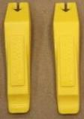
Tire patch kit | A tool for patching a flat inner tube. It contains a scratching tool, glue, and patches. | 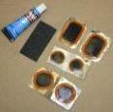

Tire pump and gauge (not included in tool kit but provided for in-person training) | A tool for inflating tires pneumatic tires. A foot pump, compressor or high pressure hand pump is necessary to inflate tires over 50psi. Tires can also be filled using gas station airlines, but a valve adaptor may need to be used. | 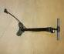
Lubricant | A tool for lubricating and protecting against corrosion. It also removes grease, gum, dirt, & scuff marks. | 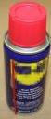
Maintenance Cards | A set of cards that you can use to remind you of the maintenance tasks and how often to perform them (can be found at: [url_removed_for_blinding]). | 