Supplemental Table 1. Gating strategies for immunophenotyping

Spleen and dLN cells
Cell Type | Gating Strategy
CD4 T cells | CD45⁺, lymphocyte gate (FSC/SSC^{low}), CD8⁻, B220⁻, NKp46⁻, CD4⁺
CD8 T cells | CD45⁺, lymphocyte gate (FSC/SSC^{low}), CD4⁻, B220⁻, NKp46⁻, CD8⁺
B cells | CD45⁺, lymphocyte gate (FSC/SSC^{low}), CD4⁻, CD8⁻, NKp46⁻, B220⁺ (MHCII/CD86 MFI increases with activation)
NK cells | CD45⁺, lymphocyte gate (FSC/SSC^{low}), CD4⁻, CD8⁻, B220⁻, NKp46⁺
Eosinophils | CD45⁺, SSC^{high}, CD11b⁺, Ly6G^{low}, Siglec-F⁺
Neutrophils | CD45⁺, SSC^{high}, CD11b⁺, Siglec-F⁻, Ly6G^{high},
DCs | CD45⁺, SSC^{int}, MHCII⁺, CD11c⁺, F4/80⁻ (MHCII/CD86 MFI increases with activation)
CD11b⁺ monocytes/macrophages | CD45⁺, SSC^{int}, CD11b⁺, SiglecF⁻, Ly6G⁻, Lyc6^{+/-}, F4/80^{+/-}
Skin (ear) cells
Cell Type | Gating Strategy
CD4 T cells | CD45⁺, Lymphocyte gate (FSC/SSC^{low}), CD3⁺, CD4⁺, CD8⁻
CD8 T cells | CD45⁺, Lymphocyte gate (FSC/SSC^{low}), CD3⁺, CD4⁻, CD8⁺
NK cells | CD45⁺, Lymphocyte gate (FSC/SSC^{low}), CD3⁻, NKp46⁺
Eosinophils | CD45⁺, SSC^{high}, CD11b⁺, Ly6G^{low}, Siglec-F⁺
Neutrophils | CD45⁺, SSC^{high}, CD11b⁺, Siglec-F⁻, Ly6G^{high}
DCs | CD45⁺, SSC^{int}, MHCII⁺, CD11c⁺, F4/80⁻ , CD11b^{+/-}

Supplemental Table 2. Genes evaluated in liver and skin
Gene | Assay ID #’s
Cd36 | Mm00432403_m1
Lpl | Mm00434764_m1
Serpine1 | Mm00435858_m1
Pltp | Mm01240573_m1
Ehhadh | Mm00619685_m1
Krt8 | Mm00835759_m1
Acox1 | Mm00443578_g1
Fabp1 | Mm00444340_m1
Scd1 | Mm00772290_m1
Fabp5 | Mm00783731_s1
Ppara | Mm00440930_m1
Nfkb | Mm00476361_m1
Il-1beta | Mm00434228_m1
Il-6 | Mm00446190_m1
Tslp | Mm01157588_m1
Flg2 | Mm02744902_g1
Itgbl1 | Mm01200043_m1
Lor | Mm01962650_s1
Flg | Mm01716522_m1
Krt10 | Mm03009921_m1
Krt14 | Mm00516876_m1
S100a7a | Mm01218201_m1
S100a8 | Mm00496696_g1
Cxcl1 | Mm04207460_m1
Cxcl2 | Mm00436450_m1

Supplemental Table 3. Histopathology grading criteria
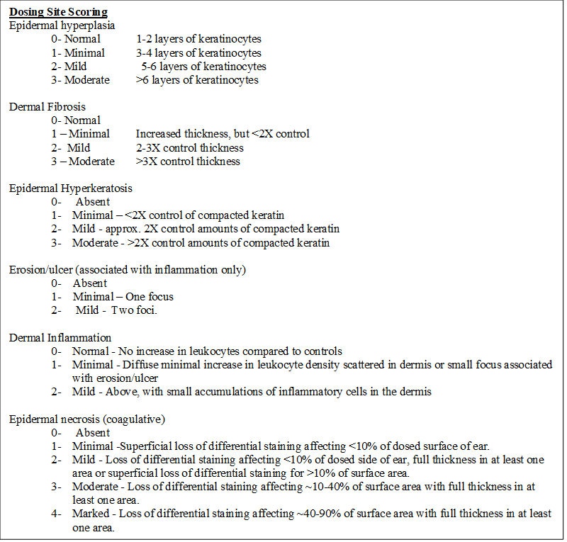

Supp. Figure 1
Supplemental Figure 1. Weight following dermal exposure to PFBA. Weight loss (final body weight (BW) – start body weight (BW)) following 28-days of PFBA exposure. Bars represent mean (± SE) of 5 mice per group. Statistical significance, relative to 0% vehicle control, was determined by one-way ANOVA followed by Dunnett’s post-test. Note: The 15% PFBA exposure group received treatment on days 1-8, 14, 15, 17, 18, 22, 25, and 28 for a total of 15 days.

Supplemental Table 4. Organ weights following dermal exposure to PFBA
 | 28 Days
PFBA (v/v) | 0% | 3.75% | 7.5% | 15%
Thymus (g) | 0.049 ± 0.003 | 0.046 ± 0.003 | 0.048 ± 0.002 | 0.052 ± 0.001
Spleen (g) | 0.074 ± 0.003 | 0.071 ± 0.003 | 0.068 ± 0.002 | 0.083 ± 0.004
Kidneys (g) | 0.268 ± 0.015 | 0.299 ± 0.013 | 0.309 ± 0.008 | 0.330 ± 0.013**
Liver (g) | 0.978 ± 0.074 | 1.313 ± 0.029*** | 1.603 ± 0.056*** | 1.534 ± 0.043***

Numbers represent mean (± SE) of 5 mice per group. Levels of statistical significance are denoted (** p < 0.01, and *** p < 0.001) as compared to vehicle control (0%). Note: The 15% PFBA exposure group received treatment on days 1-8, 14, 15, 17, 18, 22, 25, and 28 for a total of 15 days.

Supplemental Table 5. Spleen phenotyping of mice dermally exposed to PFBA

Spleen | 28 days
Parameter | 0% | 3.75% | 7.5% | 15%
Cellularity (x 10⁷) | 9.41 ± 0.5 | 7.68 ± 0.5 | 6.7 ± 0.7* | 8.5 ± 0.8
CD4+ (x 10⁶) | 6.9 ± 0.4 | 5.6 ± 0.3 | 4.9 ± 0.4** | 5.5 ± 0.5
CD4+ (%) | 20.7 ± 0.8 | 21.2 ± 0.6 | 21.4 ± 0.7 | 19.4 ± 0.6
CD8+ (x 10⁶) | 11.2 ± 0.8 | 9.6 ± 0.4 | 8.1 ± 0.9 | 9.8 ± 0.9
CD8+ (%) | 11.9 ± 0.3 | 12.5 ± 0.3 | 12.1 ± 0.3 | 11.6 ± 0.5
B-cells (x 10⁷) | 3.3 ± 0.1 | 2.6 ± 0.2 | 2.3 ± 0.2** | 2.9 ± 0.3
B-cells (%) | 35.5 ± 1.1 | 34.3 ± 0.6 | 34.3 ± 1.1 | 33.8 ± 0.7
NK (x 10⁶) | 3.1 ± 0.2 | 2.5 ± 0.2 | 2.3 ± 0.2 | 3.1 ± 0.3
NK (%) | 3.3 ± 0.2 | 3.3 ± 0.2 | 3.4 ± 0.2 | 3.8 ± 0.3
Neutrophils (x 10⁶) | 1.3 ± 0.1 | 1.2 ± 0.1 | 8.2 ± 0.1** | 1.1 ± 0.1
Neutrophils (%) | 1.4 ± 0.1 | 1.6 ± 0.1 | 1.3 ± 0.1 | 1.3 ± 0.1
DCs (x 10⁶) | 1.3 ± 0.1 | 1.1 ± 0.1 | 1.0 ± 0.2 | 1.7 ± 0.2
DCs (%) | 1.3 ± 0.1 | 1.5 ± 0.1 | 1.5 ± 0.1 | 2.1 ± 0.1**
CD11b+ (x 10⁶) | 2.0 ± 0.1 | 1.5 ± 0.1 | 1.4 ± 0.2 | 2.0 ± 0.2
CD11b+ (%) | 2.1 ± 0.1 | 2.0 ± 0.1 | 2.1 ± 0.1 | 2.3 ± 0.1
CD11b+Ly6C+ (x 10⁵) | 6.0 ± 0.5 | 4.8 ± 0.4 | 4.7 ± 0.6 | 6.0 ± 0.5
CD11b+Ly6C+ (%) | 0.64 ± 0.04 | 0.62 ± 0.03 | 0.70 ± 0.03 | 0.71 ± 0.03
CD11b+Ly6C- (x 10⁵) | 13.2 ± 0.8 | 9.8 ± 0.7 | 9.1 ± 0.1* | 12.8 ± 0.1
CD11b+Ly6C- (%) | 1.41 ± 0.08 | 1.27 ± 0.05 | 1.34 ± 0.09 | 1.52 ± 0.07
MHCII B-cells (MFI) | 2090.8 ± 79.9 | 2233.8 ± 38.9 | 2254.8 ± 83.1 | 2448.4 ± 51.0**
MHCII DCs (MFI) | 5794.8 ± 89.3 | 6157 ± 178.8 | 6002.6 ± 89.9 | 6627.8 ± 94.5***
CD86 B-cells (MFI) | 271.6 ± 5.4 | 277.4 ± 6.7 | 318.2 ± 11.2* | 302.2 ± 17.8
CD86 DCs (MFI) | 1686.6 ± 80.4 | 1959 ± 89.1 | 2109.4 ± 124.1 | 2332.6 ± 158.3**
Values are expressed as the means (± SE) for each group (n=5 mice/group).
*p < 0.05, **p<0.01, ***p<0.001

Supplemental Table 6. Liver gene expression of mice dermally exposed to PFBA

Liver | 28 days
Parameter (Fold change) | 0% | 3.75% | 7.5% | 15%
Abcb4 | 1.04 ± 0.19 | 1.94 ± 0.08 | 4.11 ± 0.08*** | 2.69 ± 0.47*
Abcc2 | 1.03 ± 0.15 | 1.56 ± 0.16 | 3.14 ± 0.02*** | 1.97 ± 0.24*
Abcc3 | 1.04 ± 0.19 | 1.62 ± 0.09 | 3.95 ± 0.17*** | 2.27 ± 0.35*
Aldoa | 1.05 ± 0.19 | 1.20 ± 0.09 | 3.28 ± 0.09*** | 1.96 ± 0.23*
Apex1 | 1.03 ± 0.13 | 1.39 ± 0.23 | 2.48 ± 0.18* | 2.39 ± 0.39*
Btg2 | 1.01 ± 0.09 | 1.24 ± 0.20 | 4.42 ± 0.24** | 3.77 ± 0.57**
Ccng1 | 1.00 ± 0.04 | 2.16 ± 0.18** | 5.84 ± 0.15*** | 2.43 ± 0.16**
Cd36 | 1.00 ± 0.09 | 14.53 ± 0.97** | 38.89 ± 2.72*** | 18.14 ± 0.90***
Col4a1 | 1.01 ± 0.09 | 1.49 ± 0.10 | 4.48 ± 0.39*** | 2.47 ± 0.41
Fabp1 | 1.01 ± 0.06 | 3.46 ± 0.37* | 9.56 ± 0.72*** | 4.22 ± 0.15**
Fasn | 1.02 ± 0.10 | 1.80 ± 0.38 | 3.89 ± 0.13* | 3.64 ± 0.79*
Gadd45a | 1.00 ± 0.05 | 1.19 ± 0.26 | 2.60 ± 0.07* | 2.31 ± 0.41*
Gclc | 1.02 ± 0.12 | 1.79 ± 0.19 | 3.79 ± 0.26*** | 2.03 ± 0.27
Gsr | 1.03 ± 0.14 | 1.61 ± 0.17 | 3.82 ± 0.15*** | 2.66 ± 0.39*
Hpn | 1.05 ± 0.18 | 1.42 ± 0.18 | 4.11 ± 0.33** | 2.97 ± 0.51*
Ipo4 | 1.04 ± 0.17 | 1.52 ± 0.24 | 4.12 ± 0.14*** | 2.82 ± 0.44*
Krt18 | 1.00 ± 0.04 | 1.44 ± 0.11 | 4.09 ± 0.11*** | 2.46 ± 0.23**
Krt8 | 1.01 ± 0.06 | 2.21 ± 0.18 | 6.26 ± 0.33*** | 3.71 ± 0.52**
Lpl | 1.13 ± 0.27 | 18.72 ± 6.12 | 55.63 ± 2.01*** | 16.66 ± 2.69
Lss | 1.07 ± 0.22 | 1.62 ± 0.46 | 3.95 ± 0.16* | 4.00 ± 0.95*
Nqo1 | 1.00 ± 0.06 | 1.87 ± 0.23 | 4.28 ± 0.15*** | 2.37 ± 0.18**
Osmr | 1.02 ± 0.10 | 1.30 ± 0.13 | 3.65 ± 0.42** | 2.28 ± 0.40
Ppara | 1.08 ± 0.24 | 1.46 ± 0.17 | 4.41 ± 0.10** | 3.58 ± 0.66*
Scd1 | 1.04 ± 0.14 | 3.52 ± 0.79 | 10.66 ± 0.95*** | 6.16 ± 0.90*
Serpine1 | 1.26 ± 0.48 | 1.96 ± 0.04 | 17.90 ± 3.16** | 10.30 ± 2.43
Fabp5 | 1.09 ± 0.28 | 1.60 ± 0.26 | 2.50 ± 0.28 | 3.44 ± 0.57*
Ehhadh | 1.31 ± 0.40 | 15.28 ± 7.10 | 28.55 ± 8.04 | 37.39 ± 11.72
Ptlp | 1.06 ± 0.21 | 2.18 ± 0.70 | 7.35 ± 1.67* | 4.72 ± 1.36
Acox1 | 1.10 ± 0.25 | 3.96 ± 1.23 | 8.21 ± 2.96 | 7.15 ± 0.69

Supp. Table 6. Livers were homogenized on a TissueLyser II in Buffer RLT (Qiagen). Total RNA was isolated using Qiagen’s RNeasy mini spin column kits with DNase treatment on a QIAcube automated RNA isolation machine. RNA concentrations and purity were analyzed on a NanoDrop spectrophotometer (Thermo Fisher Scientific). Total RNA (0.5µg) was reverse transcribed utilizing the RT² First Strand Kit (QIAGEN) under the following conditions: 42°C for 15 mins and 95°C for 5 mins. The cDNA was used on the real-time RT² Profiler PCR Array Mouse PPAR Targets and Hepatoxicity (QIAGEN; Product #: PAMM-149ZC and PAMM-093ZC). Real-time PCR (RT-PCR) was performed in combination with the RT² SYBR Green qPCR Mastermix (QIAGEN) under the following PCR conditions: 95°C for 10 min, followed by 40 cycles of 95°C for 15 s and 60°C for 1 min. Each array plate contained one set of 96 wells for testing. Genomic DNA contamination, reverse transcription, and positive PCR controls were included in each 96-well set on each plate. Reference gene β2-microglobulin was used in the assay. Gene expression was calculated using the CT value, and fold change in expression were determined with the 2^{-ΔΔCT} method. Values are expressed as the means (± SE) for each group (n=3 mice/group). *p < 0.05, **p < 0.01, ***p < 0.001.

Supp. Figure 2
Supplemental Figure 2. Skin gene expression following dermal exposure to PFBA. Gene expression in the ear following 28 days of PFBA exposure. Changes in Flg2 (A), Itgbl1 (B), Lor (C), Flg (D), Krt10 (E), and Krt14 (F) were evaluated. Data shown as the mean (± SE) of 5 mice per group. Statistical significance, relative to 0% vehicle control (VC), was determined by one-way ANOVA with Dunnett’s post-test. Note: The 15% PFBA exposure group received treatment on days 1-8, 14, 15, 17, 18, 22, 25, and 28 for a total of 15 days.

