Table S1: Time trends in CUD treatment use, specialty treatment use, and perceived treatment need among those who met DSM-5-proxy CUD criteria in the past year including age as a fixed effect, National Survey on Drug Use and Health 2002-2019 (N= 43,307)

 | CUD Treatment Use  aRR (95% CI) | CUD Specialty Treatment Use  aRR (95% CI) | Perceived CUD Treatment Need  aRR (95% CI)
Age fixed effect  12-17  18-25  $≥$26 | Ref  0.53 (0.48, 0.59)  0.66 (0.56, 0.78) | Ref  0.67 (0.57, 0.78)  0.87 (0.69, 1.09) | Ref  0.85 (0.71, 1.03)  1.63 (1.25, 2.11)
Continuous Year | 0.97 (0.95, 0.99) | 0.98 (0.95, 1.01) | 0.95 (0.92, 0.98)
Intercept at 2015 | 0.80 (0.63, 1.02) | 0.93 (0.66, 1.32) | 0.93 (0.56, 1.54)
Slope after 2015 | 1.00 (0.92, 1.09) | 0.92 (0.80, 1.06) | 0.93 (0.79, 1.10)
Yearly change  before 2015 | 0.97 (0.95, 0.99) | 0.98 (0.95, 1.01) | 0.95 (0.92, 0.98)
Yearly change  after 2015ª | 0.98 (0.90, 1.06) | 0.91 (0.79, 1.03) | 0.89 (0.76, 1.04)
Notes: CUD= cannabis use disorder; aRR= adjusted risk ratio; CI= confidence interval; Bold values indicate p<0.05.
ªValues derived from linear combinations of continuous year + slope after 2015.
CUD inclusion criteria= meeting criteria for DSM-5-proxy CUD.

Table S2: Time trends in CUD treatment use, specialty treatment use, and perceived treatment need among those who met DSM-5-proxy CUD criteria in the past year including age interactions, National Survey on Drug Use and Health 2002-2019 (N= 43,307)
 | CUD Treatment Use  aRR (95% CI) | CUD Specialty Treatment Use  aRR (95% CI) | Perceived CUD Treatment Need  aRR (95% CI)
Intercept changes
Age  12-17  18-25  $≥$26 | Ref  0.63 (0.50, 0.79)  0.71 (0.47, 1.07) | Ref  0.76 (0.54, 1.08)  0.98 (0.55, 1.77) | Ref  0.98 (0.66, 1.45)  1.65 (1.00, 2.72)
Intercept at 2015 | 0.88 (0.60, 1.28) | 0.60 (0.31, 1.16) | 1.13 (0.47, 2.72)
Age*Intercept at 2015 Interaction  12-17  18-25  $≥$26 | Ref  1.22 (0.70, 2.12)  0.64 (0.35, 1.18) | Ref  2.08 (0.79, 5.45)  1.39 (0.56, 3.46) | Ref  0.84 (0.29, 2.39)  0.78 (0.23, 2.62)
Age-specificª change in intercept at 2015 vs. 2002  12-17  18-25  $≥$26 | 0.88 (0.60, 1.28)  1.07 (0.76, 1.51)  0.57 (0.34, 0.94) | 0.60 (0.31, 1.16)  1.25 (0.72, 2.15)  0.84 (0.45, 1.56) | 1.13 (0.47, 2.72)  0.95 (0.49, 1.82)  0.88 (0.39, 1.98)
Slope changes
Continuous Year | 0.98 (0.96, 1.00) | 1.00 (0.96, 1.04) | 0.96 (0.91, 1.00)
Age*Continuous Year Interaction  12-17  18-25  $≥$26 | Ref  0.98 (0.95, 1.01)  1.00 (0.95, 1.05) | Ref  0.98 (0.93, 1.02)  0.98 (0.91, 1.05) | Ref  0.98 (0.93, 1.03)  1.00 (0.94, 1.08)
Slope after 2015 | 1.00 (0.87, 1.15) | 0.99 (0.75, 1.31) | 0.89 (0.63, 1.25)
Age*Slope after 2015 Interaction  12-17  18-25  $≥$26 | Ref  0.94 (0.77, 1.13)  1.08 (0.88, 1.32) | Ref  0.86 (0.59, 1.25)  0.98 (0.68, 1.41) | Ref  1.20 (0.79, 1.82)  0.98 (0.64, 1.50)
Age-specific^{b} change over time before 2015  12-17  18-25  $≥$26 | 0.98 (0.96, 1.00)  0.96 (0.94, 0.98)  0.98 (0.93, 1.02) | 1.00 (0.96, 1.04)  0.97 (0.94, 1.00)  0.98 (0.92, 1.04) | 0.96 (0.91, 1.00)  0.94 (0.90, 0.97)  0.96 (0.91, 1.01)
Age-specific^{c} change over time after 2015  12-17  18-25  $≥$26 | 0.98 (0.86, 1.13)  0.90 (0.80, 1.00)  1.06 (0.90, 1.24) | 0.99 (0.75, 1.31)  0.83 (0.67, 1.03)  0.95 (0.78, 1.17) | 0.85 (0.60, 1.19)  0.99 (0.81, 1.23)  0.83 (0.64, 1.08)

Notes: CUD= cannabis use disorder; aRR= adjusted risk ratio; CI= confidence interval; Bold values indicate p<0.05.
ªAge-specific values derived from linear combinations 2015 intercept + age*2015 intercept
^{b}Age-specific values derived from linear combinations continuous year + age*year interaction
^{c}Age-specific values derived from linear combinations continuous year + age*year interaction + slope after 2015 + age*slope after 2015
CUD inclusion criteria=meeting criteria for DSM-5-proxy CUD.

Table S3: Time trends in CUD treatment use, specialty treatment use, and perceived treatment need among those who met DSM-5-proxy CUD criteria in the past year by age group, National Survey on Drug Use and Health 2002-2019 (N= 43,307)

 | CUD Treatment Use  aRR (95% CI) | CUD Specialty Treatment Use  aRR (95% CI) | Perceived CUD Treatment Need  aRR (95% CI)
CUD severity  Mild  Moderate  Severe | Ref  2.18 (1.88, 2.54)  4.16 (3.68, 4.72) | Ref  2.00 (1.63, 2.46)  4.53 (3.77, 5.44) | Ref  4.06 (3.05, 5.40)  7.94 (6.15, 10.25)
Age fixed effect  12-17  18-25  $≥$26 | Ref  0.69 (0.58, 0.83)  0.87 (0.64, 1.19) | Ref  0.76 (0.57, 1.02)  1.05 (0.67, 1.64) | Ref  1.05 (0.75, 1.47)  2.13 (1.39, 3.29)
Continuous year | 0.98 (0.97, 1.00) | 0.98 (0.96, 1.01) | 0.96 (0.93, 1.00)
Age*Continuous year interaction  12-17  18-25  $≥$26 | Ref  0.98 (0.96, 1.00)  0.98 (0.95, 1.01) | Ref  0.99 (0.96, 1.02)  0.99 (0.95, 1.03) | Ref  0.99 (0.95, 1.03)  0.98 (0.94, 1.02)
Age-specific yearly changeª  Ages 12-17  Ages 18-25  Ages $≥$26 | 0.98 (0.97, 1.00)  0.66 (0.56, 0.79)  0.84 (0.63, 1.12) | 0.98 (0.96, 1.01)  0.74 (0.56, 0.98)  1.02 (0.67, 1.55) | 0.96 (0.93, 1.00)  1.00 (0.72, 1.38)  2.02 (1.33, 3.05)
Notes: CUD= cannabis use disorder; aRR= adjusted risk ratio; CI= confidence interval; Bold values indicate p<0.05.
ªValues derived from linear combinations of continuous year + age groups. CUD inclusion criteria= meeting criteria for DSM-5-proxy CUD

Figure S1: Prevalence of DSM-5-proxy CUD in the past year, NSDUH 2002-2019 (N=1,005,421)

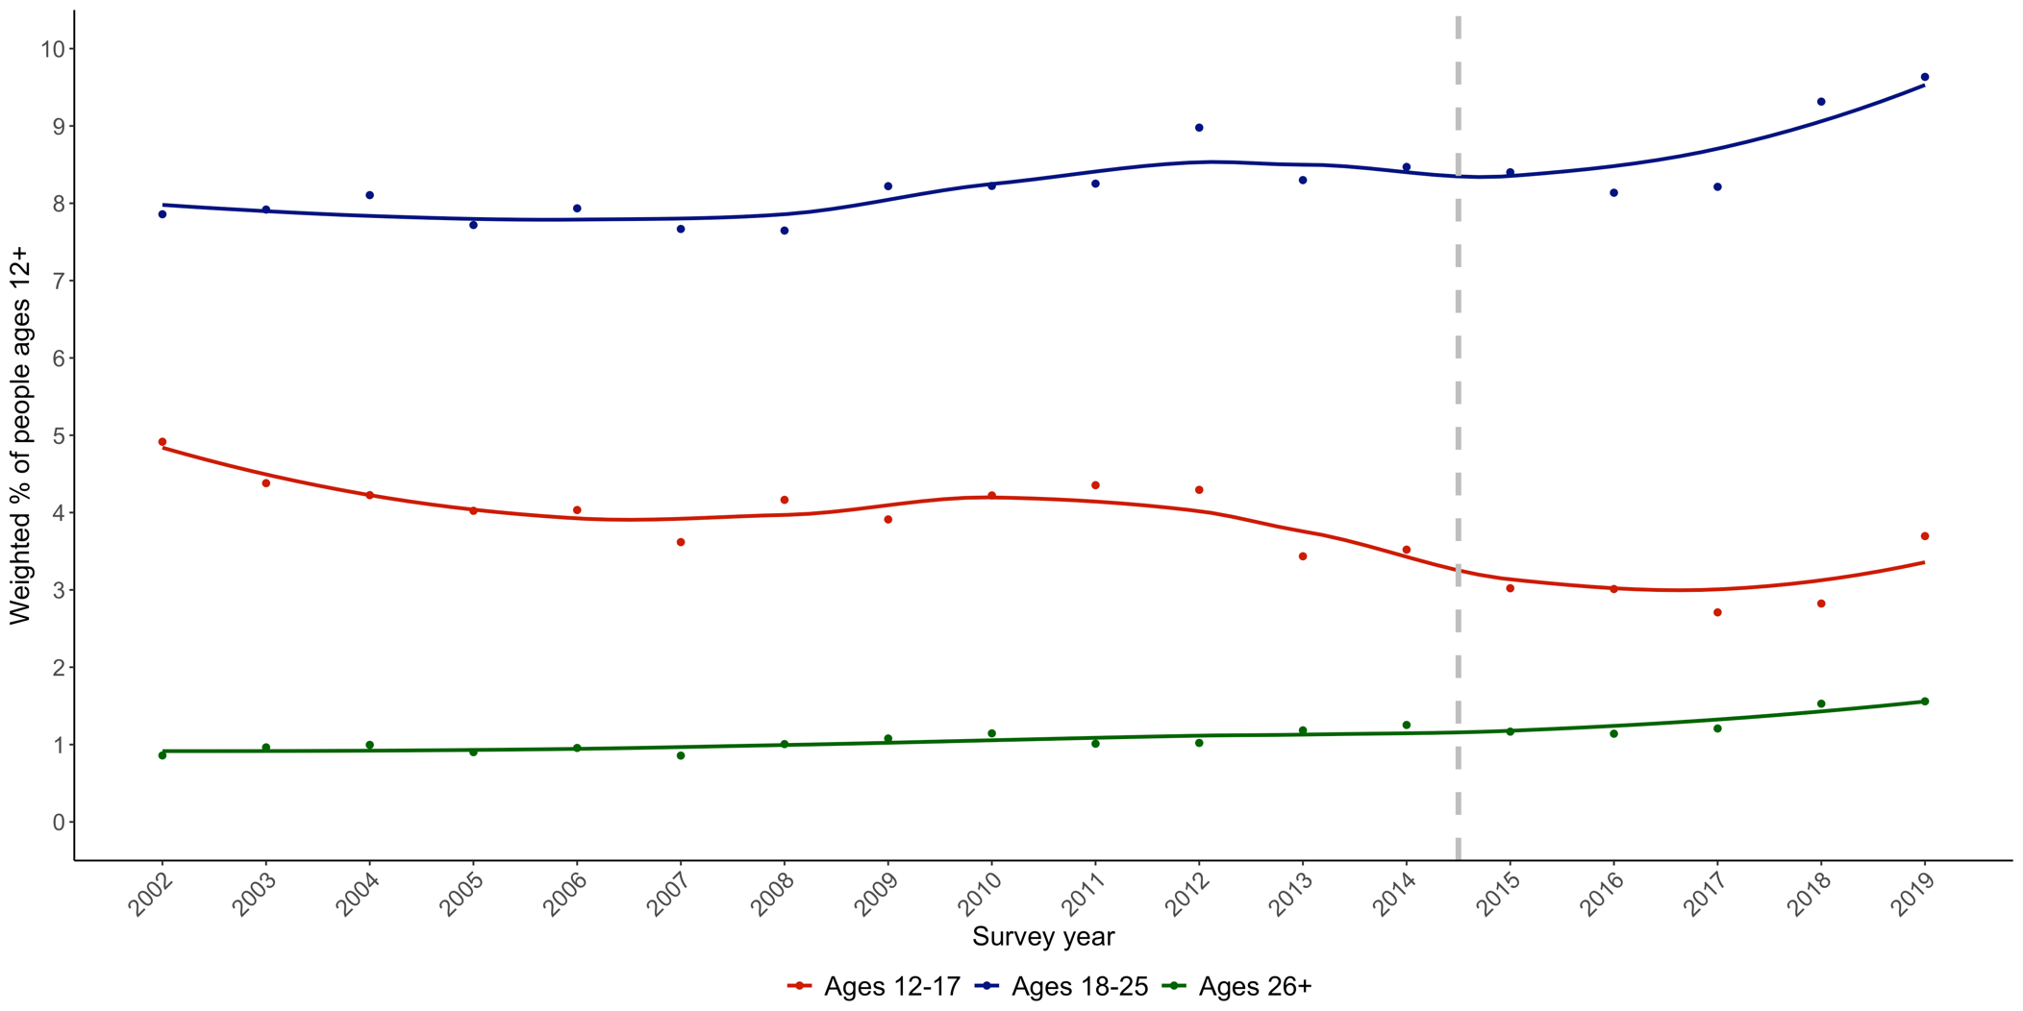

Notes: CUD= Cannabis Use Disorder. Vertical line at 2015 represents NSDUH survey redesign.
Figure S2: CUD treatment use in the past year among those with past-year DSM-5-proxy CUD, NSDUH 2002-2019 (N= 43,307)

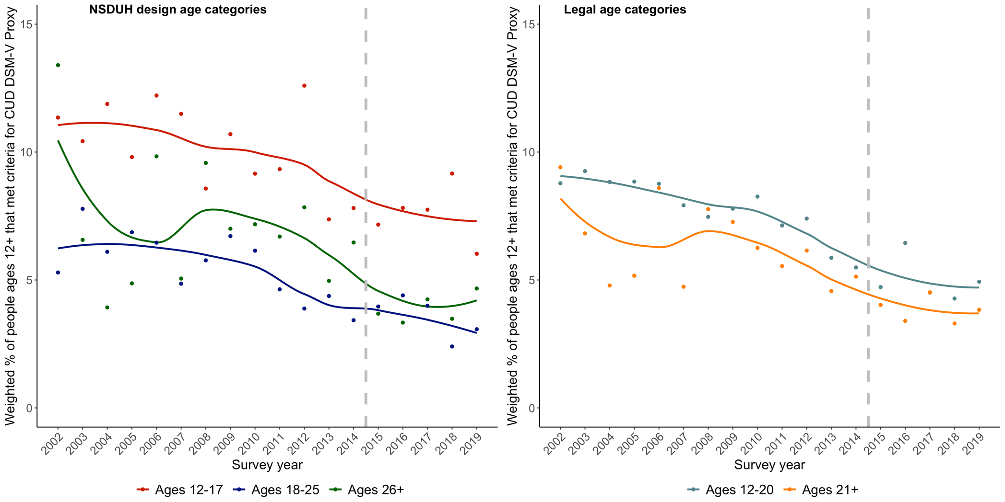

Notes: CUD= Cannabis Use Disorder. Vertical line at 2015 represents NSDUH survey redesign.
Figure S3: CUD specialty treatment use in the past year among those with past-year DSM-5-proxy CUD, NSDUH 2002-2019 (N= 43,307)

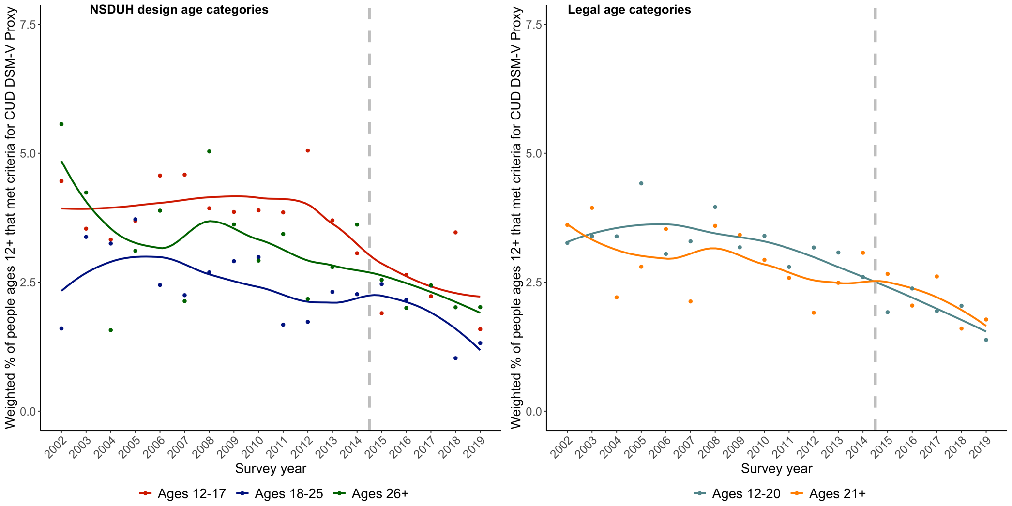

Notes: CUD= Cannabis Use Disorder. Vertical line at 2015 represents NSDUH survey redesign.
Figure S4: Perceived CUD treatment need in the past year among those with past-year DSM-5-proxy CUD, NSDUH 2002-2019 (N= 43,307)

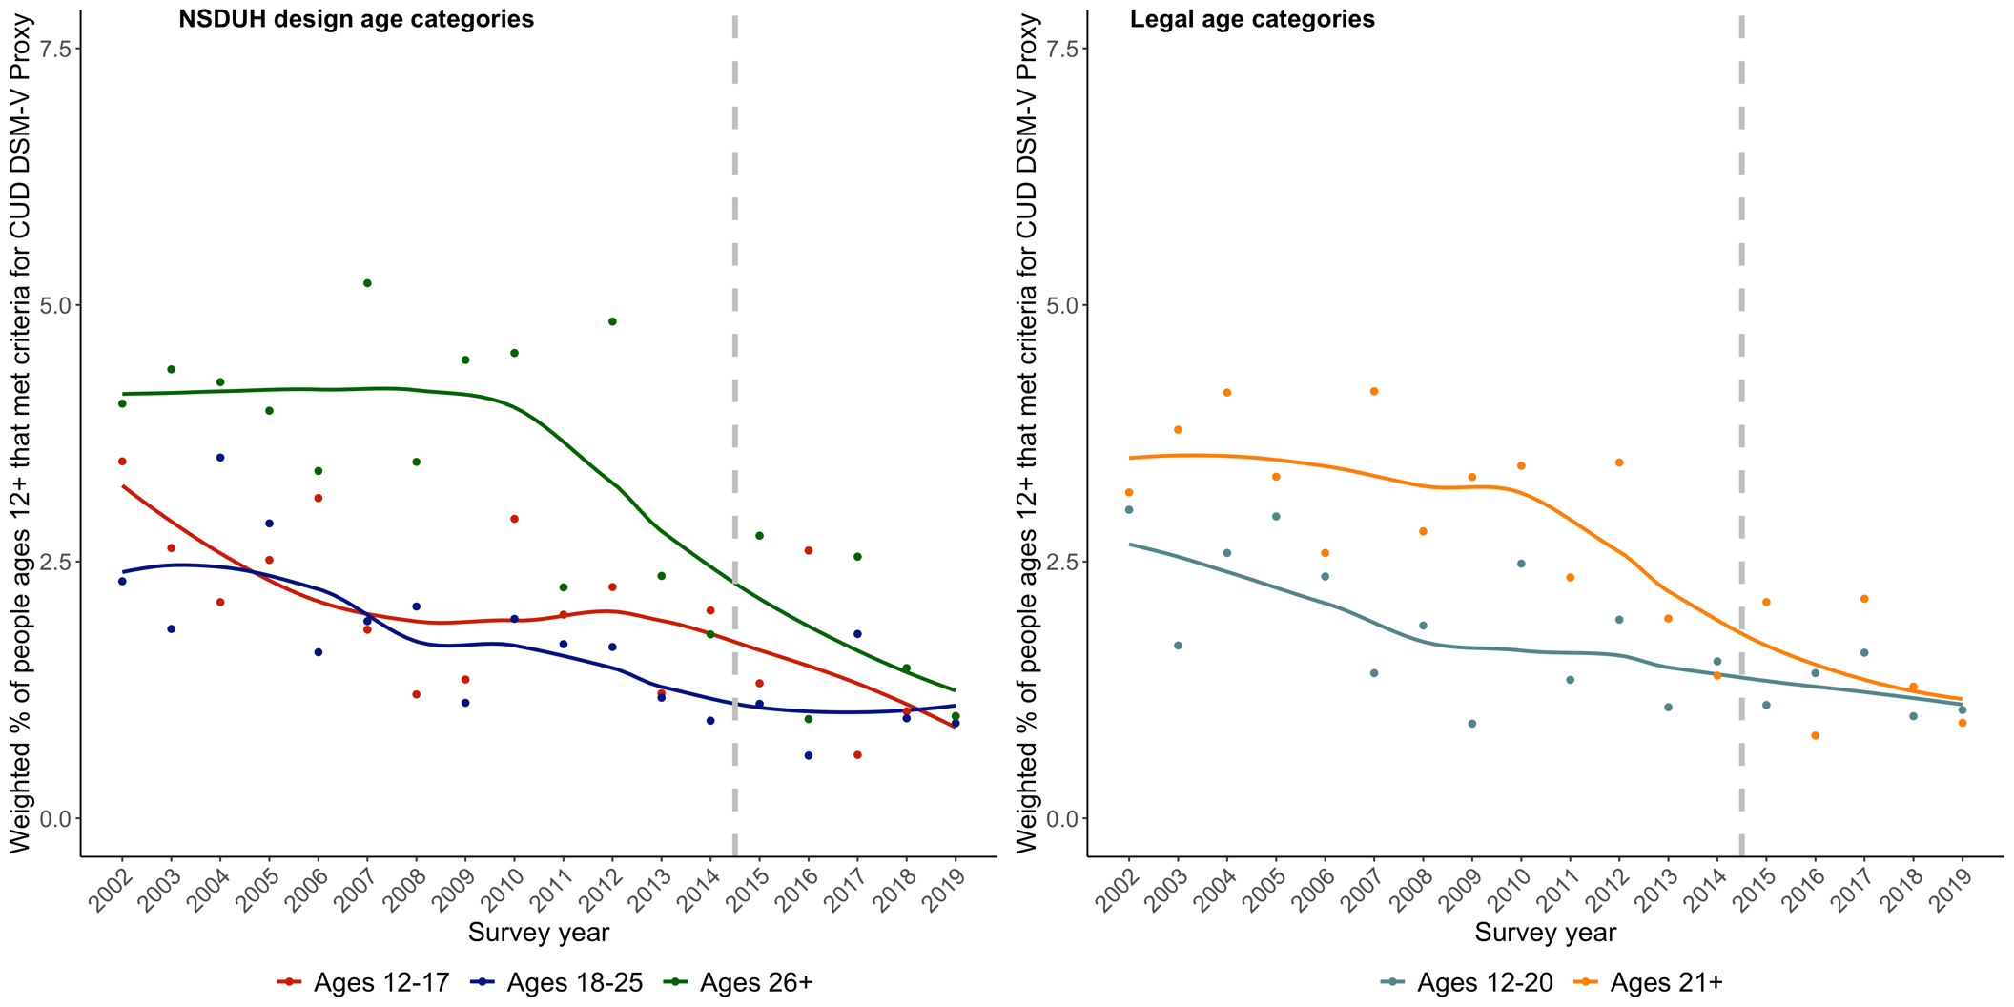

Notes: CUD= Cannabis Use Disorder. Vertical line at 2015 represents NSDUH survey redesign.

Figure S5: Trends in CUD treatment use by severity of past-year DSM-5-proxy CUD and age group, NSDUH 2002-2019 (N= 43,307)

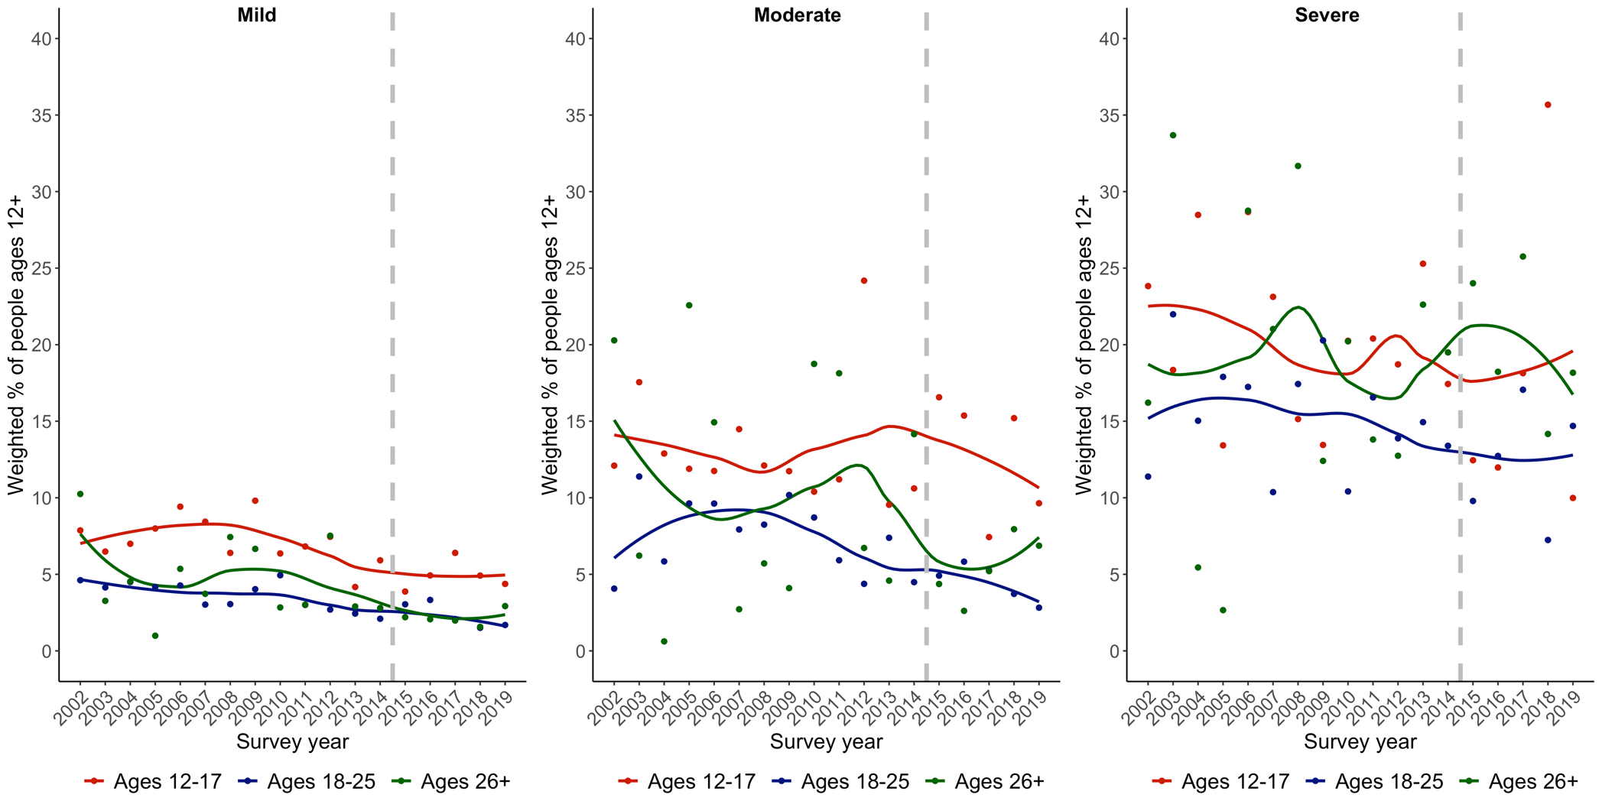

Notes: CUD= Cannabis Use Disorder. Vertical line at 2015 represents NSDUH survey redesign. Mild DSM-5-proxy CUD was characterized as 2-3 symptoms (n=30,433), moderate as 4-5 symptoms (n=8,769), and severe as 6 or more symptoms (n=4,105).

Figure S6: Trends in CUD specialty treatment use by severity of past-year DSM-5-proxy CUD and age group, NSDUH 2002-2019 (N= 43,307)

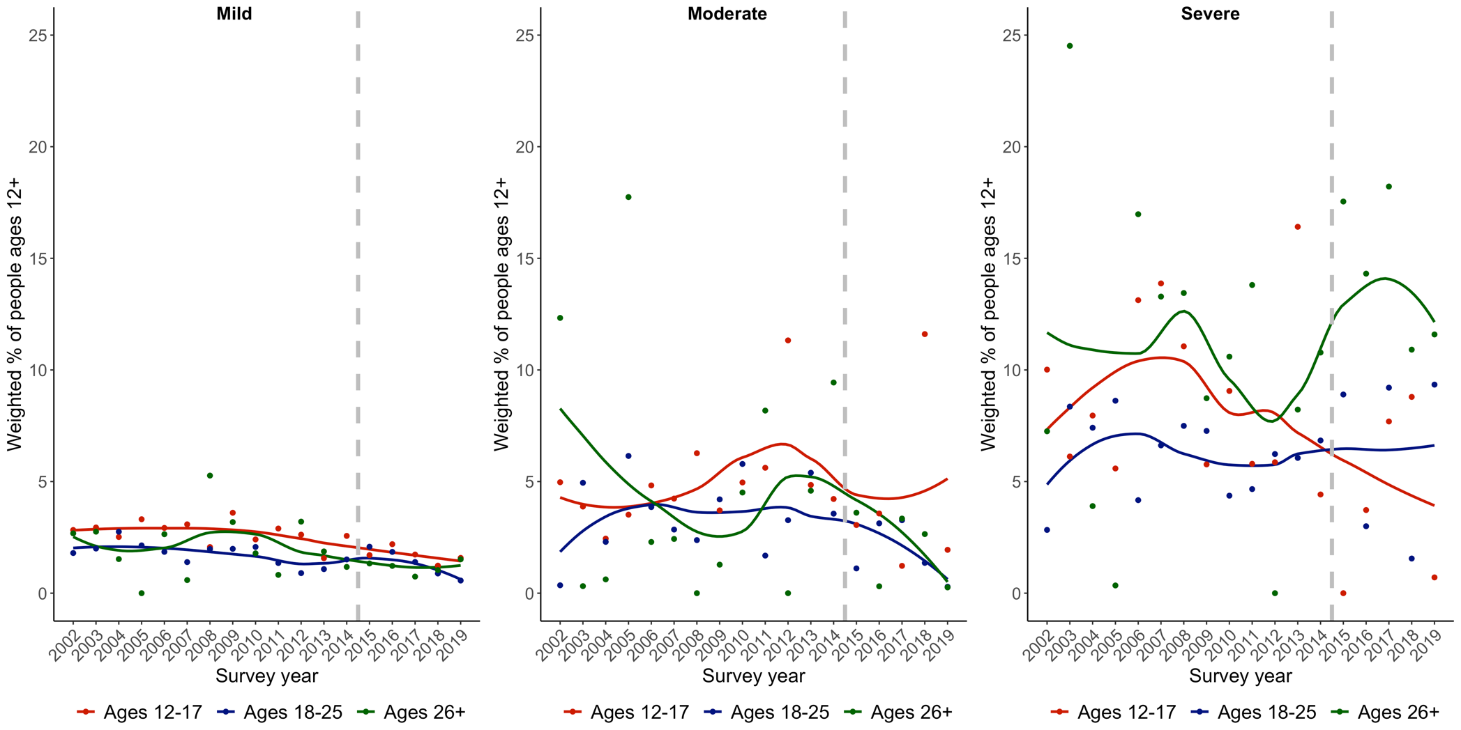

Notes: CUD= Cannabis Use Disorder. Vertical line at 2015 represents NSDUH survey redesign. Mild DSM-5-proxy CUD was characterized as 2-3 symptoms (n=30,433), moderate as 4-5 symptoms (n=8,769), and severe as 6 or more symptoms (n=4,105).

Figure S7: Trends in perceived CUD treatment need by severity of past-year DSM-5-proxy CUD and age group, NSDUH 2002-2019 (N= 43,307)

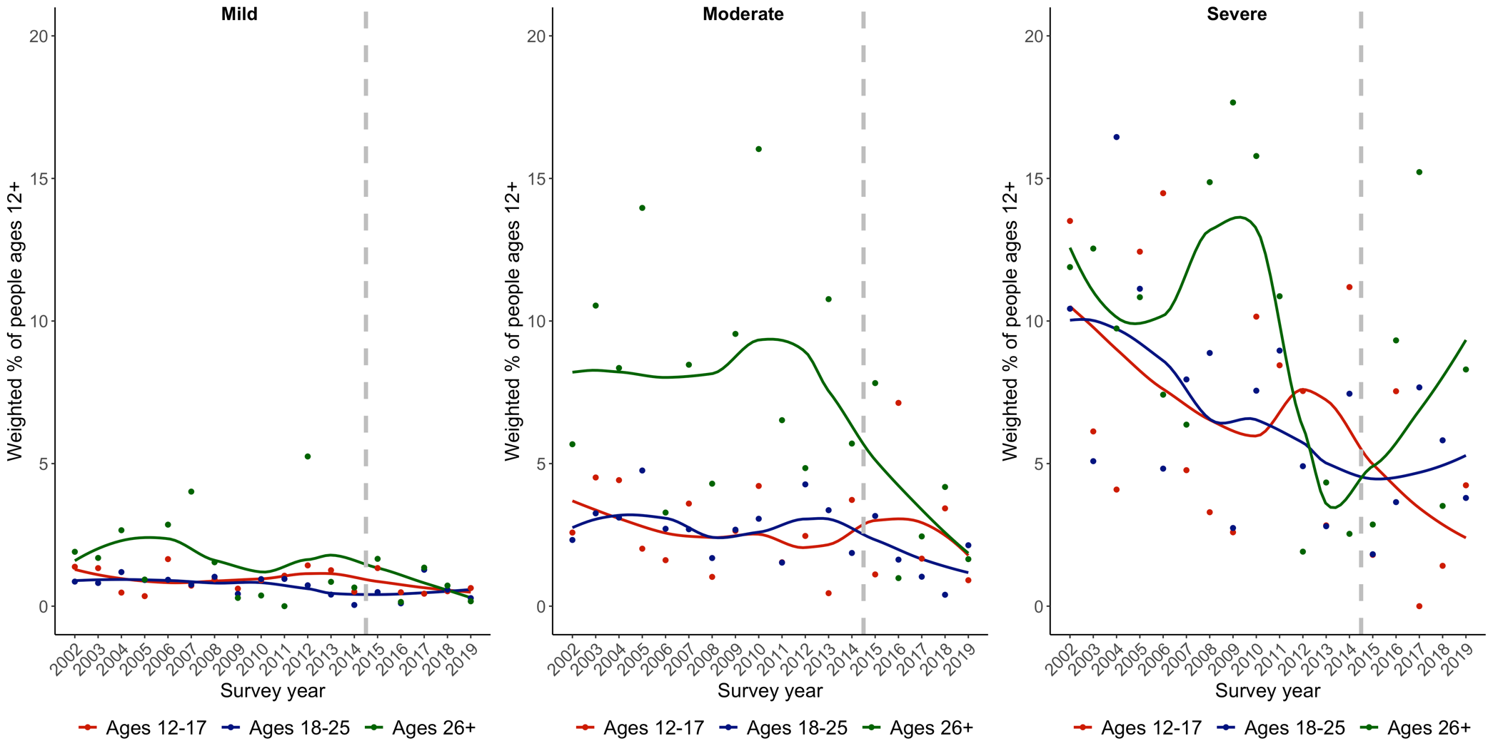

Notes: CUD= Cannabis Use Disorder. Vertical line at 2015 represents NSDUH survey redesign. Mild DSM-5-proxy CUD was characterized as 2-3 symptoms (n=30,433), moderate as 4-5 symptoms (n=8,769), and severe as 6 or more symptoms (n=4,105).

