Supplementary Material
Firefighter Hood Contamination: Efficiency of Laundering to Remove PAHs and FRs

Keywords: Firefighters, hoods, laundering, PAHs, PBDEs, flame retardants

Table SI: Contamination levels of individual PAHs (ng/g) in routinely laundered hoods vs. unlaundered hoods after 4 residential fire responses^{A}

 | Unlaundered hoods (n=5) |  |  |  | Routinely laundered hoods (n=5)
Compound^{B}  (IARC^{C}) | No. above LOD^{D} | Mean | Standard deviation |  | No. above LOD | Mean | Standard deviation | Mean difference (%)
Benzo(a)anthracene (2B) | 5 | 362 | 283 |  | 0 | 45.2 | 0.0 | -87.5
Benzo(a)pyrene (1) | 5 | 488 | 361 |  | 0 | 45.2 | 0.0 | -90.7
Benzo(b)fluoranthene (2B) | 5 | 626 | 450 |  | 0 | 45.2 | 0.0 | -92.8
Benzo(g,h,i)perylene (3) | 5 | 484 | 353 |  | 0 | 70.7 | 0.0 | -85.4
Benzo(k)fluoranthene (2B) | 5 | 219 | 147 |  | 0 | 6.40 | 0.0 | -97.1
Chrysene (2B) | 5 | 466 | 471 |  | 0 | 45.2 | 0.0 | -90.3
Dibenzo(a,h)anthracene (2A) | 5 | 2,360 | 1,430 |  | 1 | 105 | 75.7 | -95.6
Fluoranthene (3) | 5 | 1,132 | 746 |  | 5 | 216 | 47.7 | -80.9
Indeno(1,2,3-cd)pyrene (2B) | 5 | 482 | 318 |  | 0 | 70.7 | 0.0 | -85.3
Phenanthrene (3) | 5 | 196 | 102 |  | 5 | 446 | 115 | 128
Pyrene (3) | 5 | 286 | 305 |  | 2 | 77.8 | 13.4 | -72.8
Total PAHs^{E} | 73% | 7,280 | 4,920 |  | 20% | 1,370 | 109 | -81.2
- In calculating summary statistics, non-detectable levels were assigned values by taking the limit of detection divided by the square root of 2.
- Anthracene (IARC=3, 78.0 ng/g) and fluorene (IARC=3, 80.0 ng/g) were detected in one routinely laundered hood and no unlaundered hoods. Acenaphthene (IARC=3) and naphthalene (IARC=2B) were not detected in any hoods.
- IARC classification categories: 1= Carcinogenic to humans, 2A=Probably carcinogenic to humans, 2B=Possibly carcinogenic to humans, 3=Not classifiable as to its carcinogenicity to humans⁽²⁶⁾
- Limit of detection (LOD) for PAHs ranged from 9 – 100 ng/g.
- Total PAH summary statistics include PAHs not shown in table (anthracene, fluorene, acenaphthene, and naphthalene).

Table SII: Contamination levels of individual PBDEs (ng/g) in routinely laundered hoods vs. unlaundered hoods after 4 residential fire responses ^{A}
 | Unlaundered hoods (n=5) |  |  |  | Routinely laundered hoods (n=5)
Compound^{B} | No. above LOD^{C} | Mean | Standard deviation |  | No. above LOD | Mean | Standard deviation | Mean difference (%)
BDE-47 | 5 | 11.9 | 5.08 |  | 5 | 22.2 | 15.2 | 87.1
BDE-99 | 5 | 22.9 | 4.86 |  | 5 | 34.4 | 14.1 | 50.3
BDE-153 | 4 | 7.44 | 5.82 |  | 5 | 5.48 | 3.59 | -26.4
BDE-206 | 5 | 25.5 | 15.9 |  | 5 | 32.8 | 12.5 | 28.6
BDE-209 | 5 | 944 | 964 |  | 5 | 1,350 | 520 | 43.1
Total PBDEs^{D} | 53% | 1,020 | 967 |  | 58% | 1,450 | 520 | 42.9
- In calculating summary statistics, non-detectable levels were assigned values by taking the limit of detection divided by the square root of 2.
- BDE-100 (14 ng/g) detected in only one laundered hood and no unlaundered hoods. BDE-85, BDE-154, and BDE-183 were not detected in any hoods.
- Limit of detection (LOD) for all PBDEs was 2 ng/g.
- Total PBDE summary statistics include PBDEs not shown in table (BDE-85, BDE-100, BDE-154, and BDE-183).

Table SIII: Contamination levels of individual NPBFRs (ng/g) in routinely laundered hoods vs. unlaundered hoods after 4 residential fire responses^{A}
 | Unlaundered hoods (n=5) |  |  |  | Routinely Laundered hoods (n=5)
Compound^{B} | No. above LOD^{C} | Mean | Standard deviation |  | No. above LOD | Mean | Standard deviation | Mean difference (%)
TBB | 5 | 30.6 | 27.1 |  | 3 | 5.89 | 9.25 | -80.8
TBPH | 4 | 12.2 | 10.2 |  | 1 | 2.66 | 2.98 | -78.2
DBDPE | 4 | 97.8 | 61.4 |  | 3 | 38.9 | 67.3 | -60.3
TBBPA | 4 | 16.6 | 20.6 |  | 1 | 3.01 | 3.37 | -81.8
Total NPBFRs^{D} | 43% | 163 | 112 |  | 20% | 55.7 | 82.8 | -65.7
- In calculating summary statistics, non-detectable levels were assigned values by taking the limit of detection divided by the square root of 2.
- Not detected in any hoods: BTBPE and HBCD.
- Limit of detection for all NPBFRs was 2 ng/g.
- Total NPBFR summary statistics include NPBFRs not shown in table (BTBPE and HBCD).

Table SIV: Contamination levels of individual OPFRs (ng/g) in routinely laundered hoods vs. unlaundered hoods after 4 residential fire responses^{A}
 | Unlaundered hoods (n=5) |  |  |  | Routinely Laundered hoods (n=5)
Compound^{B} | No. above LOD^{C} | Mean | Standard deviation |  | No. above LOD | Mean | Standard deviation | Mean Difference (%)
TCPP | 1 | 2.04 | 1.27 |  | 1 | 3.39 | 4.22 | 66.3
TDCPP | 5 | 68.3 | 64.4 |  | 5 | 20.4 | 12.1 | -70.2
TCP | 5 | 93.3 | 61.7 |  | 5 | 36.7 | 42.0 | -60.6
TPP | 5 | 338 | 277 |  | 5 | 158 | 46.8 | -53.3
Total OPFRs^{D} | 64% | 504 | 372 |  | 64% | 220 | 103 | -56.3
- In calculating summary statistics, non-detectable levels were assigned values by taking the limit of detection divided by the square root of 2.
- Not detected in any hoods: TCEP.
- Limit of detection for all OPFRs was 2 ng/g.
- Total OPFR summary statistics include OPFRs not shown in table (TCEP).

Table SV. Concentrations of flame retardants (ug/g)* in bulk samples of the burn room furnishings
Compound measured | Carpet padding  (n = 3) | Curtain liner  (n = 1) | Inner spring mattress  foam  (n = 2) | Foam topper for bed (n = 2) | Head-board padding  (n = 1) | Chair cushion (n = 2) | Chair cushion liner  (n = 1) | Flat screen TV plastic (n = 1)
Polybrominated diphenyl ethers
BDE 47 | < 0.1 - 0.41 | 0.19 | < 0.1 | < 0.1 - 0.74 | 5,600 | < 0.1 - 4.1 | < 0.1 | < 0.1
BDE 85 | < 0.1 | < 0.1 | < 0.1 | < 0.1 | 840 | < 0.1 - 1.6 | < 0.1 | < 0.1
BDE 99 | 0.11 - 0.56 | 0.25 | < 0.1 - 0.44 | < 0.1 - 2.9 | 15,000 | < 0.1 - 25 | < 0.1 | < 0.1
BDE 100 | < 0.1 | < 0.1 | < 0.1 | < 0.1 - 0.6 | 2,500 | < 0.1 - 3.8 | < 0.1 | < 0.1
BDE 153 | < 0.1 - 5.6 | < 0.1 | < 0.1 | < 0.1 - 2.0 | 2,000 | < 0.1 - 13 | < 0.1 | < 0.1
BDE 154 | < 0.1 | < 0.1 | < 0.1 | < 0.1 - 0.69 | 1,400 | < 0.1 - 5.0 | < 0.1 | < 0.1
BDE 183 | < 0.1 - 1.1 | < 0.1 | < 0.1 | < 0.1 - 2.0 | 67 | < 0.1 | < 0.1 | < 0.1
BDE 206 | < 0.1 - 14 | 2.8 | < 0.1 - 6.3 | < 0.1 | < 0.1 | < 0.1 | < 0.1 | < 0.1
BDE 209 | 0.41 - 102 | 440 | < 0.1 - 61 | < 0.1 | < 0.1 | < 0.1 - 0.68 | < 0.1 | < 0.1
Other brominated flame retardants
TBBPA | < 0.1 | < 0.1 | < 0.1 | < 0.1 | < 0.1 | < 0.1 | < 0.1 | < 0.1
TBB | 0.38 - 3.2 | 910 | < 0.1 - 0.5 | < 0.1 - 7.5 | < 0.1 | 18,500 - 26,750 | 68.5 | < 0.1
TBPH | 0.22 - 5.7 | 340 | < 0.1 - 1.2 | < 0.1 - 3.7 | < 0.1 | 5,800 - 6,380 | 19.6 | < 0.1
DBDPE | < 0.1 - 0.53 | < 0.1 | < 0.1 | < 0.1 | < 0.1 | < 0.1 | < 0.1 | < 0.1
Phosphorylated flame retardants
TCEP | < 0.1 | 1.4 | < 0.1 | < 0.1 | < 0.1 | < 0.1 | < 0.1 | < 0.1
TCPP | 59 - 630 | 5.4 | < 0.1 | < 0.1 | 8.4 | < 0.1 - 1.3 | < 0.1 | < 0.1
TDCPP | 240 - 9,100 | 1.2 | < 0.1 | < 0.1 | < 0.1 | < 0.1 | < 0.1 | < 0.1
TPP | 0.43 - 3.8 | 4.0 | 0.16 - 0.23 | < 0.1 - 1.3 | 1,690 | 1,400 - 7,380 | 22.6 | 19
TCP | < 0.1 | < 0.1 | < 0.1 | < 0.1 | < 0.1 | < 0.1 | < 0.1 | < 0.1

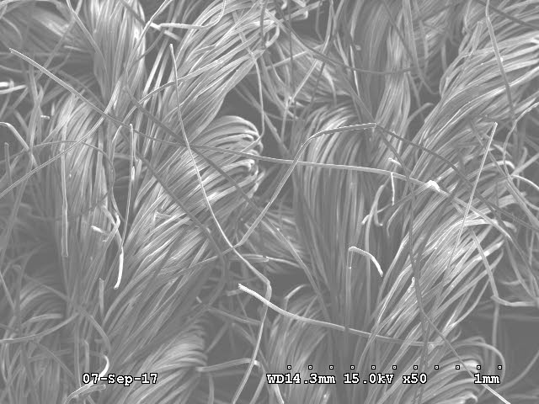

Figure S1: New Hood Microscopy

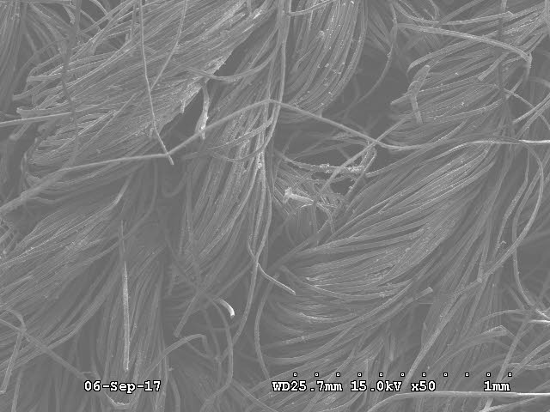

Figure S2: Unlaundered Exposed Hood Microscopy

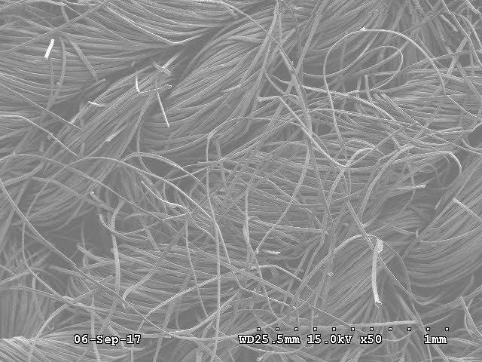

Figure S3: Exposed Laundered 4 Times Hood Microscopy

