Supplemental Figure 1: sample exercise programs
Reactive basic HEP
EXERCISE (s) **Repeat cycle 3 times** | TIME | FOOT POSITION | TOTAL TIME
- Postural sway (lean as far as you can without taking a step then back to center), working your way around a “clock” (lean towards 1o’clock, then center, 2o’clock, then center etc) | 1 min each direction (clockwise/counter clockwise) | Hip distance | 6 min | 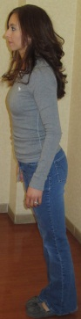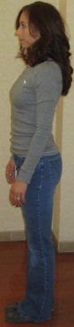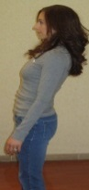
- Turn body side to side (look over right shoulder, then over left shoulder)  - Toss ball straight up in the air and catch it | 1 min each exercise | Feet together | 6 min | 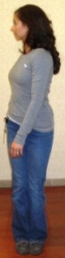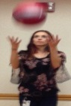
- Step forward and then backward, alternating legs over the line  - Step to the right, bring your feet together, step to the left, feet together, over the line | 1 min each exercise | Feet together/stepping | 6 min
- Reach forward as far as you can without taking a step, then come back to center | 1 minute | Feet together | 3 min | 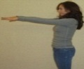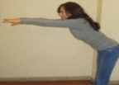

Reactive basic Virtual Reality program
DISC | GAME | LEVEL | #TIMES | EST. TIME
Adventure | 20,000 leaks (Free Play) | Basic | 2 | 6 min
Sports | Soccer (Main Event) | Any | 1 | 6 min
Sports | Table tennis (Main Event) | Any | 2 | 10 min

Reactive Intermediate HEP
EXERCISE (s) | TIME | FOOT POSITION | TOTAL TIME
- Turn body side to side (look over right shoulder, then over left shoulder) and throw/catch or bounce/catch the ball | 2 min | Feet together | 6 min | 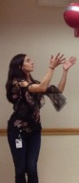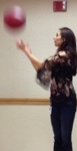
- Balloon toss (hit the balloon straight up to yourself, trying not to let it hit the ground) | 2 min | Feet tandem **weight evenly between feet | - min | 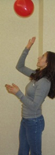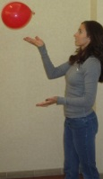
- Toss or bounce ball forward and step to catch it  - Toss or bounce ball backward as above  3. Toss or bounce ball to the right as above  4. Toss or bounce ball to the left as above | 1 min each exercise | Feet together/  stepping | 12 min | 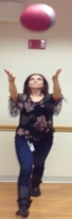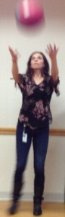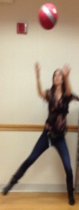

Reactive Intermediate Virtual Reality Program
DISC | GAME | LEVEL | #TIMES | EST. TIME
Adventure | 20,000 leaks (Free Play) | Intermediate | 2 | 6 min
Adventure | Rallyball (Free Play) | Intermediate | 1 | 4 min
Sports | Soccer (Main Event) | Any | 1 | 6 min
Sports | Beach volleyball (Main Event) | Any | 1 | 6 min

Reactive Advanced HEP
EXERCISE (s) | TIME | FOOT POSITION | TOTAL TIME
- Postural sway (lean as far as you can without taking a step then back to center), working your way around a “clock” (lean towards 1o’clock, then center, 2o’clock, then center etc) | 1 mineach direction (clockwise/counter clockwise | Feet together, lean toward | 6 min | 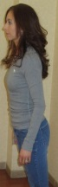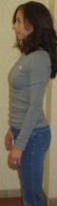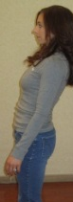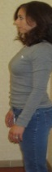
- Balloon toss (hit the balloon straight up to yourself, trying not to let it hit the ground) | 1 min each leg | Single leg | 6 min | 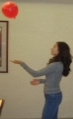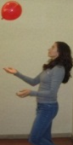
- Toss or bounce ball forward and step to catch it  - Toss or bounce ball backward as above  3. Toss or bounce ball to the right as above  4. Toss or bounce ball to the left as above | 30 sec each leg in front for each exercise | Start in tandem/ step to a lunge/return to tandem | 12 min | 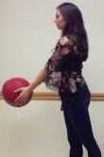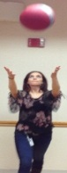

DISC | GAME | LEVEL | #TIMES | EST. TIME
Sports | Soccer (Main Event) | Any | 1 | 6 min
Sports | Beach volleyball (Main Event) | Any | 1 | 6 min
Adventure | River rush (Free Play) | Advanced | 3 | 6 min
Adventure | Rallyball (Free Play) | Advanced | 2 | 6 min

Reactive Advanced Virtual Reality Program

