Supporting Information
Portable XRF as a rapid determination tool to detect ppm levels of Ni, Zn, As, Se and Pb in human toenails: A South India case study
Mayuri Bhatia¹, Aaron Specht^{2,}*, Vallabhuni Ramya¹, Dahy Sulaiman¹, Manasa Konda ¹, Prentiss Balcom³, Elsie M. Sunderland ^{2,3}, Asif Qureshi ^{1,4}
¹Department of Civil Engineering, Indian Institute of Technology (IIT) Hyderabad, Kandi, TS 502285, India.
²Harvard T.H. Chan School of Public Health, Harvard University, Boston, MA 02115, USA.
³Harvard John A. Paulson School of Engineering and Applied Sciences, Harvard University, Cambridge, MA 02138, USA.
⁴ Department of Climate Change, Indian Institute of Technology (IIT) Hyderabad, Kandi, TS 502285, India.

Table S1. Demographic characteristic of the study population.
Demographic Characteristics |  | Number of participants (out of 97)
Age | <35 years | 23
 | 35-48 years | 37
 | >48 years | 37
Gender | Male | 35
 | Female | 62
Education | Educated | 55
 | Uneducated | 42
Rice consumption | <=300g/meal/day | 68
 | >300g/meal/day | 28
Water source | Canned water (purchased from shops) | 40
 | Pipe and other water sources | 57
Secondary exposure | Yes | 32
 | No | 65
Duration of stay at the site location | <20 years | 28
 | 20 to 35 years | 36
 | >35 years | 33
Profession | Pink collared jobs | 37
 | Blue collared jobs | 43
 | Other | 17
Income group  (INR per month,  1 USD ~ 74 INR) | < 18000 | 32
 | 18000 to 33000 | 34
 | > 33000 | 31
Fish consumption | <=150g/meal/week | 42
 | 275-450 g/meal/week | 30
 | >450 g/meal/week | 25

Figure S1. A sample spectrum from the XRF.

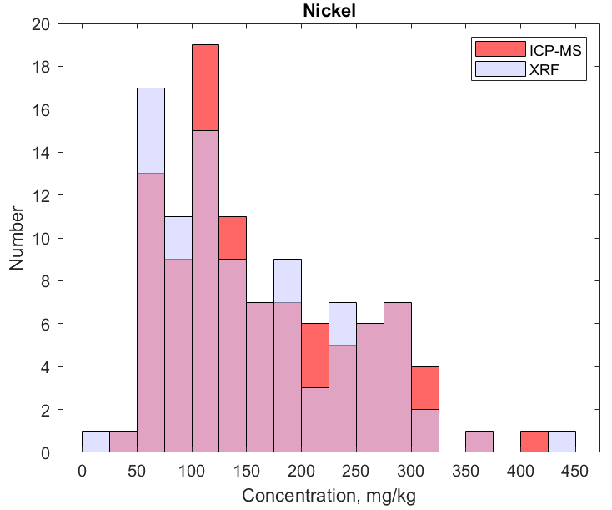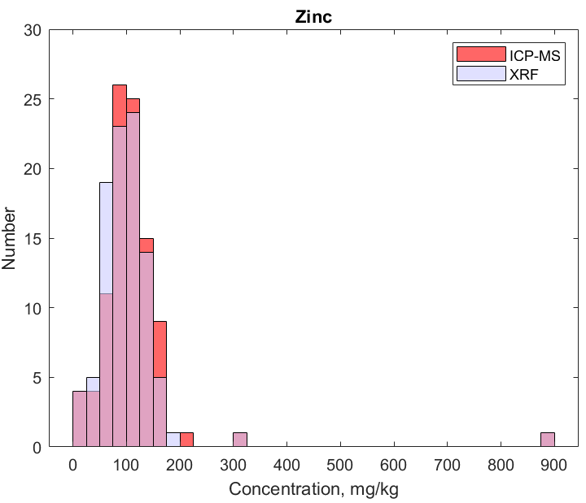
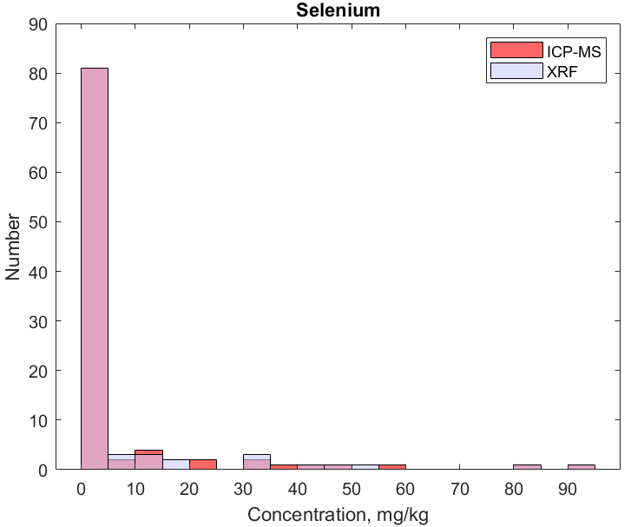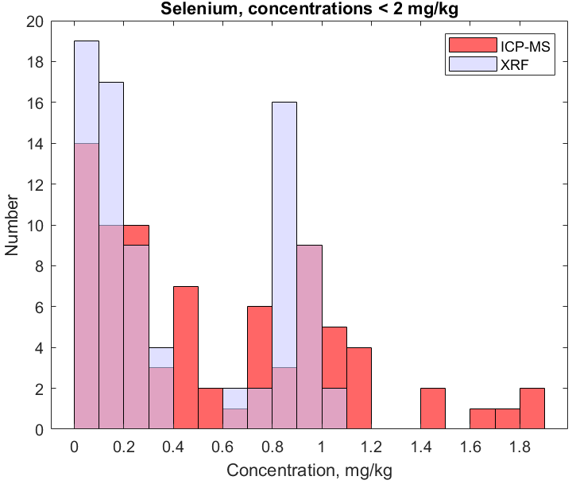
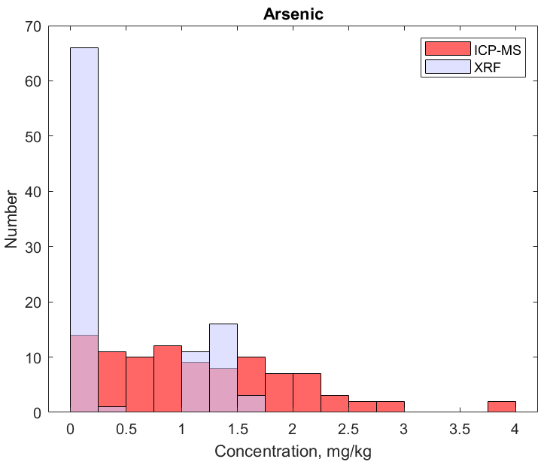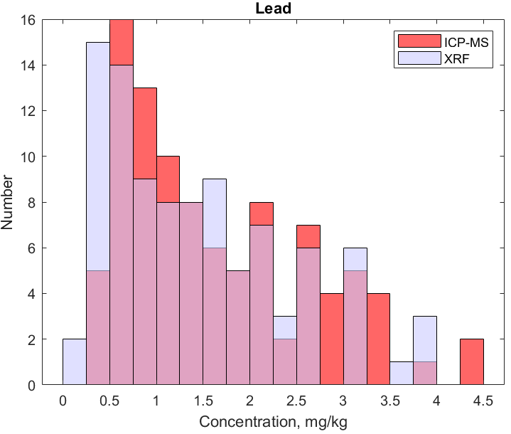
Figure S2. Distribution of measured concentrations by the two analysis methods.

S1. Concentrations of metal(loid)s in toenails for individual sites

Table S2. Mean, standard deviation (S.D.), maximum, minimum and median concentrations (mg/kg) corresponding to each metal measured in toenails. Site: Sepakkam.
Concentrations | Nickel |  | Zinc |  | Arsenic |  | Selenium |  | Lead
 | ICP-MS | XRF | ICP-MS | XRF | ICP-MS | XRF | ICP-MS | XRF | ICP-MS | XRF
Mean | 152 | 143 | 106 | 95.5 | 1.20 | 0.490 | 0.576 | 0.389 | 1.73 | 1.44
S.D. | 73.0 | 73.1 | 58.0 | 57.6 | 0.864 | 0.605 | 0.584 | 0.382 | 1.07 | 1.01
Median | 133 | 124 | 102 | 87.6 | 0.944 | 0.065 | 0.383 | 0.181 | 1.58 | 1.28
Maximum | 361 | 353 | 320 | 317 | 2.83 | 1.48 | 1.90 | 0.962 | 4.47 | 3.97
Minimum | 57.3 | 54.2 | 9.35 | 0 | 0.105 | 0.00 | 0.00 | 0.00 | 0.285 | 0.225

Table S3. Mean, standard deviation (S.D.), maximum, minimum and median concentrations (mg/kg) corresponding to each metal measured in toenails. Site: Athipattu Pudu Nagar.
Concentrations | Nickel |  | Zinc |  | Arsenic |  | Selenium |  | Lead
 | ICP-MS | XRF | ICP-MS | XRF | ICP-MS | XRF | ICP-MS | XRF | ICP-MS | XRF
Mean | 222 | 217 | 114 | 108 | 1.03 | 0.641 | 0.588 | 0.493 | 1.62 | 1.46
S.D. | 77.2 | 77.8 | 138 | 137 | 0.684 | 0.663 | 0.424 | 0.400 | 0.808 | 0.881
Median | 238 | 233 | 82.8 | 76.4 | 1.07 | 0.123 | 0.594 | 0.462 | 1.41 | 1.17
Maximum | 417 | 427 | 892 | 887 | 2.69 | 1.56 | 1.46 | 1.03 | 3.78 | 3.83
Minimum | 74.0 | 62.4 | 24.3 | 33.2 | 0.00 | 0.00 | 0.032 | 0.00 | 0.590 | 0.440

Table S4. Mean, standard deviation (S.D.), maximum, minimum and median concentrations (mg/kg) corresponding to each metal measured in toenails. Site: Avurivakkam.
Concentrations | Nickel |  | Zinc |  | Arsenic |  | Selenium |  | Lead
 | ICP-MS | XRF | ICP-MS | XRF | ICP-MS | XRF | ICP-MS | XRF | ICP-MS | XRF
Mean | 92.0 | 86.6 | 119 | 116 | 1.33 | 0.00 | 21.6 | 20.5 | 1.55 | 1.39
S.D. | 31.4 | 32.4 | 20.7 | 21.6 | 0.991 | 0.00 | 26.2 | 25.6 | 1.16 | 1.07
Median | 95.4 | 89.4 | 113 | 107 | 1.14 | 0.00 | 12.6 | 11.3 | 0.963 | 1.07
Maximum | 166 | 166 | 168 | 166 | 3.80 | 0.002 | 93.0 | 90.2 | 4.31 | 3.97
Minimum | 31.8 | 23.9 | 86.7 | 89.2 | 0.00 | 0.00 | 0.00 | 0.00 | 0.315 | 0.225

S2. Pearson’s regression results
Table S5. Statistical parameters from the comparison between XRF and ICP-MS results (Pearson’s correlation), where x is the ICP-MS measurement and y is the XRF measurement.
Metal | Model equation | Correlation | Adjusted R² | 95% CI (lower bound, upper bound) |  | Difference (%)
 |  |  |  | Beta | Intercept
Ni | y=1.00x-7.46 | 0.996 | 0.991 | 0.983, 1.02 | -11.0, -3.92 | 4.32
Zn | y=0.992x-6.34 | 0.993 | 0.986 | 0.967, 1.02 | -9.81, -2.86 | 6.48
As | y=0.354x+0.006 | 0.491 | 0.241 | 0.226, 0.483 | -0.180, 0.191 | 65.0
Se | y=0.970x-0.198 | 0.999 | 0.998 | 0.960, 0.980 | -0.366, -0.030 | 6.32
Pb | y=0.945x-0.112 | 0.974 | 0.949 | 0.900, 0.990 | -0.198, -0.027 | 12.4

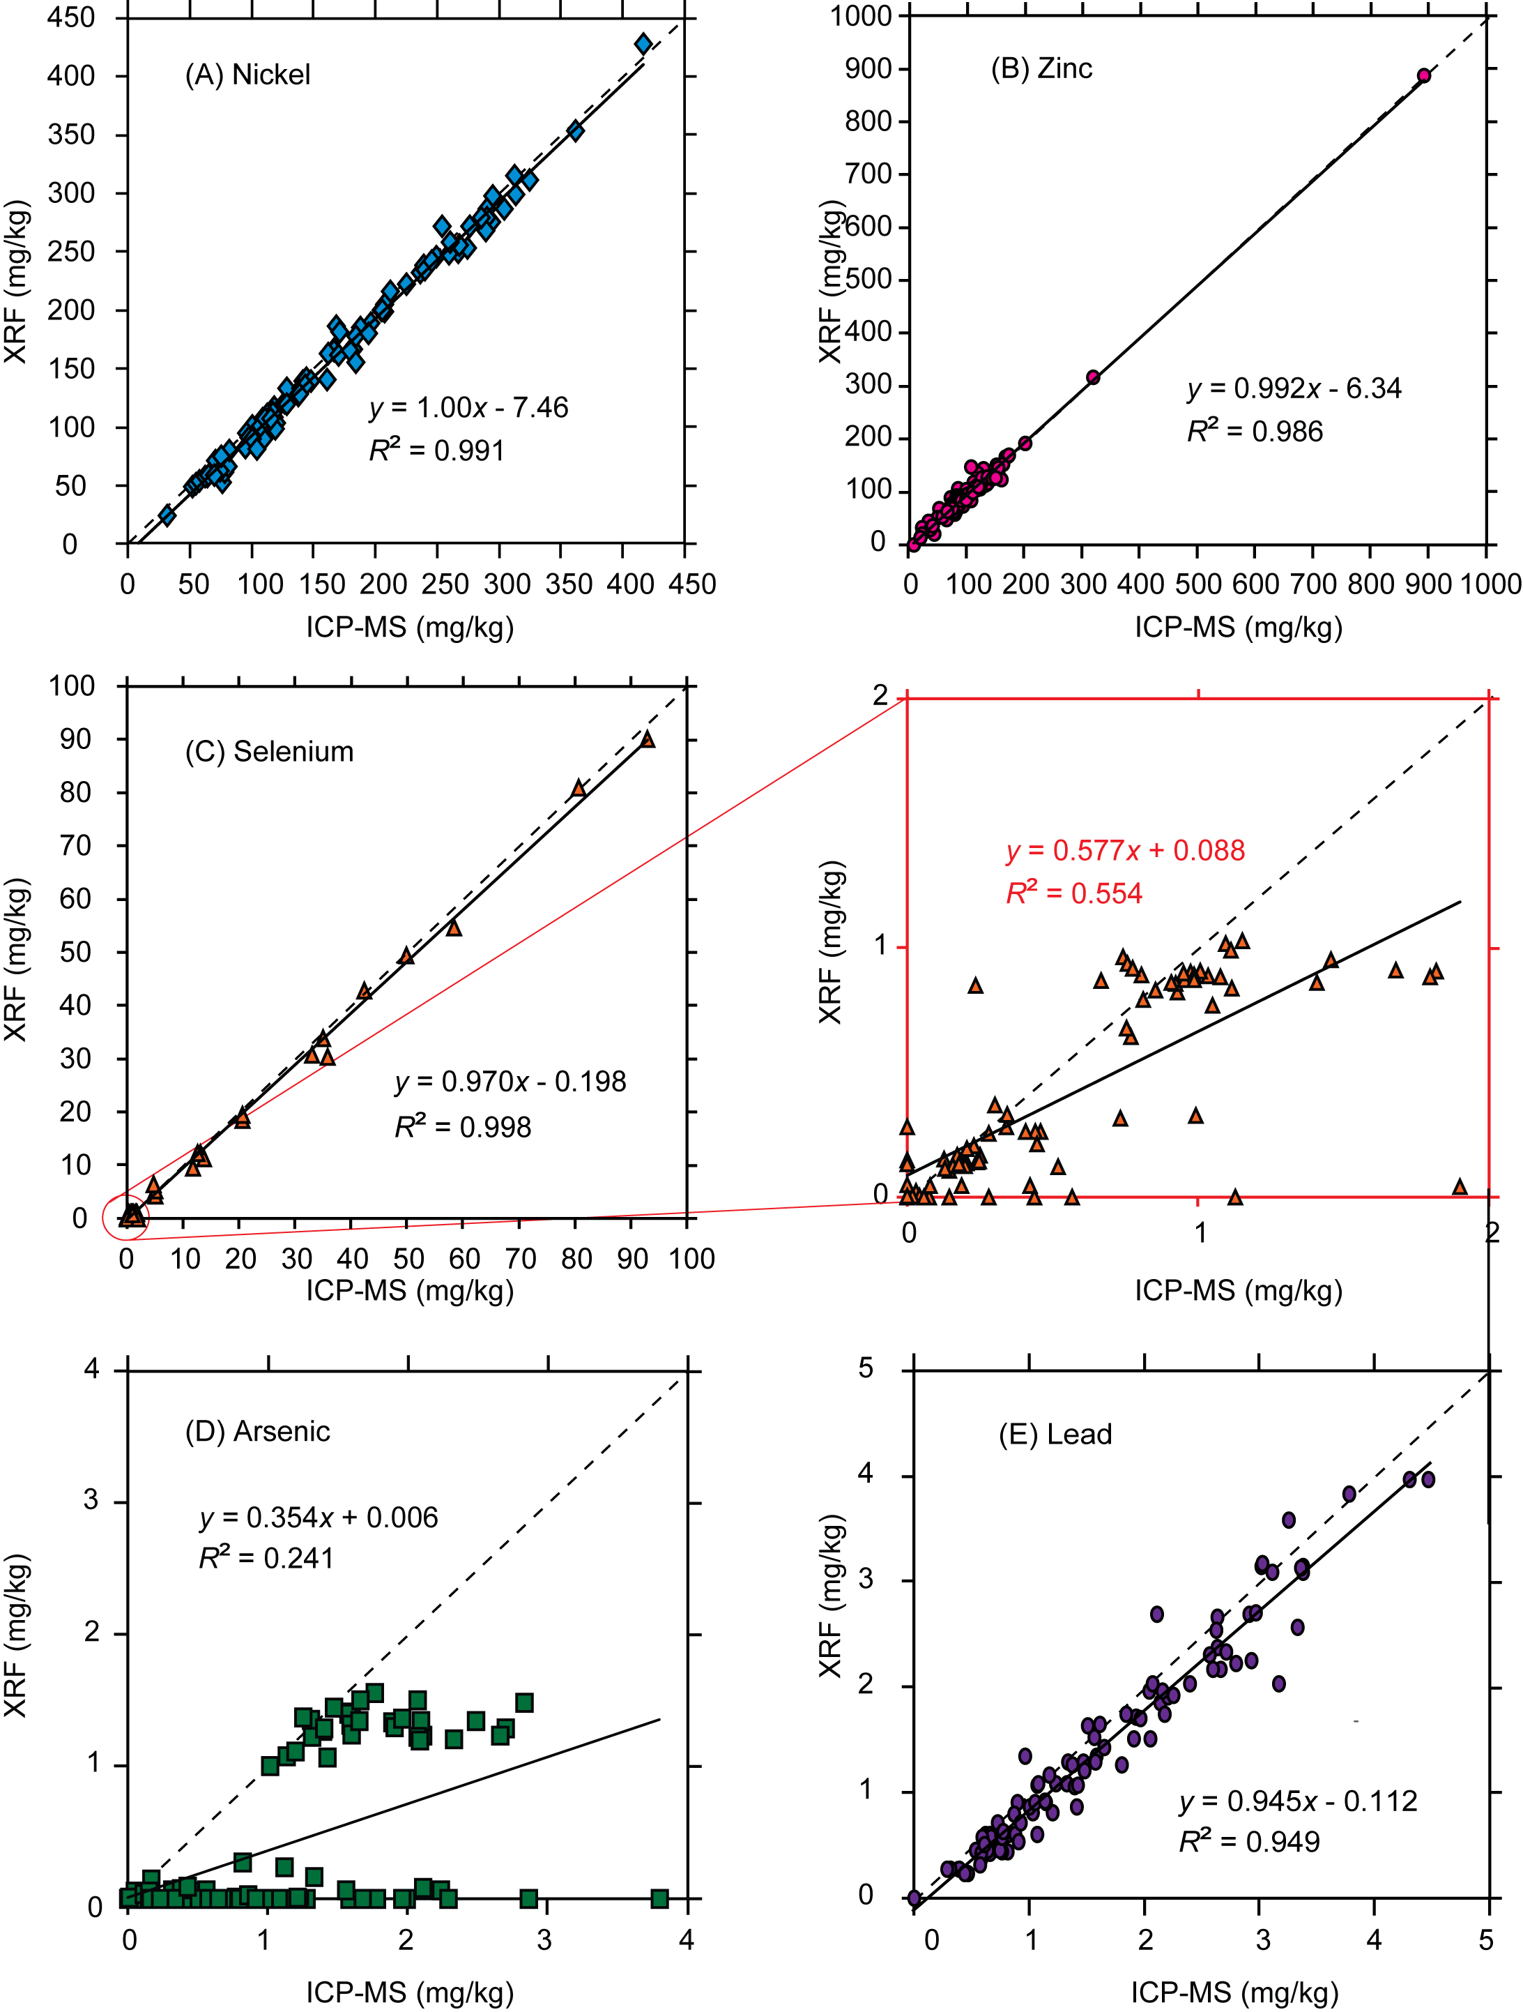
Figure S3. Linear regression between measurements of metal concentrations in toenails using XRF and ICP-MS.
S3. Normality/Lognormality tests, histograms and QQ plots of measurement values (normal and lognormal scales) obtained by ICPMS and XRF

Table S6. Test for normality / log-normality (Kolmogorov-Smirnoff test)
 | ICP values | Log-ICP values | XRF values | Log-XRF values
Nickel | Yes | Yes | Yes | Yes
Zinc * | No | No | No | Yes
Arsenic | No | Yes | No | No
Selenium | No | No | No | No
Lead | Yes | Yes | Yes | Yes

* Distributions became normally or lognormally distributed once the highest measured value of ~880 mg/kg (compared to a median of ~105 mg/kg was removed)

QQ-Plots

- Nickel
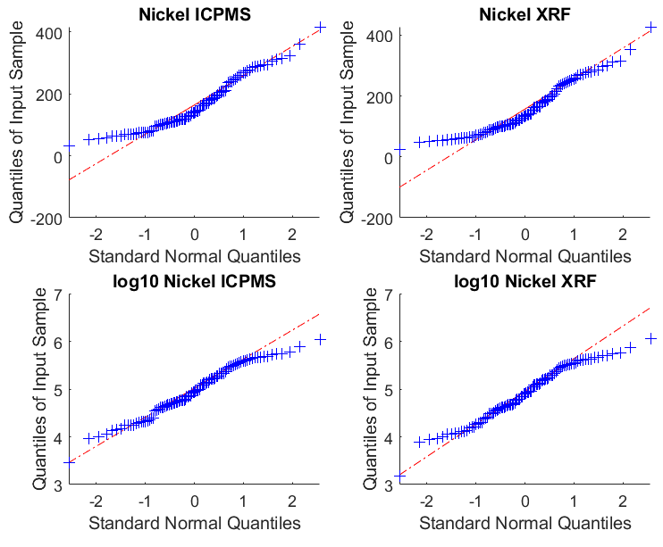

- Zinc

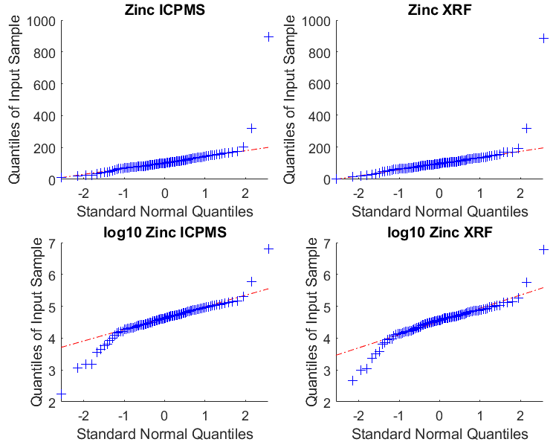

- Selenium
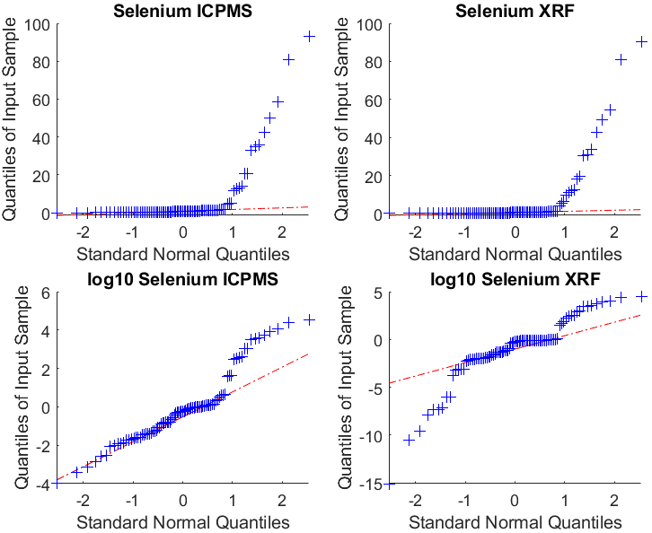
- Arsenic
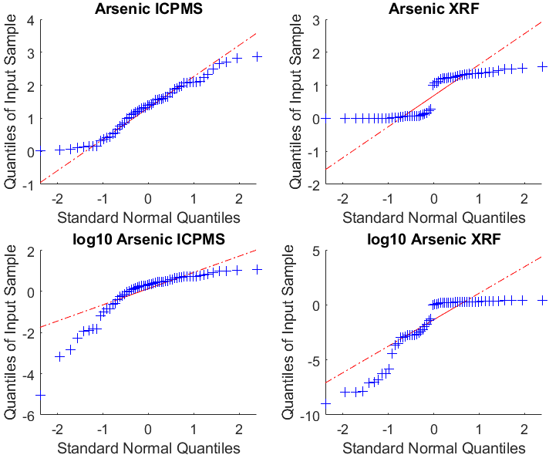

- Lead

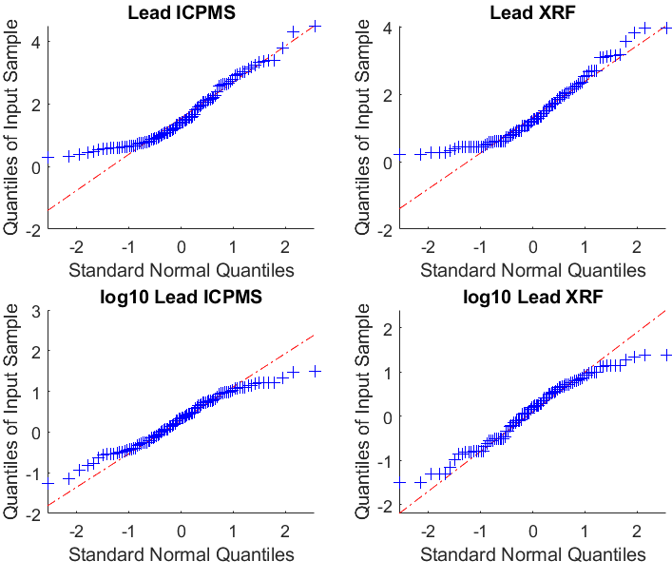
Figure S4. QQ-plots for distribution of toenail metal(loid) concentrations

S4. Results of Passing Bablok regression analysis for individual sites

Table S7. Statistical parameters from the Passing Bablok analysis of XRF and ICP-MS measurements. Results are the parameters of the equation y = a + bx, where x is the ICP-MS measurement and y is the XRF measurement expressed as median and 95% confidence interval (CI). Site: Sepakkam.

Element | a  median (95% CI) | b  median (95% CI)
Ni | -7.07 (-11.66, -3.49) | 0.999 (0.975, 1.03)
Zn | -6.33 (-9.76, -1.93) | 0.979 (0.922, 1.02)
Se | 0.011 (-0.006, 0.049) | 0.628 (0.484, 0.881)
As | -0.135 (-0.244, -0.007) | 0.568 (0.220, 0.694)
Pb | -0.070 (-0.199, 0.008) | 0.972 (0.863, 1.09)

Table S8. Statistical parameters from the Passing Bablok analysis of XRF and ICP-MS measurements. Results are the parameters of the equation y = a + bx, where x is the ICP-MS measurement and y is the XRF measurement expressed as median and 95% confidence interval (CI). Site. Atipattu Pudu Nagar.

Element | a  median (95% CI) | b  median (95% CI)
Ni | -4.76 (-17.26, 5.90) | 0.99 (0.948, 1.05)
Zn | -2.28 (-10.60, 9.07) | 0.952 (0.830, 1.03)
Se | -0.038 (-0.066, -0.014) | 0.937 (0.890, 0.981)
As | -0.062 (-0.256, 0.019) | 0.887 (0.620, 1.04)
Pb | -0.244 (-0.438, -0.131) | 1.07 (0.973, 1.18)

Table S9. Statistical parameters from the Passing Bablok analysis of XRF and ICP-MS measurements. Results are the parameters of the equation y = a + bx, where x is the ICP-MS measurement and y is the XRF measurement expressed as median and 95% confidence interval (CI). Site. Avurivakkam.

Element | a  median (95% CI) | b  median (95% CI)
Ni | -6.98 (-11.71, -1.26) | 1.02 (0.958, 1.09)
Zn | -5.99 (-38.34, 14.50) | 1.00 (0.819, 1.28)
Se | -0.180 (-0.565, -0.050) | 0.964 (0.931, 0.999)
As | 0.00 (0.00, 0.000) | 0.00 (0.00, 0.00)
Pb | -0.164 (-0.223, -0.123) | 0.947 (0.910, 0.984)

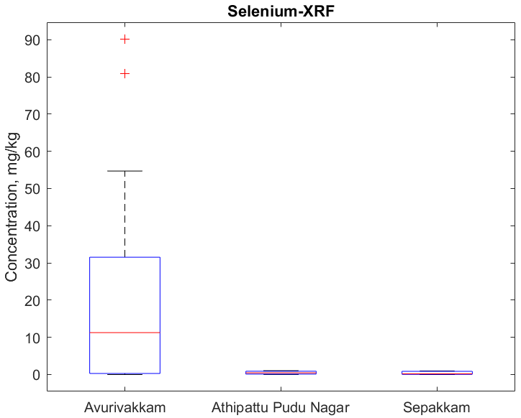

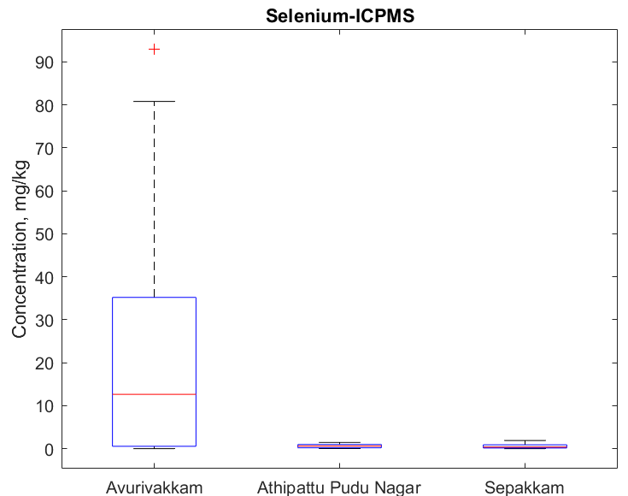

Figure S5. Boxplot for XRF and ICP-MS determined selenium concentrations at each individual site.

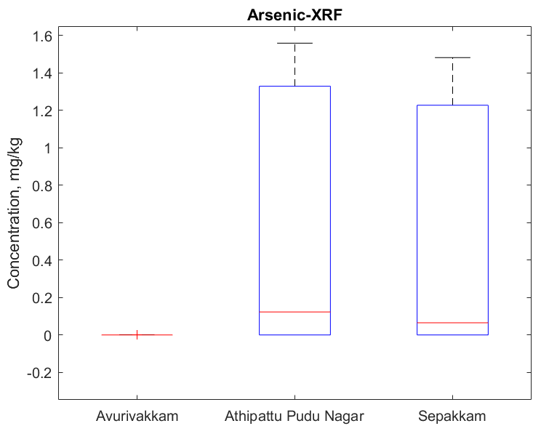
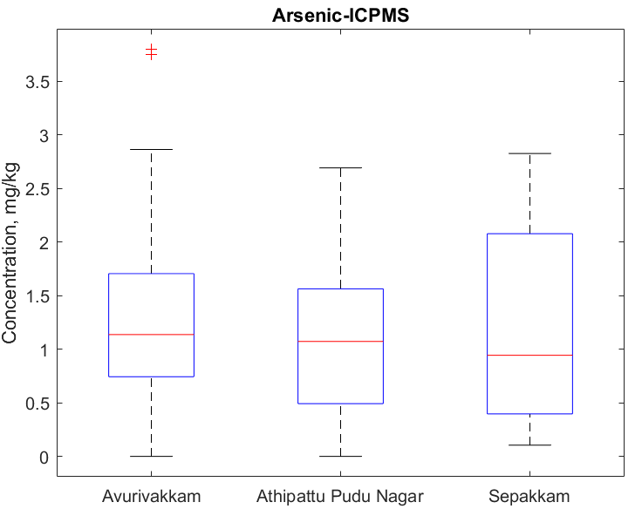
Figure S6. Boxplot for XRF and ICP-MS determined arsenic concentrations at each individual site.

