Supporting Figure S2: Cancer-specific Survival Kaplan-Meier Curves for Selected Cancer Sites
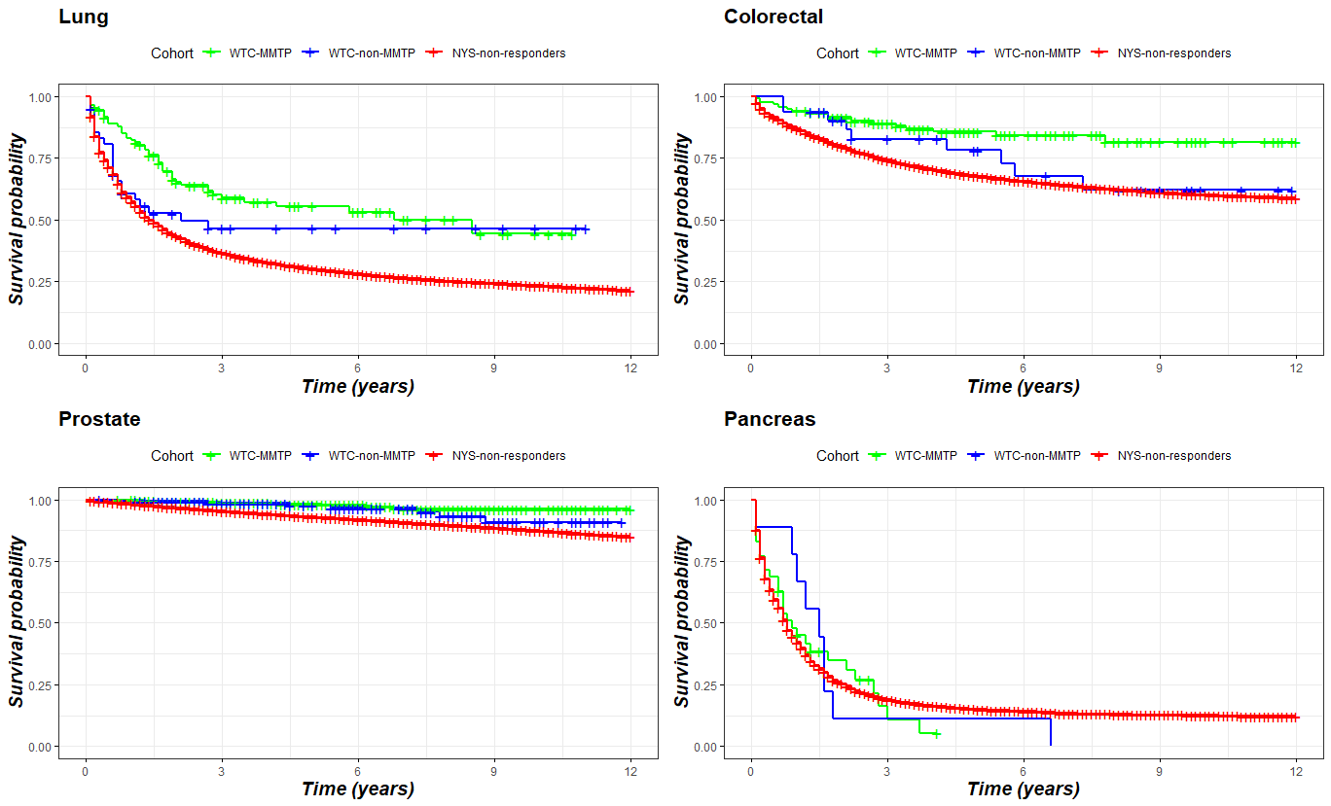

Legend:
Abbreviations: WTC MMTP: Cancer patients enrolled in the World Trade Center Medical Monitoring and Treatment Program
WTC-non-MMTP: WTC exposed cancer patients who were NOT enrolled in the WTC-MMTP
NYS-non-responders: All other cancer patients who were residents of the 11-southernmost counties of New York State and were not included in one of the WTC-responder cohorts

Top left: lung; n=110 WTC-MMTP; n=42 WTC-non-MMTP; n=58,386 NYS
Top right: colorectal; n=136 WTC-MMTP; n=32 WTC-non-MMTP; n=53,767 NYS
Bottom left: prostate; n=659 WTC-MMTP; n=162 WTC-non-MMTP; n=93,135 NYS
Bottom right: pancreatic; n=35 WTC-MMTP; n=9 WTC-non-MMTP; n=15.256 NYS

