eAppendix 1. Search strategies conducted in PubMed, Medline, Embase and Google Scholar
- (“social mix*” OR “social cont*” OR “contact pattern*”) AND (“covid” OR 'respiratory diseases' OR “respiratory infections” OR “pertussis” OR “rsv” OR “pneumococci”)
- (([survey*] OR [questionnaire*] OR [diary] OR [diaries]) AND ([social contact*] OR [mixing behavio*] OR [mixing pattern*] OR [contact pattern*] OR [contact network*] OR [contact survey*] OR [contact data]) AND ([COVID*] OR [SARS-COV*] OR [coronavirus])
- (([survey*] OR [questionnaire*] OR [diary] OR [diaries]) AND ([social contact*] OR [mixing behavio*] OR [mixing pattern*] OR [contact pattern*] OR [contact network*] OR [contact survey*]) AND ([COVID*] OR [SARS-COV*] OR [coronavirus])

eTable 1. Data sources for results¹
Study | Country or Region | Avg by age |  | Avg by setting |  | Age-specific contact matrices²
 |  | Pre | Lockdown | Pre | Lockdown | Pre | Lockdown
Backer et al | Netherlands | From paper | From paper | From paper | From paper | From supplement | From supplement
Bosetti et al | France | - | - | - | - | From authors (rescaled) | Calc. from COMES_F
Coletti et al | Belgium | From paper | From paper | Calc. from Willem et al | Calc. from data | Calc. from data | Calc. from Willem et al
Del fava et al | Belgium | Calc. from POLYMOD | From authors | POLYMOD | From authors | - | -
 | France | Calc. from POLYMOD | From authors | POLYMOD | From authors | - | -
 | Germany | Calc. from POLYMOD | From authors | POLYMOD | From authors | - | -
 | Italy | Calc. from POLYMOD | From authors | POLYMOD | From authors | - | -
 | Netherlands | Calc. from POLYMOD | From authors | POLYMOD | From authors | - | -
 | UK | Calc. from POLYMOD | From authors | POLYMOD | From authors | - | -
 | US | - | - | - | - | - | -
 | Spain | - | - | - | - | - | -
Feehan et al | US | From paper | From paper | - | - | From Rshiny | From Rshiny
Jarvis et al | UK | From paper | From paper | POLYMOD | Calc. from data | Calc. from data | Calc. from POLYMOD
Latsuzbaia et al | Luxembourg | From paper | From paper | From paper | From paper | - | -
Quaife et al | Kenya | - | - | - | - | From paper | From paper
Sypsa et al | Greece | From paper | From paper | - | - | - | -
Zhang et al | China-Shanghai | From paper | From paper | From paper | From paper | From supplement3 | From supplement
Zhang et al | China-Wuhan | From paper | From paper | - | - | From supplement | From supplement
Zhang et al | China-Changsha | From paper | From paper | From paper | From paper | From supplement | From supplement
Zhang et al | China-Shenzhen | From paper | From paper | From paper | From paper | From supplement | From supplement
McCreesh et al | South Africa | From paper | From paper | - | - | - | -
¹In some cases, no results were presented because we were missing either estimates from during the lockdown or comparable estimated from pre-pandemic
²We were only able to present setting-stratified age-specific contact matrices for studies from Backer et al, Coletti et al, Jarvis et al and Zhang et al (Shanghai) due to data availability.
³Setting-stratified age-specific contact matrices calculated from data repositories in Zenodo

eTable 2. Details for data abstraction and computing age-specific contact matrices specific for each study
Study | Lockdown matrices | Pre-lockdown matrices | Age groups (year) | Location-stratification
Backer et al | Matrix published by authors, used population size data for 2019 | Matrix published by authors, used population size data for 2017 | 0-4, 5-9, 10-19, 20-29, 30-39, 40-49, 50-59, 60-69,70-79, 80+ | No
Bosetti et al | Matrix from authors (global matrix), authors reweighted to account for gender and professional activity distributions. We recombined smaller age groups for participants into larger ones by weighing on the population distribution of France to allow comparison with pre-lockdown | We used the COMES-F survey conducted in France in 2012 without the additional “supplementary professional contacts” that were collected for participants who reported more than 20 daily professional contacts. | 21-30, 31-40, 41-50, 51-60, 61-70, 71-80, 80+ | No
Coletti et al | Matrix from data from first wave of data collection (week of April 2nd, 2020) using “socialmixr” package to construct contact matrices. | Matrix from data from POLYMOD using “socialmixr” package to construct contact matrices, excluded <18 years | 18-29, 30-39, 40-49, 50-59, 60-69, 70+ | Yes
Feehan et al | Matrix published by authors | Matrix published by authors | 25-34, 35-44, 45-64, 65-100 | No
Jarvis et al | Matrix from data from first wave of data collection (March 24-27, 2020) using “socialmixr” package to construct contact matrices. | Matrix from data from POLYMOD using “socialmixr” package to construct contact matrices, excluded <18 years | 18-29, 30-39, 40-49, 50-59, 60-69, 70+ | Yes
Quaife et al | Matrix from authors | Authors use Prem et al projections for Kenya projected onto age distribution of informal settlements in Nairobi | 0-18, 19-49, 50-80 | No
Zhang et al | Matrices published by authors | Matrices from publicly available data | 5-year age bands | Yes (Shanghai)
Zhang et al | Matrices published by authors | Matrices from publicly available data | 5-year age bands | No

eAppendix 2. Method details for age-specific contact matrices
We present the absolute change before and during lockdown in age-stratified contact matrices at each of the four locations of home, school, work and other (general community). Both pre-lockdown and lockdown matrices were weighted by the population structure of the target country or region. All matrices were made symmetric for reciprocity such that the frequency of contacts made between age group i with age group j was the same as between age group j and age group i. When line-listed social contact data were available, we constructed pre-lockdown and lockdown matrices using the ‘socialmixr’ package²², bootstrapping over 1000 iterations and sampling with replacement from the population distribution of the country or region.
Where $C_{{i,j}_{pre-COVID} }$ is the overall age-specific contact matrix pre-COVID and $C_{{i,j}_{lockdown} }$ is the age-specific contact matrix during lockdown. Location of contact is closely linked with age-specific mixing patterns especially during lockdowns, where measures such as school closure and work from home measures likely restricted contacts at specific locations. We thus further explored changes in age-specific contact matrices by contact location. The overall contact matrix, $C_{i,j}$ is partitioned into contact matrices at home ($C_{i,j}^{H})$, work ($C_{i,j}^{W})$, school ($C_{i,j}^{S})$ and other locations ${(C}_{i,j}^{O})$ by the following formula (Eq. 2):
$C_{i,j}= C_{i,j}^{H}+C_{i,j}^{W}+C_{i,j}^{S}+C_{i,j}^{O}$ (Eq. 2)

eTable 3. List of articles from full-text review that were excluded and details for exclusion
Article | Authors | Reason for exclusion | Details | Country
Physically distant but socially close? Changes in intergenerational non-physical contacts during the COVID-19 pandemic among older people in France, Italy and Spain | Arpino et al | Quantified all interpersonal contacts including virtual | Study focused on effect of interpersonal contact including non-physical virtual and phone contacts. | Italy, Spain, France
Using social contact data to predict and compare the impact of social distancing policies with implications for school re-opening | Brooks-Pollock et al | Did not quantify in-person contacts during COVID-19 pandemic | Study used pre-COVID-19 social contact data | UK
Impact assessment of non-pharmaceutical interventions against coronavirus disease 2019 and influenza in Hong Kong: an observational study | Cowling et al | Did not quantify in-person contacts during COVID-19 pandemic | Study included survey items that qualitatively assessed behavior change and changes in contact but did not explicitly quantify number of contacts per person per day | Hong Kong
Close encounters on the verge of a pandemic: the role of social contacts on the spread and mortality of COVID-19 | Cristini et al | Did not quantify in-person contacts during COVID-19 pandemic | Study used contact data from other surveys, including those that were pre-COVID-19 | Italy
Analyzing the demographic, spatial, and temporal factors influencing social contact patterns in US and implications for infectious disease spread | Dorelien et al | Did not quantify in-person contacts during COVID-19 pandemic | Study used pre-COVID-19 social contact data | US
Trend change of transmission route of COVID-19 related symptoms in Japan | Eguchi et al | Did not quantify in-person contacts during COVID-19 pandemic | Study does not explicitly quantify number of contacts per person per day during COVID-19 | Japan
Daily contacts under quarantine amid limited spread of COVID-19 | Fu et al | Quantified all interpersonal contacts including virtual | Study quantified all interpersonal contact including non-physical virtual and phone contacts | Taiwan
Estimating temporal variation in transmission of COVID-19 and adherence to social distancing measures in Australia | Golding et al | Did not quantify in-person contacts during COVID-19 pandemic | Study does not explicitly quantify number of contacts per person per day during COVID-19 | Australia
The effect of school closures and reopening strategies on COVID-19 infection dynamics in the San Francisco Bay Area: a cross-sectional survey and modeling analysis | Head et al | Study setting specific to school-children | Study setting specific to school-children | US
Social distancing and transmission-reducing practices during the 2019 coronavirus disease and 2015 Middle East Respiratory Syndrome coronavirus outbreaks in Korea | Jang et al | Did not quantify in-person contacts during COVID-19 pandemic | Study does not explicitly quantify number of contacts per person per day during COVID-19 | South Korea
Contacts in context: large-scale setting-specific social mixing matrices from the BBC Pandemic project | Klepac et al | Study not conducted during COVID-19 | Study not conducted during COVID-19 | UK
Halting SARS-CoV-2 by Targeting High-Contact Individuals | Manzo et al | Did not quantify in-person contacts during COVID-19 pandemic | Study used pre-COVID-19 social contact data | France
Prospective Diary Survey of Preschool Children's Social Contact Patters: A Pilot Study | Oh et al | Study not conducted during COVID-19 | Study not conducted during COVID-19 | South Korea
Assessing the impact of COVID-19 Pandemic in Spain: Large-Scale, Online, Self-Reported Population Survey | Oliver et al | Did not quantify in-person contacts during COVID-19 pandemic | Study does not explicitly quantify number of contacts per person per day during COVID-19 | Spain
Close encounters between infants and household members measured through wearable proximity sensors | Ozella et al | Study not conducted during COVID-19 | Study not conducted during COVID-19 | Italy
COVID-19 pandemic among Lainx Farmworkers and Nonfarmworker Families in North Carolina: Knowledge, Risk Perceptions, and Preventive Behaviors | Quandt et al | Did not quantify in-person contacts during COVID-19 pandemic | Study does not explicitly quantify number of contacts per person per day during COVID-19 | US
Relections from COVID-19 pandemic: Contact diary for assessing social contact patterns in Nepal | Shrestha et al | Did not quantify in-person contacts during COVID-19 pandemic | Study did not collect empirical data, was a brief | Nepal
A novel approach for evaluating contact patterns and risk mitigation strategies for COVID-19 in English Primary Schools with application of structured expert judgement | Sparks et al | Study setting specific to school-children | Study setting specific to school-children | UK
Adherence to physical contact restriction measures and the spread of COVID-19 in Brazil. | Szwarcwald et al | Did not quantify in-person contacts during COVID-19 pandemic | Study does not explicitly quantify number of contacts per person per day during COVID-19 | Brazil
A Contact Network-Based Approach for Online Planning of Containment Measures for COVID-19 | Thomaz et al | Did not quantify in-person contacts during COVID-19 pandemic | Study used pre-COVID-19 social contact data | Brazil
Augmenting contact matrices with time-use data for fine-grained intervention modelling of disease dynamics | van Leeuwen et al | Did not quantify in-person contacts during COVID-19 pandemic | Study used pre-COVID-19 social contact data | Multiple
SOCRATES: An online tool leveraging a social contact data sharing initiative to assess mitigation strategies for COVID-19 | Willem et al | Did not quantify in-person contacts during COVID-19 pandemic | Study used pre-COVID-19 social contact data | Multiple
Non-Compulsory Measures Sufficiently Reduced Human Mobility in Tokyo during the COVID-19 Epidemic | Yabe et al | Did not quantify in-person contacts during COVID-19 pandemic | Study used mobility data during COVID-19 | Japan
Social relationships and depression during the COVID-19 lockdown: longitudinal analysis of the COVID-19 social study | Sommerlad et al | Quantified all interpersonal contacts including virtual | Study does not explicitly quantify number of contacts per person per day during COVID-19, study on association between supportive social contact and depressive symptoms during COVID-19 | UK
Social mixing and risk exposure for SARS-CoV-2 infections in elderly persons | Haag et al | Did not quantify in-person contacts during COVID-19 pandemic | Study does not explicitly quantify number of contacts per person per day during COVID-19, study also conducted in specific population (individuals greater than 65 years) rather than general population | Switzerland
Behaviors and attitudes in response to the COVID-19 pandemic: Insights from a cross-national Facebook survey | Perrotta et al | Did not quantify in-person contacts during COVID-19 pandemic | Study surveys participant behavior changes during the pandemic but does not explicitly quantify number of contacts per person per day during COVID-19 | Multiple
Protocol of a population-based prospective COVID-19 cohort study Munich, Germany (KoCo19) | Radon et al | Did not quantify in-person contacts during COVID-19 pandemic | Article is a protocol | Germany

eTable 4. Details on interventions in place during the data collection period for each study.
Country | Lockdown Period | Strictest Interventions | Movement Restrictions | School Closures | Workplace Closures | Restaurant/Bar Closures | Other
Belgium¹ | 3/12/2020-5/4/2020 | border closures, non-essential travel limited, shop/restaurant/school closures | 3/18: ban on non-essential travel and border closures, 6/8 travel resumes; 6/15 borders re-open for EU countries | 3/12: primary and secondary schools close, 5/18: gradual phased re-opening of schools to begin | remote work encouraged 3/12 - 5/18 for professions requiring contact | 3/12: restaurants close, 6/8: re-openings begin | 5/10: every family may receive a max of 4 visitors at home, 5/11: re-opening of shops
China² | 1/23/2020-4/8/2020 | Wuhan: public transport suspended, no outbound flights or trains, full lockdown, no leaving residence for non-essential reasons | 1/23: Access to Wuhan suspended, 1/29: public urged to avoid road travel, 2/4: Gov limits trans in/out of Beijing, Wuhan suspends immigration services, 2/20: regional travel resumes in low-risk regions, 4/8: Wuhan lockdown lifted | 1/28: Ministry of ED postpones school semester, 2/5: Universities required to go online, 2/12: MOE announces phased re-opening of universities | 3/2: 90% of firms re-open in Guangdong, 3/10: safety guidelines released as manufacturing facilities resume work | 3/15: restaurant dining banned in Beijing | 1/29: community organization mass gatherings banned
France^{3,4,5} | 3/17/2020-5/11/2020 | mandatory home lockdown, extended 2x to May 11 | 3/17: all non-essential movement (other than grocery stores/pharmacies, etc) banned, 5/28: local travel resumes, 7/1 Border controls for non-EU countries lifted | 3/16: Schools and universities close, 5/11 some primary schools open, 6/22 colleges reopen | 3/17: workplaces close | 3/13: restaurants close, 6/2: restaurants reopen, 6/14: reopen in Paris | 3/13: gatherings of 100+ banned, 3/17: non-essential shops close,
Italy^{6,7} | 3/11/2020-5/4/2020 | shutdown of public transport, no travel except for proven needs, emergencies, health reasons | 2/23 mobility restrictions in Lodi province, 3/1: restrictions in Lombardy and Veneto, 5/4: travel within regions resumes | 3/4: school closures, 9/14: schools begin reopening | 3/11: workplace closures, 5/4: essential- workplaces begin re-opening | 3/11 restaurant closures, 5/4: takeout service resumes, 6/1: re-opening begins | 5/18: retail shops reopen
Luxembourg^{8,9,10} | 3/12/2020-5/11/2020 | 1 person from each household allowed to leave residence at a time for essential activities only | 3/18: border controls implemented, 3/20: public transit reductions, 6/15: Travel to other EU countries to resume | 3/16: school closures, 5/4: secondary schools open, 5/25: primary school re-openings and childcare | 3/16: businesses and shops close, 4/20: reopening of essential businesses | 3/16: restaurants close, 5/27 re-openings begin | 3/16: gatherings of 100+ banned
Kenya^{11,12,13} | 3/16/2020-7/7/2020 | national curfew, suspension of travel | 3/15: border control measures implemented, 3/25: international flights suspended, 4/6: regional travel restrictions implemented (Nairobi, Mombasa, Kilifi, Kwale), 6/6: national dusk-dawn curfew implemented, 7/7: regional movement resumes, 8/1: international flights resume | 3/20: schools and universities close | 3/15: non-essential businesses close | 3/22: bars close, restaurants takeaway only | 3/20: gatherings of 15+ people banned
Germany^{14,15} | 3/23/2020-5/10/2020 | Bavaria: cannot leave home other than for work, emergencies, exercise, or to seek healthcare | 3/15: Border Control Bans for non-essential travel, 3/17: worldwide travel warning, 3/20 Bavaria lockdown begins, 5/15: border restrictions relaxed for some EU countries, 6/14: border controls end for neighboring countries | 3/16: schools close | 3/22-23 closures- 5/15 for workplaces that require contact | 3/22: restaurants close, 5/15 can re-open | 3/9: gatherings of 1000+ banned, 3/15 Leisure business closures in Berlin, 4/20 retail shops open
Greece^{16,17} | 3/23/2020-5/4/2020 | permits for movement, and only for essential purposes | 3/23: citizens can only leave with permits for specific reasons | 3/10: all schools and universities close, 5/11: schools re-open |  | 3/13: restaurants close, 5/25 restaurants open | 3/18: all stores closed, 5/18 shops re-open
Netherlands¹⁸ | 3/15/2020-5/6/2020 | closure of non-essential businesses/schools, border restrictions | 3/18: borders close to non-Europeans, 3/23: non-essential movement discouraged, 6/15: travel advisories de-escalated/border controls loosened, 7/1: travel bans lifted for some countries | 3/15: schools close, 5/11: primary schools/childcare open, 6/2: phased opening of secondary schools | 3/12: teleworking encouraged, 5/11: contact-based business re-open | 3/15: restaurants close, 6/2: restaurants re-open w/ outdoor seating | 3/12: gatherings of 100+ banned, 3/23: all gatherings banned
South Africa¹⁹ | 3/27/2020-5/1/2020 | 5/1-5/31: Every person confined to residence except for non-essential activity with permit | 3/15: travel ban imposed on travelers from high risk countries, 3/25: cross-border passenger movements prohibited, 5/1-5/31: all domestic and international flights banned | 3/18-4/15: four-week closure of schools begins, 6/1: phased re-openings of schools begins | 6/1: manufacturing, mining, construction, professional and business services begin reopening | 3/18: limitations on bar and restaurant hours, 3/25 alcohol ban, 5/24: alcohol band lifted | 3/15: gatherings of 100+ banned
Spain^{20,21,22} | 3/14/2020-5/11/2020 | stay at home order | 3/10: cancellation of all flights to Italy, 3/12: Travel advisories issued, Catalonia lockdown begins, 3/14: non-essential movement banned, 3/28: stay at home order, 7/1: borders open to some countries | 3/12: schools close | 3/14: workplaces close | 3/14: bars and restaurants close, 5/22: re-openings in Barcelona and Madrid
UK²³ | 3/23/2020-5/10/2020 | Stay at home order | 3/17: International Travel advisory issued, 3/20: reduction in train services, 6/29: border controls loosened, travel corridors established | 3/18: schools close, 6/1: reopen | 3/20: telework encouraged | 3/20: restaurant/bar closures, 6/22 re-openings
US-NYC²⁴ | 3/22-6/8 | stay at home order for all non-essential workers | 3/12: Quarantine of New Rochelle, 4/30: NYC subway hours reduced | 3/16: public schools close | 3/22: all non-essential workplaces close | 3/17: bars and restaurants close , 7/6: outdoor dining resumes | 3/7: NY declares state of emergency, 3/28: non-essential construction sites halted
US-CA^{25,26,27,28} | stay at home order: 3/19-5/4 | stay at home order for all non-essential workers | 3/15: 7 counties in Bay Area issue Shelter in Place Orders, 3/19: statewide stay at home order | 3/19: schools close | 3/19: workplaces close | 3/19: closures, 6/2: bars and outdoor dining open, 6/28: bars in 7 counties close
US-WA²⁹ | 3/23-5/4 | stay at home order for all non-essential workers | 3/3: Seattle declares state of emergency, 3/23: stay at home order issued | 3/3: closures begin, 3/6: universities close, 3/16: statewide school closures | 3/16: workplaces close | 3/15: restaurants close, 5/11: open | 3/11: gatherings of 250+banned
US-General³⁰ |  |  |  |  |  |  | 3/15: CDC rec no gatherings of 50+ people

Sources:
- Wilmes, S. (2020, March 6). Start of Phase 3 of the phase-out plan starting on 8 June | Coronavirus COVID-19. https://www.sophiewilmes.be/en/start-of-phase-3-of-the-phase-out-plan-starting-on-8-june/
- Latest—China’s fight against novel coronavirus. (n.d.). The State Council: The People’s Republic of China. Retrieved January 13, 2021, from http://english.www.gov.cn/2020special/5e32830ec6d019625c60433b/5e32832ac6d019625c60433d
- France: Government closes all schools, nurseries, and universities due to COVID-19 from March 16 /update 6. (n.d.). GardaWorld. Retrieved January 14, 2021, from https://www.garda.com/crisis24/news-alerts/322486/france-government-closes-all-schools-nurseries-and-universities-due-to-covid-19-from-march-16-update-6
- France imposes 15-day lockdown and mobilises 100,000 police to enforce coronavirus restrictions. (2020, March 16). The Independent. https://www.independent.co.uk/news/world/europe/coronavirus-france-lockdown-cases-update-covid-19-macron-a9405136.html
- Back to school for millions in France as more Covid-19 restrictions lifted. (2020, June 22). France 24. https://www.france24.com/en/20200622-back-to-school-for-millions-in-france-as-more-covid-19-restrictions-lifted
- What towns in Italy are on lockdown because of coronavirus? (2020, February 25). Metro. https://metro.co.uk/2020/02/25/towns-italy-lockdown-coronavirus-12298246/
- Coronavirus: Italy’s PM outlines lockdown easing measures—BBC News. (2020, April 27). https://www.bbc.com/news/world-europe-52435273
- Measures to fight against Covid-19 spread in Luxembourg. (n.d.). Retrieved January 13, 2021, from https://www.justarrived.lu/en/information-coronavirus-luxembourg/
- Erang, G. (2020, March 13). RTL Today—Schools closed, no hospital or care home visits: Fighting coronavirus: Luxembourg implements drastic measures. https://today.rtl.lu/news/luxembourg/a/1482367.html
- Erang, G. (2020, March 16). Sunday’s press briefing - key points at a glance: All bars and restaurants to close, 81 confirmed cases. https://today.rtl.lu/news/luxembourg/a/1483941.html
- ADDRESS TO THE NATION BY H.E. UHURU KENYATTA, C.G.H, PRESIDENT OF THE REPUBLIC OF KENYA AND COMMANDER-IN-CHIEF OF THE DEFENCE FORCES ON COVID-19, COMMONLY KNOWN AS CORONAVIRUS AT HARAMBEE HOUSE, NAIROBI ON 15TH MARCH 2020 | The Presidency. (2020, March 15). https://www.president.go.ke/2020/03/15/address-to-the-nation-by-h-e-uhuru-kenyatta-c-g-h-president-of-the-republic-of-kenya-and-commander-in-chief-of-the-defence-forces-on-covid-19-commonly-known-as-coronavirus/
- Agutu, N. (2020, March 22). Kenya to suspend international flights in wake of Covid-19—CS Kagwe. The Star. https://www.the-star.co.ke/covid-19/2020-03-22-kenya-to-suspend-international-flights-in-wake-of-covid-19-cs/
- Maombo, S. (2020, July 6). Kenya to resume International flights from August 1. The Star. https://www.the-star.co.ke/news/2020-07-06-kenya-to-resume-international-flights-from-august-1/
- Coronavirus in Germany. (n.d.). Coronavirus: Latest Updates. Retrieved January 14, 2021, from https://www.deutschland.de/en/news/coronavirus-in-germany-informations
- Scholz, K.-A. (2020, May 21). German restaurants reopen with pandemic measures in place. DW.COM. https://www.dw.com/en/german-restaurants-reopen-with-pandemic-measures-in-place/a-53518194
- Current state of Covid-19 outbreak in Greece and timeline of key containment events. (2020, March 4). NPHO. https://eody.gov.gr/en/current-state-of-covid-19-outbreak-in-greece-and-timeline-of-key-containment-events/
- Current state of Covid-19 outbreak in Greece and timeline of key containment events. (2020, March 4). NPHO. https://eody.gov.gr/en/current-state-of-covid-19-outbreak-in-greece-and-timeline-of-key-containment-events/
- News—Coronavirus COVID-19—Government.nl. (2014, July 1). [Onderwerp]. Government of Netherlands; Ministerie van Algemene Zaken. https://www.government.nl/topics/coronavirus-covid-19/news?page=2
- Cheng, C., Barceló, J., Hartnett, A. S., Kubinec, R., & Messerschmidt, L. (2020). COVID-19 Government Response Event Dataset (CoronaNet v.1.0). Nature Human Behaviour, 4(7), 756–768. https://doi.org/10.1038/s41562-020-0909-7
- Jones, J. (2020, May 23). Easing lockdown, Spain to reopen for tourism in July. Reuters. https://www.reuters.com/article/us-health-coronavirus-spain-protest-idUSKBN22Z0KD
- Landauro, E. P., Inti. (2020, May 22). Spain allows outdoor dining again in Madrid and Barcelona. Reuters. https://www.reuters.com/article/us-health-coronavirus-spain-idUSKBN22Y1N1
- TIMELINE-How the coronavirus spread in Spain. (2020, April 1). Reuters. https://www.reuters.com/article/health-coronavirus-spain-factbox/timeline-how-the-coronavirus-spread-in-spain-idUSL8N2BO4TL
- Coronavirus: National Lockdown. (n.d.). GOV.UK. Retrieved January 14, 2021, from https://www.gov.uk/search/all
- Kerr, A. (2020, October 6). Timeline: How COVID-19 Took Over NYC. Investopedia. https://www.investopedia.com/historical-timeline-of-covid-19-in-new-york-city-5071986
- About COVID-19 restrictions. (n.d.). California ALL. Retrieved January 14, 2021, from https://covid19.ca.gov/stay-home-except-for-essential-needs/
- Bhattacharjee, W. T., Riya. (2020, March 20). California governor issues statewide order to “stay at home” as coronavirus cases soar. CNBC. https://www.cnbc.com/2020/03/19/california-governor-issues-statewide-order-to-stay-at-home-effective-thursday-evening.html
- Miguel, K., & Fortson, J. (2020, June 10). Reopening California: When will San Francisco bars reopen? ABC7 San Francisco. https://abc7news.com/6239654/
- Myers, J., Wigglesworth, A., Newberry, L., & Holland, G. (n.d.). Coronavirus: Newsom orders bars shut in L.A., 6 other counties—Los Angeles Times. Retrieved January 15, 2021, from https://www.latimes.com/california/story/2020-06-28/gavin-newsom-orders-bars-closed-in-7-california-counties-due-to-coronavirus-spread
- McNerthney, C. (2020, April 3). Coronavirus in Washington state: A timeline of the outbreak through March 2020. KIRO. https://www.kiro7.com/news/local/coronavirus-washington-state-timeline-outbreak/IM65JK66N5BYTIAPZ3FUZSKMUE/
- Bowman, E. (n.d.). CDC Recommends Against Gatherings Of 50 Or More; States Close Bars And Restaurants. NPR.Org. Retrieved January 15, 2021, from https://www.npr.org/2020/03/15/816245252/cdc-recommends-suspending-gatherings-of-50-or-more-people-for-the-next-8-weeks

eFigure 1. Timing of contact surveys for each country with 7-day average new COVID-19 cases and time periods of government-mandated lockdowns for context,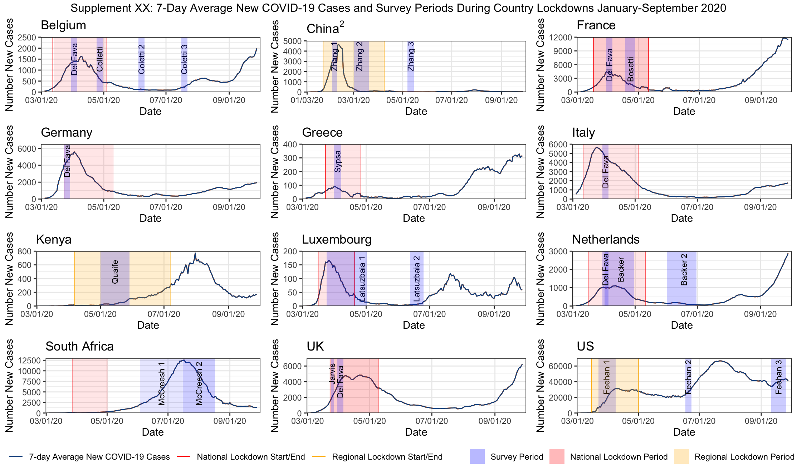
eTable 5. Table of studies included and contact definition used for each study
SN | Article | Authors | Country | Contact definition
1 | The impact of physical distancing measures against COVID-19 transmission on contacts and mixing patterns in the Netherlands: repeated cross-sectional surveys | Backer et al | Netherlands | Conversation in person or a physical contact.
2 | CoMix: comparing mixing patterns in the Belgian population during and after lockdown | Coletti et al | Belgium | In-person conversation of at least a few words, or a skin-to-skin contact; reported as individual contact or with a group of individuals
3 | The differential impact of physical distancing strategies on social contacts relevant for the spread of COVID-19 | Del fava et al | Belgium, France, Germany, Italy, Netherlands, Spain, UK, US | Not specified. Authors say "to best of knowledge, they use the same social contact definition compared to other studies in this time period"
4 | Quantifying interpersonal contact in the US during the spread of COVID-19: first results from the Berkeley Interpersonal Contact Study | Feehan et al | US | Conversational contacts defined as "people you had in-person conversational contact with yesterday: 2-way conversation with three or more words in the physical presence of another person (only face-to-face interactions)
5 | Quantifying the impact of physical distance measures on transmission of COVID-19 in the UK | Jarvis et al | UK | Direct contact defined as anyone who was met in person and with whom at least a few words were exchanged or anyone with whom the participants had any sort of skin-to-skin contact
6 | Evolving social contact patterns during the COVID-19 crisis in Luxembourg | Latsuzbaia et al | Luxembourg | Face to face conversation with more than three words at a distance of less than two meters. The total number of contacts was estimated by adding the reported number of contacts outside the household to the number of individuals living in the household
7 | The impact of COVID-19 control measures on social contacts and transmission in Kenyan informal settlements | Quaife et al | Kenya | Physical contact (any skin-to-skin contact, a handshake, embrace, kiss, seeping on the same bed/mat/blanket, sharing a meal together from same bowl, playing football or other contact sports, sitting next to someone while touching shoulder to shoulder). Non-physical contact (you did not touch the person but exchanged at least a few words, face-to-face within 2 meters, ex someone you bought something from in the market, or rode with on a minibus or worked within the same area)
8 | Modelling the SARS-CoV-2 first epidemic wave in Greece: social contact patterns for impact assessment and an exit strategy from social distancing measures | Sypsa et al | Greece | Skin-to-skin contact (physical) or a two way conversation with three or more words in the physical presence of another person (nonphysical)
9 | Changes in contact patterns shape the dynamics of the COVID-19 outbreak in China | Zhang et al | China | Two-way conversation involving three or more words in the physical presence of another person (conversational contact) or a direct physical contact (ex. handshake, hug, kiss or performing contacts sports)
10 | The impact of relaxing interventions on human contact patterns and SARS-CoV-2 transmission in China | Zhang et al | China | Two-way conversation involving three or more words in the physical presence of another person (conversational contact) or a direct physical contact (ex. handshake, hug, kiss or performing contacts sports)
11 | Lockdown impact on age-specific contact patterns and behaviors in France | Bosetti et al | France | Either physical contact (ex. a kiss or handshake), or a close contact (ex. face-to-face conversation at less than 1 meter)
12 | Impact of social distancing regulations and epidemic risk perception on social  contact and SARS-CoV-2 transmission potential in rural South Africa: analysis of repeated  cross-sectional surveys | McCreesh et al | South Africa | Direct interaction, people who you met in person and with whom you exchanged at least a few words, or with whom you had physical contact (ex. a handshake, embracing, kissing, contact sports). If you only spoke to someone over the phone or internet, they should not be included.

eTable 6. Average contact rates pre- and during COVID-19 and percent reduction for each study and study region. Contacts include all physical and non-physical/conversational contacts reported by participants unless otherwise stated.
Authors |  | Country/Region | Sample size | Percent reduction in contacts | Pre-COVID mean¹ | Initial mitigation mean (IQR)² | Pre-COVID data collection period
National-level
Coletti et al |  | Belgium | 1542 | 80.2% | 13.5 | 2.68 (1-4) | 2010
Del Fava et al |  | Belgium | 1083 | 75.2% | 11.3 | 2.8 (1-4) | 2005-2006
Del Fava et al |  | France | 1750 | 75.2% | 9.3 | 2.3 (1-3) | 2016
Bosetti et al |  | France | 42036 | 70.0% | 10.0 | 3.3³ | 2012
Del Fava et al |  | Germany | 2749 | 50.7% | 7.5 | 3.7 (1-4) | 2005-2006
Sypsa et al |  | Greece | 602 | 86.9% | 20.7 | 2.9 (2.6-3.2)⁶ | Recalled⁴
Del Fava et al |  | Italy | 1158 | 85.0% | 17.3 | 2.6 (1-3) | 2005-2006
Latsuzbaia et al |  | Luxembourg | 5664 | 81.7% | 17.5 | 3.2 (1-4) | 2005-2006
Backer et al |  | Netherlands | 2830 | 70.4% | 12.5 | 3.7 (0-4) | 2016-2017
Del Fava et al |  | Netherlands | 1880 | 71.0% | 14.6 | 4.2 (1-5) | 2005-2006
Del Fava et al |  | UK | 1306 | 75.2% | 10.1 | 2.5 (1-3) | 2005-2006
Jarvis et al |  | UK | 1356 | 74.1% | 10.8 | 2.8 (1-4) | 2005-2006
Feehan et al |  | US | 1425 | 82.0% | 12.0 | 2.7³ | 2015
Regional-level
Zhang et al |  | China-Changsha | 738 | 76.8% | 9.5 | 2.2 (2.1-2.3)⁶ | Recalled⁴
Zhang et al |  | China-Shanghai | 557 | 87.8% | 18.8 | 2.3 (2-2.3)⁶ | 2017-2018
Zhang et al |  | China-Shenzhen | 741 | 72.2% | 7.9 | 2.2 (2.1-2.3)⁶ | Recalled⁴
Zhang et al |  | China-Wuhan | 636 | 86.3% | 14.6 | 2 (1.9-2.1)⁶ | Recalled⁴
Quaife et al |  | Kenya-Nairobi | 213 | 63-67%⁵ | 26.87-28.57 | 18 (7-23) | 2011
McCreesh et al |  | South Africa-KwaZulu-Natal | 216 |  | 7.4 | -⁷ | 2019
¹Pre-COVID data were adjusted for age group, gender, education, day of week and household size (Del Fava), adjusted for age group only (Quaife). Since different groups used different pre-COVID estimates or used different adjustment strategies, studies done in the same country at times had different pre-COVID estimates.
²Some studies right censored average contacts per person. Del Fava et al excluded the top 10% of the distribution
³Authors did not provide interquartile range
⁴Participants in the study conducted during lockdown were asked to recall their contacts and contact attributes from an assigned day prior to lockdown
⁵Since there was no pre-COVID data for informal settlements in Nairobi, author took empirical estimates from Kilifi Kenya and simulated estimated from Prem et al, may be biased estimates due to differing social, cultural and population structures.
⁶Author’s presented 95% CI as an indication of distribution and spread of mean contact
⁷Data collection for the South Africa study was not conducted during government lockdown
eFigure 2. Relative changes in contacts comparing contacts pre- COVID-19 and during initial mitigation for COVID-19 stratified by contact location
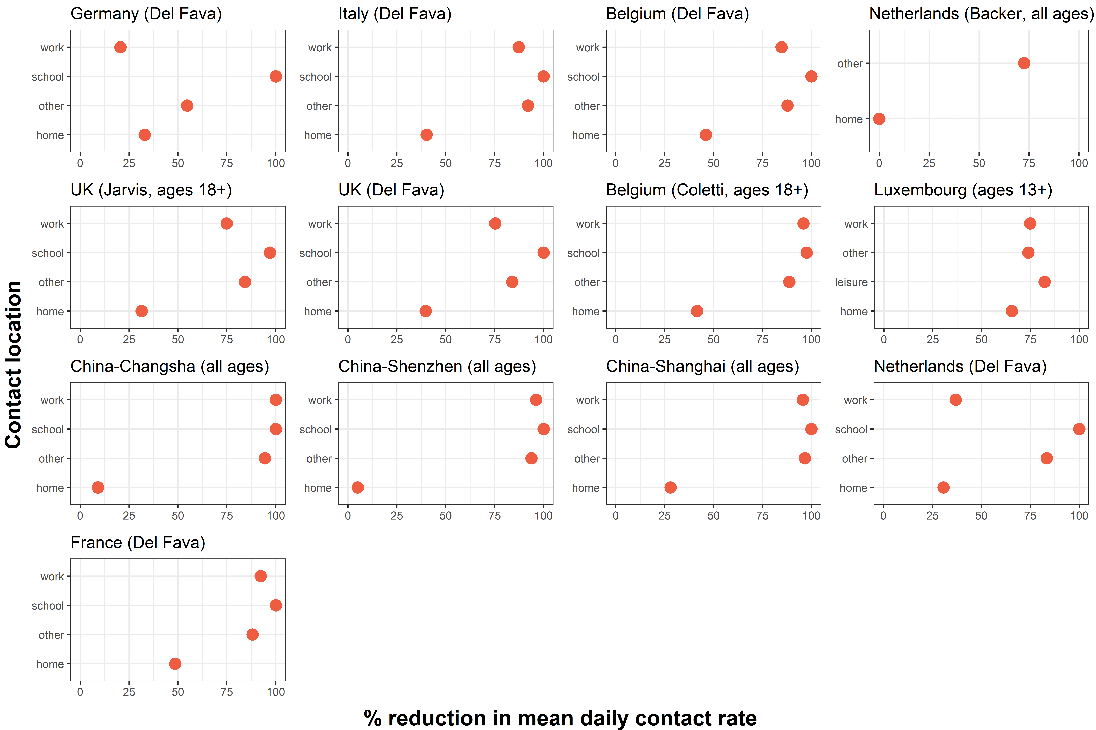

eFigure 3. Relative changes in contacts comparing pre- COVID-19 and during initial mitigation for COVID-19 stratified by participant age group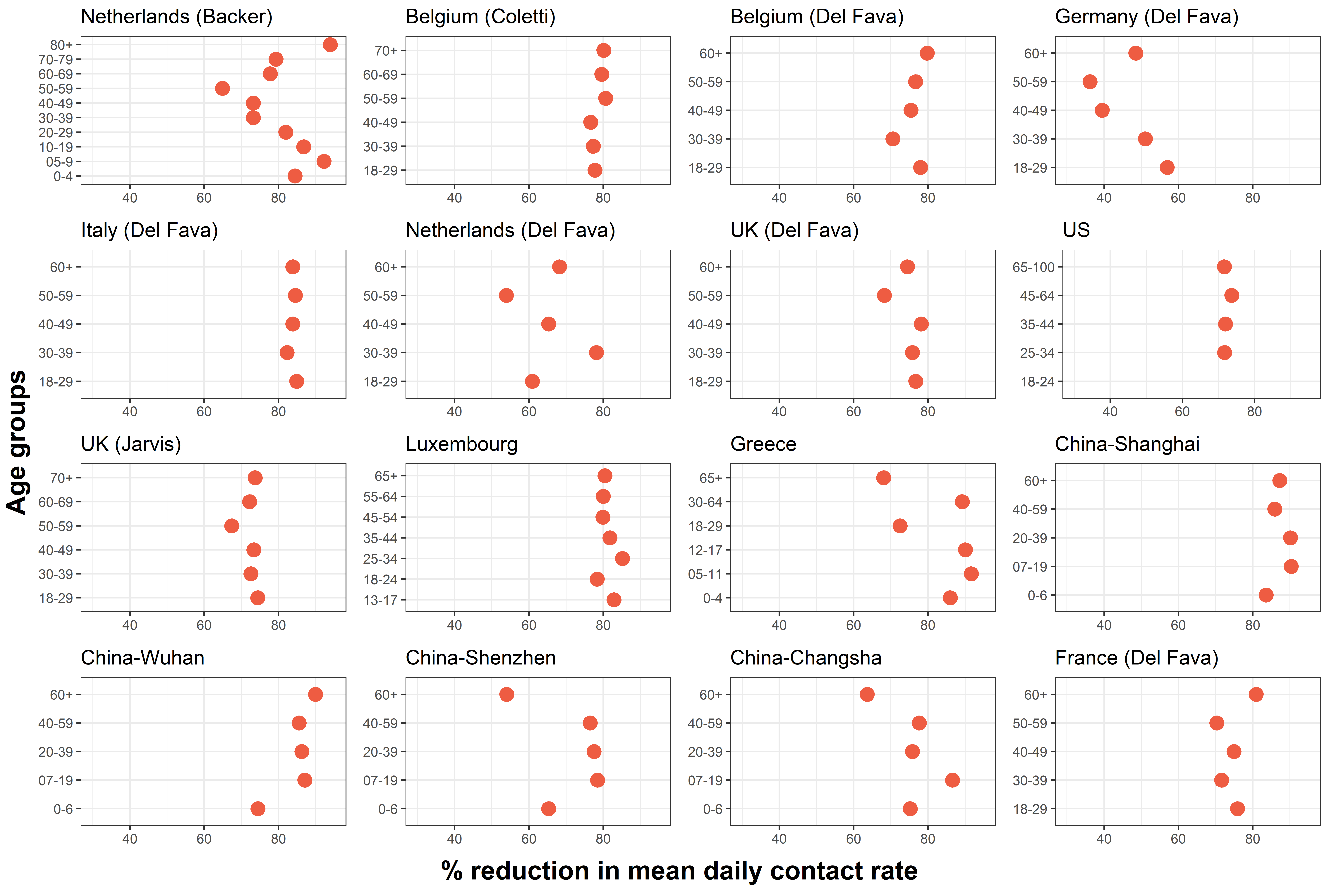
eFigure 4. Figure 5. Panel of changes in absolute age-specific contact matrices comparing pre- COVID-19 and during initial mitigation for COVID-19
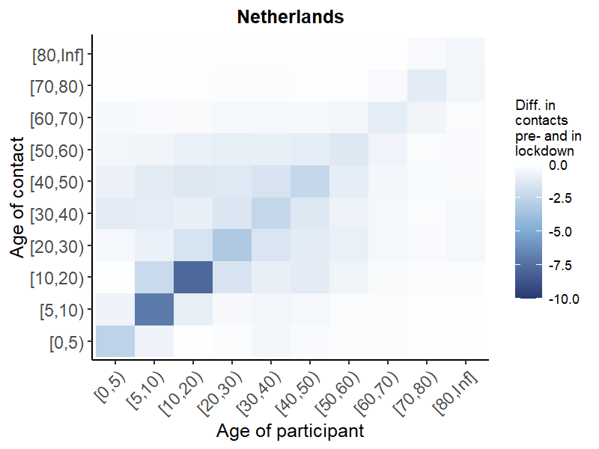
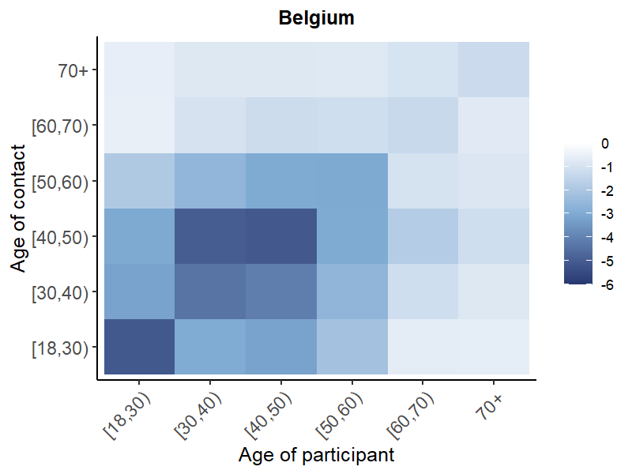
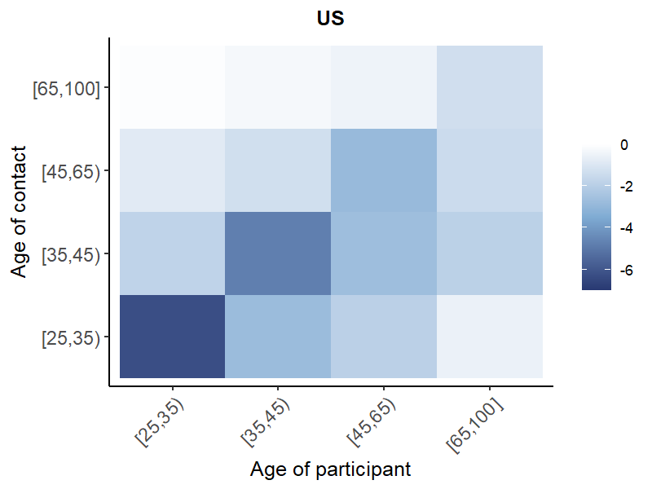
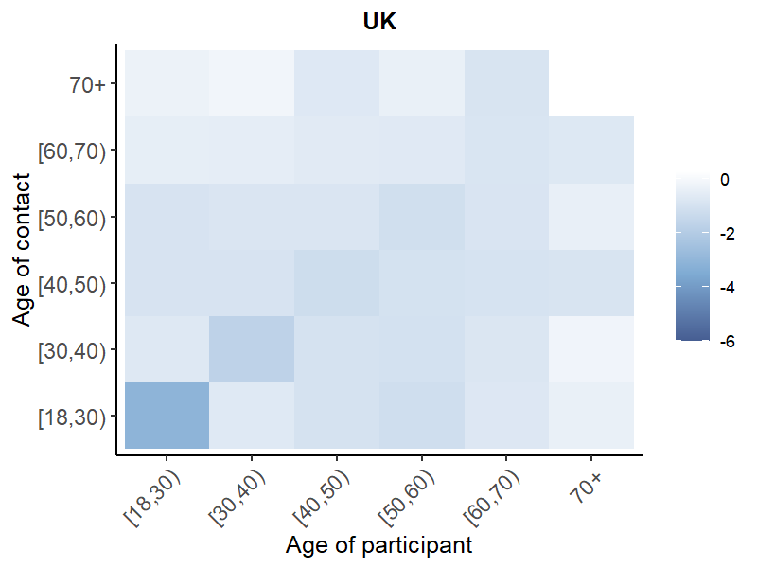
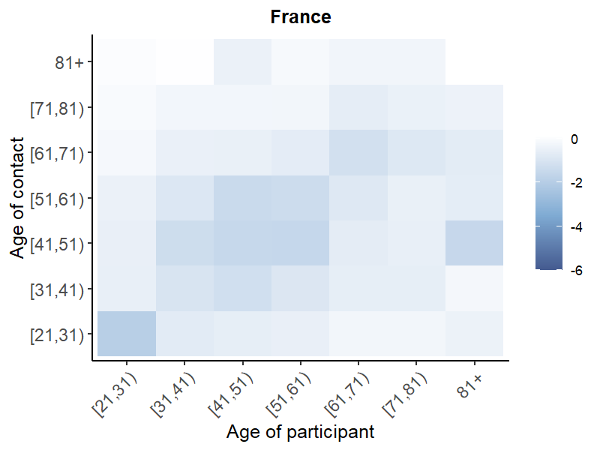
A. National-level
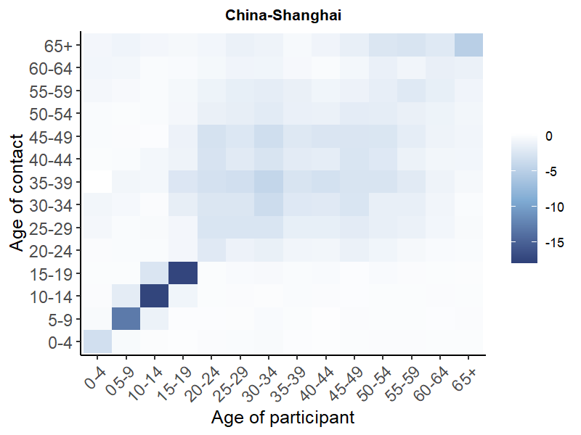
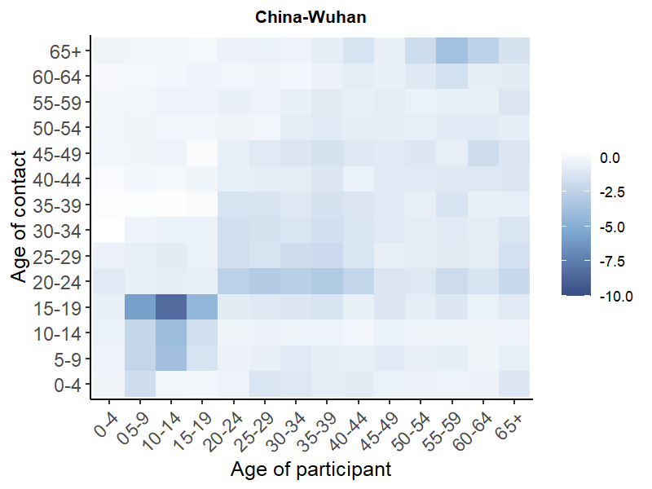
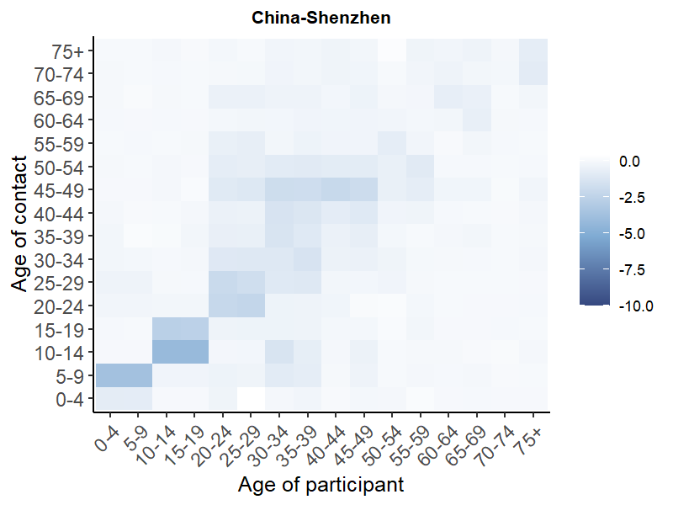
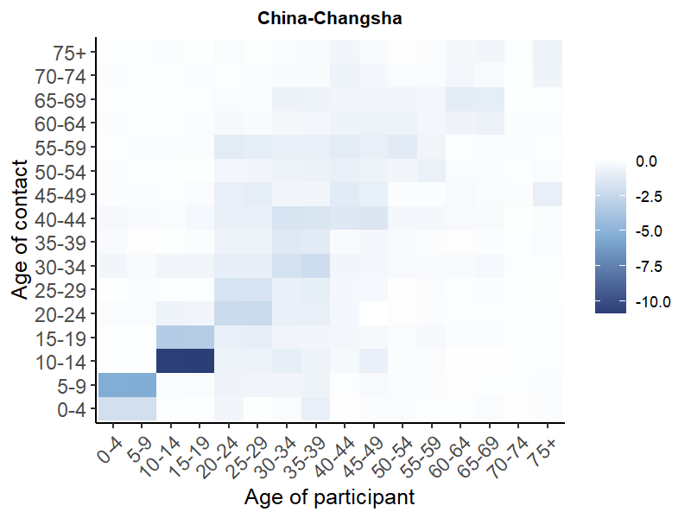
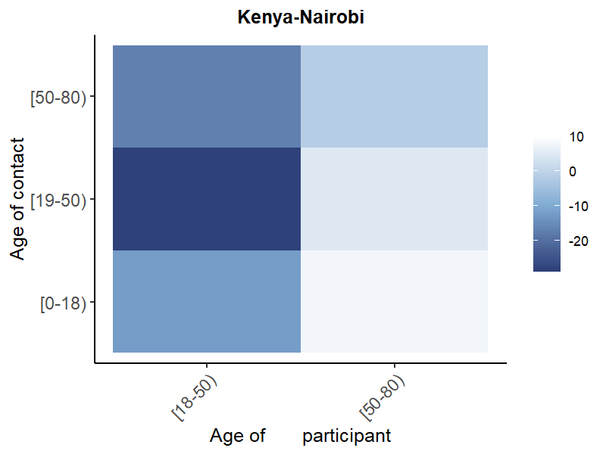
B. Regional-level
eFigure 5. Panel of change in absolute age-specific contact matrices stratified by location of contact in the UK, Belgium and Shanghai and relationship with contact in the Netherlands.
Other
Work
School
Home
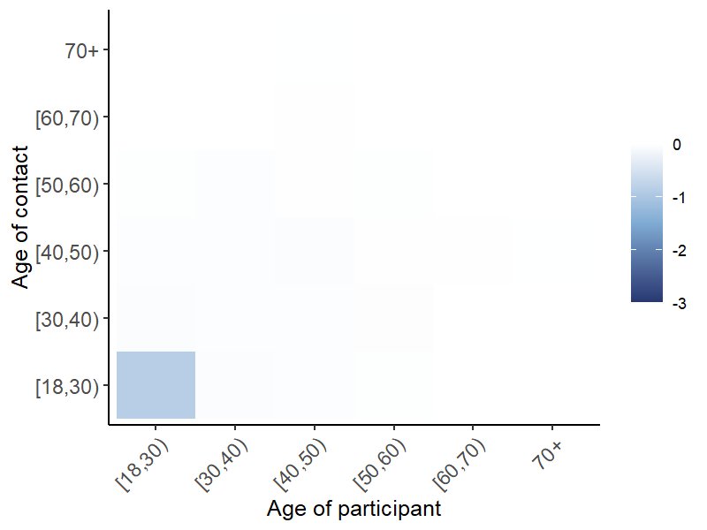
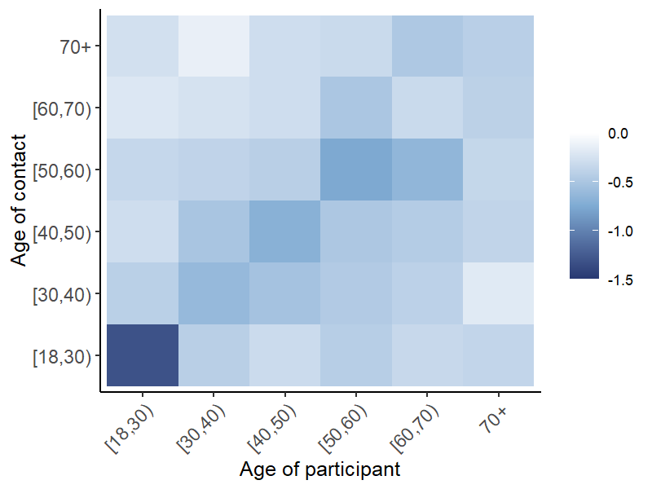
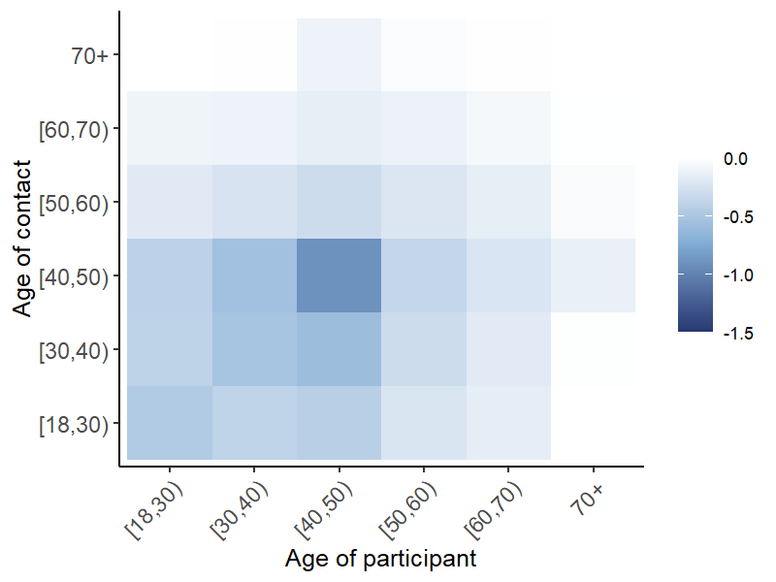
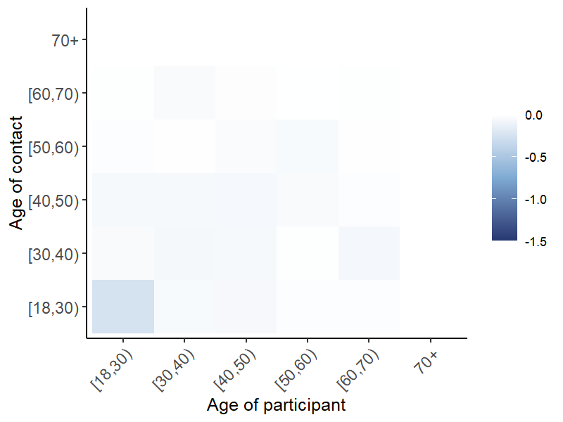
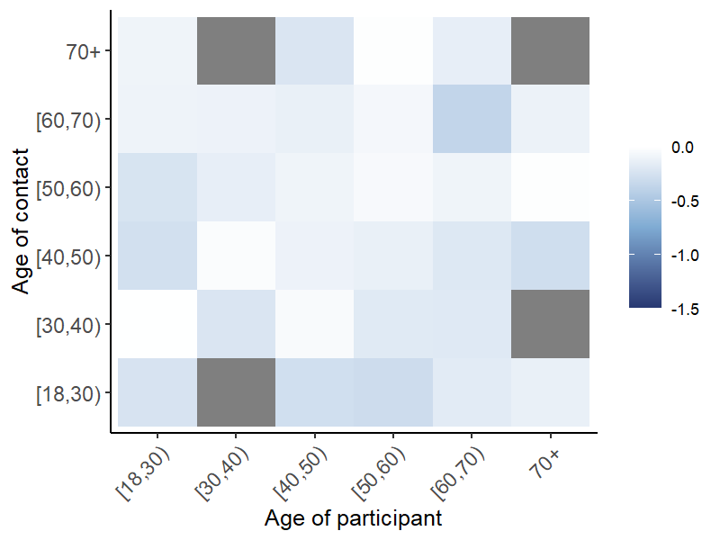
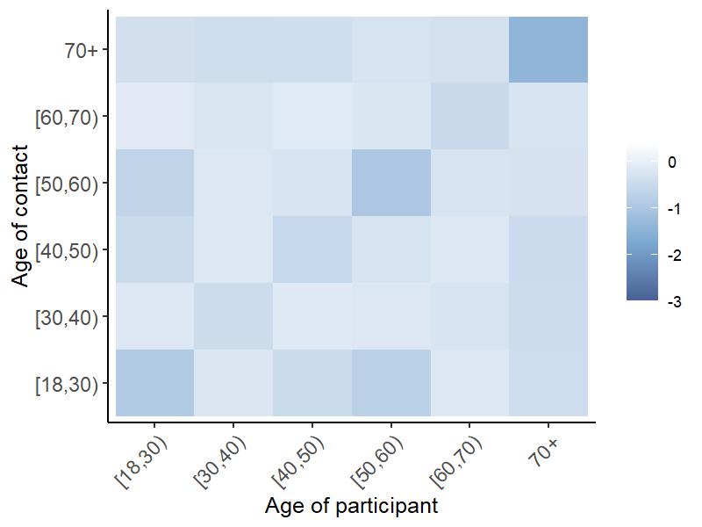
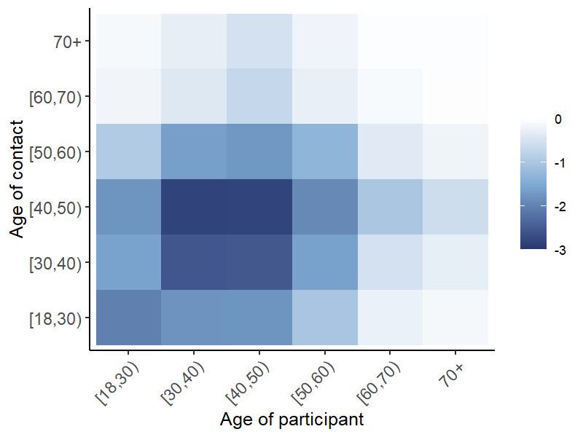

UK

Belgium

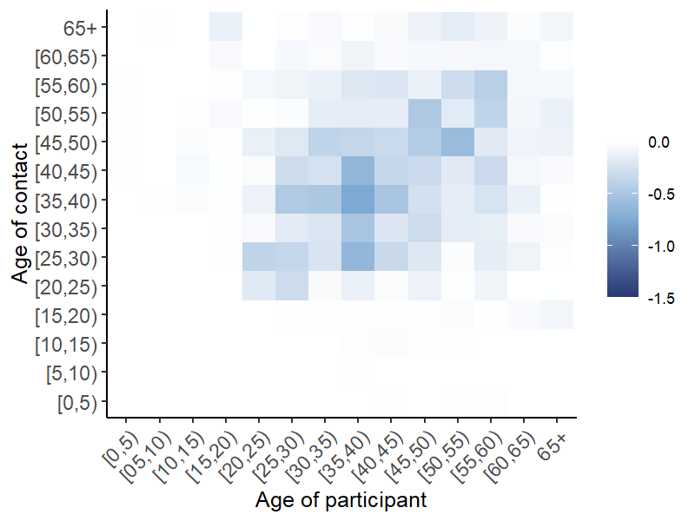
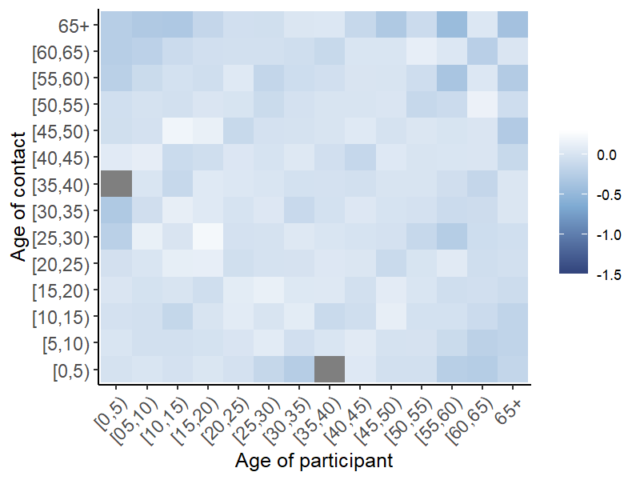
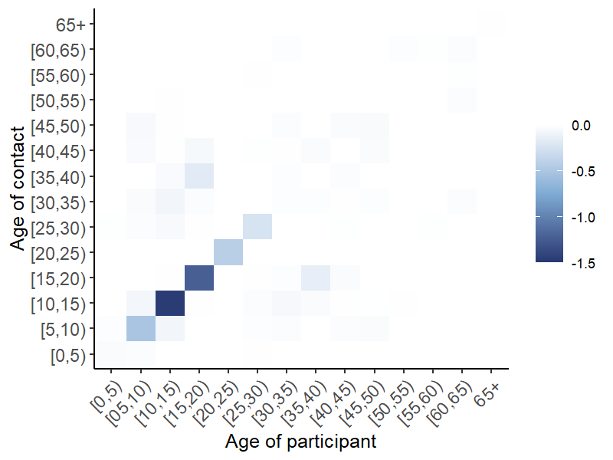
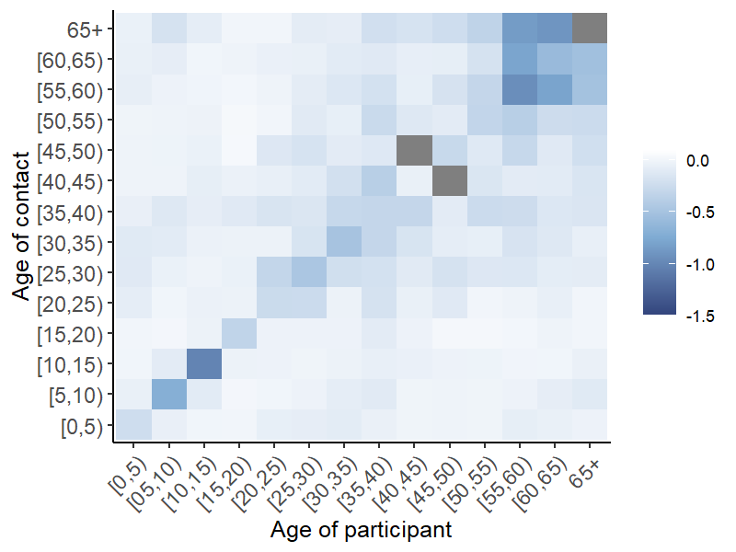

China-Shanghai

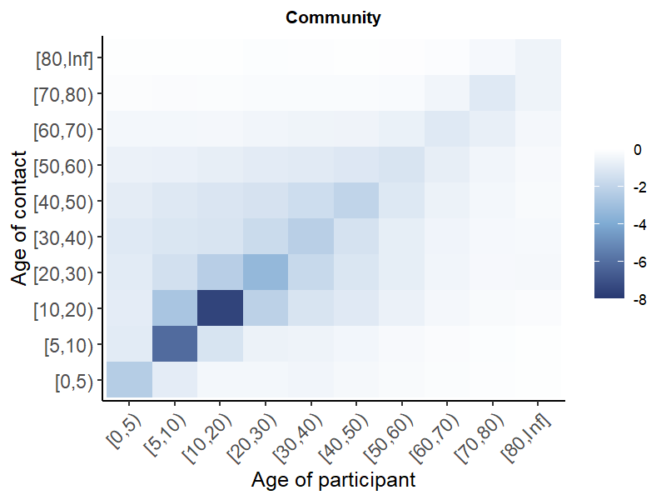
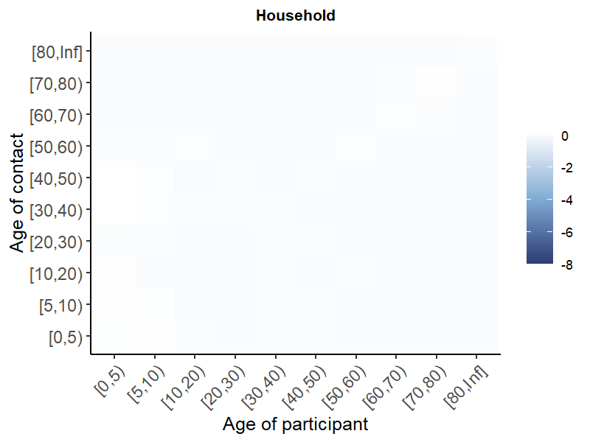
Netherlands

eTable 7. A) Average contact rates pre- COVID-19 and during initial mitigation for COVID-19 stratified by gender
Country/Region | Pre-COVID |  | Initial mitigation |  | Post-relaxation
 | Female | Male | Female | Male |  | Female | Male
Belgium (Coletti) | 13.4(6-18) | 13.6(6-17) | 2.7(1-4) | 2.7(1-4) |  | 4.7(1-5) | 5.1(1-4)
Belgium (Del Fava) | 17.7 | 17.6 | 2.6(1-3) | 3.2(1-4) |  | - | -
China-Changsha | 9.3(3-10) | 9.8(3-11) | 2(1-3) | 2.6(1-3) |  | 2(1-2) | 2.6(1-3)
China-Shanghai | 18.5(4-29.5) | 19(4.2-31) | 2.6(1-3) | 2.1(1-2.8) |  | 2.9(1.2-3) | 2.6(1-3)
China-Shenzhen | 7.2(2-9) | 8.6(3-11) | 2.6(1-3) | 2.5(1-3) |  | 2.5(1-3) | 2.5(1-3)
China-Wuhan | 14.7(3-15) | 14.5(2-18) | 2.1(2-2) | 1.8(1-2) |  | 3.6(2-4) | 3(2-3.2)
France (Del Fava) | 16.2 | 16 | 2.3(1-3) | 2.2(0-3) |  | - | -
Germany (Del Fava) | 7.7 | 7.8 | 3.3(1-4) | 4.2(1-5) |  | - | -
Greece | 20.3(18-23)² | 21.1(18-24) ² | 2.6(2.2-3.1) ² | 3.2(2.7-3.6) ² |  | - | -
Italy (Del Fava) | 18 | 18.7 | 2.4(1-3) | 2.8(1-4) |  | - | -
Kenya | - | - | 15.5(7-19.2) | 20.3(8-24) |  | - | -
Netherlands (Backer) | 15.4(5-20) | 15.3(4-21) | 3.1(0-4) | 3.8(0-4) |  | 9.5(1-11) | 9.6(1-11)
Netherlands (Del Fava) | 14.8 | 14.4 | 4(1-5) | 4.6(1-6) |  | - | -
South Africa | 7.6 | 7.1 | - | - |  | 4 | 4.6
Spain | - | - | 2.5(1-3) | 2.8(1-3) |  | - | -
UK (Del Fava) | 12 | 10.9 | 2.5(1-3) | 2.5(1-3) |  | - | -
UK (Jarvis) | 11.3(6-15) | 10.2(5-13) | 3(1-4) | 2.9(1-4) |  | - | -
US (Del Fava) | - | - | 3.3(1-4) | 3.9(1-4.6) |  | - | -

eFigure 6. A) Average contact rates pre- COVID-19 and during initial mitigation for COVID-19 stratified by household size, B) relative changes in contacts comparing contacts pre- COVID-19 and during initial mitigation for COVID-19 stratified by household size
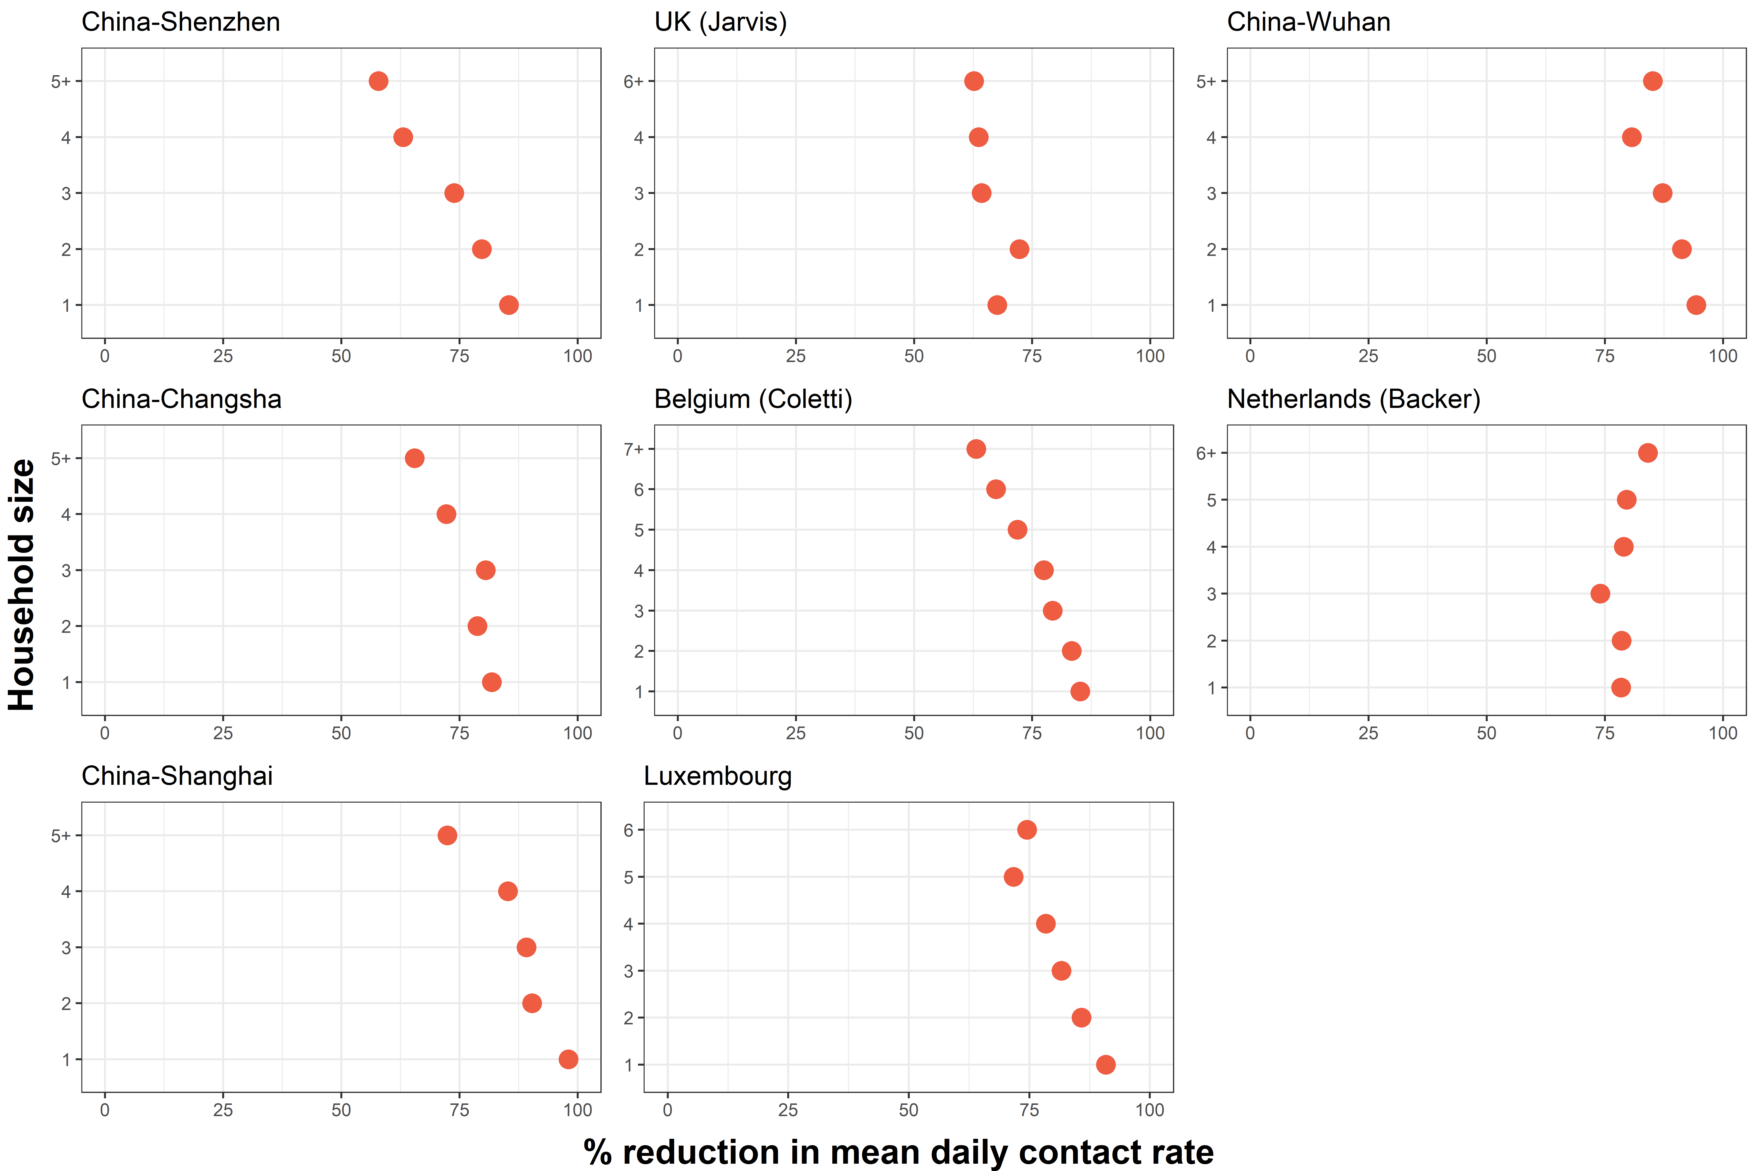

eTable 8. Estimates of changes in R0 derived from comparing age-specific contact patterns pre-COVID and during strict initial mitigation measures
Authors | Country/Region | Percent reduction in mean contacts | Percent reduction in R0 (95% CI)
National-level
Coletti et al | Belgium | 80.2% | 79% (77.5-81)
Del fava et al | Belgium | 75.2% | 72.0%
Del fava et al | France | 75.2% | 77.0%
Bosetti et al | France | 70.0% | -²
Del fava et al | Germany | 50.7% | 42.0%
Sypsa et al | Greece | 86.9% | 81% (72-86)
Del fava et al | Italy | 85.0% | 82.0%
Latsuzbaia et al | Luxembourg | 81.7% | -²
Backer et al | Netherlands | 70.4% | 62% (48-72)
Del fava et al | Netherlands | 71.0% | 71.0%
Del fava et al | UK | 75.2% | 79.0%
Jarvis et al | UK | 74.1% | 76% (73-79)
Feehan et al | US | 82.0% | 73% (72-75)
Regional-level
Zhang et al | China-Changsha | 76.8% | -³
Zhang et al | China-Shanghai | 87.8% | -³
Zhang et al | China-Shenzhen | 72.2% | -³
Zhang et al | China-Wuhan | 86.3% | -³
Quaife et al | Kenya-Nairobi | 63-67% | 64.0%
McCreesh et al | South Africa-KwaZulu-Natal | -⁴ | -⁴
¹Some studies did not provide 95% CI for percent reduction in R0
²Study did not estimate percent reduction in R0
³Studies estimated changes in R0 as a function of baseline R0 but did not directly provide quantities of percent reduction in R0
⁴Study only quantified contacts post-relaxation not during initial mitigation measures

eFigure 7. Country-level implementation and strictness of physical distancing measures (from the Oxford Stringency Index) visualized over time with the data collection period for studies. Lighter colors depict stricter measures. “0” demarks regional interventions rather than national.
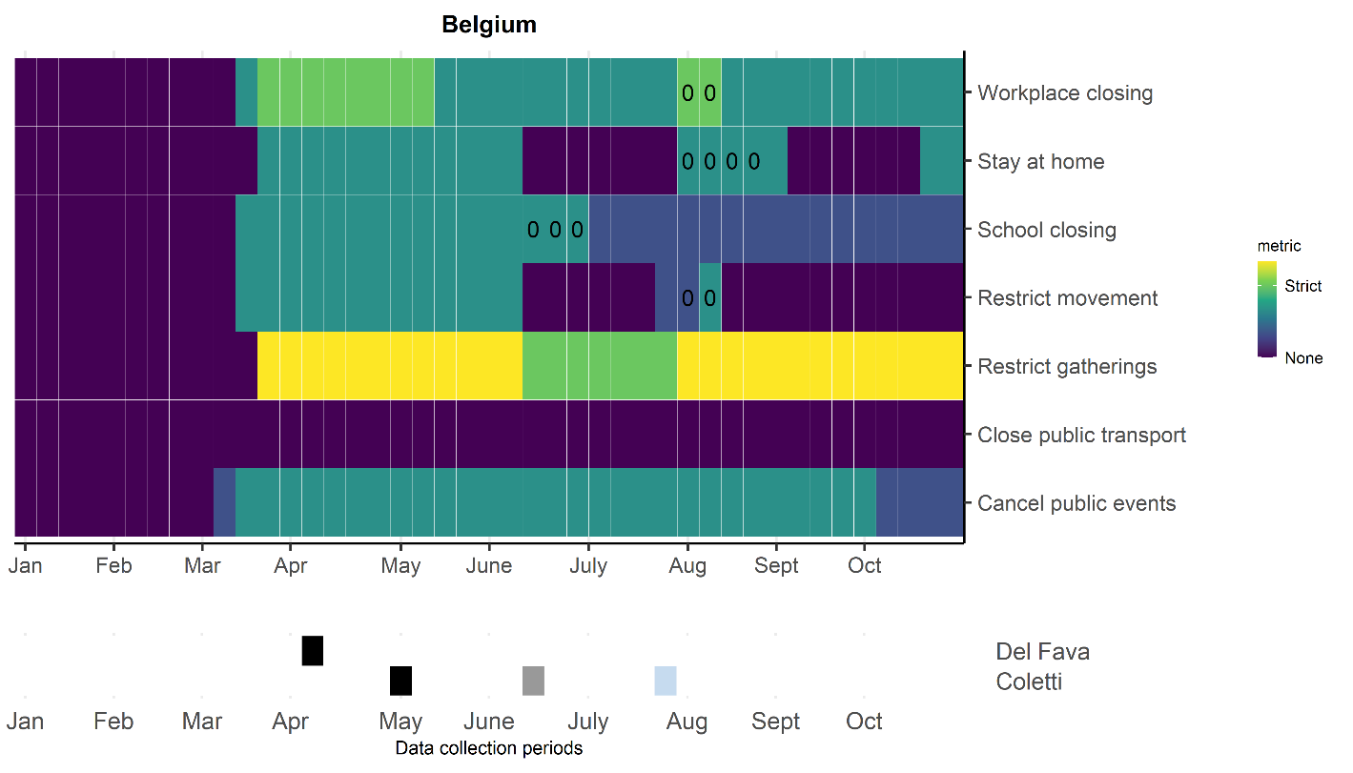
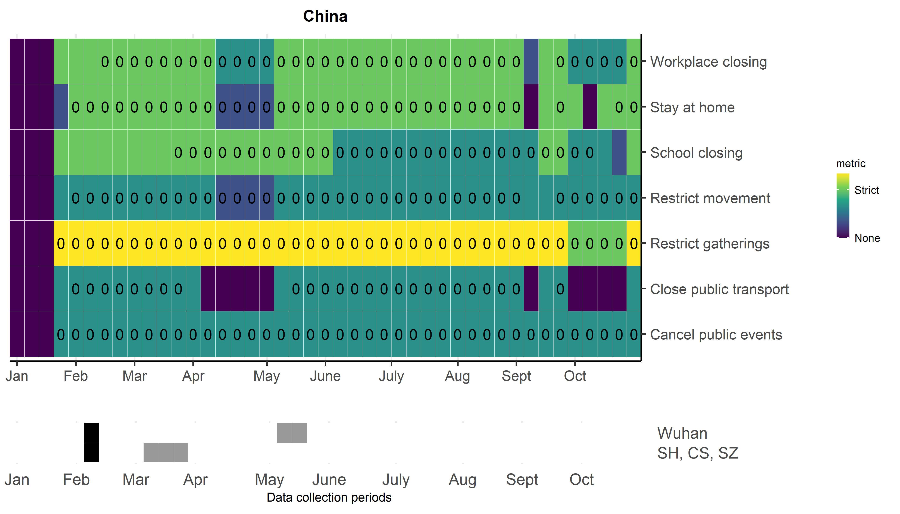
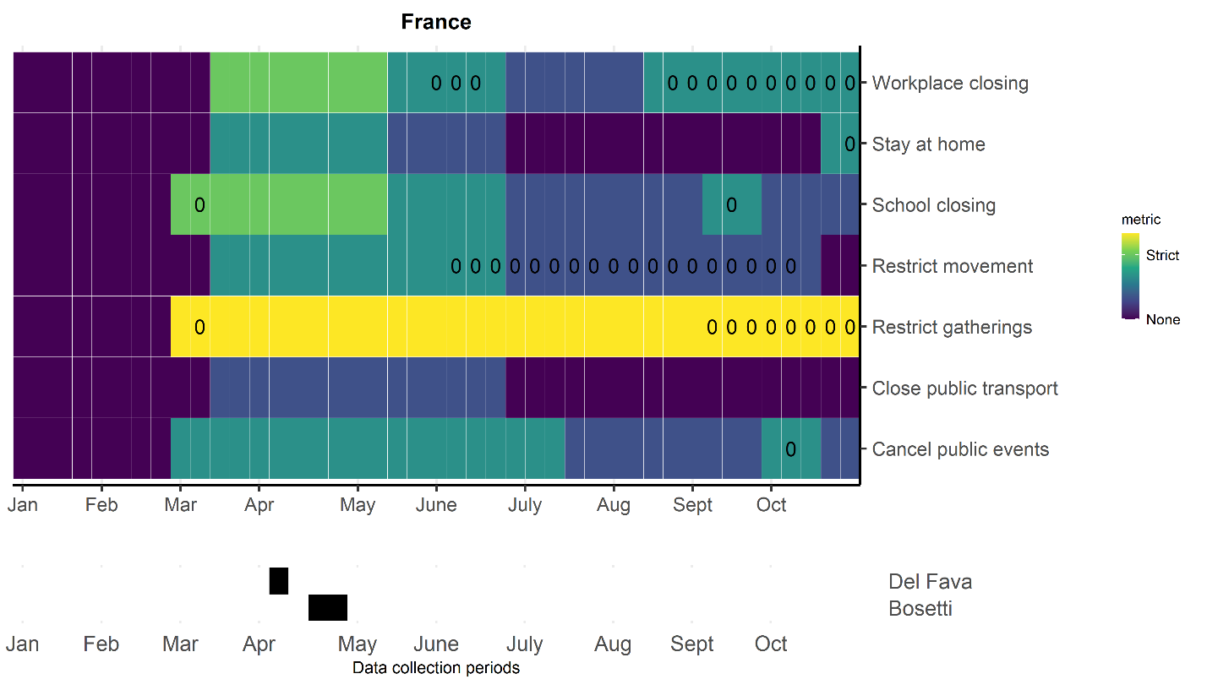
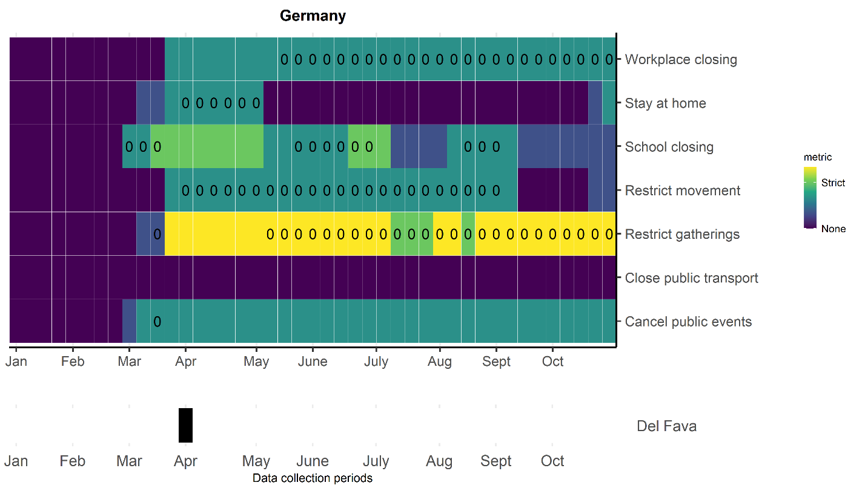
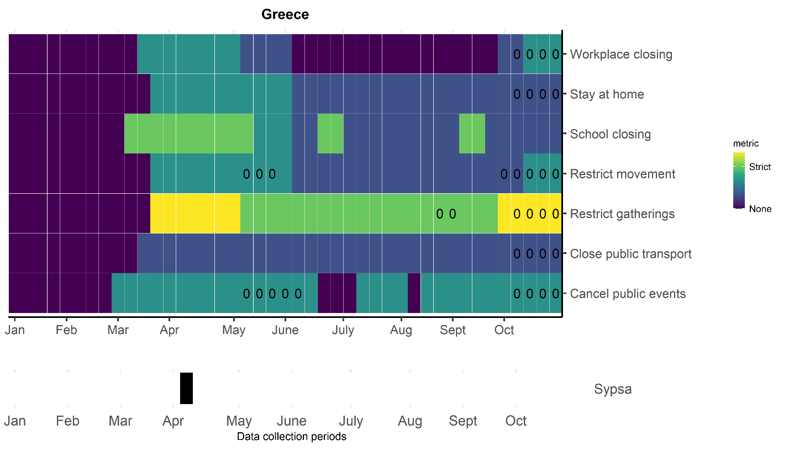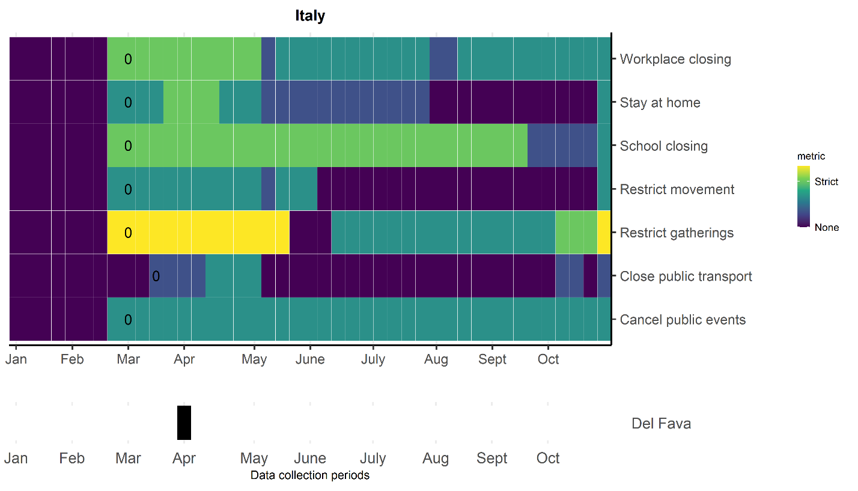

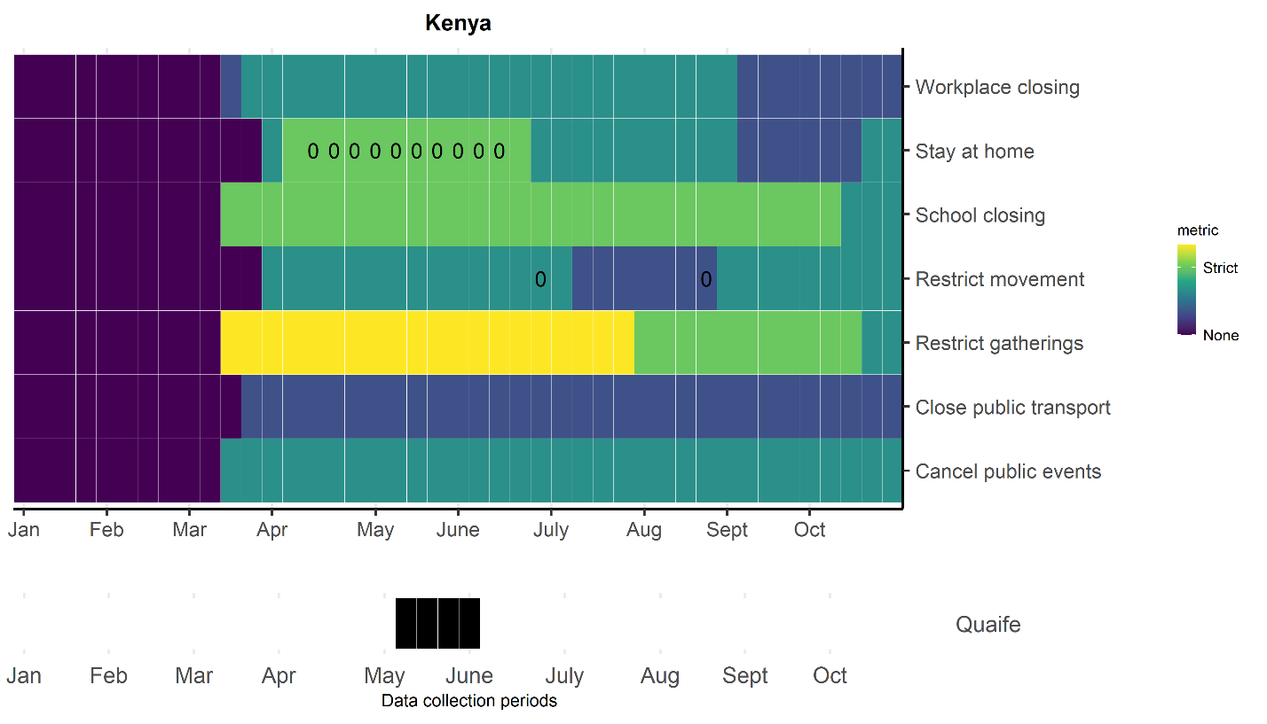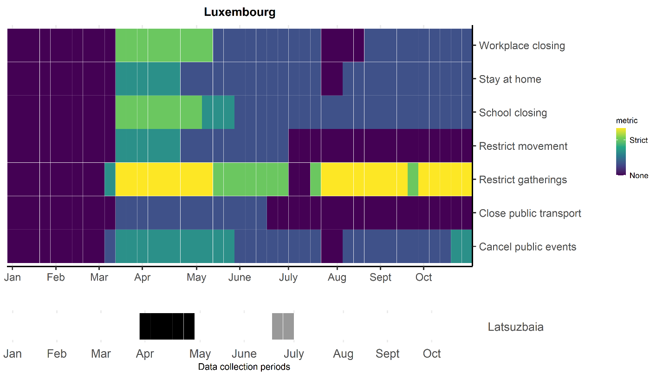

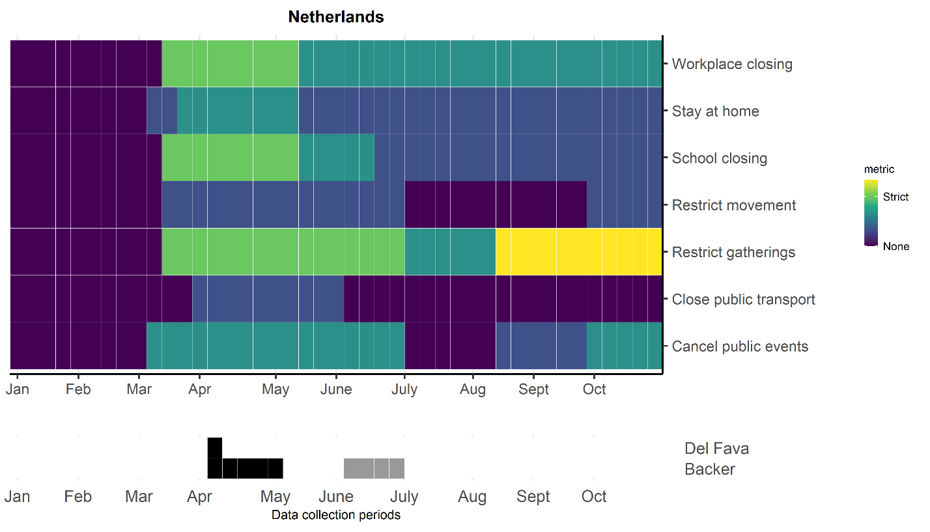
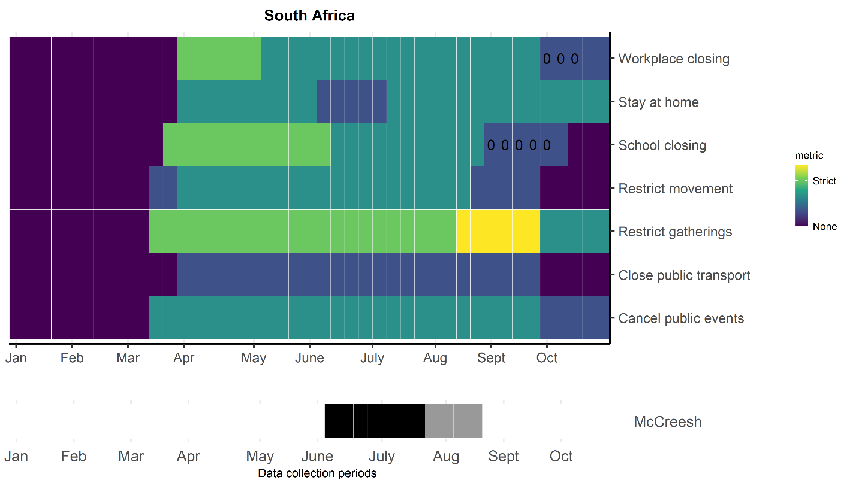

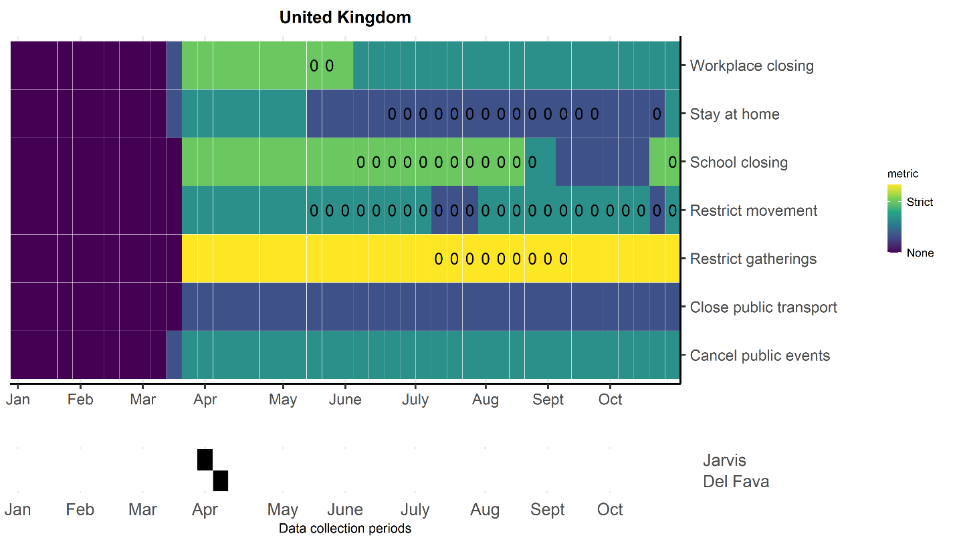

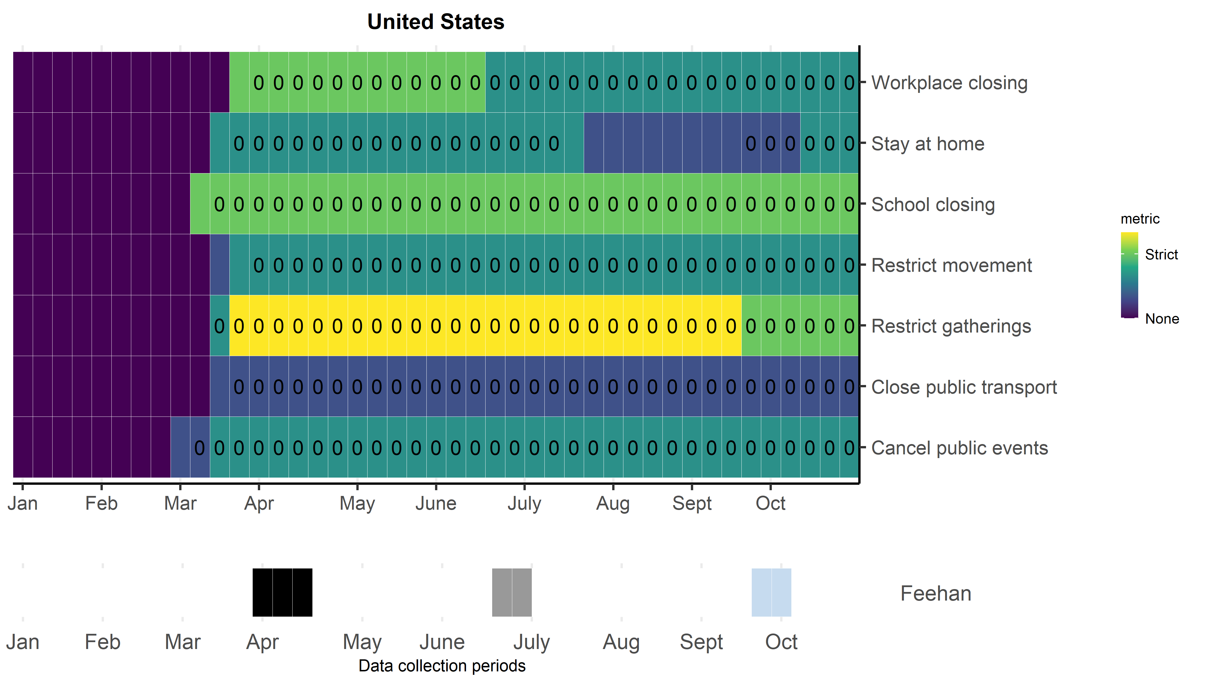

Yes indicates availability of data for both pre-lockdown and during lockdown age-specific matrices by location
For Belgium and the UK, average contacts per setting pre-COVID are for those aged >18 only. This is to be consistent with sampling from the lockdown period.
For Shanghai, the way their pre-lockdown data were collected meant an underestimate in the number of contacts that occurred in each setting. (For contacts that occurred in groups, they asked participants to report the number in aggregate, stratified by age group but not contact setting).

