Supplemental Materials

Table S1 Annual rates of changes (95% confidence interval, 95% CI) in weight, waist circumference, body fat mass, and proportion fat mass by tertiles of total PFOS serum concentrations.ª
Weight
Rate of change | Follow-up 0-9.0 years | Follow-up 9.0-18.6 years
 | Percent change per year (95% CI), % | Percent change per year (95% CI), %^{b}
Total PFOS^{c}
Tertile 1 | 0.10 (0.04, 0.17) | -0.24 (-0.32, -0.15)
Tertile 2 | 0.05 (-0.01, 0.12) | -0.28 (-0.36, -0.19)
Tertile 3 | 0.33 (0.27, 0.40) | -0.25 (-0.34, -0.17)
P for interaction | <.0001 | 0.01
Waist circumference
Rate of change | Follow-up 0-9.0 years | Follow-up 9.0-18.6 years
 | Percent change per year (95% CI), % | Percent change per year (95% CI), %^{b}
Total PFOS^{c}
Tertile 1 | 0.33 (0.27, 0.39) | 0.23 (0.15, 0.31)
Tertile 2 | 0.32 (0.26, 0.37) | 0.13 (0.06, 0.21)
Tertile 3 | 0.45 (0.39, 0.50) | 0.10 (0.02, 0.17)
P for interaction | 0.002 | 0.01
Fat mass
Rate of change | Follow-up 0-14.5 years | Follow-up 14.5-18.6 years
 | Percent change per year (95% CI), % | Percent change per year (95% CI), %^{b}
Total PFOS^{c}
Tertile 1 | 0.06 (-0.04, 0.15) | -0.92 (-1.57, -0.27)
Tertile 2 | 0.09 (-0.006, 0.18) | -0.65 (-1.25, -0.04)
Tertile 3 | 0.31 (0.22, 0.41) | -1.14 (-1.76, -0.53)
P for interaction | 0.0002 | 0.31
Proportion fat mass
Rate of change | Follow-up 0-14.5years | Follow-up 14.5-18.6 years
 | Change per year (95% CI), % | Change per year (95% CI), %
Total PFOS^{c}
Tertile 1 | 0.04 (0.02, 0.07) | -0.18 (-0.32, -0.03)
Tertile 2 | 0.05 (0.03, 0.07) | -0.09 (-0.22, 0.05)
Tertile 3 | 0.07 (0.05, 0.09) | -0.27 (-0.41, -0.14)
P for interaction | 0.32 | 0.17
ª Models were adjusted for age at baseline, race/ethnicity, study site, education, financial strain, smoking status, passive smoking, alcohol consumption, total calorie intake, physical activity, and menopausal status.
^{b} Weight, waist circumference, and body fat mass were log-transformed to ensure normality; thus percent change per year (95% CI) was calculated.
^{c} Medians (ranges) of total PFOS concentrations by tertiles were 14.8 (2.0, 20.1) ng/mL for tertile 1, 25.1 (20.2, 30.9) ng/mL for tertile 2, and 42.9 (31.0, 376.0) ng/mL for tertile 3.

Table S2 Annual rates of changes (95% confidence interval, 95% CI) in weight, waist circumference, body fat mass, and proportion fat mass by tertile of n-PFOS serum concentrations.ª
Weight
Rate of change | Follow-up 0-9.0 years | Follow-up 9.0-18.6 years
 | Percent change per year (95% CI), % | Percent change per year (95% CI), %^{b}
n-PFOS^{c}
Tertile 1 | 0.11 (0.04, 0.18) | -0.22 (-0.32, -0.14)
Tertile 2 | 0.03 (-0.03, 0.10) | -0.26 (-0.34, -0.17)
Tertile 3 | 0.03 (0.28, 0.41) | -0.28 (-0.36, -0.19)
P for interaction | <.0001 | 0.001
Waist circumference
Rate of change | Follow-up 0-9.0 years | Follow-up 9.0-18.6 years
 | Percent change per year (95% CI), % | Percent change per year (95% CI), %^{b}
n-PFOS^{c}
Tertile 1 | 0.34 (0.28, 0.40) | 0.23 (0.15, 0.30)
Tertile 2 | 0.30 (0.24, 0.36) | 0.14 (0.07, 0.21)
Tertile 3 | 0.45 (0.39, 0.51) | 0.09 (0.02, 0.17)
P for interaction | 0.0006 | 0.009
Fat mass
Rate of change | Follow-up 0-14.5years | Follow-up 14.5-18.6 years
 | Percent change per year (95% CI), % | Percent change per year (95% CI), %^{b}
n-PFOS^{c}
Tertile 1 | 0.08 (-0.01, 0.18) | -0.91 (-1.56 -0.26)
Tertile 2 | 0.02 (-0.07, 0.12) | -0.44 (-1.05, 0.17)
Tertile 3 | 0.35 (0.26, 0.44) | -1.34 (-1.95, -0.72)
P for interaction | <.0001 | 0.04
Proportion fat mass
Rate of change | Follow-up 0-14.5 years | Follow-up 14.5-18.6 years
 | Change per year (95% CI), % | Change per year (95% CI), %
n-PFOS^{c}
Tertile 1 | 0.05 (0.03, 0.07) | -0.17 (-0.32, -0.03)
Tertile 2 | 0.04 (0.02, 0.06) | -0.04 (-0.18, 0.09)
Tertile 3 | 0.07 (0.05, 0.09) | -0.32 (-0.46, -0.19)
P for interaction | 0.06 | 0.01
ª Models were adjusted for age at baseline, race/ethnicity, study site, education, financial strain, smoking status, passive smoking, alcohol consumption, total calorie intake, physical activity, and menopausal status.
^{b} Weight, waist circumference, and body fat mass were log-transformed to ensure normality; thus percent change per year (95% CI) was calculated.
^{c} Medians (ranges) of n-PFOS concentrations by tertiles were 10.6 (1.4, 14.0) ng/mL for tertile 1, 17.4 (14.1, 21.4) ng/mL for tertile 2, and 29.8 (21.5, 250.0) ng/mL for tertile 3.

Table S3 Annual rates of changes (95% confidence interval, 95% CI) in weight, waist circumference, body fat mass, and proportion fat mass by tertile of Sm-PFOS serum concentrations.ª
Weight
Rate of change | Follow-up 0-9.0 years | Follow-up 9.0-18.6 years
 | Percent change per year (95% CI), % | Percent change per year (95% CI), %^{b}
Sm-PFOS^{c}
Tertile 1 | 0.10 (0.04, 0.17) | -0.21 (-0.30, -0.12)
Tertile 2 | 0.15 (0.08, 0.21) | -0.30 (-0.39, -0.21)
Tertile 3 | 0.24 (0.17, 0.30) | -0.26 (-0.34, -0.17)
P for interaction | 0.02 | 0.19
Waist circumference
Rate of change | Follow-up 0-9.0 years | Follow-up 9.0-18.6 years
 | Percent change per year (95% CI), % | Percent change per year (95% CI), %^{b}
Sm-PFOS^{c}
Tertile 1 | 0.33 (0.27, 0.39) | 0.22 (0.14, 0.30)
Tertile 2 | 0.37 (0.32, 0.43) | 0.13 (0.06, 0.20)
Tertile 3 | 0.39 (0.33, 0.44) | 0.11 (0.04, 0.18)
P for interaction | 0.39 | 0.12
Fat mass
Rate of change | Follow-up 0-14.5years | Follow-up 14.5-18.6 years
 | Percent change per year (95% CI), % | Percent change per year (95% CI), %^{b}
Sm-PFOS^{c}
Tertile 1 | 0.14 (0.04, 0.23) | -1.22 (-1.89, -0.55)
Tertile 2 | 0.09 (-0.002, 0.18) | -0.41 (-1.01, 0.20)
Tertile 3 | 0.23 (0.14, 0.32) | -1.14 (-1.74, -0.53)
P for interaction | 0.10 | 0.12
Proportion fat mass
Rate of change | Follow-up 0-14.5 years | Follow-up 14.5-18.6 years
 | Change per year (95% CI), % | Change per year (95% CI), %
Sm-PFOS^{c}
Tertile 1 | 0.05 (0.03, 0.07) | -0.26 (-0.41, -0.11)
Tertile 2 | 0.05 (0.03, 0.07) | -0.03 (-0.17, 0.10)
Tertile 3 | 0.06 (0.04, 0.08) | -0.26 (-0.40, -0.13)
P for interaction | 0.48 | 0.03
ª Models were adjusted for age at baseline, race/ethnicity, study site, education, financial strain, smoking status, passive smoking, alcohol consumption, total calorie intake, physical activity, and menopausal status.
^{b} Weight, waist circumference, and body fat mass were log-transformed to ensure normality; thus percent change per year (95% CI) was calculated.
^{c} Medians (ranges) of Sm-PFOS concentrations by tertiles were 3.9 (<LOD, 5.5) ng/mL for tertile 1, 7.3 (5.6, 9.2) ng/mL for tertile 2, and 13.3 (9.3, 126.0) ng/mL for tertile 3.

Table S4 Annual rates of changes (95% confidence interval, 95% CI) in weight, waist circumference, body fat mass, and proportion fat mass by tertile of n-PFOA serum concentrations.ª
Weight
Rate of change | Follow-up 0-9.0 years | Follow-up 9.0-18.6 years
 | Percent change per year (95% CI), % | Percent change per year (95% CI), %^{b}
n-PFOA^{c}
Tertile 1 | 0.13 (0.07, 0.20) | -0.18 (-0.27, -0.09)
Tertile 2 | 0.14 (0.08, 0.21) | -0.33 (-0.42, -0.25)
Tertile 3 | 0.21 (0.15, 0.28) | -0.25 (-0.33, -0.16)
P for interaction | 0.19 | 0.21
Waist circumference
Rate of change | Follow-up 0-9.0 years | Follow-up 9.0-18.6 years
 | Percent change per year (95% CI), % | Percent change per year (95% CI), %^{b}
n-PFOA^{c}
Tertile 1 | 0.34 (0.29, 0.40) | 0.25 (0.17, 0.33)
Tertile 2 | 0.37 (0.31, 0.42) | 0.13 (0.05, 0.20)
Tertile 3 | 0.38 (0.32, 0.43) | 0.09 (0.02, 0.16)
P for interaction | 0.70 | 0.06
Fat mass
Rate of change | Follow-up 0-14.5years | Follow-up 14.5-18.6 years
 | Percent change per year (95% CI), % | Percent change per year (95% CI), %^{b}
n-PFOA^{c}
Tertile 1 | 0.21 (0.12, 0.31) | -1.01 (-1.70, -0.31)
Tertile 2 | 0.11 (0.02, 0.21) | -1.16 (-1.74, -0.57)
Tertile 3 | 0.14 (0.05, 0.23) | -0.46 (-1.06, 0.14)
P for interaction | 0.33 | 0.30
Proportion fat mass
Rate of change | Follow-up 0-14.5 years | Follow-up 14.5-18.6 years
 | Change per year (95% CI), % | Change per year (95% CI), %
n-PFOA^{c}
Tertile 1 | 0.06 (0.04, 0.09) | -0.20 (-0.35, -0.04)
Tertile 2 | 0.06 (0.04, 0.08) | -0.24 (-0.37, -0.11)
Tertile 3 | 0.04 (0.02, 0.06) | -0.09 (-0.22, 0.05)
P for interaction | 0.39 | 0.25
ª Models were adjusted for age at baseline, race/ethnicity, study site, education, financial strain, smoking status, passive smoking, alcohol consumption, total calorie intake, physical activity, and menopausal status.
^{b} Weight, waist circumference, and body fat mass were log-transformed to ensure normality; thus percent change per year (95% CI) was calculated.
^{c} Medians (ranges) of n-PFOA concentrations by tertiles were 2.4 (<LOD, 3.2) ng/mL for tertile 1, 4.1 (3.3, 5.1) ng/mL for tertile 2, and 6.8 (5.2, 56.5) ng/mL for tertile 3.

Table S5 Predicted rates of changes (95% confidence interval, 95% CI) in weight, waist circumference, body fat mass, and proportion fat mass by tertile of PFHxS serum concentrations.ª
Weight
Rate of change | Follow-up 0-9.0 years | Follow-up 9.0-18.6 years
 | Percent change per year (95% CI), % | Percent change per year (95% CI), %^{b}
PFHxS^{c}
Tertile 1 | 0.13 (0.06, 0.20) | -0.24 (-0.33, -0.16)
Tertile 2 | 0.06 (-0.007, 0.12) | -0.22 (-0.31, -0.14)
Tertile 3 | 0.30 (0.24, 0.37) | -0.31 (-0.39, -0.22)
P for interaction | <.0001 | 0.002
Waist circumference
Rate of change | Follow-up 0-9.0 years | Follow-up 9.0-18.6 years
 | Percent change per year (95% CI), % | Percent change per year (95% CI), %^{b}
PFHxS^{c}
Tertile 1 | 0.39 (0.33, 0.44) | 0.18 (0.11, 0.26)
Tertile 2 | 0.29 (0.23, 0.34) | 0.16 (0.09, 0.23)
Tertile 3 | 0.42 (0.36, 0.47) | 0.11 (0.04, 0.19)
P for interaction | 0.003 | 0.10
Fat mass
Rate of change | Follow-up 0-14.5years | Follow-up 14.5-18.6 years
 | Percent change per year (95% CI), % | Percent change per year (95% CI), %^{b}
PFHxS^{c}
Tertile 1 | 0.09 (-0.004, 0.19) | -1.00 (-1.64, -0.36)
Tertile 2 | 0.03 (-0.07, 0.12) | -0.65 (-1.24, -0.04)
Tertile 3 | 0.33 (0.24, 0.43) | -1.06 (-1.68, -0.43)
P for interaction | <.0001 | 0.32
Proportion fat mass
Rate of change | Follow-up 0-14.5 years | Follow-up 14.5-18.6 years
 | Change per year (95% CI), % | Change per year (95% CI), %
PFHxS^{c}
Tertile 1 | 0.05 (0.03, 0.07) | -0.13 (-0.27, 0.01)
Tertile 2 | 0.03 (0.01, 0.05) | -0.12 (-0.25, 0.02)
Tertile 3 | 0.08 (0.06, 0.10) | -0.29 (-0.43, -0.15)
P for interaction | 0.0009 | 0.08
ª Models were adjusted for age at baseline, race/ethnicity, study site, education, financial strain, smoking status, passive smoking, alcohol consumption, total calorie intake, physical activity, and menopausal status.
^{b} Weight, waist circumference, and body fat mass were log-transformed to ensure normality; thus percent change per year (95% CI) was calculated.
^{c} Medians (ranges) of PFHxS concentrations by tertiles were 0.8 (<LOD, 1.1) ng/mL for tertile 1, 1.5 (1.2, 1.9) ng/mL for tertile 2, and 3.0 (2.0, 46.5) ng/mL for tertile 3.

Table S6 Predicted rates of changes (95% confidence interval, 95% CI) in weight, waist circumference, body fat mass, and proportion fat mass by tertile of PFNA serum concentrations.ª
Weight
Rate of change | Follow-up 0-9.0 years | Follow-up 9.0-18.6 years
 | Percent change per year (95% CI), % | Percent change per year (95% CI), %^{b}
PFNA^{c}
Tertile 1 | 0.13 (0.06, 0.20) | -0.39 (-0.48, -0.30)
Tertile 2 | 0.15 (0.09, 0.21) | -0.19 (-0.27, -0.11)
Tertile 3 | 0.22 (0.15, 0.29) | -0.22 (-0.32, -0.13)
P for interaction | 0.21 | 0.19
Waist circumference
Rate of change | Follow-up 0-9.0 years | Follow-up 9.0-18.6 years
 | Percent change per year (95% CI), % | Percent change per year (95% CI), %^{b}
PFNA^{c}
Tertile 1 | 0.32 (0.26, 0.38) | 0.06 (-0.02, 0.14)
Tertile 2 | 0.40 (0.35, 0.45) | 0.19 (0.13, 0.26)
Tertile 3 | 0.37 (0.31, 0.43) | 0.18 (0.11, 0.26)
P for interaction | 0.17 | 0.62
Fat mass
Rate of change | Follow-up 0-14.5years | Follow-up 14.5-18.6 years
 | Percent change per year (95% CI), % | Percent change per year (95% CI), %^{b}
PFNA^{c}
Tertile 1 | 0.17 (0.07, 0.26) | -1.69 (-2.37, -1.00)
Tertile 2 | 0.15 (0.06, 0.23) | -0.68 (-1.23, -0.11)
Tertile 3 | 0.15 (0.05, 0.25) | -0.50 (-1.14, 0.15)
P for interaction | 0.96 | 0.04
Proportion fat mass
Rate of change | Follow-up 0-14.5 years | Follow-up 14.5-18.6 years
 | Change per year (95% CI), % | Change per year (95% CI), %
PFNA^{c}
Tertile 1 | 0.07 (0.05, 0.10) | -0.35 (-0.50, -0.19)
Tertile 2 | 0.05 (0.03, 0.07) | -0.10 (-0.23, 0.02)
Tertile 3 | 0.05 (0.03, 0.07) | -0.12 (-0.26, 0.02)
P for interaction | 0.13 | 0.03
ª Models were adjusted for age at baseline, race/ethnicity, study site, education, financial strain, smoking status, passive smoking, alcohol consumption, total calorie intake, physical activity, and menopausal status.
^{b} Weight, waist circumference, and body fat mass were log-transformed to ensure normality; thus percent change per year (95% CI) was calculated.
^{c} Medians (ranges) of PFNA concentrations by tertiles were 0.3 (<LOD, 0.4) ng/mL for tertile 1, 0.6 (0.5, 0.7) ng/mL for tertile 2, and 1.0 (0.8, 5.0) ng/mL for tertile 3.

Table S7 Predicted rates of changes (95% confidence interval, 95% CI) in weight, waist circumference, body fat mass, and proportion fat mass by tertile of EtFOSAA serum concentrations.ª
Weight
Rate of change | Follow-up 0-9.0 years | Follow-up 9.0-18.6 years
 | Percent change per year (95% CI), % | Percent change per year (95% CI), %^{b}
EtFOSAA^{c}
Tertile 1 | 0.002 (-0.07, 0.07) | -0.23 (-0.33, -0.14)
Tertile 2 | 0.20 (0.13, 0.26) | -0.24 (-0.32, -0.16)
Tertile 3 | 0.28 (0.21, 0.34) | -0.30 (-0.39, -0.22)
P for interaction | <.0001 | 0.003
Waist circumference
Rate of change | Follow-up 0-9.0 years | Follow-up 9.0-18.6 years
 | Percent change per year (95% CI), % | Percent change per year (95% CI), %^{b}
EtFOSAA^{c}
Tertile 1 | 0.27 (0.21, 0.33) | 0.24 (0.16, 0.32)
Tertile 2 | 0.39 (0.34, 0.44) | 0.17 (0.10, 0.24)
Tertile 3 | 0.42 (0.37, 0.48) | 0.06 (-0.01, 0.13)
P for interaction | 0.0006 | 0.0007
Fat mass
Rate of change | Follow-up 0-14.5years | Follow-up 14.5-18.6 years
 | Percent change per year (95% CI), % | Percent change per year (95% CI), %^{b}
EtFOSAA^{c}
Tertile 1 | 0.02 (-0.08, 0.11) | -0.72 (-1.41, -0.01)
Tertile 2 | 0.17 (0.08, 0.25) | -0.72 (-1.30, -0.13)
Tertile 3 | 0.27 (0.18, 0.36) | -1.29 (-1.89, -0.69)
P for interaction | 0.001 | 0.20
Proportion fat mass
Rate of change | Follow-up 0-14.5 years | Follow-up 14.5-18.6 years
 | Change per year (95% CI), % | Change per year (95% CI), %
EtFOSAA^{c}
Tertile 1 | 0.04 (0.02, 0.06) | -0.18 (-0.33, -0.02)
Tertile 2 | 0.05 (0.03, 0.07) | -0.09 (-0.22, 0.04)
Tertile 3 | 0.07 (0.05, 0.09) | -0.28 (-0.42, -0.15)
P for interaction | 0.18 | 0.13
ª Models were adjusted for age at baseline, race/ethnicity, study site, education, financial strain, smoking status, passive smoking, alcohol consumption, total calorie intake, physical activity, and menopausal status.
^{b} Weight, waist circumference, and body fat mass were log-transformed to ensure normality; thus percent change per year (95% CI) was calculated.
^{c} Medians (ranges) of EtFOSAA concentrations by tertiles were 0.5 (<LOD, 0.7) ng/mL for tertile 1, 1.1 (0.8, 1.7) ng/mL for tertile 2, and 3.0 (1.8, 112.5) ng/mL for tertile 3.

Table S8 Predicted rates of changes (95% confidence interval, 95% CI) in weight, waist circumference, body fat mass, and proportion fat mass by tertile of MeFOSAA serum concentrations.ª
Weight
Rate of change | Follow-up 0-9.0 years | Follow-up 9.0-18.6 years
 | Percent change per year (95% CI), % | Percent change per year (95% CI), %^{b}
MeFOSAA^{c}
Tertile 1 | 0.02 (-0.05, 0.09) | -0.10 (-0.19, -0.008)
Tertile 2 | 0.20 (0.13, 0.26) | -0.31 (-0.40, -0.23)
Tertile 3 | 0.25 (0.19, 0.32) | -0.34 (-0.42, -0.25)
P for interaction | <.0001 | <.0001
Waist circumference
Rate of change | Follow-up 0-9.0 years | Follow-up 9.0-18.6 years
 | Percent change per year (95% CI), % | Percent change per year (95% CI), %^{b}
MeFOSAA^{c}
Tertile 1 | 0.29 (0.23, 0.35) | 0.29 (0.21, 0.36)
Tertile 2 | 0.40 (0.35, 0.46) | 0.13 (0.05, 0.20)
Tertile 3 | 0.39 (0.33, 0.44) | 0.06 (-0.009, 0.13)
P for interaction | 0.02 | 0.0004
Fat mass
Rate of change | Follow-up 0-14.5years | Follow-up 14.5-18.6 years
 | Percent change per year (95% CI), % | Percent change per year (95% CI), %^{b}
MeFOSAA^{c}
Tertile 1 | 0.008 (-0.02, 0.18) | -0.06 (-0.74, 0.61)
Tertile 2 | 0.15 (0.05, 0.24) | -1.22 (-1.84, -0.61)
Tertile 3 | 0.22 (0.13, 0.31) | -1.23 (-1.82, -0.64)
P for interaction | 0.12 | 0.02
Proportion fat mass
Rate of change | Follow-up 0-14.5 years | Follow-up 14.5-18.6 years
 | Change per year (95% CI), % | Change per year (95% CI), %
MeFOSAA^{c}
Tertile 1 | 0.05 (0.03, 0.07) | -0.02 (-0.17, 0.13)
Tertile 2 | 0.05 (0.03, 0.07) | -0.20 (-0.33, -0.06)
Tertile 3 | 0.06 (0.04, 0.08) | -0.28 (-0.41, -0.15)
P for interaction | 0.82 | 0.05
ª Models were adjusted for age at baseline, race/ethnicity, study site, education, financial strain, smoking status, passive smoking, alcohol consumption, total calorie intake, physical activity, and menopausal status.
^{b} Weight, waist circumference, and body fat mass were log-transformed to ensure normality; thus percent change per year (95% CI) was calculated.
^{c} Medians (ranges) of MeFOSAA concentrations by tertiles were 0.7 (<LOD, 1.0) ng/mL for tertile 1, 1.4 (1.1, 1.9) ng/mL for tertile 2, and 2.8 (2.0, 14.4) ng/mL for tertile 3.

Table S9 Predicted geometric mean (95% confidence interval, 95% CI) of weight, waist circumference and body fat mass, as well as predicted mean (95% CI) of proportion fat mass by tertile of n-PFOS serum concentrations; and ratios of geometric mean or difference in mean across the comparison groups in women with the second the third tertiles vs. the lowest tertile as reference, from linear mixed-effect models.ª
Weight
 | Geometric mean (95% CI), kg |  |  | Ratio of geometric mean (95% CI)^{b}
 | Tertile of n-PFOS concentrations^{c}
 | Tertile 1 | Tertile 2 | Tertile 3 | Tertile 2 vs. 1 | Tertile 3 vs. 1
Baseline | 70.1 (68.4, 71.8) | 73.0 (71.2, 74.7) | 73.4 (71.7, 75.2) | 1.04 (1.01, 1.07) | 1.05 (1.02, 1.08)
Year 5 | 70.5 (68.8, 72.2) | 73.1 (71.3, 74.8) | 74.7 (72.9, 76.5) | 1.04 (1.01, 1.07) | 1.06 (1.03, 1.09)
Year 10 | 70.6 (69.0, 72.4) | 73.0 (71.2, 74.8) | 75.5 (73.7, 77.3) | 1.03 (1.01, 1.06) | 1.07 (1.04, 1.10)
Year 15 | 68.8 (68.2, 71.6) | 72.0 (70.3, 73.8) | 74.5 (72.7, 76.3) | 1.03 (1.00, 1.06) | 1.07 (1.04, 1.10)
Waist circumference
 | Geometric mean (95% CI), cm |  |  | Ratio of geometric mean (95% CI)^{b}
 | Tertile of n-PFOS concentrations^{c}
 | Tertile 1 | Tertile 2 | Tertile 3 | Tertile 2 vs. 1 | Tertile 3 vs. 1
Baseline | 84.1 (82.7, 85.6) | 86.3 (84.8, 87.8) | 86.9 (85.4, 88.5) | 1.03 (1.01, 1.05) | 1.03 (1.01, 1.05)
Year 5 | 85.6 (84.1, 87.1) | 87.6 (86.1, 89.1) | 88.9 (87.4, 90.5) | 1.02 (1.00, 1.04) | 1.04 (1.02, 1.06)
Year 10 | 86.9 (85.4, 88.5) | 88.8 (87.3, 90.4) | 90.6 (89.1, 92.2) | 1.02 (1.00, 1.04) | 1.04 (1.02, 1.06)
Year 15 | 87.9 (86.4, 89.5) | 89.4 (87.9, 91.0) | 91.0 (89.5, 92.6) | 1.02 (1.00, 1.04) | 1.04 (1.01, 1.06)
Body fat mass
 | Geometric mean (95% CI), kg |  |  | Ratio of geometric mean (95% CI)^{b}
 | Tertile of n-PFOS concentrations^{c}
 | Tertile 1 | Tertile 2 | Tertile 3 | Tertile 2 vs. 1 | Tertile 3 vs. 1
Baseline | 25.5 (24.5, 26.6) | 27.1 (26.0, 28.2) | 27.6 (26.5, 28.7) | 1.06 (1.01, 1.11) | 1.08 (1.03, 1.13)
Year 5 | 25.6 (24.6, 26.7) | 27.1 (26.0, 28.2) | 28.1 (27.0, 29.2) | 1.06 (1.01, 1.11) | 1.10 (1.05, 1.15)
Year 10 | 25.8 (24.7, 26.8) | 27.1 (26.1, 28.3) | 28.6 (27.5, 26.8) | 1.05 (1.01, 1.10) | 1.11 (1.06, 1.16)
Year 15 | 25.7 (24.7, 26.8) | 27.1 (26.0, 28.2) | 28.8 (27.8, 30.0) | 1.05 (1.01, 1.10) | 1.12 (1.07, 1.18)
Proportion fat mass
 | Mean (95% CI), % |  |  | Difference in mean (95% CI), %
 | Tertile of n-PFOS concentrations^{c}
 | Tertile 1 | Tertile 2 | Tertile 3 | Tertile 2 vs. 1 | Tertile 3 vs. 1
Baseline | 40.8 (40.0, 41.5) | 41.8 (41.0, 42.5) | 42.2 (41.5, 42.9) | 0.99 (0.22, 1.76) | 1.48 (0.68, 2.28)
Year 5 | 41.0 (40.3, 41.7) | 41.9 (41.2, 42.7) | 42.6 (41.9, 43.3) | 0.92 (0.16, 1.68) | 1.58 (0.80, 2.37)
Year 10 | 41.3 (40.6, 42.0) | 42.1 (41.4, 42.9) | 43.0 (42.3, 43.7) | 0.86 (0.08, 1.63) | 1.69 (0.89, 2.49)
Year 15 | 41.4 (40.7, 42.2) | 42.3 (41.6, 43.0) | 43.1 (42.4, 43.9) | 0.86 (0.07, 1.66) | 1.71 (0.89, 2.53)
ª Models were adjusted for age at baseline, race/ethnicity, study site, education, financial strain, smoking status, passive smoking, alcohol consumption, total calorie intake, physical activity, and menopausal status.
^{b} Weight, waist circumference, and body fat mass were log-transformed to ensure normality; thus ratios of geometric mean (95% CI) were calculated.
^{c} Medians (ranges) of n-PFOS concentrations by tertiles were 10.6 (1.4, 14.0) ng/mL for tertile 1, 17.4 (14.1, 21.4) ng/mL for tertile 2, and 29.8 (21.5, 250.0) ng/mL for tertile 3.

Table S10 Predicted geometric mean (95% confidence interval, 95% CI) of weight, waist circumference and body fat mass, as well as predicted mean (95% CI) of proportion fat mass by tertile of Sm-PFOS serum concentrations; and ratios of geometric mean or difference in mean across the comparison groups in women with the second the third tertiles vs. the lowest tertile as reference, from linear mixed-effect models.ª
Weight
 | Geometric mean (95% CI), kg |  |  | Ratio of geometric mean (95% CI)^{b}
 | Tertile of Sm-PFOS concentrations^{c}
 | Tertile 1 | Tertile 2 | Tertile 3 | Tertile 2 vs. 1 | Tertile 3 vs. 1
Baseline | 68.9 (67.2, 70.6) | 72.2 (70.5, 74.0) | 75.3 (73.5, 77.1) | 1.05 (1.02, 1.08) | 1.09 (1.06, 1.12)
Year 5 | 69.3 (67.6, 71.0) | 72.8 (71.1, 74.5) | 76.2 (74.4, 78.0) | 1.05 (1.02, 1.08) | 1.10 (1.07, 1.13)
Year 10 | 69.4 (67.7, 71.1) | 73.0 (71.3, 74.7) | 76.7 (74.9, 78.5) | 1.05 (1.02, 1.08) | 1.11 (1.07, 1.14)
Year 15 | 68.7 (67.0, 70.4) | 71.9 (70.2, 73.6) | 75.7 (74.0, 77.6) | 1.05 (1.02, 1.08) | 1.10 (1.07, 1.14)
Waist circumference
 | Geometric mean (95% CI), cm |  |  | Ratio of geometric mean (95% CI)^{b}
 | Tertile of Sm-PFOS concentrations^{c}
 | Tertile 1 | Tertile 2 | Tertile 3 | Tertile 2 vs. 1 | Tertile 3 vs. 1
Baseline | 83.0 (81.6, 84.5) | 85.9 (84.4, 87.3) | 88.5 (87.0, 90.0) | 1.03 (1.01, 1.06) | 1.07 (1.04, 1.09)
Year 5 | 84.4 (82.9, 85.9) | 87.5 (86.0, 89.0) | 90.2 (88.7, 91.7) | 1.04 (1.02, 1.06) | 1.07 (1.05, 1.09)
Year 10 | 85.7 (84.2, 87.3) | 88.9 (87.4, 90.4) | 91.7 (90.2, 93.3) | 1.04 (1.02, 1.06) | 1.07 (1.05, 1.09)
Year 15 | 86.7 (85.1, 88.2) | 89.5 (88.0, 91.0) | 92.2 (90.6, 93.8) | 1.03 (1.01, 1.05) | 1.06 (1.04, 1.09)
Body fat mass
 | Geometric mean (95% CI), kg |  |  | Ratio of geometric mean (95% CI)^{b}
 | Tertile of Sm-PFOS concentrations^{c}
 | Tertile 1 | Tertile 2 | Tertile 3 | Tertile 2 vs. 1 | Tertile 3 vs. 1
Baseline | 24.6 (23.6, 25.6) | 27.1 (26.0, 28.1) | 28.7 (27.5, 29.8) | 1.10 (1.05, 1.15) | 1.17 (1.11, 1.22)
Year 5 | 24.7 (23.7, 25.8) | 27.2 (26.1, 28.3) | 29.0 (27.9, 30.2) | 1.10 (1.05, 1.15) | 1.17 (1.12, 1.23)
Year 10 | 24.9 (23.9, 25.9) | 27.3 (26.2, 28.4) | 29.3 (28.2, 30.5) | 1.10 (1.05, 1.15) | 1.18 (1.12, 1.23)
Year 15 | 24.9 (23.9, 25.9) | 27.4 (26.3, 28.5) | 29.5 (28.3, 30.7) | 1.10 (1.05, 1.15) | 1.18 (1.13, 1.24)
Proportion fat mass
 | Mean (95% CI), % |  |  | Difference in mean (95% CI), %
 | Tertile of Sm-PFOS concentrations^{c}
 | Tertile 1 | Tertile 2 | Tertile 3 | Tertile 2 vs. 1 | Tertile 3 vs. 1
Baseline | 40.2 (39.5, 40.9) | 41.8 (41.1, 42.5) | 42.7 (42.0, 43.4) | 1.62 (0.83, 2.41) | 2.56 (1.75, 3.37)
Year 5 | 40.4 (39.7, 41.2) | 42.0 (41.3, 42.7) | 43.1 (42.4, 43.7) | 1.59 (0.82, 2.36) | 2.62 (1.82, 3.41)
Year 10 | 40.7 (40.0, 41.4) | 42.3 (41.6, 43.0) | 43.4 (42.7, 44.1) | 1.56 (0.77, 2.34) | 2.67 (1.87, 3.48)
Year 15 | 40.8 (40.1, 41.5) | 42.5 (41.7, 43.2) | 43.5 (42.8, 44.2) | 1.64 (0.84, 2.44) | 2.72 (1.90, 3.55)
ª Models were adjusted for age at baseline, race/ethnicity, study site, education, financial strain, smoking status, passive smoking, alcohol consumption, total calorie intake, physical activity, and menopausal status.
^{b} Weight, waist circumference, and body fat mass were log-transformed to ensure normality; thus ratios of geometric mean (95% CI) were calculated.
^{c} Medians (ranges) of Sm-PFOS concentrations by tertiles were 3.9 (<LOD, 5.5) ng/mL for tertile 1, 7.3 (5.6, 9.2) ng/mL for tertile 2, and 13.3 (9.3, 126.0) ng/mL for tertile 3.

Table S11 Predicted geometric mean (95% confidence interval, 95% CI) of weight, waist circumference and body fat mass, as well as predicted mean (95% CI) of proportion fat mass by tertile of PFHxS serum concentrations; and ratios of geometric mean or difference in mean across the comparison groups in women with the second the third tertiles vs. the lowest tertile as reference, from linear mixed-effect models.ª
Weight
 | Geometric mean (95% CI), kg |  |  | Ratio of geometric mean (95% CI)^{b}
 | Tertile of PFHxS concentrations^{c}
 | Tertile 1 | Tertile 2 | Tertile 3 | Tertile 2 vs. 1 | Tertile 3 vs. 1
Baseline | 71.8 (70.0, 73.7) | 73.0 (71.2, 74.7) | 71.7 (70.0, 73.4) | 1.02 (0.99, 1.04) | 1.00 (0.97, 1.03)
Year 5 | 72.3 (70.5, 74.2) | 73.2 (71.5, 74.9) | 72.8 (71.1, 74.5) | 1.01 (0.98, 1.04) | 1.01 (0.98, 1.04)
Year 10 | 72.5 (70.7, 74.4) | 73.2 (71.5, 74.9) | 73.5 (71.7, 75.2) | 1.01 (0.98, 1.04) | 1.01 (0.98, 1.04)
Year 15 | 71.6 (69.8, 73.5) | 72.4 (70.7, 74.1) | 72.3 (70.6, 74.1) | 1.01 (0.98, 1.04) | 1.01 (0.98, 1.04)
Waist circumference
 | Geometric mean (95% CI), cm |  |  | Ratio of geometric mean (95% CI)^{b}
 | Tertile of PFHxS concentrations^{c}
 | Tertile 1 | Tertile 2 | Tertile 3 | Tertile 2 vs. 1 | Tertile 3 vs. 1
Baseline | 85.2 (83.6, 86.8) | 86.9 (85.4, 88.4) | 85.4 (83.9, 86.9) | 1.02 (1.00, 1.04) | 1.00 (0.98, 1.02)
Year 5 | 86.8 (85.2, 88.4) | 88.1 (86.7, 89.6) | 87.2 (85.7, 88.7) | 1.02 (1.00, 1.04) | 1.00 (0.98, 1.03)
Year 10 | 88.3 (86.7, 90.0) | 89.3 (87.8, 90.8) | 88.8 (87.3, 90.3) | 1.01 (0.99, 1.03) | 1.01 (0.98, 1.03)
Year 15 | 89.1 (87.5, 90.8) | 90.0 (88.5, 91.6) | 89.3 (87.8, 90.8) | 1.01 (0.99, 1.03) | 1.00 (0.98, 1.02)
Body fat mass
 | Geometric mean (95% CI), kg |  |  | Ratio of geometric mean (95% CI)^{b}
 | Tertile of PFHxS concentrations^{c}
 | Tertile 1 | Tertile 2 | Tertile 3 | Tertile 2 vs. 1 | Tertile 3 vs. 1
Baseline | 26.3 (25.2, 27.5) | 27.3 (26.3, 28.4) | 26.5 (25.4, 27.6) | 1.04 (0.99, 1.09) | 1.01 (0.96, 1.06)
Year 5 | 26.5 (25.3, 27.6) | 27.3 (26.3, 28.4) | 26.9 (25.9, 28.0) | 1.03 (0.99, 1.08) | 1.02 (0.97, 1.07)
Year 10 | 26.6 (25.5, 27.7) | 27.4 (26.3, 28.5) | 27.4 (26.3, 28.5) | 1.03 (0.98, 1.08) | 1.03 (0.98, 1.08)
Year 15 | 26.6 (25.4, 27.7) | 27.3 (26.3, 28.4) | 27.7 (26.6, 28.8) | 1.03 (0.98, 1.08) | 1.04 (0.99, 1.09)
Proportion fat mass
 | Mean (95% CI), % |  |  | Difference in mean (95% CI), %
 | Tertile of PFHxS concentrations^{c}
 | Tertile 1 | Tertile 2 | Tertile 3 | Tertile 2 vs. 1 | Tertile 3 vs. 1
Baseline | 41.1 (40.4, 41.9) | 42.1 (41.4, 42.8) | 41.5 (40.8, 42.2) | 0.95 (0.16, 1.75) | 0.34(-0.49, 1.17)
Year 5 | 41.4 (40.6, 42.1) | 42.2 (41.5, 42.9) | 41.9 (41.2, 42.6) | 0.86 (0.08, 1.64) | 0.52(-0.30, 1.33)
Year 10 | 41.6 (40.9, 42.4) | 42.4 (41.7, 43.1) | 42.3 (41.6, 43.0) | 0.77 (-0.03, 1.56) | 0.69(-0.13, 1.52)
Year 15 | 41.8 (41.0, 42.5) | 42.5 (41.8, 43.2) | 42.5 (41.8, 43.3) | 0.69 (-0.13, 1.50) | 0.77(-0.07, 1.61)
ª Models were adjusted for age at baseline, race/ethnicity, study site, education, financial strain, smoking status, passive smoking, alcohol consumption, total calorie intake, physical activity, and menopausal status.
^{b} Weight, waist circumference, and body fat mass were log-transformed to ensure normality; thus ratios of geometric mean (95% CI) were calculated.
^{c} Medians (ranges) of PFHxS concentrations by tertiles were 0.8 (<LOD, 1.1) ng/mL for tertile 1, 1.5 (1.2, 1.9) ng/mL for tertile 2, and 3.0 (2.0, 46.5) ng/mL for tertile 3.

Table S12 Predicted geometric mean (95% confidence interval, 95% CI) of weight, waist circumference and body fat mass, as well as predicted mean (95% CI) of proportion fat mass by tertile of PFNA serum concentrations; and ratios of geometric mean or difference in mean across the comparison groups in women with the second the third tertiles vs. the lowest tertile as reference, from linear mixed-effect models.ª
Weight
 | Geometric mean (95% CI), kg |  |  | Ratio of geometric mean (95% CI)^{b}
 | Tertile of PFNA concentrations^{c}
 | Tertile 1 | Tertile 2 | Tertile 3 | Tertile 2 vs. 1 | Tertile 3 vs. 1
Baseline | 72.2 (70.4, 74.0) | 72.7 (71.1, 74.4) | 71.5 (69.7, 73.3) | 1.01 (0.98, 1.04) | 0.99 (0.96, 1.02)
Year 5 | 72.6 (70.8, 74.5) | 73.3 (71.6, 74.9) | 72.3 (70.5, 74.1) | 1.01 (0.98, 1.04) | 0.99 (0.97, 1.04)
Year 10 | 72.7 (70.9, 74.6) | 73.6 (71.9, 75.3) | 72.7 (70.9, 74.6) | 1.01 (0.98, 1.04) | 1.00 (0.97, 1.03)
Year 15 | 71.3 (69.6, 73.2) | 72.9 (71.2, 74.5) | 71.9 (70.1, 73.8) | 1.02 (0.99, 1.05) | 1.01 (0.98, 1.04)
Waist circumference
 | Geometric mean (95% CI), cm |  |  | Ratio of geometric mean (95% CI)^{b}
 | Tertile of PFNA concentrations^{c}
 | Tertile 1 | Tertile 2 | Tertile 3 | Tertile 2 vs. 1 | Tertile 3 vs. 1
Baseline | 85.9 (84.4, 87.5) | 86.4 (85.0, 87.8) | 85.0 (83.5, 86.6) | 1.00 (0.99, 1.02) | 0.99 (0.97, 1.01)
Year 5 | 87.3 (85.8, 88.9) | 88.1 (86.7, 89.5) | 86.6 (85.0, 88.1) | 1.01 (0.99, 1.03) | 0.99 (0.97, 1.01)
Year 10 | 88.5 (86.9, 90.1) | 89.7 (88.2, 91.1) | 88.0 (86.4, 89.6) | 1.01 (0.99, 1.03) | 0.99 (0.97, 1.02)
Year 15 | 88.8 (87.1, 90.4) | 90.5 (89.1, 92.0) | 88.8 (87.2, 90.5) | 1.02 (1.00, 1.04) | 1.00 (0.98, 1.02)
Body fat mass
 | Geometric mean (95% CI), kg |  |  | Ratio of geometric mean (95% CI)^{b}
 | Tertile of PFNA concentrations^{c}
 | Tertile 1 | Tertile 2 | Tertile 3 | Tertile 2 vs. 1 | Tertile 3 vs. 1
Baseline | 26.7 (25.6, 27.8) | 27.0 (26.0, 28.1) | 26.5 (25.4, 27.7) | 1.01 (0.97, 1.06) | 1.00 (0.95, 1.05)
Year 5 | 26.9 (25.8, 28.0) | 27.2 (26.2, 28.3) | 26.7 (25.6, 27.9) | 1.01 (0.97, 1.06) | 0.99 (0.95, 1.04)
Year 10 | 27.1 (26.0, 28.3) | 27.4 (26.4, 28.5) | 26.9 (25.8, 28.1) | 1.01 (0.97, 1.06) | 0.99 (0.95, 1.04)
Year 15 | 27.1 (25.9, 28.3) | 27.5 (26.5, 28.6) | 27.1 (25.9, 28.2) | 1.02 (0.97, 1.06) | 1.00 (0.95, 1.05)
Proportion fat mass
 | Mean (95% CI), % |  |  | Difference in mean (95% CI), %
 | Tertile of PFNA concentrations^{c}
 | Tertile 1 | Tertile 2 | Tertile 3 | Tertile 2 vs. 1 | Tertile 3 vs. 1
Baseline | 41.4 (40.7, 42.2) | 41.8 (41.1, 42.5) | 41.6 (40.8, 42.3) | 0.36 (-0.41, 1.13) | 0.14(-0.71, 1.00)
Year 5 | 41.8 (41.1, 42.5) | 42.0 (41.4, 42.7) | 41.8 (41.1, 42.5) | 0.23 (-0.53, 0.98) | 0.01(-0.83, 0.85)
Year 10 | 42.2 (41.4, 42.9) | 42.3 (41.6, 42.9) | 42.0 (41.6, 43.1) | 0.09 (-0.67, 0.86) | -0.12(-0.97,0.73)
Year 15 | 42.3 (41.6, 43.1) | 42.4 (41.7, 43.1) | 42.2 (41.4, 42.9) | 0.10 (-0.69, 0.88) | -0.13(-1.00,0.75)
ª Models were adjusted for age at baseline, race/ethnicity, study site, education, financial strain, smoking status, passive smoking, alcohol consumption, total calorie intake, physical activity, and menopausal status.
^{b} Weight, waist circumference, and body fat mass were log-transformed to ensure normality; thus ratios of geometric mean (95% CI) were calculated.
^{c} Medians (ranges) of PFNA concentrations by tertiles were 0.3 (<LOD, 0.4) ng/mL for tertile 1, 0.6 (0.5, 0.7) ng/mL for tertile 2, and 1.0 (0.8, 5.0) ng/mL for tertile 3.

Table S13 Predicted geometric mean (95% confidence interval, 95% CI) of weight, waist circumference and body fat mass, as well as predicted mean (95% CI) of proportion fat mass by tertile of EtFOSAA serum concentrations; and ratios of geometric mean or difference in mean across the comparison groups in women with the second the third tertiles vs. the lowest tertile as reference, from linear mixed-effect models.ª
Weight
 | Geometric mean (95% CI), kg |  |  | Ratio of geometric mean (95% CI)^{b}
 | Tertile of EtFOSAA concentrations^{c}
 | Tertile 1 | Tertile 2 | Tertile 3 | Tertile 2 vs. 1 | Tertile 3 vs. 1
Baseline | 68.9 (67.2, 70.7) | 73.1 (71.5, 74.8) | 74.3 (72.5, 76.1) | 1.06 (1.03, 1.09) | 1.08 (1.05, 1.11)
Year 5 | 68.9 (67.3, 70.7) | 73.8 (72.2, 75.5) | 75.3 (73.6, 77.2) | 1.07 (1.04, 1.10) | 1.09 (1.06, 1.12)
Year 10 | 68.8 (67.1, 70.5) | 74.2 (72.6, 76.0) | 76.0 (74.1, 77.8) | 1.08 (1.05, 1.11) | 1.10 (1.07, 1.14)
Year 15 | 68.0 (66.3, 69.7) | 73.4 (71.7, 75.1) | 74.8 (73.0, 76.7) | 1.08 (1.05, 1.11) | 1.10 (1.07, 1.13)
Waist circumference
 | Geometric mean (95% CI), cm |  |  | Ratio of geometric mean (95% CI)^{b}
 | Tertile of EtFOSAA concentrations^{c}
 | Tertile 1 | Tertile 2 | Tertile 3 | Tertile 2 vs. 1 | Tertile 3 vs. 1
Baseline | 83.3 (81.8, 84.8) | 86.4 (85.0, 87.9) | 87.6 (86.0, 89.1) | 1.04 (1.02, 1.06) | 1.05 (1.03, 1.07)
Year 5 | 84.4 (82.9, 86.0) | 88.1 (86.7, 89.6) | 89.4 (87.9, 91.0) | 1.04 (1.02, 1.06) | 1.06 (1.04, 1.08)
Year 10 | 85.6 (84.0, 87.1) | 89.7 (88.2, 91.2) | 91.0 (89.4, 92.6) | 1.05 (1.03, 1.07) | 1.06 (1.04, 1.09)
Year 15 | 86.6 (85.0, 88.2) | 90.4 (88.9, 92.0) | 91.3 (89.7, 92.9) | 1.04 (1.02, 1.07) | 1.05 (1.03, 1.08)
Body fat mass
 | Geometric mean (95% CI), kg |  |  | Ratio of geometric mean (95% CI)^{b}
 | Tertile of EtFOSAA concentrations^{c}
 | Tertile 1 | Tertile 2 | Tertile 3 | Tertile 2 vs. 1 | Tertile 3 vs. 1
Baseline | 24.5 (23.5, 25.5) | 27.5 (26.5, 28.6) | 28.2 (27.0, 29.3) | 1.12 (1.07, 1.18) | 1.15 (1.10, 1.21)
Year 5 | 24.5 (23.5, 25.6) | 27.8 (26.7, 28.9) | 28.5 (27.4, 29.7) | 1.13 (1.08, 1.19) | 1.16 (1.11, 1.22)
Year 10 | 24.5 (23.5, 25.6) | 28.0 (26.9, 29.1) | 28.9 (27.8, 30.1) | 1.14 (1.09, 1.19) | 1.18 (1.12, 1.24)
Year 15 | 24.5 (23.5, 25.5) | 28.1 (27.0, 29.2) | 29.1 (27.9, 30.3) | 1.15 (1.10, 1.20) | 1.19 (1.13, 1.25)
Proportion fat mass
 | Mean (95% CI), % |  |  | Difference in mean (95% CI), %
 | Tertile of EtFOSAA concentrations^{c}
 | Tertile 1 | Tertile 2 | Tertile 3 | Tertile 2 vs. 1 | Tertile 3 vs. 1
Baseline | 40.0 (39.3, 40.8) | 42.1 (41.4, 42.8) | 42.5 (41.8, 43.2) | 2.07 (1.29, 2.85) | 2.48 (1.66, 3.30)
Year 5 | 40.2 (39.5, 41.0) | 42.4 (41.7, 43.0) | 42.9 (42.2, 43.6) | 2.12 (1.35, 2.89) | 2.62 (1.81, 3.43)
Year 10 | 40.5 (39.7, 41.2) | 42.6 (42.0, 43.3) | 43.2 (42.5, 43.9) | 2.17 (1.39, 2.95) | 2.76 (1.94, 3.58)
Year 15 | 40.6 (39.8, 41.3) | 42.8 (42.1, 43.5) | 43.4 (42.7, 44.1) | 2.26 (1.46, 3.06) | 2.83 (1.99, 3.67)
ª Models were adjusted for age at baseline, race/ethnicity, study site, education, financial strain, smoking status, passive smoking, alcohol consumption, total calorie intake, physical activity, and menopausal status.
^{b} Weight, waist circumference, and body fat mass were log-transformed to ensure normality; thus ratios of geometric mean (95% CI) were calculated.
^{c} Medians (ranges) of EtFOSAA concentrations by tertiles were 0.5 (<LOD, 0.7) ng/mL for tertile 1, 1.1 (0.8, 1.7) ng/mL for tertile 2, and 3.0 (1.8, 112.5) ng/mL for tertile 3.

Table S14 Predicted geometric mean (95% confidence interval, 95% CI) of weight, waist circumference and body fat mass, as well as predicted mean (95% CI) of proportion fat mass by tertile of MeFOSAA serum concentrations; and ratios of geometric mean or difference in mean across the comparison groups in women with the second the third tertiles vs. the lowest tertile as reference, from linear mixed-effect models.ª
Weight
 | Geometric mean (95% CI), kg |  |  | Ratio of geometric mean (95% CI)^{b}
 | Tertile of MeFOSAA concentrations^{c}
 | Tertile 1 | Tertile 2 | Tertile 3 | Tertile 2 vs. 1 | Tertile 3 vs. 1
Baseline | 70.3 (68.5, 72.1) | 72.7 (71.0, 74.4) | 73.3 (71.5, 75.0) | 1.03 (1.01, 1.06) | 1.04 (1.01, 1.07)
Year 5 | 70.4 (68.6, 72.2) | 73.4 (71.7, 75.2) | 74.2 (72.5, 76.0) | 1.04 (1.01, 1.07) | 1.05 (1.02, 1.09)
Year 10 | 70.4 (68.6, 72.2) | 73.8 (72.0, 75.5) | 74.7 (72.9, 76.5) | 1.05 (1.02, 1.08) | 1.06 (1.03, 1.09)
Year 15 | 70.0 (68.2, 71.8) | 72.6 (70.9, 74.4) | 73.4 (71.7, 75.2) | 1.04 (1.01, 1.07) | 1.05 (1.02, 1.08)
Waist circumference
 | Geometric mean (95% CI), cm |  |  | Ratio of geometric mean (95% CI)^{b}
 | Tertile of MeFOSAA concentrations^{c}
 | Tertile 1 | Tertile 2 | Tertile 3 | Tertile 2 vs. 1 | Tertile 3 vs. 1
Baseline | 84.3 (82.7, 85.8) | 86.1 (84.6, 87.6) | 86.9 (85.4, 88.4) | 1.02 (1.00, 1.04) | 1.03 (1.01, 1.05)
Year 5 | 85.5 (84.0, 87.1) | 87.8 (86.3, 89.3) | 88.6 (87.1, 90.1) | 1.03 (1.01, 1.05) | 1.04 (1.01, 1.06)
Year 10 | 86.8 (85.2, 88.4) | 89.4 (87.8, 90.9) | 90.0 (88.5, 91.6) | 1.03 (1.01, 1.05) | 1.04 (1.02, 1.06)
Year 15 | 88.0 (86.4, 89.7) | 89.9 (88.4, 91.5) | 90.3 (88.8, 91.9) | 1.02 (1.00, 1.04) | 1.03 (1.00, 1.05)
Body fat mass
 | Geometric mean (95% CI), kg |  |  | Ratio of geometric mean (95% CI)^{b}
 | Tertile of MeFOSAA concentrations^{c}
 | Tertile 1 | Tertile 2 | Tertile 3 | Tertile 2 vs. 1 | Tertile 3 vs. 1
Baseline | 25.0 (23.9, 26.1) | 27.2 (26.1, 28.3) | 27.9 (26.8, 29.0) | 1.09 (1.04, 1.14) | 1.12 (1.06, 1.17)
Year 5 | 25.1 (24.0, 26.2) | 27.4 (26.3, 28.5) | 28.2 (27.1, 29.3) | 1.09 (1.04, 1.14) | 1.12 (1.07, 1.18)
Year 10 | 25.2 (24.1, 26.3) | 27.6 (26.5, 28.7) | 28.5 (27.4, 29.7) | 1.10 (1.05, 1.15) | 1.13 (1.08, 1.19)
Year 15 | 25.3 (24.2, 26.4) | 27.6 (26.5, 28.7) | 28.6 (27.5, 29.8) | 1.09 (1.04, 1.14) | 1.13 (1.08, 1.19)
Proportion fat mass
 | Mean (95% CI), % |  |  | Difference in mean (95% CI), %
 | Tertile of MeFOSAA concentrations^{c}
 | Tertile 1 | Tertile 2 | Tertile 3 | Tertile 2 vs. 1 | Tertile 3 vs. 1
Baseline | 40.2 (39.5, 41.0) | 41.9 (41.2, 42.6) | 42.5 (41.8, 43.2) | 1.65 (0.85, 2.44) | 2.29 (1.45, 3.12)
Year 5 | 40.5 (39.7, 41.2) | 42.1 (41.4, 42.8) | 42.8 (42.1, 43.5) | 1.66 (0.88, 2.44) | 2.33 (1.51, 3.16)
Year 10 | 40.7 (40.0, 41.5) | 42.4 (41.7, 43.1) | 43.1 (42.4, 43.8) | 1.67 (0.88, 2.47) | 2.38 (1.54, 3.21)
Year 15 | 40.9 (40.2,41.7) | 42.5 (41.8, 43.2) | 43.2 (42.5, 43.9) | 1.60 (0.78, 2.41) | 2.29 (1.55, 3.14)
ª Models were adjusted for age at baseline, race/ethnicity, study site, education, financial strain, smoking status, passive smoking, alcohol consumption, total calorie intake, physical activity, and menopausal status.
^{b} Weight, waist circumference, and body fat mass were log-transformed to ensure normality; thus ratios of geometric mean (95% CI) were calculated.
^{c} Medians (ranges) of MeFOSAA concentrations by tertiles were 0.7 (<LOD, 1.0) ng/mL for tertile 1, 1.4 (1.1, 1.9) ng/mL for tertile 2, and 2.8 (2.0, 14.4) ng/mL for tertile 3.

Table S15 Adjusted coefficients (βs) and standard errors (SEs) from piecewise linear mixed-effect models of log-transformed weight, log-transformed waist circumference (WC), log-transformed body fat mass, and proportion body fat with log-transformed total PFOS concentrations.
 | Weight, log(kg) |  | WC, log(cm) |  | Fat mass, log(kg) |  | Proportion fat, %
 | β (SE) | P value | β (SE) | P value | β (SE) | P value | β (SE) | P value
Log(PFOS) | 0.03 (0.007) | <0.0001 | 0.02 (0.005) | <0.0001 | 0.05 (0.01) | <0.0001 | 1.07 (0.20) | <0.0001
Time | -0.004 (0.001) | 0.0007 | 0.001 (0.0009) | 0.13 | -0.005 (0.002) | 0.002 | 0.01 (0.03) | 0.74
Time spline | 0.001 (0.002) | 0.63 | 0.003 (0.002) | 0.18 | -0.0008 (0.01) | 0.95 | 0.02 (0.26) | 0.95
Time $×$ Log(PFOS) | 0.001 (0.0002) | <0.0001 | 0.0005 (0.0002) | 0.01 | 0.001 (0.0003) | <0.0001 | 0.009 (0.007) | 0.20
Time spline $×$Log(PFOS) | -0.001 (0.0005) | 0.02 | -0.001 (0.0004) | 0.01 | -0.002 (0.002) | 0.39 | -0.05 (0.05) | 0.32
ª Models were adjusted for age at baseline, race, study site, education, financial strain, smoking status, passive smoking, alcohol consumption, total calorie intake, physical activity, and menopausal status.
^{b} Weight, waist circumference, and body fat mass were log-transformed to ensure normality.

Table S16 Adjusted coefficients (βs) and standard errors (SEs) from piecewise linear mixed-effect models of log-transformed weight, log-transformed waist circumference (WC), log-transformed body fat mass, and proportion body fat with log-transformed n-PFOA concentrations. .
 | Weight, log(kg) |  | WC, log(cm) |  | Fat mass, log(kg) |  | Proportion fat, %
 | β (SE) | P value | β (SE) | P value | β (SE) | P value | β (SE) | P value
Log(PFOA) | 0.03 (0.007) | <0.0001 | 0.02 (0.005) | 0.0002 | 0.05 (0.01) | <0.0001 | 0.99 (0.20) | <0.0001
Time | 0.0005 (0.0005) | 0.30 | 0.003 (0.0004) | <0.0001 | 0.002 (0.0007) | 0.01 | 0.07 (0.02) | <0.0001
Time spline | -0.002 (0.001) | 0.04 | -0.0004 (0.0009) | 0.70 | -0.02 (0.006) | 0.003 | -0.37 (0.13) | 0.003
Time $×$ Log(PFOA) | 0.0005 (0.0002) | 0.01 | 0.0001 (0.0002) | 0.45 | -0.0001 (0.0003) | 0.70 | -0.006 (0.007) | 0.37
Time spline $×$Log(PFOA) | -0.001 (0.0005) | 0.04 | -0.0009 (0.0004) | 0.03 | 0.003 (0.003) | 0.21 | 0.07 (0.06) | 0.24
ª Models were adjusted for age at baseline, race, study site, education, financial strain, smoking status, passive smoking, alcohol consumption, total calorie intake, physical activity, and menopausal status.
^{b} Weight, waist circumference, and body fat mass were log-transformed to ensure normality.

Table S17 Baseline characteristics, body size and composition by tertiles of total PFOS concentrationsª in midlife women from the Study of Women’s Health Across the Nation Multi-Pollutant Study (N=1,381).
Characteristics |  | PFOS tertiles
 | Total | Tertile 1  (N=460) | Tertile 2  (N=461) | Tertile 3  (N=460)
 | Median (IQR) or N (%) | Median (IQR) or N (%) | Median (IQR) or N (%) | Median (IQR) or N (%)
Age, year | 49.4 (47.3-51.4) | 49.7 (47.4-51.8) | 49.3 (47.4-51.2) | 49.3 (47.2-51.3)
Race
White | 700 (50.7%) | 243 (52.8%) | 223 (48.4%) | 234 (50.9%)
Black | 298 (21.6%) | 65 (14.1%) | 83 (18.0%) | 150 (32.6%)
Chinese | 177 (12.8%) | 78 (17.0%) | 70 (15.2%) | 29 (6.3%)
Japanese | 206 (14.9%) | 74 (16.1%) | 85 (18.4%) | 47 (10.2%)
Study site
SE Michigan | 250 (18.1%) | 60 (13.0%) | 67 (14.5%) | 123 (26.8%)
Boston | 228 (16.5%) | 92 (20.0%) | 74 (16.1%) | 62 (13.5%)
Oakland | 308 (22.3%) | 130 (28.3%) | 108 (23.4%) | 70 (15.2%)
Los Angeles | 363 (26.3%) | 118 (25.7%) | 139 (30.2%) | 106 (23.0%)
Pittsburgh | 232 (16.8%) | 60 (13.0%) | 73 (15.8%) | 99 (21.5%)
Education
$≤$High school | 248 (18.0%) | 82 (17.9%) | 74 (16.1%) | 92 (20.1%)
High school | 442 (21.2%) | 118 (25.8%) | 153 (33.4%) | 171 (37.3%)
College | 337 (24.5%) | 144 (31.4%) | 107 (23.4%) | 86 (18.8%)
Post-college | 347 (25.3%) | 114 (24.9%) | 124 (27.1%) | 109 (23.8%)
Difficulty paying for basics
Very hard | 88 (6.4%) | 24 (5.3%) | 26 (5.7%) | 38 (8.3%)
Somewhat hard | 342 (24.9%) | 118 (25.9%) | 105 (22.8%) | 119 (25.9%)
Not hard at all | 945 (68.7%) | 314 (68.8%) | 329 (71.5%) | 302 (65.8%)
Smoking status
Never smoked | 871 (63.1%) | 309 (67.2%) | 295 (64.0%) | 267 (58.0%)
Past smoker | 366 (26.5%) | 112 (24.3%) | 118 (25.6%) | 136 (29.6%)
Current smoker | 144 (10.4%) | 39 (8.5%) | 48 (10.4%) | 57 (12.4%)
Passive smoking
0 person-hrs | 824 (59.7%) | 308 (67.0%) | 274 (59.4%) | 242 (52.6%)
1-4 person-hrs | 319 (23.1%) | 93 (20.2%) | 105 (22.8%) | 121 (26.3%)
$≥$5 person-hrs | 238 (17.2%) | 59 (12.8%) | 82 (17.8%) | 97 (21.1%)
Alcohol intake
None/Low use | 733 (53.0%) | 229 (49.8%) | 255 (55.3%) | 249 (54.1%)
Moderate use | 324 (23.5%) | 110 (23.9%) | 98 (21.3%) | 116 (25.2%)
High use | 324 (23.5%) | 121 (26.3%) | 108 (23.4) | 95 (20.7%)
Physical activity score | 7.8 (6.6-9.0) | 8.0 (6.7-9.3) | 7.8 (6.6-9.0) | 7.8 (6.6-8.8)
Menopausal status
Surgical post | 47 (3.4%) | 20 (4.3%) | 14 (3.0%) | 13 (2.8%)
Natural post | 154 (11.1%) | 38 (8.3%) | 50 (10.9%) | 66 (14.3%)
Late perimenopausal | 111 (8.0%) | 29 (6.3%) | 41 (8.9%) | 41 (8.9%)
Early perimenopausal | 705 (51.1%) | 252 (54.8%) | 240 (52.1%) | 213 (46.3%)
Premenopausal | 161 (11.7%) | 56 (12.2%) | 55 (11.9%) | 50 (10.9%)
Unknown with hormone therapy | 203 (14.7%) | 65 (14.1%) | 61 (13.2%) | 77 (16.7%)
Total calorie intake | 1686 (1333-2167) | 1690 (1324-2105) | 1672 (1341-2211) | 1689 (1332-2150)
Body size and composition
Weight, kg | 68.7 (58.5-83.9) | 64.3 (56.2-78.1) | 69.4 (57.9-82.0) | 74.4 (61.8-93.4)
Waist circumference, cm | 82.3 (73.7-94.9) | 80.5 (72.0-90.0) | 81.4 (73.7-94.2) | 87.0 (76.2-100.9)
Fat mass, kg | 25.1 (19.0-34.2) | 23.1 (18.0-31.0) | 25.2 (18.7-32.8) | 28.4 (21.1-38.3)
Percent body fat, % | 40.4 (35.6-45.1) | 39.4 (34.3-43.5) | 40.0 (35.3-44.5) | 42.0 (37.3-47.0)
ª Medians (ranges) of total PFOS concentrations by tertiles were 14.8 (2.0, 20.1) ng/mL for tertile 1, 25.1 (20.2, 30.9) ng/mL for tertile 2, and 42.9 (31.0, 376.0) ng/mL for tertile 3.

Table S18 Baseline characteristics, body size and composition by tertiles of n-PFOA concentrationsª in midlife women from the Study of Women’s Health Across the Nation Multi-Pollutant Study (N=1,381).
Characteristics |  | n-PFOA tertiles
 | Total | Tertile 1  (N=460) | Tertile 2  (N=461) | Tertile 3  (N=460)
 | Median (IQR) or N (%) | Median (IQR) or N (%) | Median (IQR) or N (%) | Median (IQR) or N (%)
Age, year | 49.4 (47.3-51.4) | 49.6 (47.5-51.6) | 49.4 (47.2-51.5) | 49.3 (47.3-51.3)
Race
White | 700 (50.7%) | 165 (36.4%) | 257 (55.3%) | 278 (60.0%)
Black | 298 (21.6%) | 92 (20.3%) | 94 (20.2%) | 112 (24.2%)
Chinese | 177 (12.8%) | 135 (29.8%) | 32 (6.9%) | 10 (2.2%)
Japanese | 206 (14.9%) | 61 (13.5%) | 82 (17.6%) | 63 (13.6%)
Study site
SE Michigan | 250 (18.1%) | 72 (15.9%) | 75 (16.1%) | 103 (22.3%)
Boston | 228 (16.5%) | 62 (13.7%) | 90 (19.4%) | 76 (16.4%)
Oakland | 308 (22.3%) | 179 (39.5%) | 86 (18.5%) | 43 (9.3%)
Los Angeles | 363 (26.3%) | 91 (20.1%) | 146 (31.4%) | 126 (27.2%)
Pittsburgh | 232 (16.8%) | 49 (10.8%) | 68 (14.6%) | 115 (24.8%)
Education
$≤$High school | 248 (18.0%) | 109 (24.2%) | 59 (12.7%) | 80 (17.5%)
High school | 442 (21.2%) | 124 (27.5%) | 158 (34.0%) | 160 (34.9%)
College | 337 (24.5%) | 116 (25.7%) | 122 (26.2%) | 99 (21.6%)
Post-college | 347 (25.3%) | 102 (22.6%) | 126 (27.1%) | 119 (26.0%)
Difficulty paying for basics
Very hard | 88 (6.4%) | 33 (7.3%) | 25 (5.4%) | 30 (6.5%)
Somewhat hard | 342 (24.9%) | 126 (27.9%) | 94 (20.3%) | 122 (26.5%)
Not hard at all | 945 (68.7%) | 292 (64.8%) | 345 (74.3%) | 308 (67.0%)
Smoking status
Never smoked | 871 (63.1%) | 324 (71.5%) | 297 (63.9%) | 250 (54.0%)
Past smoker | 366 (26.5%) | 94 (20.8%) | 127 (27.3%) | 145 (31.3)
Current smoker | 144 (10.4%) | 35 (7.7%) | 41 (8.8%) | 68 (14.7%)
Passive smoking
0 person-hrs | 824 (59.7%) | 296 (65.3%) | 284 (61.1%) | 244 (52.7%)
1-4 person-hrs | 319 (23.1%) | 95 (21.0%) | 108 (23.2%) | 116 (25.1%)
$≥$5 person-hrs | 238 (17.2%) | 62 (13.7%) | 73 (15.7%) | 103 (22.2%)
Alcohol intake
None/Low use | 733 (53.0%) | 274 (60.5%) | 235 (50.6%) | 224 (48.4%)
Moderate use | 324 (23.5%) | 84 (18.5%) | 122 (26.2%) | 118 (25.5%)
High use | 324 (23.5%) | 95 (21.0%) | 108 (23.2%) | 121 (26.1%)
Physical activity score | 7.8 (6.6-9.0) | 7.7 (6.5-8.9) | 8.0 (6.7-9.2) | 7.8 (6.6-8.8)
Menopausal status
Surgical post | 47 (3.4%) | 16 (3.5%) | 12 (2.6%) | 19 (4.1%)
Natural post | 154 (11.1%) | 33 (7.3%) | 52 (11.2%) | 69 (14.9%)
Late perimenopausal | 111 (8.0%) | 23 (5.1%) | 51 (11.0%) | 37 (8.0%)
Early perimenopausal | 705 (51.1%) | 261 (57.6%) | 234 (50.3%) | 210 (45.4%)
Premenopausal | 161 (11.7%) | 52 (11.5%) | 55 (11.8%) | 54 (11.6%)
Unknown with hormone therapy | 203 (14.7%) | 68 (15.0%) | 61 (13.1%) | 74 (16.0%)
Total calorie intake | 1686 (1333-2167) | 1691 (1317-2212) | 1671 (1342-2106) | 1695 (1326-2145)
Body size and composition
Weight, kg | 68.7 (58.5-83.9) | 63.8 (55.6-76.9) | 70.8 (59.2-83.9) | 73.8 (61.4-89.3)
Waist circumference, cm | 82.3 (73.7-94.9) | 80.0 (72.5-90.6) | 82.7 (73.2-94.3) | 85.8 (75.6-100.3)
Fat mass, kg | 25.1 (19.0-34.2) | 22.6 (17.5-30.3) | 25.7 (18.9-33.4) | 28.2 (21.3-37.5)
Percent body fat, % | 40.4 (35.6-45.1) | 39.0 (34.0-43.3) | 40.0 (35.1-44.7) | 42.3 (37.6-46.7)
ª Medians (ranges) of n-PFOA concentrations by tertiles were 2.4 (<LOD, 3.2) ng/mL for tertile 1, 4.1 (3.3, 5.1) ng/mL for tertile 2, and 6.8 (5.2, 56.5) ng/mL for tertile 3.

Table S19 Annual rates of changes (95% confidence interval, 95% CI) in weight, waist circumference, body fat mass, and proportion fat mass by tertile of total PFOS serum concentrations.ª
Weight
Rate of change | Follow-up 0-9.0 years | Follow-up 9.0-18.6 years
 | Percent change per year  (95% CI), % | Percent change per year  (95% CI), %^{b}
Total PFOS^{c}
Tertile 1 | 0.10 (0.04, 0.17) | -0.24 (-0.33, -0.15)
Tertile 2 | 0.05 (-0.01, 0.12) | -0.28 (-0.36, -0.19)
Tertile 3 | 0.33 (0.27, 0.40) | -0.25 (-0.34, -0.16)
P for interaction | <0.0001 | 0.01
Waist circumference, WC
Rate of change | Follow-up 0-9.0 years | Follow-up 9.0-18.6 years
 | Percent change per year  (95% CI), % | Percent change per year  (95% CI), % ^{b}
Total PFOS^{c}
Tertile 1 | 0.33 (0.27, 0.38) | 0.23 (0.16, 0.31)
Tertile 2 | 0.32 (0.26, 0.38) | 0.14 (0.07, 0.21)
Tertile 3 | 0.45 (0.40, 0.51) | 0.10 (0.03, 0.18)
P for interaction | 0.0007 | 0.007
Fat mass
Rate of change | Follow-up 0-14.5 years | Follow-up 14.5-18.6 years
 | Percent change per year  (95% CI), % | Percent change per year  (95% CI), % ^{b}
Total PFOS^{c}
Tertile 1 | 0.05 (-0.04, 0.15) | -0.92 (-1.57, -0.27)
Tertile 2 | 0.08 (-0.008, 0.18) | -0.65 (-1.25, -0.04)
Tertile 3 | 0.32 (0.23, 0.41) | -1.15 (-1.76, -0.53)
P for interaction | <0.0001 | 0.30
Proportion fat mass
Rate of change | Follow-up 0-14.5years | Follow-up 14.5-18.6 years
 | Change per year (95% CI), % | Change per year (95% CI), %
Total PFOS^{c}
Tertile 1 | 0.04 (0.02, 0.06) | -0.18 (-0.32, -0.03)
Tertile 2 | 0.05 (0.03, 0.07) | -0.09 (-0.22, 0.05)
Tertile 3 | 0.07 (0.05, 0.09) | -0.27 (-0.41, -0.14)
P for interaction | 0.26 | 0.16
ª Models were adjusted for age at baseline, race/ethnicity, study site, education, financial strain, smoking status, passive smoking, alcohol consumption, total calorie intake, physical activity, menopausal status, and baseline body mass index.
^{b} Weight, waist circumference, and body fat mass were log-transformed to ensure normality; thus, percent change per year (95% CI) was calculated.
^{c} Medians (ranges) of total PFOS concentrations by tertiles were 14.8 (2.0, 20.1) ng/mL for tertile 1, 25.1 (20.2, 30.9) ng/mL for tertile 2, and 42.9 (31.0, 376.0) ng/mL for tertile 3.

Table S20 Annual rates of changes (95% confidence interval, 95% CI) in weight, waist circumference, body fat mass, and proportion fat mass by tertile of n-PFOA serum concentrations.ª
Weight
Rate of change | Follow-up 0-9.0 years | Follow-up 9.0-18.6 years
 | Percent change per year  (95% CI), % | Percent change per year  (95% CI), %^{b}
n-PFOA^{c}
Tertile 1 | 0.13 (0.07, 0.20) | -0.18 (-0.27, -0.09)
Tertile 2 | 0.14 (0.08, 0.21) | -0.33 (-0.41, -0.24)
Tertile 3 | 0.21 (0.15, 0.28) | -0.25 (-0.33, -0.16)
P for interaction | 0.18 | 0.23
Waist circumference, WC
Rate of change | Follow-up 0-9.0 years | Follow-up 9.0-18.6 years
 | Percent change per year  (95% CI), % | Percent change per year  (95% CI), % ^{b}
n-PFOA^{c}
Tertile 1 | 0.34 (0.28, 0.40) | 0.25 (0.17, 0.33)
Tertile 2 | 0.37 (0.32, 0.43) | 0.13 (0.06, 0.20)
Tertile 3 | 0.38 (0.33, 0.44) | 0.10 (0.03, 0.17)
P for interaction | 0.57 | 0.07
Fat mass
Rate of change | Follow-up 0-14.5 years | Follow-up 14.5-18.6 years
 | Percent change per year  (95% CI), % | Percent change per year  (95% CI), % ^{b}
n-PFOA^{c}
Tertile 1 | 0.21 (0.12, 0.31) | -1.02 (-1.72, -0.32)
Tertile 2 | 0.11 (0.02, 0.20) | -1.14 (-1.73, -0.55)
Tertile 3 | 0.14 (0.05, 0.23) | -0.47 (-1.07, 0.14)
P for interaction | 0.31 | 0.32
Proportion fat mass
Rate of change | Follow-up 0-14.5years | Follow-up 14.5-18.6 years
 | Change per year (95% CI), % | Change per year (95% CI), %
n-PFOA^{c}
Tertile 1 | 0.06 (0.04, 0.09) | -0.20 (-0.35, -0.04)
Tertile 2 | 0.06 (0.03, 0.08) | -0.24 (-0.37, -0.11)
Tertile 3 | 0.04 (0.02, 0.07) | -0.09 (-0.22, 0.05)
P for interaction | 0.42 | 0.26
ª Models were adjusted for age at baseline, race/ethnicity, study site, education, financial strain, smoking status, passive smoking, alcohol consumption, total calorie intake, physical activity, menopausal status, and baseline body mass index.
^{b} Weight, waist circumference, and body fat mass were log-transformed to ensure normality; thus, percent change per year (95% CI) was calculated.
^{c} Medians (ranges) of n-PFOA concentrations by tertiles were 2.4 (<LOD, 3.2) ng/mL for tertile 1, 4.1 (3.3, 5.1) ng/mL for tertile 2, and 6.8 (5.2, 56.5) ng/mL for tertile 3.

Table S21 Predicted baseline geometric mean (95% confidence interval, 95% CI) of weight, waist circumference and body fat mass, as well as predicted baseline mean (95% CI) of proportion fat mass by tertile of serum PFAS concentrations; and ratios of geometric mean or difference in mean across the comparison groups in women with the second the third tertiles vs. the lowest tertile as reference, from linear mixed-effect models.
Weight
 | Geometric mean (95% CI), kg |  |  | Ratio of geometric mean (95% CI)^{b}
 | Tertile of PFAS concentrations
 | Tertile 1 | Tertile 2 | Tertile 3 | Tertile 2 vs. 1 | Tertile 3 vs. 1
PFOS | 68.2 (66.5, 69.9) | 71.5 (69.8, 73.3) | 72.3 (70.5, 74.1) | 1.05 (1.02, 1.08) | 1.06 (1.03, 1.09)
n-PFOA | 68.0 (66.3, 69.9) | 71.2 (69.5, 73.0) | 72.3 (70.5,74.1) | 1.05 (1.02, 1.08) | 1.06 (1.03, 1.09)
PFHxS | 70.3 (68.4, 72.2) | 71.3 (69.6, 73.1) | 70.2 (68.4, 71.9) | 1.02 (0.99, 1.04) | 1.00 (0.97, 1.03)
PFNA | 70.6 (68.8, 72.5) | 71.1 (69.4, 72.7) | 70.0 (68.2, 71.9) | 1.01 (0.98, 1.03) | 0.99 (0.96, 1.02)
EtFOSAA | 67.6 (65.9, 69.4) | 71.5 (69.9, 73.3) | 72.6 (70.8, 74.4) | 1.06 (1.03, 1.09) | 1.07 (1.04, 1.10)
MeFOSAA | 68.9 (67.1, 70.7) | 71.1 (69.4, 72.9) | 71.6 (69.8, 73.3) | 1.03 (1.00, 1.06) | 1.04 (1.01, 1.07)
Waist circumference
 | Geometric mean (95% CI), cm |  |  | Ratio of geometric mean (95% CI)^{b}
 | Tertile of PFAS concentrations
 | Tertile 1 | Tertile 2 | Tertile 3 | Tertile 2 vs. 1 | Tertile 3 vs. 1
PFOS | 82.6 (81.1, 84.1) | 85.3 (83.7, 86.8) | 86.1 (84.5, 87.7) | 1.03 (1.01, 1.05) | 1.04 (1.02, 1.06)
n-PFOA | 82.8 (81.2, 84.4) | 84.5 (83.0, 86.1) | 86.3 (84.8, 87.9) | 1.02 (1.00, 1.04) | 1.04 (1.02, 1.06)
PFHxS | 83.9 (82.4, 85.6) | 85.6 (84.1, 87.2) | 84.2 (82.7, 85.7) | 1.02 (1.00, 1.04) | 1.00 (0.98, 1.02)
PFNA | 84.8 (83.2, 86.4) | 85.1 (83.7, 86.6) | 83.9 (82.3, 85.5) | 1.00 (0.99, 1.02) | 0.99 (0.97, 1.01)
EtFOSAA | 82.3 (80.8, 83.9) | 85.3 (83.8, 86.8) | 86.3 (84.7, 87.9) | 1.04 (1.02, 1.06) | 1.05 (1.03, 1.07)
MeFOSAA | 83.2 (81.6, 84.8) | 84.9 (83.4, 86.4) | 85.6 (84.1, 87.1) | 1.02 (1.00, 1.04) | 1.03 (1.01, 1.05)
Body fat mass
 | Geometric mean (95% CI), kg |  |  | Ratio of geometric mean (95% CI)^{b}
 | Tertile of PFAS concentrations
 | Tertile 1 | Tertile 2 | Tertile 3 | Tertile 2 vs. 1 | Tertile 3 vs. 1
PFOS | 24.4 (23.4, 25.4) | 26.3 (25.2, 27.4) | 26.9 (25.8, 28.0) | 1.08 (1.03, 1.13) | 1.10 (1.05, 1.16)
n-PFOA | 24.2 (23.2, 25.3) | 26.0 (25.0, 27.2) | 27.0 (25.9, 28.1) | 1.07 (1.02, 1.13) | 1.11 (1.06, 1.17)
PFHxS | 25.4 (24.3, 26.5) | 26.3 (25.3, 27.4) | 25.5 (24.5, 26.6) | 1.04 (0.99, 1.09) | 1.01 (0.96, 1.06)
PFNA | 25.7 (24.6, 26.8) | 26.0 (25.0, 27.1) | 25.6 (24.5, 26.8) | 1.01 (0.97, 1.06) | 1.00 (0.95, 1.05)
EtFOSAA | 23.7 (22.7, 24.8) | 26.6 (25.5, 27.7) | 27.1 (26.0, 28.3) | 1.12 (1.07, 1.17) | 1.14 (1.09, 1.20)
MeFOSAA | 24.1 (23.1, 25.2) | 26.2 (25.1, 27.3) | 26.8 (25.8, 28.0) | 1.09 (1.04, 1.14) | 1.11 (1.06, 1.17)
Proportion fat mass
 | Mean (95% CI), % |  |  | Difference in mean (95% CI), %
 | Tertile of PFAS concentrations
 | Tertile 1 | Tertile 2 | Tertile 3 | Tertile 2 vs. 1 | Tertile 3 vs. 1
PFOS | 40.0 (39.2, 40.7) | 41.2 (40.4, 41.9) | 41.7 (41.0, 42.5) | 1.24 (0.46, 2.01) | 1.78 (0.98, 2.58)
n-PFOA | 40.0 (39.2, 40.8) | 40.9 (40.1, 41.7) | 41.8 (41.1, 42.6) | 0.92 (0.11, 1.73) | 1.84 (1.00, 2.68)
PFHxS | 40.5 (39.7, 41.3) | 41.4 (40.7, 42.2) | 40.8 (40.1, 41.6) | 0.97 (0.18, 1.77) | 0.35 (-0.48, 1.17)
PFNA | 40.7 (39.9, 41.5) | 41.1 (40.4, 41.8) | 41.0 (40.2, 41.7) | 0.37 (-0.39, 1.14) | 0.22 (-0.63, 1.08)
EtFOSAA | 39.5 (38.7, 40.3) | 41.5 (40.8, 42.2) | 41.9 (41.1, 42.6) | 2.00 (1.21, 2.79) | 2.38 (1.56, 3.20)
MeFOSAA | 39.6 (38.8, 40.4) | 41.2 (40.5, 42.0) | 41.8 (41.1, 42.6) | 1.63 (0.84, 2.43) | 2.25 (1.41, 3.08)
ª Models were adjusted for age at baseline, race, study site, education, financial strain, smoking status, passive smoking, alcohol consumption, total calorie intake, physical activity, menopausal status, and consumption of pizza, salty snacks, French fries and fish.
^{b} Weight, waist circumference, and body fat mass were log-transformed to ensure normality; thus, ratios of geometric mean (95% CI) were calculated.

Table S22 Annual rates of changes (95% confidence interval, 95% CI) in weight, waist circumference, body fat mass, and proportion fat mass by tertile of total PFOS serum concentrations.ª
Weight
Rate of change | Follow-up 0-9.0 years | Follow-up 9.0-18.6 years
 | Percent change per year  (95% CI), % | Percent change per year  (95% CI), %^{b}
Total PFOS^{c}
Tertile 1 | 0.13 (0.06, 0.20) | -0.23 (-0.32, -0.14)
Tertile 2 | 0.08 (0.01, 0.14) | -0.28 (-0.36, -0.19)
Tertile 3 | 0.35 (0.28, 0.41) | -0.25 (-0.34, -0.17)
P for interaction | <0.0001 | 0.02
Waist circumference, WC
Rate of change | Follow-up 0-9.0 years | Follow-up 9.0-18.6 years
 | Percent change per year  (95% CI), % | Percent change per year  (95% CI), % ^{b}
Total PFOS^{c}
Tertile 1 | 0.35 (0.29, 0.41) | 0.23 (0.15, 0.31)
Tertile 2 | 0.33 (0.28, 0.39) | 0.13 (0.06, 0.21)
Tertile 3 | 0.46 (0.40, 0.51) | 0.09 (0.02, 0.17)
P for interaction | 0.003 | 0.01
Fat mass
Rate of change | Follow-up 0-14.5 years | Follow-up 14.5-18.6 years
 | Percent change per year  (95% CI), % | Percent change per year  (95% CI), % ^{b}
Total PFOS^{c}
Tertile 1 | 0.10 (0.009, 0.20) | -0.98 (-1.63, -0.33)
Tertile 2 | 0.11 (0.02, 0.21) | -0.68 (-1.29, -0.07)
Tertile 3 | 0.33 (0.24, 0.43) | -1.17 (-1.78, -0.55)
P for interaction | 0.0007 | 0.34
Proportion fat mass
Rate of change | Follow-up 0-14.5years | Follow-up 14.5-18.6 years
 | Change per year (95% CI), % | Change per year (95% CI), %
Total PFOS^{c}
Tertile 1 | 0.05 (0.03, 0.07) | -0.19 (-0.33, -0.04)
Tertile 2 | 0.06 (0.04, 0.08) | -0.09 (-0.23, 0.04)
Tertile 3 | 0.07 (0.05, 0.09) | -0.28 (-0.41, -0.14)
P for interaction | 0.51 | 0.18
ª Models were adjusted for age at baseline, race/ethnicity, study site, education, financial strain, smoking status, passive smoking, alcohol consumption, total calorie intake, physical activity, menopausal status, and consumption of pizza, salty snacks, French fries and fish.
^{b} Weight, waist circumference, and body fat mass were log-transformed to ensure normality; thus, percent change per year (95% CI) was calculated.
^{c} Medians (ranges) of total PFOS concentrations by tertiles were 14.8 (2.0, 20.1) ng/mL for tertile 1, 25.1 (20.2, 30.9) ng/mL for tertile 2, and 42.9 (31.0, 376.0) ng/mL for tertile 3.

Table S23 Annual rates of changes (95% confidence interval, 95% CI) in weight, waist circumference, body fat mass, and proportion fat mass by tertile of n-PFOA serum concentrations.ª
Weight
Rate of change | Follow-up 0-9.0 years | Follow-up 9.0-18.6 years
 | Percent change per year  (95% CI), % | Percent change per year  (95% CI), %^{b}
n-PFOA^{c}
Tertile 1 | 0.16 (0.09, 0.22) | -0.18 (-0.27, -0.09)
Tertile 2 | 0.17 (0.10, 0.24) | -0.34 (-0.42, -0.25)
Tertile 3 | 0.23 (0.16, 0.29) | -0.24 (-0.33, -0.16)
P for interaction | 0.28 | 0.19
Waist circumference, WC
Rate of change | Follow-up 0-9.0 years | Follow-up 9.0-18.6 years
 | Percent change per year  (95% CI), % | Percent change per year  (95% CI), % ^{b}
n-PFOA^{c}
Tertile 1 | 0.36 (0.30, 0.42) | 0.25 (0.17, 0.33)
Tertile 2 | 0.39 (0.33, 0.44) | 0.12 (0.05, 0.20)
Tertile 3 | 0.39 (0.33, 0.44) | 0.09 (0.02, 0.16)
P for interaction | 0.79 | 0.08
Fat mass
Rate of change | Follow-up 0-14.5 years | Follow-up 14.5-18.6 years
 | Percent change per year  (95% CI), % | Percent change per year  (95% CI), % ^{b}
n-PFOA^{c}
Tertile 1 | 0.25 (0.16, 0.35) | -1.05 (-1.74, -0.36)
Tertile 2 | 0.15 (0.05, 0.24) | -1.22 (-1.81, -0.63)
Tertile 3 | 0.15 (0.06, 0.25)  3 | -0.47 (-1.07, 0.14)
P for interaction | 0.22 | 0.23
Proportion fat mass
Rate of change | Follow-up 0-14.5years | Follow-up 14.5-18.6 years
 | Change per year (95% CI), % | Change per year (95% CI), %
n-PFOA^{c}
Tertile 1 | 0.07 (0.05, 0.09) | -0.20 (-0.36, -0.05)
Tertile 2 | 0.06 (0.04, 0.08) | -0.25 (-0.38, -0.12)
Tertile 3 | 0.05 (0.03, 0.07) | -0.09 (-0.22, 0.05)
P for interaction | 0.24 | 0.20
ª Models were adjusted for age at baseline, race/ethnicity, study site, education, financial strain, smoking status, passive smoking, alcohol consumption, total calorie intake, physical activity, menopausal status, and consumption of pizza, salty snacks, French fries and fish.
^{b} Weight, waist circumference, and body fat mass were log-transformed to ensure normality; thus, percent change per year (95% CI) was calculated.
^{c} Medians (ranges) of n-PFOA concentrations by tertiles were 2.4 (<LOD, 3.2) ng/mL for tertile 1, 4.1 (3.3, 5.1) ng/mL for tertile 2, and 6.8 (5.2, 56.5) ng/mL for tertile 3.

Table S24 Predicted baseline geometric mean (95% confidence interval, 95% CI) of weight, waist circumference and body fat mass, as well as predicted baseline mean (95% CI) of proportion fat mass by tertile of serum PFAS concentrations; and ratios of geometric mean or difference in mean across the comparison groups in women with the second the third tertiles vs. the lowest tertile as reference, from linear mixed-effect models.
Weight
 | Geometric mean (95% CI), kg |  |  | Ratio of geometric mean (95% CI)^{b}
 | Tertile of PFAS concentrations
 | Tertile 1 | Tertile 2 | Tertile 3 | Tertile 2 vs. 1 | Tertile 3 vs. 1
PFOS | 69.7 (68.2, 71.3) | 73.1 (71.5, 74.7) | 73.8 (72.2, 75.5) | 1.05 (1.02, 1.08) | 1.06 (1.03, 1.09)
n-PFOA | 69.7 (68.2, 71.3) | 72.9 (71.3, 74.5) | 74.0 (72.4, 75.6) | 1.05 (1.02, 1.08) | 1.06 (1.03, 1.09)
PFHxS | 72.0 (70.4, 73.6) | 73.0 (71.4, 74.6) | 71.7 (70.1, 73.3) | 1.01 (0.99, 1.04) | 1.00 (0.97, 1.02)
PFNA | 72.3 (70.6, 73.9) | 72.7 (71.3, 74.2) | 71.4 (69.8, 73.1) | 1.01 (0.98, 1.03) | 0.99 (0.96, 1.02)
EtFOSAA | 68.9 (67.4, 70.5) | 73.0 (71.5, 74.6) | 74.3 (72.7, 75.9) | 1.06 (1.03, 1.09) | 1.08 (1.05, 1.11)
MeFOSAA | 70.3 (68.6, 71.9) | 72.7 (71.2, 74.3) | 73.2 (71.6, 74.8) | 1.03 (1.01, 1.06) | 1.04 (1.01, 1.07)
Waist circumference
 | Geometric mean (95% CI), cm |  |  | Ratio of geometric mean (95% CI)^{b}
 | Tertile of PFAS concentrations
 | Tertile 1 | Tertile 2 | Tertile 3 | Tertile 2 vs. 1 | Tertile 3 vs. 1
PFOS | 84.0 (82.7, 85.4) | 86.7 (85.3, 88.1) | 87.5 (86.1, 88.9) | 1.03 (1.01, 1.05) | 1.04 (1.02, 1.06)
n-PFOA | 84.4 (83.0, 85.8) | 86.0 (84.6, 87.3) | 87.8 (86.4, 89.2) | 1.02 (1.00, 1.04) | 1.04 (1.02, 1.06)
PFHxS | 85.6 (84.2, 87.0) | 87.1 (85.7, 88.5) | 85.5 (84.2, 86.9) | 1.02 (1.00, 1.04) | 1.00 (0.98, 1.02)
PFNA | 86.2 (84.8, 87.7) | 86.6 (85.3, 87.9) | 85.1 (83.7, 86.6) | 1.00 (0.98, 1.02) | 0.99 (0.97, 1.01)
EtFOSAA | 83.5 (82.2, 84.9) | 86.6 (85.3, 87.9) | 87.8 (86.4, 89.2) | 1.04 (1.02, 1.06) | 1.05 (1.03, 1.07)
MeFOSAA | 84.5 (83.0, 85.9) | 86.3 (85.0, 87.7) | 87.1 (85.7, 88.5) | 1.02 (1.00, 1.04) | 1.03 (1.01, 1.05)
Body fat mass
 | Geometric mean (95% CI), kg |  |  | Ratio of geometric mean (95% CI)^{b}
 | Tertile of PFAS concentrations
 | Tertile 1 | Tertile 2 | Tertile 3 | Tertile 2 vs. 1 | Tertile 3 vs. 1
PFOS | 25.3 (24.4, 26.3) | 27.3 (26.3, 28.3) | 27.9 (26.9, 28.9) | 1.08 (1.03, 1.13) | 1.10 (1.05, 1.15)
n-PFOA | 25.3 (24.3, 26.3) | 27.1 (26.1, 28.1) | 28.1 (27.0, 29.1) | 1.07 (1.06, 1.12) | 1.11 (1.06, 1.16)
PFHxS | 26.4 (25.5, 27.5) | 27.4 (26.4, 28.4) | 26.5 (25.5, 27.5) | 1.03 (0.99, 1.08) | 1.00 (0.96, 1.05)
PFNA | 26.7 (25.7, 27.8) | 27.1 (26.1, 28.0) | 26.5 (25.5, 27.6) | 1.01 (0.97, 1.06) | 0.99 (0.94, 1.04)
EtFOSAA | 24.5 (23.6, 25.5) | 27.5 (26.6, 28.5) | 28.2 (27.2, 29.3) | 1.12 (1.07, 1.18) | 1.15 (1.10, 1.21)
MeFOSAA | 25.0 (24.0, 26.0) | 27.2 (26.3, 28.2) | 27.9 (26.9, 28.9) | 1.09 (1.04, 1.14) | 1.12 (1.06, 1.17)
Proportion fat mass
 | Mean (95% CI), % |  |  | Difference in mean (95% CI), %
 | Tertile of PFAS concentrations
 | Tertile 1 | Tertile 2 | Tertile 3 | Tertile 2 vs. 1 | Tertile 3 vs. 1
PFOS | 40.6 (39.9, 41.3) | 41.8 (41.2, 42.5) | 42.4 (41.7, 43.0) | 1.23 (0.45, 2.00) | 1.75 (0.96, 2.55)
n-PFOA | 40.7 (40.0, 41.3) | 41.6 (40.9, 42.2) | 42.5 (41.8, 43.1) | 0.93 (0.12, 1.73) | 1.83 (1.00, 2.67)
PFHxS | 41.2 (40.5, 41.9) | 42.1 (41.4, 42.7) | 41.4 (40.8, 42.7) | 0.92 (0.13, 1.71) | 0.27 (-0.54, 1.09)
PFNA | 41.4 (40.7, 42.1) | 41.8 (41.2, 42.4) | 41.5 (40.8, 42.2) | 0.35 (-0.42, 1.12) | 0.11 (-0.74, 0.95)
EtFOSAA | 40.0 (39.3, 40.7) | 42.1 (41.5, 42.7) | 42.5 (41.9, 43.2) | 2.07 (1.29, 2.85) | 2.50 (1.68, 3.32)
MeFOSAA | 40.2 (39.5, 40.9) | 41.9 (41.2, 42.5) | 42.5 (41.8, 43.1) | 1.68 (0.88, 2.47) | 2.29 (1.46, 3.13)
ª Models were adjusted for age at baseline, race, study site, education, financial strain, smoking status, passive smoking, alcohol consumption, total calorie intake, physical activity, and time-varying menopausal status.
^{b} Weight, waist circumference, and body fat mass were log-transformed to ensure normality; thus, ratios of geometric mean (95% CI) were calculated.

Table S25 Annual rates of changes (95% confidence interval, 95% CI) in weight, waist circumference, body fat mass, and proportion fat mass by tertile of total PFOS serum concentrations.ª
Weight
Rate of change | Follow-up 0-9.0 years | Follow-up 9.0-18.6 years
 | Percent change per year  (95% CI), % | Percent change per year  (95% CI), %^{b}
Total PFOS^{c}
Tertile 1 | 0.08 (0.002, 0.15) | -0.20 (-0.31, -0.10)
Tertile 2 | 0.02 (-0.05, 0.10) | -0.24 (-0.34, -0.14)
Tertile 3 | 0.30 (0.23, 0.38) | -0.25 (-0.35, -0.15)
P for interaction | <0.0001 | 0.01
Waist circumference, WC
Rate of change | Follow-up 0-9.0 years | Follow-up 9.0-18.6 years
 | Percent change per year  (95% CI), % | Percent change per year  (95% CI), % ^{b}
Total PFOS^{c}
Tertile 1 | 0.29 (0.22, 0.35) | 0.21 (0.12, 0.30)
Tertile 2 | 0.28 (0.21, 0.34) | 0.08 (-0.004, 0.17)
Tertile 3 | 0.41 (0.35, 0.47) | 0.03 (-0.06, 0.12)
P for interaction | 0.001 | 0.006
Fat mass
Rate of change | Follow-up 0-14.5 years | Follow-up 14.5-18.6 years
 | Percent change per year  (95% CI), % | Percent change per year  (95% CI), % ^{b}
Total PFOS^{c}
Tertile 1 | -0.11 (-0.22, -0.007) | -0.30 (-1.36, 0.77)
Tertile 2 | -0.10 (-0.20, 0.009) | 0.17 (-0.83, 1.17)
Tertile 3 | 0.15 (0.04, 0.25) | -0.56 (-1.52, 0.42)
P for interaction | <0.0001 | 0.43
Proportion fat mass
Rate of change | Follow-up 0-14.5years | Follow-up 14.5-18.6 years
 | Change per year (95% CI), % | Change per year (95% CI), %
Total PFOS^{c}
Tertile 1 | -0.009 (-0.03, 0.01) | 0.01 (-0.22, 0.25)
Tertile 2 | -0.004 (-0.03, 0.02) | 0.15 (-0.08, 0.37)
Tertile 3 | 0.01 (-0.009, 0.04) | -0.008 (-0.22, 0.21)
P for interaction | 0.25 | 0.56
ª Models were adjusted for age at baseline, race/ethnicity, study site, education, financial strain, smoking status, passive smoking, alcohol consumption, total calorie intake, physical activity, and time-varying menopausal status.
^{b} Weight, waist circumference, and body fat mass were log-transformed to ensure normality; thus, percent change per year (95% CI) was calculated.
^{c} Medians (ranges) of total PFOS concentrations by tertiles were 14.8 (2.0, 20.1) ng/mL for tertile 1, 25.1 (20.2, 30.9) ng/mL for tertile 2, and 42.9 (31.0, 376.0) ng/mL for tertile 3.

Table S26 Annual rates of changes (95% confidence interval, 95% CI) in weight, waist circumference, body fat mass, and proportion fat mass by tertile of n-PFOA serum concentrations.ª
Weight
Rate of change | Follow-up 0-9.0 years | Follow-up 9.0-18.6 years
 | Percent change per year  (95% CI), % | Percent change per year  (95% CI), %^{b}
n-PFOA^{c}
Tertile 1 | 0.11 (0.03, 0.19) | -0.16 (-0.27, -0.05)
Tertile 2 | 0.11 (0.04, 0.19) | -0.28 (-0.39, -0.18)
Tertile 3 | 0.19 (0.12, 0.26) | -0.26 (-0.36, -0.16)
P for interaction | 0.17 | 0.25
Waist circumference, WC
Rate of change | Follow-up 0-9.0 years | Follow-up 9.0-18.6 years
 | Percent change per year  (95% CI), % | Percent change per year  (95% CI), % ^{b}
n-PFOA^{c}
Tertile 1 | 0.30 (0.24, 0.37) | 0.21 (0.12, 0.31)
Tertile 2 | 0.33 (0.27, 0.39) | 0.08 (-0.01, 0.17)
Tertile 3 | 0.34 (0.28, 0.40) | 0.03 (-0.06, 0.11)
P for interaction | 0.62 | 0.04
Fat mass
Rate of change | Follow-up 0-14.5 years | Follow-up 14.5-18.6 years
 | Percent change per year  (95% CI), % | Percent change per year  (95% CI), % ^{b}
n-PFOA^{c}
Tertile 1 | 0.03 (-0.08, 0.14) | -0.60 (-1.78, 0.58)
Tertile 2 | -0.05 (-0.16, 0.05) | -0.49 (-1.45, 0.48)
Tertile 3 | -0.03 (-0.14, 0.07) | 0.39 (-0.55, 1.34)
P for interaction | 0.43 | 0.33
Proportion fat mass
Rate of change | Follow-up 0-14.5years | Follow-up 14.5-18.6 years
 | Change per year (95% CI), % | Change per year (95% CI), %
n-PFOA^{c}
Tertile 1 | 0.007 (-0.02, 0.03) | 0.0002 (-0.26, 0.26)
Tertile 2 | 0.005 (-0.02, 0.03) | -0.06 (-0.27, 0.16)
Tertile 3 | -0.009 (-0.03, 0.01) | 0.20 (-0.009, 0.41)
P for interaction | 0.49 | 0.21
ª Models were adjusted for age at baseline, race/ethnicity, study site, education, financial strain, smoking status, passive smoking, alcohol consumption, total calorie intake, physical activity, and time-varying menopausal status.
^{b} Weight, waist circumference, and body fat mass were log-transformed to ensure normality; thus, percent change per year (95% CI) was calculated.
^{c} Medians (ranges) of n-PFOA concentrations by tertiles were 2.4 (<LOD, 3.2) ng/mL for tertile 1, 4.1 (3.3, 5.1) ng/mL for tertile 2, and 6.8 (5.2, 56.5) ng/mL for tertile 3.

Table S27 Predicted baseline geometric mean (95% confidence interval, 95% CI) of weight, waist circumference and body fat mass, as well as predicted baseline mean (95% CI) of proportion fat mass by tertile of serum PFAS concentrations; and ratios of geometric mean or difference in mean across the comparison groups after censoring women at the visit of developing diabetes or any type of cancer during the follow-up visits, from linear mixed-effect models.ª
Weight
 | Geometric mean (95% CI), kg |  |  | Ratio of geometric mean (95% CI)^{b}
 | Tertile of PFAS concentrations
 | Tertile 1 | Tertile 2 | Tertile 3 | Tertile 2 vs. 1 | Tertile 3 vs. 1
PFOS | 69.5 (67.9, 71.2) | 72.4 (70.7, 74.1) | 73.4 (71.6, 75.2) | 1.04 (1.02, 1.07) | 1.06 (1.03, 1.09)
n-PFOA | 69.3 (67.5, 71.1) | 72.2 (70.5, 74.0) | 73.4 (71.7, 75.1) | 1.04 (1.01. 1.07) | 1.06 (1.03, 1.09)
PFHxS | 71.7 (69.9, 73.6) | 72.3 (70.7, 74.1) | 71.2 (69.5, 72.9) | 1.01 (0.98, 1.04) | 0.99 (0.96, 1.02)
PFNA | 71.9 (70.1, 73.7) | 72.2 (70.5, 73.8) | 71.2 (69.4, 73.0) | 1.00 (0.98, 1.03) | 0.99 (0.96, 1.02)
EtFOSAA | 68.7 (67.0, 70.4) | 72.7 (71.0, 74.4) | 73.8 (72.0, 75.6) | 1.06 (1.03, 1.09) | 1.07 (1.04, 1.11)
MeFOSAA | 69.9 (68.1, 71.7) | 72.3 (70.6, 74.0) | 72.8 (71.1, 74.6) | 1.03 (1.01, 1.06) | 1.04 (1.01, 1.07)
Waist circumference
 | Geometric mean (95% CI), cm |  |  | Ratio of geometric mean (95% CI)^{b}
 | Tertile of PFAS concentrations
 | Tertile 1 | Tertile 2 | Tertile 3 | Tertile 2 vs. 1 | Tertile 3 vs. 1
PFOS | 83.6 (82.2, 85.1) | 85.9 (84.5, 87.4) | 86.9 (85.4, 88.4) | 1.03 (1.01, 1.05) | 1.04 (1.02, 1.06)
n-PFOA | 83.7 (82.2, 85.3) | 85.3 (83.8, 86.8) | 87.1 (85.6, 88.6) | 1.02 (1.00, 1.04) | 1.04 (1.02, 1.06)
PFHxS | 85.0 (83.5, 86.6) | 86.4 (84.9, 87.8) | 85.0 (83.6, 86.5) | 1.02 (1.00, 1.04) | 1.00 (0.98, 1.02)
PFNA | 85.8 (84.2, 87.3) | 85.9 (84.5, 87.3) | 84.7 (83.2, 86.3) | 1.00 (0.98, 1.02) | 0.99 (0.97, 1.01)
EtFOSAA | 83.1 (81.6, 84.6) | 86.1 (84.7, 87.5) | 87.2 (85.7, 88.7) | 1.04 (1.02, 1.06) | 1.05 (1.03, 1.07)
MeFOSAA | 83.9 (82.4, 85.5) | 85.8 (84.3, 87.3) | 86.5 (85.0, 88.0) | 1.02 (1.00, 1.04) | 1.03 (1.01, 1.05)
Body fat mass
 | Geometric mean (95% CI), kg |  |  | Ratio of geometric mean (95% CI)^{b}
 | Tertile of PFAS concentrations
 | Tertile 1 | Tertile 2 | Tertile 3 | Tertile 2 vs. 1 | Tertile 3 vs. 1
PFOS | 25.0 (24.0, 26.1) | 26.7 (25.7, 27.8) | 27.5 (26.4, 28.6) | 1.07 (1.02, 1.12) | 1.10 (1.05, 1.15)
n-PFOA | 24.8 (23.7, 25.9) | 26.6 (25.5, 27.7) | 27.6 (26.5, 28.8) | 1.07 (1.02, 1.13) | 1.11 (1.06, 1.17)
PFHxS | 26.2 (25.1, 27.3) | 26.8 (25.8, 27.9) | 26.1 (25.1, 27.2) | 1.02 (0.98, 1.07) | 1.00 (0.95, 1.05)
PFNA | 26.3 (25.2, 27.5) | 26.6 (25.6, 27.7) | 26.2 (25.1, 27.4) | 1.01 (0.97, 1.06) | 1.00 (0.95, 1.05)
EtFOSAA | 24.1 (23.1, 25.2) | 27.2 (26.1, 28.3) | 27.9 (26.8, 29.1) | 1.13 (1.08, 1.18) | 1.16 (1.10, 1.21)
MeFOSAA | 24.7 (23.6, 25.8) | 26.8 (25.7, 27.9) | 27.5 (26.4, 28.6) | 1.09 (1.04, 1.14) | 1.11 (1.06, 1.17)
Proportion fat mass
 | Mean (95% CI), % |  |  | Difference in mean (95% CI), %
 | Tertile of PFAS concentrations
 | Tertile 1 | Tertile 2 | Tertile 3 | Tertile 2 vs. 1 | Tertile 3 vs. 1
PFOS | 40.4 (39.6, 41.1) | 41.5 (40.8, 42.2) | 42.2 (41.4, 42.9) | 1.14 (0.36, 1.93) | 1.81 (1.00, 2.63)
n-PFOA | 40.3 (39.6, 41.1) | 41.3 (40.5, 42.0) | 42.3 (41.5, 43.0) | 0.94 (0.11, 1.76) | 1.92 (1.06, 2.77)
PFHxS | 40.9 (40.2, 41.7) | 41.8 (41.0, 42.5) | 41.2 (40.5, 41.9) | 0.82 (0.01, 1.63) | 0.28 (-0.57, 1.12)
PFNA | 41.2 (40.4, 41.9) | 41.5 (40.8, 42.2) | 41.4 (40.6, 42.1) | 0.32 (-0.47, 1.10) | 0.20 (-0.67, 1.07)
EtFOSAA | 39.8 (39.0, 40.5) | 41.8 (41.1, 42.5) | 42.4 (41.6, 43.1) | 2.05 (1.26, 2.85) | 2.59 (1.76, 3.43)
MeFOSAA | 40.0 (39.2, 40.7) | 41.6 (40.9, 42.3) | 42.3 (41.6, 43.0) | 1.62 (0.81, 2.43) | 2.31 (1.46, 3.16)
ª Models were adjusted for age at baseline, race, study site, education, financial strain, smoking status, passive smoking, alcohol consumption, total calorie intake, physical activity, menopausal status, and consumption of pizza, salty snacks, French fries and fish.
^{b} Weight, waist circumference, and body fat mass were log-transformed to ensure normality; thus, ratios of geometric mean (95% CI) were calculated.

Table S28 Annual rates of changes (95% confidence interval, 95% CI) in weight, waist circumference, body fat mass, and proportion fat mass by tertile of total PFOS serum concentrations after censoring women at the visit of developing diabetes or any type of cancer during the follow-up visits.ª
Weight
Rate of change | Follow-up 0-9.0 years | Follow-up 9.0-18.6 years
 | Percent change per year  (95% CI), % | Percent change per year  (95% CI), %^{b}
Total PFOS^{c}
Tertile 1 | 0.12 (0.06, 0.19) | -0.22 (-0.31, -0.13)
Tertile 2 | 0.13 (0.07, 0.20) | -0.19 (-0.28, -0.11)
Tertile 3 | 0.39 (0.32, 0.46) | -0.21 (-0.30, -0.13)
P for interaction | <0.0001 | 0.007
Waist circumference, WC
Rate of change | Follow-up 0-9.0 years | Follow-up 9.0-18.6 years
 | Percent change per year  (95% CI), % | Percent change per year  (95% CI), % ^{b}
Total PFOS^{c}
Tertile 1 | 0.34 (0.28, 0.40) | 0.25 (0.18, 0.33)
Tertile 2 | 0.37 (0.31, 0.43) | 0.20 (0.13, 0.28)
Tertile 3 | 0.50 (0.44, 0.56) | 0.13 (0.06, 0.21)
P for interaction | 0.0002 | 0.003
Fat mass
Rate of change | Follow-up 0-14.5 years | Follow-up 14.5-18.6 years
 | Percent change per year  (95% CI), % | Percent change per year  (95% CI), % ^{b}
Total PFOS^{c}
Tertile 1 | 0.09 (-0.006, 0.19) | -0.88 (-1.54, -0.23)
Tertile 2 | 0.21 (0.11, 0.30) | -0.74 (-1.36, -0.11)
Tertile 3 | 0.40 (0.30, 0.50) | -1.24 (-1.87, -0.60)
P for interaction | <0.0001 | 0.30
Proportion fat mass
Rate of change | Follow-up 0-14.5years | Follow-up 14.5-18.6 years
 | Change per year (95% CI), % | Change per year (95% CI), %
Total PFOS^{c}
Tertile 1 | 0.05 (0.03, 0.07) | -0.17 (-0.32, -0.03)
Tertile 2 | 0.07 (0.05, 0.09) | -0.10 (-0.24, 0.04)
Tertile 3 | 0.08 (0.06, 0.10) | -0.29 (-0.43, -0.15)
P for interaction | 0.19 | 0.17
ª Models were adjusted for age at baseline, race/ethnicity, study site, education, financial strain, smoking status, passive smoking, alcohol consumption, total calorie intake, physical activity, menopausal status, and consumption of pizza, salty snacks, French fries and fish.
^{b} Weight, waist circumference, and body fat mass were log-transformed to ensure normality; thus, percent change per year (95% CI) was calculated.
^{c} Medians (ranges) of total PFOS concentrations by tertiles were 14.8 (2.0, 20.1) ng/mL for tertile 1, 25.1 (20.2, 30.9) ng/mL for tertile 2, and 42.9 (31.0, 376.0) ng/mL for tertile 3.
Table S29 Annual rates of changes (95% confidence interval, 95% CI) in weight, waist circumference, body fat mass, and proportion fat mass by tertile of n-PFOA serum concentrations after censoring women at the visit of developing diabetes or any type of cancer during the follow-up visits.ª
Weight
Rate of change | Follow-up 0-9.0 years | Follow-up 9.0-18.6 years
 | Percent change per year  (95% CI), % | Percent change per year  (95% CI), %^{b}
n-PFOA^{c}
Tertile 1 | 0.15 (0.08, 0.22) | -0.16 (-0.25, -0.07)
Tertile 2 | 0.20 (0.13, 0.26) | -0.27 (-0.35, -0.18)
Tertile 3 | 0.29 (0.23, 0.36) | -0.20 (-0.28, -0.11)
P for interaction | 0.008 | 0.15
Waist circumference, WC
Rate of change | Follow-up 0-9.0 years | Follow-up 9.0-18.6 years
 | Percent change per year  (95% CI), % | Percent change per year  (95% CI), % ^{b}
n-PFOA^{c}
Tertile 1 | 0.35 (0.29, 0.41) | 0.27 (0.19, 0.35)
Tertile 2 | 0.42 (0.36, 0.47) | 0.18 (0.11, 0.26)
Tertile 3 | 0.44 (0.38, 0.50) | 0.14 (0.07, 0.26)
P for interaction | 0.10 | 0.04
Fat mass
Rate of change | Follow-up 0-14.5 years | Follow-up 14.5-18.6 years
 | Percent change per year  (95% CI), % | Percent change per year  (95% CI), % ^{b}
n-PFOA^{c}
Tertile 1 | 0.24 (0.14, 0.34) | -0.98 (-1.68, -0.28)
Tertile 2 | 0.21 (0.11, 0.30) | -1.14 (-1.74, -0.53)
Tertile 3 | 0.25 (0.15, 0.34) | -0.66 (-1.28, -0.03)
P for interaction | 0.83 | 0.65
Proportion fat mass
Rate of change | Follow-up 0-14.5years | Follow-up 14.5-18.6 years
 | Change per year (95% CI), % | Change per year (95% CI), %
n-PFOA^{c}
Tertile 1 | 0.07 (0.05, 0.09) | -0.18 (-0.34, -0.03)
Tertile 2 | 0.07 (0.05, 0.09) | -0.24 (-0.37, -0.10)
Tertile 3 | 0.06 (0.04, 0.08) | -0.12 (-0.26, 0.02)
P for interaction | 0.85 | 0.51
ª Models were adjusted for age at baseline, race/ethnicity, study site, education, financial strain, smoking status, passive smoking, alcohol consumption, total calorie intake, physical activity, menopausal status, and consumption of pizza, salty snacks, French fries and fish.
^{b} Weight, waist circumference, and body fat mass were log-transformed to ensure normality; thus, percent change per year (95% CI) was calculated.
^{c} Medians (ranges) of n-PFOA concentrations by tertiles were 2.4 (<LOD, 3.2) ng/mL for tertile 1, 4.1 (3.3, 5.1) ng/mL for tertile 2, and 6.8 (5.2, 56.5) ng/mL for tertile 3.

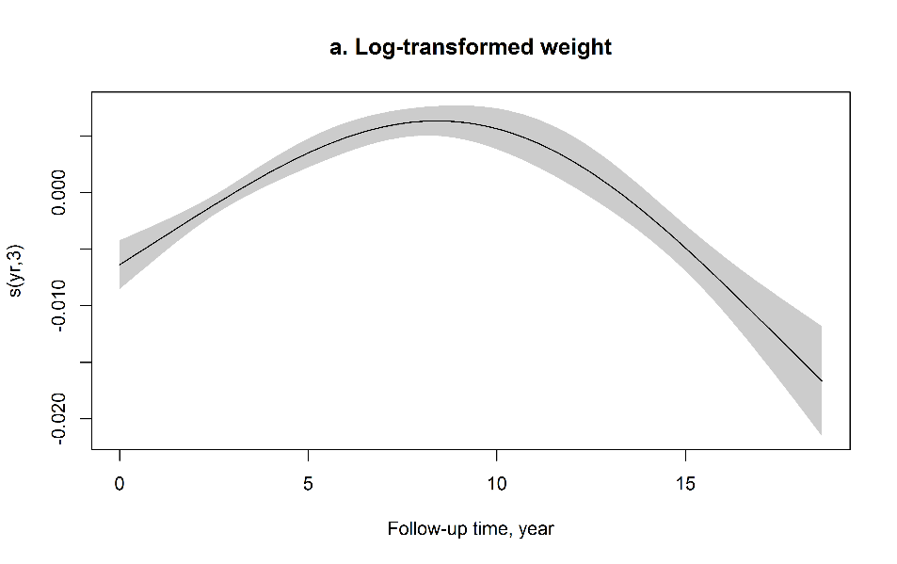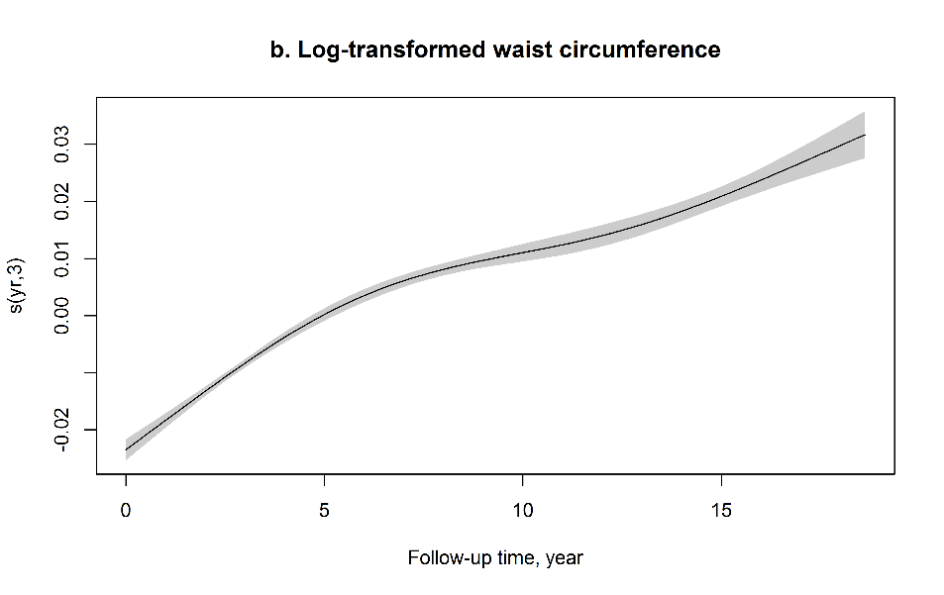
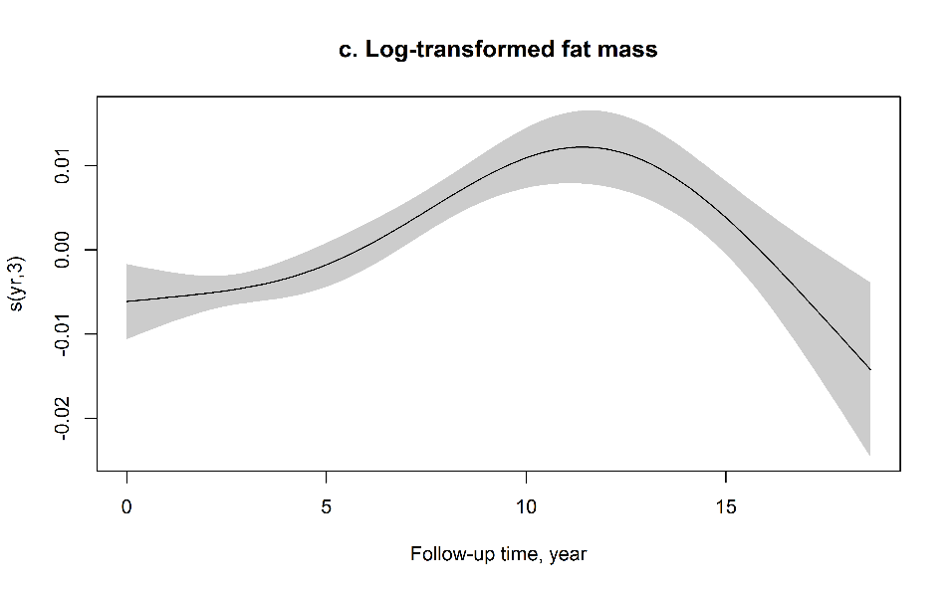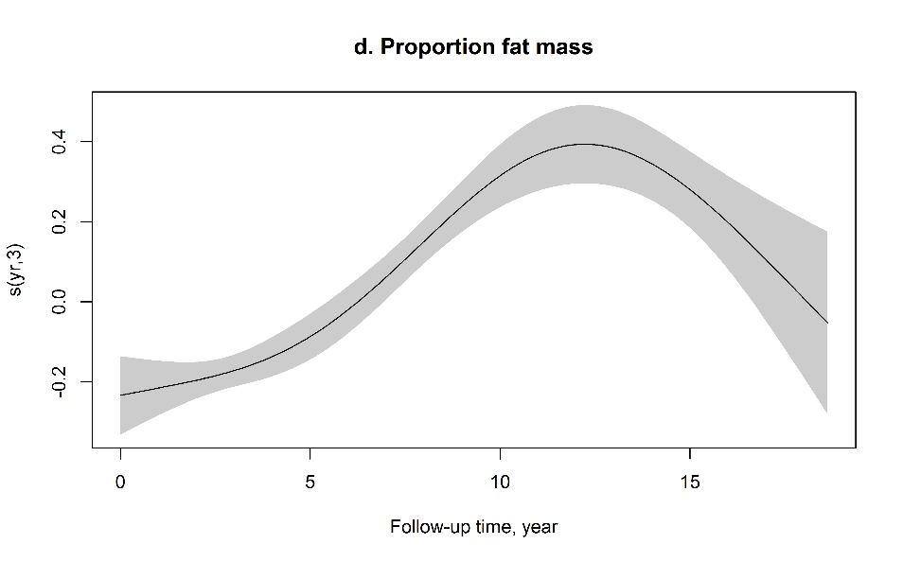Figure S1 Generalized additive mixed models with penalized spline functions of follow-up time (in years) to capture the shape of longitudinal trends of a. log-transformed weight, b. log-transformed waist circumference, c. log-transformed body fat mass, and d. proportion fat mass. Models were adjusted for age at baseline, race, study site, education, financial strain, smoking status, passive smoking, alcohol consumption, total calorie intake, physical activity, and menopausal status.

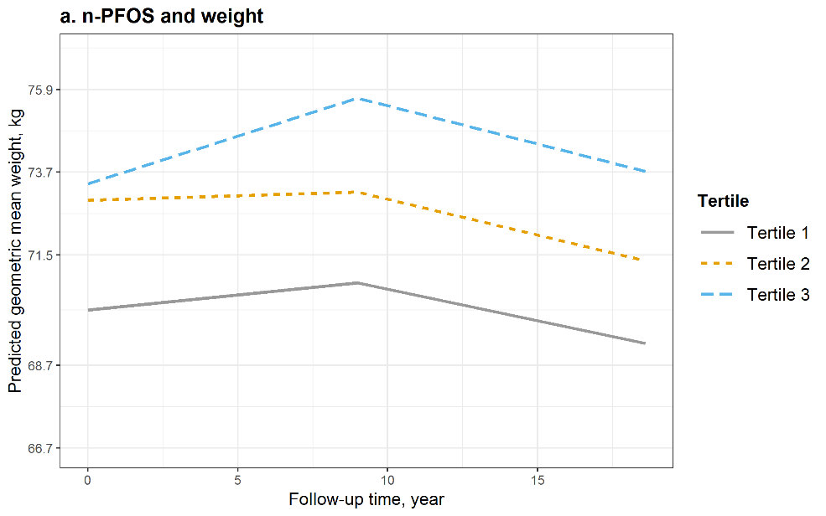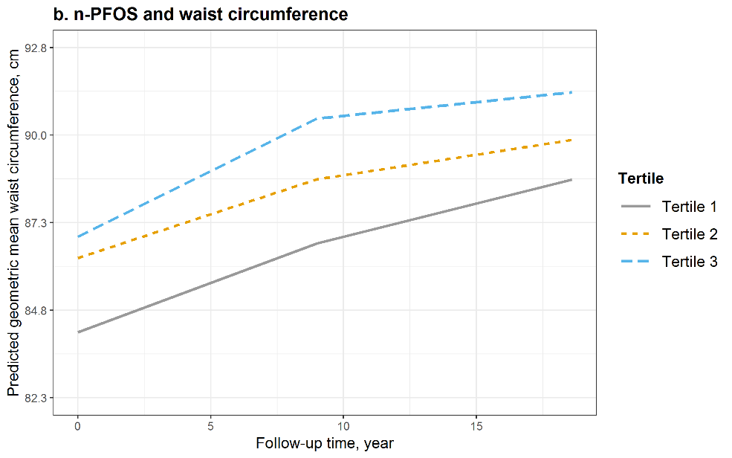
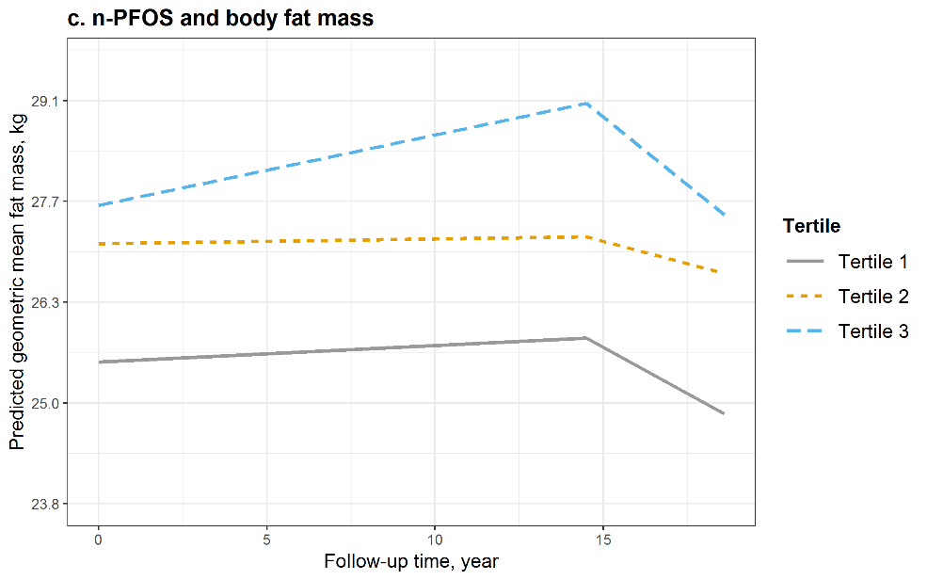 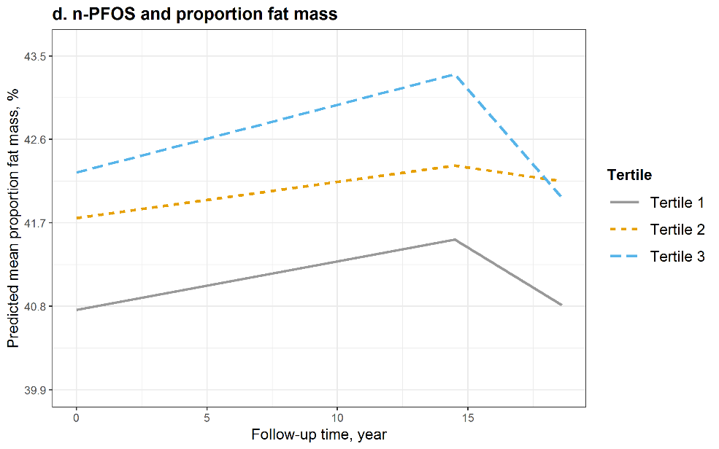 Figure S2 Predicted geometric mean (95% confidence interval, 95% CI) of a. weight, b. waist circumference, c. body fat mass, and d. proportion fat mass by tertiles of serum concentrations of n-PFOS at baseline and during the follow-up. Models were adjusted for age at baseline, race, study site, education, financial strain, smoking status, passive smoking, alcohol consumption, total calorie intake, physical activity, and menopausal status. Medians (ranges) of n-PFOS concentrations by tertiles were 10.6 (1.4, 14.0) ng/mL for tertile 1, 17.4 (14.1, 21.4) ng/mL for tertile 2, and 29.8 (21.5, 250.0) ng/mL for tertile 3.
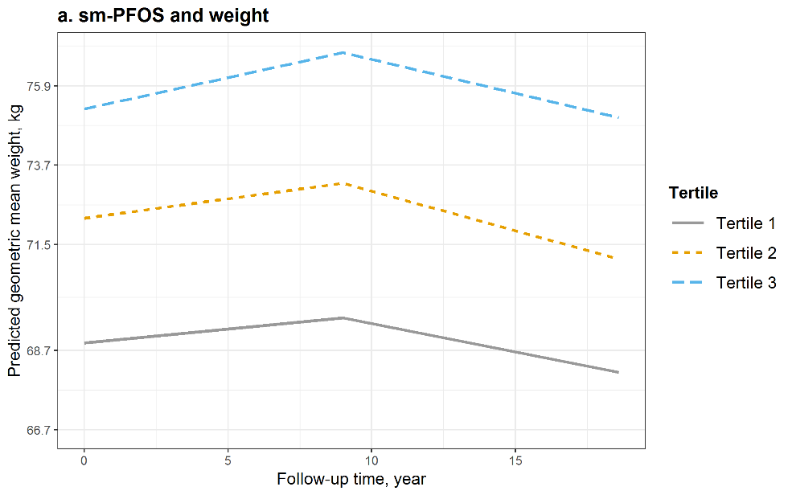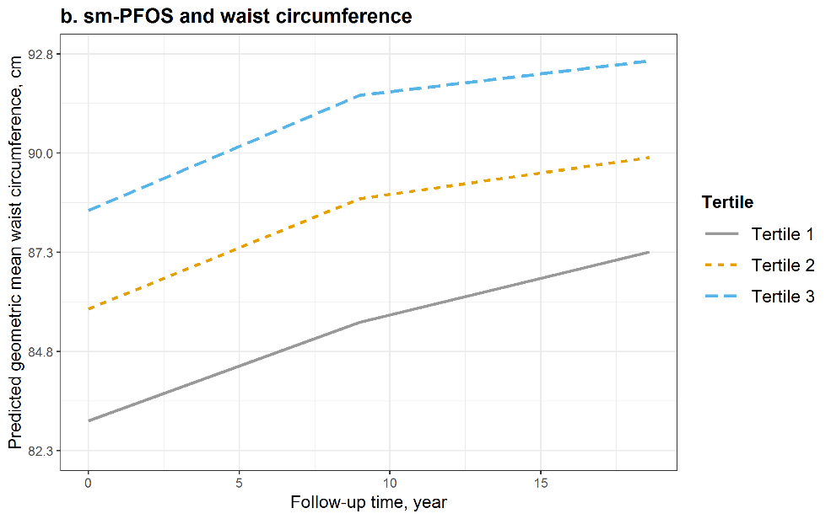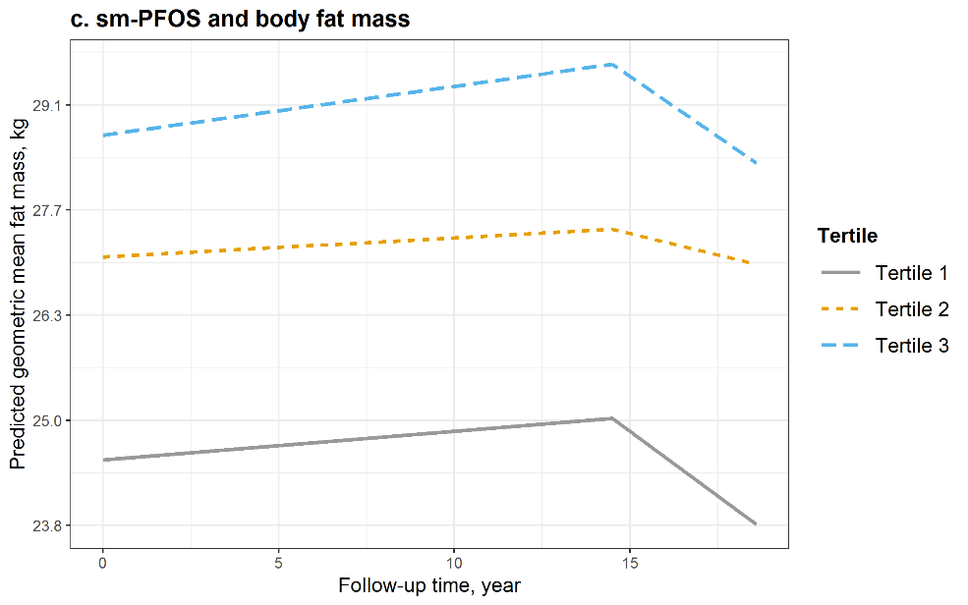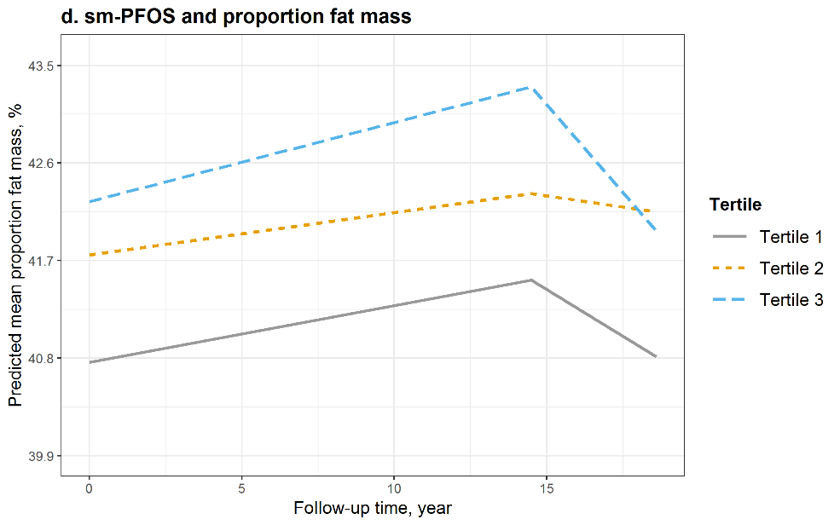
Figure S3 Predicted geometric mean (95% confidence interval, 95% CI) of a. weight, b. waist circumference, c. body fat mass, and d. proportion fat mass by tertiles of serum concentrations of Sm-PFOS at baseline and during the follow-up. Models were adjusted for age at baseline, race, study site, education, financial strain, smoking status, passive smoking, alcohol consumption, total calorie intake, physical activity, and menopausal status. Medians (ranges) of Sm-PFOS concentrations by tertiles were 3.9 (<LOD, 5.5) ng/mL for tertile 1, 7.3 (5.6, 9.2) ng/mL for tertile 2, and 13.3 (9.3, 126.0) ng/mL for tertile 3.
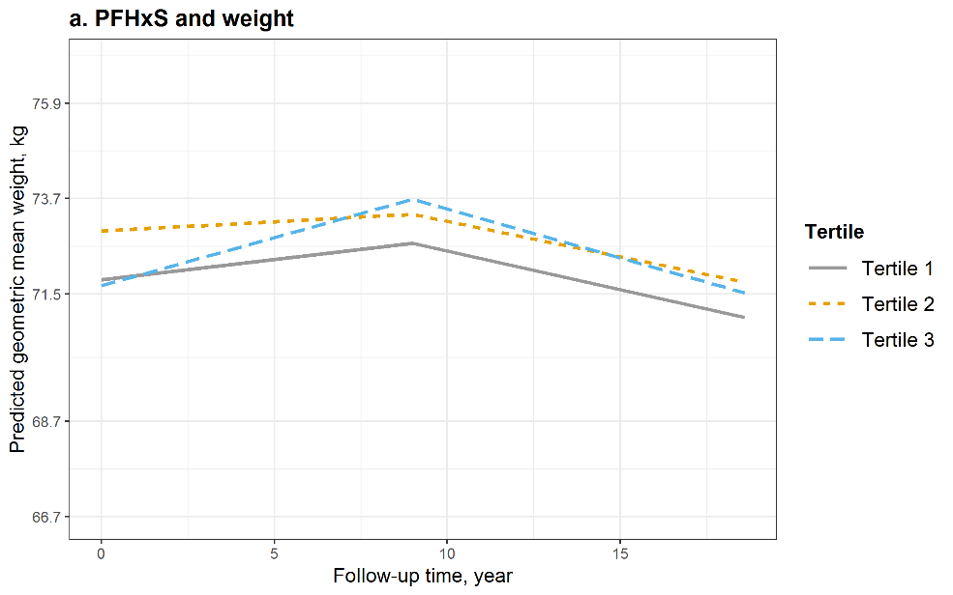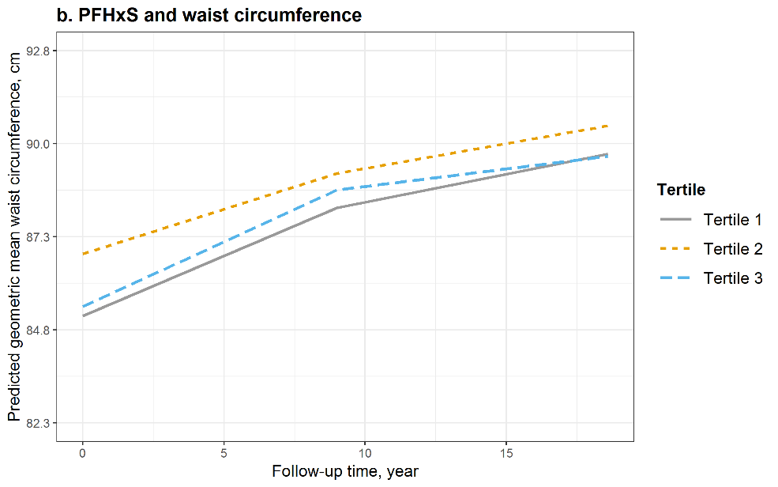 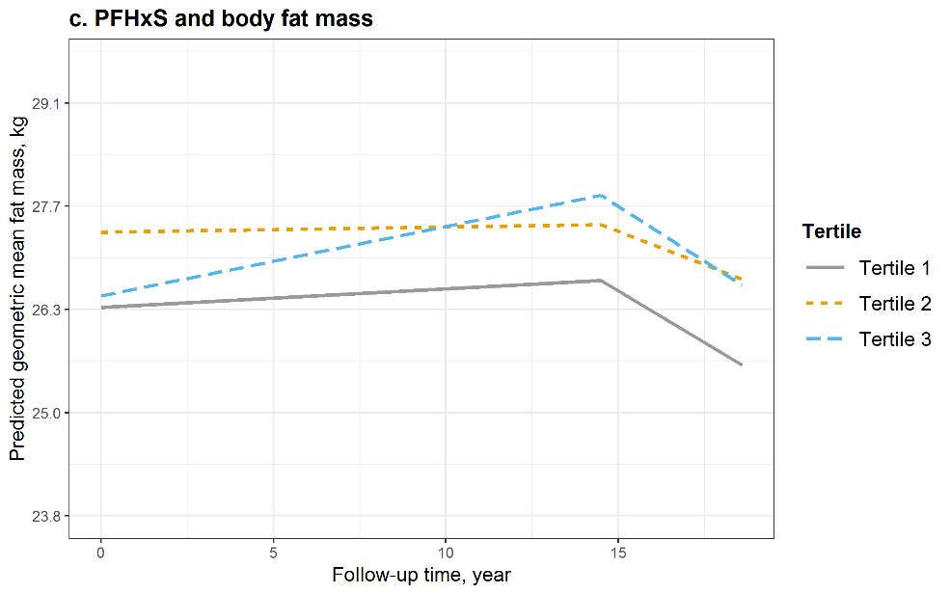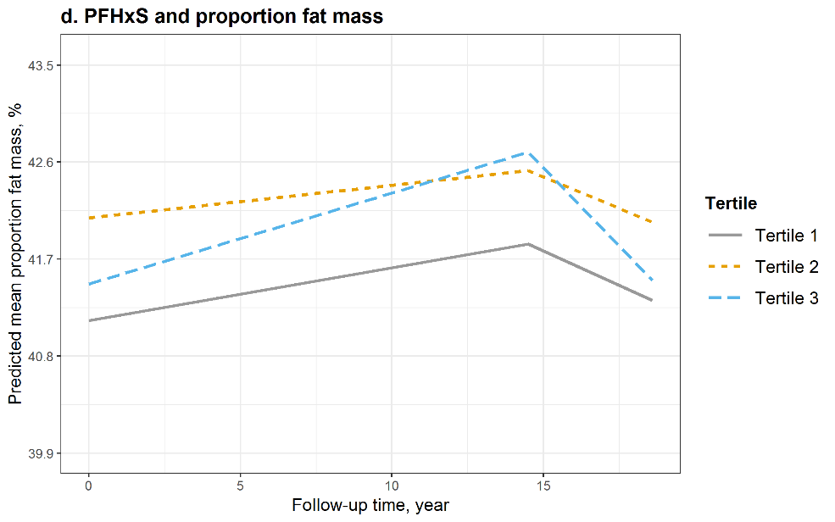Figure S4 Predicted geometric mean (95% confidence interval, 95% CI) of a. weight, b. waist circumference, c. body fat mass, and d. proportion fat mass by tertiles of serum concentrations of PFHxS at baseline and during the follow-up. Models were adjusted for age at baseline, race, study site, education, financial strain, smoking status, passive smoking, alcohol consumption, total calorie intake, physical activity, and menopausal status. Medians (ranges) of PFHxS concentrations by tertiles were 0.8 (<LOD, 1.1) ng/mL for tertile 1, 1.5 (1.2, 1.9) ng/mL for tertile 2, and 3.0 (2.0, 46.5) ng/mL for tertile 3.
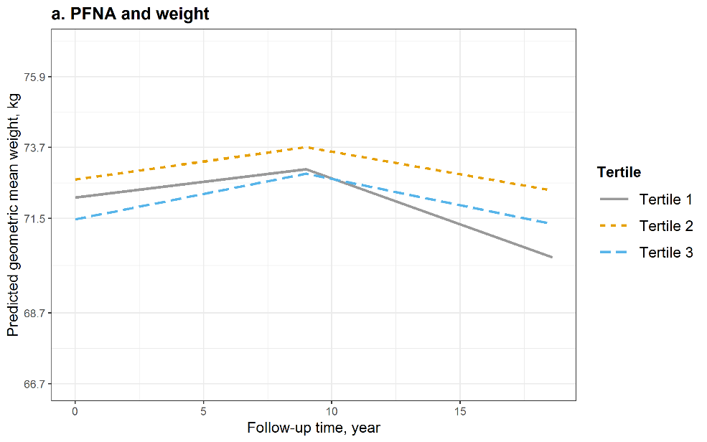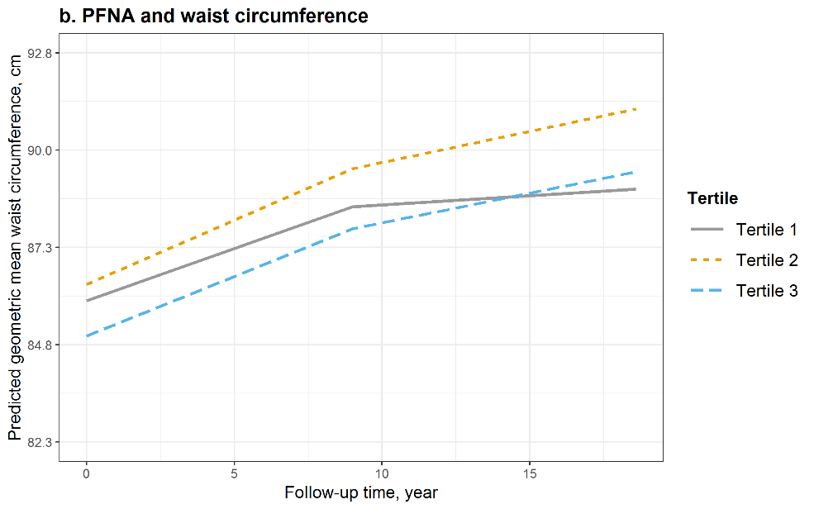 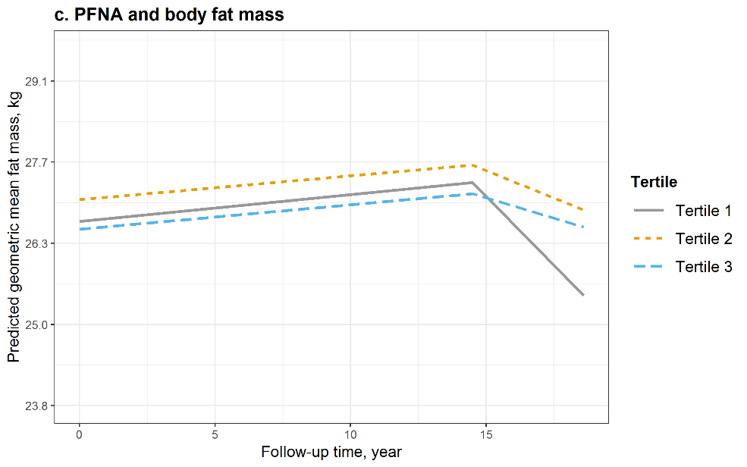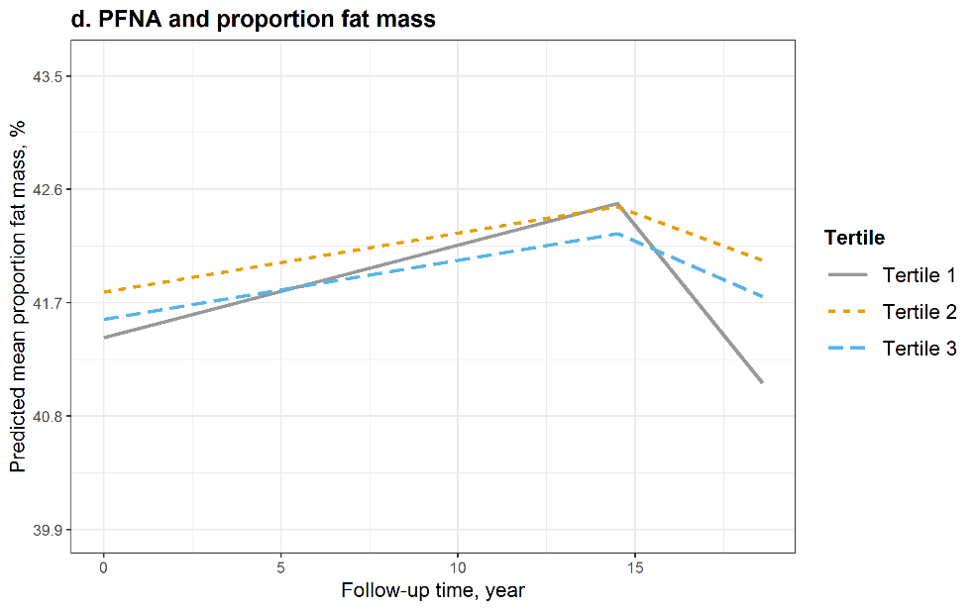Figure S5 Predicted geometric mean (95% confidence interval, 95% CI) of a. weight, b. waist circumference, c. body fat mass, and d. proportion fat mass by tertiles of serum concentrations of PFNA at baseline and during the follow-up. Models were adjusted for age at baseline, race, study site, education, financial strain, smoking status, passive smoking, alcohol consumption, total calorie intake, physical activity, and menopausal status. Medians (ranges) of PFNA concentrations by tertiles were 0.3 (<LOD, 0.4) ng/mL for tertile 1, 0.6 (0.5, 0.7) ng/mL for tertile 2, and 1.0 (0.8, 5.0) ng/mL for tertile 3.

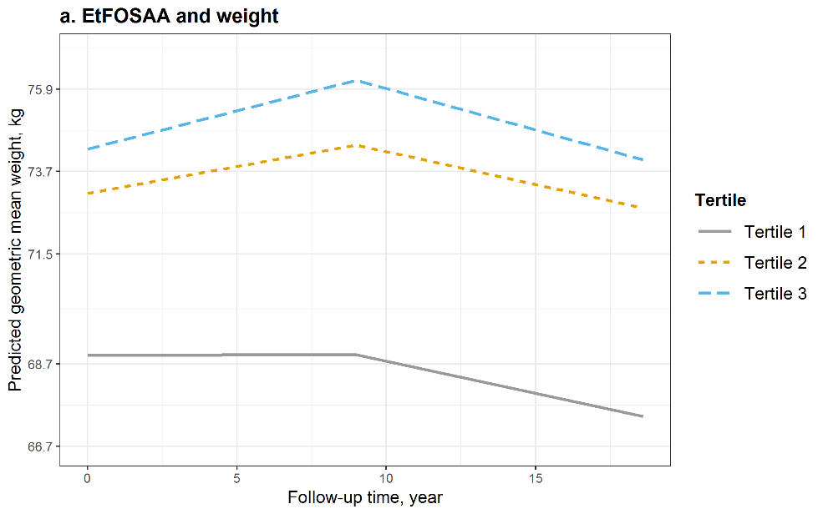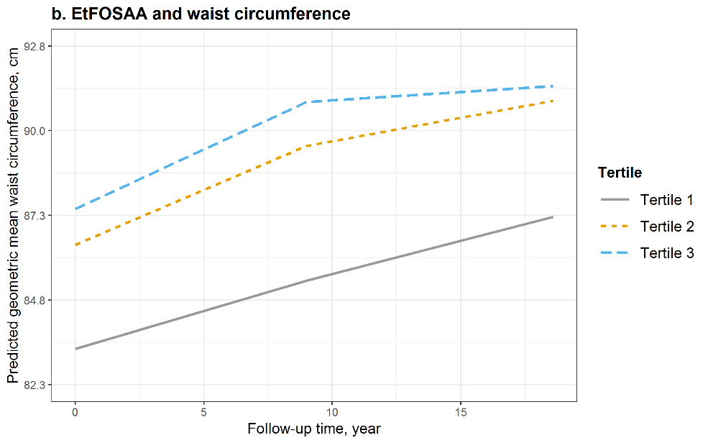 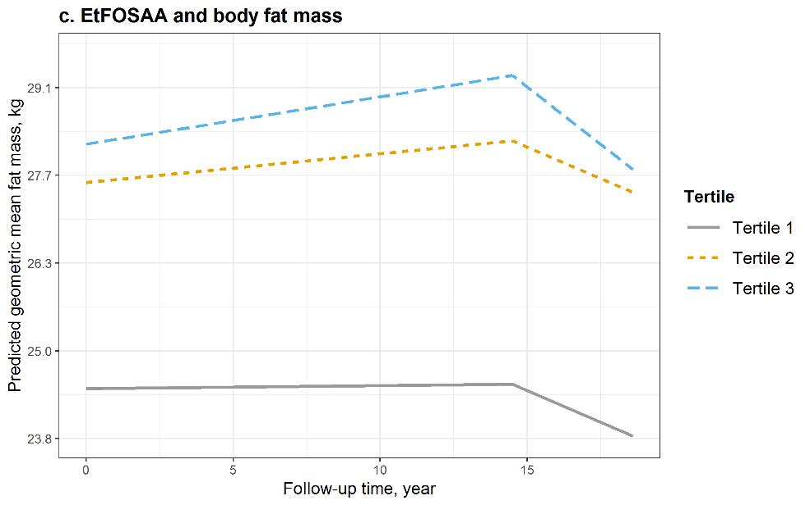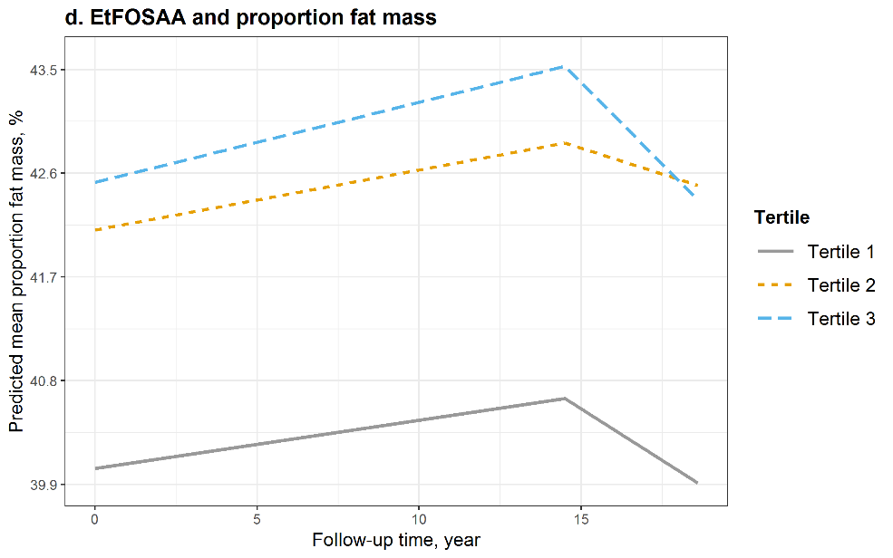Figure S6 Predicted geometric mean (95% confidence interval, 95% CI) of a. weight, b. waist circumference, c. body fat mass, and d. proportion fat mass by tertiles of serum concentrations of EtFOSAA at baseline and during the follow-up. Models were adjusted for age at baseline, race, study site, education, financial strain, smoking status, passive smoking, alcohol consumption, total calorie intake, physical activity, and menopausal status. Medians (ranges) of EtFOSAA concentrations by tertiles were 0.5 (<LOD, 0.7) ng/mL for tertile 1, 1.1 (0.8, 1.7) ng/mL for tertile 2, and 3.0 (1.8, 112.5) ng/mL for tertile 3.
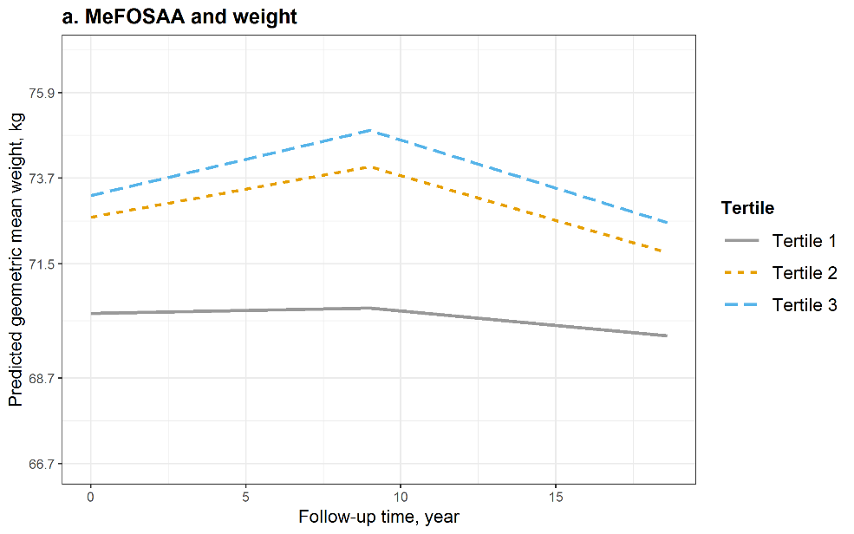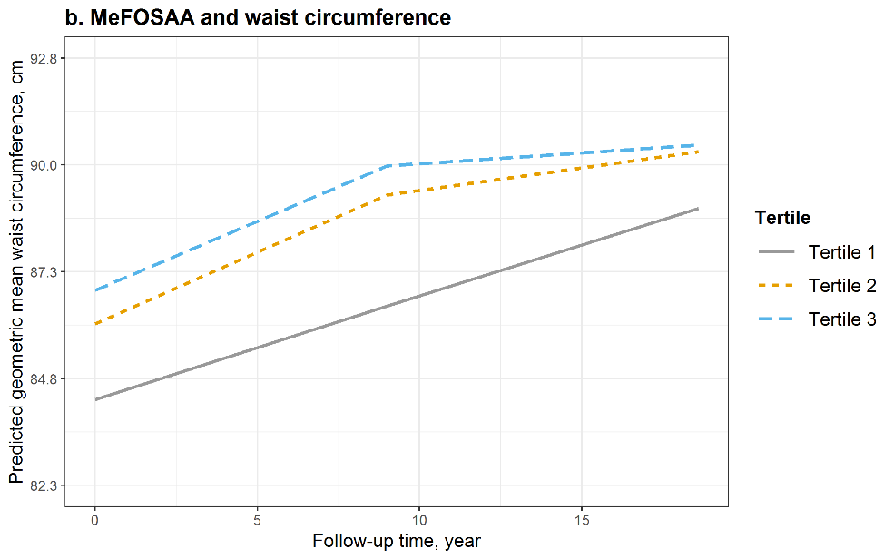 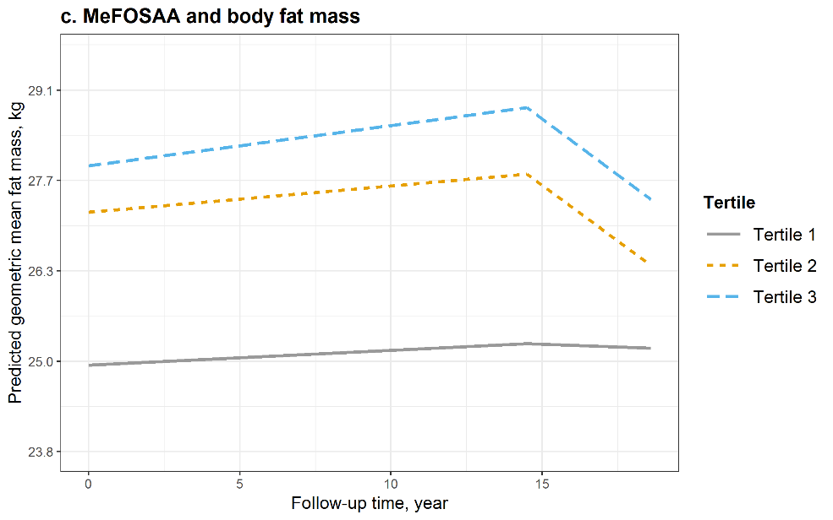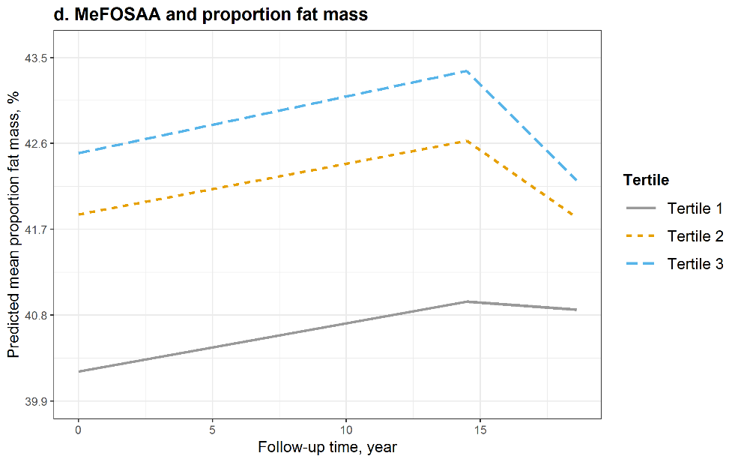Figure S7 Predicted geometric mean (95% confidence interval, 95% CI) of a. weight, b. waist circumference, c. body fat mass, and d. proportion fat mass by tertiles of serum concentrations of MeFOSAA at baseline and during the follow-up. Models were adjusted for age at baseline, race, study site, education, financial strain, smoking status, passive smoking, alcohol consumption, total calorie intake, physical activity, and menopausal status. Medians (ranges) of MeFOSAA concentrations by tertiles were 0.7 (<LOD, 1.0) ng/mL for tertile 1, 1.4 (1.1, 1.9) ng/mL for tertile 2, and 2.8 (2.0, 14.4) ng/mL for tertile 3.

