Efficacy of universal masking for source control and personal protection from simulated respiratory aerosols in a room

Supplemental materials

William G. Lindsley a, Donald H. Beezhold a, Jayme Coyle a, Raymond C. Derk a, Francoise M. Blachere a, Theresa Boots a, Jeffrey S. Reynolds a, Walter G. McKinney a, Erik Sinsel a, and John D. Noti a

a Health Effects Laboratory Division, National Institute for Occupational Safety and Health, Centers for Disease Control and Prevention, Morgantown, West Virginia, USA

Corresponding author:

Dr. William G. Lindsley

National Institute for Occupational Safety and Health (NIOSH)

1000 Frederick Lane, M/S 4020

Morgantown, WV 26508-5402

Email: [wlindsley@cdc.gov](mailto:wlindsley@cdc.gov)

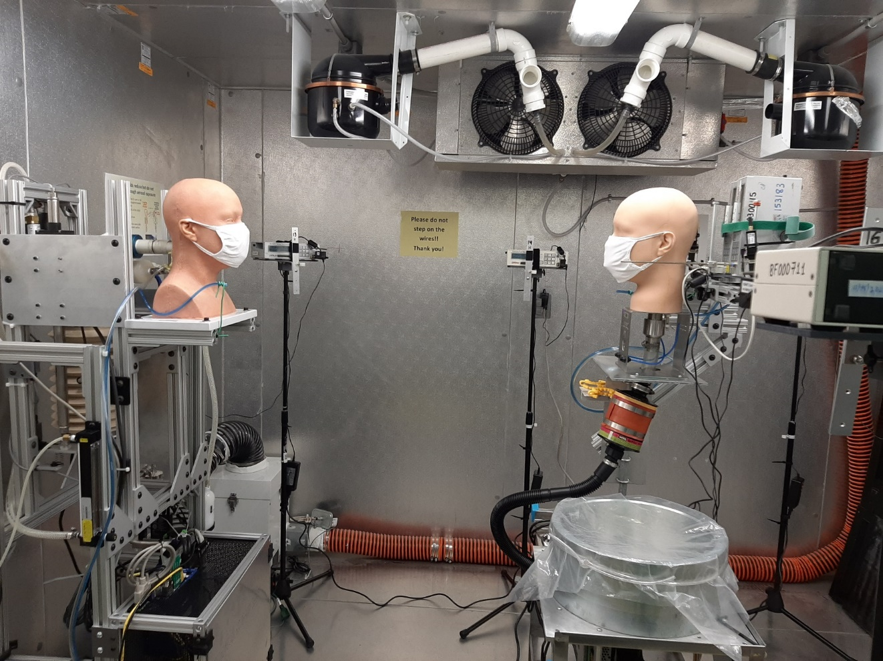

Coughing/breathing aerosol simulator (source)

Breathing simulator

(recipient)

Particle counters

**3 or 6 feet**

Figure S1: Photograph of experimental set-up in the environmental chamber. In this experiment, the source and recipient simulators were front-to-front 0.9 m apart.

(Below) Figure S2: Layout of source simulator, recipient simulator and optical particle counters during experiments with different orientations and separation distances. Dimensions are in inches (1” = 2.54 cm). Drawings are to scale.



|  |  |
| --- | --- |
| **A**  **Source**  **(aerosol simulator)**  **Recipient (breathing simulator)** | **B** |
| **C** | **D** |
| No mask/  no mask  No mask/  cloth mask  Cloth mask/  no mask  Cloth mask/  cloth mask | |

Figure S3: Mean aerosol concentrations at different locations in chamber with simulators 0.9 m apart. The magenta dots indicate the particle counter locations. The bar plots show the mean aerosol concentrations at each location with the source and recipient unmasked or masked as indicated in the legend below the plot. The mean values are reported in µg/m3 and were calculated over 15 minutes. Error bars indicate the standard deviations for three experiments. (A) Source is coughing, simulators are front-to-front. (B) Source is coughing, simulators are side-by-side. (C) Source is breathing, simulators are front-to-front. (D) Source is breathing, simulators are side-by-side.

|  |  |
| --- | --- |
| **A**  **Source**  **(aerosol simulator)**  **Recipient (breathing simulator)** | **B** |
| **C** | **D** |
| No mask/  no mask  No mask/  cloth mask  Cloth mask/  no mask  Cloth mask/  cloth mask | |

Figure S4: Mean aerosol concentrations at different locations in chamber with simulators front-to-back. The magenta dots indicate the particle counter locations. The bar plots show the mean aerosol concentrations at each location with the source and recipient unmasked or masked as indicated in the legend below the plot. The mean values are reported in µg/m3 and were calculated over 15 minutes. Error bars indicate the standard deviations for three experiments. (A) Source is coughing, simulators are 0.9 m apart. (B) Source is coughing, simulators are 1.8 m apart. (C) Source is breathing, simulators are 0.9 m apart. (D) Source is breathing, simulators are 1.8 m apart.