Impacts of changing sexual behavior on chlamydia and gonorrhea burden among US high school students, 2007-2017

Supplementary Digital Content

Steven M. Goodreau^{1,2}, Emily D. Pollock^{1,2}, Li Yan Wang³, Maria V. Aslam⁴, Lisa C. Barrios³, Richard L. Dunville³, Elizabeth M. Rosenthal⁵, Deven T. Hamilton², Eli S. Rosenberg⁵.

- Department of Anthropology, University of Washington, Seattle WA

- Center for Studies in Demography and Ecology, University of Washington, Seattle WA

- Division of Adolescent and School Health, National Center for HIV/AIDS, Viral Hepatitis, STD, and TB Prevention, Centers for Disease Control and Prevention, Atlanta, GA

- Office of the Director, National Center for HIV/AIDS, Viral Hepatitis, STD, and TB Prevention, Centers for Disease Control and Prevention, Atlanta, GA

- Department of Epidemiology and Biostatistics, University at Albany School of Public Health, State University of New York, Rensselaer, NY

Table of Contents

Table S1: Parameter inputs used for simulations 3
Literature review for STI transmission probabilities 6
Table S2: Per-act transmission probabilities for chlamydia and gonorrhea identified in literature search 7
Costs 8
Table S3. Medical costs saved per case of chlamydia and gonorrhea averted (2017 dollars) 8
Regression methods 9
Calibration methods 11
Regression estimates for sexual behavior trends 12
Table S4: Regressions on sexual behavior trends in YRBS 13
Predicted values for behaviors 15
Table S5a: predicted values for all behaviors for female students 15
Table S5b: predicted values for all behaviors for male students 16
Figure S1: Predicted vs. observed values for behavior change measures 17
Partner prevalence ratios 20
Table S6: Partner prevalence ratios (PPRs) 20
Figure S2: Estimated incident cases in the presence and absence of behavior change 21
Credible intervals 22
Table S7a: Credible intervals for NIA and costs saved by year and sex: chlamydia 23
Table S7b: Credible intervals for NIA and costs saved by year and sex: gonorrhea 24

Table S1: Parameter inputs used for simulations
Symbol | Parameter | Female value(s) | Male value(s) |  | Sources
$$E_{s,a,r}$$ | Population size | Product of the three quantities below. Note that observed changes in population size and composition result from annual fluctuations in past birth and migration rates and stochasticity in the YRBS sample. To smooth these, we calculated total HS-attending population and breakdown by age and race/ethnicity, each averaged across surveys, and the grand mean for proportion by sex. We then multiplied these to obtain age-sex-race/ethnicity-year-specific population sizes.
 | - Overall composition by sex | 49.3% | 50.7% |  | Youth Risk Behavior Survey (YRBS); total weights for each sex; averaged across 2007-17 survey years.
 | - Mean size of HS-attending population | 17,139,294 |  |  | US Census Bureau, American Community Survey table B14001: “School enrollment by level of school for the population 3 years and over”; averaged across years 2007-17.
` | - Prop. of HS students by race/ethnicity and age | Age Black Hisp. White  13ª 0.02% 0.02% 0.04%  14 1.62% 2.48% 5.77%  15 3.56% 5.32% 13.98%  16 3.66% 5.18% 14.54%  17 3.27% 4.55% 14.12%  18 2.00% 2.67% 8.25% |  |  | Youth Risk Behavior Survey (YRBS); total weights for each group; averaged across 2007-17 survey years. Note that numbers add to 91% instead of 100% because students may identify as a race/ethnicity other than the three included in this model.
$$D_{s,a,r,y}$$ | Prop. of HS students who report having ever had sex | See Table S5a |  | See Table S5b | Specific values for each age-sex-race/ethnicity-year combination, derived through regressions from YRBS data as described in text
$$p_{s,a,r,y}$$ | STI prevalence | When y=2007, prevalence (in and out of HS) is calculated as follows: initial diagnoses x mean duration of infection/ prop. diagnosed / mean size of the pop. aged 13ª-18. Because STI diagnoses in CDC data are not limited to those in HS, we estimate diagnoses in the 13ª-18-year age range and divide by the total population (in or out of HS) of the same age to obtain an estimate of prevalence. All other subsequent calculations in the model are then limited to HS students only.
 | - Initial diagnoses (in and out of HS) | Chlamydia:  Black: 121,114  Hispanic: 53,418  White: 67,542  Gonorrhea:  Black: 37,199  Hispanic: 5,303  White: 9,495 | Chlamydia:  Black: 33,260  Hispanic: 10,630  White: 8,649  Gonorrhea:  Black: 20,049  Hispanic: 2,475  White: 1,948 |  | Derived from CDC’s 2007 STD Surveillance Report.¹ Since this reports initial diagnoses in fixed age groups (10-14, 15-19), we re-weighted the numbers by age to obtain estimates for the 13ª-18 year age range.
 | - Mean duration of infection (years) | Chlamydia: 0.69  Gonorrhea: 0.46 | Chlamydia: 0.41  Gonorrhea: 0.23 |  | Satterwhite et al. (2013).² See teen-SPARC manual for further information (www.emorycamp.org/teensparc).
 | - Prop. of infections that are diagnosed | Chlamydia: 45.0%  Gonorrhea: 52.3% | Chlamydia: 23.4%  Gonorrhea: 49.0% |  | Owusu-Edusei et al. (2013).³ See teen-SPARC manual for further information (www.emorycamp.org/teensparc). We use proportion diagnosed as a first approximation for the proportion that are reported, recognizing that this is likely biased.
 | - Mean size of the pop. aged 13ª-18, in or out of HS | Black: 1,805,113  Hispanic: 2,677,875  White: 6,875,477 | Black: 1,898,397  Hispanic: 2,816,260  White: 7,230,785 |  | US Census Bureau American Community Survey, table name “Annual Estimates of the Resident Population by Single Year of Age and Sex;” averaged across years 2007-17
 |  | For subsequent years (2008-2017), prevalence is the product of the previous year incidence $I_{s,a,r,y-1}$ and the mean duration of infection listed above. Note that the expression $p_{s,∙,r^{'},y}$ that appears in the equation for incidence entails multiple unique features, since it is referring to the partners of the group whose incidence is being calculated: its value for sex is the opposite for the terms in the remainder of the equation; the dot ($∙$) for age indicates that this quantity should be a weighted average across ages for the relevant sex; and the $r'$ indicates partner race.
$$β_{s}$$ | Prob. of chlamydia or gonorrhea acquisition per act of condomless intercourse with an infected partner | Chlamydia: 0.12  Gonorrhea: 0.50 | Chlamydia: 0.11  Gonorrhea: 0.25 |  | Median of estimates obtained during literature search; see online supplement for full set of citations, with more information in Table S2.
$$τ_{s,r}$$ | Partner prevalence ratio | See Table S6 | See Table S6 |  | Generated as a calibration parameter, as described in the text
$$c_{s,a,r,y}$$ | Num. of condomless acts per year | Function of three quantities: partners x acts x (1 – condom use):
 | - partners per year | See Table S5a | See Table S5b |  | Specific values for each age-sex-race/ethnicity-year combination, derived through regressions from YRBS data as described in text
 | - mean acts of SI per partner | 13ª-15-year-olds: 9.4  16-17-year-olds: 24.7  18-year-olds: 46.7 | 13ª-15-year-olds: 11.9  16-17-year-olds: 19.3  18 -year-olds: 29.3 |  | Derived from the National Survey of Family Growth (NSFG) as described in the teen-SPARC manual (www.emorycamp.org/teensparc). Note that YRBS does not include data on coital frequency.
 | - prob. of condom use | See Table S5a | See Table S5b |  | Specific values for each age-sex-race/ethnicity-year combination, derived through regressions from YRBS data as described in text
 |  | We note that our formula here collapses all across partners, making multiple acts with one partner equivalent to few acts with more partners. This is because, for short, curable STIs like gonorrhea and chlamydia, a single partner might actually move through multiple states (e.g. uninfected, infected, uninfected) over the course of a relationship with one partner. See the teen-SPARC manual (www.emorycamp.org/teensparc) for more discussion.
$$φ_{s,r,r^{'} }$$ | Proportion of partners by race/ethnicity | Black: 88% B, 9% H, 3% W  Hispanic: 11% B, 74% H, 15% W  White: 6% B, 11% H, 83% W | Black: 76% B, 12% H, 12% W  Hispanic: 3% B, 80% H, 17% W  White: 1% B, 9% H, 90% W |  | National Survey of Family Growth (NSFG), 2006-2015. Note that YRBS does not include data on partner race/ethnicity.
ª We included 13-year-olds throughout the process of developing and parameterizing the model. However, their very small size and low rates of sexual activity meant that some of their behavioral estimates showed wide variation from year to year. For this reason, we ultimately excluded them from our final modeling analyses. A comparison including them revealed that the estimates of total infections averted differed by less than 0.03%.
Abbreviations: B = Black, H = Hisp. = Hispanic, W = White, HS = high school
Subscripts: s = sex (with values f = female, m = male), a = age, r = race for index person, $r'$= race for partner; y = year

Literature review for STI transmission probabilities

We conducted a literature review in PubMed for sources estimating per-contact penile-vaginal transmission risk for chlamydia or gonorrhea empirically or through model calibration, and from which estimates are cited and used in the current modeling literature. We used the following keywords in various combinations: Chlamydia trachomatis, Neisseria gonorrhea, transmission, transmissibility, acquisition risk, infection, model. All years and source types present in PubMed were eligible for inclusion. Additionally, any sources that were referenced in the entries found by this search (but not themselves included in the search results) and that estimated or used transmissibility parameters were also evaluated. The most common reason why sources were excluded after initial identification was because they estimated per-partnership transmission risk or yearly acquisition risk, while we were interested in the per-contact risk of transmission. Although we were open to inclusion of sources that produced estimates disaggregated by age or other demographic predictors relevant to our model, no identified sources provided numerical estimates of this type.

Our final set of papers included 20 papers that had estimates for penile-vaginal CT transmissibility,⁴⁻²³ and 16 papers that had estimates for penile-vaginal GC transmissibility.^{5,7-9,11,12,16,20,23-30} Nine of those papers considered both diseases, and thus were included in both analyses. The median and range of values obtained from this literature review are listed in Table S2. One additional paper ³¹ was inadvertently excluded from the set of papers providing chlamydia estimates, a fact identified after the completion of the modeling. We note that this paper provided a joint estimate for female-to-male and male-to-female transmission; their median estimate from their main analysis is 0.095, close to the median of our review and well within the measured range.

Table S2: Per-act transmission probabilities for chlamydia and gonorrhea identified in literature search

STI (n = number of papers identified) | Chlamydia (n = 20) |  |  | Gonorrhea (n = 16)
 | Median | Range |  | Median | Range
Female to male (ins. penile-vaginal) | 0.11 | 0.0375 – 0.45 |  | 0.25 | 0.09 – 0.6
Male to female (rec. penile-vaginal) | 0.12 | 0.049 – 0.45 |  | 0.50 | 0.2 – 0.8

Costs

Our costing methods included 3% annual compounding; for clarity, we present here both the uncompounded and compounded rates. We also include the values used to create a range of uncertainty in the costs (worst-case scenario = 50% of costs caved; best-case scenario = 150% of costs saved).

Table S3. Medical costs saved per case of chlamydia and gonorrhea averted (2017 dollars)
 | Chlamydia
 | Female |  |  |  | Male
 | Uncompounded costs ($) | Compounded costs ($) | Compounded costs (+/- 50%, $) |  | Uncompounded costs ($) | Compounded costs ($) | Compounded costs (+/- 50%, $)
2007-2008 | 445.45 | 581.20 | 290.60-871.81 |  | 36.71 | 47.90 | 23.95-71.85
2008-2009 | 445.45 | 564.28 | 282.14-846.41 |  | 36.71 | 46.51 | 23.25-69.76
2009-2010 | 445.45 | 547.84 | 273.92-821.76 |  | 36.71 | 45.15 | 22.58-67.73
2010-2011 | 445.45 | 531.88 | 265.94-797.83 |  | 36.71 | 43.84 | 21.92-65.75
2011-2012 | 445.45 | 516.39 | 258.20-774.59 |  | 36.71 | 42.56 | 21.28-63.84
2012-2013 | 445.45 | 501.35 | 250.68-752.03 |  | 36.71 | 41.32 | 20.66-61.98
2013-2014 | 445.45 | 486.75 | 243.37-730.12 |  | 36.71 | 40.12 | 20.06-60.18
2014-2015 | 445.45 | 472.57 | 236.29-708.86 |  | 36.71 | 38.95 | 19.47-58.42
2015-2016 | 445.45 | 458.81 | 229.40-688.21 |  | 36.71 | 37.81 | 18.91-56.72
2016-2017 | 445.45 | 445.45 | 222.72-668.17 |  | 36.71 | 36.71 | 18.36-55.07
 | Gonorrhea
 | Female |  |  |  | Male
 | Uncompounded costs ($) | Compounded costs ($) | Compounded costs (+/- 50%, $) |  | Uncompounded costs ($) | Compounded costs ($) | Compounded costs (+/- 50%, $)
2007-2008 | 433.21 | 565.24 | 282.62-847.86 |  | 96.68 | 126.14 | 63.07-189.21
2008-2009 | 433.21 | 548.77 | 274.39-823.16 |  | 96.68 | 122.47 | 61.23-183.70
2009-2010 | 433.21 | 532.79 | 266.40-799.19 |  | 96.68 | 118.90 | 59.45-178.35
2010-2011 | 433.21 | 517.27 | 258.64-775.91 |  | 96.68 | 115.44 | 57.72-173.15
2011-2012 | 433.21 | 502.21 | 251.10-753.31 |  | 96.68 | 112.07 | 56.04-168.11
2012-2013 | 433.21 | 487.58 | 243.79-731.37 |  | 96.68 | 108.81 | 54.40-163.21
2013-2014 | 433.21 | 473.38 | 236.69-710.07 |  | 96.68 | 105.64 | 52.82-158.46
2014-2015 | 433.21 | 459.59 | 229.79-689.38 |  | 96.68 | 102.56 | 51.28-153.85
2015-2016 | 433.21 | 446.20 | 223.10-669.31 |  | 96.68 | 99.58 | 49.79-149.36
2016-2017 | 433.21 | 433.21 | 216.60-649.81 |  | 96.68 | 96.68 | 48.34-145.01
Note. Compounded costs are the future (2017) value of the medical costs saved per case averted in a given year and compounded at 3% annually.

Regression methods

We conducted regressions with each of the three behavioral variables as outcomes and with the four dimensions of behavioral variation (age, sex, race/ethnicity, year) as predictors. We conducted logistic regression for those behaviors with binary outcomes (having ever had SI, of condom use) and Poisson regression for count data (number of new partners per year). We confirmed a lack of over-dispersion for the Poisson regression using Dean’s test. We note that these predictive models serve only to provide smoothed, parametric estimates of mean values of each behavior for each entry in the four-way stratification (sex, age, race/ethnicity, year). The simulation model that these predicted values are used in does not actually track individuals, but only counts of people in different states (i.e. the model is “compartmental” rather than “individual-based”, in the language of epidemic modeling). Thus, for example, the full distribution of the number of new partners per year is never drawn from, as it would be in an individual-based model; we merely use the mean value for each entry in the four-way stratification and apply it as a population average for that group. This means that the exact form of the distribution around the mean is of less significance than it would be for an individual-based model. We also note that these regressions are not designed to identify the proximal or distal causal determinants of the behavioral measures, of which there are many.

For having ever had SI and condom use, we parametrized age as a nominal variable since our data were sufficient to allow this full specification, and we confirmed that the AIC for this model was lower than for two commonly used parametric models that we examined (age as numerical; age and age squared as numerical). Our choices for number of new partners per year were more constrained. This metric was required for model simulation given the nature of this dynamic process with annual steps; however, our data came in the form of current age, age at first sexual intercourse, and lifetime number of partners. We thus back-calculated estimates of number of new partners per year from the partner data provided by all combinations of students by current and first-sex ages (see ref. 32 for details). However, because this method is imperfect, and cannot precisely assign each partner to a specific age, we erred on the side of not over-specifying the model by allowing each age to be estimated separately in the regression. Moreover, this method does not provide a clean estimate for the highest age (here, 18), since respondents have not yet completed that age, and the dynamics of partnership counts per year do not aggregate up neatly from parts of years to years, unlike our other measures, given that partnerships have durations (i.e. it is common for someone to have 1 partner in the last month, 1 partner in the last 6 months, and 1 partner in the last year). We thus required a method that allowed us to extrapolate out through the end of age 18. We compared the same two parametric models as above (age as numerical; age and age squared as numerical), and confirmed that the latter had both lower AIC and greater visual fit to the data. We also note that it has a reasonable interpretation here – although one might expect mean partner numbers per year to increase by age across adolescents, here the measure is conditional on having ever had sex. Thus, the pool of students included in the measure continually increases by age, progressively incorporating students who have their first sex at later ages and are thus less sexually precocious as those included at younger ages. This thus provides a counter-mechanism that could lead to reductions in mean partner counts among those sexually active by age. The two terms (age and age squared) allow for these countervailing processes to both be accounted for.

We included 13-year-olds throughout the process of developing and parameterizing the model, including the regression models. However, their very small size and low rates of sexual activity meant that some of their behavioral estimates showed wide variation from year to year. For this reason, we ultimately excluded them from our final modeling analyses. A comparison including them revealed that the estimates of total infections averted differed by less than 0.03%.

Calibration methods

Calibration was performed in order to obtain reasonable model outcomes in the absence of behavior change. We assumed that such a scenario would have generated stable incidence from year to year. The calibration parameter set comprised the six race- and sex-specific “partner prevalence ratios” (PPR), as described in the main text. Our target data did not disaggregate STI burden (incidence or diagnoses) by the specific age groups used in the model; thus, the calibration process served the second goal of determining a distribution for these that was consistent with overall diagnoses for this age range and with the distributions of sexual behavior by age. For each of the two STIs, the calibration process consisted of the following steps:

- Set a uniform prior range of 0 to 15 for each of the six PPRs.
- Randomly distribute the initial incident cases, as estimated from 2007 and sex- and race-specific diagnosis counts and rates, across ages (but within sex and race/ethnicity groups)
- Conduct a sequential sampling ABC using the Beaumont method,³² as implemented in the R package EasyABC. This consists of running the following steps 13 times, with increasingly strict requirements for the match in incidence across years at each step:
  - Randomly drawing 100 sets of PPRs randomly from the prior distributions
  - Simulating one year of the epidemic using the equation in the main text
  - Calculating incidence for each age-, sex- and race-ethnicity group, and summing across ages.
  - Comparing these age sums to initial incidence data
  - Determining weights for each parameter set as a function of the similarity in incidence numbers across the two years, and generating a new prior distribution.
- Simulate a population forward one year using the best-fitting set of PPRs from the final round of Step 3
- Use the age-specific incidence numbers that resulted from Step 4 as a starting point to conduct another round of ABC all over again, this time comparing age-, race-, and sex-specific incidence across years.
- Adopt the best-fitting set of PPRs from Step 5 for the model.
- Simulate a population forward one year using the selected PPRs to get the starting age- sex- and race-specific incidence numbers.

Regression estimates for sexual behavior trends

Table S4 lists the coefficients from the regression models, as well as the odds ratios (for logistic regression) and incidence rate ratio (for Poisson regression) for all coefficients other than the intercept, for ease of interpretation. All predictors for having ever had SI were significant, with the odds ratio generally increasing with age. The odds ratio for year was significantly below 1, confirming the previous finding of increasingly delayed sexual initiation over time during this decade.³³ The odds ratios below 1 for Hispanic and White students, combined with those above 1 on their interactions with year, suggest that these two groups initially had lower proportions who had ever had intercourse than Black students, but that Black rates subsequently fell faster.

Condom use generally fell with age (with older ages significant and younger ones not, given the latter’s small sample sizes since only those having had sex were included here). Once again, the odds ratio for year was significantly below 1 for both sexes (declining condom use with time), with main effects below 1 for Hispanic and White students (less condom use than Black students initially), but with interaction effects above 1 for each with year (i.e. less steep declines).

Mean number of new partners per year does not show a significant overall decline, even as the incidence rate ratio on year is below 1 for both sexes (as a reminder, this metric is conditional on having ever had sex). The significant increasing effect of age and decreasing effect of age-squared yield an increasing number of partners per year over the age range considered, albeit one that begins to plateau. Interaction effects between race/ethnicity and year are mixed, with statistically significant decreases among Hispanic male students and statistically significant increases among White female students, although both with small effect sizes.

Table S4: Regressions on sexual behavior trends in YRBS

 | a) Having ever had sexual intercourse (SI) ⁽¹⁾
 |  | female students |  |  |  |  | male students
 |  | β coef. | SE | p-value | odds ratio exp(β) |  | est. | SE | p-value | odds ratio exp(β)
Intercept |  | 0.428 | 0.050 | <0.001 |  |  | 0.715 | 0.051 | <0.001
age 13 ⁽²⁾ |  | -2.210 | 0.619 | <0.001 | 0.110 |  | -0.800 | 0.397 | 0.044 | 0.449
age 14 |  | -1.287 | 0.044 | <0.001 | 0.276 |  | -0.978 | 0.043 | <0.001 | 0.376
age 15 |  | -0.630 | 0.030 | <0.001 | 0.533 |  | -0.497 | 0.030 | <0.001 | 0.608
age 16 |  | Ref. |  |  |  |  | Ref.
age 17 |  | 0.459 | 0.029 | <0.001 | 1.582 |  | 0.533 | 0.029 | <0.001 | 1.704
age 18 |  | 0.760 | 0.035 | <0.001 | 2.138 |  | 0.757 | 0.033 | <0.001 | 2.132
year ⁽³⁾ |  | -0.104 | 0.008 | <0.001 | 0.901 |  | -0.091 | 0.008 | <0.001 | 0.913
Black |  | Ref. |  |  |  |  | Ref.
Hispanic |  | -0.528 | 0.063 | <0.001 | 0.590 |  | -0.549 | 0.063 | <0.001 | 0.578
White |  | -0.623 | 0.053 | <0.001 | 0.536 |  | -1.142 | 0.053 | <0.001 | 0.319
Hispanic:year ⁽³⁾ |  | 0.065 | 0.011 | <0.001 | 1.067 |  | 0.028 | 0.010 | 0.007 | 1.028
White:year ⁽³⁾ |  | 0.072 | 0.009 | <0.001 | 1.075 |  | 0.069 | 0.009 | <0.001 | 1.071
 | b) Condom use at last sexual intercourse (SI) ⁽¹⁾
 |  | female students |  |  |  |  | male students
 |  | β coef. | SE | p-value | odds ratio exp(β) |  | est. | SE | p-value | odds ratio exp(β)
Intercept |  | 0.562 | 0.070 | <0.001 |  |  | 1.263 | 0.073 | <0.001
age 13 ⁽²⁾ |  | -2.014 | 1.625 | 0.215 | 0.133 |  | -- ⁽²⁾ | -- ⁽²⁾ | -- ⁽²⁾ | -- ⁽²⁾
age 14 |  | 0.205 | 0.081 | 0.011 | 1.228 |  | 0.078 | 0.084 | 0.350 | 1.081
age 15 |  | 0.124 | 0.050 | 0.013 | 1.132 |  | 0.068 | 0.053 | 0.199 | 1.070
age 16 |  | Ref. |  |  |  |  | Ref.
age 17 |  | -0.119 | 0.042 | 0.004 | 0.888 |  | -0.111 | 0.045 | 0.013 | 0.895
age 18 |  | -0.349 | 0.047 | <0.001 | 0.705 |  | -0.327 | 0.048 | <0.001 | 0.721
year ⁽³⁾ |  | -0.048 | 0.012 | <0.001 | 0.953 |  | -0.040 | 0.012 | 0.001 | 0.961
Black |  | Ref. |  |  |  |  | Ref.
Hispanic |  | -0.261 | 0.090 | 0.004 | 0.770 |  | -0.412 | 0.091 | <0.001 | 0.662
White |  | -0.138 | 0.073 | 0.060 | 0.871 |  | -0.249 | 0.077 | 0.001 | 0.780
Hispanic:year ⁽³⁾ |  | 0.034 | 0.016 | 0.028 | 1.035 |  | 0.031 | 0.016 | 0.050 | 1.031
White:year ⁽³⁾ |  | 0.034 | 0.013 | 0.011 | 1.035 |  | -0.004 | 0.014 | 0.771 | 0.996
 | c) Number of new partners per year ⁽¹⁾
 |  | female students |  |  |  |  | male students
 |  | β coef. | SE | p-value | inc.rate ratio exp(β) |  | est. | SE | p-value | inc.rate ratio exp(β)
Intercept |  | -7.246 | 0.836 | <0.001 |  |  | -5.269 | 0.713 | <0.001
age |  | 1.012 | 0.112 | <0.001 | 2.751 |  | 0.740 | 0.096 | <0.001 | 2.096
age squared |  | -0.033 | 0.004 | <0.001 | 0.968 |  | -0.024 | 0.003 | <0.001 | 0.976
year ⁽³⁾ |  | -0.007 | 0.004 | 0.058 | 0.993 |  | -0.001 | 0.003 | 0.776 | 0.999
Black |  | Ref. |  |  |  |  | Ref.
Hispanic |  | -0.066 | 0.029 | 0.024 | 0.936 |  | 0.048 | 0.024 | 0.044 | 1.049
White |  | -0.010 | 0.023 | 0.658 | 0.990 |  | -0.023 | 0.020 | 0.246 | 0.977
Hispanic:year ⁽³⁾ |  | -0.004 | 0.005 | 0.470 | 0.996 |  | -0.014 | 0.004 | 0.001 | 0.986
White:year ⁽³⁾ |  | 0.010 | 0.004 | 0.027 | 1.010 |  | 0.000 | 0.004 | 0.975 | 1.000
(1) Reference categories were Black (for all analyses) and age 16 (for analyses A and B)
(2) We included 13-year-olds throughout the process of developing and parameterizing the model. However, their very small size and low rates of sexual activity meant that some of their behavioral estimates showed wide variation from year to year. For example, condom use was reported by 100% of the nine 13-year old male students who answered the question and had complete data for other relevant questions (i.e. race); thus no finite coefficient could be estimated. We ultimately excluded 13-year-olds from our final modeling analyses, but we include them in this table and throughout the description of the methods as relevant for the sake of transparency.
(3) Year is recoded as calendar year minus 2007, and thus ranges from 0 to 10.

Predicted values for behaviors

The statistical models laid out in the previous section yield predicted values for each of the three relevant behaviors, for each combination of age by sex by race/ethnicity by year in our model. We present these predicted values here, in Table S5a (female students) and S5b (male students).

Table S5a: predicted values for all behaviors for female students

 |  | Proportion reporting having ever had SI |  |  |  |  |  |  | Proportion reporting condom use at last SI |  |  |  |  |  |  | Mean number of new partners per year¹
 | Age | 2007 | 2009 | 2011 | 2013 | 2015 | 2017 |  | 2007 | 2009 | 2011 | 2013 | 2015 | 2017 |  | 2007 | 2009 | 2011 | 2013 | 2015 | 2017
Black female HS students | 14 | 0.298 | 0.256 | 0.219 | 0.185 | 0.156 | 0.131 |  | 0.683 | 0.662 | 0.640 | 0.618 | 0.595 | 0.572 |  | 1.422 | 1.401 | 1.381 | 1.362 | 1.342 | 1.323
 | 15 | 0.450 | 0.399 | 0.350 | 0.305 | 0.263 | 0.225 |  | 0.665 | 0.644 | 0.621 | 0.599 | 0.576 | 0.552 |  | 1.480 | 1.459 | 1.438 | 1.418 | 1.398 | 1.378
 | 16 | 0.605 | 0.555 | 0.503 | 0.452 | 0.401 | 0.352 |  | 0.637 | 0.615 | 0.592 | 0.569 | 0.545 | 0.522 |  | 1.441 | 1.421 | 1.400 | 1.380 | 1.361 | 1.341
 | 17 | 0.708 | 0.664 | 0.616 | 0.566 | 0.514 | 0.462 |  | 0.609 | 0.586 | 0.563 | 0.539 | 0.515 | 0.492 |  | 1.312 | 1.294 | 1.275 | 1.257 | 1.239 | 1.221
 | 18 | 0.766 | 0.727 | 0.684 | 0.638 | 0.589 | 0.538 |  | 0.553 | 0.529 | 0.506 | 0.482 | 0.458 | 0.435 |  | 1.117 | 1.102 | 1.086 | 1.070 | 1.055 | 1.040
Hispanic female HS students | 14 | 0.200 | 0.188 | 0.177 | 0.166 | 0.155 | 0.146 |  | 0.624 | 0.618 | 0.611 | 0.605 | 0.599 | 0.592 |  | 1.331 | 1.302 | 1.273 | 1.246 | 1.219 | 1.192
 | 15 | 0.325 | 0.309 | 0.293 | 0.277 | 0.262 | 0.247 |  | 0.605 | 0.598 | 0.592 | 0.586 | 0.579 | 0.573 |  | 1.385 | 1.355 | 1.326 | 1.297 | 1.269 | 1.241
 | 16 | 0.475 | 0.456 | 0.437 | 0.418 | 0.400 | 0.382 |  | 0.575 | 0.568 | 0.562 | 0.555 | 0.549 | 0.542 |  | 1.349 | 1.319 | 1.291 | 1.263 | 1.235 | 1.209
 | 17 | 0.589 | 0.570 | 0.551 | 0.532 | 0.513 | 0.494 |  | 0.545 | 0.539 | 0.532 | 0.526 | 0.519 | 0.512 |  | 1.228 | 1.201 | 1.175 | 1.150 | 1.125 | 1.101
 | 18 | 0.659 | 0.642 | 0.624 | 0.606 | 0.588 | 0.569 |  | 0.488 | 0.481 | 0.475 | 0.468 | 0.462 | 0.455 |  | 1.046 | 1.023 | 1.001 | 0.979 | 0.958 | 0.937
White female HS students | 14 | 0.185 | 0.176 | 0.167 | 0.159 | 0.150 | 0.142 |  | 0.652 | 0.646 | 0.640 | 0.633 | 0.627 | 0.620 |  | 1.407 | 1.414 | 1.421 | 1.427 | 1.434 | 1.441
 | 15 | 0.305 | 0.292 | 0.279 | 0.266 | 0.254 | 0.243 |  | 0.634 | 0.627 | 0.621 | 0.614 | 0.608 | 0.601 |  | 1.465 | 1.472 | 1.479 | 1.486 | 1.493 | 1.500
 | 16 | 0.451 | 0.436 | 0.421 | 0.405 | 0.390 | 0.376 |  | 0.605 | 0.598 | 0.591 | 0.585 | 0.578 | 0.571 |  | 1.427 | 1.433 | 1.440 | 1.447 | 1.454 | 1.460
 | 17 | 0.566 | 0.550 | 0.535 | 0.519 | 0.503 | 0.488 |  | 0.576 | 0.569 | 0.562 | 0.555 | 0.549 | 0.542 |  | 1.299 | 1.305 | 1.311 | 1.317 | 1.324 | 1.330
 | 18 | 0.638 | 0.623 | 0.608 | 0.593 | 0.578 | 0.563 |  | 0.519 | 0.512 | 0.505 | 0.498 | 0.491 | 0.484 |  | 1.106 | 1.111 | 1.117 | 1.122 | 1.127 | 1.132
 |  | HS = high school. SI = sexual intercourse.
 |  | ¹ Mean number of new partners per year is calculated among (and applied in the model to) only those HS students who have ever had sexual intercourse.

Table S5b: predicted values for all behaviors for male students

 |  | Proportion reporting having ever had SI |  |  |  |  |  |  | Proportion reporting condom use at last SI |  |  |  |  |  |  | Mean number of new partners per year¹
 | Age | 2007 | 2009 | 2011 | 2013 | 2015 | 2017 |  | 2007 | 2009 | 2011 | 2013 | 2015 | 2017 |  | 2007 | 2009 | 2011 | 2013 | 2015 | 2017
Black male HS students | 14 | 0.435 | 0.390 | 0.348 | 0.308 | 0.270 | 0.236 |  | 0.793 | 0.779 | 0.765 | 0.750 | 0.735 | 0.719 |  | 1.346 | 1.343 | 1.341 | 1.339 | 1.337 | 1.334
 | 15 | 0.554 | 0.509 | 0.463 | 0.418 | 0.375 | 0.333 |  | 0.791 | 0.777 | 0.763 | 0.749 | 0.733 | 0.717 |  | 1.388 | 1.385 | 1.383 | 1.381 | 1.378 | 1.376
 | 16 | 0.671 | 0.630 | 0.587 | 0.542 | 0.496 | 0.451 |  | 0.779 | 0.765 | 0.751 | 0.736 | 0.720 | 0.703 |  | 1.363 | 1.360 | 1.358 | 1.356 | 1.353 | 1.351
 | 17 | 0.777 | 0.744 | 0.708 | 0.668 | 0.627 | 0.583 |  | 0.760 | 0.745 | 0.729 | 0.713 | 0.697 | 0.680 |  | 1.274 | 1.272 | 1.270 | 1.268 | 1.266 | 1.264
 | 18 | 0.813 | 0.784 | 0.752 | 0.716 | 0.678 | 0.637 |  | 0.718 | 0.702 | 0.685 | 0.667 | 0.649 | 0.631 |  | 1.135 | 1.133 | 1.131 | 1.129 | 1.127 | 1.125
Hispanic male HS students | 14 | 0.307 | 0.281 | 0.256 | 0.233 | 0.211 | 0.191 |  | 0.717 | 0.713 | 0.709 | 0.705 | 0.701 | 0.697 |  | 1.412 | 1.371 | 1.332 | 1.293 | 1.255 | 1.219
 | 15 | 0.418 | 0.387 | 0.358 | 0.329 | 0.302 | 0.276 |  | 0.715 | 0.711 | 0.707 | 0.703 | 0.699 | 0.695 |  | 1.456 | 1.414 | 1.373 | 1.333 | 1.295 | 1.257
 | 16 | 0.541 | 0.510 | 0.478 | 0.447 | 0.416 | 0.385 |  | 0.701 | 0.697 | 0.693 | 0.689 | 0.685 | 0.681 |  | 1.430 | 1.389 | 1.348 | 1.309 | 1.271 | 1.235
 | 17 | 0.668 | 0.639 | 0.610 | 0.579 | 0.548 | 0.516 |  | 0.677 | 0.673 | 0.669 | 0.664 | 0.660 | 0.656 |  | 1.337 | 1.299 | 1.261 | 1.224 | 1.189 | 1.154
 | 18 | 0.716 | 0.689 | 0.661 | 0.632 | 0.602 | 0.572 |  | 0.628 | 0.624 | 0.619 | 0.615 | 0.610 | 0.606 |  | 1.191 | 1.156 | 1.123 | 1.090 | 1.059 | 1.028
White male HS students | 14 | 0.197 | 0.190 | 0.183 | 0.177 | 0.170 | 0.164 |  | 0.749 | 0.732 | 0.714 | 0.696 | 0.677 | 0.658 |  | 1.315 | 1.312 | 1.310 | 1.307 | 1.305 | 1.302
 | 15 | 0.284 | 0.275 | 0.266 | 0.257 | 0.249 | 0.241 |  | 0.747 | 0.730 | 0.712 | 0.694 | 0.675 | 0.655 |  | 1.356 | 1.353 | 1.351 | 1.348 | 1.345 | 1.343
 | 16 | 0.395 | 0.384 | 0.374 | 0.363 | 0.353 | 0.343 |  | 0.734 | 0.716 | 0.698 | 0.679 | 0.660 | 0.640 |  | 1.331 | 1.329 | 1.326 | 1.324 | 1.321 | 1.319
 | 17 | 0.526 | 0.515 | 0.504 | 0.493 | 0.482 | 0.470 |  | 0.711 | 0.693 | 0.674 | 0.655 | 0.634 | 0.614 |  | 1.245 | 1.243 | 1.240 | 1.238 | 1.236 | 1.233
 | 18 | 0.582 | 0.571 | 0.560 | 0.549 | 0.537 | 0.526 |  | 0.665 | 0.645 | 0.625 | 0.604 | 0.583 | 0.562 |  | 1.109 | 1.107 | 1.104 | 1.102 | 1.100 | 1.098
 |  | HS = high school. SI = sexual intercourse.
 |  | ¹ Mean number of new partners per year is calculated among (and applied in the model to) only those HS students who have ever had sexual intercourse.

Figure S1: Predicted vs. observed values for behavior change measures

A) Proportion of male HS students reporting having ever had SI is shown (proportion of female HS students reporting having ever had SI is shown in the paper body as an example)
B) Mean number of new partners per year for female HS students
C) Mean number of new partners per year for male HS students
D) Condom use at last sex for female HS students
E) Condom use at last sex for male HS students

A.
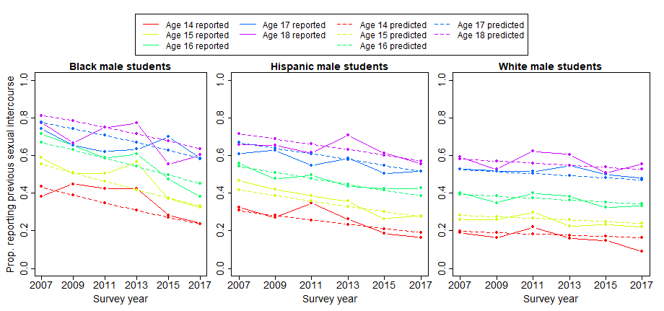

B.
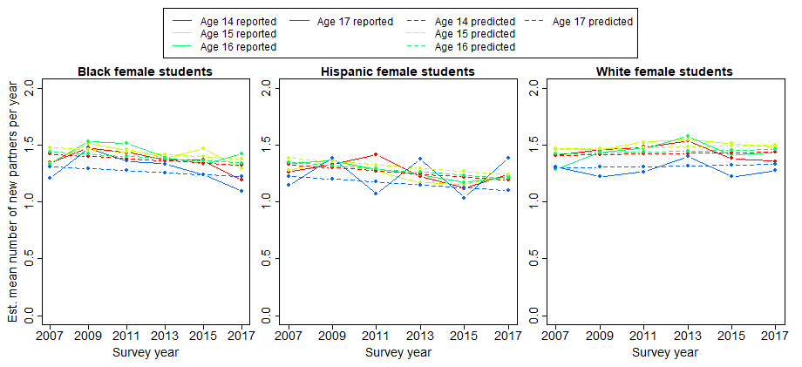

C.
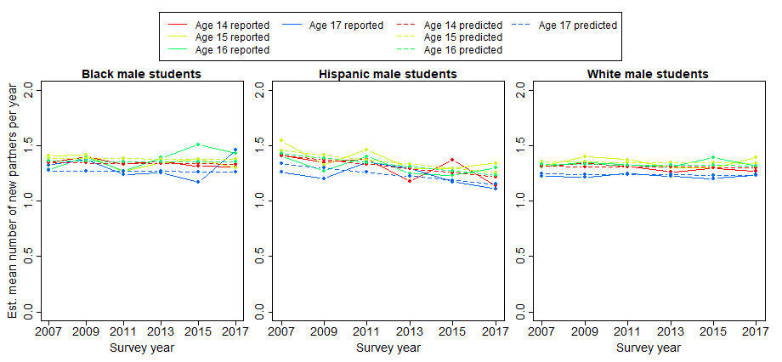

D.
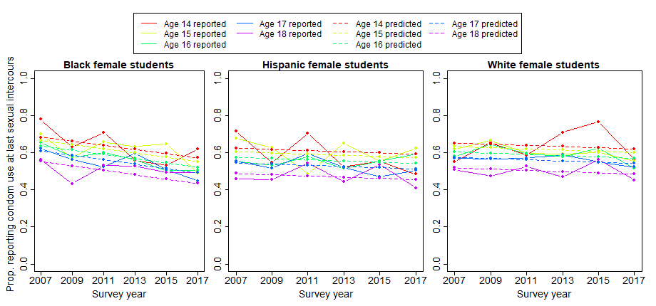

E.
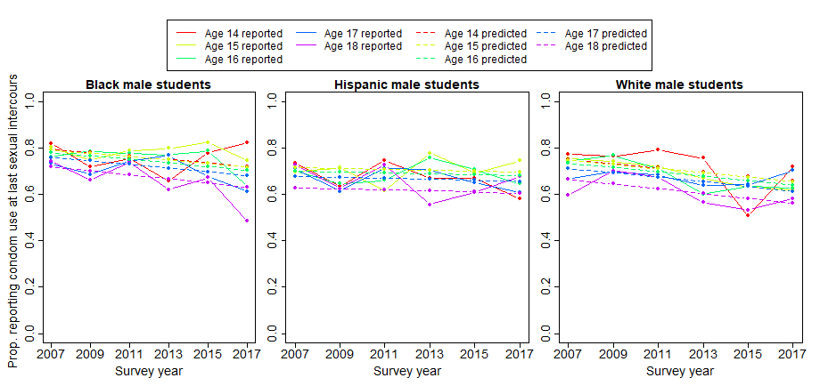

Partner prevalence ratios

Partner prevalence ratios emerged during the process of calibration as the unique set of values that generated stable diagnoses in the presence of stable behaviors. They are listed in Table S6. As described in the main text, they represent the ratio between STI prevalence for a given group’s actual sexual partners to that of the HS student population of the appropriate sex and with the same race composition as those partners. For instance, the PPR for Hispanic female students for gonorrhea is 1.52, meaning that gonorrhea prevalence among their partner pool is 52% higher than among the HS-attending male students in the model at any given timepoint, weighted by the partner race/ethnicity reported by Hispanic female students. Such discrepancies come from at least two reasonable sources. First, actual sexual partnering likely violates our assumption of random age mixing among adolescents with no partners outside the age range. Second, high variations in sexual partnering rates among individuals (including some with no partners) means that some individuals are over-represented in the partner pool, with those over-represented also being those most likely to be infected. The PPRs by sex and race/ethnicity follow clear patterns: PPRs for female students are consistently higher than for their male counterparts of the same race/ethnicity, and values consistently decline from Black to Hispanic to White adolescents. This is consistent with younger female students disproportionately partnering with older males, a widespread observation across many settings.³⁴⁻³⁸ It is also consistent with males exhibiting higher variance in partner numbers than females; this is also a commonly observed pattern.³⁹⁻⁴¹ Finally, the pattern suggests highest levels of one or both of these phenomena among Black students, intermediate among Hispanic students, and lowest among White students.

Table S6: Partner prevalence ratios (PPRs)

 |  | Black | Hispanic | White
Chlamydia | female | 10.14 | 8.15 | 7.78
 | male | 2.73 | 1.36 | 1.09
Gonorrhea | female | 2.88 | 1.52 | 2.10
 | male | 1.88 | 0.89 | 0.65

Figure S2: Estimated incident cases in the presence and absence of behavior change

To aid the reader in understanding the nature of the model, we include an example plot for the incident cases in the presence and absence of behavior change; this represents the underlying data from which the number of infections averted (NIA) and proportion of infections averted (PIA) are then calculated. We provide sex- and race/ethnicity-specific outcomes by year for gonorrhea.

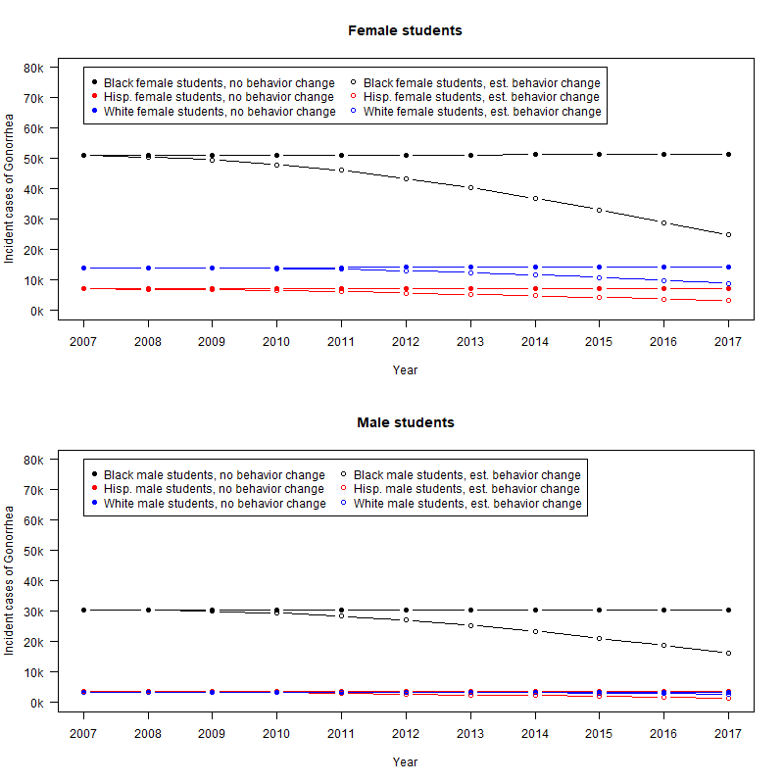

Credible intervals

For the numbers in Table 1 of the main manuscript, we generated credible intervals by generating new estimates of each of the three behaviors for every combination of age, sex/ race/ethnicity and year, 100 times over. We then reran both the observed and counterfactual (no behavior change) scenarios for each of these 100 behavioral models. Full details of the process are:

- Determine the variance/covariace matrix among the beta coefficients from each of the regressions, using the R function stats:vcov

- Sample 100 new possible sets of coefficients from the model, by drawing from the multivariate-normal distribution with means equal to the point estimates of the beta coefficients from the regression, and the variance/covariance as calculated in step 1. This method assumes that the probability distribution for coefficient values is indeed approximated by a multivariate normal distribution. For this step, we use the R function MASS:mvrnorm.

- Use these coefficients to calculate new predicted values for each of the behavioral measures for each of the age-sex-race/ethnicity-year combinations.

- Rerun both the base and behavior-change models with each of the sets of predicted values sets from Step 3.

- Recalculate the NIA and PIA for each set of 100 simulation pairs.

- Constructed credible intervals (CrI) as the central 95% of results, listed in Table S7a.

Because this method occurs after calibration, it likely overstates uncertainty considerably, although this is partly counteracted by other forms of uncertainty not considered here.

Table S7a: Credible intervals for NIA and costs saved by year and sex: chlamydia

 | Chlamydia
 | Female students |  |  |  |  |  |  |  |  |  |  | Male students
 | cases averted |  |  |  |  | total $ saved |  |  |  |  |  |  |  | cases averted |  |  |  |  |  | total $ saved
 | lower | main | upper |  | lower¹ |  | main | upper¹ |  |  |  |  | lower |  | main | upper |  |  | lower¹ |  | main | upper¹
2008 | 3,444 | 6,117 | 10,673 |  | $2,001,653 |  | $3,555,200 | $6,203,148 |  |  |  |  | -980 |  | 567 | 2,337 |  |  | -$46,942 |  | $27,159 | $111,942
2009 | 6,189 | 13,238 | 26,707 |  | $3,492,329 |  | $7,469,939 | $15,070,226 |  |  |  |  | 656 |  | 4,356 | 10,590 |  |  | $30,511 |  | $202,598 | $492,541
2010 | 14,271 | 27,527 | 63,304 |  | $7,818,225 |  | $15,080,392 | $34,680,463 |  |  |  |  | 1,654 |  | 8,544 | 19,775 |  |  | $74,678 |  | $385,762 | $892,841
2011 | 20,712 | 41,750 | 89,560 |  | $11,016,299 |  | $22,205,990 | $47,635,173 |  |  |  |  | 4,774 |  | 15,779 | 39,798 |  |  | $209,292 |  | $691,751 | $1,744,744
2012 | 32,442 | 62,531 | 151,577 |  | $16,752,724 |  | $32,290,383 | $78,272,847 |  |  |  |  | 7,348 |  | 22,792 | 52,067 |  |  | $312,731 |  | $970,028 | $2,215,972
2013 | 41,240 | 81,735 | 176,876 |  | $20,675,674 |  | $40,977,842 | $88,676,783 |  |  |  |  | 12,398 |  | 32,504 | 81,304 |  |  | $512,285 |  | $1,343,065 | $3,359,481
2014 | 56,387 | 106,748 | 259,813 |  | $27,446,372 |  | $51,959,589 | $126,463,978 |  |  |  |  | 16,656 |  | 41,354 | 91,952 |  |  | $668,239 |  | $1,659,122 | $3,689,114
2015 | 66,659 | 128,797 | 277,605 |  | $31,501,044 |  | $60,865,598 | $131,187,795 |  |  |  |  | 23,279 |  | 52,568 | 127,384 |  |  | $906,717 |  | $2,047,524 | $4,961,607
2016 | 85,712 | 155,984 | 373,218 |  | $39,325,523 |  | $71,567,019 | $171,236,151 |  |  |  |  | 28,371 |  | 62,353 | 134,043 |  |  | $1,072,708 |  | $2,357,567 | $5,068,166
2017 | 95,216 | 179,022 | 376,847 |  | $42,413,967 |  | $79,745,350 | $167,866,496 |  |  |  |  | 36,842 |  | 74,217 | 173,065 |  |  | $1,352,470 |  | $2,724,506 | $6,353,216
Total | 422,272 | 803,449 | 1,806,180 |  | $202,443,809 |  | $385,717,302 | $867,293,059 |  |  |  |  | 130,998 |  | 315,034 | 732,315 |  |  | $5,092,688 |  | $12,409,082 | $28,889,625
1. Note that the uncertainty in costs expressed in this table results from the uncertainty in the number of cases averted, and is independent of the best/worst-case pricing scenarios included in Table S3 and the main text.

Table S7b: Credible intervals for NIA and costs saved by year and sex: gonorrhea

 | Gonorrhea
 | Female students |  |  |  |  |  |  |  |  |  | Male students
 | cases averted |  |  |  |  | total $ saved |  |  |  |  |  | cases averted |  |  |  |  |  | total $ saved
 | lower | main | upper |  | lower¹ |  | main | upper¹ |  |  | lower |  | main | upper |  |  | lower¹ |  | main |  | upper¹
2008 | 117 | 965 | 2,170 |  | $66,133 |  | $545,457 | $1,226,571 |  |  | -663 |  | 2 | 519 |  |  | -$83,631 |  |  | $252 |  | $65,467
2009 | 138 | 1,961 | 5,615 |  | $75,730 |  | $1,076,138 | $3,081,344 |  |  | -864 |  | 634 | 2,217 |  |  | -$105,814 |  |  | $77,646 |  | $271,516
2010 | 484 | 4,238 | 14,651 |  | $257,870 |  | $2,257,964 | $7,805,906 |  |  | -1,487 |  | 1,325 | 4,761 |  |  | -$176,804 |  |  | $157,543 |  | $566,083
2011 | 598 | 6,666 | 24,228 |  | $309,327 |  | $3,448,122 | $12,532,418 |  |  | -1,616 |  | 2,715 | 10,542 |  |  | -$186,551 |  |  | $313,420 |  | $1,216,968
2012 | 1,337 | 10,385 | 44,025 |  | $671,455 |  | $5,215,451 | $22,109,795 |  |  | -1,986 |  | 4,214 | 15,277 |  |  | -$222,571 |  |  | $472,263 |  | $1,712,093
2013 | 1,741 | 14,272 | 59,216 |  | $848,877 |  | $6,958,742 | $28,872,537 |  |  | -1,650 |  | 6,383 | 26,414 |  |  | -$179,537 |  |  | $694,534 |  | $2,874,107
2014 | 2,975 | 19,265 | 89,582 |  | $1,408,306 |  | $9,119,666 | $42,406,327 |  |  | -1,653 |  | 8,645 | 33,821 |  |  | -$174,623 |  |  | $913,258 |  | $3,572,850
2015 | 4,173 | 24,301 | 107,115 |  | $1,917,869 |  | $11,168,497 | $49,228,983 |  |  | -893 |  | 11,444 | 49,561 |  |  | -$91,586 |  |  | $1,173,697 |  | $5,082,976
2016 | 5,830 | 30,085 | 144,354 |  | $2,601,346 |  | $13,423,927 | $64,410,755 |  |  | -271 |  | 14,240 | 58,091 |  |  | -$26,986 |  |  | $1,418,019 |  | $5,784,702
2017 | 7,573 | 35,667 | 160,260 |  | $3,280,699 |  | $15,451,301 | $69,426,235 |  |  | 955 |  | 17,355 | 76,399 |  |  | $92,329 |  |  | $1,677,881 |  | $7,386,255
Total | 24,966 | 147,805 | 651,216 |  | $11,437,613 |  | $68,665,263 | $301,100,870 |  |  | -10,128 |  | 66,957 | 277,602 |  |  | -$1,155,774 |  |  | $6,898,513 |  | $28,533,018
1. Note that the uncertainty in costs expressed in this table results from the uncertainty in the number of cases averted, and is independent of the best/worst-case pricing scenarios included in Table S3 and the main text.

Citations

1. Centers for Disease Control and Prevention. Sexually transmitted disease surveillance 2007. https://www.cdc.gov/std/stats/archive/Surv2007FINAL.pdf. Atlanta; 2008.
2. Satterwhite CL, Torrone E, Meites E, Dunne EF, Mahajan R, Ocfemia MCB, et al. Sexually transmitted infections among US women and men: prevalence and incidence estimates, 2008. Sexually Transmitted Diseases 2013;40:187-193.
3. Owusu-Edusei K, Jr., Chesson HW, Gift TL, Tao G, Mahajan R, Ocfemia MC, et al. The estimated direct medical cost of selected sexually transmitted infections in the United States, 2008. Sex Transm Dis 2013;40(3):197-201.
4. Andersen B, Gundgaard J, Kretzschmar M, Olsen J, Welte R, Øster-Gaard L. Prediction of costs, effectiveness, and disease control of a population-based program using home sampling for diagnosis of urogenital Chlamydia trachomatis infections. Sexually Transmitted Diseases 2006;33:407-415.
5. Bracher M, Santow G, Watkins SC. "Moving" and marrying: modeling HIV infection among newly-weds in Malawi. Demographic Research 2003;9:207-246.
6. Gray RT, Beagley KW, Timms P, Wilson DP. Modeling the impact of potential vaccines on epidemics of sexually transmitted Chlamydia trachomatis infection. Journal of Infectious Diseases 2009;199:1680-1688.
7. Hui BB, Gray RT, Wilson DP, Ward JS, Smith AMA, Philip DJ, et al. Population movement can sustain STI prevalence in remote Australian indigenous communities. BMC Infectious Diseases 2013;13:188.
8. Johnson LF, Alkema L, Dorrington RE. A Bayesian approach to uncertainty analysis of sexually transmitted infection models. Sexually Transmitted Infections 2010;86:169-174.
9. Johnson LF, Dorrington RE, Bradshaw D, Coetzee DJ. The role of sexually transmitted infections in the evolution of the South African HIV epidemic. Tropical Medicine & International Health 2012;17:161-168.
10. Katz BP. Estimating transmission probabilities for chlamydial infection. Statistics in Medicine 1992;11:565-577.
11. Korenromp EL, Van Vliet C, Grosskurth H, Gavyole A, Van der Ploeg CP, Fransen L, et al. Model-based evaluation of single-round mass treatment of sexually transmitted diseases for HIV control in a rural African population. AIDS 2000;14:573-93.
12. Kretzschmar M, Van Duynhoven YTHP, Severijnen AJ. Modeling prevention strategies for gonorrhea and chlamydia using stochastic network simulations. American Journal of Epidemiology 1996;144:306-317.
13. Kretzschmar M, Welte R, van den Hoek A, Postma MJ. Comparative model-based analysis of screening programs for Chlamydia trachomatis infections. American Journal of Epidemiology 2001;153:90-101.
14. Low N, McCarthy A, Macleod J, Salisbury C, Campbell R, Roberts TE, et al. Epidemiological, social, diagnostic and economic evaluation of population screening for genital chlamydial infection. Health Technology Assessment 2007;11.
15. Lycke E, Löwhagen GB, Hallhagen G, Johannisson G, Ramstedt K. The risk of transmission of genital Chlamydia trachomatis infection is less than that of genital Neisseria gonorrhoeae infection. Sexually Transmitted Diseases 1980;7:6-10.
16. Orroth KK, Freeman EE, Bakker R, Buvé A, Glynn JR, Boily M-C, et al. Understanding the differences between contrasting HIV epidemics in east and west Africa: results from a simulation model of the Four Cities Study. Sexually Transmitted Infections 2007;83 Suppl 1:i5-16.
17. Regan DG, Wilson DP, Hocking JS. Coverage is the key for effective screening of Chlamydia trachomatis in Australia. Journal of Infectious Diseases 2008;198:349-358.
18. Ruijs GJ, Schut IK, Schirm J, Schröder FP. Prevalence, incidence, and risk of acquiring urogenital gonococcal or chlamydial infection in prostitutes working in brothels. Genitourinary Medicine 1988;64:49.
19. Severijnen A, Laar MVD, Ossewaard J. Infecties met chlamydia trachomatis. In: Seksueel overdraagbare aandoeningen in Nederland. Bilthoven: RIVM (Rijksinstituut voor Volksgezondheid en Milieu); 1993.
20. Stigum H, Magnus P, Veierød M, Bakketeig LS. Impact on sexually transmitted disease spread of increased condom use by young females, 1987-1992. International Journal of Epidemiology 1995;24:813-820.
21. Tu W, Ghosh P, Katz BP. A stochastic model for assessing Chlamydia trachomatis transmission risk by using longitudinal observational data. Journal of the Royal Statistical Society: Series A (Statistics in Society) 2011;174:975-989.
22. Turner KM, Adams EJ, Gay N, Ghani AC, Mercer C, Edmunds WJ. Developing a realistic sexual network model of chlamydia transmission in Britain. Sexually Transmitted Infections 2004;80:354-362.
23. Vickerman P, Watts C, Alary M, Mabey D, Peeling RW. Sensitivity requirements for the point of care diagnosis of Chlamydia trachomatis and Neisseria gonorrhoeae in women. Sexually Transmitted Infections 2003;79:363-7.
24. Chen MI, Ghani AC, Edmunds WJ. A metapopulation modelling framework for gonorrhoea and other sexually transmitted infections in heterosexual populations. Journal of the Royal Society Interface 2009;6:775-791.
25. Garnett GP, Mertz KJ, Finelli L, Levine WC, St Louis ME. The transmission dynamics of gonorrhoea: modelling the reported behaviour of infected patients from Newark, New Jersey. Philosophical Transactions of the Royal Society of London. Series B (Biological Sciences) 1999;354:787-97.
26. Hethcote HW, Yorke JA. Gonorrhea transmission dynamics and control. Berlin: Springer; 1984.
27. Holmes K, Johnson D, Trostle H. An estimate of the risk of men aquiring gonorrhea by sexual contact with infected females. American Journal of Epidemiology 1970;91:170.
28. Hooper RR, Reynolds GH, Jones OG, Zaidi A, Wisener PJ, Latimer KP, et al. Cohort study of venereal disease. I: the risk of gonorrhea transmission from infected women to men. American Journal of Epidemiology 1978;108:136-144.
29. Marseille E, Kahn JG, Billinghurst K, Saba J. Cost-effectiveness of the female condom in preventing HIV and STDs in commercial sex workers in rural South Africa. Social Science & Medicine 2001;52:135-148.
30. Platt R, Rice PA, McCormack WM. Risk of acquiring gonorrhea and prevalence of abnormal adnexal findings among women recently exposed to gonorrhea. JAMA: The Journal of the American Medical Association 1983;250:3205-3209.
31. Althaus CL, Heijne JC, Low N. Towards more robust estimates of the transmissibility of Chlamydia trachomatis. Sex Transm Dis 2012;39(5):402-4.
32. Beaumont MA, Cornuet J, Marin J, Robert CP. Adaptive approximate Bayesian computation. Biometrika 2009;96:983–990.
33. Centers for Disease Control and Prevention. Youth Risk Behavior Survey: data summary and trends report 2007-2017. https://www.cdc.gov/healthyyouth/data/yrbs/pdf/trendsreport.pdf. Atlanta; 2018.
34. Casterline JB, Williams L, McDonald P. The age difference between spouses: variations among developing countries. Population studies 1986;40(3):353-374.
35. Buss DM. Sex differences in human mate preferences: Evolutionary hypotheses tested in 37 cultures. Behavioral and brain sciences 1989;12(1):1-14.
36. Morris M. A log-linear modeling framework for selective mixing. Math Biosci 1991;107(2):349-77.
37. Kraut-Becher JR, Aral SO. Patterns of age mixing and sexually transmitted infections. Int J STD AIDS 2006;17(6):378-83.
38. Manlove J, Terry-Humen E, Ikramullah E. Young teenagers and older sexual partners: correlates and consequences for males and females. Perspect Sex Reprod Health 2006;38(4):197-207.
39. Brisson M, Boily MC, Masse BR, Adrien A, Leaune V. Highlights of the sexual activity of the heterosexual population in the province of Quebec. Sex Transm Infect 1999;75(5):296-9.
40. Gouveia-Oliveira R, Pedersen AG. Higher variability in the number of sexual partners in males can contribute to a higher prevalence of sexually transmitted diseases in females. J Theor Biol 2009;261(1):100-6.
41. Ashenhurst JR, Wilhite ER, Harden KP, Fromme K. Number of Sexual Partners and Relationship Status Are Associated With Unprotected Sex Across Emerging Adulthood. Arch Sex Behav 2017;46(2):419-432.

