Supplementary Material
Conventional wastewater treatment and reuse site practices modify bacterial community structure but do not eliminate some opportunistic pathogens in reclaimed water

Prachi Kulkarni¹, Nathan D. Olson^{2,3}, Joseph N. Paulson⁴, Mihai Pop², Cynthia Maddox⁵, Emma Claye¹, Rachel E. Rosenberg Goldstein¹, Manan Sharma⁶, Shawn G. Gibbs⁷, Emmanuel F. Mongodin⁵, Amy R. Sapkota¹

¹Maryland Institute for Applied Environmental Health, University of Maryland School of Public Health 4200 Valley Drive, College Park, MD 20742; ²University of Maryland Institute for Advanced Computer Studies 8223 Paint Branch Drive, College Park, MD 20740; ³ National Institute of Standards and Technology Biosystems and Biomaterials Division 100 Bureau Drive, Gaithersburg, MD 20899; ⁴Genentech, Department of Biostatistics, Product Development, 1 DNA Way, South San Francisco, CA 94080-4990; ⁵Institute for Genome Sciences, University of Maryland School of Medicine 801 West Baltimore St., BioPark II, 6th floor,, Baltimore, MD 21201; ⁶ USDA, Agricultural Research Service, Environmental and Microbial Food Safety Laboratory, 10300 Baltimore Avenue, BARC-East, Bldg. 201, Beltsville, Maryland 20705-2350; ⁷Indiana University Bloomington, School of Public Health 1025 E. 7th St, Bloomington, Indiana 47405.

*Corresponding Author:
Amy R. Sapkota, Ph.D., M.P.H.
Maryland Institute for Applied Environmental Health
University of Maryland School of Public Health
School of Public Health Building (255)
4200 Valley Drive, Room 2234P
College Park, MD 20742
Phone 301-405-1772
Fax 301-314-1012
Email ars@umd.edu
Supplementary Text
Detailed Description of Sampling Sites
Treatment processes utilized at Mid-Atlantic WWTP1, an urban tertiary wastewater treatment plant processing 681,390 m³ of wastewater (including domestic and hospital wastewater) per day (Rosenberg Goldstein et al., 2012; Rosenberg Goldstein et al., 2014), are screens, primary clarifier, activated sludge reactors, secondary clarifier, sand filters, chlorination (2-3 mg/L), de-chlorination and effluent discharge (<0.1 mg/L chlorine residual) (Rosenberg Goldstein et al., 2012; Rosenberg Goldstein et al., 2014). A portion of the treated effluent from this plant is transported, through an enclosed pipe, to Mid-Atlantic SI1 for spray irrigation (Rosenberg Goldstein et al., 2014) where it undergoes screening and ultraviolet (UV) disinfection (>30,000 µW/cm², 254nm UV wavelength) followed by storage in an open-air pond (peak capacity 15141.65 m³) (Rosenberg Goldstein et al., 2014). Water from the storage pond is then pumped to spray heads as needed (Rosenberg Goldstein et al., 2014). Backpack sprayers are used to apply reclaimed water to locations not covered by spray heads (Rosenberg Goldstein et al., 2014).
Treatment processes at Mid-Atlantic WWTP2, a suburban tertiary wastewater treatment plant processing 7,570 m³ of wastewater (including domestic and hospital wastewater) per day (Rosenberg Goldstein et al., 2012; Rosenberg Goldstein et al., 2014), are screens, primary clarifier, primary aeration tank, secondary aeration tank, secondary clarifier, multimedia filter, chlorination (2-3 mg/L), de-chlorination and effluent discharge (< 0.1 mg/L chlorine residual) with a portion of the effluent being transported to a landscaping site for re-use via spray irrigation (Rosenberg Goldstein et al., 2012; Rosenberg Goldstein et al., 2014).
Midwest WWTP1 is a rural tertiary treatment plant processing 1,363 m³ of wastewater (including domestic wastewater and agriculturally influenced storm-water) per day, with treatment processes being screens, activated sludge lagoons, clarifiers, seasonal chlorination and de-chlorination (4 mg/L in June, July and August) and effluent discharge (chlorine residual of 0 mg/L) (Rosenberg Goldstein et al., 2012; Rosenberg Goldstein et al., 2014). A portion of effluent from this plant is transported to a landscaping site for re-use via spray irrigation (Rosenberg Goldstein et al., 2012; Rosenberg Goldstein et al., 2014).
Midwest WWTP2 is a rural tertiary treatment plant processing 1,439 m³ of wastewater (domestic, food production and agriculturally influenced wastewater) per day with treatment processes being screens, sequencing batch reactor, lagoon cell A, lagoon cell B, lagoon cell C, lagoon cell D, lagoon cell E, and effluent discharge (Rosenberg Goldstein et al., 2012; Rosenberg Goldstein et al., 2014). There is no on-site disinfection and unchlorinated effluent is transported to an agricultural site for irrigation of fodder crops (Rosenberg Goldstein et al., 2012; Rosenberg Goldstein et al., 2014).
Supplementary Figure Legends
Figure S1 Number of observed sequences and Good’s coverage, a metric used to estimate sample coverage, for samples sequenced. Samples with fewer than 100 sequences were filtered.
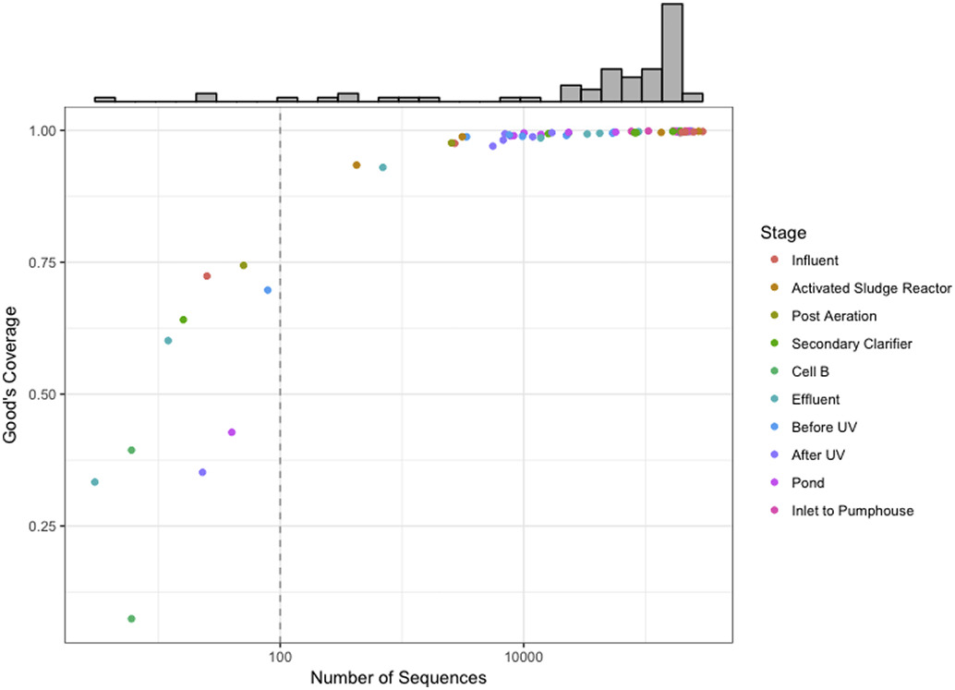
Figure S2 Alpha-diversity estimates and observed operational taxonomic unit (OTU) number in influent samples from all four wastewater treatment plants (WWTPs). No statistically significant differences in alpha-diversity estimates were found across influent samples from all four wastewater treatment plants.
