Table 1S. Androgen binding receptors classification for the EPA/EDSP Tier 1 data set.
Chemical name | AR Actual
2,4 D | n
Abamectin | n
Acephate | n
Acetone | n
Atrazine | n
Benfluralin | n
Bifenthrin | n
Captan | n
Carbaryl | p
Carbofuran | n
Chlorothalonil | n
Chlorpyrifos | e
Cyfluthrin | n
Cypermethrin | e
DCPA | u
Diazinon | p
Diclobenil | p
Dimethoate | n
EPTC | e
Esfenvalerate | n
Ethoprop | n
Fenbutatin oxide | n
Flutolanil | e
Folpet | n
Glyphosate | n
Imidacloprid | n
Iprodione | e
Isophorone | n
Linuron | p
Malathion | e
Metalaxyl | n
Methomyl | n
Metolachlor | p
Metribuzin | n
MGK 264 | n
Myclobutanil | p
Norflurazon | n
o-Phenylphenol | p
oxamyl | n
PCNB | n
Permethrin | e
Phthalophos | p
Piperonyl butoxide | n
Propargite | n
Propiconazole | p
Propyzamide | n
Pyriproxyfen | n
Simazine | n
Tebuconazole | p
Tetrachlorvinphos | e
Triadimefon | n
Trifluralin | n
Abbreviations: AR = androgen receptor, n = negative, p = positive, e = equivocal, u = untested, i = insoluble

Table 2S. Major metabolites of Carbaryl predicted by MetaDrug™ software.
Name | Structure | LogOC
Carbaryl | 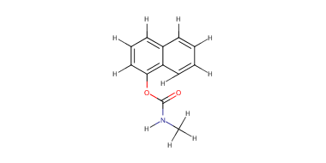
Carbaryl Aromatic_hydroxylation1 | 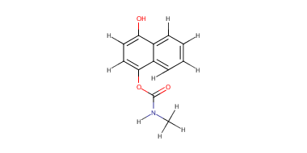 | -1.08
Carbaryl  Aromatic_hydroxylation3 | 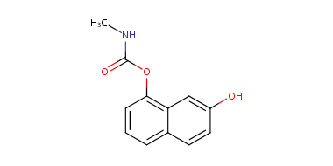 | -1.08
Carbaryl  Aromatic_hydroxylation5 | 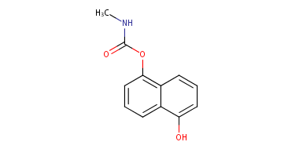 | -1.08
Carbaryl  N-dealkylation1A | 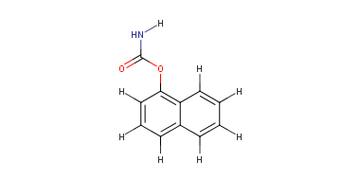 | -1.21
Figure 1S. Ontological categories representation of predicted targets of Carbaryl, ordered by –log (p-value) of the hypergeometric distribution. Top graphic shows biological processes, and down graphic the toxicity networks.
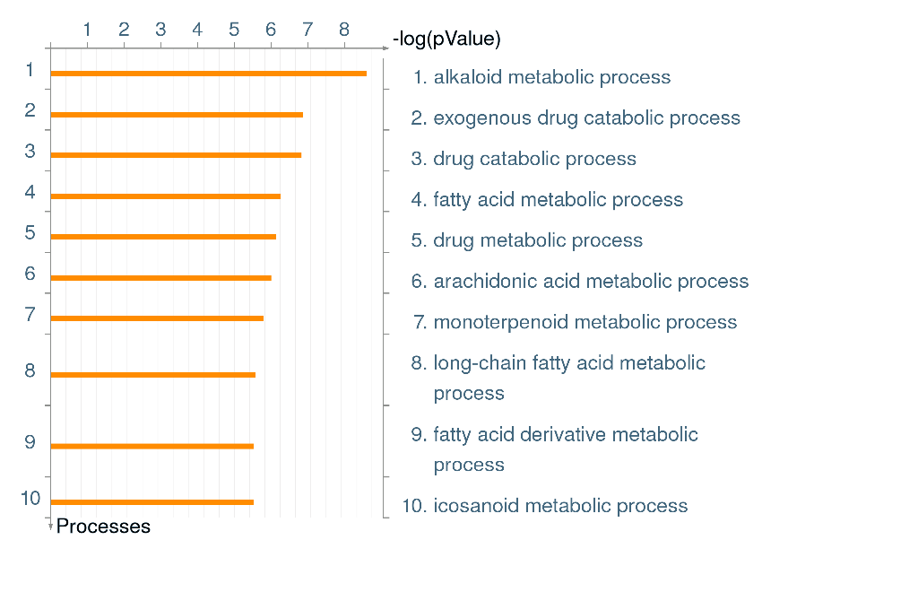
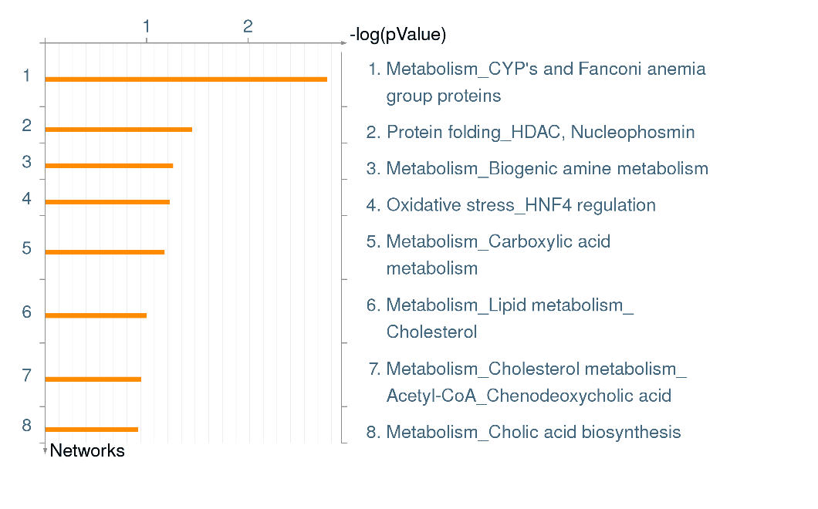

Figure 2S. Visualization of the Androgen Receptor and transcriptional targets that are related to the GO process “reproductive structure development”. All transcription regulation targets are based off of manually curated information coming from peer reviewed articles.
