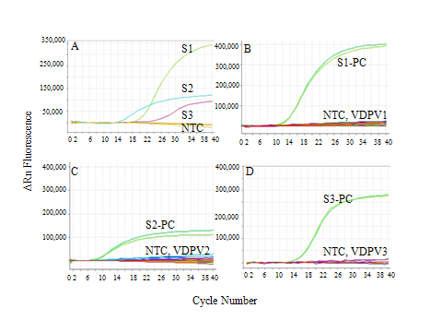
Fig. 1S. Amplification of reference Sabin strain (S, serotype indicated by number) sequences in the rRT-PCR VDPV assays. Assays used the FAM fluorophore for targeting the VP1 gene. The no-template controls (NTC) were used to manually set the zero baseline fluorescence emissions. The efficiency of each assay was >90%, based on 10-fold dilutions of control RNA (10 ng to 1 pg). Cycle threshold values of ≥30 were observed to approach the sensitivity limits of the real-time detection system; therefore, cycle threshold values of <30 were considered positive detections of the target template. The serotype-specific assays are shown using Sabin reference strain control RNAs (A) and a collection of VDPVs; B-VDPV1, C-VDPV2 and D-VDPV3.

Table 1S. VDPV primers/probes.
Primer/Probe Sequence (5′ → 3′)ª Positionª

S1 VDPV-S CATGCGTGGCCATTATA 2753-2769
S1 VDPV-A TAAATTCCATATCAAATCTA 2902-2883
S1 VDPV-Probe FAM-CACCAAGAATAAGGATAAGC-BHQ-1 2789-2809
S2 VDPV-S GACATGGAGTTCACTTTTG 2890-2908
S2 VDPV-A CTCCGGGTGGTATATAC 2989-2973
S2 VDPV-Probe FAM-CATTGATGCAAATAAC-BHQ-1 2925-2940
S3 VDPV-S CATTTACATGAAACCCAAAC 3276-3295
S3 VDPV-A TGGTCAAACCTTTCTCAGA 3400-3382
S3 VDPV-Probe FAM-TAGGAACAACTTGGAC-BHQ-1 3360-3374
_____________________________________________________________________________________________________________
ª All target sequences are in VP1. Nucleotide positions were numbered according to (Toyoda et al., 1984). S, Sense; A, Antisense.

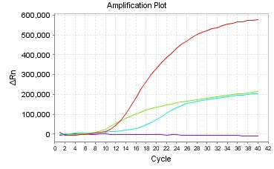
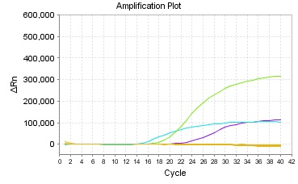
100,000
200,000
300,000
400,000
500,000
100,000
200,000
300,000
400,000
500,000
ΔRn Fluorescence
Cycle Number
0 2 4 6 8 10 12 14 16 18 20 22 24 26 28 30 32 34 36 38 40
A
S1

S3
S2

NTCs
S1

S2

S3

NTCs
0 2 4 6 8 10 12 14 16 18 20 22 24 26 28 30 32 34 36 38 40

Fig. 2S. The dual-stage run method was found to lower the Ct values of the assays in general. A) shows the single stage run method using 40 cycles of amplification for each of the Sabin assays. B) shows the dual stage method using 5 cylces at lower temperatures (95°C-44°C-60°C) followed immediately with 40 cycles at higher temperatures (95°C-50°C-65°C). Lowering the Ct values of the samples with the dual stage run method increases our sensitivity of virus detection by > 1 log of virus copy number when comparing serial RNA dilutions with either run method (data not shown).

