Supplementary Data

Supplementary Methods

Participant Consent
Consent for school EAGs was collected from school directors and following community meetings to inform parents and allow opt-out. At health facility and church EAGs, adult participants provided consent directly, and consent for children (<18 years) was provided by a parent or guardian and children above 6 years gave assent to participate. Individuals aged 16 or 17 who were married, head of household or a parent were considered ‘mature minors’ and consented directly. Thumbprint consent or assent (countersigned by a witness) was used for illiterate participants. Individuals under 6 months of age or requiring immediate medical attention were excluded.
For the population-based household survey, verbal consent for overall permission to conduct the survey was obtained from the head of household and/or primary caretaker and documented in the electronic data collection instrument. Individual-level verbal consent was sought from each present individual for the blood sample collection, and assent from persons ages 7–17 years.
EAG Survey Design
Two separate but similar EAG surveys were conducted in 2017. The first EAG took place in the Artibonite department in the communes of La Chapelle and Verrettes (estimated P. falciparum incidence: 1.0 to 4.9 cases per 1,000 residents), in the same target area and at the same climate season as the household-based survey (see below). The EAG survey was administered in three different types of venues: health facilities, schools, and churches. All nine functioning health facilities in the area were targeted, and recruitment took place continuously until the maximum sample size either for a particular health facility (n=450) or for all health facilities (n=2,100) was reached. All patients and accompanying persons were eligible, irrespective of their symptoms. For the schools and the churches, a sampling frame was created by combining data obtained from local associations, the Ministry of Education, the Archdiocese, and field visits. A sample of 21 schools and 9 churches was selected using stratified random sampling – stratification was based on distance to the main road and access to a health facility (for schools) or on faith (for the churches). Children were chosen by systematic random sampling per grade, and any church attendees approached were asked to participate in the study. The targeted sample size per type of venue was 2,100 participants, with a total targeted sample size of 6,300 participants. Data collection was performed in April–May 2017.
Recruitment procedures were similar for the second EAG survey in Grande-Anse Department communes of Anse-d'Hainault, Les Irois, Dame-Marie, Chambellan, and Moron (estimated P. falciparum incidence 5.0 to 60.2 cases per 1,000 residents), with the exceptions that churches were not sampled for this survey and the number of schools sampled was increased to 25. The overall target sample size was reduced to 5,000 participants, half of them to be recruited in schools, the other half in health facilities. All functioning health facilities (n=16) were included – and a maximum sample size per health facility was 300 participants. Data collection was performed in November–December 2017, which is a season of higher malaria transmission in Haiti. A questionnaire was administered to all participants to gather information about their history of fever, treatment-seeking practices, travel, and sociodemographic characteristics. A blood sample was collected by finger prick using a sterile lancet to perform both types of RDT and for blood collection on filter paper. Individuals under 6 months of age or severely ill requiring urgent care (in health facilities) were not eligible to participate in the EAG studies.

Artibonite Household-based Community Survey
A population-based household survey was conducted in the communes of La Chapelle and Verrettes in the Artibonite department of Haiti from July–October 2017. A complete census of the survey area was conducted prior to the household survey, where 33,060 residential, inhabited households were identified and constituted the sampling frame for the household survey. The sampling methodology for the survey took into consideration the geographic distribution of the households, where the survey area was subdivided into 1 km² grids, each representing an operational unit (OU), where households were selected by simple random sampling within each OU from three strata:
- 10% of households were sampled in OUs with >200 households;
- 20 households were sampled in OUs with 20–200 households;
- All households were sampled in OUs with <20 households.
Based on the geographic distribution of the homes, and 5% oversample in each OU to account for potential refusals, 8,818 households were sampled to survey, with an estimated population of 33,085 persons. All members of each consenting household were eligible to participate and have their blood drawn by finger prick for testing for malaria by RDTs and laboratory tests.

Reagent Preparation and Detection of HRP2 in the Laboratory
A magnetic bead region (MagPlex ®, Luminex Corp) was coated by the EDC/Sulfo-NHS intermediate reaction with anti-HRP2 antibodies (Abcam mouse IgG anti-P. falciparum HRP2 IgG; ab9203) at 20 µg per 12.5x10⁶ beads. Biotinylated detection antibodies (Abcam, a 1:1 mixture of mouse IgG anti-P. falciparum HRP2 (ab9203) and mouse IgM anti-P. falciparum HRP2 (ab9206)) were prepared by Thermo Scientific EZ-Link Micro Sulfo-NHS-Biotinylation Kit (ThermoFisher Scientific) according to the manufacturer’s protocol and stored at 4°C at a final concentration of 1 mg/mL.
The HRP2 antigen detection was conducted at the Laboratoire National de Sante Publique (LNSP) in Port-au-Prince, Haiti with the bead-based immunoassay. Briefly, a 6mm punch of a dried blood spot (DBS) was rehydrated in a blocking buffer (Buffer B, PBS pH 7.2, 0.5% Polyvinyl alcohol (Sigma) 0.5% polyvinylpyrrolidine (Sigma), 0.1% casein (ThermoFisher), 0.5% BSA (Sigma), 0.3% Tween-20, 0.05% sodium azide, and 0.01% E. coli extract to prevent non-specific binding) to a final dilution of 1:20x. Beads coated with capture antibody were added to assay plates (BioPlex Pro, BioRad) in a reagent diluent (Buffer A, PBS pH 7.2, Tween20 0.05%, BSA 0.5%, sodium azide 0.02%) at approximately 800 beads/well and washed twice with PBS (pH 7.2) with 0.05% Tween 20 (PBS-T). Incubation of the beads with 50 µL of the sample elution occurred for 90 min under gentle shaking at room temperature with plates protected from light. Plates were washed 3x with PBS-T after incubation. Biotinylated detection antibody was added to the wells (50 µL/well of 1:500x dilution) and incubated with shaking for 45 min after which plates were washed 3x with PBS-T. Streptavidin-phycoerythrin (Invitrogen) was added to all wells at a volume of 50 µL (1:250x of 1 mg/mL), incubated under shaking for 30 min. Following 3 washes with PBST, a final wash step was performed with Buffer A for 30 min, and then wells were washed once, and resuspended in 100 µL PBS. Assay plates were read on a MAGPIX instrument (Millipore Sigma) by generating the median fluorescence intensity (MFI) signal for 50 beads. The final measure, denoted as MFI-bg, was reported by subtracting MFI values from beads on each plate only exposed to sample diluent during the sample incubation step. The MFI-bg threshold for a true positive HRP2 assay signal was ascertained if the sample MFI-bg was higher than the mean + 3SD of the MFI-bg signal of a panel of known negative DBS samples. To translate between a MFI-bg value and antigen concentration for classified positive samples, equations for a standard curve of recombinant HRP2 were calculated. Recombinant PfHRP2 antigen was provided by Microcoat Biotechnologie GmbH, and lyophilized preparations were rehydrated according to the manufacturer’s instructions. Based on the previously-reported limit of HRP2 quantification for the bead assay as 8.8 pg/mL, in accounting for the 1:20 dilution of the blood coming off a filter paper blood sample, the lowest quantification for the bead assay would be 176 pg/mL HRP2 in undiluted blood.

Real-time PET-PCR for P. falciparum DNA
DNA was extracted from DBS by using the QIAamp DNA Mini Kit (QIAGEN) as described by the manufacturer. Briefly, a 6mm punch of the DBS were punched out and placed into a 1.5 mL tube and processed according to instructions. The DNA was eluted in 150 µL of elution buffer, and stored at -20°C until use. The amplification of Plasmodium genus (forward primer: GGCCTAACATGGCTATGACG; reverse primer: FAM-aggcgcatagcgcctggCTGCCTTCCTTAGATGTGGTAGCT) was performed in a 20 µL reaction containing 2X TaqMan Environmental buffer 2.0 (Applied BioSystems) and 125 nM each of forward and reverse primers. For each sample, PET-PCR reactions were run with 2 µL of DNA template used in the PCR reaction with the following cycling parameters: initial hotstart at 95°C for 10 min, followed by 45 cycles of denaturation at 95°C for 10 sec, annealing at 60°C for 40 sec. The cycle threshold (CT) values were recorded at the end of annealing step and a positive CT value was considered below 37.0. All assays were performed using an Applied Biosystems 7500 Fast Real-Time PCR system. To extrapolate an estimated parasite density (in parasites per microliter blood, p/µL) from a CT value, average standard curve was made using extracted DNA from the 3D7 and Dd2 culture strains previously quantified by microscopy (Supplementary Figure 1).

Supplementary Figures

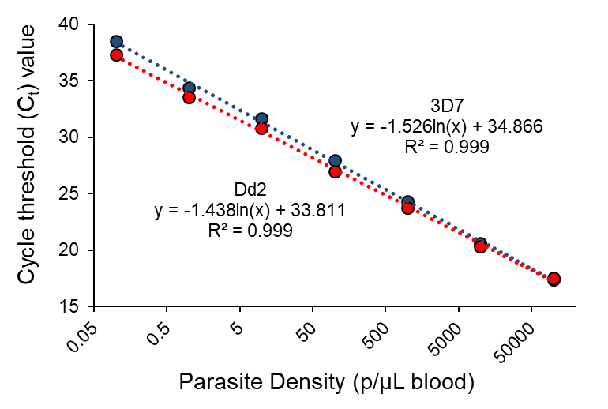
Supplementary Figure 1. Standard Curve of Purified DNA to Estimate P. falciparum Parasite Density. Parasite culture strains 3D7 and Dd2 had parasite density quantified via microscopy, DNA extracted, and run by PET-PCR to estimate parasite quantity for different C_{t} values.

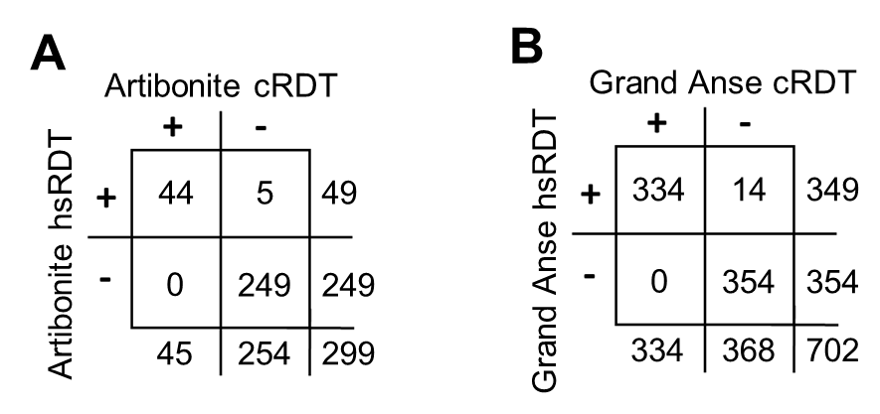
Supplementary Figure 2. Agreement between cRDT and hsRDT results from Artibonite (A) and Grand Anse (B) Easy Access Group (EAG) surveys only for persons whose samples were selected for further lab assays.

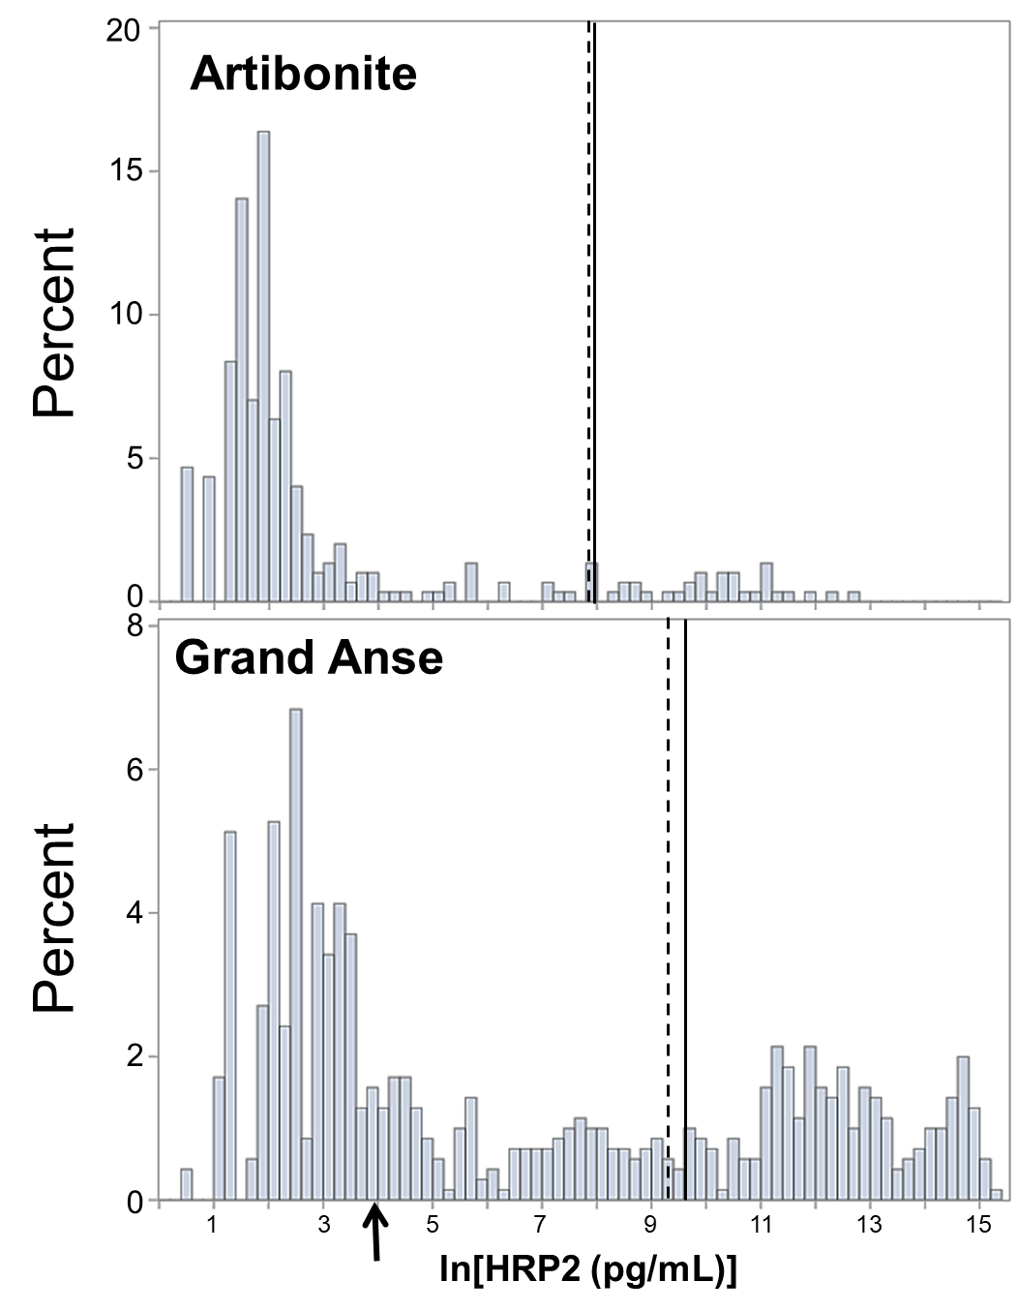
Supplementary Figure 3. Distribution of HRP2 antigen concentration from Artibonite and Grand Anse EAG surveys. For all persons in the two surveys with quantified HRP2, histograms are shown with 95% sensitivity estimates as solid line for the cRDT or vertical hashed line for the hsRDT as indicated in Table 1. Arrow on x-axis indicates limit of detection of HRP2 bead assay.

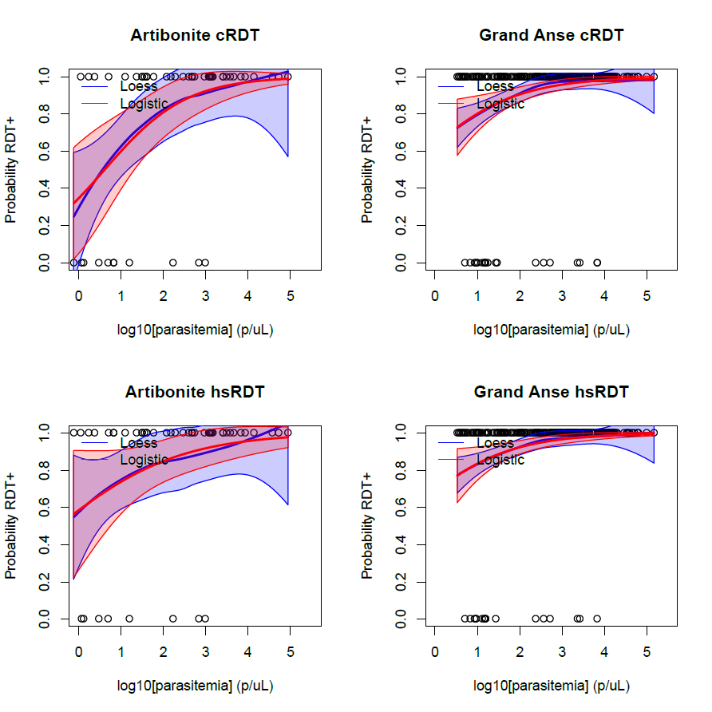

Supplementary Figure 4. Parametric and non-parametric regression for dose-response relationship between estimated parasite density and RDT result. Panels are shown for the Artibonite and Grand Anse EAG study sites for the conventional and high-sensitivity RDTs.

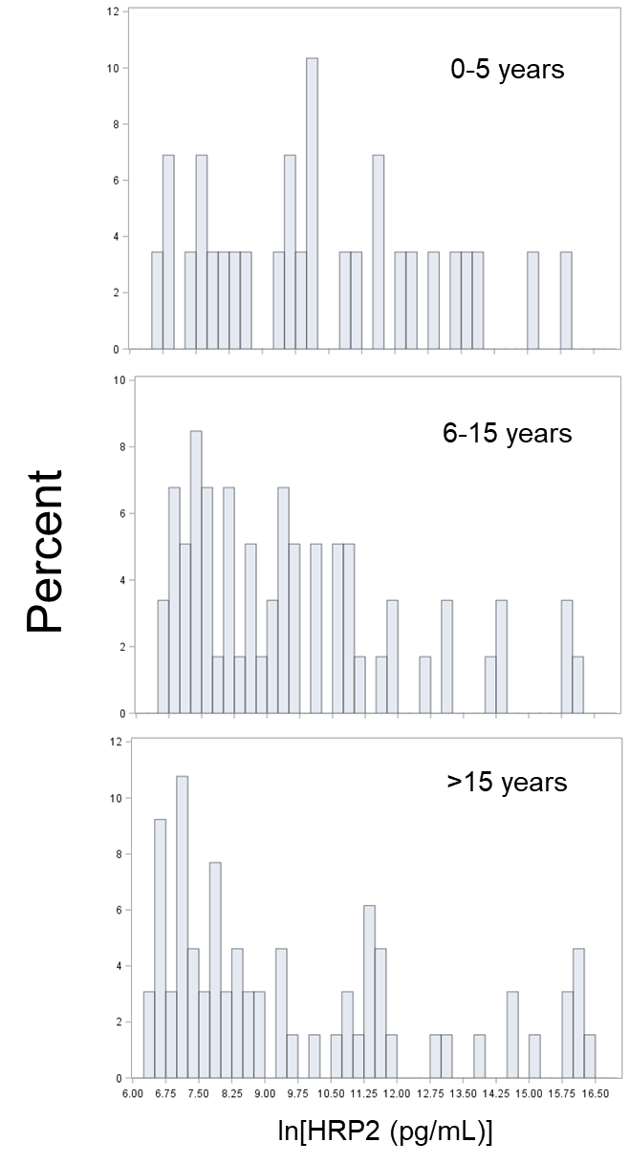
Supplementary Figure 5. Distribution of HRP2 antigen concentration by age category for RDT positive persons in Artibonite household survey.

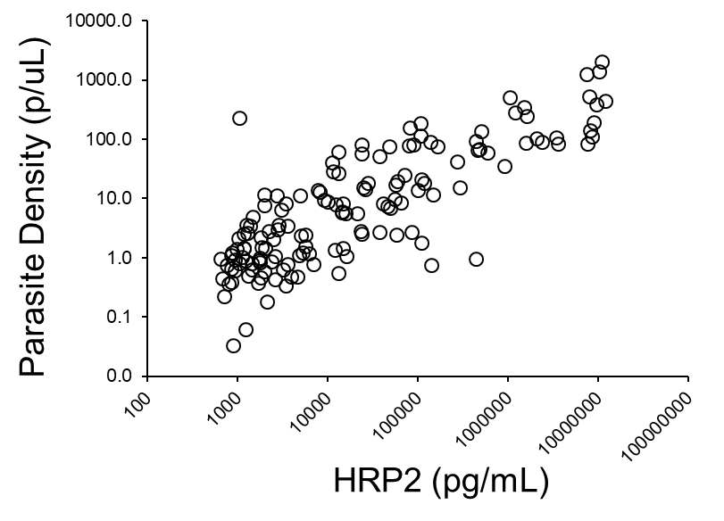
Supplementary Figure 6. Relationship between HRP2 Antigen Concentration and P. falciparum Parasite Density as Estimated by PET-PCR for RDT Positive Blood Samples in Artibonite Household Survey.

