Organic Dust Exposure Induces Stress Response and Mitochondrial Dysfunction in Monocytic Cells
Sanjana Mahadev Bhat ¹, Denusha Shrestha ¹, Nyzil Massey ¹, Locke A. Karriker ², Anumantha G. Kanthasamy ¹, Chandrashekhar Charavaryamath ^{1*}
¹ Department of Biomedical Sciences, 2008 Vet Med Building, Iowa State University, Ames, IA, USA.
² Department of Veterinary Diagnostic and Production Animal Medicine, 2203 Lloyd Veterinary Medical Center, Iowa State university, Ames, IA, USA
*To whom correspondence should be addressed: Chandrashekhar Charavaryamath, BVSc, MVSc, PhD., Assistant Professor, Department of Biomedical Sciences, Iowa State University, Ames, IA 50011. Telephone: (515) 294-7710; Fax: (515) 294-2315; Email: chandru@iastate.edu

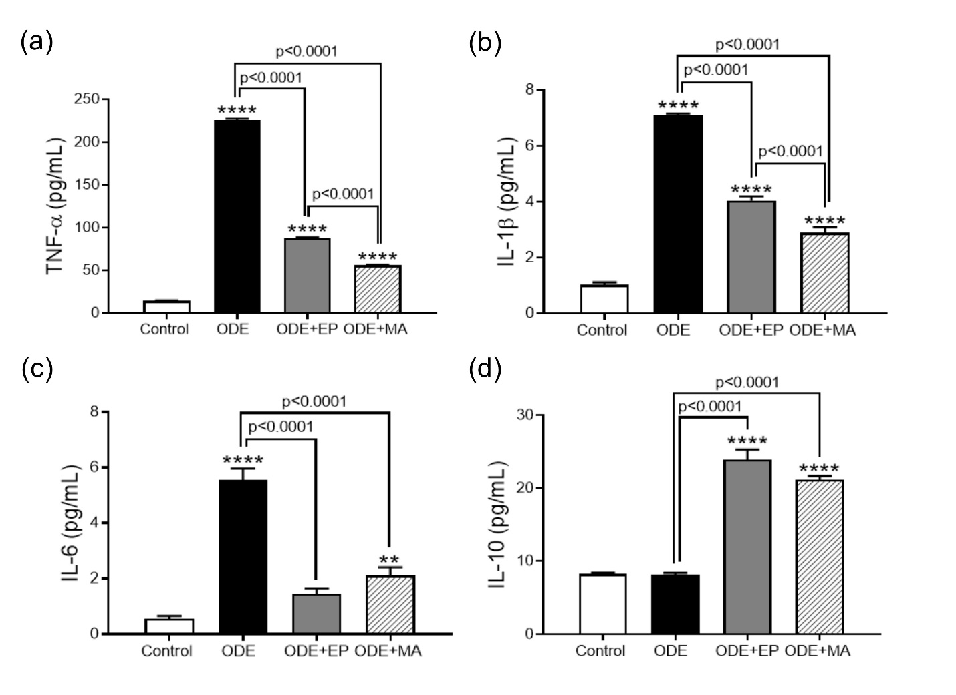
Supplementary fig. S1 ODE increases production of proinflammatory cytokines
Cytokine levels in the supernatant of THP1 cells treated with either medium or ODE (1%) followed by either medium or EP (2.5 µM) or MA (10 µM) for 24 hours was measured. Expression of pro-inflammatory cytokines TNF-α (a), IL-1β (b), and IL-6 (c) were measured. Expression of anti-inflammatory cytokine IL-10 (d) was measured. For all assays, samples were derived from the same experiment and were processed in parallel. Data was analyzed using one-way ANOVA with Tukey’s multiple comparison test (*p < 0.05, **p < 0.01, ***p < 0.001, ****p < 0.0001) and represented as mean ± SEM with n = 6/treatment (* indicates significant difference from control).

