S11A Fig.
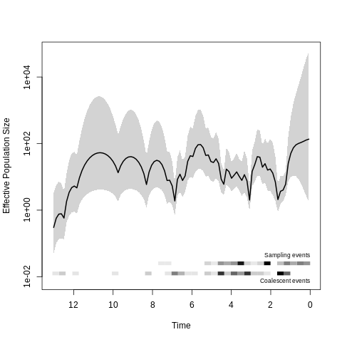
S11B Fig.
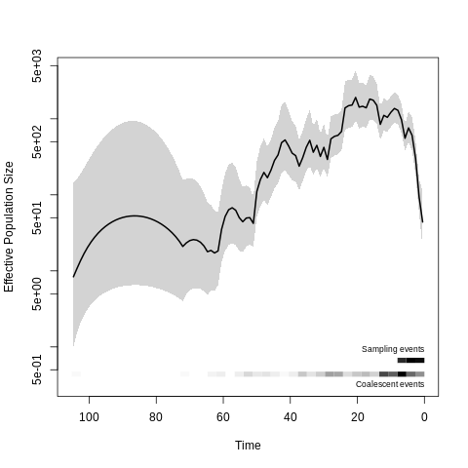
S11C Fig.
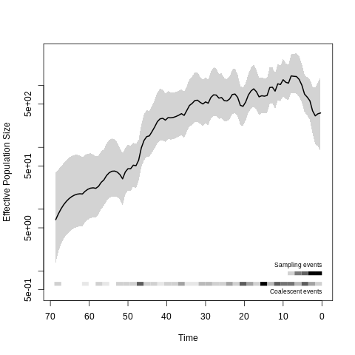
S11 Fig: Demographic history of genomic cluster 5 partitions (CC32, shown in S5 Fig). Time is measured in years before 2017, and the effective population size is scaled to the number of generations per year. A. Partition 1, consisting of a single clade of 62 US isolates indicated by red shading in supplementary figure 5. B. Partition 2 (blue shading). C. Partition 3 (green shading).

