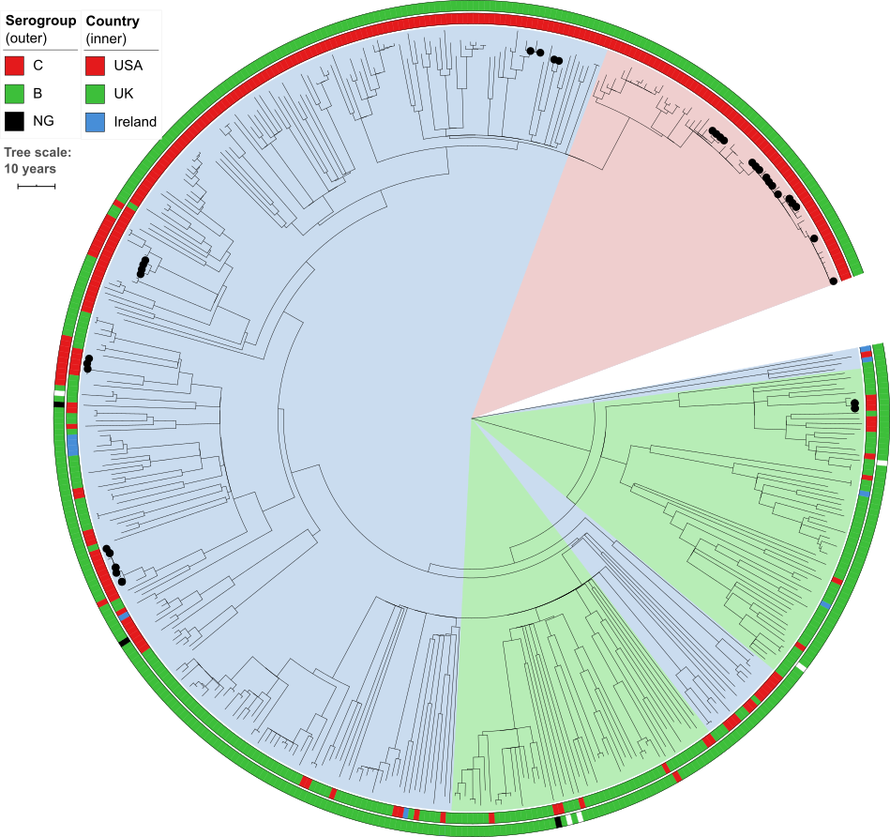
S5 Fig: Time-calibrated phylogeny of genomic cluster 5 (CC32, 454 isolates, 1,277,833bp core genome alignment). Inner ring shows the country of origin, outer ring shows serogroup. Internal shading shows TreeStructure partitions, with the US-specific partition #1 shaded red (detail in Fig 2). Black dots indicate isolates from 11 outbreak clades in the USA. Tree scale bar is 10 years. The estimated evolutionary rate is 9.8×10⁻⁷ subs/site/year.

